Hibernate & Jpa

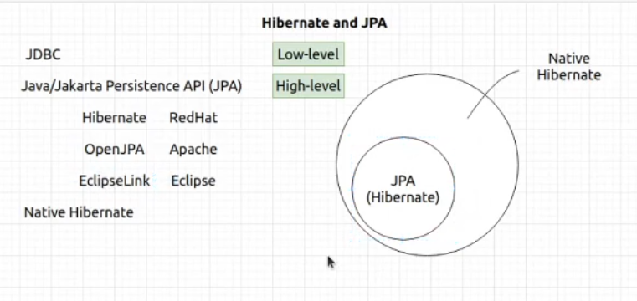
JDBC kiyanna low level ekak eke athule api hemadema karanna one query gahanna one transaction balanna one okkoma. But enterprise application ekakata enakota apita meeta wada features thiyana deyak awashya una.

Ekta use karanawa Java/Jakarta Persistance Api kiyana eka meka JavaEE wala spec ekak but me spec eka thibbata wedak nehe apita meka implement karapu ekak hambune neththam. Hariyta nikan servelet thibbata wedak nehe tomcat neththam wage. Eka nisa ekata thiyanawa Hibernate, OpenJPA,EclipseLink wage implementation apita use karanna puluwan. Eta amatharaawa thiyanawa Native hibernate kiyala meka godak petelenawa apita JPA walath hibernate kiyala implimentation ekak thiyana nisa. But meka apita native kiyana kellen aduraganna puluwan lesiyenma. Meke wisheshathwe thama JPA walata wada godak weda tikak karaganna puluwan apita features wedi. Meke features wediyen denna gihin anagaththa thenuth thiyanawa.

Godakma Native hibernate walata giyoth apita hibernate, OpenJPA wage ekakata kohethma maru wenna behe mokada Hibernate JPA walata wada godak features dela thiyana nisa ethakota a JPA wala nethi features use kalama apita kohmath wena JPA implementation ekakta maru wenna behe.

Apita Native hibernate wala idan JPA wala thiyana onama functionalities ekak use karanna puluwan. Native hibernate wala enne wediyen features tikak witharai. Namuth apita me dekema idan directly JDBC use karanna behe athule JDBC thibbata. Ewa tika encapsulate karala thiyenne.
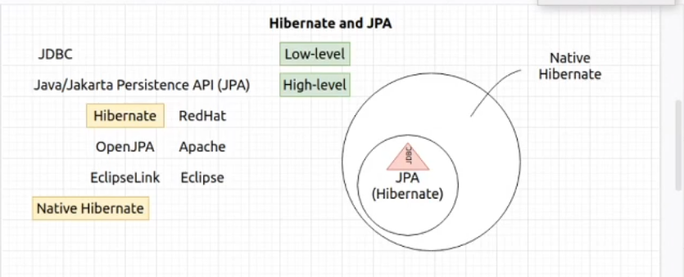
Elaga eka thamai api dan meka bawitha karana kota native hibernate saha hibernate kiyana dekama apita hambawenne ekata. A kiyanen download karala gannakota hari dependency wise gannakota hari apita meka hambawenne eka bundle ekak widiyata. Eta passe api code eka gahala meka use karanna yaddi thamai api hibernate da pawichchi karanne native hibernate da pawichchi karanne kiyala theerane karanne.

HibernateORM kiyanne hibernate and native hibernate kiyana dekema ekathuwata.
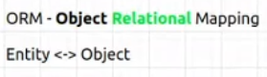

Me concept eka genna mokada OOP developers la wediyenma kemathi Object ekka weda karanna.

Api meka gena kiyawanna one ekama doc eka thama userguide ekai javadoc ekai witharai wena kisima deyak kiyawanna awasya nehe.

https://docs.jboss.org/hibernate/orm/5.6/javadocs/

https://docs.jboss.org/hibernate/orm/5.6/userguide/html_single/Hibernate_User_Guide.html

How to add hibernate to our project??
According to our hibernate version we can add it through maven or gradle to our project from maven repository.

<!-- https://mvnrepository.com/artifact/org.hibernate/hibernate-core -->
<dependency>
<groupId>org.hibernate</groupId>
<artifactId>hibernate-core</artifactId>
<version>5.6.2.Final</version>
</dependency>

Aththatama meka add kalama hibernate site ekat gihin. Apita JPA and native hibernate kiyana dekama enawa ape project ekata ithin meka api JPA use karnawada hibernate use karanawada kiyala theerane wenne api project eke karana code eka matha. Ekata kiyanawa api bootstrapping karnawa kiyala. Bootstarp karnawa kiyala ketiyenma kiyanne ape project ekata integrate karaganna kiyan ekata. Dependency eka dammata eka nikanma add wenne nehe ape project ektaa.

How to do Bootstrapping JPA and Native Hibernate

api doc ekata giyama apita balaganna puluwan userguide eke thiyanwa bootstrapping kiyala section ekak a section eka athule thiyanawa kohomada JPA bootstrap karana viiyai Native hibernate bootstrap karna vidiyai kiyala.

Api native hibernate walata enakota api eken hema welema weda karanne session ekath ekka. A kiyanne ddatabase ekath ekka session ekak hadagannawa api weda karanakota. Session eka start wela thinayakal apita eka eka dewal karanna puluwan session ekath ekka eka iwara unama kathawa iwarai. A adahasa athuwa thama me session kiyana eka genalla thiyene.

A unata apita me Native hibernate ekka weda karana Session eka apita ekaparama ganna behe. Mokada a gollo eka object creation eka hangala thiyenne. Eka nisa eka ganna one Factory ekakin. Session kiyanne interface ekak. Hibernate athulata yanna thiyana eka thama me factory eka. Eka nama thama SessionFactory eka. Api session factory eken thama illaganne sessions.

Ithin me kiyana factory eka hadaganna podi gemak gahanna one. Apita me factory eka hadala iwara unata passe ona tharam sessoin me factory ekata kiyala illaganna puluwan.

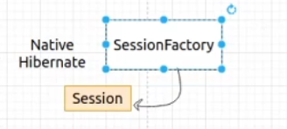

Dan me SessionFactory eka thama apita hadagnna one sessions hadaganna tihin bootstrap usergude eke bootstrpping chapter eka yatathe kiyanne me SessionFactory eka hadaganna vidiya.
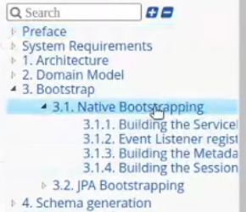

Version eken version ekata sessionFactory eka hadana vidiya wenas. Eka nisa bootstrap doc eke bootstrapping secion eke 3.1.4 yatathe thiyanawa 3 steps process ekak eka anugamanaya karala apita me kiyana SessionFactory eka hadaganna puluwan. Hadissiye hari me hadana vidiya wenas unoth apita meka hoyaganna puluwan wenne doc eka kiyawalama witharai.

How to create Native Hibernate Configuration file

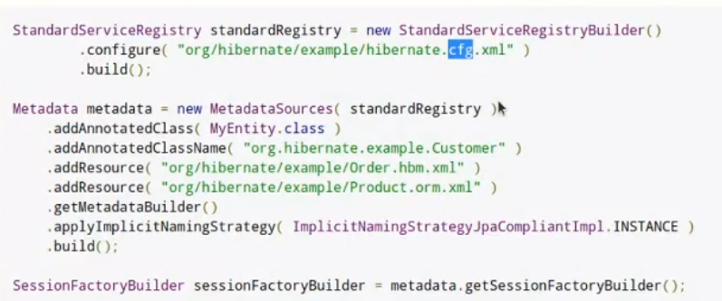
Methana thiyana .configure(“org/hibernate/example/hibernate.cfg.xml”) kiyanne. Cfg kiyanne samanyen configuration kiyana ekata abbrevation ekak. Ethakota api methana deela thiyanana configuration data thiyana xml file ekak hadganna one eka hadanne mehemai.

Project structure gihin danata JPA kiyala aduragena thiyenne ape module eka ekata plus sign eka click karala hibernate kiyana eka add karaganna one.

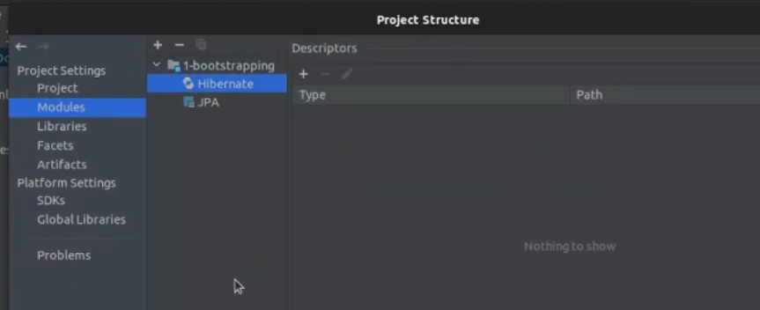
Eta passe puluwan apita ara adala configuration file eka addd karaganna anith plus sign eka click karala eka add karana kota by default add wenne resource ekata aththtatama eka ethanata thama add wenna one samahara then wala wenas vidiyakata woth eka wenas karala add karanna.

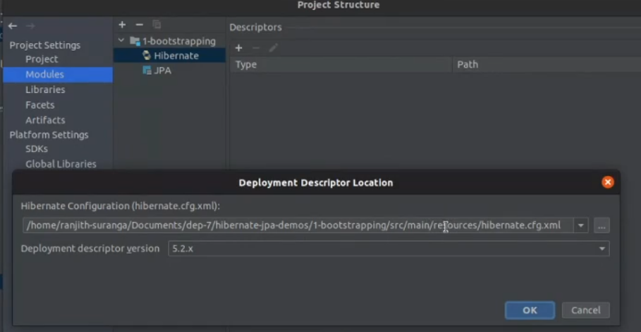
Meka hariyata unoth ehema oyalata file ekak balganna puluwan me vidiyata.

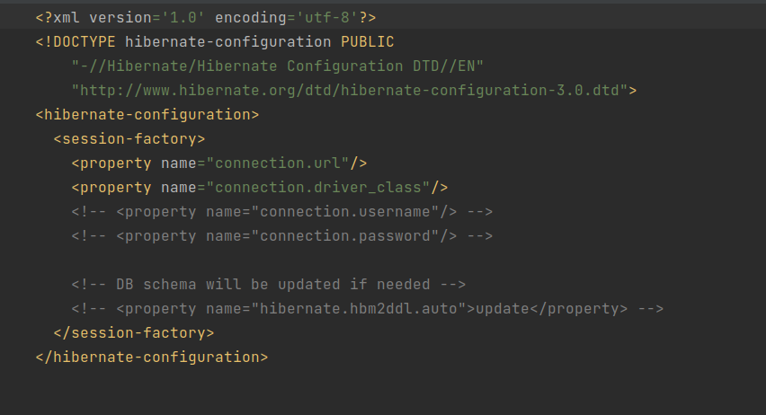
Me file eke configuration tikak hadaganna one adala vidiyata. Ethakota thama SessionFactory eka apita hadaganna puluwan wenne. Ekata 24 chapter eke thiyanawa database connect karana vidiya saha anith dewal. Java walin patan ganne JPA wla ewa saha Hibernate walin pagan ganna Native hibernate wala dewal. Api mysql driver connector eka ehema set karnna one mokada meka athulen kohomath ewda karanne mysql kiyal aapi hodatama danna nisa.

Eta passe chapter 22 genaral configuration kiyana ekata ghin gannawa hibernate.dialect kiyana eka.
Eka danna one aluthen property ekak hdala. Dialect eka kiyanne ape mysql version eka. Mokada underlyne database eka aduraganna one hibernate ta eka nisa api kynna one mokakda use karanne kyiala pehdiliwa. Okkoma dialect thiyene org.hibernate.dialect kiyana package eke.

Eta psase chapter 24 hibernate.show.sql kiyana ekath add karanna one moakda ethakota apita balaganna puluwan hibernate athulen kohomada mokada karanne kiyala log ekak vidiyata apita meka godak wedagath. Develop karana kota daganna ekak godak welawata.( logging )

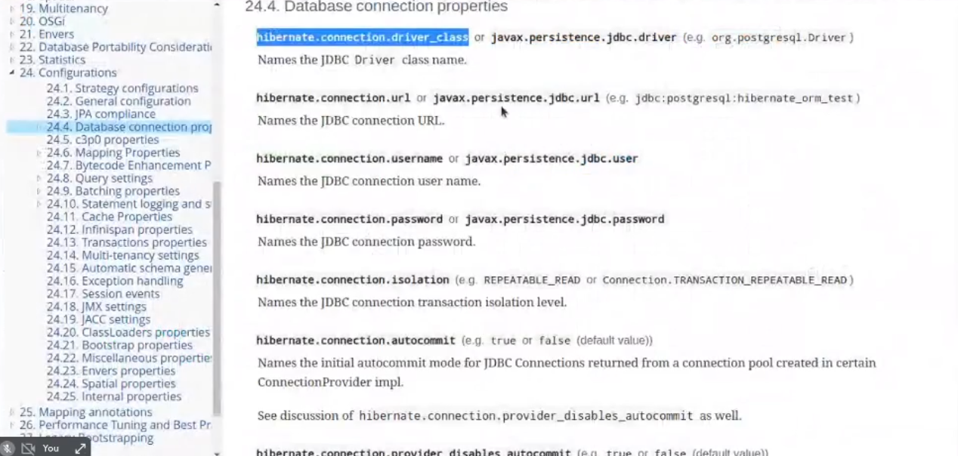
Final output of hibernate.cfg.xml
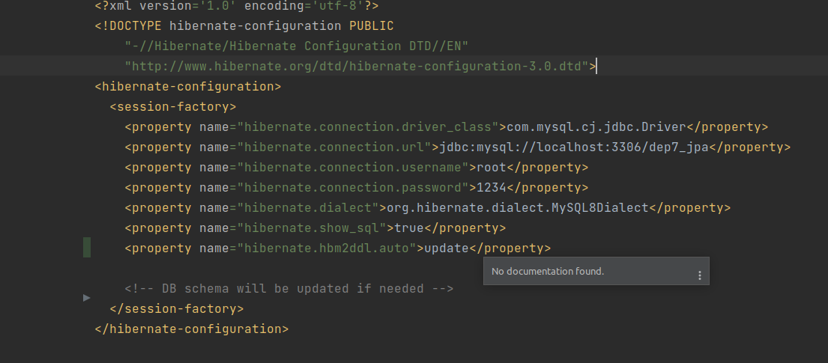

How to create SessionFactory class
the convention is the class name as HibernateUtil. But apita ona namakin meka hadaganna pluwan. Meka ekthara vidiye singleton class ekak hebai ape normal singleton class eka neme. Mekatama awenika kramayak thiyanawa issara idanma apu. Meka singleton karanne menna me wage,

SessionFactory eken wenne session hadana eka api danne nehe athule implementation eka mokakda kiyala api danne nehe mokada meka access karanna deela thiyenne interface ekak through nisa. Eyata session factory eka hadanna awashya wishra tika api denna one configuration details vidiyata. Eka heduwata passe meyage factory eka thama sessoin onama factory ekak wage apita meyagen sessin illaganna puluwan.

Note: api SessionFactory ekak hadagena Session ekak use karanawa wage Native hibernate walata JPA walatath api use karanne EntityManager kiyala ekak eka ganna use karana Factory eka thama EntityMangerFactory kiyana eka.
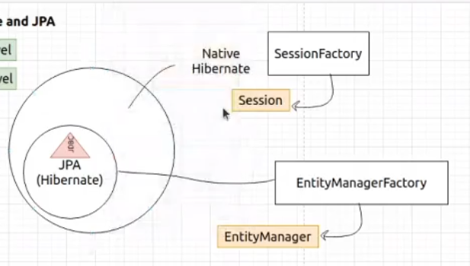

Step 1,
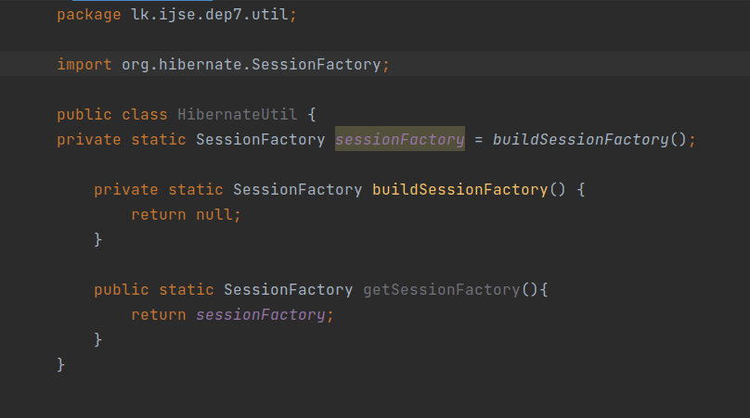
dan methan buildSessoinFactory() kiyana method eka athule api gahanna one Sessioneka return karana code eka ekata maha loku deyak karanna nehe doc eke Native bootstrapping wala 3.1.4 thiyena code eka copy krala dagnna thiyenne.

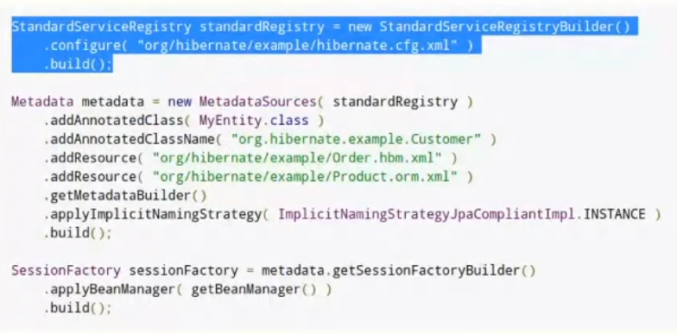
Final source code of SessionFactory HibernateUtil class

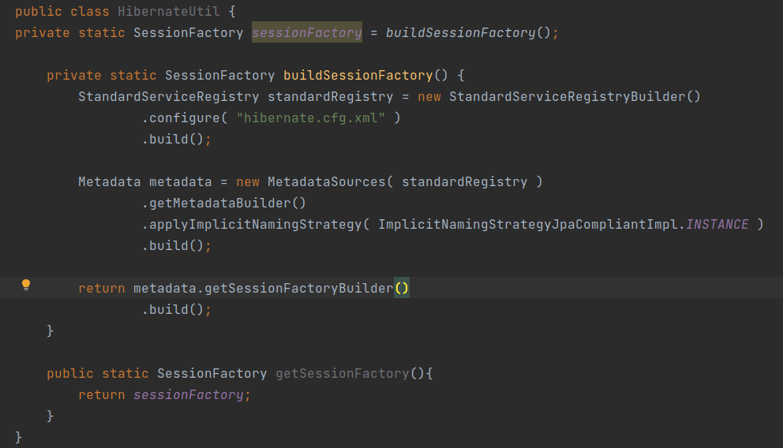
Making a mainclass and test the SessionFactory is working or not here is the main class and class files.
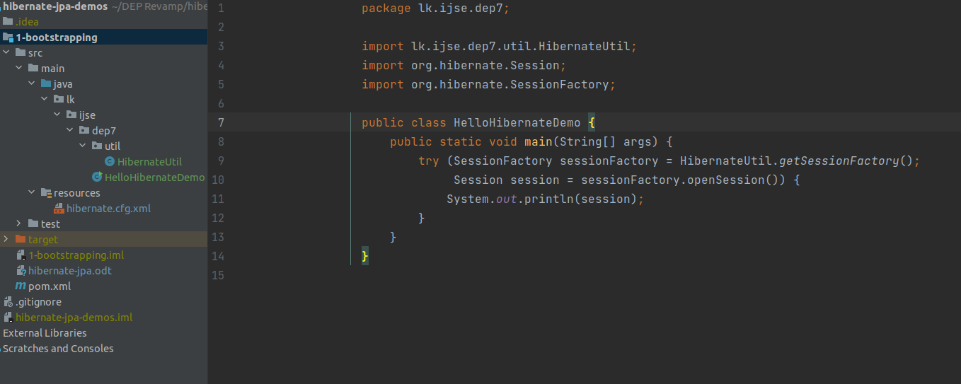
If the log comes with some red INFO it is not errors. If it ends up with SessionImpl(842298743<open>) it is okay. We have created Sessoin perfectly.
