Second method for making the session factory
Kalin wagema man thawath module ekak hadagannawa 2-bootstrapping kiyala. Eka athulata kalin hadagaththa Hibernate Util ekai main HelloHibernateDemo kiyana class ekai add karagannawa. Eta passe main eka run karala beluwoth apita error ekak enawa hibernate.cfg.xml file eka nehe kiyala.

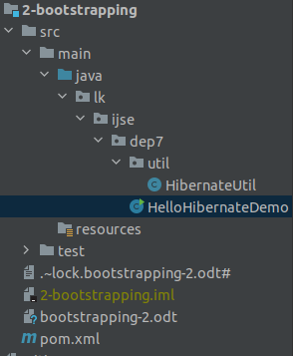

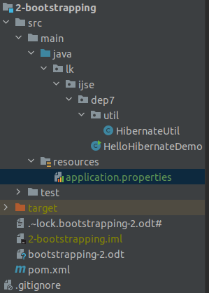
Api dan aluth vidiyata me bootstrapping eka karanna yanakota apita awashya wenawa issellama. Resource bundle ekak eka thama boho welawata external configuration thiyaganne file ekak vidiyata. Api kalin ape configuration kale xml file ekaka dan karanna yanne resource bundle ekaka. Api me file eka concentionaly nam karanawa application kiyala wena nam walin api meka nam karanne nehe.
Api hinernate.cfg.xml file eke thibba okkoma dewal applicatoin.properties file ekata genalla danaawa.
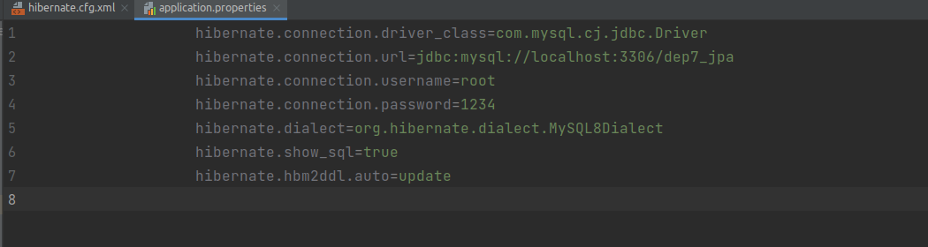
Eta passe api ape HibernateUtil class eke thiyana load config file eka ain karala. LoadProperties kiyana method ekata ape application.properties kiyana file name eka denawa. Eta passe run karanawa.
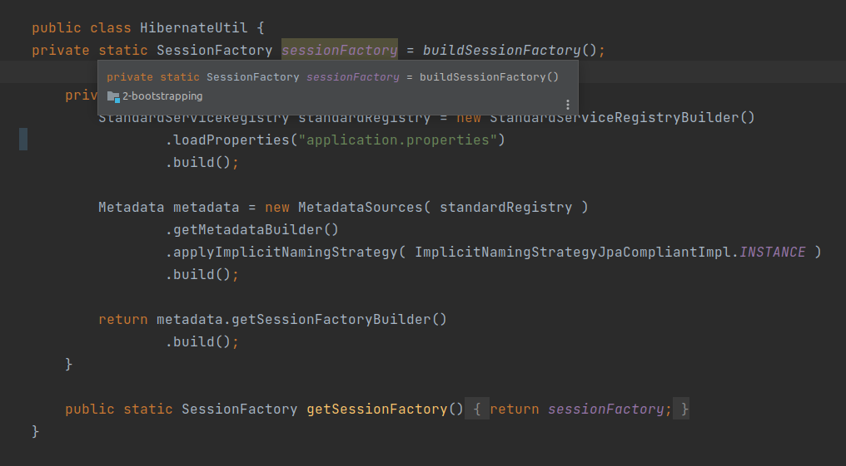

Eta passe run krala balnna puluwan.

