***Programming Principles02 – Tutorial03***

**Task 1 – Enhancing a Conversion Program**

1. **Kilometres_miles.java**

import java.util.Scanner;

public class Kilometres_miles {

public static void main(String[] args){

Scanner scan=new Scanner(System.in);

System.out.println("Enter \n 1. Kilometres to miles \n 2. miles to kilometres ");

int choice = scan.nextInt();

switch(choice){

case 1:

System.out.println("Enter kilometers :");

double km=scan.nextDouble();

double miles=km*0.621;

System.out.println(km+" km ="+miles+" miles");

break;

case 2:

System.out.println("Enter miles :");

double mile = scan.nextDouble();

double kms= mile*1.609 ;

System.out.println( mile+" mile = "+kms+ "km");

break;

default:

System.err.println("Invalid command");

}

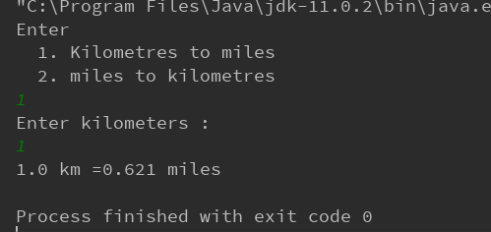

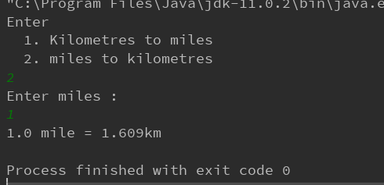

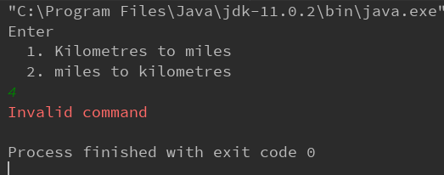

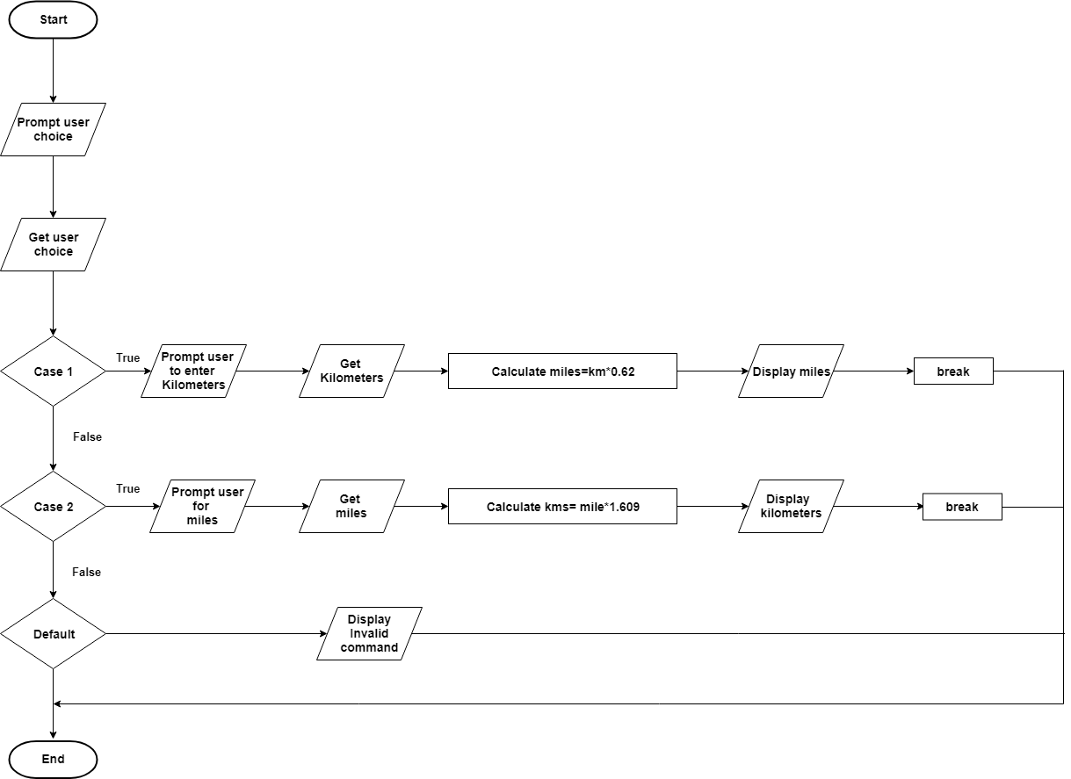

1. **Centimeters_Inch.java**

import java.util.Scanner;

public class Centimeters_Inch {

public static void main(String[] args){

Scanner scan=new Scanner(System.in);

System.out.println("Enter \n 1. centimetres to inch \n 2. inch to centimetres ");

int choice = scan.nextInt();

switch(choice) {

case 1:

System.out.println("Enter centimetres :");

double cm = scan.nextDouble();

double inch = cm * 0.393;

System.out.println(cm + " cm =" + inch + " inches");

break;

case 2:

System.out.println("Enter miles :");

inch = scan.nextDouble();

cm = inch * 2.54;

System.out.println(inch + " inch = " + cm + "cm");

break;

default:

System.err.println("Invalid command");

}

}

}

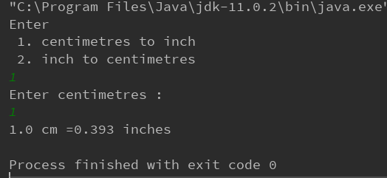

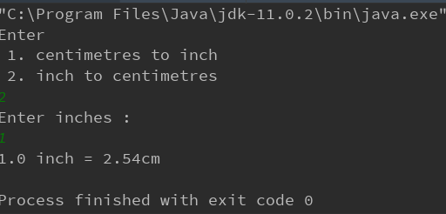

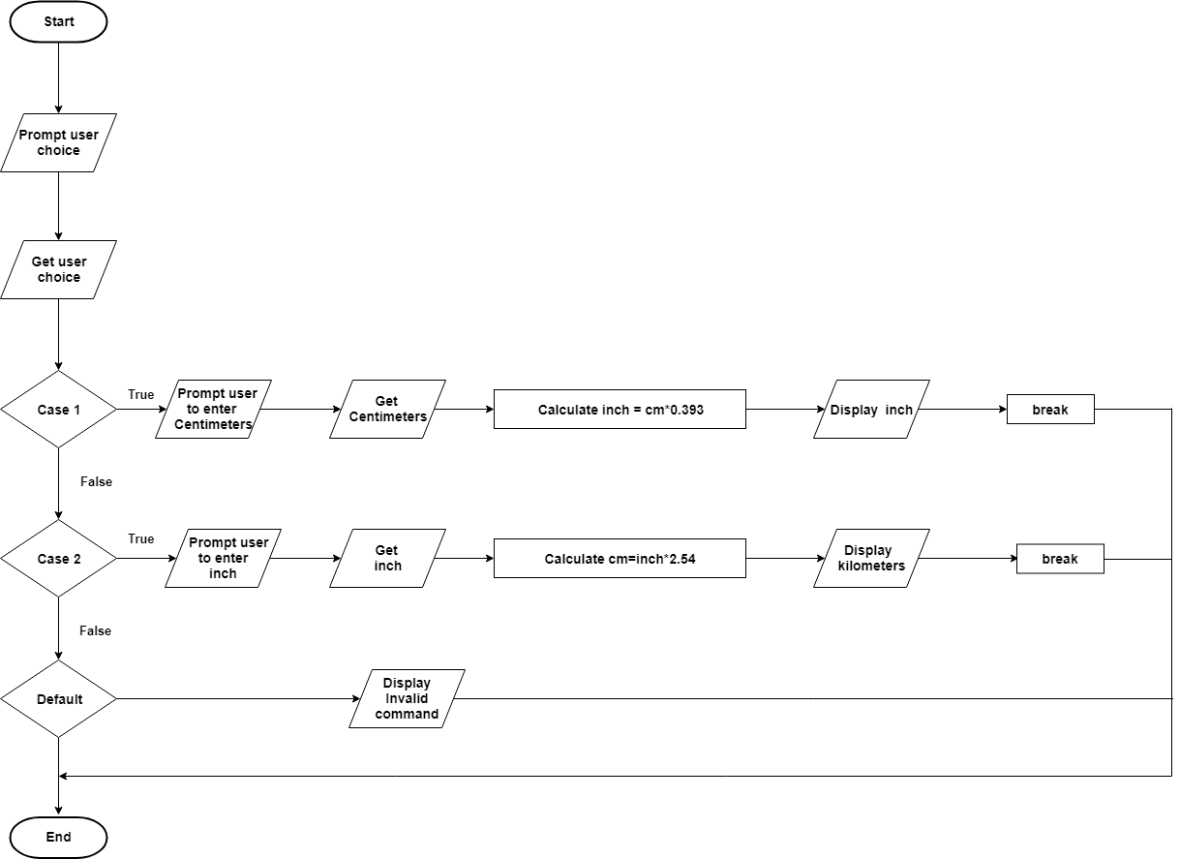

1. **Metre_Foot.java**

import java.util.Scanner;

public class Metre_Foot {

public static void main(String[] args){

Scanner scan=new Scanner(System.in);

System.out.println("Enter \n 1. metres to foot \n 2. foot to metres ");

int choice = scan.nextInt();

switch(choice) {

case 1:

System.out.println("Enter metres :");

double m = scan.nextDouble();

double feet = m * 3.281;

System.out.println(m + " m =" + feet + " feet");

break;

case 2:

System.out.println("Enter foots :");

feet = scan.nextDouble();

m = feet * 0.305;

System.out.println(feet + " feet = " + m + "m");

break;

default:

System.err.println("Invalid command");

}

}

}

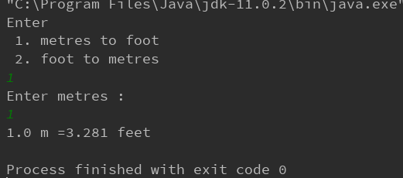

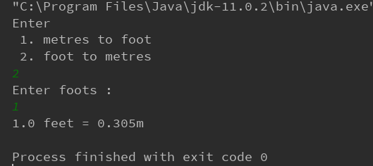

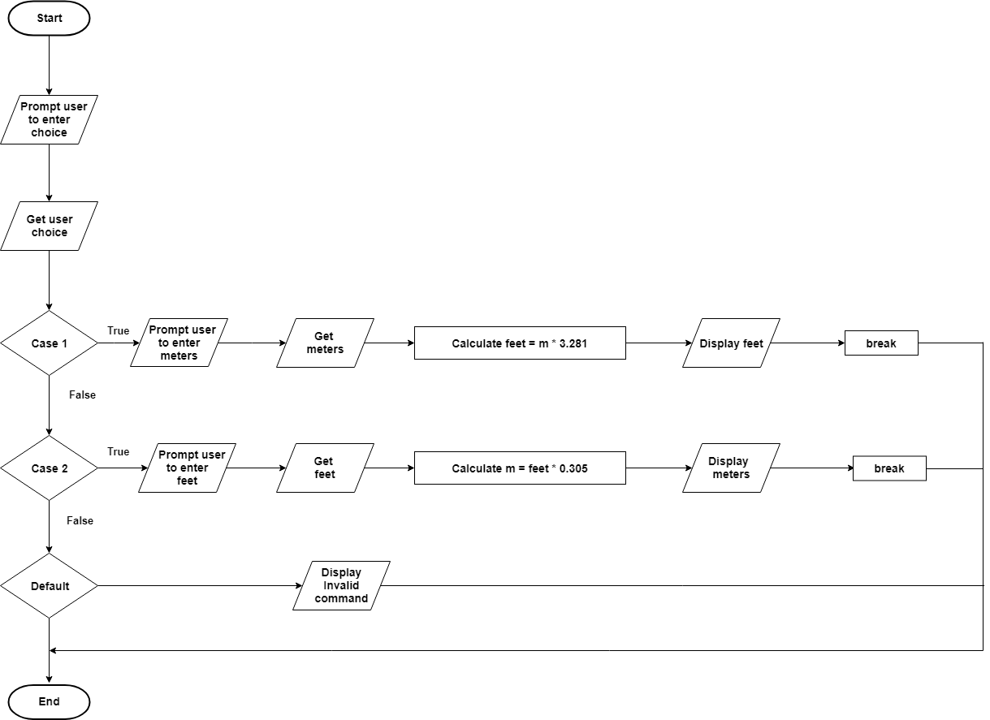

1. **Gram_ounce.java**

import java.util.Scanner;

public class Gram_ounce {

public static void main(String[] args){

Scanner scan=new Scanner(System.in);

System.out.println("Enter \n 1. grams to ounce \n 2. ounce to grams ");

int choice = scan.nextInt();

switch(choice) {

case 1:

System.out.println("Enter grams :");

double gram = scan.nextDouble();

double ounce = gram * 0.035;

System.out.println(gram + " g =" + ounce + " ounce");

break;

case 2:

System.out.println("Enter ounce :");

ounce = scan.nextDouble();

gram = ounce * 28.35;

System.out.println(ounce + " ounce = " + gram + " g");

break;

default:

System.err.println("Invalid command");

}

}

}

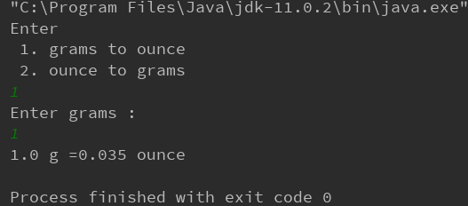

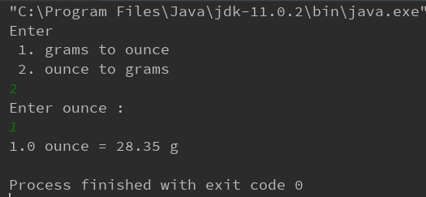

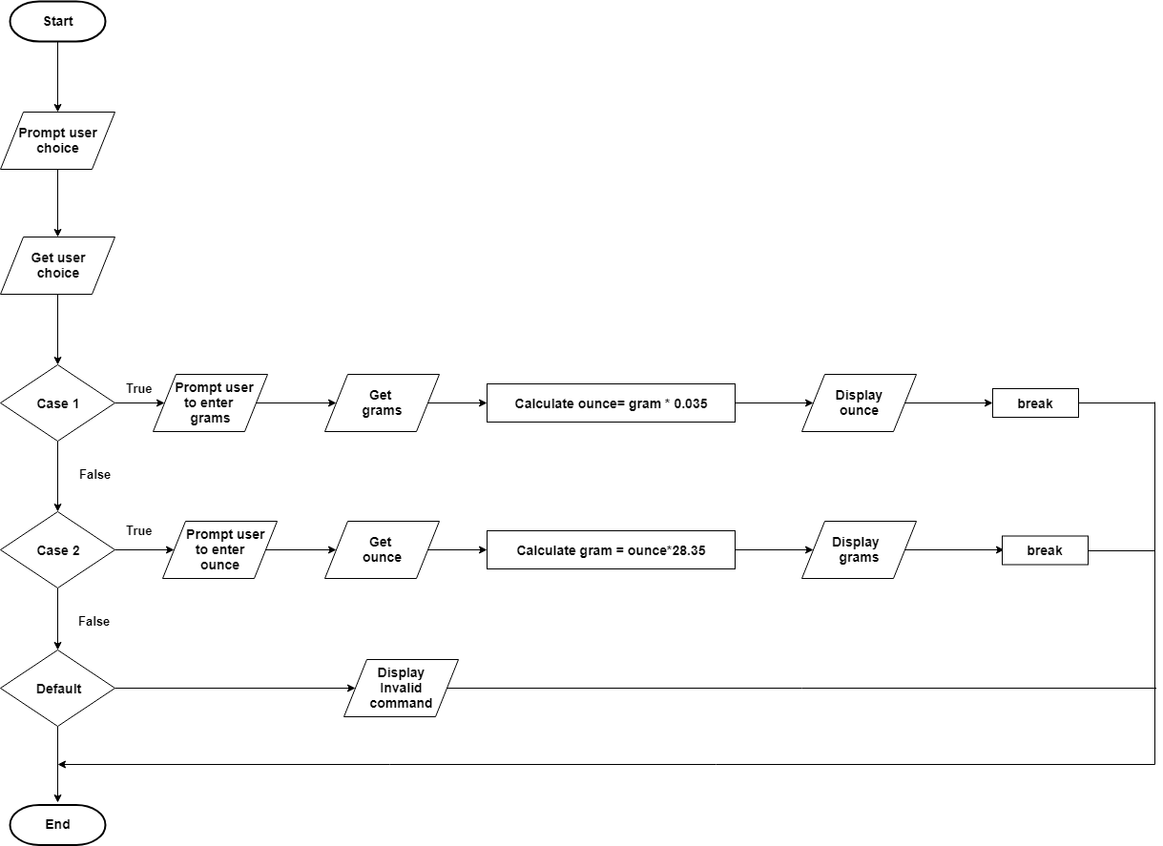

1. **Kilogram_Pound.java**

import java.util.Scanner;

public class Kilogram_Pound {

public static void main(String[] args){

Scanner scan=new Scanner(System.in);

System.out.println("Enter \n 1. kilograms to pound \n 2. pound to kilograms ");

int choice = scan.nextInt();

switch(choice) {

case 1:

System.out.println("Enter kilograms :");

double kg = scan.nextDouble();

double pound = kg * 2.204;

System.out.println(kg + " kg =" + pound + " pound");

break;

case 2:

System.out.println("Enter pounds :");

pound = scan.nextDouble();

kg = pound * 0.454;

System.out.println(pound + " pound = " + kg + "kg");

break;

default:

System.err.println("Invalid command");

}

}

}

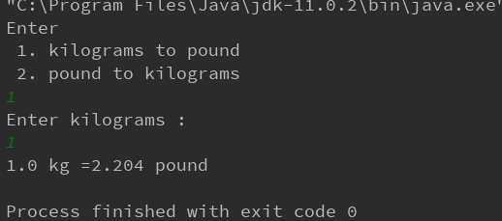

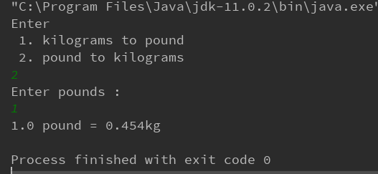

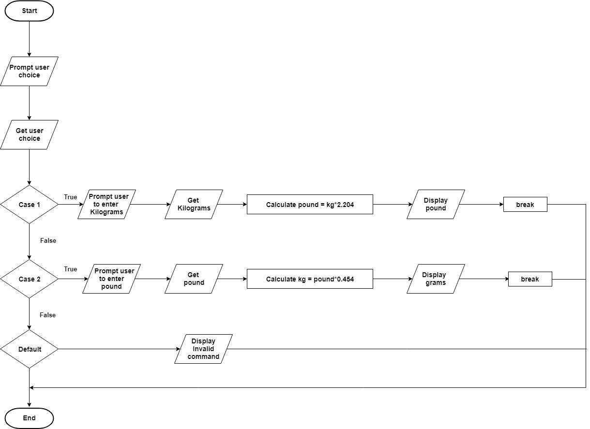

1. **Litre_Quart.java**

import java.util.Scanner;

public class Litre_Quart {

public static void main(String[] args){

Scanner scan=new Scanner(System.in);

System.out.println("Enter \n 1. litre to quart \n 2. quart to litre ");

int choice = scan.nextInt();

switch(choice) {

case 1:

System.out.println("Enter litres :");

double l = scan.nextDouble();

double quart = l * 0.878;

System.out.println(l + " l =" + quart + " quarts");

break;

case 2:

System.out.println("Enter quart :");

quart = scan.nextDouble();

l = quart * 1.137;

System.out.println(quart + " quart = " + l + " l");

break;

default:

System.err.println("Invalid command");

}

}

}

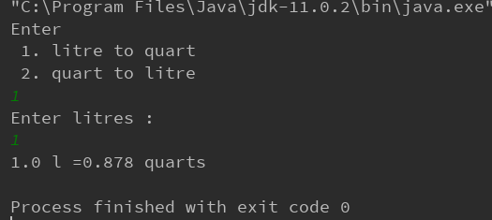

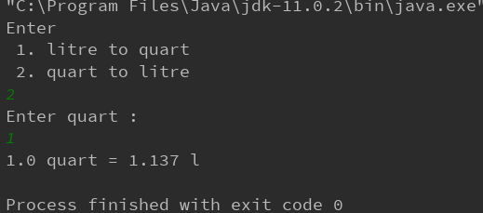

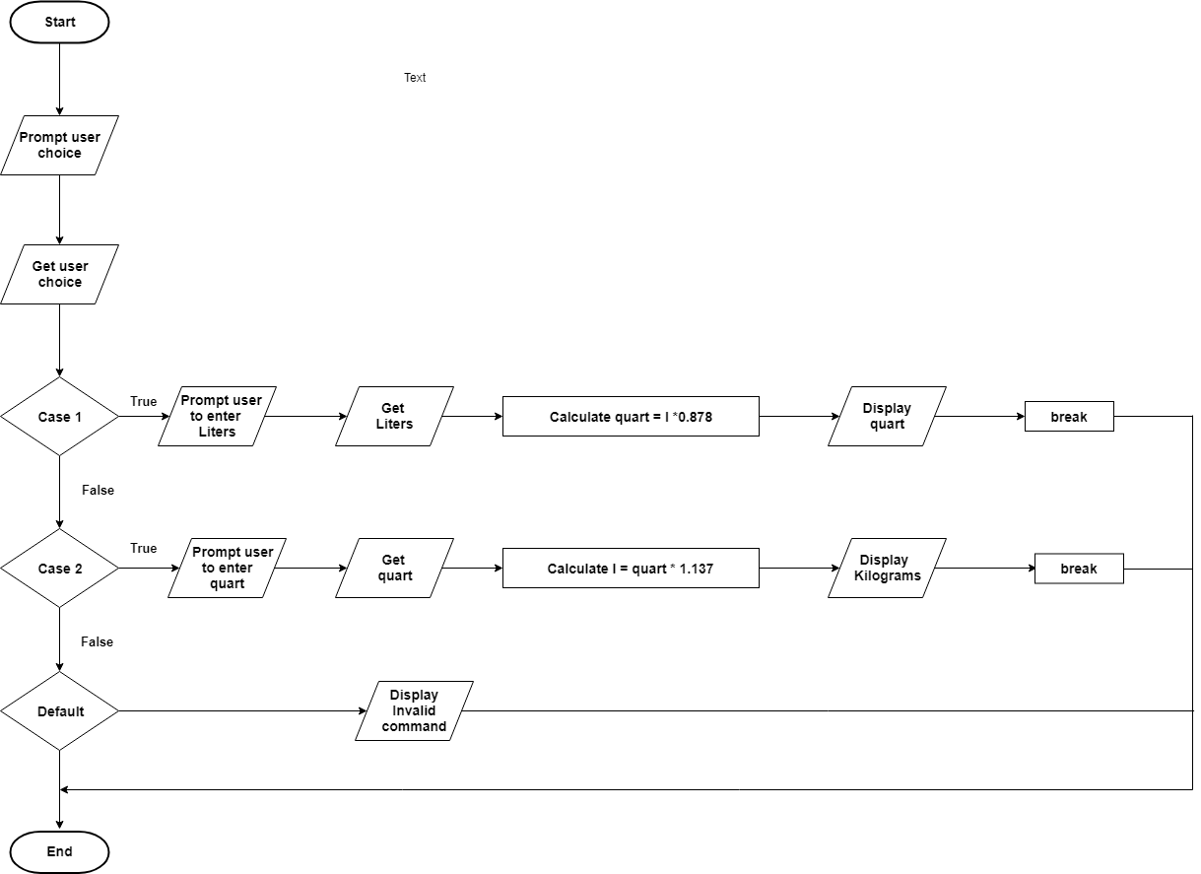

1. **Millilitre_FluidOunce.java**

import java.util.Scanner;

public class Millilitre_FluidOunce {

public static void main(String[] args){

Scanner scan=new Scanner(System.in);

System.out.println("Enter \n 1. millilitres to fluid ounce \n 2. fluid ounce to millilitres ");

int choice = scan.nextInt();

switch(choice) {

case 1:

System.out.println("Enter millilitres :");

double ml = scan.nextDouble();

double fluid_ounce = ml * 0.035;

System.out.println(ml + " ml =" + fluid_ounce + " fluid ounce");

break;

case 2:

System.out.println("Enter fluid ounce :");

fluid_ounce = scan.nextDouble();

ml = fluid_ounce * 28.413;

System.out.println(ml + " ml = " + fluid_ounce + "fluid ounce");

break;

default:

System.err.println("Invalid command");

}

}

}

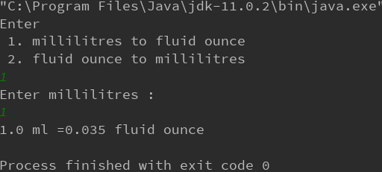

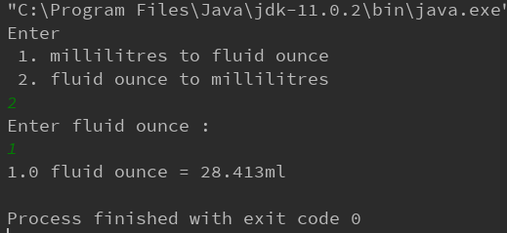

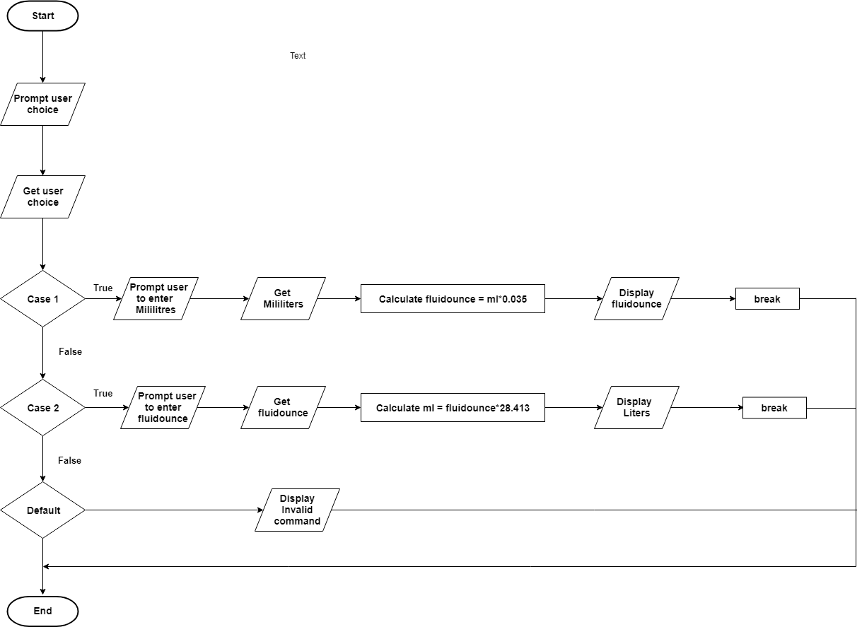

**Task 2 – Enhancing the Grade Calculation**

**Exam.java**

import java.util.Scanner;

public class Exam {

public static void main(String[] args) {

Scanner scan=new Scanner(System.in);

System.out.println("Enter your exam marks :");

int marks=scan.nextInt();

System.out.println("Did you pass the exam(y/n) :");

String input=scan.next().toLowerCase();

if(marks>=50){

if(input.equals("y")){

System.out.println("Pass");}

else if(input.equals("n")){

System.out.println("Fail");

}

}

else{

System.out.println("Fail");

}

}

}

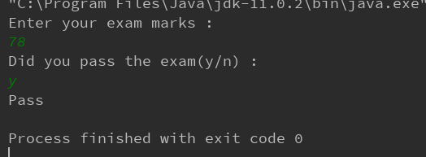

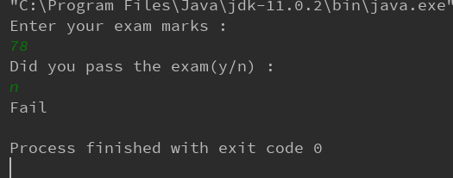

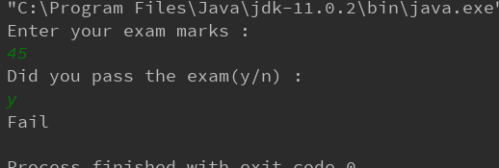

**Task 3 – Income Tax Program**

import java.util.Scanner;

public class Income_Tax {

public static void main(String[] args) {

Scanner scan=new Scanner(System.in);

System.out.print("Enter your income: ");

double income=scan.nextDouble();

if(income>=0 && income<=18200){

System.out.println("You must pay tax = 0");

}

else if(income>=18201 && income<=37000){

double tax=(income-18200)*0.19;

System.out.println("You must pay tax = $"+tax);

}

else if(income>=37001 && income<=80000){

double tax=3572+((income-37000)*0.325);

System.out.println("You must pay tax = $"+tax);

}

else if(income>=80001 && income<=180000){

double tax=17547+((income-80000)*0.37);

System.out.println("You must pay tax = $"+tax);

}

else if(income>=180000){

double tax=54547+((income-180000)*0.45);

System.out.println("You must pay tax = $"+tax);

}

else{

System.err.println("Invalid income");

}

}

}

