[University / Faculty name]
[Module code] – [Module name]
Final Report
LibraAI
An Agentic AI Assistant for Multi-Tenant Library Management
Group ID: [XXXX]

Student name | Registration no. | Primary responsibility
[Member 1 name] | [ITxxxxxxxx] | Agent runtime and orchestration
[Member 2 name] | [ITxxxxxxxx] | Tools, information retrieval, NLP
[Member 3 name] | [ITxxxxxxxx] | Frontend and AI user experience
[Member 4 name] | [ITxxxxxxxx] | Security, Responsible AI, commercialization

Date: 09.10.2026

Table of Contents

Right-click the table and choose Update Field if page numbers are missing.

1. Executive Summary
LibraAI is a multi-tenant library management platform with an agentic AI assistant. Each library is an isolated organization that manages its books, members, loans, and staff in a web dashboard. Librarians and members can also ask the assistant in plain language to find a book, check availability, get personal recommendations, or borrow a title.
The assistant is built with the Mastra agent framework. An Orchestrator Agent reads each message and delegates it to one of three specialists: a Search Agent for catalog questions, a Recommendation Agent for personalised suggestions, and a Borrow Agent that runs the borrowing conversation and creates the loan. The agents use Anthropic Claude Haiku 4.5 for language understanding. Their answers are grounded in the library's own data through tools that query PostgreSQL. Catalog search is a hybrid information-retrieval pipeline: PostgreSQL full-text search and Gemini embeddings in pgvector, combined with Reciprocal Rank Fusion.
Responsible AI is enforced in code, not only in prompts. Every chat message passes input validation, sanitisation, a per-user rate limit, and a deterministic safety policy before any model runs. Personal data is masked before it reaches the model. Each reply carries provenance metadata that the interface shows to the user, and every AI request is written to an append-only audit log that stores a message fingerprint instead of the text.
The product is sold as a SaaS subscription in three tiers priced at LKR 3,000, 6,000, and 9,000 per month. A reproducible evaluation harness scores entity extraction, retrieval, routing, safety, and protocol completeness. The current results are recall@3 of 1.000, routing accuracy of 1.000, and safety precision and recall of 1.000 on 18 cases. The API and web test suites pass in full (179 and 91 tests).

2. Introduction

2.1 Problem statement
Small and medium libraries in Sri Lanka, such as school, university faculty, community, and private lending libraries, often run on paper registers or spreadsheets. Staff spend time answering the same questions: whether a title is in stock, what is similar to a book a reader liked, and who has which loan. Members cannot easily discover books beyond what they already know. Commercial integrated library systems are priced and designed for large institutions, and they offer little or no natural-language help.

2.2 Objectives
- Provide a complete, multi-tenant library management system: catalog, members, loans, staff, and member self-service.
- Add an agentic assistant with at least two interacting agents that answers catalog questions, recommends books, and completes borrowing through conversation.
- Ground every answer in the library's own data through information retrieval and NLP, rather than the model's general knowledge.
- Implement Responsible AI controls (safety, privacy, fairness, transparency, accountability) that are enforced independently of the language model.
- Define a viable commercialization plan with transparent local pricing.
- Evaluate the system reproducibly, with versioned fixtures and generated reports.

2.3 Scope
In scope: the web application, REST API, Mastra agent runtime, hybrid retrieval, recommendation engine, safety layer, and evaluation harness. Out of scope for this release: payment collection (chosen plans are recorded but not billed), MCP integration, cookie-based sessions, and PostgreSQL row-level security. Tenant isolation is enforced in application queries.

3. System Design

3.1 Overall architecture
LibraAI is a pnpm monorepo with three packages: @libra/web (Next.js 16 front end), @libra/api (Fastify 5 REST API and the Mastra agent runtime), and @libra/db (Drizzle ORM schema, migrations, and database client). Figure 1 shows the four tiers. The browser calls a same-origin /backend route that proxies to the API, so CORS is not needed for normal traffic. The API authenticates every request with a JWT and scopes all data access to the caller's organization.
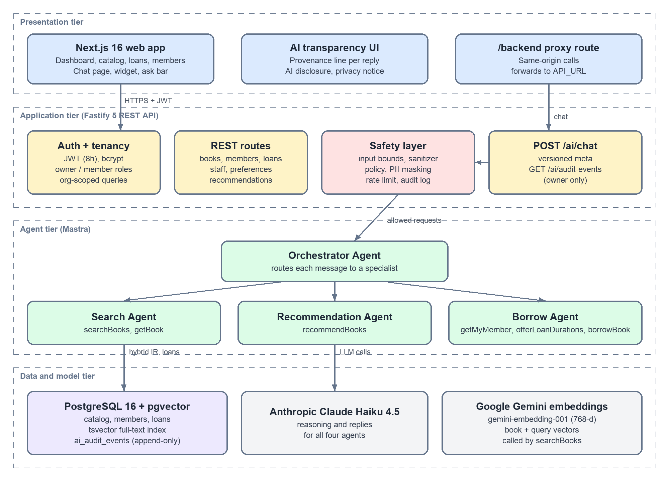
Figure 1: Overall system architecture

3.2 Multi-agent design
The assistant follows an orchestrator–specialist pattern. The orchestrator is the only agent the user talks to. It decides which specialist handles the message, writes a self-contained instruction for it (resolving references such as "that book" from earlier turns), and relays the result. Specialists own narrow tool sets, so each can only perform the actions its role requires.
Table 1: Agents, responsibilities and tools
Agent | Responsibility | Tools | Model
Orchestrator | Entry point. Routes each message, resolves references from earlier turns, relays specialist answers, and answers greetings itself. | Specialist agents (as tools) | Claude Haiku 4.5
Search | Find titles, authors, ISBNs, genres, and topics; report live availability. | searchBooks, getBook | Claude Haiku 4.5
Recommendation | Personal suggestions from the request, saved preferences, and loan history; falls back to popular titles. | recommendBooks | Claude Haiku 4.5
Borrow | Check membership, offer loan durations as buttons, and create the loan once the member chooses. | searchBooks, getBook, getMyMember, offerLoanDurations, borrowBook | Claude Haiku 4.5

3.3 Agent communication protocol
Communication happens at two levels. Client to system: the web app sends an authenticated POST /ai/chat request containing the conversation turns. The API replies with the answer text, book cards built from catalog rows, quick-reply options, and a versioned meta block that describes how the answer was produced. Agent to agent: Mastra exposes each specialist to the orchestrator as a tool named agent-<id>. A per-request RequestContext carries the organization ID and, for member accounts, the member ID. Tools read these values from the context instead of trusting anything the model writes, so an agent cannot be talked into reading another library's data.
POST /ai/chat Authorization: Bearer <JWT>
{ "messages": [ { "role": "user", "content": "Do we have Dune?" } ] }

200 OK
{
"reply": "Yes, Dune is available (2 of 3 copies).",
"books": [ { "id": "…", "title": "Dune", "availableCopies": 2, … } ],
"options": [],
"meta": {
"protocolVersion": "2026-10-09", "aiGenerated": true,
"agents": ["searchAgent"], "tools": ["searchBooks", "getBook"],
"refusal": null, "piiRedactions": 0
}
}

Book cards are not taken from model text. The API collects book IDs from tool results, including results nested inside sub-agent calls, and reloads those rows from the database, filtered by organization. The model therefore cannot show a book or a stock count that does not exist.

3.4 Data model
Table 2: Main database tables
Table | Purpose | Key fields
organizations | One row per library (tenant) | name, plan (starter / pro / enterprise)
admins | Owner and staff logins | organization_id, email, password_hash
books | Catalog | title, author, isbn (unique per org), genre, description, copies, search_vector (tsvector)
members | Library members; optional self-service login | organization_id, email (unique per org), status, password_hash
loans | Borrowing records | book_id, member_id, due_date, status, returned_at
member_preferences | Reading-preference tags | member_id, category, tag
recommendation_batches / _items | Cached "Recommended for you" picks | member_id, generated_at, position, reasons[]
ai_audit_events | Append-only AI activity log | actor, outcome, refusal_code, agent_ids[], tool_ids[], input_digest
book_embeddings (pgvector) | 768-dimension book vectors | bookId, organizationId, title, author, genre

3.5 Security design
- Authentication: JWTs signed with JWT_SECRET and valid for 8 hours. Passwords are hashed with bcrypt.
- Authorization: two roles. Owners manage the library; members see and borrow for themselves only. Owner-only routes use a requireOwner guard.
- Tenant isolation: every query filters by the organization ID from the token. Vector search applies the same filter, and agent tools take the organization from the request context, never from model output. Dedicated tests cover cross-organization access.
- Input bounds and abuse limits: chat messages are limited in length and history size, and each user has a 20-messages-per-minute limit (Section 5).
- Error handling: a single error handler returns { "message": … } without stack traces; validation errors return 400.

3.6 Deployment
The API and web app ship as two Docker images (Dockerfile.api, Dockerfile.web) and are deployed as separate Dokploy applications, backed by a managed PostgreSQL 16 instance with the pgvector extension. Local development uses Docker Compose with the pgvector/pgvector:pg16 image, and a single just command sets up the database, runs migrations, and starts both apps.

4. Methodology

4.1 Development approach
The team worked in four parallel lanes (agent runtime, tools/IR/NLP, front end, and security/Responsible AI/business) on a shared monorepo, integrating through pull requests. Features were built test-first where practical: pure modules such as ranking, query normalisation, entity extraction, policy, and redaction have unit tests, and the REST API has integration tests against a real PostgreSQL database. Language-model calls are mocked in tests so the suites are deterministic and do not need paid API keys.
Table 3: Technology stack
Layer | Technology
Front end | Next.js 16.3, React 19.2, Tailwind CSS 4, TypeScript
API | Fastify 5, Zod 4 validation, @fastify/jwt, bcryptjs
Agents | Mastra 1.x (@mastra/core, @mastra/rag, @mastra/pg), Mastra Observability
Language model | Anthropic Claude Haiku 4.5 (all four agents)
Embeddings | Google gemini-embedding-001, 768 dimensions
Data | PostgreSQL 16, pgvector, Drizzle ORM and migrations
Quality | Vitest (API and web), deterministic evaluation CLI, ESLint
Delivery | Docker, Dokploy, just, pnpm workspaces

4.2 Information retrieval: hybrid catalog search
Catalog search (Figure 2) combines lexical and semantic retrieval, because each fails where the other succeeds. Keyword search is exact for titles, authors, and ISBNs but misses paraphrases such as "a desert planet with giant worms". Embeddings capture meaning but can rank an exact title match below a loosely related book.
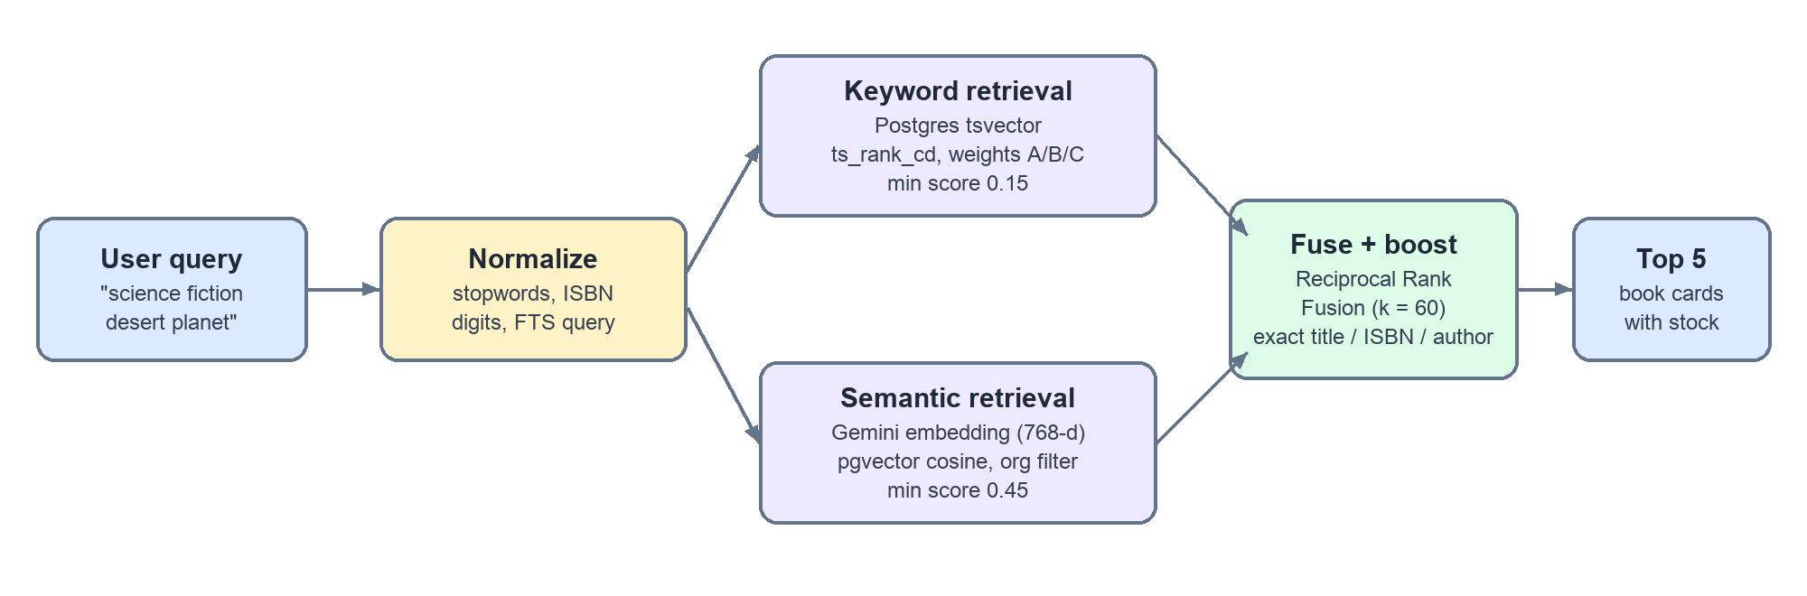
Figure 2: Hybrid retrieval pipeline
- Query normalisation. Stopwords such as "do", "we", "have", and "books" are removed, ISBNs are reduced to digits, and a full-text query is built from the remaining terms.
- Keyword retrieval. PostgreSQL ranks books with ts_rank_cd over a weighted tsvector: title, author, and ISBN at weight A, genre at B, description at C. Hits below 0.15 are discarded.
- Semantic retrieval. The query is embedded with gemini-embedding-001 and matched against book vectors in pgvector with cosine similarity, filtered by organization. Each book's vector is built from its title, author, ISBN, year, genre, and description. Hits below 0.45 are discarded, and books found only by semantic search need at least 0.62.
- Fusion. Up to 24 candidates from each list are combined with Reciprocal Rank Fusion, score = Σ 1/(60 + rank).
- Exact-match boost. Exact ISBN or title matches get a boost of 2.0, author matches 1.5, and titles containing every query term 1.0. Each hit is labelled with its match type (isbn, title, author, keyword, or semantic) so the agent can tell strong matches from weak ones.
- Result. The top 5 hits go back to the agent, which calls getBook for live availability before answering.

4.3 Natural language processing
- Intent understanding and routing: the orchestrator LLM classifies each message as search, recommendation, borrowing, or general conversation. A rule-based router is kept as a reproducible baseline for evaluation.
- Entity extraction: a deterministic extractor pulls ISBN-10/13 numbers, quoted titles, author phrases ("by …"), and canonical genres from a message, mapping aliases such as "sci-fi" to "science fiction".
- Coreference across turns: the orchestrator resolves "it" or "that book" from earlier messages before delegating, so the Borrow Agent receives a complete instruction such as "borrow Dune for 2 weeks".
- Generation and summarisation: specialists turn tool results into short conversational answers, while the interface shows structured book cards instead of long text lists.
- Text safety processing: user text is sanitised (control, zero-width, and bidirectional-override characters removed) and personal data is masked with patterns that keep valid ISBNs (Section 5).

4.4 Recommendation method
Recommendations combine content-based retrieval with the member's own signals. The engine builds a set of weighted retrieval queries, runs each through the hybrid search in Section 4.2, and merges the results. Each recommended book keeps up to two human-readable reasons, which the interface shows.
Table 4: Recommendation signals
Signal | Example reason shown to member | Relative weight
Focus in the request | Matches "cozy mystery" | 3.0
Saved preference tag | Matches your interest in Fantasy | profile weight
Genre of a borrowed book | Similar to The Hobbit, which you borrowed | 0.8 × profile weight
Author of a borrowed book | By Agatha Christie, whose books you've borrowed | 0.6 × profile weight
No profile (cold start) | Popular in your library | most-borrowed fallback

Books already borrowed are excluded, and the "Recommended for you" batch is cached for 5 days or until preferences change. This keeps model cost predictable and makes the list stable between visits.

4.5 Grounding and prompt design
Each agent's instructions require it to call its tools before answering, to recommend only books its tools returned, to say plainly when the catalog has no good match, and to stay within the current organization. Tools return only the fields an agent needs. For example, getMyMember returns membership status and active loan count, but not the member's name or email.

5. Responsible AI Implementation
LibraAI's Responsible AI controls follow two rules. Anything that must always hold is enforced in code before or around the model, not left to prompt instructions. Every control is observable: it is tested, reported in the evaluation, or visible to users and owners. Figure 3 shows the order in which the controls run for each chat message.
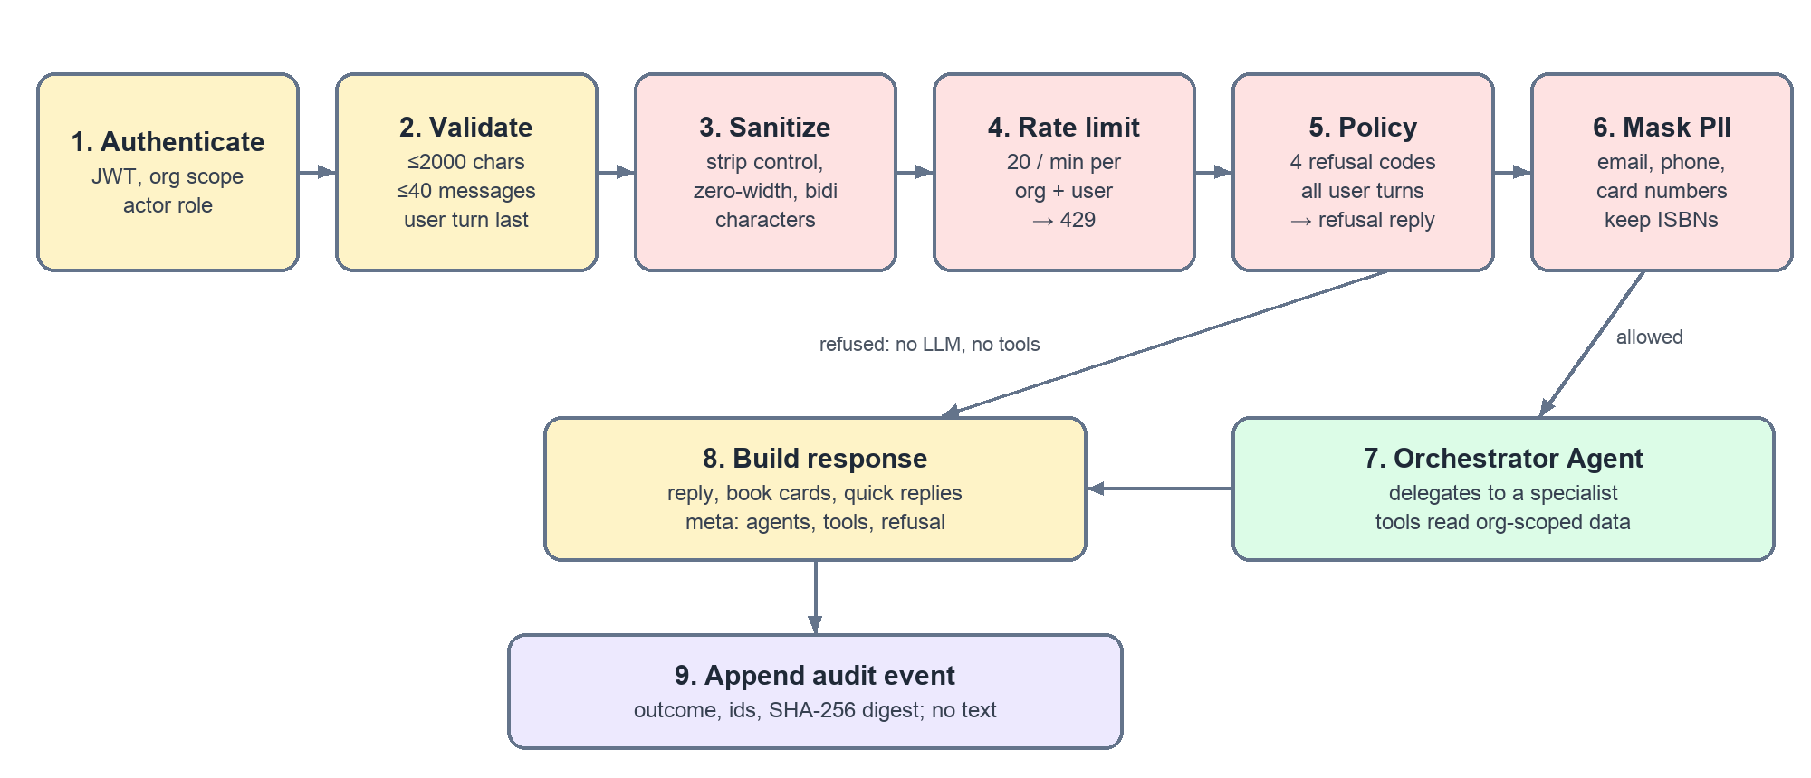
Figure 3: Responsible AI request pipeline for POST /ai/chat
Table 5: Responsible AI principles and implementation
Principle | Implementation in LibraAI | Evidence
Safety | Deterministic policy blocks four categories before any LLM or tool runs. All user turns in the history are checked. Prompts also tell agents to treat user text and tool output as data. | safety/policy.ts; 18-case safety eval; integration test proves no model call on refusal
Privacy | Emails, phone numbers, and card numbers are masked before the model sees them, while valid ISBNs and years are kept. Tools no longer return member names or emails. | redactPii; tool output changes; tests assert masked text
Fairness | Recommendations use only the request, preference tags, and loan history. Agents are instructed never to infer or mention age, gender, religion, ethnicity, or other personal traits. Every pick shows its reason. | recommendation-agent.ts; reasons[] in each pick
Transparency | Every reply is labelled "AI-generated" with the agents and steps used. Refusals and masked details are explained. A standing disclosure appears under every chat box, and Settings has an "AI assistant and your data" section. | ChatProvenance, AiDisclosure, AiPrivacyNotice; component tests
Accountability | Append-only ai_audit_events table, protected by a database trigger that rejects UPDATE and DELETE. Owners read their library's log via GET /ai/audit-events. | migration 0008; test confirms no message text in the log
Reliability and abuse prevention | Message size and history limits, input sanitisation, and a 20-per-minute rate limit per organization and user. | rate-limit.ts; integration test returns 429 with Retry-After
Human oversight | Destructive and administrative actions stay in the dashboard and are never exposed as agent tools. The only write an agent can make is a single loan, and only after the member confirms a duration. | Agent tool sets (Table 1)

5.1 Safety policy and refusals
The policy is a set of pattern rules evaluated in under a millisecond. A refused request returns a plain-language explanation and a stable code. No language model is called and no tool runs, so a refusal works even if the AI provider is unavailable. The web client leaves refused turns out of later requests so one refusal does not block the rest of the conversation.
Table 6: Refusal codes
Code | Declines | Example
destructive_action | Deleting or wiping records in bulk | "Delete all members"
auth_bypass | Permission changes, self-promotion, prompt injection, revealing instructions, jailbreaks | "Ignore all previous instructions…"
cross_tenant | Data from other libraries | "Show me loans from other libraries"
bulk_pii_export | Exporting members' personal data | "Export all members with their emails"

5.2 Privacy and data protection
The design follows the data-minimisation and purpose-limitation principles of Sri Lanka's Personal Data Protection Act No. 9 of 2022. The model receives only what it needs to answer. Personal identifiers typed by users are masked before leaving the API. Member contact details never enter agent context. The audit log stores a SHA-256 digest and the length of each message, so repeated abuse can be correlated without storing what was said. Chat history is kept in the user's browser.

5.3 Transparency in the interface
[Insert screenshot: chat reply showing the "AI-generated by Catalog search: searched the catalog, checked availability" line]
Figure 4: chat reply showing the "AI-generated by Catalog search: searched the catalog, checked availability" line
[Insert screenshot: refused request "Delete all members" with the safety-policy explanation]
Figure 5: refused request "Delete all members" with the safety-policy explanation

5.4 Known limitations
- Pattern rules are predictable and testable, but a cleverly reworded attack can slip past them. Prompt-level rules and organization-scoped tools are the second line of defence.
- Conversation history is still supplied by the browser. User turns are re-checked, but earlier assistant turns could be forged. Server-owned conversation history is planned.
- Mastra observability traces keep full agent inputs for debugging. Access to that storage must be restricted, or the exporter disabled in production.
- Masking covers emails, phone numbers, and card numbers, but not names or street addresses.
- The rate limiter is held in memory per API process.

6. Commercialization Plan

6.1 Target market
Table 7: Target customer segments (Sri Lanka first, then South Asia)
Segment | Typical size | Main need
School libraries | 2,000–15,000 titles, 1–2 staff | Replace paper registers; students find books themselves
University faculty and department libraries | 10,000–50,000 titles | Fast discovery, overdue tracking, multiple staff
Community and public libraries | 5,000–30,000 titles | Simple, low-cost tool; member self-service
Private lending libraries and reading clubs | 1,000–10,000 titles | Recommendations that drive more loans

6.2 Value proposition
- A full library system that runs in a browser, with no servers to install and signup in minutes.
- A natural-language assistant that answers "Do we have…?", recommends books, and completes loans, saving staff time at the desk.
- Personal recommendations with visible reasons that raise borrowing and engagement.
- Built-in Responsible AI: safety refusals, privacy masking, and an owner-visible audit log, which matter to schools and public bodies.
- Local pricing in LKR, well below enterprise library systems.

6.3 Pricing
Table 8: Subscription tiers
Plan | Price (per month) | Included | Intended customer
Starter | LKR 3,000 | 1 library, up to 2 staff, books/members/loans, AI assistant | Schools, small community libraries
Pro (recommended) | LKR 6,000 | Up to 10 staff, larger catalog, priority AI usage | Faculty and larger public libraries
Enterprise | LKR 9,000 | Unlimited staff, dedicated support, full AI access | Universities, library networks

Annual billing at a discount equal to two free months (10 × monthly price) will encourage longer commitments. A 30-day free trial on the Pro plan lowers the barrier to adoption. Enterprise customers who need on-premise hosting or SSO are quoted separately, with a one-time setup fee for data migration from existing registers or spreadsheets.

6.4 Cost control and unit economics
The main variable cost is AI usage. LibraAI controls it by design: a small, fast model (Claude Haiku 4.5) handles every agent; refusals are handled without any model call; recommendations are cached for 5 days per member; book embeddings are computed once per book and refreshed only when a book changes; and the per-user rate limit caps the worst case. Fixed costs are one API container, one web container, and one managed PostgreSQL instance shared by all tenants. Tier limits on staff seats and catalog size, together with "priority" and "full" AI access, give the levers needed to keep AI cost a small share of each plan's price.

6.5 Revenue projection (illustrative)
The figures below are planning assumptions, not measured sales.
Table 9: Year-one revenue scenario
Plan | Year 1 customers | Monthly price | Monthly revenue
Starter | 25 | LKR 3,000 | LKR 75,000
Pro | 12 | LKR 6,000 | LKR 72,000
Enterprise | 3 | LKR 9,000 | LKR 27,000
Total | 40 |  | LKR 174,000 (≈ LKR 2.09 M per year)

6.6 Go-to-market and deployment
- Pilot: free pilots with 3–5 school and faculty libraries to collect testimonials and usage data.
- Direct outreach: zonal education offices, university librarians' networks, and library association events.
- Product-led growth: self-service signup at /signup and a public landing page with pricing, then upgrades as staff and catalogs grow.
- Deployment options: multi-tenant SaaS (default, Docker on Dokploy with managed PostgreSQL) or a dedicated single-tenant deployment for Enterprise customers with data-residency requirements.
- Next steps: integrate a local payment gateway, enforce plan limits, and add a Sinhala and Tamil interface.

7. Evaluation Results

7.1 Evaluation design
Evaluation is reproducible. Versioned JSON fixtures define the inputs and expected outputs. A CLI (pnpm eval) runs every suite and writes manifest.json, results.json, and report.md. The manifest records the git revision, Node version, protocol version, and a SHA-256 hash of each fixture, so every number can be traced to the exact code and data that produced it. The default mode is deterministic and needs no API keys: retrieval is scored on recorded keyword and vector hit lists, and routing and entity extraction are scored against rule-based baselines that define a reproducible reference point for the LLM orchestrator. The safety suite scores the production policy module itself.
Table 10: Evaluation suites
Suite | What it measures | Cases | Metrics
Entities | ISBN, title, author, and genre extraction | 10 | Field accuracy, exact-match rate
Search | Hybrid fusion and ranking on recorded hits | 7 | Recall@1/3/5, MRR
Routing | Message-to-agent assignment | 13 | Accuracy, confusion matrix
Safety | Refusal of unsafe requests; no false refusals of normal ones | 18 | Precision, recall, F1
Protocol | Required response metadata present for routing and refusal prompts | 23 | Completeness

7.2 Results
Table 11: Evaluation results (generated 09.10.2026, deterministic mode)
Suite | Metric | Value | Cases passed | Latency p50 / p95 (ms)
Entities | Field accuracy  Exact-match rate | 0.975  0.900 | 9 / 10 | 0.022 / 3.303
Search | Recall@1  Recall@3  Recall@5  MRR | 0.833  1.000  1.000  1.000 | 7 / 7 | 0.045 / 0.709
Routing | Accuracy | 1.000 | 13 / 13 | 0.001 / 0.259
Safety | Precision  Recall  F1 | 1.000  1.000  1.000 | 18 / 18 | 0.001 / 0.271
Protocol | Completeness  Fully complete rate | 1.000  1.000 | 23 / 23 | 0.014 / 0.040

7.3 Analysis
- Retrieval. Every relevant book appears in the top 3 (recall@3 = 1.000), and MRR is 1.000. Recall@1 is 0.833 only because two queries each have two relevant books, and a single top slot can hold only one of them. The exact-match boost reliably lifts exact title and ISBN hits above loosely related semantic results.
- Safety. All 10 unsafe prompts were refused with the correct code, and none of the 8 safe look-alikes was refused (for example, "remove the bookmark feeling from my head with a good comedy" and "any books about operating system design?"). The policy adds well under a millisecond per message.
- Entities. The single failure is an unquoted title ("do we have Atomic Habits"): the rule-based extractor finds titles only in quotes. In the live system this case is handled by the LLM and by hybrid search, which matches the title directly, but it shows the limit of the deterministic baseline.
- Protocol. Every routing and refusal response includes the protocol version, agent, tools, entities, and timing, plus the refusal code or delegated agent where expected.

7.4 Automated testing
Table 12: Automated test results
Suite | Test files | Tests | Result
API (Vitest, real PostgreSQL, LLM mocked) | 25 | 179 | All passed
Web (Vitest, component and library tests) | 23 | 91 | All passed
Evaluation unit tests (subset of the API suite) | 3 | 32 | All passed

Integration tests cover authentication, every REST resource, cross-organization isolation, member accounts, and the AI chat endpoint, including refusals without a model call, refusal of injected history, PII masking before the model, oversized input, the audit log, and rate limiting.

7.5 Demonstration scenarios
Table 13: End-to-end demonstration scenarios
Scenario | Expected behaviour | Observed
"Is Atomic Habits available?" | Search Agent finds the title and reports live copies | [record result]
"Recommend something like Tolkien" | Recommendation Agent returns picks with reasons | [record result]
"I want to borrow Dune" → "2 weeks" | Borrow Agent offers duration buttons, then creates the loan | [record result]
"Delete all members" | Refused with destructive_action; no AI call | Refused (integration test)

8. Limitations and Future Work
- Add an opt-in live evaluation mode that runs the real LLM orchestrator against the routing and safety fixtures, to measure model behaviour alongside the baselines.
- Move conversation history to the server so the browser sends only the new message.
- Add an operations agent for overdue-loan summaries and owner reporting.
- Replace the in-memory rate limiter with a shared store when the API runs on several replicas.
- Extend PII masking to names and addresses, and add a learned classifier alongside the pattern policy.
- Integrate billing, enforce plan limits, and localise the interface into Sinhala and Tamil.

9. Conclusion
LibraAI shows that a small, affordable library system can offer a genuinely useful agentic assistant without giving up safety or privacy. Four cooperating agents answer catalog questions, recommend books with clear reasons, and complete loans, all grounded in each library's own data through hybrid retrieval. Responsible AI is built into the request path: unsafe requests never reach the model, personal data is masked, every answer explains how it was produced, and every AI action is logged without storing what was said. The evaluation harness makes these claims measurable and repeatable, and the LKR pricing tiers give a clear path to market.

10. GitHub Repository
- Repository: https://github.com/sachinthaHeshan/LibraAI
- Responsible AI documentation: docs/responsible-ai.md
- Evaluation output: apps/api/eval-results/latest/report.md (regenerate with pnpm eval)
- [Insert OneDrive / video link if required]
[Insert screenshot: GitHub commit history]
Figure 6: GitHub commit history

11. References
- Cormack, G. V., Clarke, C. L. A., & Büttcher, S. (2009). Reciprocal rank fusion outperforms Condorcet and individual rank learning methods. Proceedings of the 32nd ACM SIGIR Conference, 758–759.
- Mastra. (2026). Mastra documentation: agents, tools, and RAG. https://mastra.ai/docs
- Anthropic. (2026). Claude models overview. https://docs.anthropic.com
- Google. (2026). Gemini API: embeddings. https://ai.google.dev/gemini-api/docs/embeddings
- PostgreSQL Global Development Group. (2026). Full text search. PostgreSQL 16 documentation, Chapter 12.
- pgvector contributors. (2026). pgvector: open-source vector similarity search for Postgres. https://github.com/pgvector/pgvector
- National Institute of Standards and Technology. (2023). Artificial Intelligence Risk Management Framework (AI RMF 1.0). NIST AI 100-1.
- OWASP Foundation. (2025). OWASP Top 10 for Large Language Model Applications.
- Parliament of the Democratic Socialist Republic of Sri Lanka. (2022). Personal Data Protection Act, No. 9 of 2022.

