**Ref:**

<https://www.feedingindia.org/ourwork>

https://www.akshayapatra.org/covid-relief-services

**Home Page:**

---------------------------------------------------------------------------------------------------------------------------------

Header:

How it’s work, Donate, Engage Your Employees, Request for Food

Body:

Some pics, we can add as donating something, motivational etc..

Footer:

Share The Meal, Quick Donate, Leave Message

---------------------------------------------------------------------------------------------------------------------------------

**Details of each Action of Display In Page:**

**Engage Your Employees:** Post a campaign request on behalf of CSR team of FIS or someone else with in team (as working in project).

**Post campaign** Form:

If user is not registered then just take basic details and then go to next page as camping details.

To Register User Form: just ask basic field..

**Step1:**

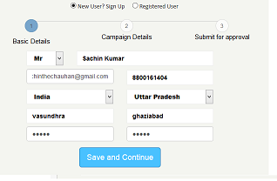

Step 2:

**Camping Details:**

Item Name:- drop down list – from DB data

Goal: quantity- text field –

Start Date:

End Date:

Message: text area

Need to add validation between both start date and date as one month or 2 month max.

**Step3:** send for approval. All raised request will be display with status and action items as edit, delete

**Leave Message: Form:**

Name

Email,

Subject,

Message,

Submit button:

**Quick Donate: need to add motivational header message:**

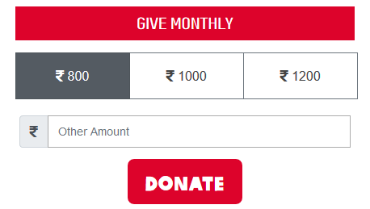

Request for Food: NGO can submit a request for food and after success full submit; Admin user will see and take decision.

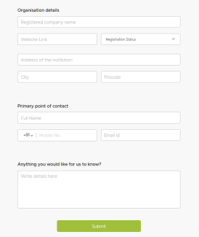

**Share The Meal:**

**Team Name:**

**No of Lunch: select-drop down- for select lunch –Start with 10 upto**

**Planned Date:- greater than current date**

**This Request will go for approval. Admin can check and approve/reject the request.**

**Donate:**

**Item Category: select**

**Quantity: text box**

**Message: text area**

**Action: Send for approval**

**Note: need to add motivation message in form on bases of action type.**