Sip: invest -90230

Out: 122500

Profit: 32000 - Donate-320

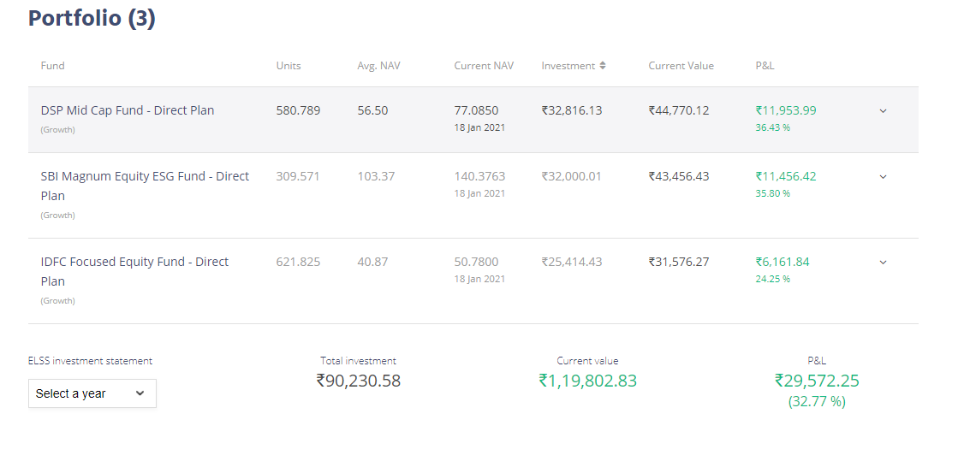SIP Tracker:

<https://www.moneycontrol.com/mutual-funds/performance-tracker/returns/mid-cap-fund.html>

