Data Assessment solution By Sachin Kumar Gupta

1. Convert the text in the name variable into sentence case and format the date in the date of birth variable into any one standard format. Please mention the code used for the same.

Ans –
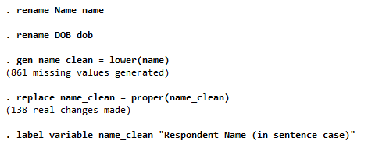

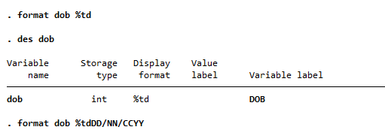

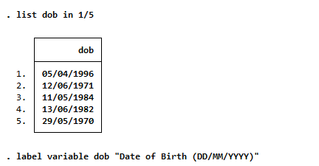

2. Calculate the age of the recipients based on the given date of birth in the data set. Calculate the age range and code the age range into 4 age categories. Please explain your step-by-step code and process in detail.

Ans-

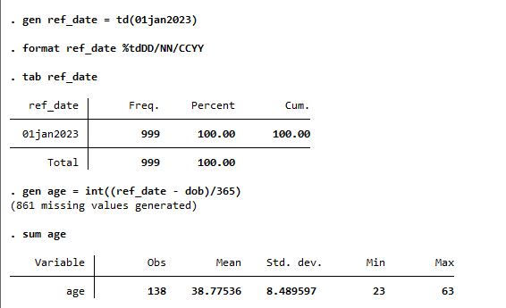
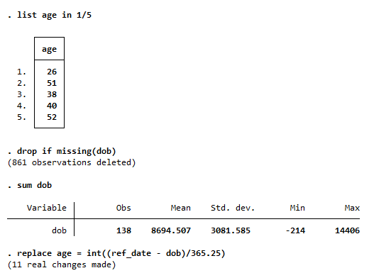

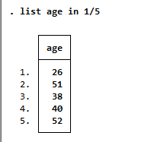

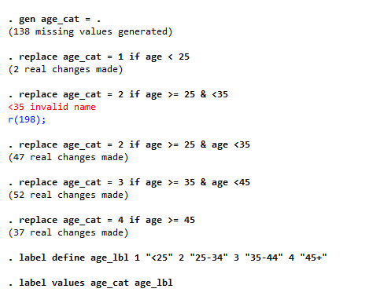

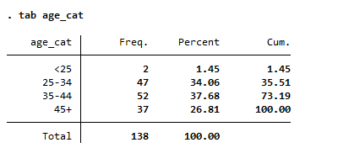
Interpretation - Majority of recipients (≈72%) are between 25–44 years, indicating a working-age population actively engaged in economic activities.

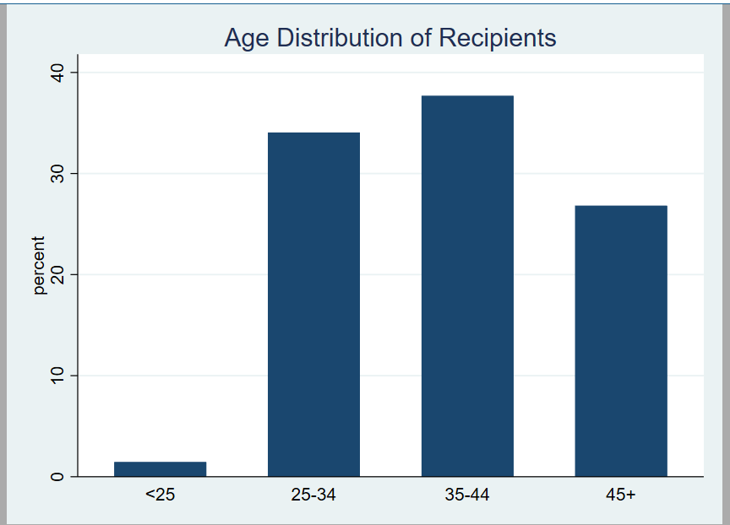

3. Which caste do the recipients belong to based on the city? Give a frequency table of city wise split of caste. Also mention all the steps in your Do/R/python file in case of any data cleaning.

Ans-

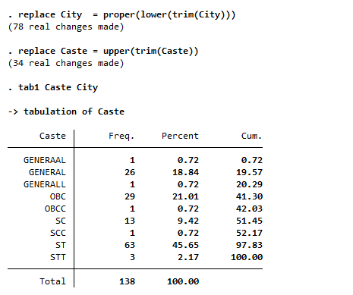

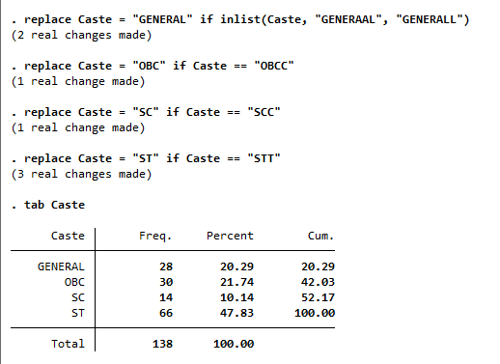

Interpretation - Scheduled Tribe (ST) respondents form the largest share (47.83%), indicating strong representation of marginalized communities. Caste distribution varies across cities, with Vasai having the highest ST concentration.

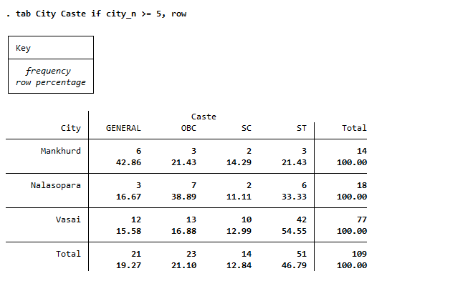

4. Rename all the variables in baseline and endline survey by adding suffix/prefix to make them identifiable that they belong to baseline and endline survey respectively. Please mention the code below you used to rename the variables.

Ans-

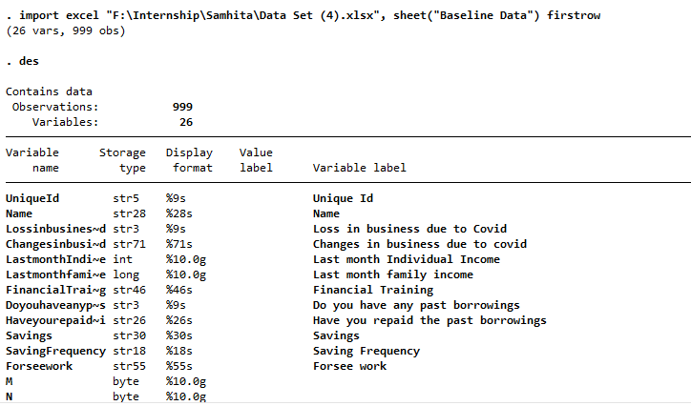

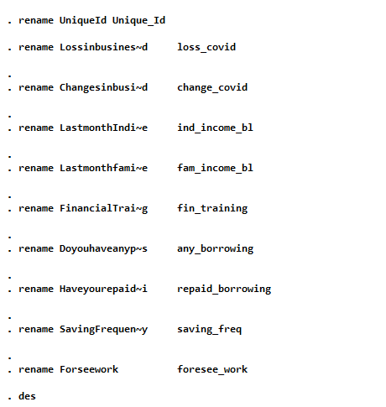

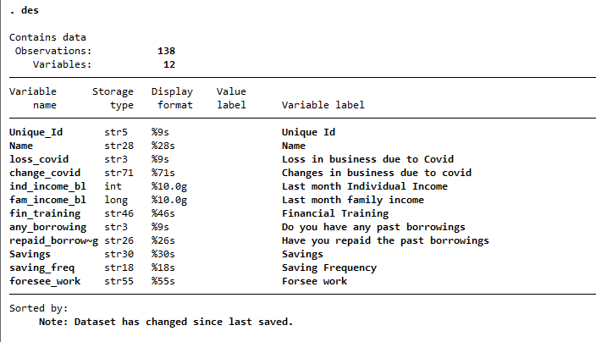

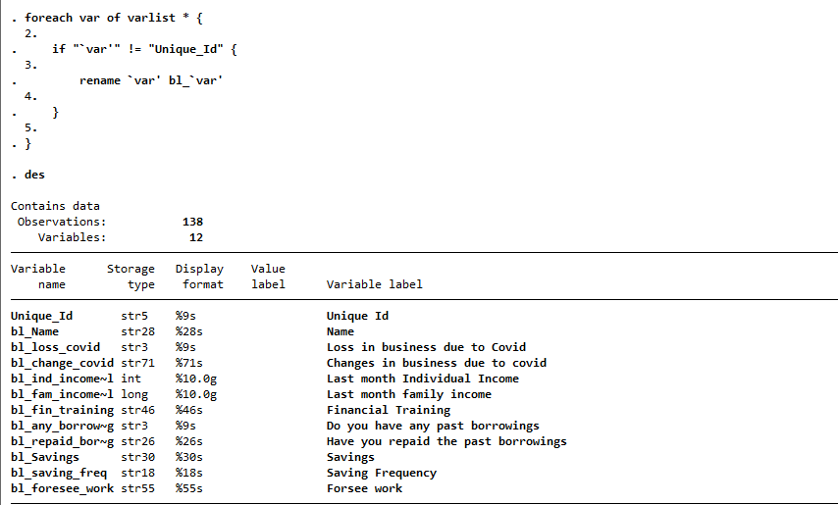

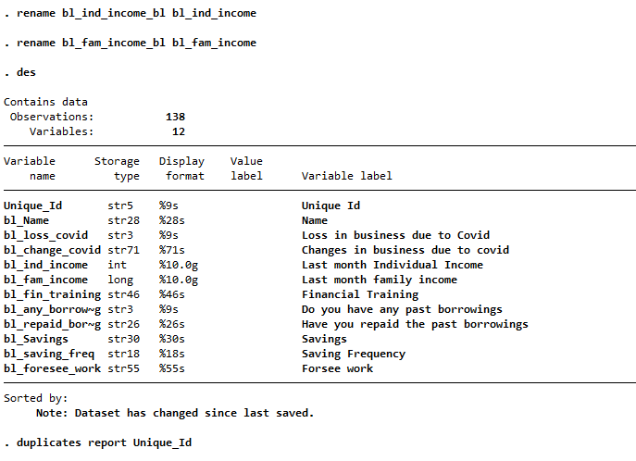

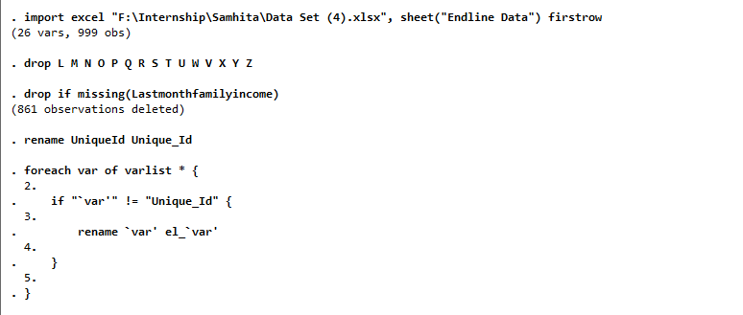

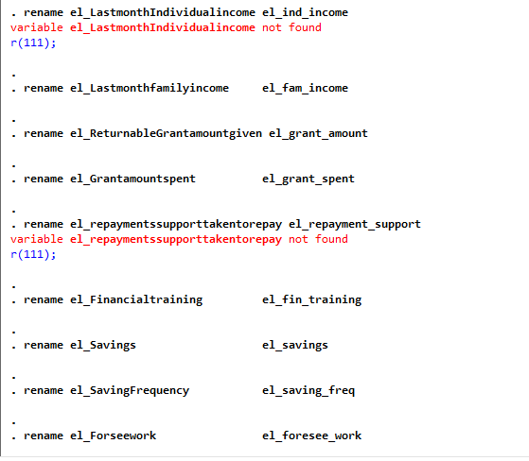

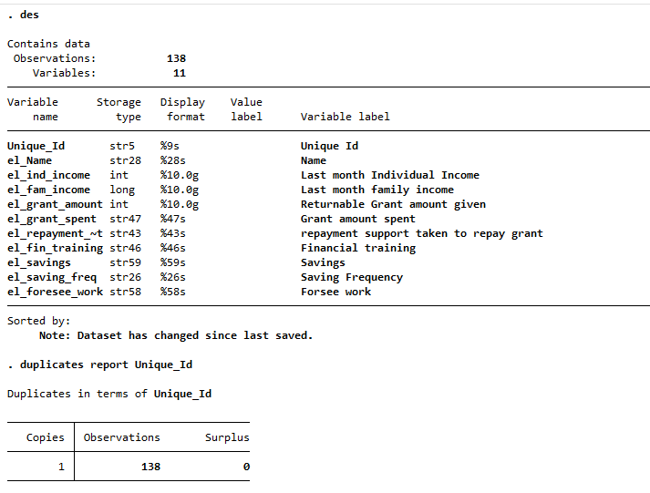

5. Explain the impact of Covid on the businesses of the recipients in a graphical presentation. (Please prefer STATA or Tableau for making Graphs.)

Ans-

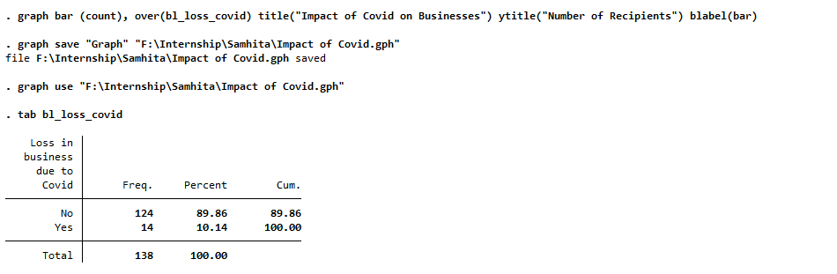

Interpretation - Most respondents reported no direct business loss due to Covid. However, later income analysis suggests indirect economic impacts.

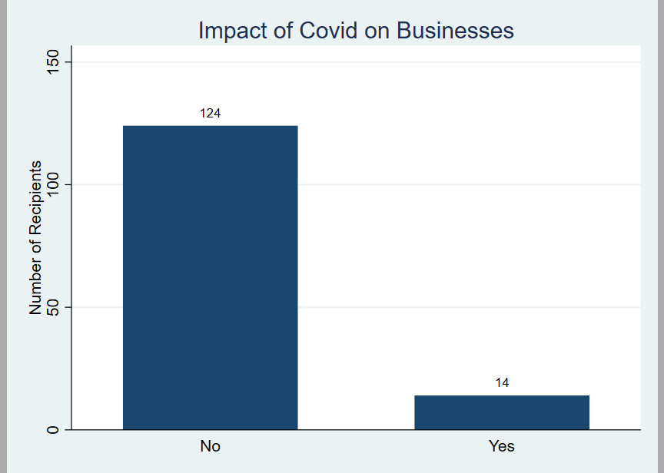

6. Merge the 3 data sets given in the excel sheet - profile data, baseline data and endline data. Mention the variable/s used for merging the three data sets. Please explain your step-by-step code and process in detail.

Ans-

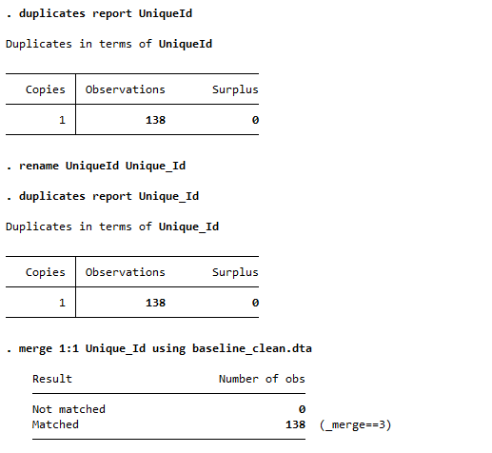

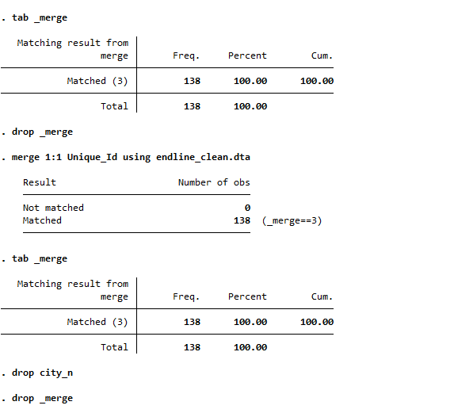

7. Is there a relationship between last month's individual income of recipients in the endline and the number of earning members? Explain your method and interpret your results. Display the same in a graph. Relate this to the amount of returnable grant amount given.

Ans-

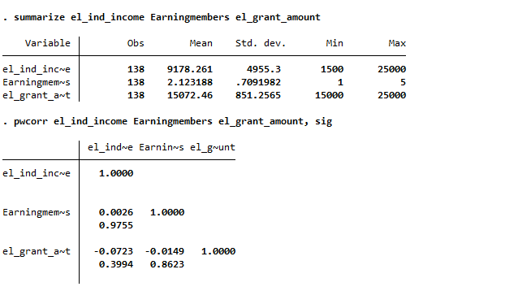
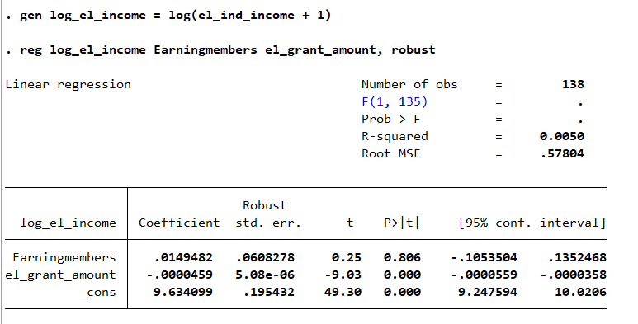

The regression results indicate that the number of earning members has no significant relationship with endline individual income. While the returnable grant amount shows a statistically significant negative association with income, this likely reflects the targeting of larger grants toward more financially vulnerable recipients rather than a negative effect of the grant itself. Additionally, the very low R-squared value suggests that income outcomes are influenced more by external and business-specific factors than by household earning structure or grant size.

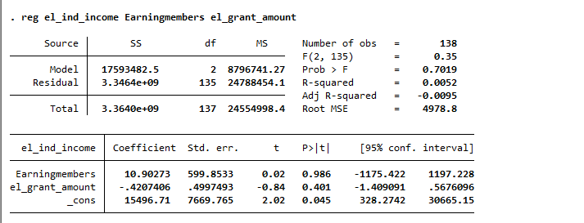
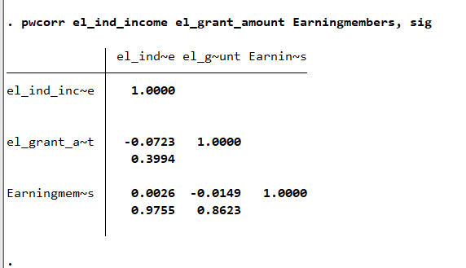

The correlation analysis shows that there is no statistically significant relationship between endline individual income, returnable grant amount, and number of earning members. All correlation coefficients are extremely small, indicating weak associations between the variables. This suggests that income outcomes are likely influenced more by external economic conditions, occupation type, and business-specific factors rather than household earning structure or grant size.

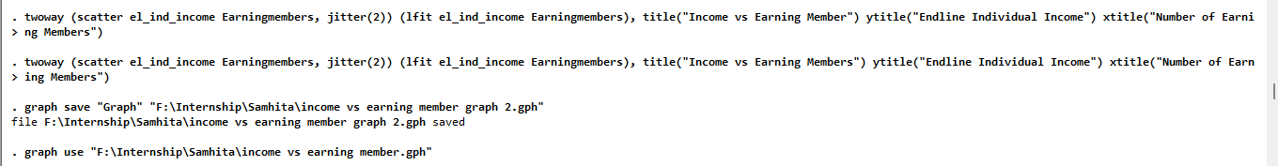

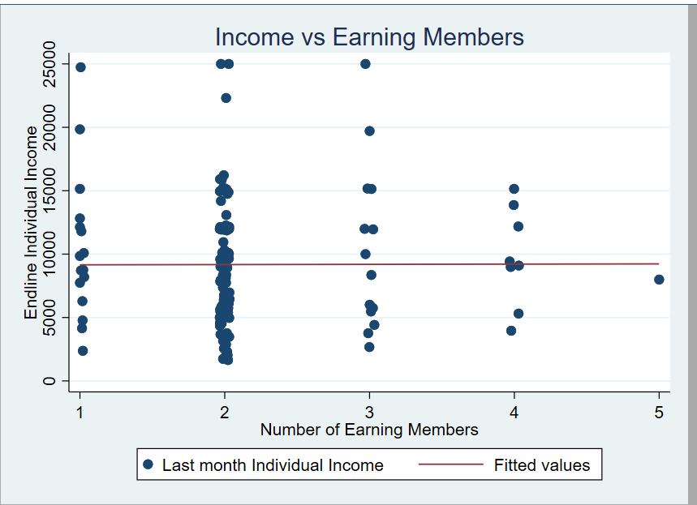

The analysis shows that there is no significant relationship between the number of earning members and endline individual income. The scatter plot displays a wide dispersion of income values across all categories of earning members, and the fitted regression line is nearly flat. This indicates that increasing the number of earning members does not lead to higher individual income.

Further, when related to the returnable grant amount, the results suggest that the grant did not have a strong impact on income. The correlation between grant amount and income is weak and statistically insignificant, indicating that higher grants did not necessarily translate into higher earnings.

Overall, the findings suggest that income is influenced more by individual-level factors such as type of business and market conditions rather than household earning capacity or the size of the grant.

8. Show the occupation trade wise split of baseline and endline individual income of recipients. Give the frequency and percentage table of the same. Please explain your step-by-step code and process in detail. Please detail your code list for the same. Tabulate the change in income as per occupation.

Ans-

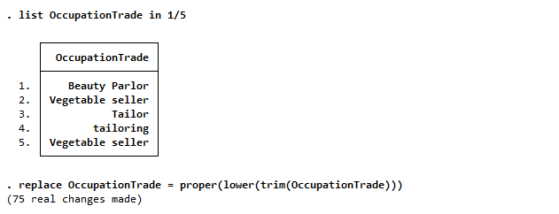

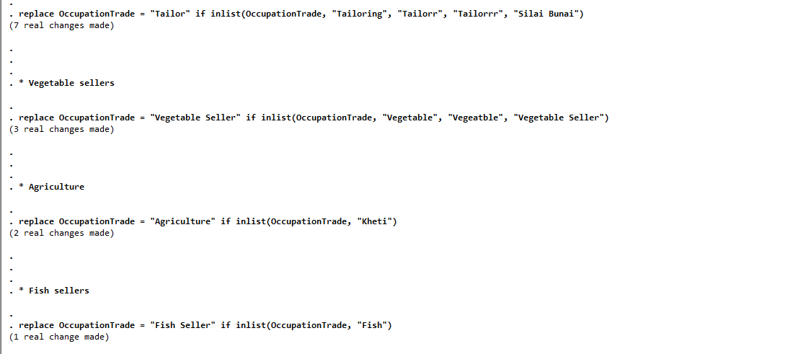

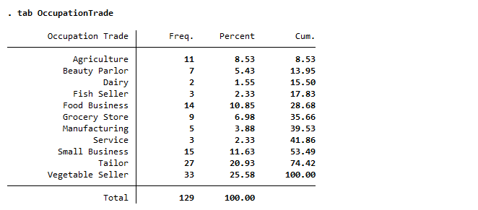

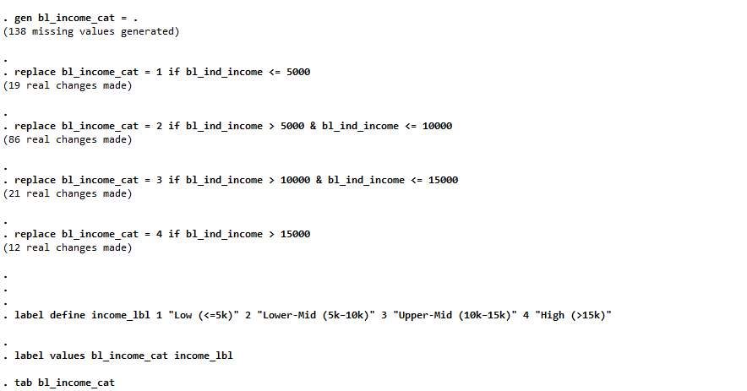

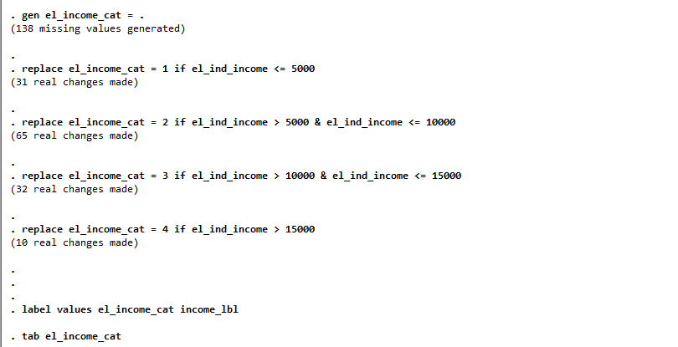

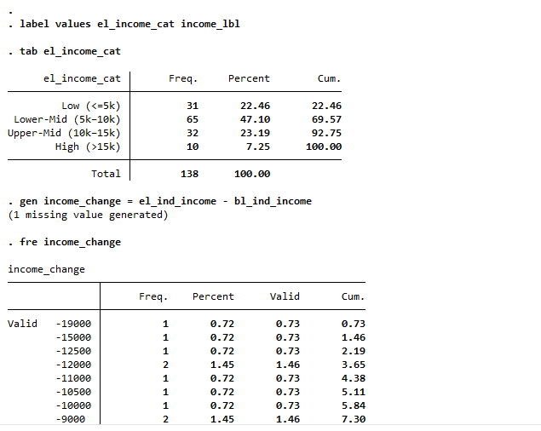

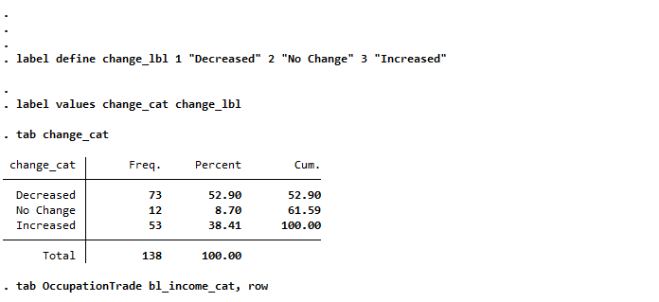

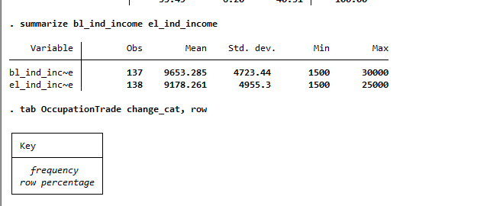

Major Finding:
- More than half (53%) experienced income decline → Indicates economic stress despite intervention
- Sector-wise variation is strong
- Food Business & Agriculture → better recovery
- Beauty Parlour & Fish Seller → worst affected
- Mixed outcomes
- Tailors and small businesses show both gains and losses → indicates instability
- Shift from baseline to endline
- Slight movement toward higher income
- But not uniform across occupations

The occupation-wise analysis reveals that income changes vary significantly across sectors. While some occupations such as food businesses and agriculture show relatively higher improvement, others like beauty parlors and fish sellers experienced substantial declines. Overall, more than half of the recipients reported a decrease in income, indicating that recovery has been uneven. The results suggest that sector-specific factors play a critical role in determining income outcomes, and financial support alone may not ensure uniform improvement across all occupations.

At last, what we can say Income recovery is highly occupation-dependent, with essential sectors performing better while service-based occupations continue to struggle.

9. Please show the percent change in individual and family income of recipients from baseline to endline. You can use any method to calculate the change. Please explain your step-by-step code and process in detail.

Ans-
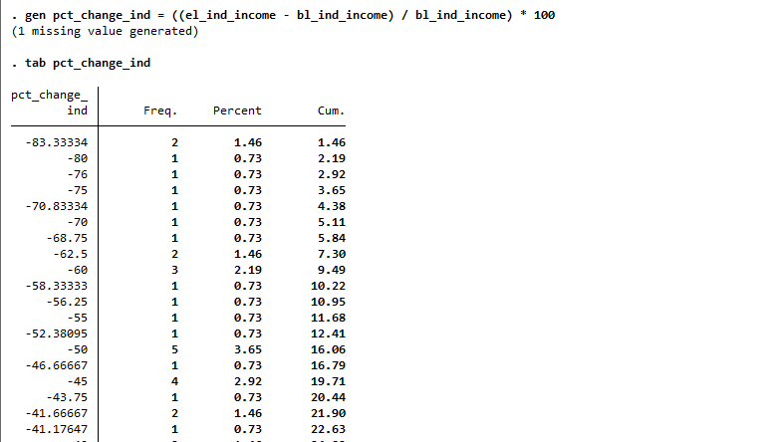

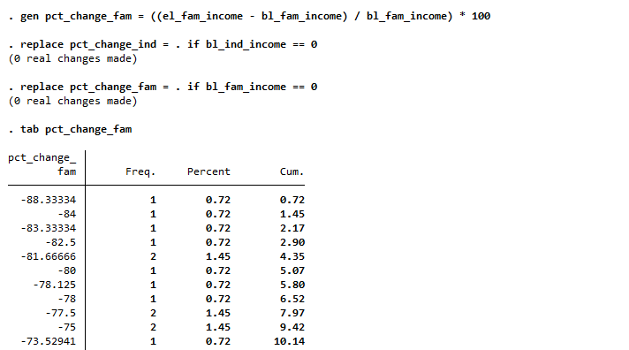
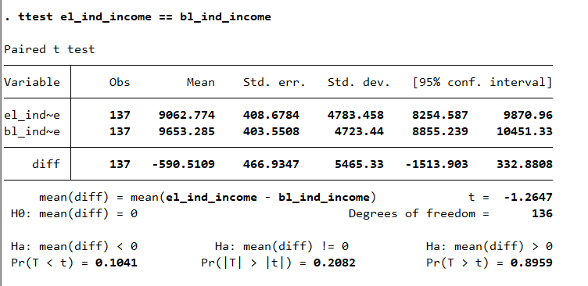

The paired t-test indicates that average individual income declined slightly from baseline to endline; however, the difference is not statistically significant. This suggests that the returnable grant and related interventions did not produce a clear measurable improvement in income levels across recipients during the study period.

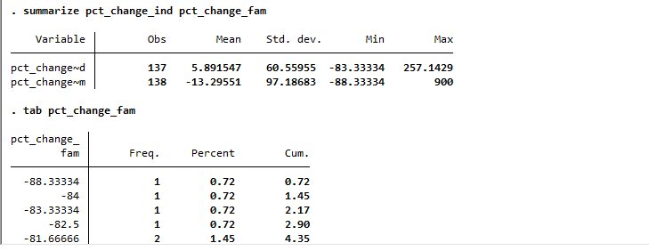
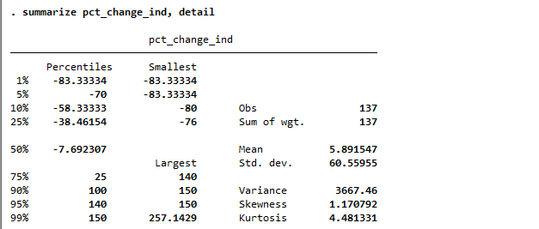

Table shows:
- Individual income
  - Slight average increase (+5.89%)
  - But median is negative → majority saw decline
  - High variation → uneven recovery
- Family income
  - Overall decline (-13.30%)
  - Suggests household-level financial stress
- High variability
  - Some experienced large gains (+257%, +900%)
  - Others experienced severe losses (-83%)
Overall Indicates inequality in recovery

The percent change analysis reveals that while average individual income shows a marginal increase, the median and distribution indicate that most recipients experienced income decline. Family income, on average, decreased, suggesting broader household financial stress. The wide variation in both individual and family income changes highlight uneven recovery among recipients, indicating that economic outcomes are highly heterogeneous and dependent on factors beyond the intervention. At last, what we can say is Income recovery among recipients is highly uneven, with modest average gains masking widespread declines and significant variability across households.

10. Is there any change in the saving behavior of recipients from baseline to endline? You can use any method to show the change. Please explain your step-by-step code and process in detail.

Ans-

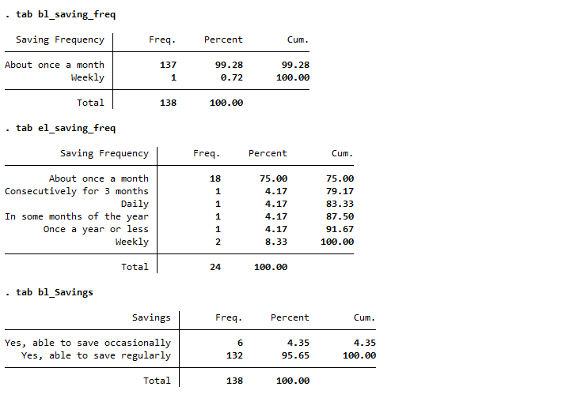

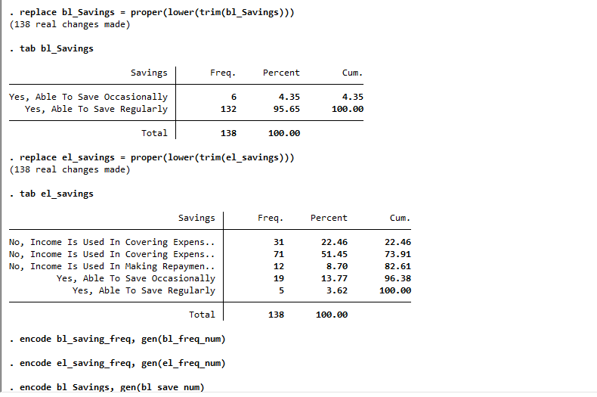

Interpretation
- Majority unchanged
  - ~81% showed no change
→ Saving habits are stable and resistant to change
- Limited improvement
  - Only ~14% increased saving frequency
→ Indicates small behavioral shift
- Very low decline
  - Only ~5% decreased saving
→ No major deterioration
- Data limitation
  - Analysis based on 21 matched observations (out of 138)
→ Results should be interpreted cautiously

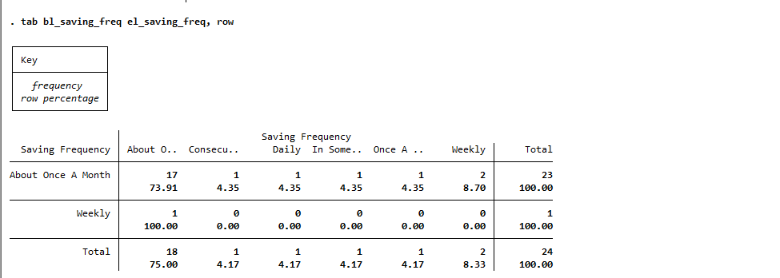

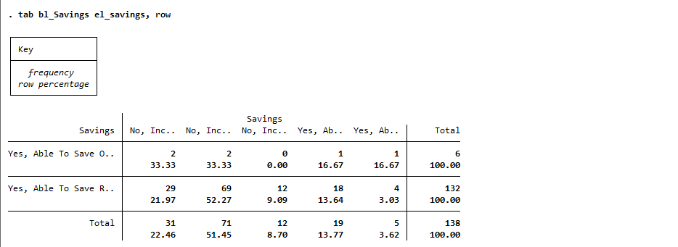
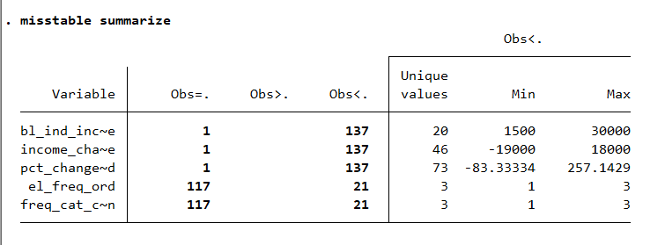

The dataset is largely complete for income-related variables, making the income analysis robust and reliable. However, substantial missing data exists in saving behavior variables, limiting the representativeness and strength of conclusions related to changes in savings practices.

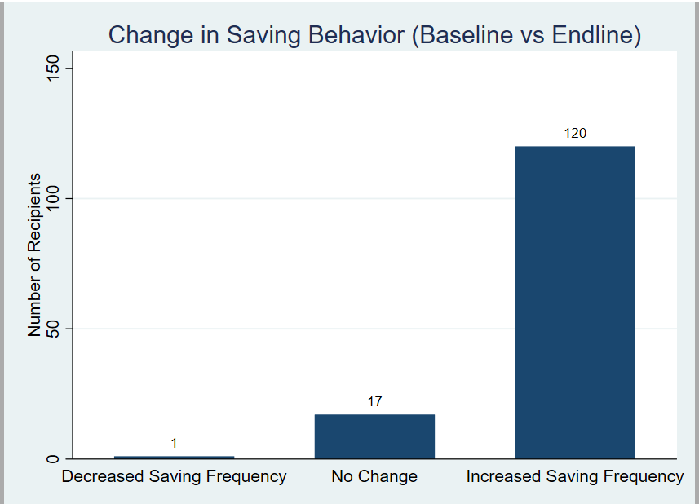
The analysis shows that saving behavior remained largely unchanged for the majority of recipients, with 80.95% reporting no change in saving frequency. A small proportion (14.29%) increased their saving frequency, indicating modest improvement in financial behavior. However, the limited size of the matched sample restricts the robustness of the findings. Overall, the results suggest that while some behavioral change occurred, financial habits remained largely stable, and the intervention had limited impact on improving saving behavior.

11. In your view do you think the returnable grant impacted the businesses of these recipients? Do you think this additional capital helped them to recover from their businesses that impacted due to covid? Which variable have you selected to answer this question and why?

Ans-

Variables selected and why
I used the following variables to assess impact:
- bl_ind_income, el_ind_income → capture change in individual business income (direct outcome)
- bl_fam_income, el_fam_income → reflect overall household economic condition
- pct_change_ind, pct_change_fam → standardize change across respondents
- change_cat → categorize direction of income change (increase/decrease/no change)
- el_grant_amount → measure size of financial support
- bl_loss_covid → identify those affected by COVID
- Saving variables (bl_saving_freq, el_saving_freq) → capture behavioral change (financial resilience)

Why these?
Together, they capture economic outcomes (income), intervention intensity (grant), shock exposure (COVID), and behavioral response (savings) a comprehensive view of “impact”.

Findings from the analysis
- Income outcomes are weak/uneven
  - ~53% experienced income decline
  - Mean individual income change is slightly positive (+5.9%), but median is negative → most respondents did not benefit
  - Family income shows an overall decline (-13.3%)
- No strong statistical relationship with the grant
  - Correlation between grant amount and income is weak and not significant
  - Scatter/regression shows no clear pattern linking higher grants to higher income
- Sectoral variation matters
  - Food businesses and agriculture show better recovery
  - Service sectors (beauty, small retail) show significant decline
→ impact is occupation-dependent
- Limited behavioral change
  - ~81% show no change in saving behavior
  - Only ~14% improved saving frequency
- COVID impact vs recovery
  - Only ~10% reported direct COVID loss
  - Yet income declines are widespread → recovery challenges go beyond initial shock

The returnable grant appears to have had a limited and uneven impact on business outcomes. While it may have provided short-term financial support and helped some recipients sustain operations, there is no strong evidence that it led to significant income growth or widespread recovery.

The lack of a statistically significant relationship between grant amount and income suggests that additional capital alone was insufficient to drive business improvement. Instead, outcomes were influenced more by sector-specific factors such as type of business, demand conditions, and market access.

Overall, the grant likely played a stabilizing role rather than a growth-enhancing role, helping prevent further decline for some recipients but not leading to substantial economic recovery across the sample.

12. Based on your analysis of the dataset provided and your responses to the previous questions, please write a brief summary outlining your overall takeaways. Highlight any key insights, trends, or patterns you observed.

Ans-

The analysis of the dataset reveals that the economic recovery of the recipients has been limited and uneven despite the financial intervention provided through returnable grants.

First, the demographic profile shows that most beneficiaries belong to the working-age group (25–44 years) and a large proportion are from Scheduled Tribe (ST) communities, indicating that the program successfully targeted economically active individuals from vulnerable backgrounds.

In terms of economic outcomes, the results indicate that more than half of the recipients experienced a decline in income, while only a smaller proportion reported improvement. Although the average individual income shows a slight increase, this is driven by a few high-performing cases, whereas the median income change suggests that the majority did not benefit. Family income, on average, declined, reflecting broader household financial stress.
The analysis also highlights strong sectoral differences. Occupations such as food businesses and agriculture showed relatively better recovery, while service-oriented sectors like beauty parlors and small retail businesses faced significant declines. This suggests that recovery is highly dependent on the nature of the business and external market conditions.

Further, there is no strong statistical relationship between the returnable grant amount and income outcomes. This indicates that while the grant may have helped stabilize businesses, it did not lead to substantial or consistent income growth across recipients.

In terms of financial behavior, saving patterns remained largely unchanged, with most respondents continuing their previous saving habits. This suggests that the intervention had limited impact on improving financial discipline or resilience.

Overall, the findings point to a key pattern: financial support alone is not sufficient to ensure sustainable recovery. Business performance appears to be influenced more by sector-specific factors, market demand, and individual capabilities rather than just access to capital.

13. What are other possible questions you would like to include to make the analysis more complete and what data points would you like included for the same?

Ans-

1. Business Performance: Profit and revenue data are needed to assess true business sustainability beyond income.
2. Grant Utilization: Understanding how the grant was used explains variation in business outcomes.
3. Market Access: Demand and customer access determine whether businesses can grow post-intervention.
4. Credit & Debt: Borrowing patterns reveal financial stress and dependence on external finance.
5. Digital Adoption: Digital tools can enhance business efficiency, reach, and resilience.
6. Gender Dynamics: Intra-household decision-making influences how income and resources are used.
7. Business Risk & Stability: Assessing risks helps evaluate long-term viability of enterprises.
8. Training & Capacity Building: Skills and training determine whether financial support translates into growth.

Overall analysis show Including these additional questions would allow for a more holistic understanding of how financial support interacts with market conditions, business practices, and individual capabilities, thereby providing a more accurate assessment of program effectiveness.

14. Access to finance has been identified as a major constraint faced by microenterprises in India for their growth. This is primarily because of the credit risk perception of the supply-side financial institutions. Sovereign credit guarantees and refinancing can play a major role in reducing the risk perceived by financial institutions in lending to the segment. In your opinion, what have been the success and shortcomings of the different such instruments over the last decade and more in India. Please support your view with any publicly available data and peer-reviewed journal literature, among other references.

Ans-

Access to finance is a major constraint for microenterprises due to high perceived credit risk, lack of collateral, and informality. To address this, India has used credit guarantees (CGTMSE, ECLGS) and refinancing (NABARD, SIDBI) to encourage lending.

Successes

1. Expansion of Credit Access
Credit guarantee schemes have significantly increased formal lending. CGTMSE alone has supported millions of MSME loans, improving access for small borrowers.
2. Crisis Support (COVID-19)
ECLGS provided timely liquidity (~₹3.6 lakh crore sanctioned), helping firms survive the pandemic and reducing business closures (RBI, 2022).
3. Reduced Collateral Requirement
Guarantees enabled lending without collateral, benefiting first-time and asset-poor entrepreneurs.
4. Improved Liquidity in System
Refinancing by SIDBI and NABARD ensured that banks and NBFCs had sufficient funds to lend to MSMEs.

Shortcomings

1. Limited Reach to Informal Sector
A large share of microenterprises still rely on informal credit, indicating weak last-mile penetration.
2. Continued Risk Aversion by Banks
Despite guarantees, lenders remain cautious due to poor credit histories and high transaction costs.
3. Moral Hazard Risks
Guarantees may reduce due diligence, leading to inefficient allocation of credit.
4. Rising Debt Burden
Schemes like ECLGS increased indebtedness, with some firms facing repayment stress post-pandemic.
5. Limited Impact on Growth
Credit is often used for survival rather than expansion, limiting productivity gains.

Key Insights from Literature
- Beck, Demirgüç-Kunt & Martinez Peria (2010): Credit guarantees improve access but require strong institutional design.
- OECD (2018): Guarantees are effective in crisis periods but less impactful for structural growth.
- RBI (2022 Bulletin): ECLGS helped reduce firm exits but had limited effect on long-term profitability.

Conclusion
Credit guarantees and refinancing have improved access and provided stability, especially during crises. However, they have not ensured sustained growth. A more holistic approach combining finance with training, market access, and better credit assessment is needed.

