Table of Contents

SwiftLoan — Technical Architecture Document (TAD)
Document ownership & accountable roles — Product Owner: Sridhar Muppidi · Product / Technical Head: Sachin Tulla · Head of Engineering: Hari PS · Security Head: Anil M.
Classification: CONFIDENTIAL — Internal / auditor distribution only. Do not circulate outside the ISMS scope or the engaged assessment body.

1. Document control
Field | Value
Document title | SwiftLoan Platform — Technical Architecture Document (TAD)
Document ID | SL-COMP-TAD-002
Version | 1.0
Date | 2026-08-04
Status | Draft for audit review
Owner | Head of Engineering / Platform Architecture
Approver | CTO; Information Security Officer (ISMS owner)
Classification | Confidential
Applicable ISMS | ISO/IEC 27001:2022 (primary); ISO/IEC 27701, 27017/27018 (supporting)
Assurance target | SOC 2 (AICPA Trust Services Criteria) — Security (CC1–CC9), Availability (A1), Confidentiality (C1), Processing Integrity (PI1), Privacy (P)
Source of truth | docs/compliance/_AUDIT_BRIEF.md (Verified Fact Base)

1.1 Revision history
Version | Date | Author | Change summary
0.1 | 2026-07-28 | Platform Architecture | Initial skeleton, component inventory
0.9 | 2026-08-01 | Platform Architecture | Data + security architecture drafted against verified fact base
1.0 | 2026-08-04 | Platform Architecture | Current-vs-target gap table (C1–C14), ISO 27001 traceability, diagrams; issued for audit review

1.2 Distribution
ISMS owner, CTO, Engineering leads, external ISO/IEC 27001 lead assessor, Data Protection Officer (to be appointed — see gap C10/governance).

2. Introduction

2.1 Purpose
This Technical Architecture Document (TAD) is the authoritative description of how the SwiftLoan platform is built, deployed, secured, and operated. It exists to give an ISO/IEC 27001:2022 assessor a single, verifiable view of the technology estate, its data flows, its trust boundaries, and the delta between the current state (as it exists in the repository today) and the target state required to pass an information-security audit and to meet the applicable Indian regulatory regime.
This document deliberately records known architectural gaps as first-class content (Section 8 and Section 11). These gaps are traced to the verified concern register (C1–C14) and to the Annex A controls they violate. Nothing in this document overstates the current control posture.

2.2 Scope
This document supports two concurrent assurance targets that share the same underlying architecture and evidence: ISO/IEC 27001:2022 (the primary certification, an ISMS/Annex A control audit) and SOC 2 against the AICPA Trust Services Criteria (an assurance report over Security plus the elected categories Availability, Confidentiality, Processing Integrity, and Privacy). The ISO Annex A tags and the SOC 2 TSC references in Sections 8 and 12 are complementary views of the same controls. SOC 2 Type II additionally requires evidence of operating effectiveness over a defined review period (typically 3–12 months) — not merely that a control is designed, but that it operated continuously — so several target-state controls in Section 11 must be in place and generating evidence before a Type II window opens.
In scope: the five deployable/first-party components — the React Native mobile app, the Express/Prisma/PostgreSQL backend API, the Next.js admin dashboard, the marketing website, and the integration boundary with the external Ello/Getello voice AI (“Ruby”). Includes the data model, authentication model, transport security, hosting on Render, and the data flows across all trust boundaries.
Out of scope (referenced, not owned): internals of the third-party Ello voice platform, internals of RBI-regulated lending partners and credit bureaus, and the underlying cloud provider’s physical/host controls (inherited under ISO 27017/27018 and treated as supplier controls under A.5.19–A.5.23).

2.3 Audience
ISO/IEC 27001 lead assessor and audit team; Information Security Officer; DPO (to be appointed); Engineering and DevOps; senior management accountable for the ISMS. A working knowledge of web/mobile architecture and TLS/JWT concepts is assumed.

2.4 Regulatory posture (context for the architecture)
SwiftLoan is a Lending Service Provider (LSP) operating a Digital Lending App (DLA) on behalf of RBI-regulated lenders. It does not lend directly and does not decide approvals. This shapes the architecture: the platform is an origination, recommendation, and handoff system, not a core lending ledger. The regulatory obligations that most directly constrain the architecture are RBI Digital Lending Guidelines 2022 (data minimisation, localisation, no biometric storage, direct-disbursal, grievance redressal), the DPDP Act 2023 (consent, purpose limitation, data-principal rights), and CERT-In 2022 (6-hour breach reporting, 180-day log retention, NTP sync).

2.5 References
- _AUDIT_BRIEF.md — Verified Fact Base (governing source).
- CLAUDE.md — engineering architecture notes (navigation state machine, tracking layer, admin dashboard).
- server/prisma/schema.prisma — canonical data model.
- render.yaml — deployment blueprint.
- ios/SwiftLoan/Info.plist — iOS App Transport Security posture.
- Companion documents: 01-PRD, 03-Security-&-Compliance, 04-Test-Cases.

2.6 Definitions and abbreviations
Term | Meaning
LSP / DLA | Lending Service Provider / Digital Lending App (RBI 2022)
PII / SPDI | Personal Information / Sensitive Personal Data or Information (IT Act §43A + SPDI Rules 2011)
PAN | Permanent Account Number (Indian tax ID) — SPDI-class financial identifier
KYC / CKYC | Know Your Customer / Central KYC
OTP | One-Time Passcode (SMS-based login factor)
JWT | JSON Web Token (stateless access token)
RBAC | Role-Based Access Control
KMS | Key Management Service
DSAR | Data Subject Access Request (DPDP data-principal rights)
DPA | Data Processing Agreement
ATS | App Transport Security (iOS TLS enforcement)
Ruby / Ello | The external Getello voice AI assistant (“Ruby”) and its platform
RoPA / DPIA | Records of Processing Activities / Data Protection Impact Assessment

3. Architecture overview

3.1 System context
SwiftLoan is a distributed, multi-tier system composed of five first-party components and three classes of external processors/partners. The customer interacts primarily through the React Native mobile app; a marketing website and an optional voice assistant act as top-of-funnel entry points; an internal Next.js admin dashboard is used by operations staff. All state of record lives in a single PostgreSQL database behind the Express API.
The five components:
- React Native mobile app (iOS + Android, RN 0.86, React 19, TypeScript). The primary customer surface. Runs the entire onboarding + loan funnel. Uses a hand-rolled navigation state machine and an in-memory store (no router library, no Redux). Talks to the backend through a single typed API client (src/api/client.ts) and, optionally, to the external Ello voice service.
- Backend API (Node/Express + Prisma + PostgreSQL). The system of record and the only component that touches the database. Layered as modules/*.routes.ts → lib/prisma.ts. Owns authentication (JWT access + rotating hashed refresh + hashed OTP), the loan funnel, KYC records, tracking ingestion, and the admin API.
- Admin dashboard (Next.js 14 + SWR + Recharts). Internal operations console for users, leads, loans, onboarding funnels, downloads, analytics, and notifications. Talks only to the backend API. Has its own real admin auth (bcrypt + JWT + rotating refresh) and an optional Ello voice-navigation widget.
- Marketing website (static website/ + website-next/). Lead capture and app promotion. Hosts a browser voice widget that can create leads / context sessions for the deferred-deep-link install handoff.
- External Ello/Getello voice AI (“Ruby”) — a third-party processor. Not owned by SwiftLoan. Provides the conversational assistant used in the mobile app and admin dashboard. Receives session context and audio over its own API/WSS endpoints authenticated with an x-api-key.
External partners (data recipients / sources): RBI-regulated lending partners (offer/handoff, soft-pull), credit bureaus (CIBIL/CRIF under CICRA 2005 soft enquiry), and SMS/notification providers.

3.2 Trust boundaries
- B1 — Device ↔ Backend: public internet; TLS required. iOS enforces ATS; Android release disallows cleartext. This boundary carries PII including full PAN today.
- B2 — Device/Website ↔ Ello: public internet to a third-party processor. Currently defaults to cleartext ws:///http:// in the mobile voice config (gap C13), and live on-screen field values (incl. PAN) can egress via read_screen / page_context (gap C2).
- B3 — Admin browser ↔ Backend: public internet; TLS. Admin tokens are held in localStorage (gap C11).
- B4 — Backend ↔ PostgreSQL: managed database connection. No app-level encryption-at-rest / tokenisation of PAN today (gaps C1, C12).
- B5 — Backend ↔ Lenders / Bureaus: server-to-server; consent-gated in target state (currently Consent model exists but is not enforced end-to-end).

3.3 Component / data-flow diagram (system context)
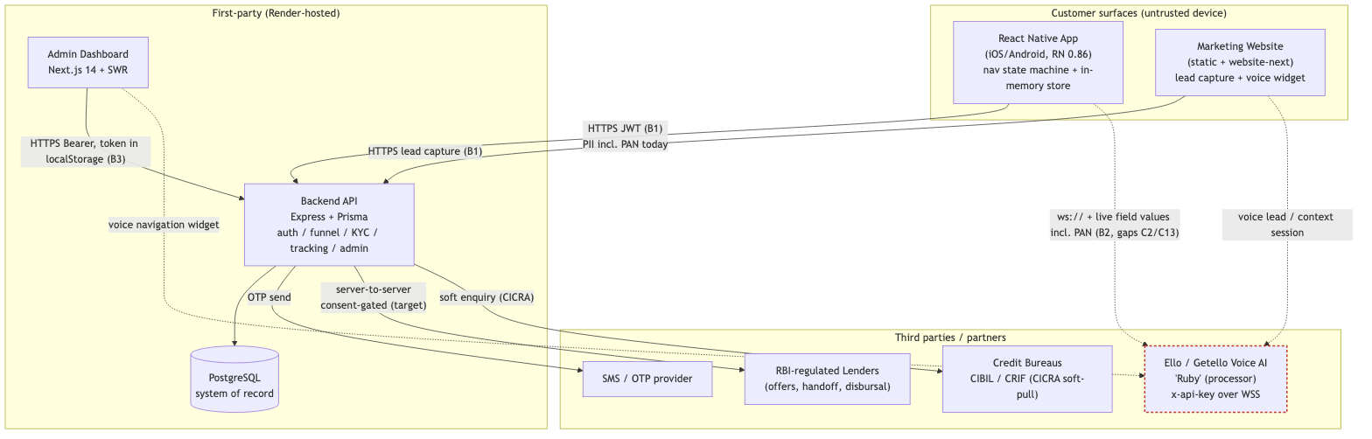
Figure 1 — System context and data flows
Figure rendered to a real image; editable source: docs/compliance/diagrams/tad-fig1-system-context.mmd.

4. Technology stack
Component | Language / runtime | Framework | Key libraries | Infra / hosting | Datastore
Mobile app | TypeScript, React 19 | React Native 0.86 (bare CLI, no Expo) | Hand-rolled nav (Context + useReducer), react-native-linear-gradient, react-native-svg, react-native-safe-area-context; Material Symbols + Inter fonts | iOS App Store / Google Play (device) | In-memory store; session token in api-client module
Backend API | TypeScript / Node.js | Express | Prisma v6 (pinned), zod (validation), helmet, cors, morgan, express-rate-limit, bcryptjs, jsonwebtoken, BullMQ (Redis-optional jobs) | Render web service (server/, :4000) | PostgreSQL (via DATABASE_URL, e.g. Neon)
Admin dashboard | TypeScript / Node.js | Next.js 14 | SWR (data fetching), Recharts (charts), Ello agent client | Render web service (admin/, :4001) | None (reads via API)
Marketing website | HTML/CSS/JS (+ Next variant) | Static site / Next.js | voice-widget.js (Ello browser client) | Render static site (website/) | None (posts leads to API)
Voice AI (“Ruby”) | External (Getello) | Getello assistant / Gemini Live | Ello session API + WSS transport, x-api-key auth | Third-party (*.getello.ai) | Owned by Ello (out of scope)
Cross-cutting conventions: all new API responses use the { success, data, message, pagination?, error? } envelope; all monetary amounts are stored and transported in paise; tracking calls are fire-and-forget.

5. Application architecture

5.1 Mobile app
The mobile app is not built on a conventional router/state library. Three purpose-built pieces make up its architecture:
- Navigation state machine — src/state/store.ts is a React Context + useReducer holding all app state (current screen, every form field, auth/OTP state, profile, notification prefs). It exposes go(screen), back(), set(), showToast(), reset(). The back-stack is a static PREV map (store.ts:33), and two timed auto-transitions (splash→language, finding→offers, both 2.6 s) run in an effect. src/Router.tsx renders SCREENS[state.screen]. The canonical screen list is SCREEN_NAMES (store.ts:21); several routes (apply/income/residence/consent/prequalify) are intentionally logic-only dead routes.
- In-memory store — there is no persistent client store; app state lives in memory for the session. The API session token is held in the api-client module (src/api/client.ts) and mirrored (authUser/applicationId/loanId) in the store. Security note: because there is no encrypted client-side persistence, there is also no client-side secure input / field masking for PAN/Aadhaar today (gap C14).
- API client — src/api/client.ts is the single typed gateway to the backend. Base URL auto-selects localhost (iOS) / 10.0.2.2 (Android). It attaches the JWT as a Bearer header, applies a 4 s request timeout (REQUEST_TIMEOUT_MS, client.ts:30), and degrades gracefully to demo data when offline. The demo path accepts a fixed OTP 123456 (DEMO_OTP, client.ts:77) with DEMO_ALLOWED = true including release builds (client.ts:84) — gap C3.
The voice layer (src/voice/) is a self-contained client for the external Ello assistant: config.ts (endpoints/keys), actionRegistry.ts + screenGraph.ts (what the assistant can see/do per screen), tools.ts (read_screen, perform_ui_action), and sensitive.ts (the sensitive flag). The sensitive flag blocks the assistant from writing a field but does not redact its current value from reads — read_screen/page_context still emit current_value (tools.ts:260, actionRegistry.ts:204) — gap C2.

5.2 Backend API
Layered and module-oriented. Each domain is an Express router in server/src/modules/*.routes.ts (auth, users, applications, kyc, loans, catalog, tools, support, plus WS4 tracking, admin, adminAuth, and WS3 context, downloads). Routers validate input with zod middleware and reach the database only through lib/prisma.ts. Global middleware in app.ts: helmet(), cors() (fully open — gap C7), express.json({ limit: '1mb' }), and morgan in non-prod. A single authLimiter (30 req/60 s) is applied to /api/auth and /api/admin/auth only — no per-route rate limiting elsewhere (gap C7). A health check is exposed at /api/health.
The funnel data path: application funnel → LoanApplication → Offer → Loan + Repayment[]. KYC verifications are recorded in KycVerification (the app’s KYC screens are currently non-functional demo stubs).

5.3 Admin dashboard
Next.js 14 App Router with SWR for data fetching and Recharts for visualisation. It talks only to the backend API at NEXT_PUBLIC_API_BASE. Pages: Master Overview, Onboarding (list + single journey), Loan Pipeline (+ single), Leads & Contact Us (+ single lead journey), App Downloads, All Users, User Profile, Analytics, Notifications. A token-guarded Shell wraps authenticated pages. Admin access + refresh tokens are stored in browser localStorage (admin/src/lib/api.ts:10-27) and attached as Bearer headers — XSS-exfiltratable (gap C11). An optional Ello voice-navigation widget (admin/src/lib/ello-agent.ts, ello-tools-admin.ts) is env-gated.

5.4 Authentication model
Aspect | Implementation | Reference
Primary login | Phone + SMS OTP | auth.routes.ts /otp/request, /otp/verify
Access token | Stateless JWT, TTL 900 s (ACCESS_TTL) | signAccess, render.yaml:29
Refresh token | Opaque random 32-byte token; only the SHA-256 hash is stored (RefreshToken.tokenHash, unique); rotated; revocable on logout | auth.routes.ts:14-18,102-123; schema.prisma:107
OTP storage | SHA-256 hashed (OtpToken.codeHash), 5-min expiry, single-use (consumed) | crypto.ts:6; schema.prisma:94
Password storage | bcrypt (cost 10) for User.passwordHash and AdminUser.passwordHash | crypto.ts:4; schema.prisma:51,462
Admin auth | Real: bcrypt + JWT + rotating hashed AdminRefreshToken | adminAuth.routes.ts; schema.prisma:471-481
Anonymous session | “Skip” issues an anonymous/degraded session | client.ts ensureSession
Controls already in place (do not “fix”): hashed OTP and refresh tokens, bcrypt passwords, rotation + revocation of refresh tokens. Gaps: fixed-OTP demo bypass in production (C3), default super-admin credentials seeded and displayed on the login page (C4), fail-open JWT/admin secrets (C6), no MFA on admin, admin token in localStorage (C11).

6. Data architecture

6.1 Prisma data model (system of record)
The canonical model is server/prisma/schema.prisma: Postgres provider, UUID PKs, enums, indexes, and createdAt/updatedAt audit timestamps throughout. Principal entities:
- Identity & auth: User (phone-unique root record), OtpToken, RefreshToken, Consent (types: terms, soft_pull, data_sharing, communications).
- Funnel: LoanApplication → Offer (← LenderPartner) → Loan → Repayment[]; KycVerification.
- Support/governance: SupportTicket (query/grievance), AuditLog (exists but is not yet written to — gap C10).
- WS4 tracking + admin (additive): Session, ActivityEvent, OnboardingFunnel, AnonymousLead, AppDownload, AdminUser, AdminRefreshToken, Notification.
- WS3 handoff: ContextSession (opaque-token deep-link context carry).

6.2 PII data model and classification
Data element | Model field | Class (IT Act SPDI / DPDP) | State today | Ref
Phone number | User.phone (unique) | PII | plaintext | schema:49
Name (first/last/full) | User.firstName/lastName/fullName | PII | plaintext | schema:52-54
DOB / age | User.dob | PII | plaintext (full DOB) | schema:55
Monthly income | User.monthlyIncome, LoanApplication.monthlyIncome | SPDI (financial) | plaintext | schema:60,169
PAN card | User.panNumber and LoanApplication.panNumber | SPDI (financial) | FULL PAN, PLAINTEXT, duplicated ⚠ | schema:62,171
Aadhaar | User.aadhaarLast4 | SPDI | last-4 only ✓ | schema:63
Bank account | Loan.accountLast4 | SPDI (financial) | last-4 only ✓ | schema:265
Selfie / face | (not captured) | SPDI (biometric) | stub, nothing stored ✓ | —
Voice / voiceprint | (Ello, third-party) | SPDI (biometric) | egressed to processor ⚠ | src/voice/
Email, address/pincode | User.email, User.pincode | PII | plaintext | schema:50,57
Credit score | User.creditScore (default 750) | SPDI (financial) | plaintext | schema:65
Passwords | User.passwordHash, AdminUser.passwordHash | credential | bcrypt ✓ | schema:51,462
OTP | OtpToken.codeHash | credential | SHA-256 ✓ | schema:94
Tracking metadata | ActivityEvent.metadata (free JSON) | potential PII sink | unvalidated ⚠ | schema:368
Leads (name/phone/city) | AnonymousLead, ContextSession | PII | plaintext, never purged ⚠ | schema:411,509

6.3 Data-at-rest posture
- Current: PostgreSQL stores PII in plaintext columns. Full PAN is stored in two places (User.panNumber, LoanApplication.panNumber) with no encryption/tokenisation (gap C1). No application-level field encryption and no documented DB transparent-encryption-at-rest or India residency in the repo (gap C12). Credentials (passwords/OTP/refresh) are the one bright spot — all hashed.
- Target: PAN tokenised or field-encrypted and de-duplicated to a single authoritative store; envelope encryption with keys in a managed KMS; database transparent encryption-at-rest with encrypted backups pinned to an India region; masking on read for all SPDI fields (A.8.11).

6.4 Data lifecycle
Create → in-app collection → API validation (zod) → Prisma persistence → read via API (app/admin) → optional egress to processor/partners → deletion. Today DELETE /me (users.routes.ts:91) performs a hard cascade delete of a user’s rows. Gaps: orphan PII (AnonymousLead, ContextSession, Notification.body) is outside that cascade and has no retention TTL / purge job (gap C9); there is no DSAR beyond user self-delete — no correct/export/erase for leads/context, and the AuditLog is never written (gap C10). Target: retention TTL + scheduled purge, DSAR APIs (access/correct/export/erase incl. orphan PII), and audit-on-PII-access.

7. Integration architecture

7.1 Ello voice AI (“Ruby”) — third-party processor
The app and admin dashboard connect to Ello (*.getello.ai) using a session API over HTTPS and a streaming transport over WebSocket, authenticated with an x-api-key. Data that egresses to Ello: session context, live screen state, and audio. Critically, the per-screen page_context / read_screen payload includes current_value for on-screen controls — so live field values including PAN can be sent to the third party (the sensitive flag blocks writes only, not reads) — gap C2. The mobile voice transport defaults to cleartext ws:///http:// (src/voice/config.ts:22,30) — gap C13. A real Ello API key is committed in render.yaml:53 and website/js/voice-widget.js — gap C5. Target: consent-gate voice, redact SPDI values from page_context, enforce wss:///https:// only, rotate the leaked key, and execute a DPA with Ello.

7.2 Lending partners (handoff / soft-pull)
Server-to-server. After the funnel produces Offers (from LenderPartner catalog), the handoff step transfers the applicant to the chosen RBI-regulated lender for approval and direct disbursal (SwiftLoan never disburses). Target: gate the profile share on Consent(type = data_sharing) and execute DPAs with each lender.

7.3 Credit bureaus (CICRA soft-pull)
A soft enquiry to CIBIL/CRIF must be gated on Consent(type = soft_pull) per CICRA 2005. The Consent model exists but is not yet enforced before the pull.

7.4 Marketing-site lead capture / context handoff
The website (and its voice widget) create AnonymousLead / ContextSession rows. The ContextSession design carries only a short opaque token in the app-download deep link — the PII stays server-side and is resolved on first app open (schema.prisma:509-524). This is a good pattern, but the captured rows are currently never purged (gap C9).

7.5 Sequence diagram — OTP login flow
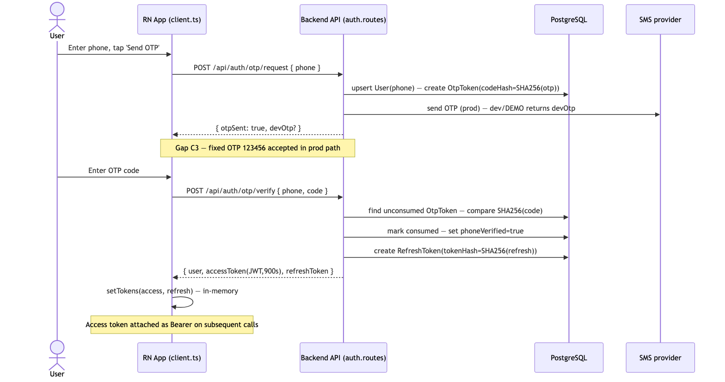
Figure 2 — OTP login sequence
Figure rendered to a real image; editable source: docs/compliance/diagrams/tad-fig2-otp-sequence.mmd.

8. Security architecture
Each control area below is tagged with the relevant ISO/IEC 27001:2022 Annex A controls and the corresponding SOC 2 Trust Services Criteria (TSC). “State” reflects the verified fact base; gaps carry their C-ID. The two frameworks are complementary: Annex A names the control, the TSC names the assurance criterion the control satisfies. For SOC 2 Type II, each control must additionally produce operating-effectiveness evidence across the review period (see §8.10).

8.1 Authentication — A.8.5 (secure authentication) · SOC 2 CC6.1, CC6.2, CC6.3 (logical access)
- In place: phone+OTP login with hashed OTP; JWT access + rotating hashed refresh tokens; bcrypt passwords; real admin auth.
- Gaps: fixed OTP 123456 accepted in production (C3); default super-admin admin@swiftloan.com / admin123 seeded and shown on the login page (C4); no MFA for admin.
- Target: disable DEMO_LOGIN/OTP bypass in prod; remove default admin creds + enforce MFA; account/OTP rate limiting and lockout.

8.2 Authorization / RBAC — A.8.2 (privileged access), A.8.3 (information access restriction) · SOC 2 CC6.1, CC6.3 (role-based least-privilege access)
- State: AdminUser.role enum exists (super_admin/admin/analyst) but role-based enforcement is a current gap — admin routes are not yet differentiated by role. User-scoped API access is enforced via JWT sub.
- Target: enforce least-privilege RBAC on every /api/admin route; segregate analyst (read-only) from admin/super-admin; log privileged actions to AuditLog.

8.3 Cryptography — A.8.24 (use of cryptography) · SOC 2 CC6.1, CC6.7 (encryption of data at rest/in transit), Confidentiality C1.1
- In-transit: TLS on all first-party HTTP boundaries (Render-terminated).
- At-rest (target): PAN tokenisation/field-encryption; DB encryption-at-rest; KMS-managed keys with rotation. Current gap: none of the above (C1, C12).
- Hashing (in place): bcrypt (passwords), SHA-256 (OTP + refresh tokens).
- Gap: cleartext voice transport by default (C13) undermines in-transit crypto on boundary B2.

8.4 Secrets management — A.8.9 (configuration management), A.8.24 · SOC 2 CC6.1 (credential protection), CC8.1 (change/config control)
- Current gap: fail-open JWT/admin secrets — config/env.ts:12-13 falls back to dev-access/dev-refresh when unset, and the admin secret derives from them (C6). A real Ello API key is committed in render.yaml:53 and website/js/voice-widget.js (C5).
- Target: fail-closed secret loading (crash if a required secret is absent in prod); rotate and purge the committed key; move all secrets to a managed KMS / secret store; no secrets in the repo or in NEXT_PUBLIC_* client bundles.

8.5 Network security — A.8.20 (network security), A.8.21 (security of network services), A.8.22 (segregation), A.8.23 (web filtering) · SOC 2 CC6.1, CC6.6 (boundary protection), CC7.1 (infrastructure monitoring)
- Current gap: cors() is fully open (app.ts:27) and rate-limiting is applied to auth routes only (C7); no WAF.
- Target: strict CORS allow-list (admin origin only), per-route rate limiting, and a WAF in front of the API and admin services.

8.6 Transport security — A.8.20, A.8.24 · SOC 2 CC6.7 (transmission encryption), Confidentiality C1.1
- In place: iOS ATS enforced — NSAllowsArbitraryLoads = false (Info.plist:29-35); Android release build disallows cleartext (RN gradle default).
- Gap: the mobile voice transport defaults to ws:///http:// (config.ts:22,30) — C13.
- Target: enforce wss:///https:// for the voice channel; pin/verify certificates where feasible.

8.7 Input validation — A.8.25–A.8.28 (secure development lifecycle, secure coding) · SOC 2 CC8.1 (secure change), Processing Integrity PI1.1–PI1.3 (input completeness/accuracy)
- In place: zod schema validation on API routes; JSON body cap of 1 MB; helmet security headers.
- Gaps: ActivityEvent.metadata is free-form, unvalidated JSON — an uncontrolled PII sink (C8); no client-side secure input / masking for PAN/Aadhaar (C14).
- Target: schema-validate and scrub tracking metadata; secure text entry + on-screen masking for SPDI fields.

8.8 Logging and audit — A.8.15 (logging), A.8.11 (data masking) · SOC 2 CC7.1–CC7.3 (monitoring, event detection, incident response)
- State: AuditLog model exists but is never written to (C10); request logging via morgan is dev-only; no structured, PII-masked audit trail.
- Target: write AuditLog on every PII access / privileged action; structured, masked logging; 180-day log retention and NTP sync per CERT-In 2022.

8.9 Data masking / minimisation — A.8.11, A.8.12 (DLP) · SOC 2 Confidentiality C1.1–C1.2, Privacy P4 (use/retention/disposal minimisation)
- In place: Aadhaar and bank account reduced to last-4 only; selfie/biometric not stored (aligns with RBI “no biometric storage”).
- Gaps: full PAN and full DOB retained in plaintext; SPDI values readable by the voice assistant (C2).
- Target: mask PAN on read; store DOB granularity only as required; redact SPDI from voice/page_context and from logs.

8.10 Additional SOC 2-specific control areas
The following areas are less prominent in an Annex A control listing but are first-class SOC 2 criteria and are called out explicitly here.
- Change management / CI-CD — SOC 2 CC8.1; ISO A.8.32. Builds and deploys run through the Render blueprint (§9.3). Target for evidence: version-controlled change requests, peer review/approval on merge, separation of build from deploy, and an auditable deployment history across the review period.
- System operations & monitoring — SOC 2 CC7.1–CC7.5; ISO A.8.15, A.8.16. Currently morgan dev-only; target: centralised masked logging with alerting, event detection, a defined incident-response runbook (incl. CERT-In 6-hour breach reporting), and recovery procedures — all producing continuous evidence.
- Risk mitigation & third parties — SOC 2 CC9.1, CC9.2; ISO A.5.19–A.5.23. The Ello processor, lending partners, and Render host require executed DPAs and a vendor risk-review cadence (gap C12).
- Availability — SOC 2 A1.1–A1.3; ISO A.8.13, A.8.14. Health checks, capacity/scaling, encrypted backups, and a tested DR/restore procedure with defined RPO/RTO (§9.4, §10).
- Privacy — SOC 2 P1–P8; ISO A.5.34, A.8.11. Consent capture and enforcement, purpose limitation, data-principal/DSAR rights, retention/disposal (gaps C9, C10) — aligned with DPDP 2023.
- Control environment / risk assessment — SOC 2 CC1–CC5. Governance, organisational structure, and risk-assessment processes underpin every technical control; the ISMS being stood up for ISO 27001 (policies, roles, RoPA/DPIA, DPO) supplies the CC1–CC5 evidence base.
SOC 2 Type II note. A Type I report attests control design at a point in time. A Type II report attests operating effectiveness across a review period (commonly 3–12 months): the auditor samples evidence — access reviews, deploy logs, monitoring alerts, backup restores, incident tickets, consent records — to confirm each control operated continuously. Consequently the target-state controls in Section 11 must not only be implemented but must run and generate retained evidence for the full window before a Type II examination can commence.

8.11 SOC 2 Trust Services Criteria — companion control mapping
Architecture control area (§8) | SOC 2 TSC | Current state | Gap(s)
Authentication (8.1) | CC6.1, CC6.2, CC6.3 | Hashing/rotation in place; demo/default-cred bypass | C3, C4
Authorization / RBAC (8.2) | CC6.1, CC6.3 | Roles modelled, not enforced | (RBAC gap)
Cryptography (8.3) | CC6.1, CC6.7, C1.1 | In-transit + hashing good; no at-rest/tokenisation | C1, C12, C13
Secrets management (8.4) | CC6.1, CC8.1 | Prod secrets generated; fail-open + committed key | C5, C6
Network security (8.5) | CC6.1, CC6.6, CC7.1 | Auth-only rate-limit; open CORS; no WAF | C7
Transport security (8.6) | CC6.7, C1.1 | iOS ATS + Android cleartext-off; voice ws:// | C13
Input validation (8.7) | CC8.1, PI1.1–PI1.3 | zod validation; unvalidated tracking metadata | C8, C14
Logging & audit (8.8) | CC7.1–CC7.3 | AuditLog model unused; dev-only logging | C10
Data masking / minimisation (8.9) | C1.1–C1.2, P4 | Aadhaar/bank last-4; PAN/DOB unmasked | C1, C2, C9
Change management / CI-CD (8.10) | CC8.1 | Blueprint deploys; approval/evidence trail pending | —
System operations & monitoring (8.10) | CC7.1–CC7.5 | Dev-only logging; no alerting/IR runbook | C10
Risk / third parties (8.10) | CC9.1, CC9.2 | No DPAs / vendor review cadence | C12
Availability / DR (8.10, §9–10) | A1.1–A1.3 | Health checks; backups/DR undefined in repo | C12
Privacy / consent / DSAR (8.10, §6.4) | P1–P8 | Consent model exists, not enforced; no DSAR | C9, C10
Governance / risk assessment (8.10) | CC1–CC5 | ISMS forming; RoPA/DPIA/DPO pending | (governance)
SOC 2 Type II: every row above must additionally evidence continuous operation across the review period (see §8.10).

9. Deployment and infrastructure architecture

9.1 Hosting (Render blueprint)
render.yaml defines three services: swiftloan-api (Node web service, server/, health check /api/health), swiftloan-admin (Next.js web service, admin/), and swiftloan-website (static site, website/). The database is an external managed PostgreSQL referenced by DATABASE_URL (e.g. Neon), set as a sync: false secret in the Render UI.

9.2 Environments
Development (local Postgres on :5432, Metro bundler, npm start), and production (Render). NODE_ENV=production toggles prod behaviour. Note the demo/prod blurring: DEMO_LOGIN="true" is set in the production blueprint (render.yaml:21) — this must be removed for a real launch (C3).

9.3 CI/CD and configuration
Build via Render (npm install --include=dev && npx prisma generate for the API; npm run build for admin). Schema changes applied with npm run prisma:push. Config is environment-variable driven. JWT/admin secrets are Render generateValue: true in prod — good — but the code’s fail-open fallback (C6) and the committed Ello key (C5) undermine this and must be closed. NEXT_PUBLIC_* values are baked into the client bundle at build time and are therefore client-exposed by design — no server secret may ever be placed there.

9.4 Backups, residency, and data protection
- Current gap: no DB encryption-at-rest or data residency defined in the repo, and no DPA with Ello or the lenders (C12).
- Target: encrypted automated backups, India-region database + backups (RBI localisation + DPDP), documented restore/DR runbook, and executed DPAs with all processors (Ello, lenders, host) — supplier controls A.5.19–A.5.23.

10. Non-functional architecture
- Scalability: stateless API (JWT, no server session affinity) scales horizontally behind Render; PostgreSQL is the vertical/read-replica scaling point; indexes on hot paths (schema.prisma @@index on User.createdAt, LoanApplication[userId,status], ActivityEvent[userId,ts], etc.). BullMQ jobs (idle-detector, loan/onboarding-stale, notification-sender) run out-of-band with an in-process fallback when Redis is absent.
- Availability: managed platform (Render) with health checks (/api/health); target: multi-instance API, managed PG with failover.
- Performance: 4 s client request timeout for fast failover to offline demo data; paise integer arithmetic (no float money); SWR client caching in admin.
- Observability: currently morgan (dev) only. Target: structured, masked, centralised logging with 180-day retention and NTP-synced timestamps (CERT-In); metrics/alerting; audit trail via AuditLog.
- DR / backup: target encrypted, India-region backups with a tested restore procedure and defined RPO/RTO (see Section 9.4).

11. Current-state vs target-state architecture
The two views below summarise the platform’s as-built data-protection posture and the recommended target posture. The gap table that follows maps each verified concern (C1–C14) to the architectural change that closes it.
Figure 3 — Current as-built architecture (data-protection view). Red boxes/labels mark data-protection concerns.
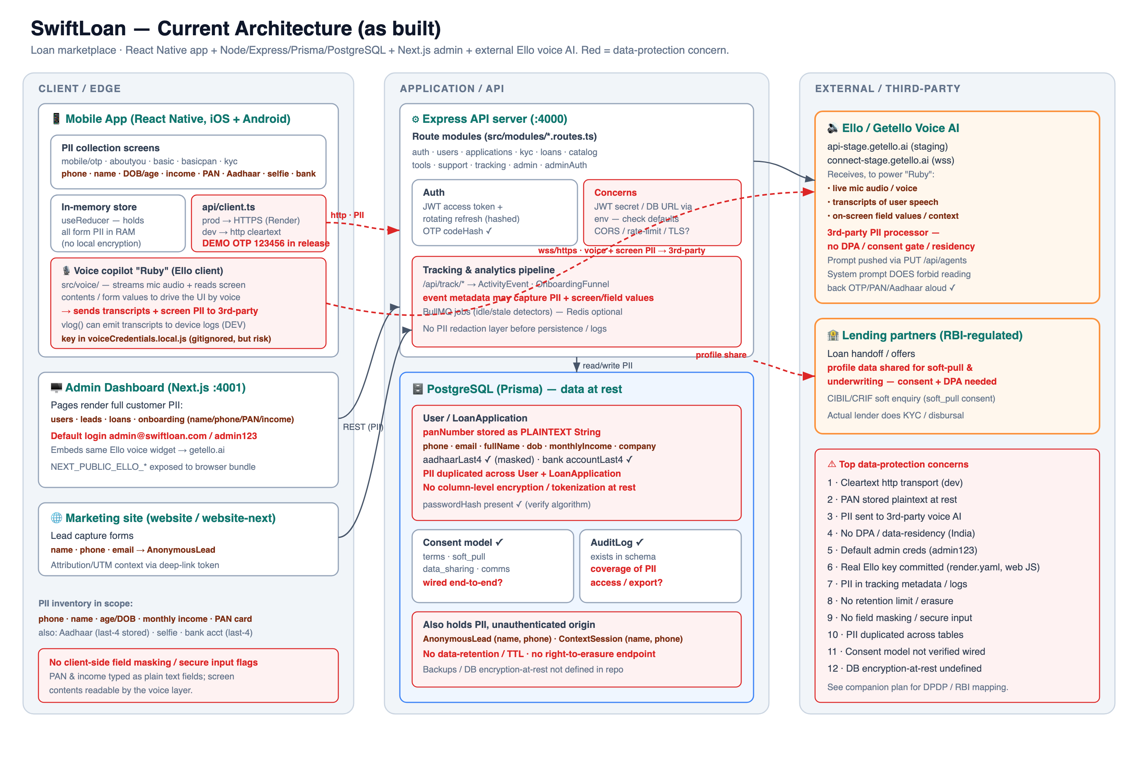
Figure 3 — SwiftLoan current as-built architecture
Figure 4 — Recommended target architecture. Green marks new/changed controls; blue tags indicate the ISO 27001:2022 / SOC 2 TSC / DPDP / RBI obligation each control satisfies, inside an India data-residency boundary.
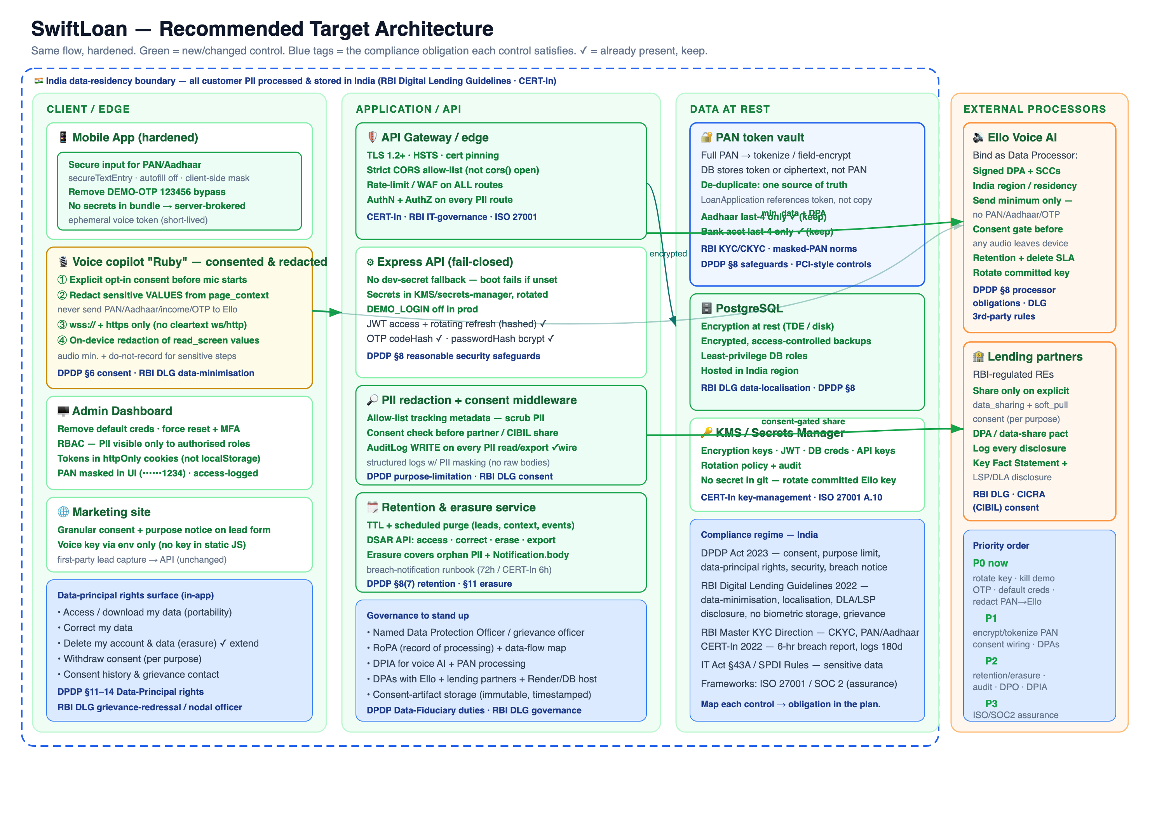
Figure 4 — SwiftLoan recommended target architecture
ID | Verified gap (current) | Ref | Architectural change (target)
C1 | PAN stored full + plaintext, duplicated across two models | schema:62,171 | Tokenise/field-encrypt PAN via KMS; de-duplicate to one authoritative store; mask on read
C2 | Live field values (incl. PAN) egress to voice AI via read_screen/page_context; sensitive blocks writes only | actionRegistry:204, screenGraph:207, tools:259 | Redact SPDI current_value from page_context; consent-gate voice reads
C3 | Fixed OTP 123456 accepted in production; DEMO_LOGIN set in prod blueprint | crypto:9-11, render.yaml, client:77-84 | Disable demo OTP in prod (fail-closed); remove DEMO_LOGIN from prod
C4 | Default super-admin admin@swiftloan.com / admin123 seeded and shown on login | seed.ws4:74,82-83 | Remove default creds; forced first-login rotation; MFA
C5 | Real Ello API key committed to repo | render.yaml:53, voice-widget.js:17 | Rotate + purge key; move to secret store; proxy voice auth server-side
C6 | Fail-open JWT/admin secrets (dev-access/dev-refresh fallback) | env:12-13 | Fail-closed secret loading; KMS-managed secrets
C7 | CORS fully open; rate-limiting on auth routes only | app:27 | Strict CORS allow-list; per-route rate-limit; WAF
C8 | Unvalidated free-form tracking metadata (PII sink) | tracking:30,67 | Schema-validate + PII-scrub metadata
C9 | Orphan PII (leads, context, notifications) never purged; no TTL | schema:411,509 | Retention TTL + scheduled purge jobs
C10 | No DSAR beyond self-delete; AuditLog never written | users:91, schema:325 | DSAR APIs (access/correct/export/erase); write AuditLog on PII access
C11 | Admin access/refresh tokens in localStorage (XSS-exfiltratable) | admin/api:12-22 | httpOnly, Secure, SameSite cookies; CSRF protection
C12 | No DB encryption-at-rest / residency in repo; no DPAs | — | Encryption-at-rest + encrypted India-region backups; execute DPAs
C13 | Voice transport defaults to cleartext ws:///http:// | voice/config:22,30 | Enforce wss:///https:// only
C14 | No client-side secure input / masking for PAN/Aadhaar | (mobile UI) | Secure text entry + on-screen masking for SPDI fields

12. Control-to-architecture traceability (ISO 27001 Annex A + SOC 2 TSC)
This table maps each architectural element to both its ISO/IEC 27001:2022 Annex A control and the corresponding SOC 2 Trust Services Criteria, so a single row serves both audits. See §8.11 for the SOC 2-first companion view. For SOC 2 Type II, each row additionally requires operating-effectiveness evidence across the review period.
Annex A control (2022) | SOC 2 TSC | Architecture element | Current state | Gap(s)
A.5.19–A.5.23 Supplier / cloud relationships | CC9.1, CC9.2 | Ello processor, lenders, Render host | No DPAs executed | C12
A.5.34 Privacy & PII protection | P1–P8 | PII data model (§6.2), DSAR | Partial (minimisation on Aadhaar/bank) | C1, C9, C10
A.8.2 Privileged access rights | CC6.1, CC6.3 | Admin RBAC | Roles modelled, not enforced | (RBAC gap)
A.8.3 Information access restriction | CC6.1, CC6.3 | JWT user-scoping; admin routes | User scoping enforced; admin not role-gated | (RBAC gap)
A.8.5 Secure authentication | CC6.1, CC6.2 | OTP/JWT/refresh/bcrypt; admin auth | Hashing in place; demo/default-cred bypass | C3, C4
A.8.8 / A.8.25–A.8.28 Vulnerability mgmt & secure dev | CC8.1, PI1.1–PI1.3 | zod validation, helmet, SDLC | Input validation present; secure-input/VAPT pending | C8, C14
A.8.9 Configuration management | CC8.1 | render.yaml, env.ts secrets | Prod secrets generated; fail-open fallback + committed key | C5, C6
A.8.11 Data masking | C1.1–C1.2, P4 | Aadhaar/bank last-4; selfie not stored | Partial; PAN/DOB unmasked; voice reads SPDI | C1, C2
A.8.12 Data leakage prevention | C1.1, CC6.7 | Tracking metadata, voice egress | Uncontrolled sinks | C2, C8
A.8.13 Information backup | A1.2, A1.3 | Render/PG backups | Not defined in repo | C12
A.8.15 / A.8.16 Logging & monitoring | CC7.1–CC7.3 | AuditLog model, morgan | Model unused; dev-only logging | C10
A.8.20–A.8.23 Network security | CC6.6, CC7.1 | CORS, rate-limit, WAF, TLS | Auth-only rate-limit; open CORS; no WAF | C7
A.8.24 Use of cryptography | CC6.7, C1.1 | TLS, bcrypt, SHA-256, at-rest | In-transit + hashing good; no at-rest/tokenisation | C1, C12, C13
A.5.1–A.5.8 / A.6 Governance & risk assessment | CC1–CC5 | ISMS policies, roles, risk process | Forming; RoPA/DPIA/DPO pending | (governance)

End of document. Classification: CONFIDENTIAL. Prepared against the verified fact base (_AUDIT_BRIEF.md); do not distribute beyond the ISMS scope.

