AZURE PORTAL

CREDENTIALS

Url : https://portal.azure.com
username : adityahivr@outlook.com
Password : @dityahivr

How To Create New web-app ?

Step 1 : Portal Dashboard->New
Step 2 : Select web+mobile
Step 3 : Select web-app
Step 4 : Enter the name of web-app
Step 5 : Choose Resource Group from existing(RG_HIVR)

Sonar Run On : 192.168.54.65:9000

// Genrate Security Report by Yasca

Version :yasca-core-2.0
CMD-> yasca Project webcontent folder Path

// Jenkins credentials

username: aditya
password : system123#

// Git credentials

192.168.56.221:8080/git
username: aditya.sharma
password : System123#

Create BaseLine:-

Step1: Clone to the git repository
Step2: Check Show loag to the last commit from where you need to create base line
Step3: Create Brance
Step4: Give the name of branch

Step5: Git Swtch to the created branch
Step6: Push to the created branch

How to create Replica from PROD To QA:-

To Create Replica we need to work on the below things:

    - Active -Directory (Same No change in which)
    - Search (Need to clean the search)
    - Storage (Need to Run the script to Replica the strorage)
    - Webapp
    - Database

How To Create Storage:-

    - Name of the Storage
    - Subscription (Select Hivr)
    - Resource Group (Select RG-Hivr)
    - Resource Location (Centeral India)

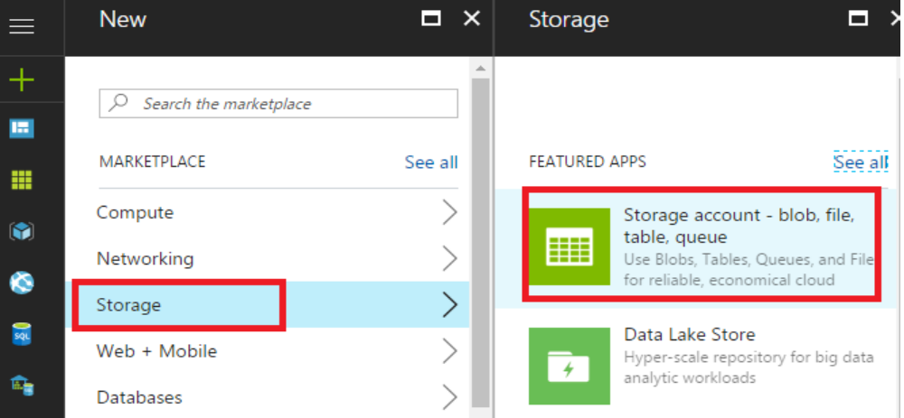

Azur Portal Login Details for microsite

Username: aditya.sharma352016@newgen.co.in
Password : system123#

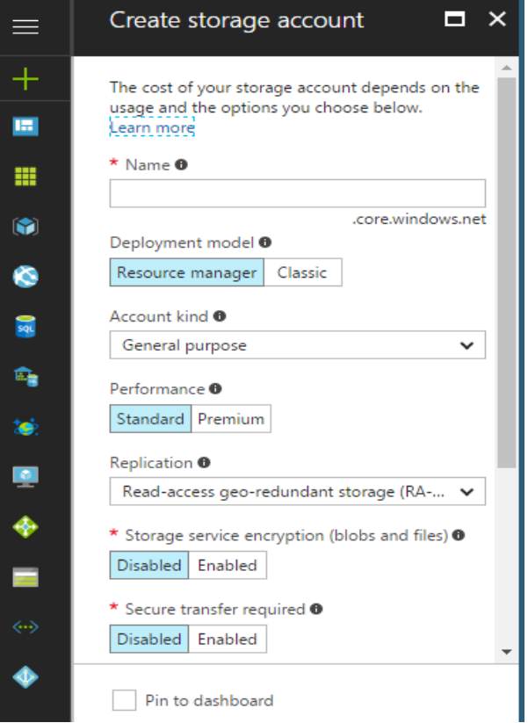

* After Creating Storage Run the bat file that is created from the powershell Script
Powershell to the Script path->Enter

  - For making Replica we need to also update the Azure-username On Database

email :- admn.hivr@gmail.com
Password: corrus123#
https://optimize.google.com/optimize/home/#/accounts

shubhi.nigam@hivr.in
Password : system123#

