

##### VISVESVARAYA TECHNOLOGICAL UNIVERSITY,

##### JNANA ANGAMA, BELAGAVI - 590 018, KARNATAKA.

AN INTERNSHIP REPORT ON

“Working on Full Stack Web Developement”

A Case Study - Revolutionary Ride Rentals: Unleash the Wheels of Wonders

*Submitted in the partial fulfillment of the requirements for the award of Degree*

#### B.E. in Computer Science & Engineering

##### PROJECT ASSOCIATES

**Vinayka M C 4BD21CS181**

**Sachin B 4BD21CS124**

**Rahul N 4BD21CS105**

**Manu M N 4BD21CS072**

**Keerthi N G 4BD21CS060**

**PROJECT GUIDE EXTERNAL GUIDE**

**Prof. Waseem Khan , Mr.Matheiyarashan T,**

Assosiate Professor, Dept.of CS&E, External Guide,

B.I.E.T. Davangere Destination, Bengaluru



#### Department of Computer Science and Engineering, Bapuji Institute of Engineering & Technology, Davangere- 577004

**2022-23**

**Bapuji Institute of Engineering and Technology, Davangere - 577004**



#### Department of Computer Science and Engineering

CERTIFICATE

This is to certify that **Vinayaka M C, Sachin B, Rahul N, Manu M N, Keerthi N G,** bearing USNs **4BD21CS181, 4BD21CS124, 4BD21CS105, 4BD21CS072,4BD21CS060,** respectively Computer Science and Engineering department have satisfactorily submitted the Internship Project Report entitled “Working on Full Stack Web Development” A Case Study - Revolutionary Ride Rentals: Unleash the Wheels of Wonders ” in the partial fulfillment of the requirements for the award of Degree of Bachelor of Engineering (B.E.) in Computer Science & Engineering, under the VTU during the academic year 2022-23.

**INTERNSHIP GUIDES**

Prof. Waseem Khan Dr. Naresh Patel Ph.D. Mr.Matheiyarashan T

Internal Guide Internship Co-ordinator External Guide

|  |  |  |  |  |
| --- | --- | --- | --- | --- |
| **Dr. Gangadhrappa S Ph.D.** |  | **Dr. Nirmala C R Ph.D.** |  | **Dr. H B Aravind Ph.D.** |
| Internship Co-ordinator |  | Head of the Department |  | Principal |

Bapuji Educational Association (Regd.)

Bapuji Institute of Engineering and Technology, Davangere-577004 Department of Computer Science and Engineering

**Vision and Mission of the Department**

##### VISION

To be a center of excellence in imparting state-of-the-art technology in the field of Computer Science and Engineering education enabling the students to become professionally sound and ethically strong.

##### MISSION

|  |  |
| --- | --- |
| M1 | Adapting best teaching and learning techniques that cultivates Questioning and  Reasoning culture among the students. |
| M2 | Creating collaborative learning environment that ignites the critical thinking in  students and leading to the innovation. |
| M3 | Establishing Industry Institute relationship to bridge the skill gap and make them  industry ready and relevant. |
| M4 | Mentoring students to be socially responsible by inculcating ethical and moral values. |

###### PROGRAM EDUCATIONAL OBJECTIVES (PEOs)

The graduates will be able to

|  |  |
| --- | --- |
| PEO1 | To apply the skills acquired in the field of computer science and engineering in  solving the societal and industrial problems with technology intervention. |
| PEO2 | To continue their career in industry, academia and to pursue higher studies and  research |
| PEO3 | To become successful entrepreneurs, innovators and job creators to design and  develop software products and services to meet the societal, technical and business challenges |
| PEO4 | To work in diversified environment by acquiring leadership qualities with strong  Communication skills along with professional and ethical values |

**PROGRAM SPECIFIC OUTCOMES (PSOs)**

|  |  |
| --- | --- |
| PSO1 | Analyze and develop solutions for problems that are complex in nature but applying  the knowledge acquired from the core subjects of this program. |
| PSO2 | To develop secure, Scalable, Resilient and distributed applications for industry and  Societal requirements. |
| PSO3 | To learn and apply the concepts and construct of emerging technologies like  Artificial Intelligence, Machine learning, Deep learning, Big Data Analytics, IOT, Cloud Computing, etc for any real time problems. |

## ACKNOWLEDGMENT

Salutations to our beloved and highly esteemed institute, “**BAPUJI INSTITUTE OF ENGINEERING AND TECHNOLOGY**” for having well-qualified staff and labs furnished with the necessary equipment.

Foremost, we would like to express our sincere gratitude to **Ms.Pavithra kannan** , Program manager, i sans technology, Bengaluru, for his guidance and knowledge sharing throughout this journey to carry out the internship project work successfully.

We express our sincere thanks to our guide **Dr. Nirmala C R,** who is also our respected

H.O.D of Department of Computer Science & Engineering for giving us constant encouragement, support and valuable guidance throughout the course of the project without whose stable guidance this project would not have been achieved.

We express wholehearted gratitude to our Internship Coordinator **Dr. Arun Kumar G H**. We wish to acknowledge him, who made our task easy, by providing with his valuable help and encouragement.

We also express our whole hearted gratitude to our principal, **Dr. H B Aravind** for his moral support and encouragement.

We would like to extend our gratitude to all staff of **Department of Computer Science and Engineering** for the help and support rendered to us. We have been benefited a lot from the feedback, suggestions given by them.

**Rohith M 4BD21CS122**

**Goutham M 4BD21CS046**

**Abhishek G M 4BD21CS003**

**Bharghav M U 4BD21CS022**

**Dheeraj Kumar R 4BD21CS040**

# ABSTRACT

Revolutionary Ride Rentals introduces an innovative approach to the world of transportation services by offering a comprehensive platform for diverse, cutting-edge mobility solutions. The project aims to transform the way people perceive and access transportation by integrating a wide range of vehicles, catering to various preferences and needs. The platform's core philosophy revolves around accessibility, sustainability, and convenience. It offers an array of rental options, including electric scooters, bicycles, electric cars, and more, all of which are eco-friendly and promote a greener mode of transportation. The seamless rental process is designed to be user-friendly, encouraging a shift towards sustainable commuting options.

A central feature of the project is the mobile application, providing users with a user-friendly interface to locate, rent, and unlock their chosen mode of transport. The app incorporates GPS tracking, real-time availability updates, and secure payment methods, ensuring a hassle-free and efficient experience for users.

Revolutionary Ride Rentals emphasizes safety, providing guidelines, and resources on responsible riding practices. Additionally, it collaborates with local authorities to ensure compliance with traffic regulations and enhance road safety measures.

The project's focus extends beyond individual users to partnerships with city councils, corporations, and event organizers to promote eco-conscious transportation solutions. Collaborations with urban planners and businesses aim to integrate these services into existing infrastructure, contributing to the development of smart cities and sustainable mobility ecosystems.

The platform's adaptability accommodates various demographics, making it an ideal solution for commuters, tourists, students, and those seeking flexible and affordable transportation options. Offering subscription models and discount packages further enhances its accessibility and affordability.

Revolutionary Ride Rentals sets itself apart by fostering community engagement and awareness through educational programs, workshops, and community events. These initiatives aim to instill the significance of eco-friendly transportation and garner support for a sustainable future.

#### CONTENTS

**TOPICS PAGE NO.**

**Chapter 1: Introduction 01-03**

* 1. About the Company
  2. Agile Methodology
  3. DevOps
  4. Fullstack with java
  5. Java Introduction

**Chapter 2: Tasks Performed 04-06**

* 1. Task Performed in Week 1 and 2
  2. Task Performed in Week 3 and 4

**Chapter 3: System Requirements 07**

* 1. Tools and Technologies Identified
     1. Hardware Requirements
     2. Software Requirements
     3. Tools Identified

**Chapter 4: System Design 08**

* 1. System Architecture
  2. Flow Diagram

**Chapter 5: Methodology 09-11**

* 1. Description of the Project Work
  2. Steps to be followed

**Chapter 6: Results and Discussion 12-14**

**Conclusion References**

## CHAPTER 1

### INTRODUCTION

###### About the Company/ Resource Person

Welcome to Destination Technologies, your premier destination for cutting-edge software training and professional development. Our mission is to equip individuals with the latest technologies and skills demanded by the employment market. With a focus on staying current and offering top-notch training, we provide a platform for new students and professionals to thrive in the IT industry.

Mr. Subramanya Raj brings over 5+ years of industry experience, leading engineering teams for Mresult Services Pvt Ltd. With an additional 9+ years of teaching experience, he has become a prominent academic voice in the field of software engineering. We strive to bridge the gap between talent and opportunity, equipping our clients with the skills and expertise needed to thrive in the digital world. We are dedicated to providing a wide range of services, including online training, corporate training, and classroom training, tailored to the specific needs of our diverse client base. We aim to foster a culture of continuous learning, enabling individuals and organizations to unlock their full potential and achieve their goals.

###### Agile Methodology

Agile is an iterative approach of project management and software development that helps team members deliver significance to their clients more rapidly and stress-free. An agile team produces work in small, digestible increments as opposed to placing all of their eggs in one massive "big bang" launch. Due to the regular evaluation of needs, plans, and results, teams have a technique for responding quickly to change.

The Manifesto for Agile Software Development: The programmers describe a novel approach to creating software as well as 4 crucial characteristics they believe should take precedence over other factors. As they put it, agile software development teams should value:

* + - Individuals and interactions over processes and tools
    - Working software over comprehensive documentation
    - Customer collaboration over contract negotiation
    - Responding to change over following a plan

###### DevOps

A Specific team that works to design, create, and deliver secure software quickly is known as a DevOps team. With automation, teamwork, quick feedback, and iterative improvement, DevOps principles allow software development (dev) and operations (ops) teams to expedite deliveries.

Stemming from an Agile approach to software development, a DevOps process expands on the cross-functional approach of building and shipping applications in a faster and more iterative manner. In adopting a DevOps development process, one can make a decision to improve the flow and value delivery of their application by encouraging a more collaborative environment at all stages of the development cycle.

DevOps represents a change in mindset for IT culture. In building on top of Agile, lean practices, and systems theory, DevOps focuses on incremental development and rapid delivery of software. Success relies on the ability to create a culture of accountability, improved collaboration, empathy, and joint responsibility for business outcomes.

###### Fullstack with java

A full-stack Java development approach involves utilizing the Java programming language for both backend (server-side) and frontend (client-side) components. On the backend, developers commonly opt for frameworks such as Spring Boot, which streamlines the development of robust and scalable server-side applications. The backend architecture includes the implementation of RESTful APIs, connecting to a chosen database through technologies like Java Database Connectivity (JDBC) or Object-Relational Mapping (ORM) tools like Hibernate. Additionally, authentication and authorization mechanisms, often handled by frameworks like Spring Security, ensure secure user interactions.

On the frontend, HTML, CSS, and JavaScript form the foundation for building the user interface. Developers may choose to employ frontend frameworks like React, Angular, or Vue.js for creating dynamic and interactive web applications. Asynchronous communication between the frontend and backend is facilitated through technologies such as AJAX or the Fetch API. JSON serves as the standard format for data interchange between the two layers, and HTTP/HTTPS protocols are leveraged for communication.

###### Java Introduction

provides a comprehensive and versatile solution for developing end-to-end web applications. Java, a versatile and widely adopted programming language, has played a pivotal role in the evolution of modern software development. Introduced by Sun Microsystems in the mid-1990s, Java was designed with the promise of "Write Once, Run Anywhere" (WORA), emphasizing platform independence. This key feature allows Java applications to run seamlessly on diverse computing platforms, from embedded systems and mobile devices to enterprise servers. Known for its simplicity, portability, and strong community support, Java has become the foundation for countless applications, ranging from web and mobile applications to large-scale enterprise systems. Its object-oriented nature, extensive standard libraries, and robust ecosystem of frameworks and tools make it a go-to choice for developers seeking to build scalable, maintainable, and cross-platform solutions. As Java continues to evolve with regular updates and new features, it remains a cornerstone of the software development landscape, empowering developers to create innovative and reliable solutions for a wide array of domains and industries.

## CHAPTER 2

### TASK PERFORMED

###### Task Performed During Week 1 and 2

**HTML:**

**Basics:**

Learn about HTML syntax, elements, and attributes.

Practice creating a basic HTML document.

Understand the purpose of HTML tags like <head>, <body>, <p>, <h1>, etc.

**Forms:**

Study form elements such as <form>, <input>, <select>, <textarea>.

Learn about form validation and attributes like required.

**Multimedia:**

Explore embedding images and videos using <img> and <video> tags.

Understand the <audio> tag for embedding sound files.

**Tables:**

Learn to create tables using <table>, <tr>, <td>, <th> tags.

Understand how to merge cells and create accessible tables.

**Semantic HTML:**

Familiarize yourself with semantic elements like <header>, <nav>, <article>, <footer>.

Understand their roles in improving website structure and accessibility.

**CSS:**

**Selectors and Styling:**

Learn about CSS selectors and how to apply styles to HTML elements.

Practice using properties like color, font-size, margin, padding, etc.

**Layout:**

Study different layout techniques like Flexbox and Grid.

Learn about positioning and the box model.

**Responsive Design:**

Understand media queries for creating responsive designs.

Learn about viewport units and flexible layouts.

**Transitions and Animations:**

Explore CSS transitions and animations for adding interactivity to your designs.

**CSS Preprocessors (Optional):**

Learn a CSS preprocessor like Sass or Less for more organized and maintainable stylesheets.

**JavaScript:**

**Basic Concepts:**

Understand variables, data types, and operators.

Learn about control structures: if, else, switch, loops (for, while).

**Functions:**

Study function declarations, expressions, and the concept of scope.

Learn about parameters and return values.

**DOM Manipulation:**

Understand how to manipulate the Document Object Model (DOM) using JavaScript.

Practice selecting and modifying HTML elements dynamically.

**Events:**

Learn about handling user events (click, submit, etc.).

Understand event delegation for efficient event handling.

**AJAX and Fetch API:**

Study asynchronous JavaScript and how to make HTTP requests using Fetch API.

Learn about promises and async/await.

###### Task Performed During Week 3 and 4

**Java:**

**Java Basics:**

Understand the syntax, data types, and control flow structures.

Study object-oriented programming (OOP) concepts like classes, objects, inheritance,

polymorphism, encapsulation, and abstraction.

**Java Advanced Concepts:**

Learn about exception handling, multithreading, and file I/O.

Study collections framework, generics, and lambda expressions.

**Java EE (Enterprise Edition):**

Explore Java servlets and JavaServer Pages (JSP) for web development.

Understand the basics of JavaBeans and how to use them in a Java EE environment.

**Servlet:**

Learn about servlet and http request and response protocol

Explore other popular libraries and tools in the Java ecosystem.

**Build Tools and Version Control:**

Familiarize yourself with build tools like Maven or Gradle.

Understand version control systems, such as Git.

**MySQL:**

**Database Basics:**

Learn the fundamentals of databases, including concepts like tables, rows, columns, and

relationships.

**MySQL Installation and Setup:**

Install MySQL on our machine.

Learn to navigate the MySQL command-line interface.

**SQL (Structured Query Language):**

Study SQL queries for CRUD operations (Create, Read, Update, Delete).

Understand complex SQL queries involving joins, subqueries, and indexing.

**Database Design:**

Explore concepts of normalization and denormalization.

Design a database schema for a given problem.

**MySQL in a Programming Environment:**

Integrate MySQL with Java applications using JDBC (Java Database Connectivity).

**Database Administration:**

Understand basic database administration tasks, such as backup and recovery.

Study user management, permissions, and security.

## CHAPTER 3

### SYSTEM REQUIREMENTS

###### Tools and Technologies Identified

* + 1. **Hardware Requirements**

The hardware required for the development of this project is:

* + - * Processor : Intel 5th generation(i3)
      * Processor Speed : 2.4 GHz
      * RAM Size : 8GB
      * Hard Disk Capacity : 250 GB(min)
      * System Type : X64-based Processor

###### Software Requirements

The software required for the development of this project is:

* + - * Operating System : Windows 10(and any other higher version)
      * Editor : Eclipse
      * Server : Apache Tomcat 9.0

###### Tools Identified

* + - * Git
      * Java Eclipse Enterprise Edition
      * Apache Tomcat
      * MySQL workbench

## CHAPTER 4

### SYSTEM DESIGN

###### System Topology

Web Browser

Front End

(HTML,CSS,JS)

Web Server

Back End

(Java,Servelet)

Database

Mysql

Request

Mysql

Response

Fig 4.1 System Topology

Figure 4.1 shows the system architecture of the project.

###### Flow Diagram

Requirements

Design

Development

Testing

Deployment

Maintenance

Fig 4.2: Flow diagram

The Figure 4.2 describes the process flow of the project.

###### Schema Diagram

**4.1 TABLE DESIGN**

**4.1.1TABLE NAME: HOME PAGE TABLE**

|  |  |  |  |
| --- | --- | --- | --- |
| FIELD NAME | DATA TYPE | SIZE | CONSTRAIN |
| HOME | VARCHAR | 10 | NOT NULL |
| ABOUT | VARCHAR | 10 | NOT NULL |
| TAGS | VARCHAR | 12 | NOT NULL |
| RECEIPES | VARCHAR | 11 | NOT NULL |
| CONTACT US | VARCHAR | 12 | NOT NULL |

**4.1.2 TABLE NAME: TAG PAGE TABLE**

|  |  |  |  |
| --- | --- | --- | --- |
| FIELD NAME | DATA TYPE | SIZE | CONSTRAIN |
| BREAKFAST | VARCHAR | 10 | NOT NULL |
| BRUNCH | VARCHAR | 10 | NOT NULL |
| LUNCH | VARCHAR | 12 | NOT NULL |
| DINNER | VARCHAR | 10 | NOT NULL |

**4.1.3 TABLE NAME: ABOUT US PAGE TABLE**

|  |  |  |  |
| --- | --- | --- | --- |
| FIELD NAME | DATA TYPE | SIZE | CONSTRAIN |
| CONTACT | INT | 10 | PRIMARY KEY |
| EMAIL | VARCHAR | 10 | NOT NULL |
| SUMMARY | TEXT | 12 | NOT NULL |

**4.1.4 TABLE NAME: RECIPES PAGE TABLE**

|  |  |  |  |
| --- | --- | --- | --- |
| FIELD NAME | DATA TYPE | SIZE | CONSTRAIN |
| RECIPE 1 | VARCHAR | 10 | NOT NULL |
| RECIPE 2 | VARCHAR | 10 | NOT NULL |
| RECIPE 3 | VARCHAR | 12 | NOT NULL |
| RECIPE 4 | VARCHAR | 11 | NOT NULL |

**4.1.5 TABLE NAME: REVIEW PAGE TABLE**

|  |  |  |  |
| --- | --- | --- | --- |
| FIELD NAME | DATA TYPE | SIZE | CONSTRAIN |
| NAME | VARCHAR | 10 | NOT NULL |
| EMAIL | VARCHAR | 10 | NOT NULL |
| MESSAGE | TEXT | 12 | NOT NULL |
| SUBMIT | VARCHAR | 11 | NOT NULL |

## CHAPTER 5

### METHODOLOGY

###### Description of the Project work

The main objective of the project is to know fundamental concepts and can work on Agile methodology and DevOps frameworks, to gain a broad understanding build cycles.

The project flows as users create multiple projects in Jenkins to fetch the code, build, prepare data in database, run the automation tests, and deploy the code webserver.

To accomplish this, we have worked on the activities and tasks like Requirement analysis, User Story creation, and Story board on Trello, Write automation tests in Cypress, create projects in **5.1.2 Waterfall Method**

|  |  |  |  |  |  |
| --- | --- | --- | --- | --- | --- |
| **Sl. No** | **Requirements** | **Description** | **Requirement Type** | **Priority** | **Responsible** |
| 1 | Admin Login | Provide an interface for the users to enter user id and password | GUI | High | Dheeraj R |
| Redirect to Add teachers Page | GUI, Back-end | High |
| 2 | Login | Provide an interface for Customer to login | GUI | High | Rohith M |
| Redirect to customer homePage | GUI, Back-end | High |
| 3 | Add | Provide an interface to import details of recipies | GUI | High | Dheeraj R |
| Provide an interface to add details of the recipies | GUI | High |
| Creating individual recipies | GUI, Back-end, DB | Medium |
| Store the details of the registration in database | Back-end, DB | High |
| Display the contact table | GUI | High |
| Provide content for recipies | GUI | Low |
| 4 | Add about us  page | Provide an interface to import the  Data of the user | GUI | High | Rohith M |
| Provide the interface to enter the details of the user | GUI | High |
| Store the details in database | Back-end, DB | High |
| Display the about us page | GUI | High |
| 5 | Add ingredients  content | Provide an interface to seperate recipies | GUI | Medium | Goutham M |
| Store the ingredients content | Back-end DB | Medium |
| Display the ingredients | GUI | High |

|  |  |  |  |  |  |
| --- | --- | --- | --- | --- | --- |
| 6 | General conformation | Provide an interface to select a particular recipe | GUI | High | Goutham M |
| Provide an interface to view history | GUI | High |
| Provide an interface to generate history | GUI | High |
| Display the history | GUI,Backend | High |

## CHAPTER 6

### RESULTS AND DISCUSSIONS

##### 6.1 SNAPSHOTS

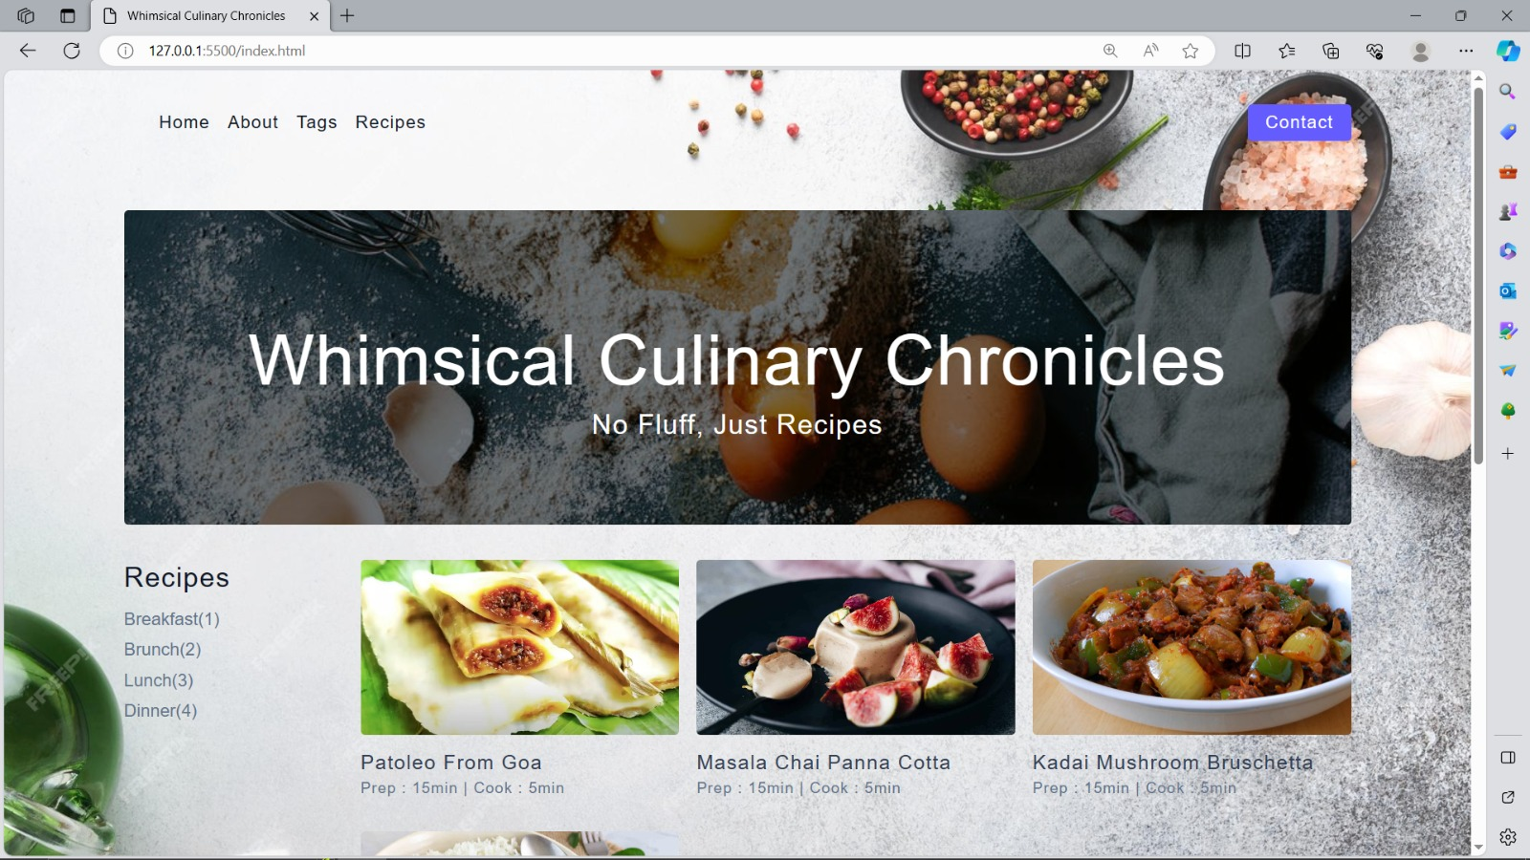

Fig 6.1: Home page

The Figure 6.1 shows the home page of the project

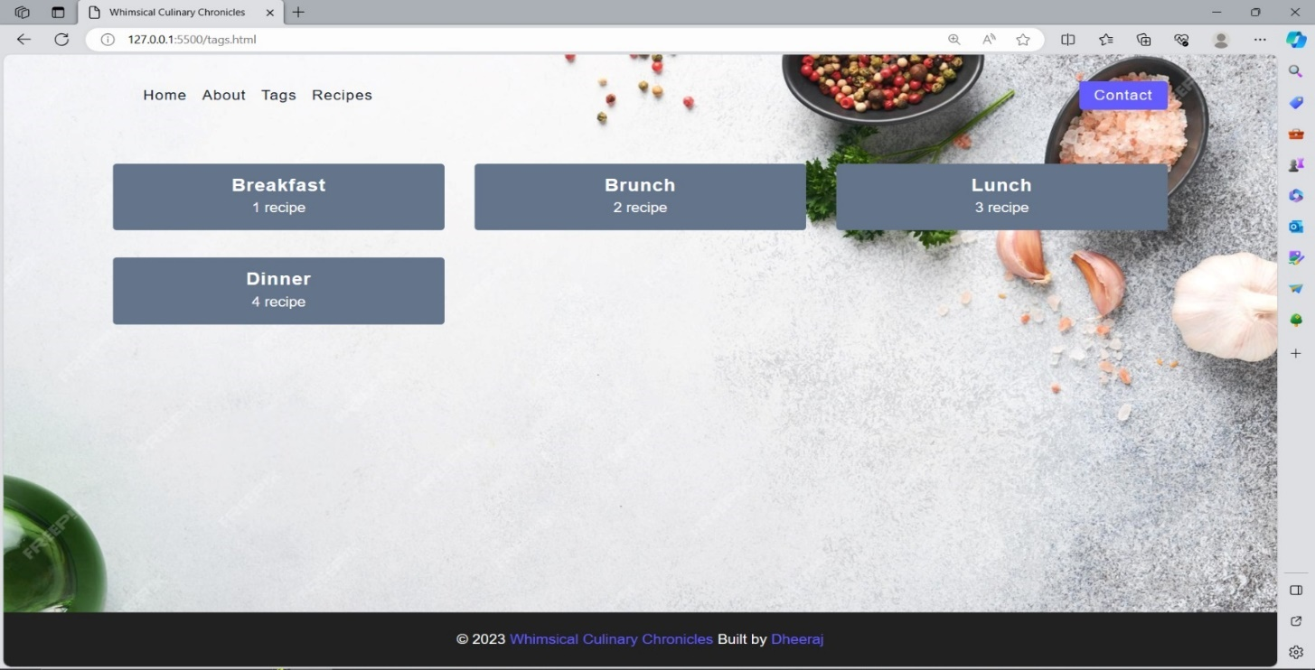

Fig 6.2: display of recipies

The Figure 6.2 shows that the display for recipies

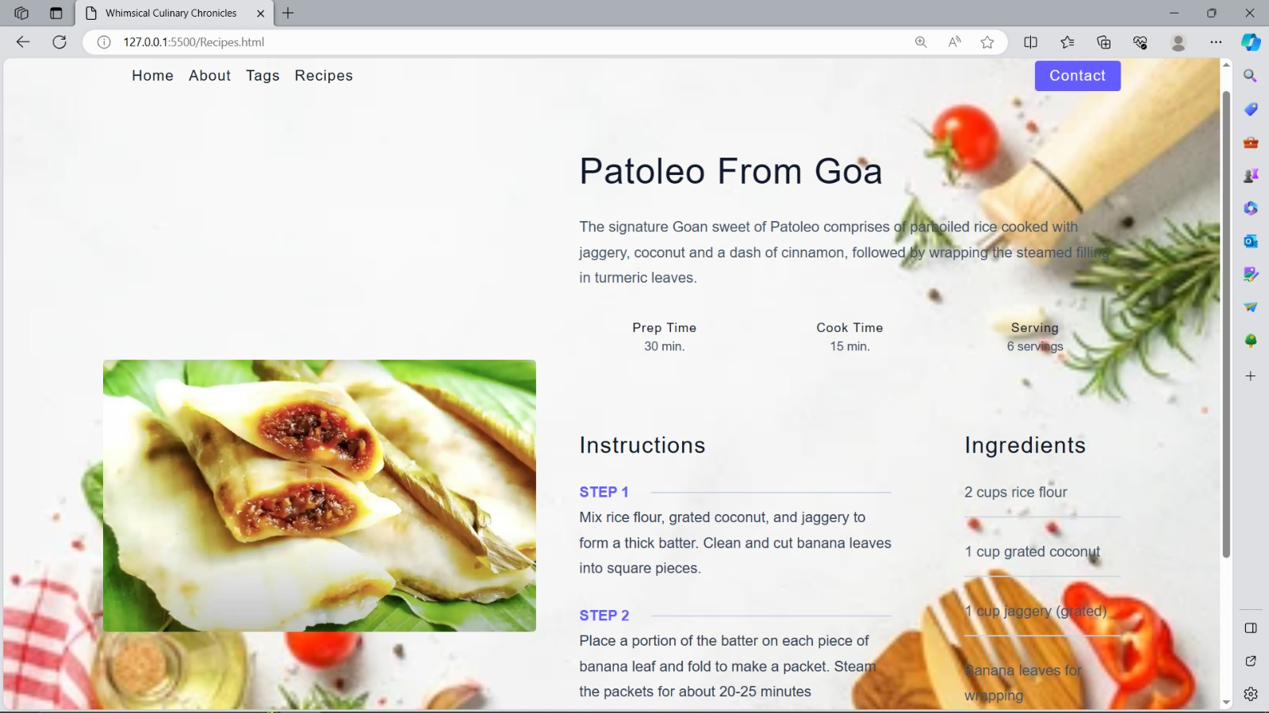

Fig 6.3: display of individual recipe page

The Figure 6.3 shows the display of individual recipe page

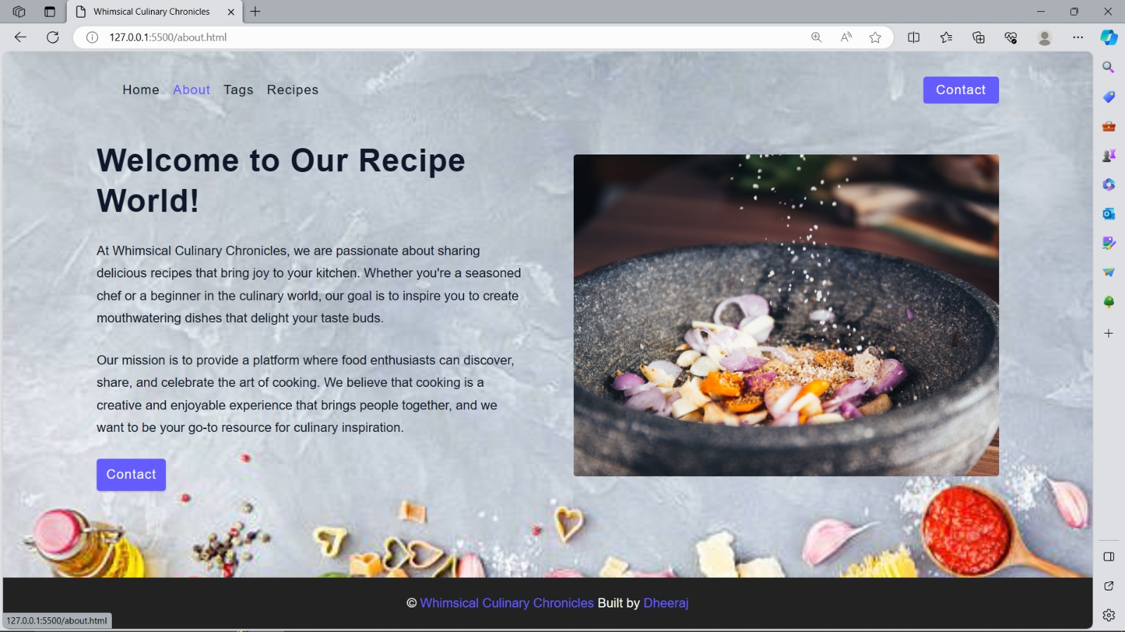

Fig 6.4: About page

The Figure 6.4 display about page

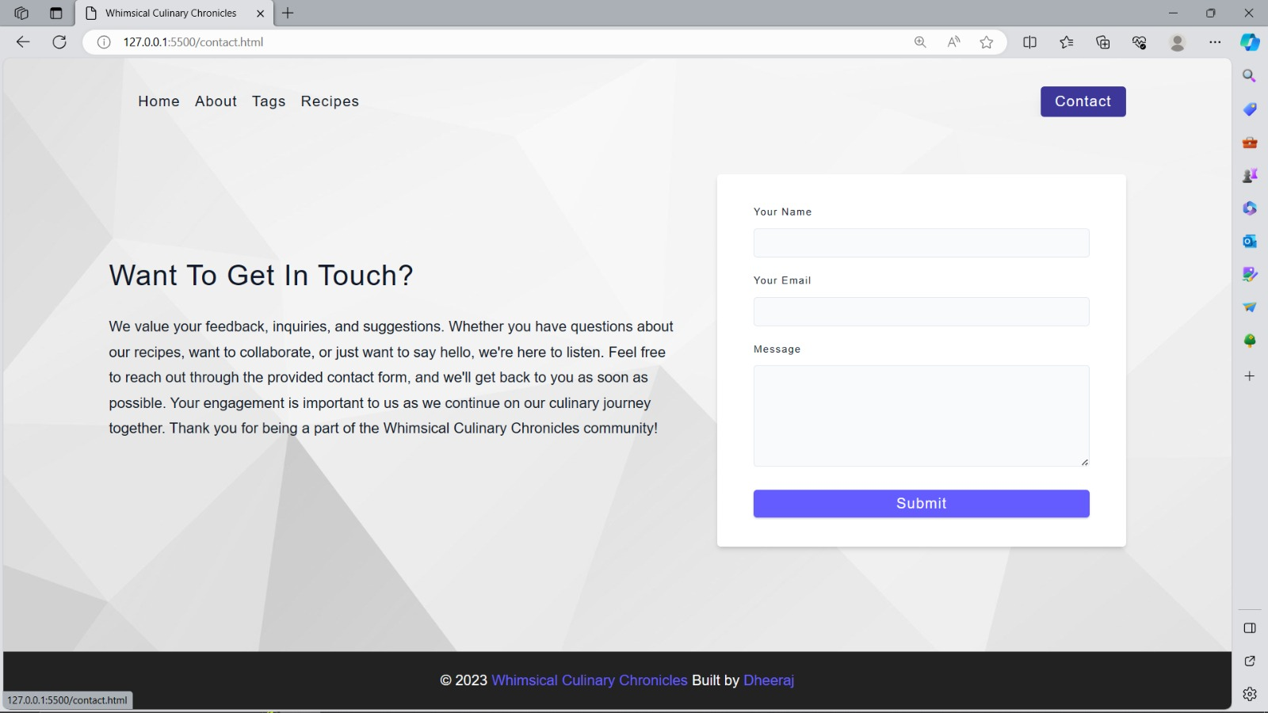

Fig 6.6: Contact Page

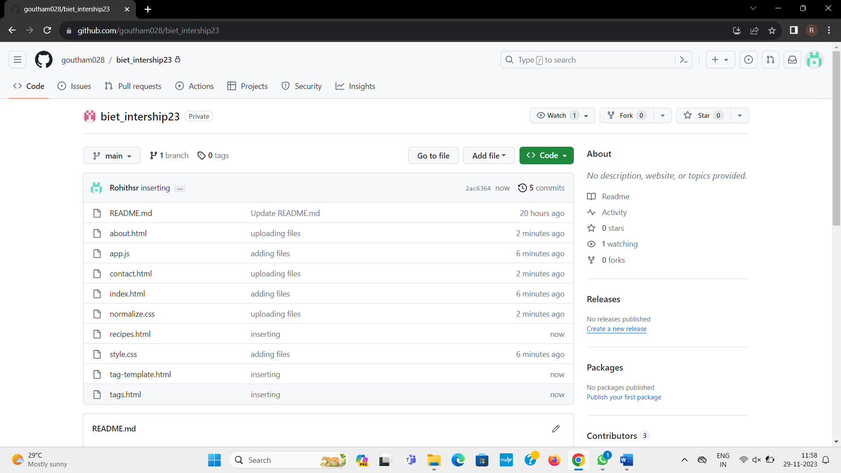

**Fig: github commits by group members**

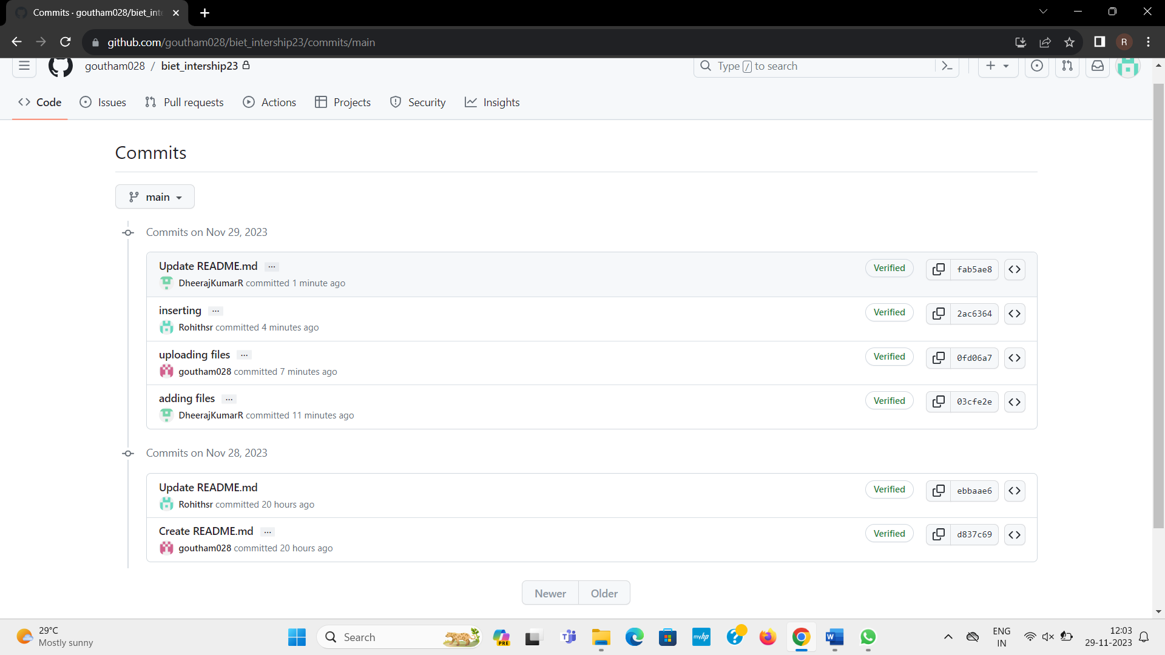

## CONCLUSION

The activities on Agile methodology, DevOps concepts and cloud computing have been learnt and demonstrated. By considering a case study of a” Whimsical Culinary Chronicles ” project, the Agile process, DevOps workflow have been implemented.

The detailed understanding of concepts on CI and CD has made. Git facilitated distributed version control and access control, it enabled us to work on different parts of our project Individually.

## REFERENCES

###### Links:

* https://[www.jenkins.io/doc/book/installing/](http://www.jenkins.io/doc/book/installing/)
* https://docs.cypress.io/guides/end-to-end-testing/writing-your-first-end-to-end-test

###### Text books:

* DevOps for Beginners – Joseph Joyner
* Effective DevOps with AWS: Implement continuous delivery and integration in the AWS environment, 2nd Edition – Yogesh Raheja
* Modern DevOps Practices: Implement and secure DevOps in the public cloud with cutting-edge tools, tips, tricks, and techniques – Gaurav Agarwal