**Name: Sachin Vadhel**

**Subject name: Information & Learning procedure**

**Prof. Name: Dr. Anna Androvitsanea**

**Topic name: India: Unemployment, population, life expectancy and GDP. Men and women**

**Index**

Introduction about topic..................................................................................(1)

Step by step procedure....................................................................................(2)

What is pandas?............................................................................................(2.1)

What is matplotlib?.......................................................................................(2.3)

India unemployment rate(male)…....................................................................(3)

India unemployment rate(female)…................................................................(4)

Question 1?...................................................................................................(4.1)

India life expectancy rate(male)…....................................................................(5)

India life expectancy rate(female)….................................................................(6)

Question 2?...................................................................................................(6.1)

India population(male)…..................................................................................(7)

India population(female)…...............................................................................(8)

Question 3?...................................................................................................(8.1)

India GDP..........................................................................................................(9)

Question 4?...................................................................................................(9.1)

Question 5?...................................................................................................(9.2)

Question 6?...................................................................................................(9.3)

Question 7?....................................................................................................(10)

Question 8?....................................................................................................(11)

Conclusion......................................................................................................(12)

1. **Introduction about topic:**

Well, the topic name is india unemployment, population, life expectancy and GDP. Men and women and we are going to use jupyter notebook for execution of the data. Firstly, we need the data in .csv file and be remember data must have column wise because you must define x axis and y axis to make a line graph.

1. **Step by step procedure**

**What** **is pandas?**

We require pandas library it is a Python library for data manipulation and analysis. It provides data structures for efficiently storing and manipulating data, and functions for performing operations on data like filtering, grouping, aggregation, and merging. It can perform data Frame is a two-dimensional tabular data structure that consists of rows and columns, like a spreadsheet.

To use Pandas, you need to first install the library using a package manager like pip. Once installed, you can import the Pandas library into your Python script or Jupyter Notebook using the **import pandas as pd** statement.

After importing the library, you can use Pandas to read in data from various file formats like CSV, Excel, JSON, SQL databases, and more. Pandas can then manipulate and analyse the data using its built-in functions and methods.

**(2.1)What is matplotlib?**

Matplotlib is a popular data visualization library in Python that is used to create high-quality graphs, charts, and other types of visualizations. It provides a wide range of tools to create different types of visualizations, including line plots, scatter plots, bar plots, histograms, heatmaps, and more.

To use Matplotlib for graphing, you first need to install the library using a package manager like pip. Once you have Matplotlib installed, you can import it into your Python script or Jupyter notebook using the following command:

import matplotlib.pyplot as plt

1. Import the library: The first step is to import the Matplotlib library using the import statement. Typically, you will also give it an alias, such as **import matplotlib.pyplot as pl**t.
2. Create the data: You will need to create the data that you want to plot. This may involve reading data from a file, generating data using Python code, or loading data from a database.
3. Create the plot: You can create a plot using one of the many plotting functions provided by Matplotlib, such as**plot(),** **scatter(),** **bar(),** **hist(), or imshow()**. You will pass in the data to these functions, along with any other arguments that control the appearance of the plot.
4. Customize the plot: You can customize the plot in many ways, such as changing the colors, labels, title, legend, axis limits, and other visual elements. Matplotlib provides a wide range of customization options, and you can usually achieve any desired effect with a few lines of code.
5. Save or display the plot: You can either save the plot to a file, such as a **PNG, PDF, or SVG** file, using the **savefig()** function, or display it on the screen using the **show()** function.
6. Matplotlib is a versatile library that can handle a wide range of data and produce high-quality graphs and visualizations. With a bit of practice and experimentation, you can create beautiful and informative graphs that help you understand and communicate your data.

**3. India unemployment rate(men)**

# import necessary libraries

import pandas as pd

import matplotlib.pyplot as plt

# get input data

df = pd.read_csv('unemploymentratemen.csv')

df.plot(x='Years', y='unemployment rate of india(%)')

plt.title('Unemployment rate of men 1990-2020')

plt.xlabel("Years")

plt.ylabel("rate in percentage(%)")

plt.show()

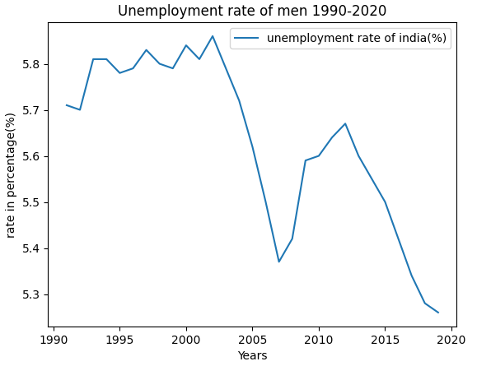

**4. India unemployment rate(female)**

# import necessary libraries

import pandas as pd

import matplotlib.pyplot as plt

# get input data

df = pd.read_csv('unemploymentratewomen.csv')

df.plot(x='Years', y='unemployment rate of india(%)')

plt.title('Unemployment rate of men 1990-2020')

plt.xlabel("Years")

plt.ylabel("rate in percentage(%)")

plt.show()

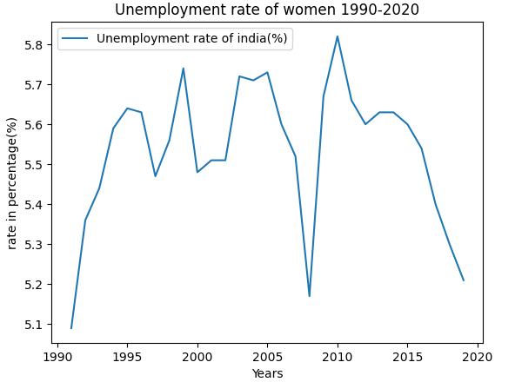

**(4.1) Question 1: Which gender is more likely to be unempoyed?**

**Answer:**

According to the World Bank, the female unemployment rate in India was higher than the male unemployment rate in 2019.

In 2019, the female unemployment rate in India was 5.21%, while the male unemployment rate was 3.8%. This suggests that females are more likely to be unemployed in India compared to males.

There are several reasons for this gender disparity in unemployment in India. One of the primary reasons is that women face significant social and cultural barriers to workforce participation, particularly in certain parts of the country. This can include limited access to education and training, as well as discrimination and harassment in the workplace.

**5. India life expectancy rate(male)**

# import necessary libraries

import pandas as pd

import matplotlib.pyplot as plt

# get input data

df = pd.read_csv('lifeexpectancymale.csv')

df.plot(x='Years', y='Life expectancy rate in years(male)')

plt.title('Life expectancy rate male 1960-2019')

plt.xlabel("Years")

plt.ylabel("totel years")

plt.show()

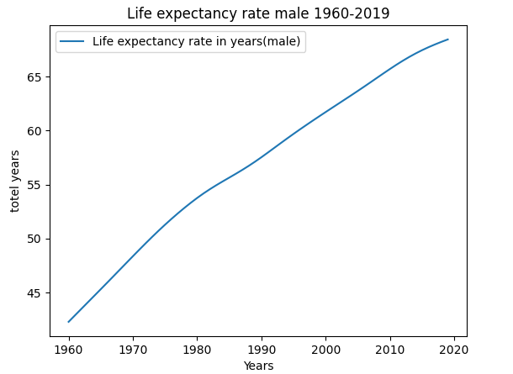

**6. India life expectancy rate(female)**

# import necessary libraries

import pandas as pd

import matplotlib.pyplot as plt

# get input data

df = pd.read_csv('indiapopulationfemale.csv')

df.plot(x='Years', y='Population of india(female)')

plt.title('india population of female 1960-2020')

plt.xlabel("Years")

plt.ylabel("totel years")

plt.show()

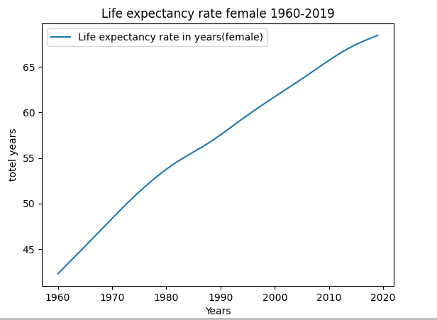

**(6.1) Question 2: Which gender has a bigger life expectancy?**

Answer:

As of 2019, the life expectancy in India is around 68.46 years for males and around 71 years for females.

Therefore, females have a slightly higher life expectancy than males in India.

This pattern is consistent with global trends, where females tend to have higher life expectancies than males. However, it is worth noting that life expectancy can vary depending on factors such as access to healthcare, socioeconomic status, and lifestyle choices.

1. **India population(male)**

# import necessary libraries

import pandas as pd

import matplotlib.pyplot as plt

# get input data

df = pd.read_csv('indiapopultionmale.csv')

df.plot(x='Years', y='Population of india(male)')

plt.title('india population of male 1960-2020')

plt.xlabel("Years")

plt.ylabel("Population in millions")

plt.show()

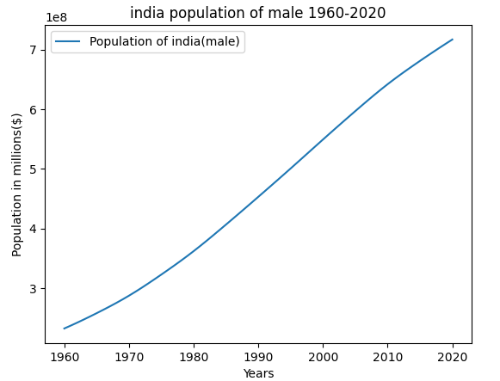

1. **India population(female)**

# import necessary libraries

import pandas as pd

import matplotlib.pyplot as plt

# get input data

df = pd.read_csv('indiapopulationfemale.csv')

df.plot(x='Years', y='Population of india(female)')

plt.title('india population of female 1960-2020')

plt.xlabel("Years")

plt.ylabel("Population in millions($)")

plt.show()

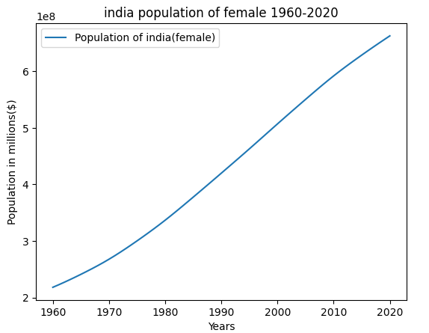

**(8.1) Question 3: Which gender forms the bigger part regarding India's population?**

Answer:

According to the World bank in 2011, the population of India is approximately 1.21 billion, with males comprising about 51.7% (623.7 million) of the population and females about 48.3% (586.5 million) of the population.

1. **India GDP**

# import necessary libraries

import pandas as pd

import matplotlib.pyplot as plt

# get input data

df = pd.read_csv('indiaGDP.csv')

df.plot(x='Years', y='GDP( Billions of US $)')

plt.title('GDP of india')

plt.xlabel("Years")

plt.ylabel("amount in billion")

plt.show()

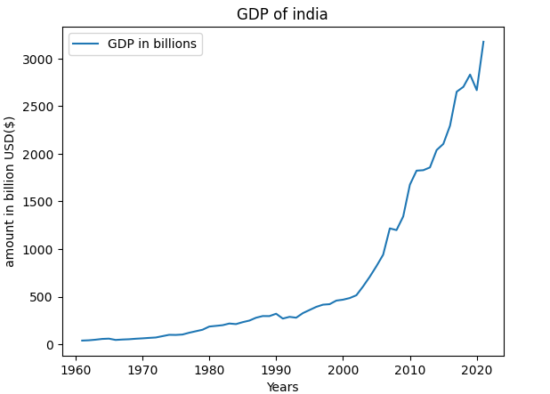

**(9.1) Question 4: Is there any connection between GDP and unemployment?**

**Answer:**

the relationship between GDP and unemployment in India is not always straightforward, and there are several factors that can affect the link between these two variables.

For example, India has a large informal economy, which is not always captured in official GDP statistics, and therefore may not necessarily result in direct job creation.

Additionally, changes in technology, government policies, and global economic conditions can also influence the relationship between GDP and unemployment.

Overall, while there is a general relationship between GDP and unemployment in India, it is important to consider other factors that may affect the dynamics of the labour market and the economy.

import pandas as pd

# Read the first CSV file into a pandas dataframe

df1 = pd.read_csv('gdpindia.csv')

# Read the second CSV file into a pandas dataframe

df2 = pd.read_csv('indiapopultionmale.csv')

# Select the same two columns from each dataframe

#col1_df1 = df1['Years']

col2_df1 = df1['GDP of india in billion']

#col1_df2 = df2['Years']

col2_df2 = df2['Population of india(male)']

# Calculate correlation coefficient between the two columns from each dataframe

corr_coef = col2_df1.corr(col2_df2)

# Print the result

print(f"Correlation coefficient between column1 and column2: {corr_coef}")

**Output:**

Correlation coefficient between GDP of india in and unemployment rate of india is: 0.8577721014361375

**(9.2) Question 5: Is there any connection between GDP and life expectancy?**

**Answer:**

The relationship between GDP and life expectancy can be explained by several factors.

First, higher GDP usually means that a country has more resources available for investing in healthcare, education, and other social services that can promote better health outcomes.

Second, higher GDP also tends to be associated with higher levels of economic development, which can lead to improvements in sanitation, access to clean water, and other environmental factors that can affect health.

Third, higher GDP can also lead to increased access to nutrition and better living standards, which can contribute to better health outcomes and increased life expectancy.

import pandas as pd

# Read the first CSV file into a pandas dataframe

df1 = pd.read_csv('gdpindia.csv')

# Read the second CSV file into a pandas dataframe

df2 = pd.read_csv('lifeexpectancymale.csv')

# Select the same two columns from each dataframe

#col1_df1 = df1['Years']

col2_df1 = df1['GDP of india in billion']

#col1_df2 = df2['Years']

col2_df2 = df2['Life expectancy rate in years(male)']

# Calculate correlation coefficient between the two columns from each dataframe

corr_coef = col2_df1.corr(col2_df2)

# Print the result

print(f"Correlation coefficient between GDP of india in and lifeexpectancy rate of india is: {corr_coef}")

**Output:**

Correlation coefficient between GDP of india in and lifeexpectancy rate of india is: 0.8004102288221597

**(9.3) Question 6: Is there any connection between GDP and population?**

**Answer:**

there has been a significant increase in GDP per capita over the past few decades, which has been accompanied by a decline in population growth rates.

However, India still has one of the largest populations in the world, and population growth continues to be a major concern for policymakers.

Overall, while there is a connection between GDP and population in India, it is important to note that other factors, such as social and cultural factors, government policies, and access to education and healthcare, also play a significant role in determining population growth rates.

import pandas as pd

# Read the first CSV file into a pandas dataframe

df1 = pd.read_csv('gdpindia.csv')

# Read the second CSV file into a pandas dataframe

df2 = pd.read_csv('indiapopultionmale.csv')

# Select the same two columns from each dataframe

#col1_df1 = df1['Years']

col2_df1 = df1['GDP of india in billion']

#col1_df2 = df2['Years']

col2_df2 = df2['Population of india(male)']

# Calculate correlation coefficient between the two columns from each dataframe

corr_coef = col2_df1.corr(col2_df2)

# Print the result

print(f"Correlation coefficient between GDP of india in and Population of india(male) is: {corr_coef}")

**Output:**

Correlation coefficient between GDP of india in and Population of india(male) is: 0.8577721014361375

**(10) Question 7: Is there any connection between unemployment and life expectancy?**

**Answer:**

the relationship between unemployment and life expectancy in India is not straightforward. India has a large informal economy and a high level of poverty, which means that many people who are technically unemployed may still be engaged in some form of informal work or subsistence farming. Additionally, access to healthcare, sanitation, and nutrition can have a greater impact on life expectancy than employment status alone.

Overall, while there may be a connection between unemployment and life expectancy in India, it is important to consider other factors such as access to healthcare, nutrition, and education, as well as social and economic factors such as poverty and inequality

import pandas as pd

# Read the first CSV file into a pandas dataframe

df1 = pd.read_csv('unemploymentratemen.csv')

# Read the second CSV file into a pandas dataframe

df2 = pd.read_csv('lifeexpectancymale.csv')

# Select the same two columns from each dataframe

#col1_df1 = df1['Years']

col2_df1 = df1['unemployment rate of india(%)']

#col1_df2 = df2['Years']

col2_df2 = df2['Life expectancy rate in years(male)']

# Calculate correlation coefficient between the two columns from each dataframe

corr_coef = col2_df1.corr(col2_df2)

# Print the result

print(f"Correlation coefficient between unemployment rate and Life expectancy rate(male) is: {corr_coef}")

**Output:**

Correlation coefficient between unemployment rate and Life expectancy rate(male) is: -0.7770728194800688

The output clearly shows there is no any connection between unemployment rate and life expectancy in india

**(11)Question 8: Is there any connection between life expectancy and population?**

**Answer:**

the relationship between population and life expectancy in India is not straightforward. India has made significant progress in improving life expectancy over the past few decades, despite having one of the largest populations in the world. This can be attributed to a range of factors such as improved access to healthcare, sanitation, and nutrition, as well as advancements in medical technology.

This suggests that there is not necessarily a direct link between population growth and life expectancy, and that other factors such as access to healthcare and social and economic development may have a greater impact on health outcomes.

Overall, while there may be a connection between life expectancy and population in India, it is important to consider other factors such as access to healthcare, nutrition, and education, as well as social and economic factors such as poverty and inequality.

import pandas as pd

# Read the first CSV file into a pandas dataframe

df1 = pd.read_csv('lifeexpectancymale.csv')

# Read the second CSV file into a pandas dataframe

df2 = pd.read_csv('indiapopultionmale.csv')

# Select the same two columns from each dataframe

#col1_df1 = df1['Years']

col2_df1 = df1['Life expectancy rate in years(male)']

#col1_df2 = df2['Years']

col2_df2 = df2['Population of india(male)']

# Calculate correlation coefficient between the two columns from each dataframe

corr_coef = col2_df1.corr(col2_df2)

# Print the result

print(f"Correlation coefficient between Life expectancy rate and population of india(male) is: {corr_coef}")

**Output:**

Correlation coefficient between Life expectancy rate and population of india(male) is: **0.988212033291134**

This output define there is many similarities between life expectancy rate and population of india

**(12)Conclusion**

To conclude, loading a CSV file into Python is a common task when working with data. Python provides several libraries that make it easy to load and manipulate CSV files, such as Pandas, NumPy, and CSV.

Once the CSV file is loaded, we can use various Python libraries, such as Matplotlib, Seaborn, or Plotly, to create graphs and visualizations from the data. These libraries provide a range of options for customizing the graphs, including selecting the type of graph, adding titles and labels, adjusting the colors, and more.

If we talk about the data of india, there are complex and indirect connections between GDP, population, unemployment, and life expectancy in India. While these factors can have some impact on each other, other factors such as access to healthcare, sanitation, nutrition, education, and social and economic development can also play a significant role in determining health outcomes.

India has made significant progress in improving life expectancy over the past few decades, despite having one of the largest populations in the world. This can be attributed to a range of factors such as improved access to healthcare, sanitation, and nutrition, as well as advancements in medical technology.

However, there are still significant disparities in health outcomes between different regions of the country, and addressing these disparities will require continued investment in healthcare infrastructure, education, and social services.

Overall, while there are connections between these various factors, it is important to consider each factor individually as well as how they interact with each other to gain a better understanding of the complex dynamics that affect health outcomes in India.