SVKM’s NMIMS
Mukesh Patel School of Technology Management & Engineering Department of Artificial Intelligence

Subject: Random Process and Estimation techniques Program: B tech AI
Sem: III

Faculty: Prof. Kapil Rathor

AY: 2025-2026

List of Experiments

Sr. no | AIM of the experiment | Date of submission
1 | To calculate the Probability and CDF of a random experiment and demonstrate the results in table format Using Python | 17/07/2025

EXPERIMENT 1

Roll No.: I065 | Name: Ninaad Wagle
Prog/Yr/Sem: BTECH AI SEM III | Batch: B2
Date of Experiment: 15-07-2025 | Date of Submission: 29-07-2025

Aim –
To calculate the Probability and CDF of a random experiment and demonstrate the results in table format.

Theory –
- Probability:- Probability is a measure of the likelihood of an event to occur. Many events cannot be predicted with total certainty. We can predict only the chance of an event to occur i.e., how likely they are going to happen, using it. Probability can range from 0 to 1, where 0 means the event to be an impossible one and 1 indicates a certain event. The probability of all the events in a sample space adds up to 1.
For example, when we toss a coin, either we get Head OR Tail, only two possible outcomes are possible (H, T). But when two coins are tossed then there will be four possible outcomes, i.e. {(H, H), (H, T), (T, H), (T, T)}

- PMF:- The Probability Mass function, which accepts all arguments of any real number, is defined on all values of R. When the argument value is equal to zero, it does not belong to the value of X, and when it does, the PMF value should be positive.
The probability mass function is usually the primary component of defining a discrete probability distribution, but it differs from the probability density function (PDF) where it produces distinct outcomes. This is the reason why probability mass function is used in computer programming and statistical modelling.

- CDF:- The Cumulative Distribution Function (CDF), of a real-valued random variable X, evaluated at x, is the probability function that X will take a value less than or equal to x. It is used to describe the probability distribution of random variables in a table. And with the help of these data, we can easily create a CDF plot in an excel sheet.
In other words, CDF finds the cumulative probability for the given value. To determine the probability of a random variable, it is used and also to compare the probability between values under certain conditions. For discrete distribution functions, CDF gives the probability values till what we specify and for continuous distribution functions, it gives the area under the probability density function up to the given value specified.

1 ) To calculate the PMF and CDF when coin is tossed ‘n’ times.
Output:-
import pandas as pd
import numpy as np
c=0
d=0
n=10000
for i in range(n):
a=np.random.randint(2)
if a==0:
c+=1
else:
d+=1
data = {
'Sample Space': ['Heads', 'Tails'],
'Count': [c, d],
'PMF': [c/n, d/n],
'PDF': [c/n, (c+d)/n],
}
df = pd.DataFrame(data)

df

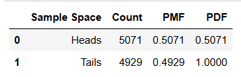

c=0
d=0
n=20
for i in range(n):
a=np.random.randint(2)
if a==0:
c+=1
else:
d+=1
data = {
'Sample Space': ['Heads', 'Tails'],
'Count': [c, d],
'PMF': [c/n, d/n],
'PDF': [c/n, (c+d)/n],
}
df = pd.DataFrame(data)

df

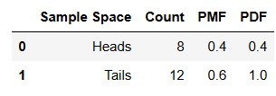

2) To calculate the PMF and CDF when dice is thrown ‘n’ times

Output:-

import pandas as pd
import numpy as np
c=0
d=0
e=0
f=0
g=0
h=0
n=100000
for i in range(n):
a=np.random.randint(6)
if a==1:
c+=1
elif a==2:
d+=1
elif a==3:
e+=1
elif a==4:
f+=1
elif a==5:
g+=1
else:
h+=1
data = {
'Sample Space': [1, 2, 3, 4, 5, 6],
'Count': [c,d,e,f,g,h],
'PMF': [c/n, d/n, e/n, f/n, g/n, h/n],
'PDF': [c/n, (c+d)/n, (c+d+e)/n, (c+d+e+f)/n, (c+d+e+f+g)/n, (c+d+e+f+g+h)/n],
}
df = pd.DataFrame(data)
df
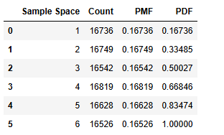

import pandas as pd
import numpy as np
c=0
d=0
e=0
f=0
g=0
h=0
n=20
for i in range(n):
a=np.random.randint(6)
if a==1:
c+=1
elif a==2:
d+=1
elif a==3:
e+=1
elif a==4:
f+=1
elif a==5:
g+=1
else:
h+=1
data = {
'Sample Space': [1, 2, 3, 4, 5, 6],
'Count': [c,d,e,f,g,h],
'PMF': [c/n, d/n, e/n, f/n, g/n, h/n],
'PDF': [c/n, (c+d)/n, (c+d+e)/n, (c+d+e+f)/n, (c+d+e+f+g)/n, (c+d+e+f+g+h)/n],
}
df = pd.DataFrame(data)
df
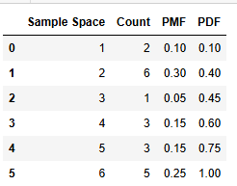

Conclusion:- From the outputs of the experiments, we can infer that the observed probability mean functions of the events almost match the expected values of the same when the size of the sample is a big number.
In case of smaller sample size, the probability mean functions vary from the expected values.

