**CN1 Project-1: Client-Server Using HTTP**

**Name: Sachin Ravindra Wani**

**Student ID: 1001563321**

**Files:**

1. cn_server.py – server core functionality
2. cn_client.py – client core functionality
3. demo.txt – demo text file with some text
4. index.html – demo html file

**How to execute?**

The code is written in python (version 3.7), using http.server and http.client libraries

To execute follow these steps:

1. Install python 3 or above
2. Open cmd and type: python cn_server.py to start the server

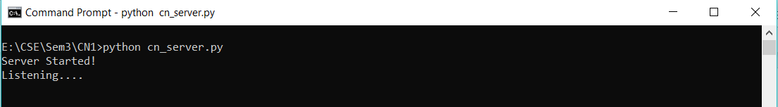

1. Open another cmd and type: python cn_client.py to start the client. On start client will ask you to enter file name. Enter ‘demo.txt’ or ‘index.html’

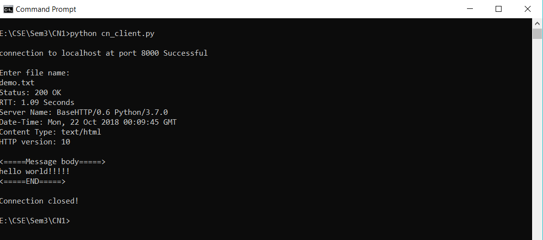

1. Now check the server cmd to find out information about client request

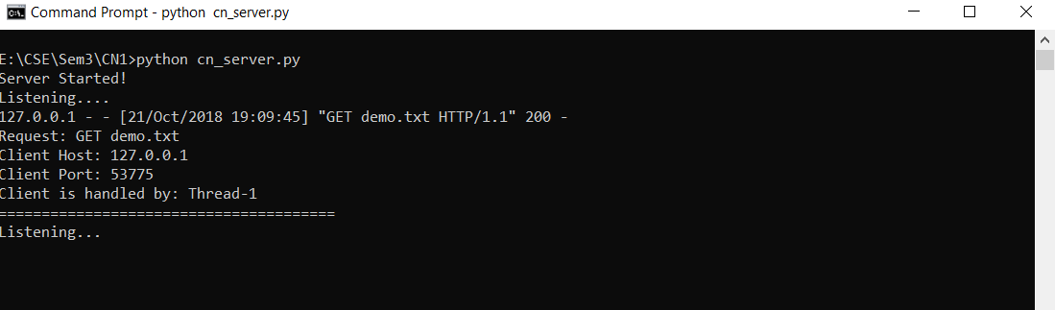

1. To test in the browser,
2. Start the server using step 1
3. Open the browser and type in URL as: 127.0.0.1: 8000/index.html
4. If you try to access some file which is not on the server, it will respond with 404 Not Found.

**Assumptions:**

1. Server and client are running on the same host.
2. Server will be online before any client tries to connect

**References:**

How to create web server in python: https://wiki.python.org/moin/BaseHttpServer