DrishtiX v3.0 — Architectural Diagrams & Visual Models
Print-Optimized High-DPI Visualizations & Schema Specifications

DrishtiX v3.0 — Repository-Accurate Architectural Diagrams
All diagrams are based on a complete scan of the DrishtiX repository at d:\TY-IT\Enterprise_Java\Java_project\services\drishtix-app\.
Every class name, method call, thread pool name, and collection field is traced directly to source code.

1. System Flowchart — Video Capture to UI Alert
Source files: DashboardController.java, DnnFaceDetectionService.java, DnnFaceRecognitionService.java, AlertService.java

Diagram 1: 1. System Flowchart — Video Capture to UI Alert
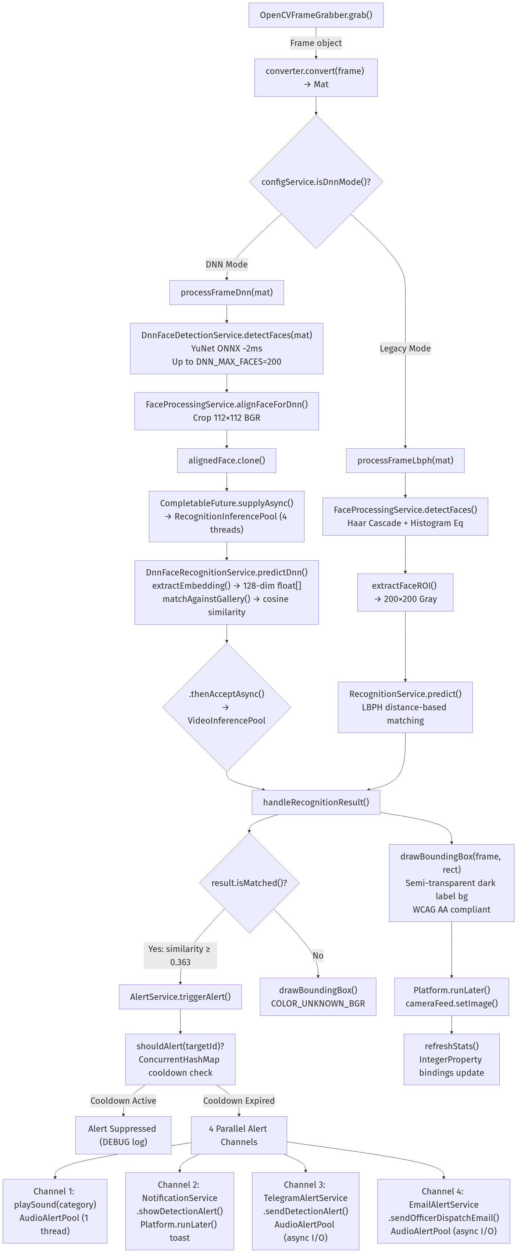
Figure 1: High-Resolution Landscape Diagram (Print-Scaled 24px Font)

2. ER Diagram — MongoDB Schema
Source files: drishtix_init.js, TargetDAO.java, DetectionLogDAO.java, PersonEmbeddingDAO.java

Diagram 2: 2. ER Diagram — MongoDB Schema
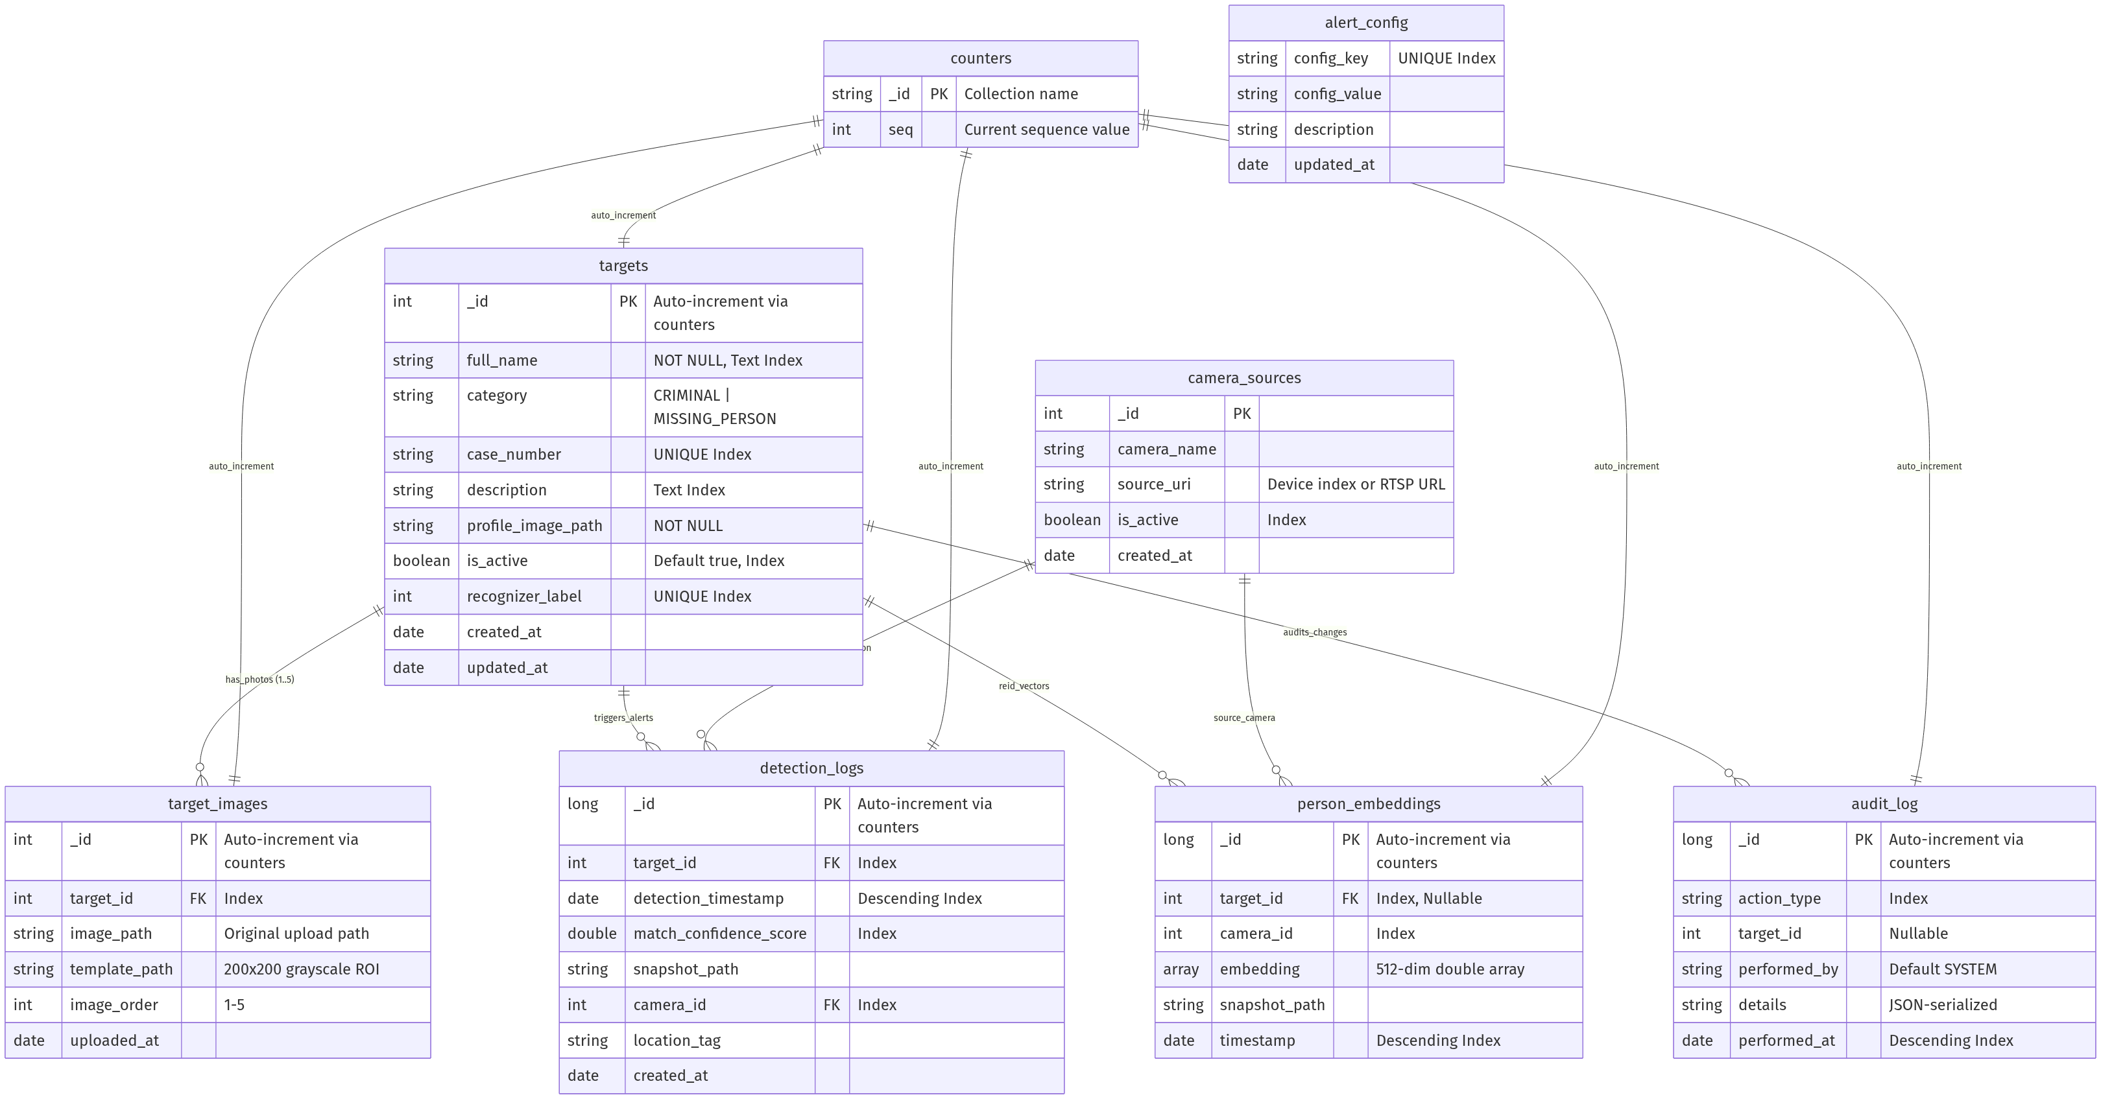
Figure 2: High-Resolution Landscape Diagram (Print-Scaled 24px Font)

3. Table Design — Complete Field Specifications

Collection: `targets`
Field | BSON Type | Constraint | Index | Source: TargetDAO.mapDocument()
_id | Integer | PK (auto-increment via counters) | Primary | doc.getInteger("_id")
full_name | String | NOT NULL | Text Index (compound with description) | doc.getString("full_name")
category | String | Enum: "CRIMINAL", "MISSING_PERSON" | Secondary | TargetCategory.fromDbValue(doc.getString("category"))
case_number | String | UNIQUE | Unique Index | doc.getString("case_number")
description | String | Nullable | Text Index (compound) | doc.getString("description")
profile_image_path | String | NOT NULL | — | doc.getString("profile_image_path")
is_active | Boolean | Default: true | Secondary | doc.getBoolean("is_active", true)
recognizer_label | Integer | UNIQUE | Unique Index | doc.getInteger("recognizer_label", 0)
created_at | Date | Auto-populated | — | doc.getDate("created_at")
updated_at | Date | Auto-populated | — | doc.getDate("updated_at")

Collection: `target_images`
Field | BSON Type | Constraint | Index | Source: TargetImageDAO
_id | Integer | PK (auto-increment) | Primary | Auto-generated
target_id | Integer | FK → targets._id | Secondary | Application-managed cascade
image_path | String | NOT NULL | — | Original uploaded image
template_path | String | NOT NULL | — | 200×200 grayscale ROI
image_order | Integer | Range: 1–5 | — | MAX_PHOTOS_PER_TARGET = 5
uploaded_at | Date | Auto-populated | —

Collection: `detection_logs`
Field | BSON Type | Constraint | Index | Source: DetectionLogDAO
_id | Long | PK (auto-increment) | Primary | getNextSequenceLong("detection_logs")
target_id | Integer | FK → targets._id | Secondary
detection_timestamp | Date | NOT NULL | Descending | Sorted newest-first
match_confidence_score | Double | NOT NULL | Secondary | LBPH distance or cosine similarity
snapshot_path | String | Nullable | — | Annotated frame PNG
camera_id | Integer | FK → camera_sources._id | Secondary
location_tag | String | Nullable | — | Optional geolocation
created_at | Date | Auto-populated | —

4. Process Flow — Background Ingestion Engine
Source: BackgroundIngestionEngine.java, FbiWantedApiClient.java, CbiWantedScraper.java, TrackChildScraper.java

Diagram 3: 4. Process Flow — Background Ingestion Engine
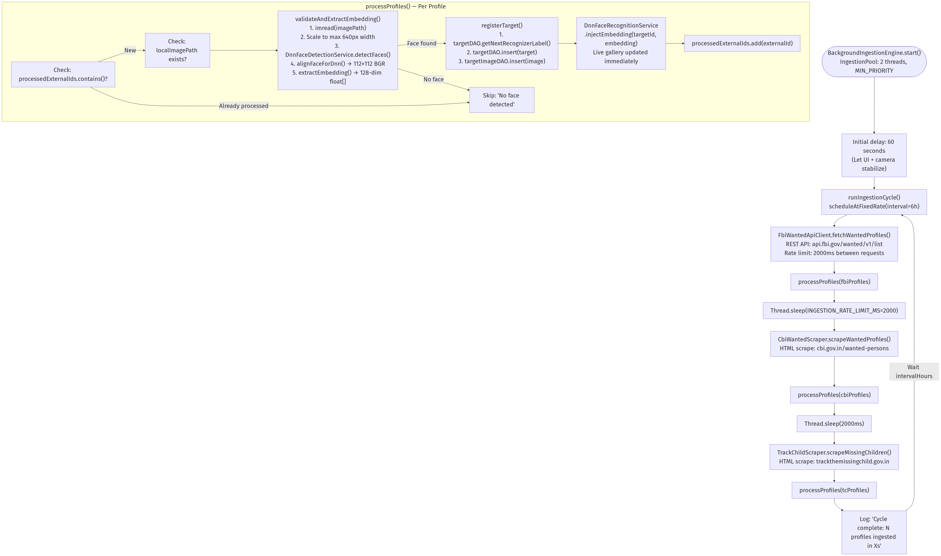
Figure 3: High-Resolution Landscape Diagram (Print-Scaled 24px Font)

5. DFD Level 0 — Context Diagram

Diagram 4: 5. DFD Level 0 — Context Diagram
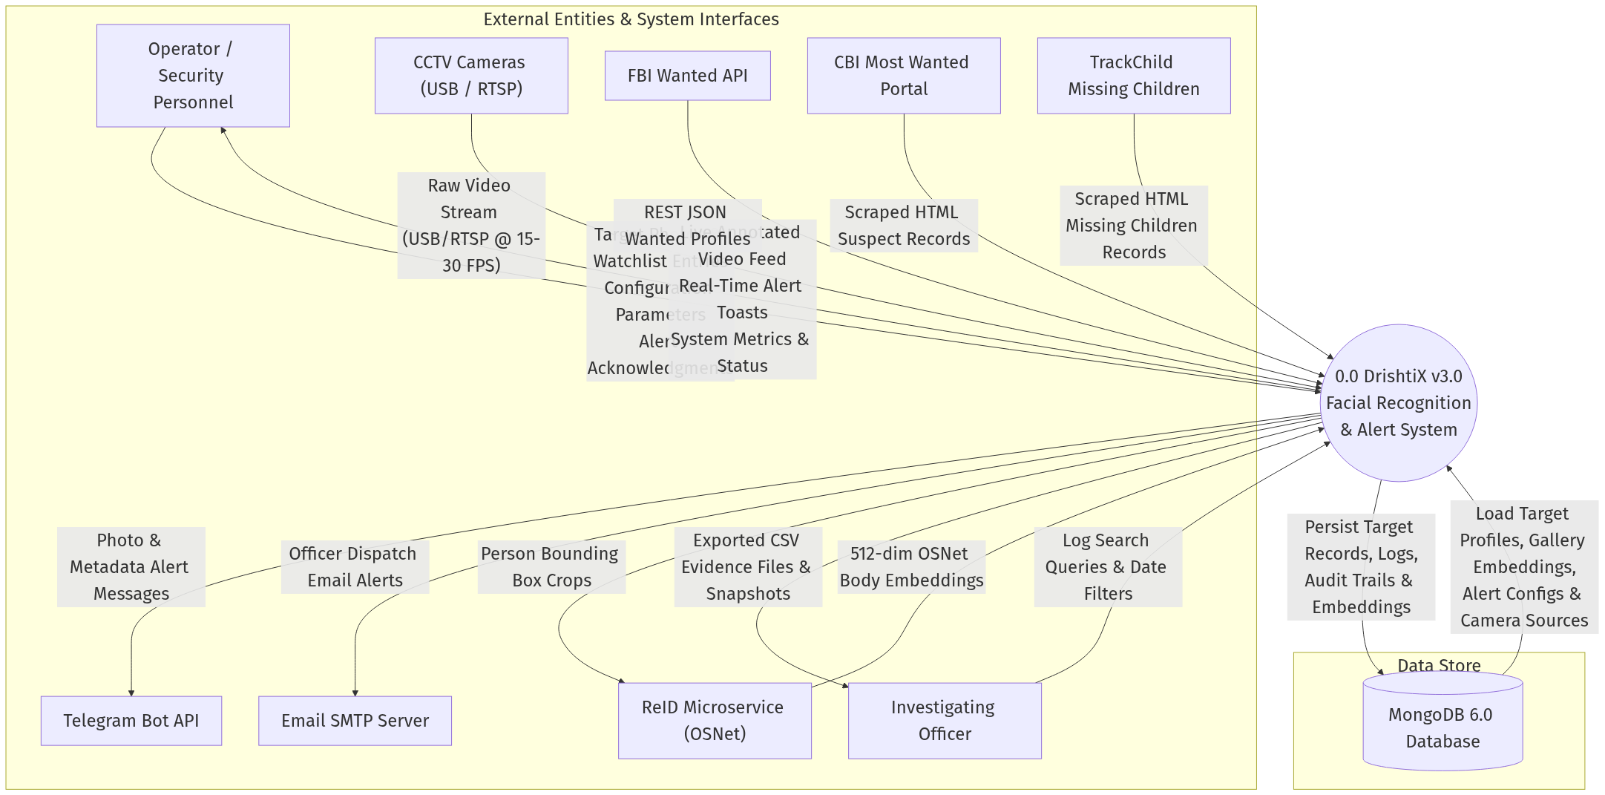
Figure 4: High-Resolution Landscape Diagram (Print-Scaled 24px Font)

6. DFD Level 1 — Module Decomposition

Diagram 5: 6. DFD Level 1 — Module Decomposition
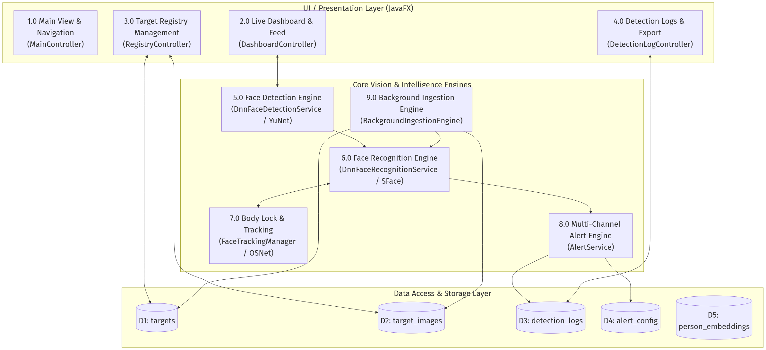
Figure 5: High-Resolution Landscape Diagram (Print-Scaled 24px Font)

Diagram 6: 6. DFD Level 1 — Module Decomposition
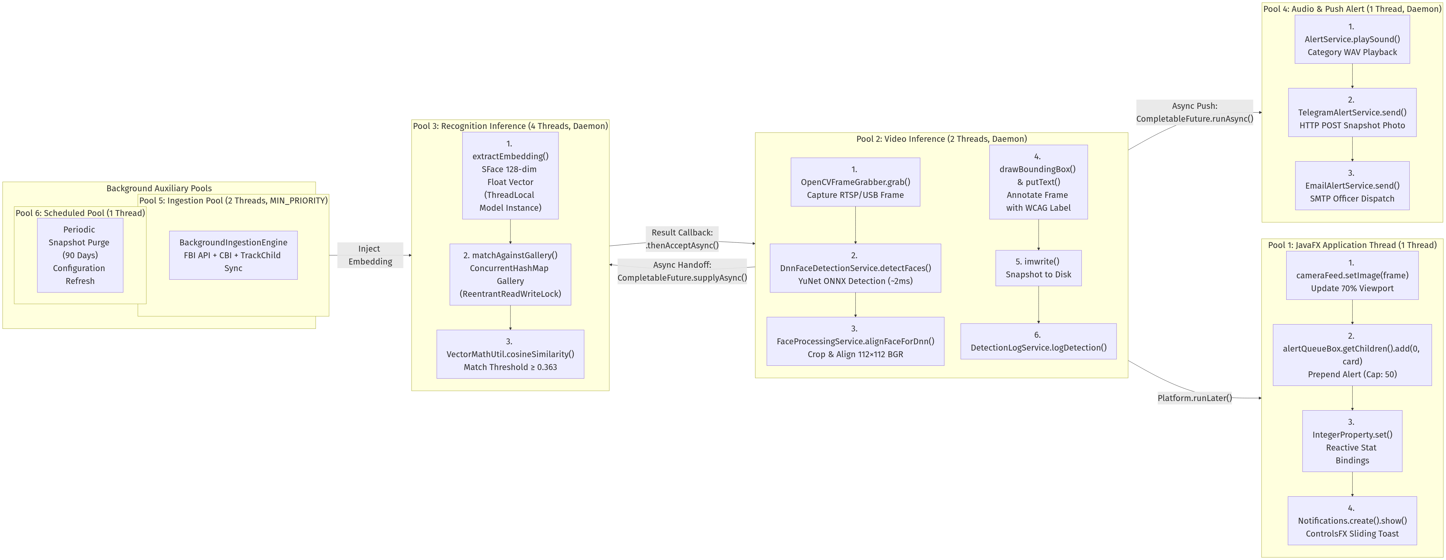
Figure 6: High-Resolution Landscape Diagram (Print-Scaled 24px Font)

