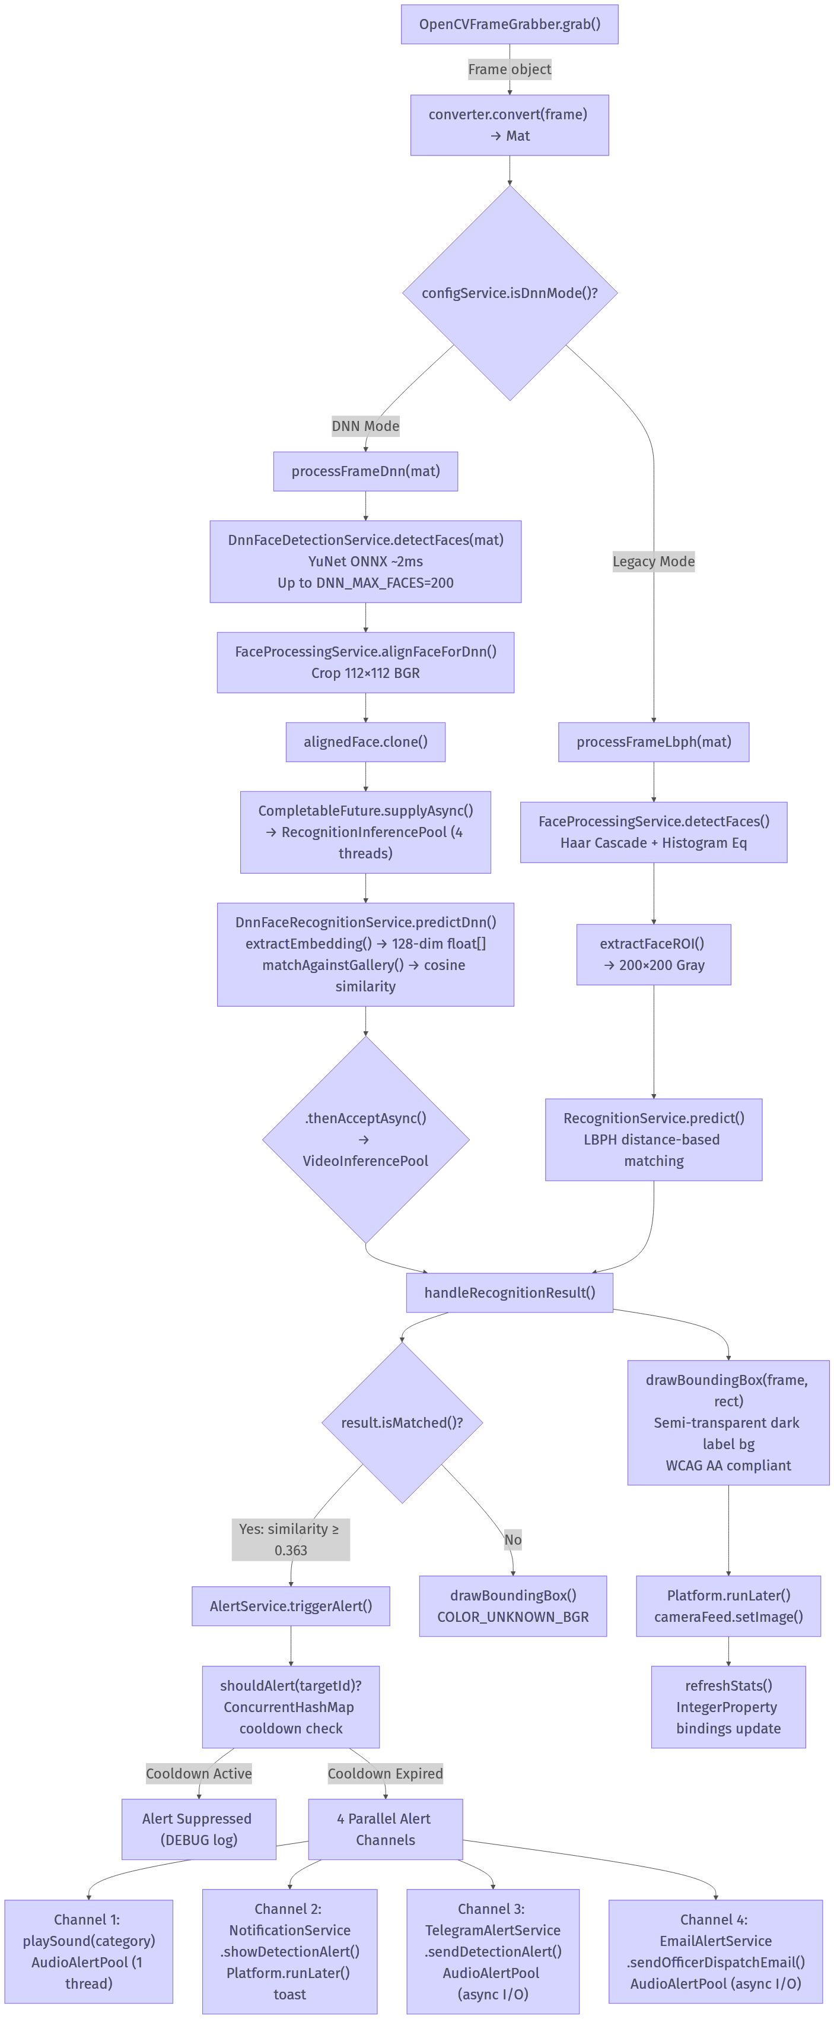

System Flowchart

2. ER Diagram — MongoDB Schema

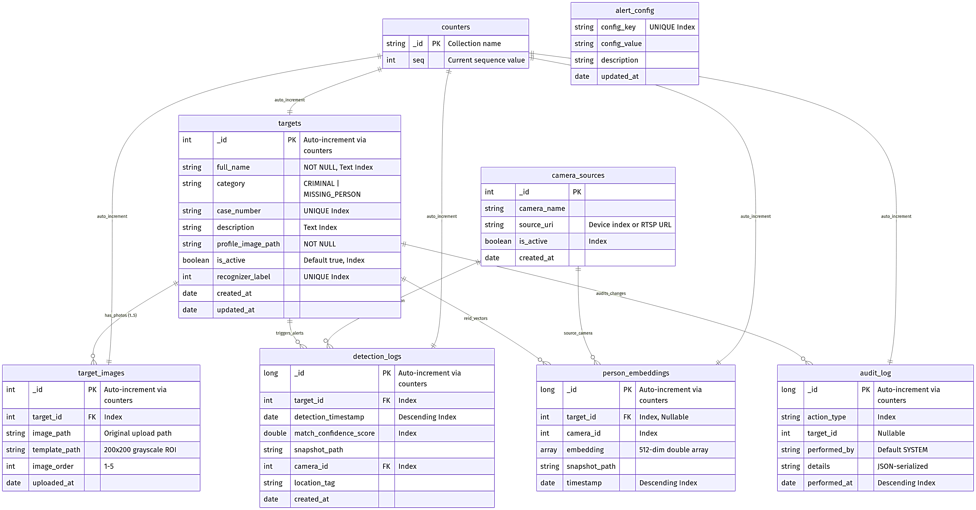

3. Table Design — Complete Field Specifications

`targets`
Field | BSON Type | Constraint | Index
_id | Integer | PK (auto-increment via counters) | Primary
full_name | String | NOT NULL | Text Index (compound with description)
category | String | Enum: "CRIMINAL", "MISSING_PERSON" | Secondary
case_number | String | UNIQUE | Unique Index
description | String | Nullable | Text Index (compound)
profile_image_path | String | NOT NULL | —
is_active | Boolean | Default: true | Secondary
recognizer_label | Integer | UNIQUE | Unique Index
created_at | Date | Auto-populated | —
updated_at | Date | Auto-populated | —

`target_images`
Field | BSON Type | Constraint | Index
_id | Integer | PK (auto-increment) | Primary
target_id | Integer | FK → targets._id | Secondary
image_path | String | NOT NULL | —
template_path | String | NOT NULL | —
image_order | Integer | Range: 1–5 | —
uploaded_at | Date | Auto-populated | —

`detection_logs`
Field | BSON Type | Constraint | Index
_id | Long | PK (auto-increment) | Primary
target_id | Integer | FK → targets._id | Secondary
detection_timestamp | Date | NOT NULL | Descending
match_confidence_score | Double | NOT NULL | Secondary
snapshot_path | String | Nullable | —
camera_id | Integer | FK → camera_sources._id | Secondary
location_tag | String | Nullable | —
created_at | Date | Auto-populated | —

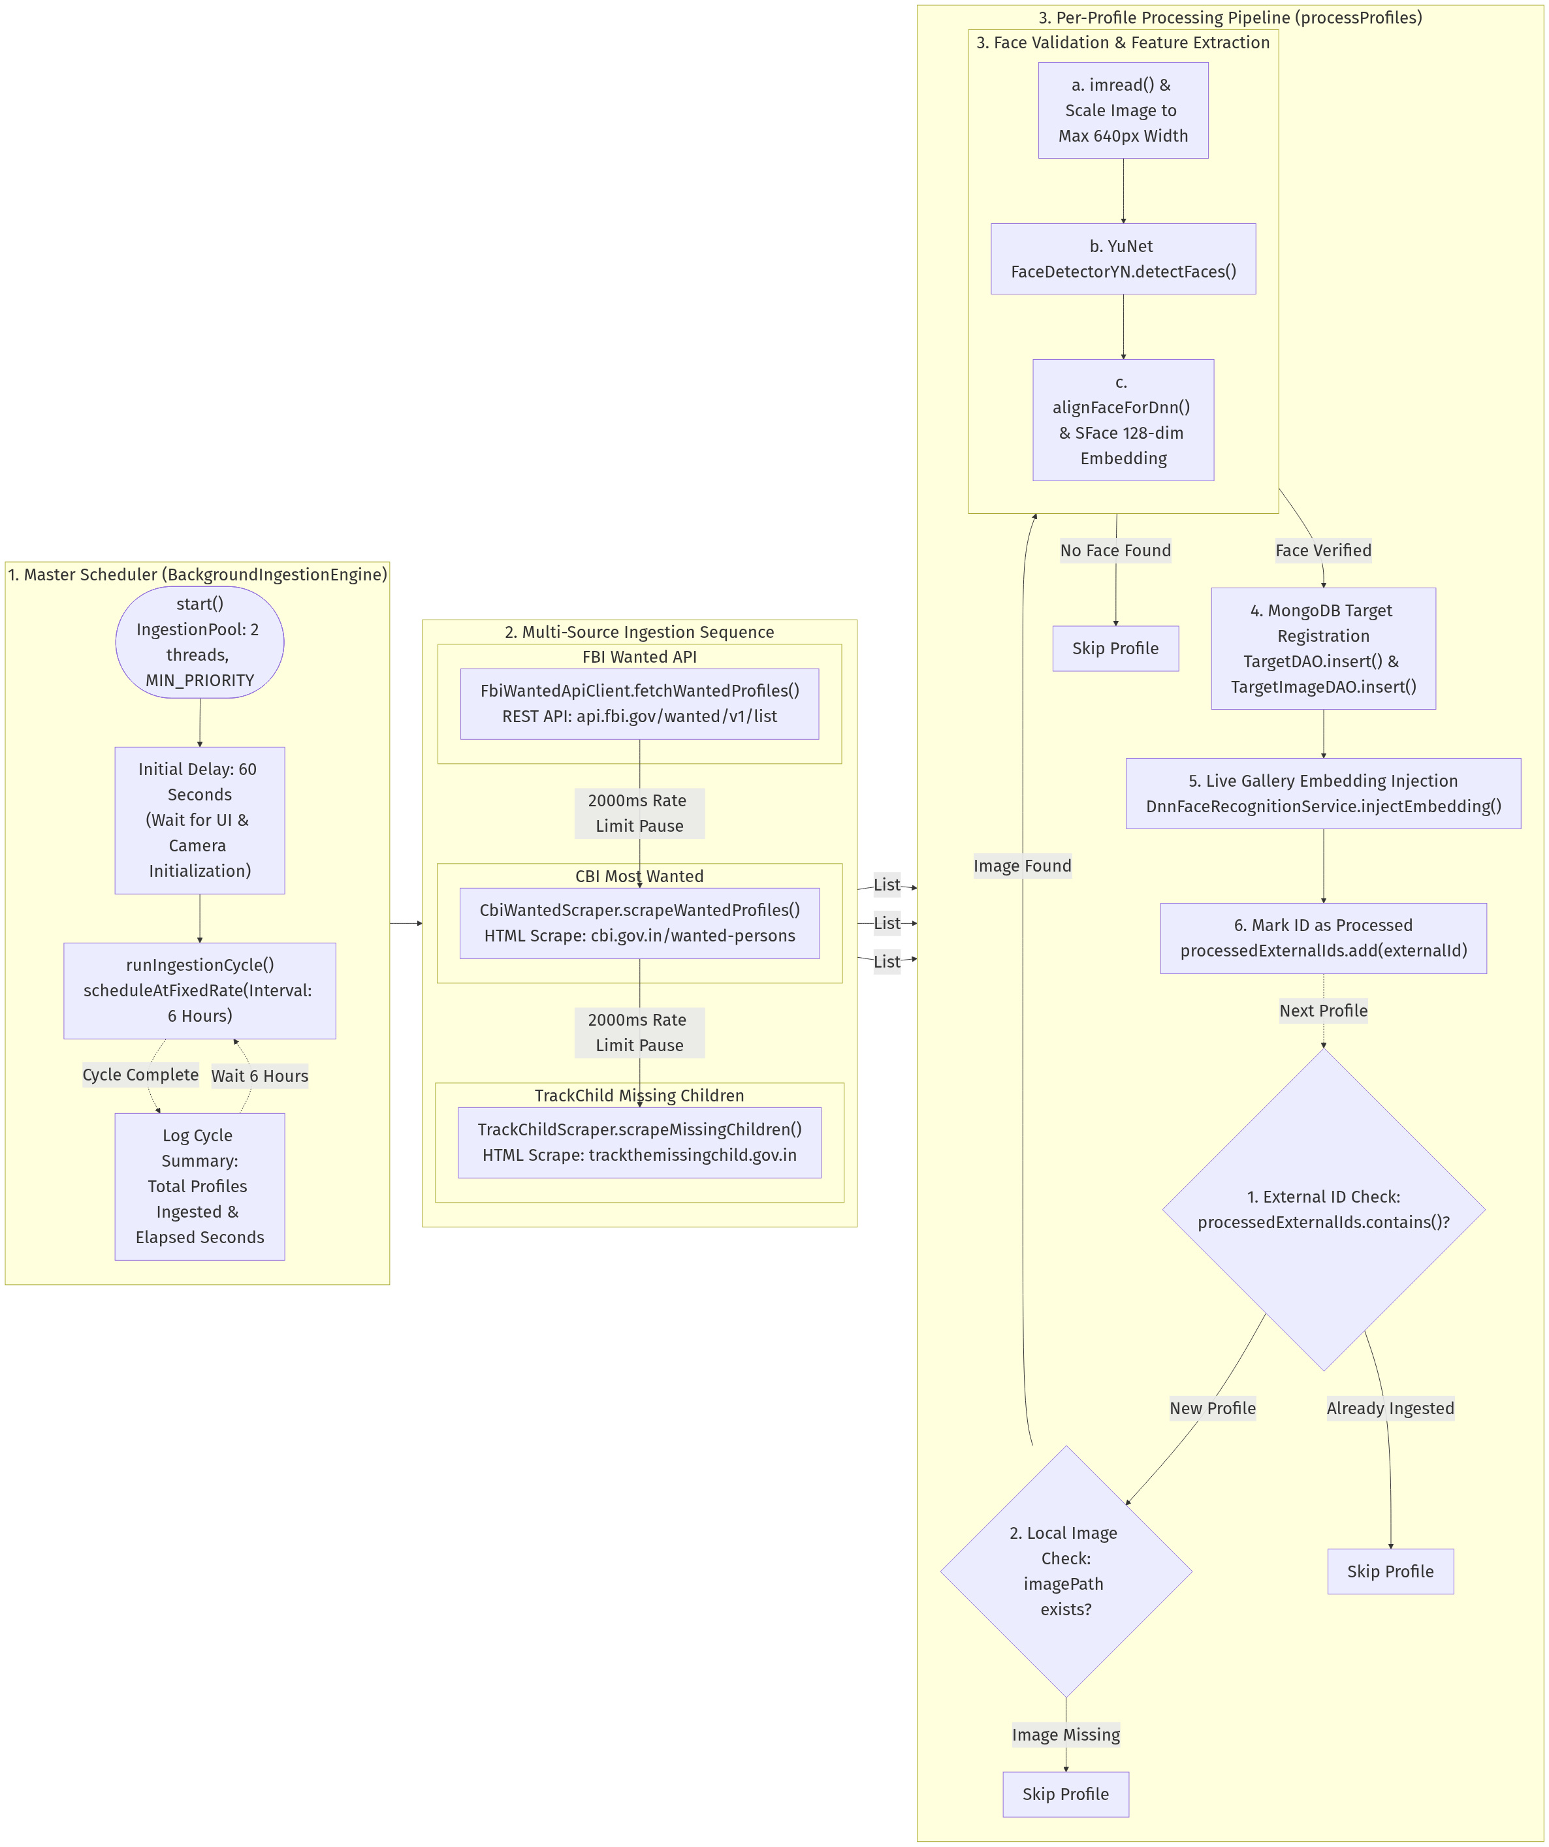
Diagram 3: 4. Process Flow — Background Ingestion Engine

DFD Level 0 — Context Diagram
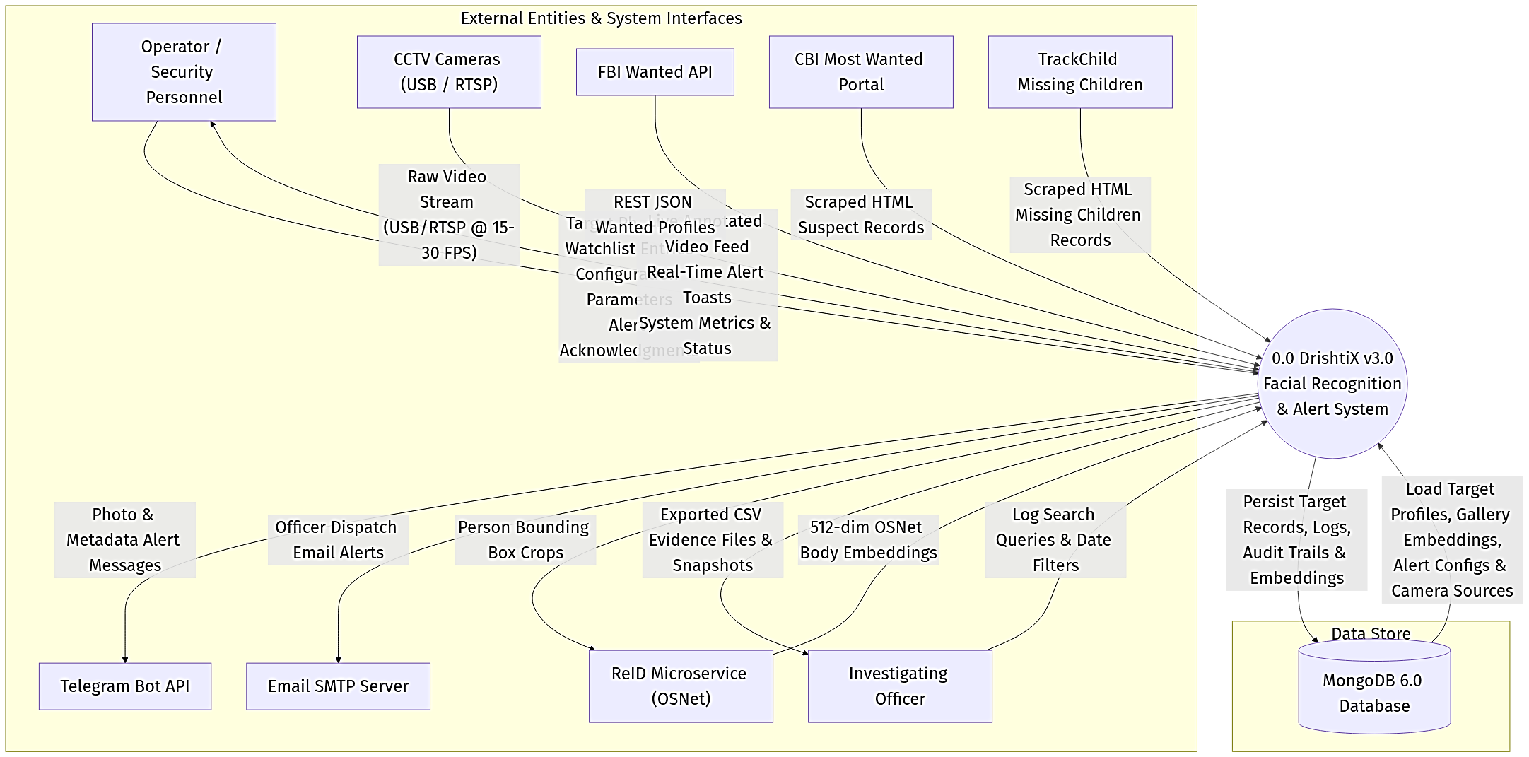

DFD Level 1 — Module Decomposition

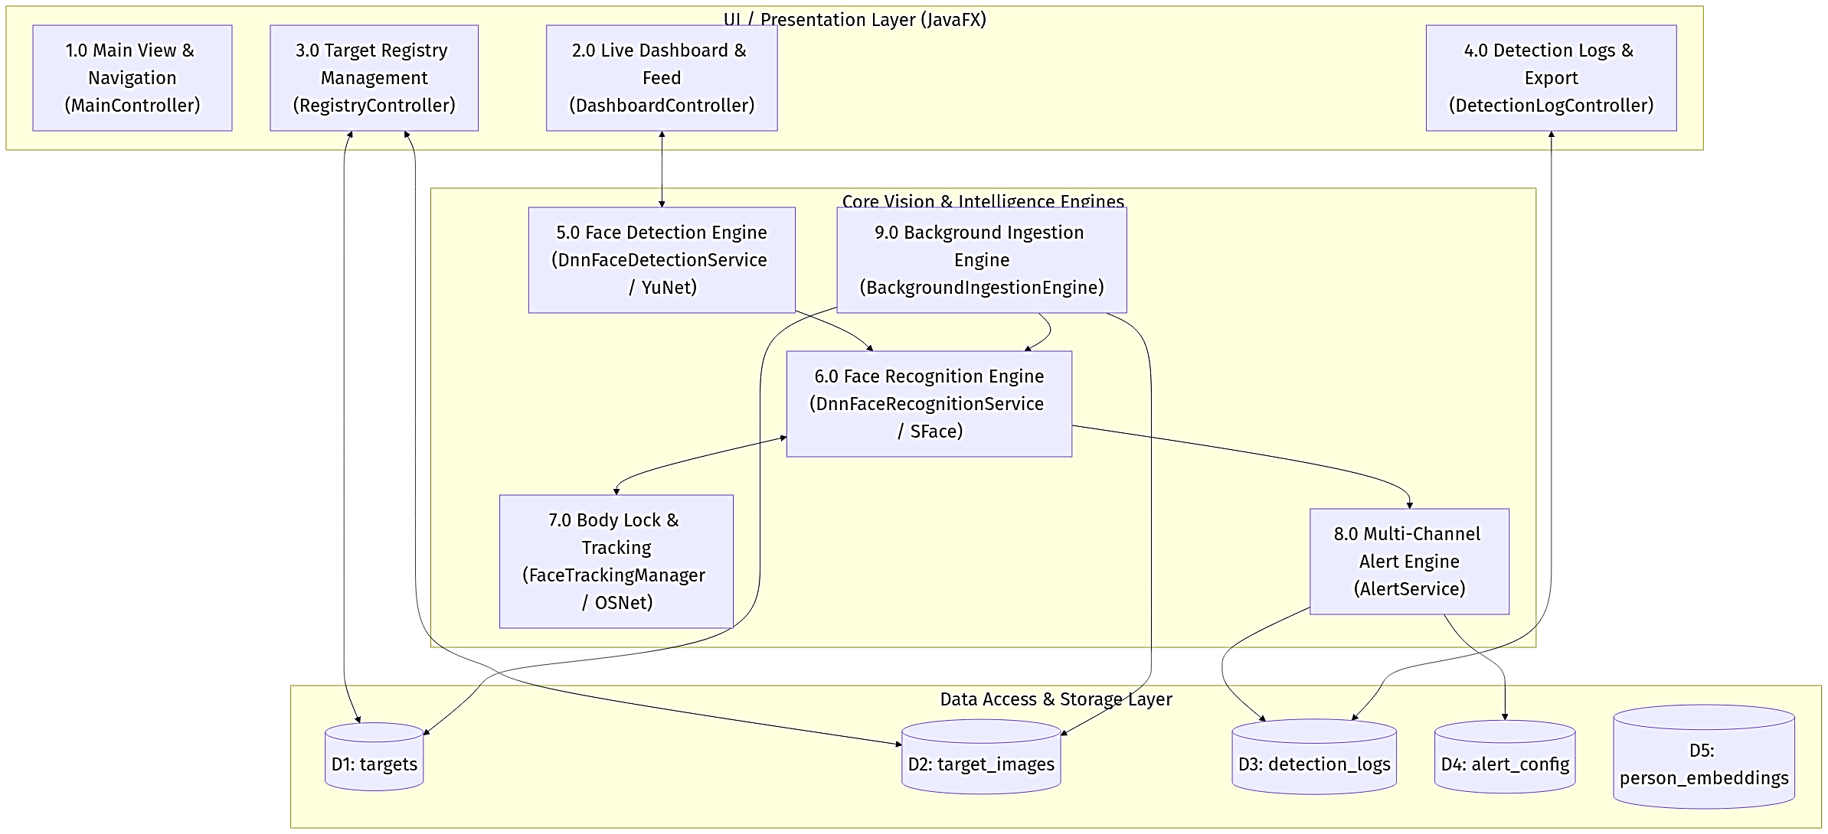

DFD Level 2 — Threading & AI Inference Pipeline

