Jenkins Pipeline to Deploy Docker Swarm SS.

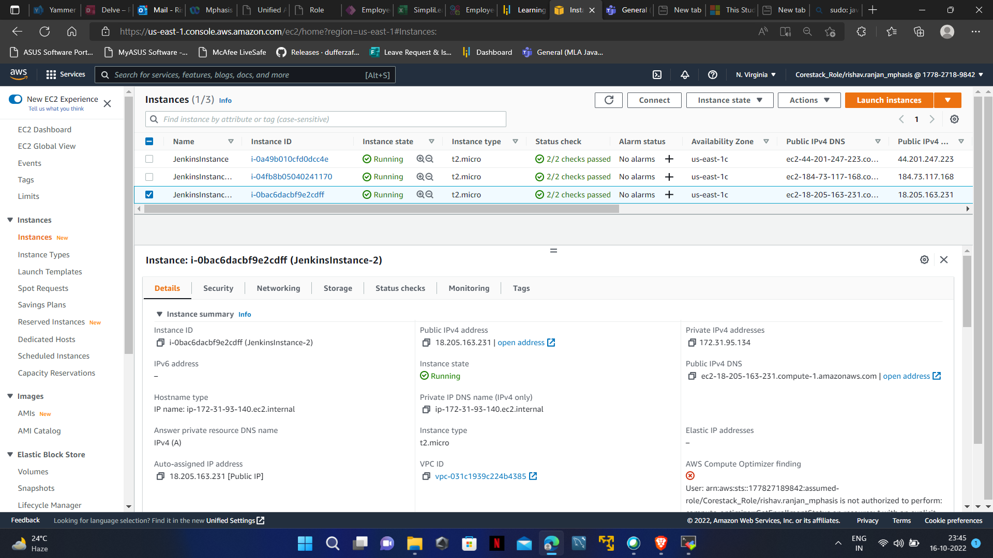

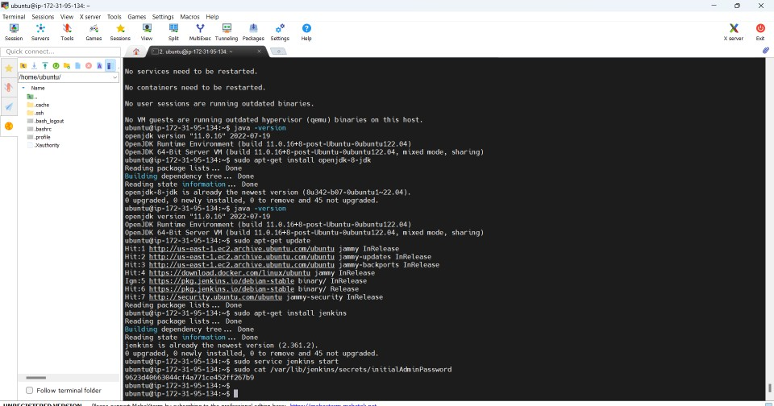

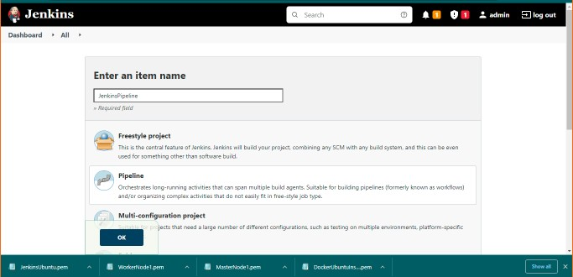

Select pipeline project

Link: https://github.com/Nikunj-Java/SpringBootDockerApp.git

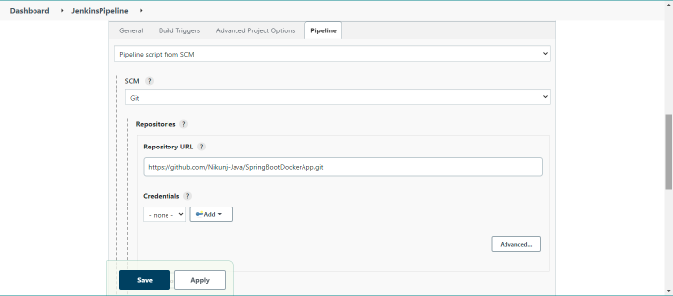

Save it click on build now

If you are getting permission denied error in build

Run below code:

sudo chm od 777 /va r/run/ docker.sock

click on Build Now

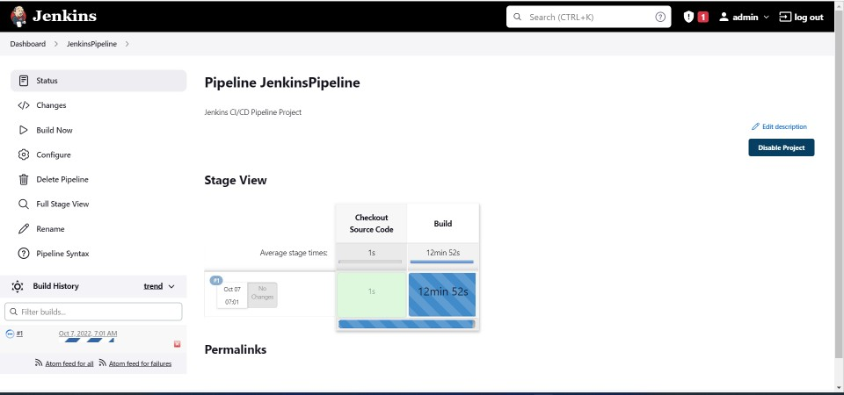

Goto moba xterm and run below code Sudo docker images