|  |  |  |  |  |  |  |  |  |  |  |  |  |  |
| --- | --- | --- | --- | --- | --- | --- | --- | --- | --- | --- | --- | --- | --- |
| User's manual  AOSAnalyzer | | | | | | | | | | | | | |
| Responsible Division: | Responsible Unit: | | Document Type: | | | | | Distribution Status: | | Document State: | | | |
|  |  | | User's manual | | | | | Internal | | Draft | | | |
| Prepared: |  | Nicklas Blomqvist | | |  | Electronically signed | | | | |  | 2012-09-02 | |
|  |  | Software Engineer | | |  |  | | | | |  |  | |
| Verified: |  |  | | |  |  | | | | |  |  | |
|  |  |  | | |  |  | | | | |  |  | |
| Approved: |  |  | | |  |  | | | | |  |  | |
|  |  | Name / Title | | |  | Handwritten Signature | | | | |  | Date  (yyyy-mm-dd) | |
| This document and its contents are the property of Bombardier Inc. or its subsidiaries. This document contains confidential proprietary information. The reproduction, distribution, utilization or the communication of this document or any part thereof, without express authorisation is strictly prohibited. Offenders will be held liable for the payment of damages.  © 2012 Bombardier Inc. or its subsidiaries. All rights reserved. | | | | Identity Number: | | |  | | | | | | |
|  | | | | |  | | --- | | 3NSS000000D1234 | | | | | | | | | | |
|  | | | | Effective Date: | | | | | Version: | | | | Language: |
|  | | | | As release date | | | | | 1.0 | | | | EN |
| Based on : ENG Techn Doc Template GRP~000108 SE-11.dot | | | | | | | | | | | | | |

Version Log

|  |  |  |  |
| --- | --- | --- | --- |
| Version | Date (yyyy-mm-dd) | Description of Changes | Name  (first and surname) |
| 1.0 | 2012-09-02 | First issue | Nicklas Blomqvist |
|  |  |  |  |
|  |  |  |  |
|  |  |  |  |
|  |  |  |  |
|  |  |  |  |

**Table of Contents**

|  |  |  |
| --- | --- | --- |
| **Section** | **Subject** | **Page** |

1 Executive Summary 4

2 Definitions and abbreviations 4

3 AOSAnalyzer 4

4 AOSAnalyzer scenarios 5

4.1 Connecting to a unit 5

4.2 Add a graph 5

4.3 Remove graphs 5

4.4 Edit a graph 5

4.5 Change color of the measurables 5

4.6 Reading and changing parameters 6

4.7 Markers 6

5 Protocol 6

5.1 Connection to the unit 6

5.2 Data sets 6

5.2.1 Measurables 6

5.2.2 Unit Data 7

5.2.3 Parameters 7

5.3 Unknown commands 7

# Executive Summary

This document describes how to use the AOSAnalyzer for analyzing and changing parameters in trains during runtime.

# Definitions and abbreviations

|  |  |
| --- | --- |
| **Term** | **Description** |
| ATO | Automatic Train Operator |
| ATP | Automatic Train Protection |
| GUI | Graphical User Interface |
| Measurable | A variable which is continuously measured on the unit |
| Measure | Previously measured data that can be saved or loaded. |
| Marker | A vertical line in the graph used for analyzing the measure |

# AOSAnalyzer

The AOSAnalyzer is started by running the *AOSAnalyzer.exe* file. From start the workspace is empty and is ready to load a measure or connect to a unit.

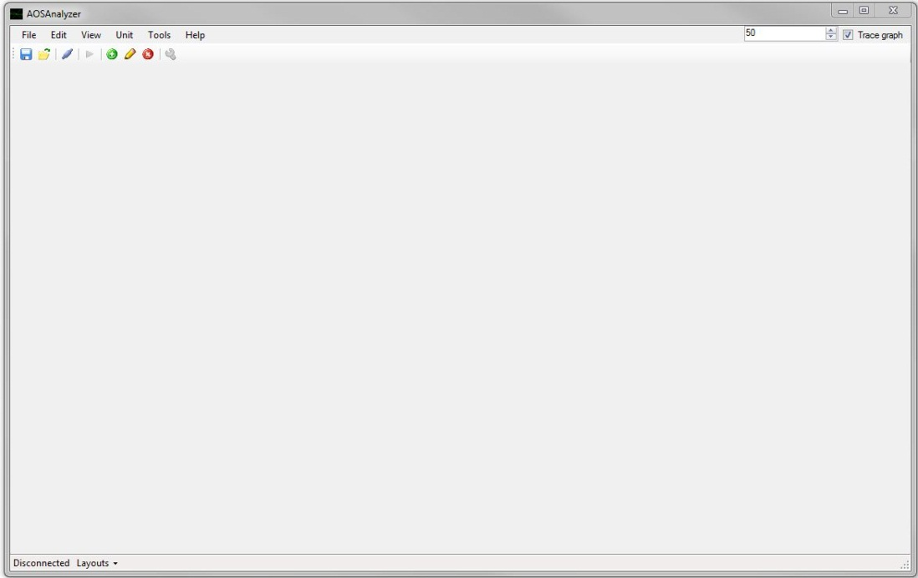

## Buttons in the GUI

To make it easier to access AOSAnalyzers functions it has buttons in the GUI linked to them.

C:\Users\Nicklas\AppData\Local\Temp\tmp86BD.tmp\Save.png Save Measure

C:\Users\Nicklas\AppData\Local\Temp\tmpAFC0.tmp\Open.png Open Measure

C:\Users\Nicklas\AppData\Local\Temp\tmpFE0A.tmp\connect.png Connect to Unit

C:\Users\Nicklas\AppData\Local\Temp\tmp941.tmp\Disconnect.png Disconnect from Unit

C:\Users\Nicklas\AppData\Local\Temp\tmp8E53.tmp\Add.png Add Graph

C:\Users\Nicklas\AppData\Local\Temp\tmpE07B.tmp\Edit.png Edit Graph

C:\Users\Nicklas\AppData\Local\Temp\tmpB786.tmp\Delete.png Remove Graph

C:\Users\Nicklas\AppData\Local\Temp\tmpA5F8.tmp\Configure.png Parameters

C:\Users\Nicklas\AppData\Local\Temp\tmp3C82.tmp\start.png Start Measurement

C:\Users\Nicklas\AppData\Local\Temp\tmp514A.tmp\stop.png Stop Measurement

# AOSAnalyzer scenarios

This chapter aims at describing all scenarios a user of the AOSAnalyzer application may encounter.

## Connecting to a unit

The connect window is accessed by clicking the connect-button or by the menu (Unit->Connect). On creation it will try to load saved connections from the file “Connections.xml” if it exists.

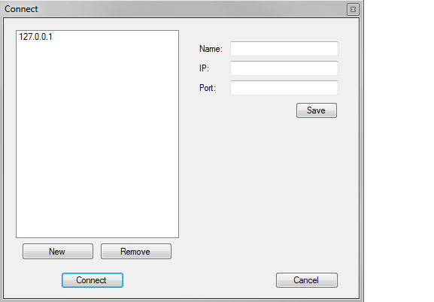

To create a new connection, press “New” and enter a name in the dialog. Then enter IP-address and port number in the boxes and press “Save”.

To remove a connection, click on the connection’s name and then press “Remove”.

To connect, click on the connection’s name and click “Connect”

## Add a graph

The add graph window is accessed by clicking the add graph-button or by the menu (Edit->Graph->New graph).

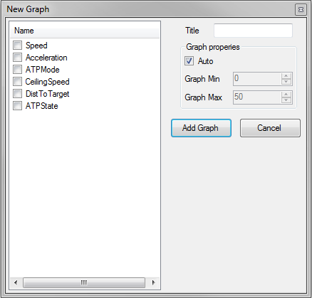

All measurables are loaded into a checklist from where you can select those which shall be in the graph. Graph title and manual values for the value-axis can also be set in the window.

## Remove graphs

The remove graph window is accessed by clicking the remove graphs-button or by the menu (Edit->Graph->New graph).

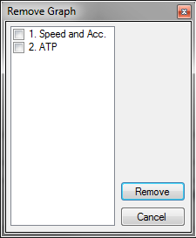

All graphs are loaded into a checklist from where you can select those which shall be removed from the program.

## Edit a graph

The edit graph window is accessed by clicking the add graph-button or by the menu (Edit->Graph->Edit graph).

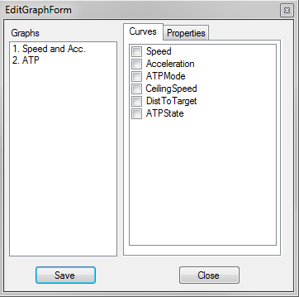

All graphs and measurables are loaded into separate checklists. When a graph is selected its current measurables are automatically checked and the graph’s properties are loaded into their textbox. When changes has been made you press “Save”.

## Change color of the measurables

The edit graph window is accessed by the menu (Edit ->Edit colors).

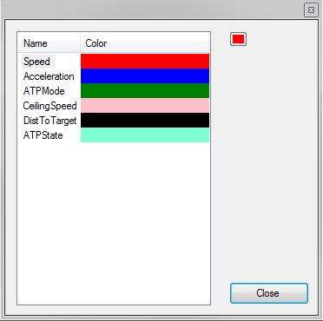

All measurables and its current color are loaded into a list. By marking one measurable and clicking on the color picker you can change the measureable’s color.

## Reading and changing parameters

The parameter window is accessed by clicking the parameter-button or by the menu (Unit->Parameters).

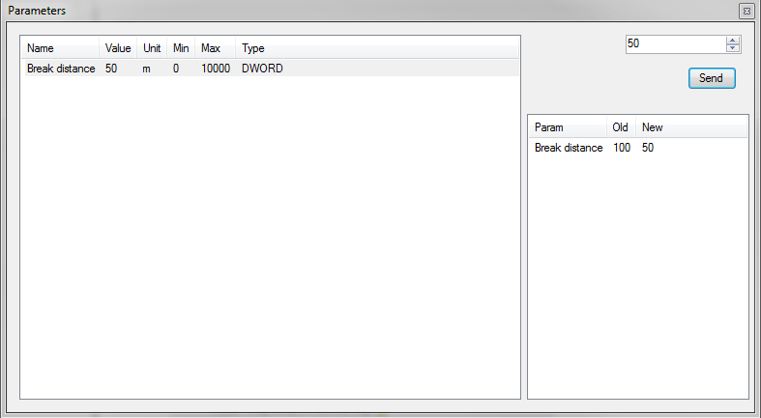

All parameters will be listed with its name, value, unit, min, max and type. By marking a parameter its value will show in the number box. There it can be edited and sent to the unit. All changes from the connection to the unit will be shown in the history window. Double-clicking a parameter in the history window will select that parameter for editing.

## Markers

The marker window is accessed by the menu (Tools->Markers).

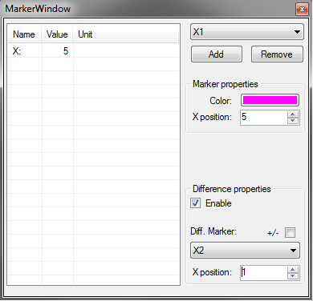

All markers are loaded into a dropdown list and the first markers values will be shown in the value window. By adding a marker it will appear at the default x-value 10. It will then show the value of all measureables in the value window. When choosing a difference marker the difference between the two markers will be shown as the value in the value window. By enabling the “+/-“-box the sign of the difference will change.

# Protocol

This chapter will describe the protocol used in the communication with the unit. It will be split into subchapters with the different part of the protocol. All messages shall have a line break at the end.

## Connection to the unit

The connection is made with a standard socket connection. When the connection is established the unit sends three sets of data. Each set has its own start- and end string.

* Measurables
* Unit Data
* Parameters

## Data sets

### Measurables

The measurables is the variables the unit will report during measurement. After the start message all data is sent separated by line break until the end message is sent.

Start: [MeasurablesStart]

Data: “Name”;”Description”;Type;”Unit”;Min;Max

End: [MeasurablesEnd]

### Unit Data

The unit data describes the unit by name, version and protocol version. After the start message all data is sent separated by line break until the end message is sent.

Start: [UnitDataStart]

Data: DataName Data

End: [UnitDataEnd]

### Parameters

The parameter is the variables in the unit you’re able to change. You can both receive and set parameters with the protocol.

#### Receiving parameters

On connection the unit will send the parameters automatically but they can be obtained by sending a get-message to the unit.

The syntax is:

“get parameters”

After the start message all data is sent separated by line break until the end message is sent.

Start: [ParametersStart]

Data: “Name”;”Description”;Type;”Unit”;Min;Max;Value

End: [ParametersEnd]

#### Set parameters

Setting a parameter is done by sending a set-message to the unit.

The syntax is:

“set parametername value”

## Unknown commands

When a unit doesn’t get a correct message it will send back an unknown command-message including the command you sent.