|  |  |  |  |  |  |  |  |  |  |  |  |  |
| --- | --- | --- | --- | --- | --- | --- | --- | --- | --- | --- | --- | --- |
| AOS  Add Train  Add train to test environment for AOS | | | | | | | | | | | | |
| Responsible Division: | Responsible Unit: | | Document Type: | | | | Distribution Status: | | | Document State: | | |
| RCS | EMI | | ReadMe | | | | Internal | | | Draft | | |
| Prepared: |  | Amarnath Kushwaha | | |  |  | | |  | | 2018-05-27 | |
|  |  |  | | |  |  | | |  | |  | |
| Verified: |  |  | | |  |  | | |  | |  | |
|  |  |  | | |  |  | | |  | |  | |
| Approved: |  |  | | |  |  | | |  | |  | |
|  |  |  | | |  |  | | |  | |  | |
|  |  | Name / Title | | |  | Signature | | |  | | **Date** | |
| This document and its contents are the property of Bombardier Inc. or its subsidiaries. This document contains confidential proprietary information. The reproduction, distribution, utilization or the communication of this document or any part thereof, without express authorisation is strictly prohibited. Offenders will be held liable for the payment of damages.  © 2011 Bombardier Inc. or its subsidiaries. All rights reserved. | | | | Identity Number: | | | | | | | | |
|  | | | | | | | | |
| Effective Date: | | | | Version: | | | | Language: |
|  | | | | 1.6 | | | | En |

Version Log

|  |  |  |  |
| --- | --- | --- | --- |
| Revision | Date (yyyy-mm-dd) | Description of Changes | Signature |
| 1.0 | 2012-11-29 | First issue | B.Hermansson |
| 1.1 | 2013-01-17 | Corrected and clarified port no values in chapter 3 | B.Hermansson |
| 1.2 | 2013-11-26 | Corrected for AOSPC | B.Hermansson |
| 1.3 | 2014-08-21 | Supporting trains with  2 =< number =< 99 | B.Hermansson |
| 1.4 | 2017-09-22 | Adapted for BHP project | A.Kushwaha |
| 1.5 | 2018-05-27 | N-JRU changed to RU + minor updates | M. Lundgren |
| 1.6 | 2018-09-19 | Updated input-arguments and descriptions for AddTrain.bat-file. | M. Lundgren |

**Table of Contents**

|  |  |  |
| --- | --- | --- |
| **Section** | **Subject** | **Page** |

1 Introduction 4

2 Installation 4

2.1 Preparations 4

2.1.1 Setup AOS Test Environment 4

2.1.2 Use AOS Test Environment 4

2.1.3 Support folder 4

2.1.4 Batch file 4

2.2 Add a simulated train 5

2.2.1 Desktop shortcuts 5

3 Run the additional train 6

4 Identify the windows of the additional train 7

4.1 AOSPC 7

4.2 LocoSim 8

4.3 DMI 8

4.4 TestATP 10

# Introduction

This document describes how to add another simulated train to the AOS test environment used within the AOS project.

# Installation

## Preparations

Install the AOS Test environment as described in below wiki page:

### Setup AOS Test Environment

<http://stoweb01.scan.bombardier.com/~ebiconfig/dokuwiki/doku.php?id=aos:setup_aos_test>

### Use AOS Test Environment

<http://stoweb01.scan.bombardier.com/~ebiconfig/dokuwiki/doku.php?id=aos:use_aos_test>

### Support folder

Copy the Support folder from tools_bhp repository to: .../AOSTestEnvironment/<Version> folder.

These EditIniFile.exe and CreateShortcut.exe placed in the Support folder are being used to run the batch file for multiple train test environment creation.

### Batch file

Copy the batch file “AddTrain.bat” in the ‘AddTrain’-folder from tools_bhp repository to: .../AOSTestEnvironment/<Version> folder.

## Add a simulated train

Run the batch – file AddTrain.bat located in the .../AOSTestEnvironment/<Version> folder.

It takes three arguments:

1. Train number (2-200)
2. Number of vehicles (1-350)
3. Train Node-address offset (>=Number of vehicles)

Example 1:

C:\AOS_Test>**AddTrain 2 20 30**

This will:

* Create the subfolder Train2 and log2 folder.
* Copy executables and ini-files this subfolder
* Edit ini-files necessary to simulate this train.

The train-composition sent from LCS Simulator to ATP will include 1loco + 19 cars with node addresses 31-50 ((1 + (TrainNumber-1)*Offset) = 31)

Example 2:

C:\AOS_Test>**AddTrain 3 26 30**

This will:

* Create the subfolder Train3 and log3 folder.
* Copy executables and ini-files this subfolder
* Edit ini-files necessary to simulate this train.

The train-composition sent from LCS Simulator to ATP will include 1loco + 25 cars with node addresses 61-86 ((1 + (TrainNumber-1)*Offset) = 61)

### Desktop shortcuts

Desktop short-cuts are automatically created for the additional train.

The shortcuts for e.g. train 2 are:

* DMI_2
* AOSPC_2
* N-JRU_2

# Run the additional train

Just as the first train you need to start

* LocoSim (and start the AOS)
* DMI
* AOSPC (framework for LCSSim and future simulation panels)
* N-JRU (for logging)

TCC needs to establish a connection with the new train(ATP) on

* Same IP as the first train (Localhost for SIL environment)
* Port no 30032/30033/30034 + (Train number * 100)  
  E.g. 30132 for the original train 1 and 30232 for train 2.

# Identify the windows of the additional train

## AOSPC

AOSPC is a framework for various simulation-panels. Currently LCSSim, LocoSim, TIMSSim and Console are integrated into AOSPC.

AOSPC will display the LocoName in the window caption.

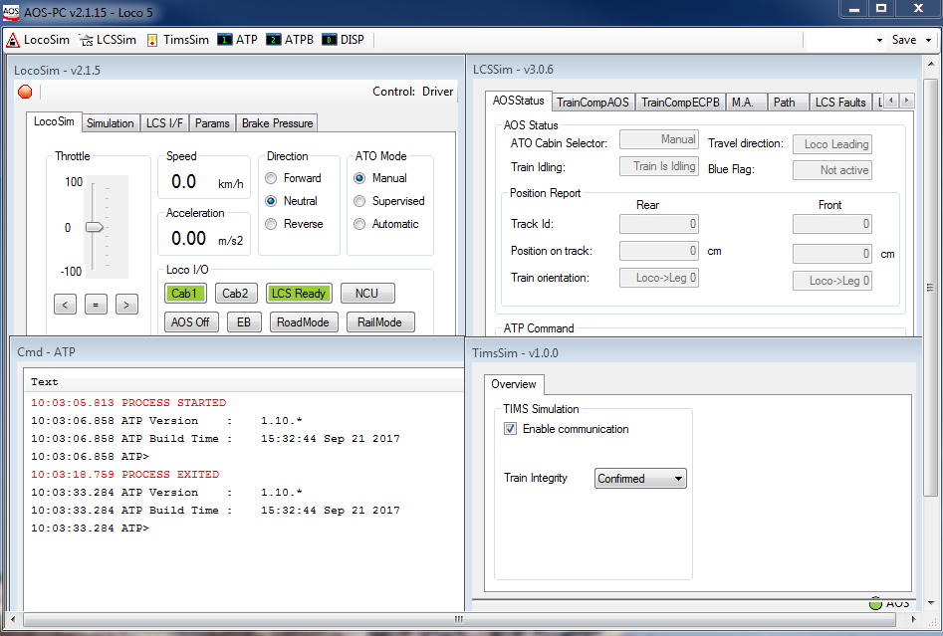

## LocoSim

The LocoSim caption displays the its version number and its Control i.e Driver or LCS

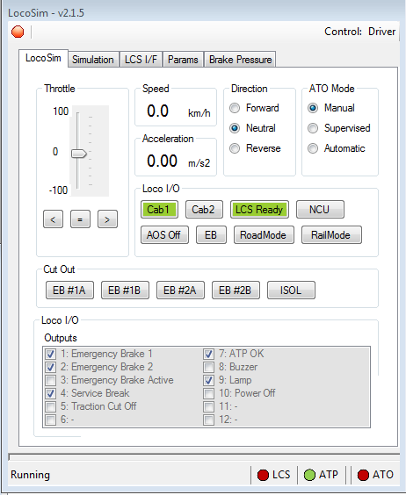

## DMI

As in “real life” there is nothing on the DMI indicating which loco you are in until the train is configured and registered.

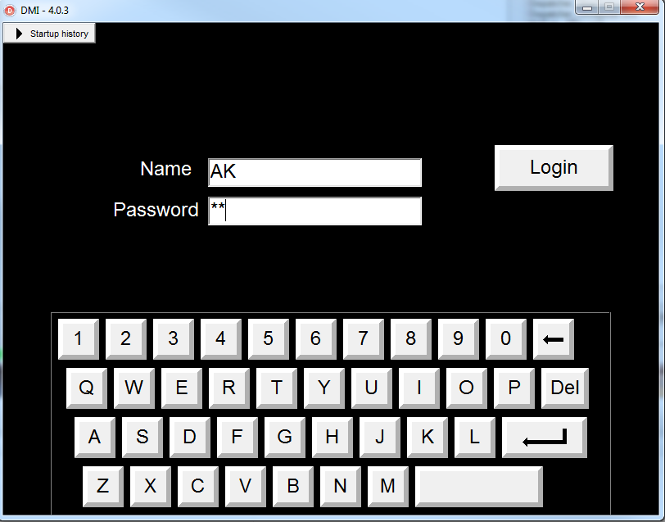

## TestATP

In order to check which test_atp.exe is running for the current train test environment, the ATPFile path in AOSPC.ini needs to be checked. The add train batch file will update the path of the ATPFile so that while running in the test environment, it picks the correct test_atp.exe (which is being copied to TestATP).

