**Least Recently Used (LRU) Cache Implementation.**

[ CSE MIET ]



**Submitted By:**

Sachit Sharma.

Gautam kumar.

Himanshu Sharma.

**ROLL NO.**

2021a1r027

2021a1r005

2021a1r012

**Email Id.**

[**2021a1r027@mietjammu.in**](mailto:2021a1r027@mietjammu.in)

[**2021a1r005@mietjammu.in**](mailto:2021a1r005@mietjammu.in)

[**2021a1r012@mietjammu.in**](mailto:2021a1r012@mietjammu.in)

**BRANCH:**

CSE

**SEMESTER:**

3rd sem.

**Abstract:**

Least Recently Used (LRU) algorithm is a page replacement technique used for memory management. According to this method, the page which is least recently used is replaced. Therefore, in memory, any page that has been unused for a longer period of time than the others is replaced.

**1.1 INTRODUCTION:**

LRU stands for Least Recently Used. As the name suggests, this algorithm is based on the strategy that whenever a page fault occurs, the least recently used page will be replaced with a new page. So, the page not utilized for the longest time in the memory (compared to all other pages) gets replaced. This strategy is known as *LRU paging*.

A *page fault* occurs when a running program tries to access a piece (or page) of memory that is not already present in the main memory (RAM). On the other hand, if that page is already present in the memory, it is called a *page hit*. The LRU page replacement algorithm comes into the picture whenever a page fault occurs.

**1.2 SPECIFICATIONS:**

Least Recently Used (LRU) algorithm is a page replacement technique used for memory management. According to this method, the page which is least recently used is replaced. Therefore, in memory, any page that has been unused for a longer period of time than the others is replaced.

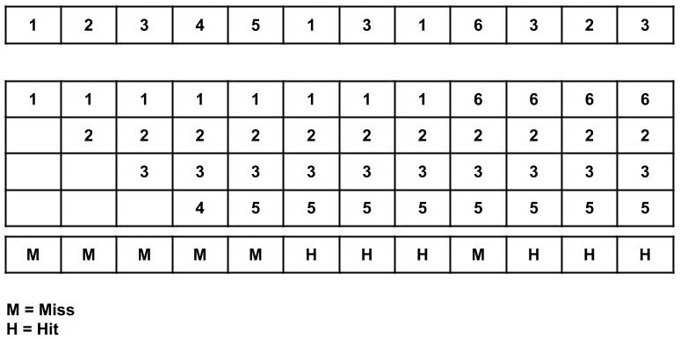

**IMPLEMENTATION:**

**Given a reference string: 0, 1, 2, 3, 0, 1, 4, 0, 1, 2, 3, 4 and given that there are a total of 3 memory locations available.**

1. **The first three pages, 0, 1, 2, will give rise to 3-page faults (look at the image above).**
2. **Now that the table is filled and the next page, 3, is not present in the table, a page must be replaced. Since 0 is the least recently used page, page 3 will replace 0. This will result in a 1 page fault.**
3. **This process is repeated for the entire reference string.**
4. **When a number from the reference string already exists in the table, there is no page fault and no effort is required to replace the page. In that case, the reference page will become the recently used page (like when 0 is referenced when the page frames contain 4, 0 and 1.)**
5. **Make sure you look at whether or not a given page is recently used from the reference string.**

## **Pseudocode of LRU Algorithm:**

**Let us say that s is the main memory's capacity to hold pages and pages is the list containing all pages currently present in the main memory.**

1. **Iterate through the referenced pages.**
   * **If the current page is already present in pages:**
     1. **Remove the current page from pages.**
     2. **Append the current page to the end of pages.**
     3. **Increment page hits.**
   * **Else:**
     1. **Increment page faults.**
     2. **If pages contains less pages than its capacity s:**
        + **Append the current page into pages.**
     3. **Else:**
        + **Remove the first page from pages.**
        + **Append the current page at the end of pages.**
2. **Return the number of page hits and page faults.**

## **Advantages of LRU Page Replacement Algorithm:**

Following are the advantages of the LRU page replacement algorithm:

* The page that has not been used for the longest time gets replaced.
* It gives lesser page faults than any other algorithm.
* The algorithm never suffers from the Belady's anomaly .
* The algorithm is capable of complete analysis.

## **Disadvantages of LRU Page Replacement Algorithm:**

Following are the disadvantages of the LRU page replacement algorithm:

* The execution of this algorithm is complicated.
* This algorithm's execution may require significant assistance from the hardware.

## **Conclusion:**

* The LRU page replacement algorithm replaces the least recently used page in the memory with a new page.
* The LRU page replacement algorithm is based on the assumption that among all pages in the memory, the least recently used page will not be used for a long time.
* A page fault occurs when a program tries to access a memory page that is not already present in the memory.
* A page hit occurs when a program tries to access a memory page that is present in the memory.
* LRU page replacement algorithm gives the least page faults compared to other page replacement algorithms.
* The LRU algorithm requires assistance from the hardware to execute.

**References:**

1. **Scaler.com**
2. **Geeksforgeeks**