Product Requirements Specification
  - Honda Vezel Custom Android Head-Unit Launcher • PRD-001 • Version 1.0

1. Purpose and product vision
Create a premium, offline-first, landscape Android home launcher for a Honda Vezel head unit. The reference dashboard uses a digital speedometer on the left, media and weather cards at the top, a prominent central Vezel visualization, and a bottom dock. The launcher is a replaceable home application, not a firmware replacement or Android Auto projection app.

2. Reference dashboard
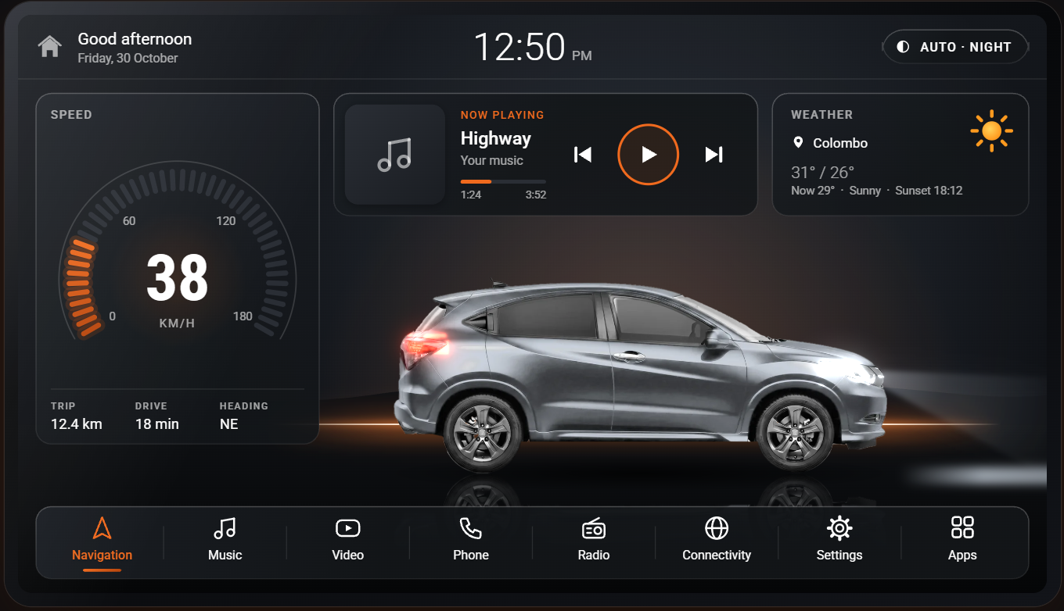
Design reference supplied by the project owner. Recreate as an original implementation rather than copying third-party application assets.

3. Target platform and constraints
Item | Baseline / verification
Head-unit identity | HONDA_W15 / alps 8227L_demo; AC8227L
OS compatibility | Device Info HW: Android 8.1 / API 27. Factory About page reports Android 15; prioritize API reading, validate by APK testing.
CPU / ABI | 4 × ARM Cortex-A7; armeabi-v7a, 32-bit
GPU | Mali-450 MP; OpenGL ES 2.0
Display | 1280 × 720 px, landscape; 160 dpi; 60 Hz
Memory | 4 GiB reported; 220 MiB free at capture; re-test under idle conditions
Install | APK side-load via trusted USB source; no ADB required
OEM compatibility | Keep factory radio, phone, reverse camera, and steering control routes intact

4. User journeys
- Start vehicle → home dashboard appears promptly after head-unit wake/reboot.
- Tap Navigation → preferred installed map application opens.
- Tap Music → chosen player opens; compatible playing track appears on dashboard.
- Tap Apps → installed launchable applications appear in a categorized grid.
- Park vehicle → Settings → change Vezel paint color; choice persists after restart.
- When GPS or internet is unavailable, show graceful placeholders instead of stale data.
- Return to factory home through a prominent recovery action until pilot sign-off.

5. Feature requirements
ID / priority | Requirement | Acceptance criteria
FR-01 / P0 | Home and navigation dock | 1280×720 UI with large touch targets; all dock shortcuts open configured apps.
FR-02 / P0 | Vehicle hero | Clearly recognizable Vezel model graphic centered with shadow and glow; no frame drops in idle.
FR-03 / P0 | Paint color | At least 6 swatches; same vehicle silhouette/perspective; persists after app restart.
FR-04 / P0 | Clock / date | Use system locale and time; updates reliably across wake and time changes.
FR-05 / P0 | Apps drawer | Show user-launchable apps; handle missing/uninstalled app targets.
FR-06 / P0 | GPS speed | Shows km/h from valid location fix; distinguish unavailable GPS from 0 km/h.
FR-07 / P0 | OEM shortcuts | Configurable link to existing radio/Bluetooth/phone apps; no direct MCU manipulation.
FR-08 / P0 | Safe recovery | Always offer path to stock launcher/system settings before default-home switch.
FR-09 / P1 | Now playing | Track title/art and controls when compatible accessible media session exists; fallback tile otherwise.
FR-10 / P1 | Weather | Consent-based location and online service; hide widget gracefully offline.
FR-11 / P1 | Theme | Dark/day/auto preference and saved accent palette; accessible contrast.
FR-12 / P2 | Car animations | Subtle lights, appearance and tilt animation; completely optional.
FR-13 / P2 | True 3D | Evaluate only after benchmarks and model licensing; not required for initial release.
FR-14 / P2 | Vehicle telemetry | OBD-II or OEM integration only with supported hardware and explicit validation.

6. Screen specification
Screen | Content / interaction
Dashboard | Header greeting/date/time; speedometer left; media center top; weather right top; car hero middle; dock bottom.
Apps | Installed app grid, search/filter, configurable pinned apps.
Settings | Car model/render color, theme, startup behavior, preferred apps, diagnostics, factory-home shortcut.
Vehicle appearance | Paint swatches and preview; optionally choose viewing angle from pre-rendered set.
Diagnostics | OS/API, memory, GPU, app versions, permissions status, safe-reset action.

7. Non-functional requirements
- Target smooth 30 fps on dashboard, subject to hardware measurement; avoid persistent high GPU load.
- Prefer < 150 MiB launcher process proportional-set size (PSS) as an initial benchmark target, not a guaranteed limit.
- Offline-first home view; no blocking network request during launcher startup.
- All key primary controls accessible within one tap, with approximate 48 dp minimum touch targets.
- No system/MCU flashing, root requirements, or risky changes to car safety systems.
- No video playback promoted on the home screen while driving; setup actions intended for parked use.
- Avoid storing precise trip history by default; request minimal Android permissions.

8. Scope and release criteria
MVP included: home screen, car renders/color selection, app launcher/dock, clock, GPS speed, persistent preferences, OEM shortcuts, safe rollback. P1 release: weather, media session UI, themes. Explicitly excluded from MVP: full 3D model, automatic doors/headlamps from CANBUS, reverse-camera takeover, custom radio implementation, firmware modifications.
Release gate: test cold boot, warm wake, 30-minute dashboard soak, map/audio switching, GPS unavailable, Wi-Fi unavailable, camera engagement with the stock app, stock launcher recovery and home-role behavior. No default launcher setting before recovery tests pass.

9. Risks and unresolved items
- Exact Honda Vezel generation/model year and allowed vehicle model asset license must be confirmed.
- Mali-450 performance, current memory pressure, and true head-unit home-app restrictions need physical-device tests.
- Factory app package names and media-session behavior are device-specific; capture manually on the unit.
- Weather API/provider, consent UX and connectivity availability are TBD.
- Android 8.1 app permissions and OEM launch behavior need testing even when Android 15 is displayed in factory settings.

