**Venue**

The AusCTW 2024 workshop will be held at the Forum, Melbourne Connect, one of the most iconic buildings in the entire City of Melbourne featuring a floor area of nearly 74,000 sqm.

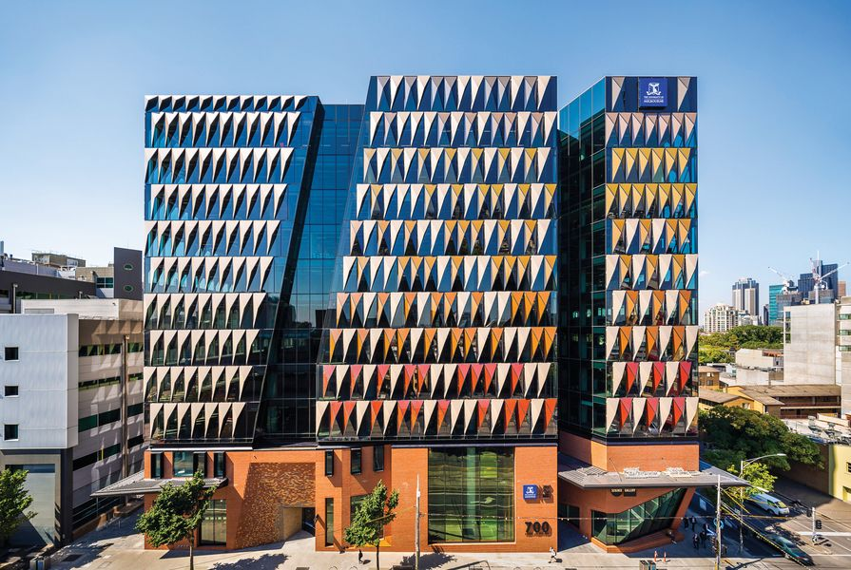

**Address:**

700 Swanston St, Carlton VIC 3053

**How to Get There:**

The Forum is accessible via the Superfloor of Melbourne Connect.

1. Enter the foyer through the revolving glass doors from the covered walkway at 700 Swanston Street and proceed to the Superfloor via the stairs or by using the lifts on the right side of the foyer (press M on the lift call button).

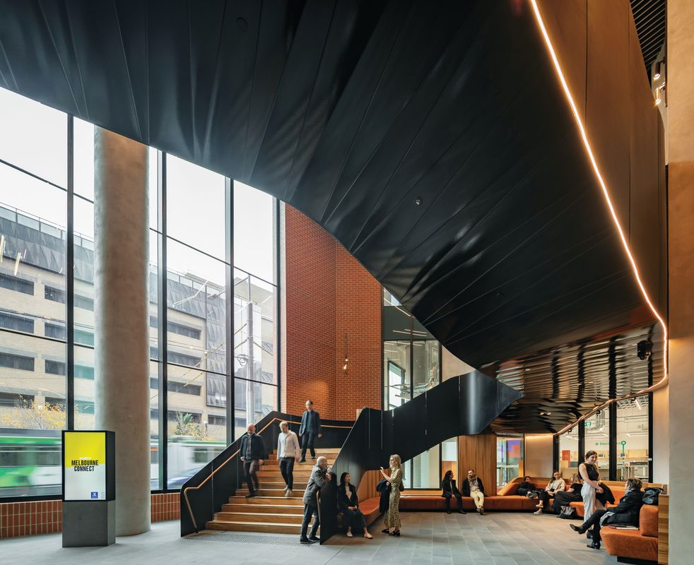

1. Upon exiting the lifts or arriving at the top of the stairs, proceed to the Forum doors located to the right of the top of the stairs.

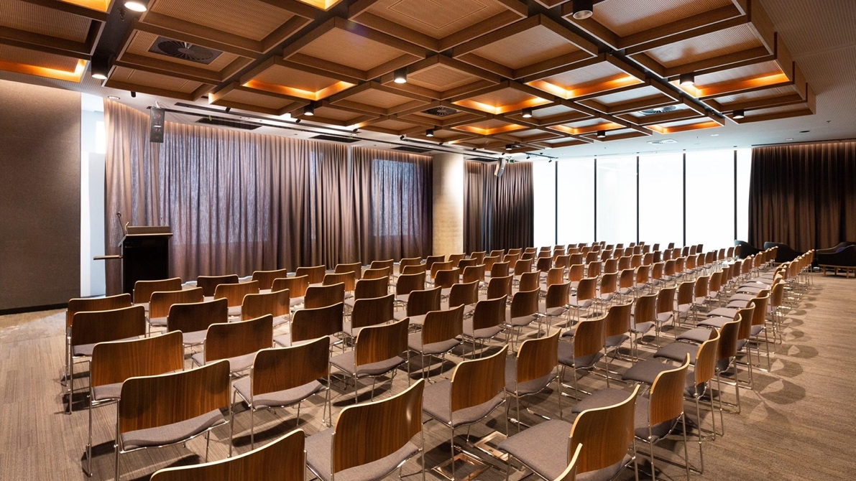

Please contact the organiser if any further directions are required.