AMC Management
Annual Maintenance Contracts – User Manual
Item | Details
System | Odoo 18 – Warranty Management solution
Modules | amc_management 18.0.1.1.0, amc_management_warranty 18.0.1.0.0, amc_management_service 18.0.1.0.0
Audience | AMC users, coordinators, managers, approvers, Helpdesk users, technicians, accountants
Version / date | 1.0 – 06 November 2026
Screens | Captured from a demonstration database (sample customers and amounts)

Contents
Contents 2
1. Introduction 3
1.1 Modules 3
1.2 Roles 3
1.3 The AMC process at a glance 3
2. Configuration (AMC Manager) 5
2.1 AMC settings 5
2.2 Billing plans 5
2.3 AMC plans 6
2.4 Pricing formulas 7
3. Selling an AMC 10
3.1 Opportunities 10
3.2 Creating a contract 11
3.3 Calculating the price 12
3.4 Price override 12
3.5 Quotation and activation 13
4. Billing 16
5. AMC visits and services 17
5.1 AMC visits 17
5.2 Creating a service request 19
5.3 Helpdesk, Service Job and Field Service 20
6. Contract lifecycle 25
6.1 Hold and resume 25
6.2 Expiring and renewal 26
6.3 Closing and cancelling 27
7. Warranty integration 28
8. Reports 29
9. Messages and troubleshooting 30
Scheduled action 30

Right-click the table and choose Update Field to refresh the page numbers.

1. Introduction
The AMC Management application manages Annual Maintenance Contracts (AMC) separately from the warranty card: plans and prices, quotations and activation, preventive visits and included free services, billing, renewals and closure. AMC visits are carried out through the same Helpdesk Ticket → Service Job → Field Service process as warranty services.

1.1 Modules
Module | What it adds
AMC Management | Plans, pricing formulas, opportunities, contracts, quotations, AMC visits, billing schedule, renewals, AMC Visit Schedule report
AMC Management – Warranty Link | Draft AMC after warranty confirmation, Convert to AMC, warranty units on the covered equipment, offer AMC when a warranty expires
AMC Management – Service Execution | Service requests from AMC visits: Helpdesk ticket, AMC warranty case, Service Job, Field Service visit, worksheet and customer sign-off

1.2 Roles
Role | Can do
AMC User | View plans, contracts and visits; prepare Draft opportunities and contracts; Convert to AMC
AMC Coordinator | Everything of the User + calculate prices, request overrides, create quotations, create invoices, plan visits, create service requests, renew contracts
AMC Manager | Everything of the Coordinator + configure plans, billing plans and formulas, cancel / hold / resume / close contracts, cancel or reopen visits
AMC Approver | Approve or reject price / pricelist overrides (never their own requests)
Helpdesk user / Technician | Process the AMC case and Service Job; complete the Field Service visit with the customer sign-off
Accountant | Post AMC invoices and register payments (standard Accounting)

1.3 The AMC process at a glance
- Configure the AMC plan, its pricing formula and billing plan.
- Create an AMC contract (manually, from an opportunity, or from a warranty card).
- Price and quote – calculate the price and create the standard quotation.
- Activate – on Sales Order confirmation or when the first invoice is paid.
- Service – the preventive visits and free services are generated; each visit is executed through Helpdesk → Service Job → Field Service.
- Bill – billing periods are released on schedule and invoiced with the standard invoicing.
- Renew or close – the contract becomes Expiring before its end date, is renewed or closed.
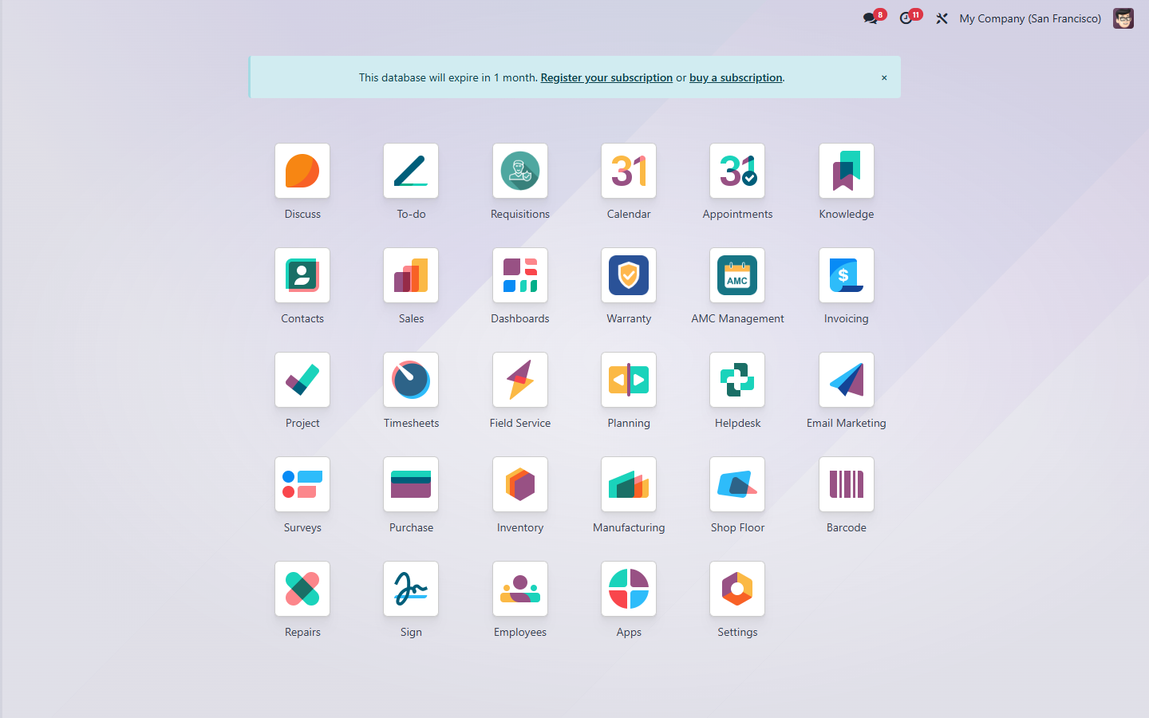
Figure 1 – The AMC Management application in the main menu

2. Configuration (AMC Manager)

2.1 AMC settings
Open AMC Management > Configuration > Settings. The settings apply to the current company.
Setting | Meaning
Default AMC Plan | Plan proposed for new opportunities and contracts (also used for draft AMC from warranty)
Default Pricelist (fallback) | Used only when the customer has no pricelist of its own or of its country
Default Billing Plan / Start Criteria / Renewal Rule / Alert Days | Proposed for new AMC plans
Activation Trigger | When contracts become Active: on Sales Order confirmation, or when the invoice of the first billing period is paid (a plan can override it)
AMC Service Product | Service product used on AMC quotation lines (invoiced on delivered quantities)
AMC Auto-create Mode | Warranty Link: None / Draft AMC Opportunity / Draft AMC Contract after a warranty card is confirmed
Offer AMC on Warranty Expiry | Warranty Link: a to-do reminds the warranty alert users to offer an AMC when a card expires

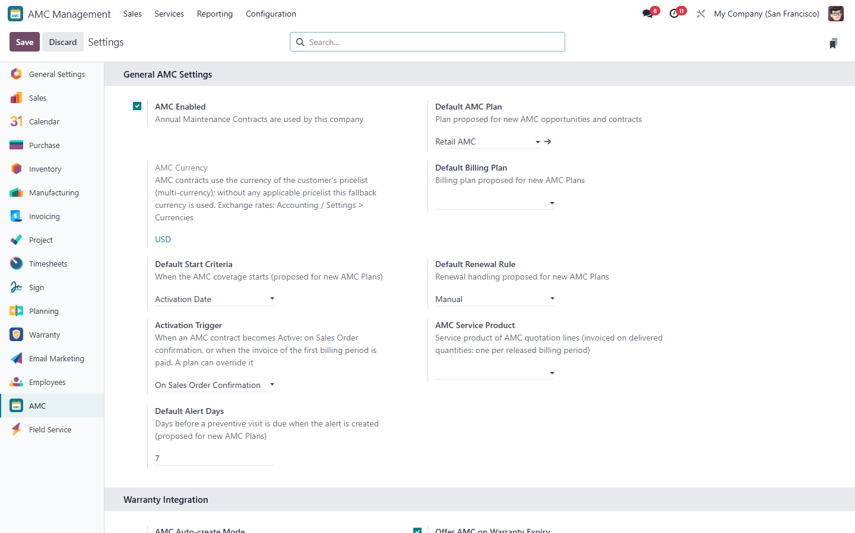
Figure 2 – AMC settings

2.2 Billing plans
Billing plans (Configuration > Billing Plans) define how the contract value is invoiced: Upfront (once, in advance), Monthly, Quarterly, Half-yearly, Annual (in advance or in arrears) or Per Preventive Visit (in arrears, when each visit is completed).
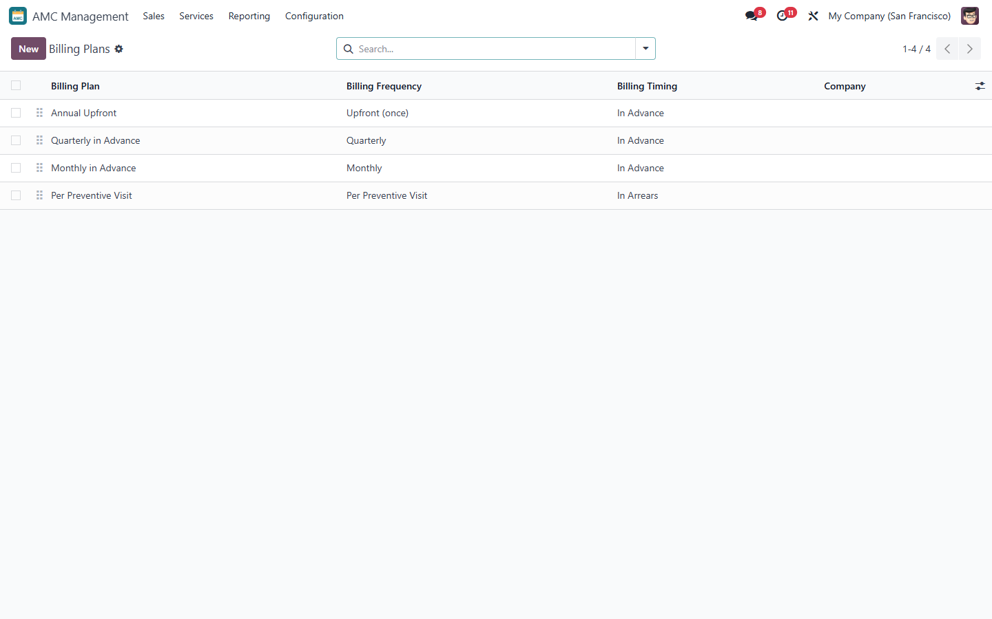
Figure 3 – Billing plans

2.3 AMC plans
An AMC plan (Configuration > AMC Plans) defines the entitlements of every covered unit and the contract rules.
Field | Meaning
Service Basis | Period (visits per month / year) or Usage (a visit every X operating hours, cycles, km…)
Visit Count (Preventive) | Preventive visits per covered unit during the contract, e.g. 3
Visit Frequency | Visits per month / year, e.g. 3 per Year = a visit every 4 months
Included Free Services | On-demand services per covered unit, separate from the preventive visits
Visit Planning | Alert-Driven (to-do Alert Days before each due date) or Manual
Grace Period / Mark Missed After Grace Period | Days a visit stays Overdue before it is marked Missed (optional)
Pricing Method / Billing Plan | Method of new formula versions; how the contract is invoiced
Start Criteria / Contract Duration | Activation Date or Manual Start Date; duration in months / years
Renewal Rule / Renewal Notice | Manual or Auto Offer; days before the end when the contract becomes Expiring
Activation Trigger | Overrides the company trigger for this plan
Applicability | Pricelists (customer types), products and product categories the plan applies to (empty = all)

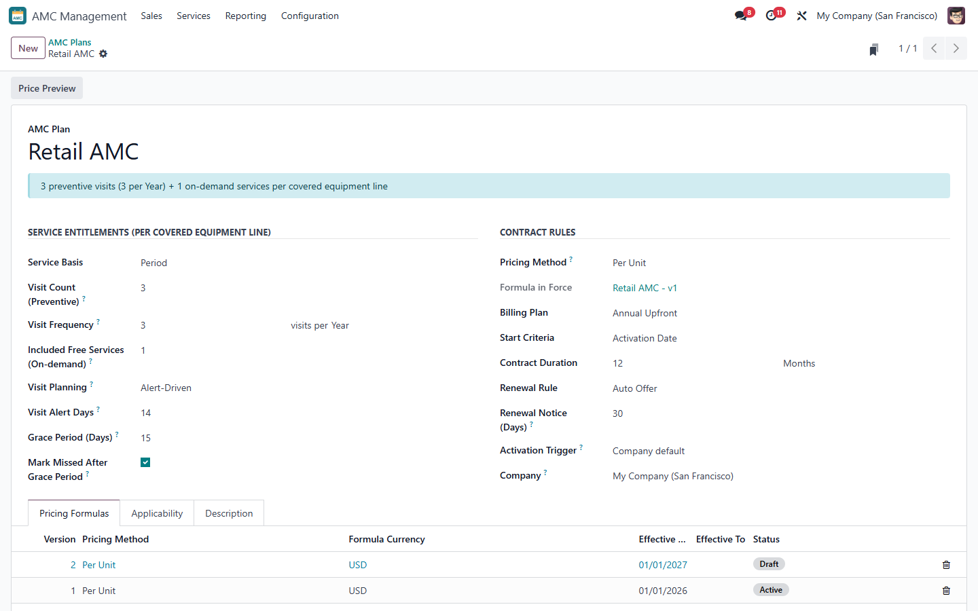
Figure 4 – AMC plan – entitlements and contract rules
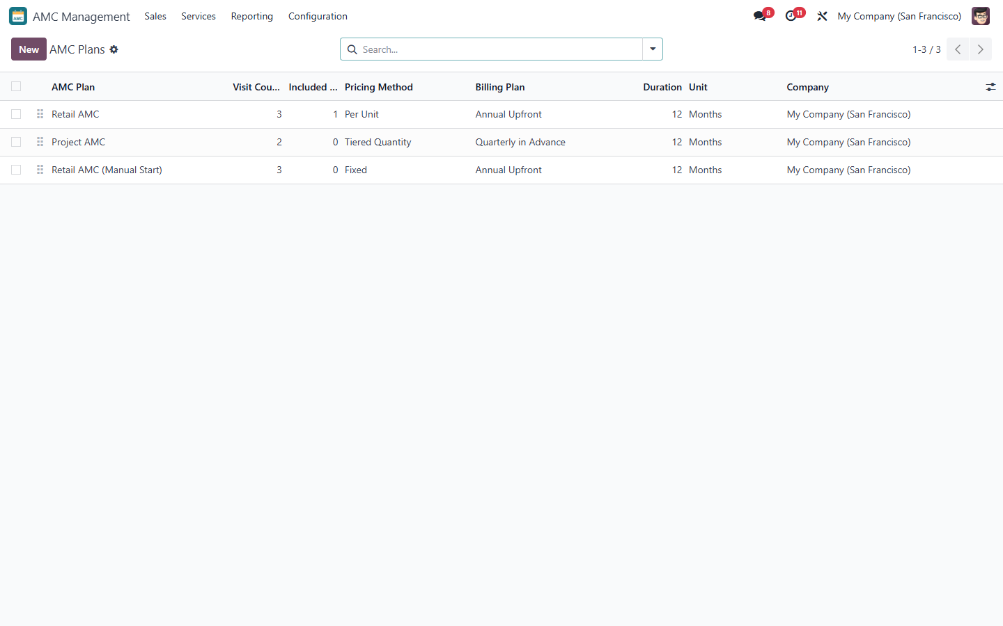
Figure 5 – AMC plans list
Note: A plan cannot promise more preventive visits than fit into its duration at its frequency, and Per Preventive Visit billing requires activation on Sales Order confirmation.

2.4 Pricing formulas
Each plan has pricing formula versions (Configuration > Pricing Formulas). Supported methods: Fixed, Per Unit, Per Visit, Percentage of Equipment / Sales Value, Tiered Quantity, Site-Based, Usage-Based and Hybrid (a controlled expression with the variables equipment_value, quantity, visit_count, contract_months, usage, site_count, factor, min_price, max_price and the functions min, max, round, abs).
- Create a version, choose the method and enter its rates; optionally Minimum / Maximum Price, Rounding Step, product / category factors and tiers.
- Check the Sample section (sample quantity, value, sites, usage) – it shows the calculated sample price and the full breakdown.
- Click Activate. An Active version cannot be changed: use New Version (it starts after the current one). Activating a version ends the previous open version the day before.
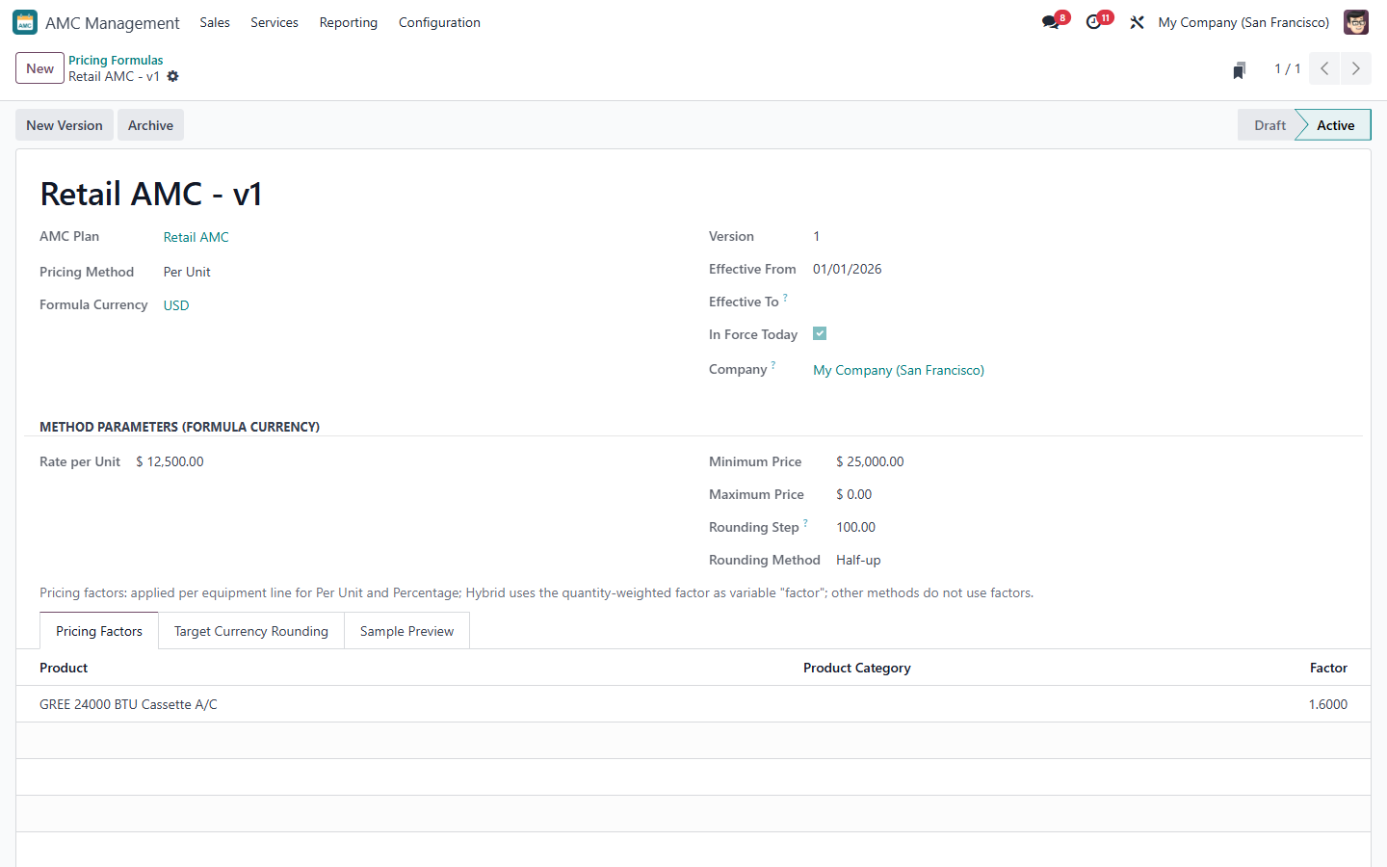
Figure 6 – Pricing formula version with sample calculation
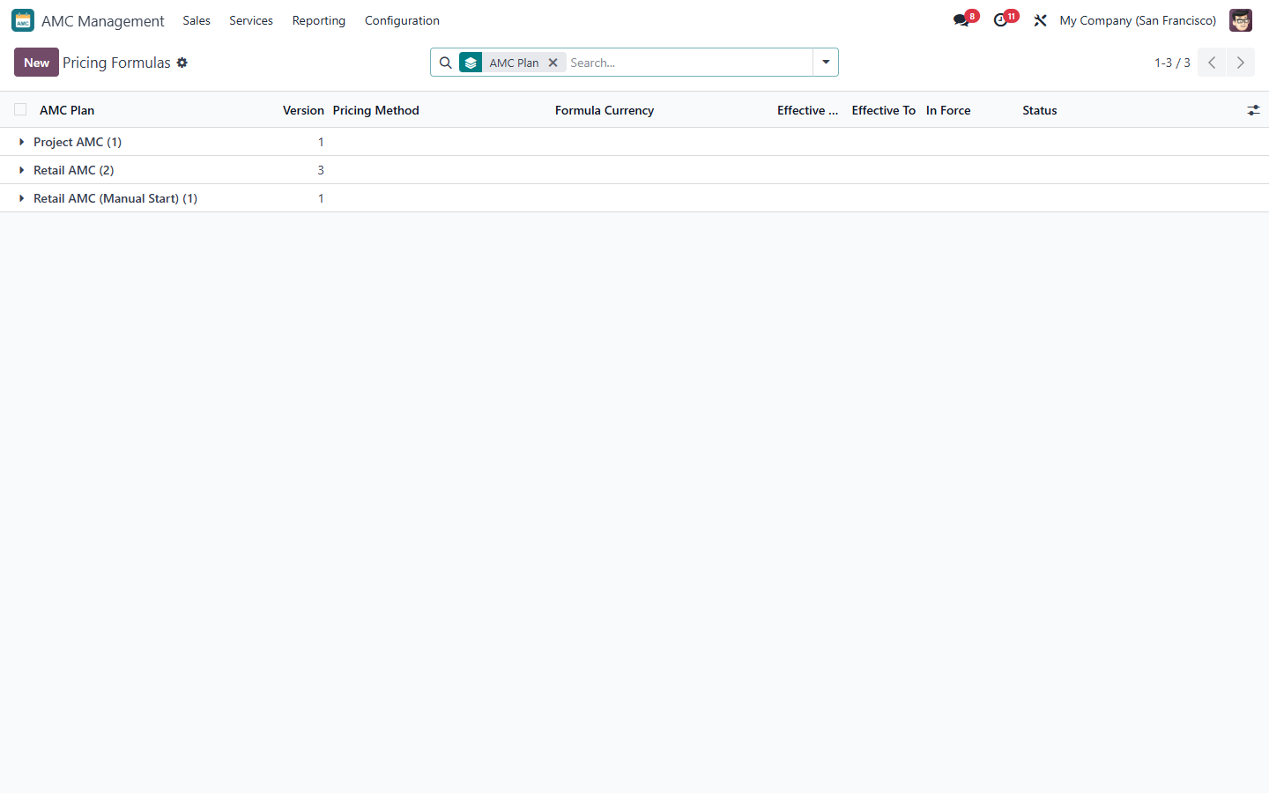
Figure 7 – Formula versions (Active, Draft) per plan

Price Preview
On the plan, Price Preview calculates a price for a customer and sample equipment without creating anything.
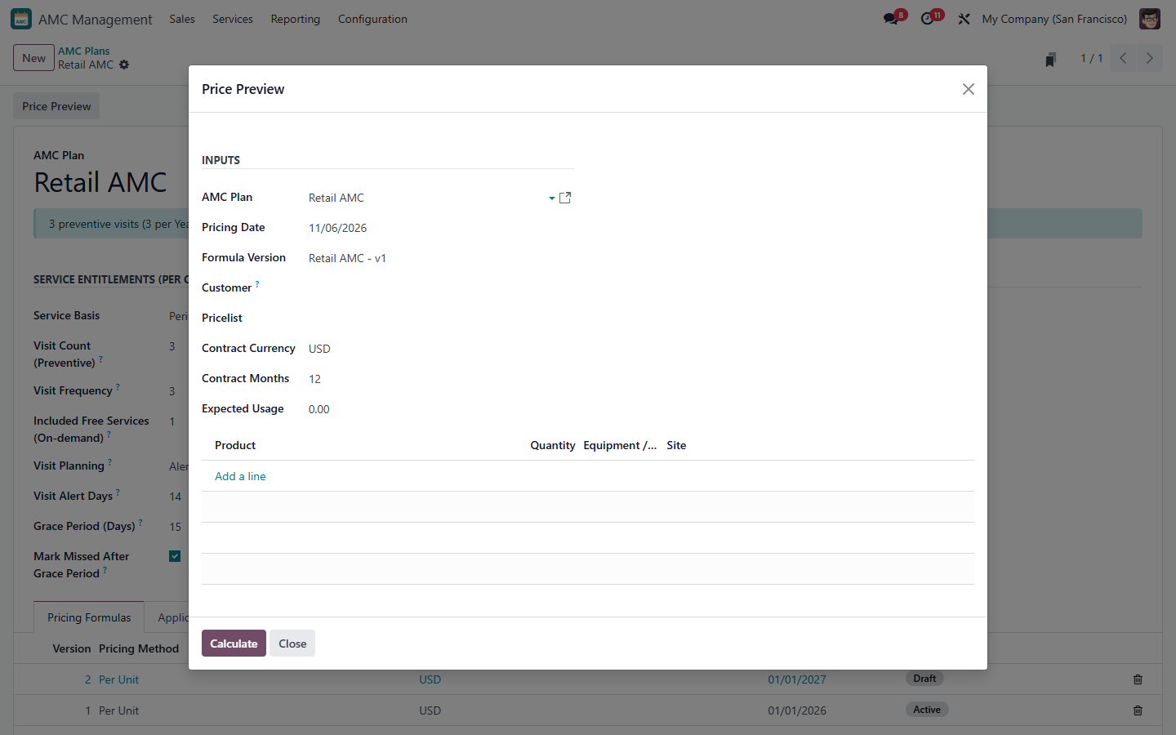
Figure 8 – Price Preview

3. Selling an AMC

3.1 Opportunities
Optional pre-sales follow-up: Sales > Opportunities. Statuses New → Offer Sent → Won (Create Contract) or Lost (with a reason).
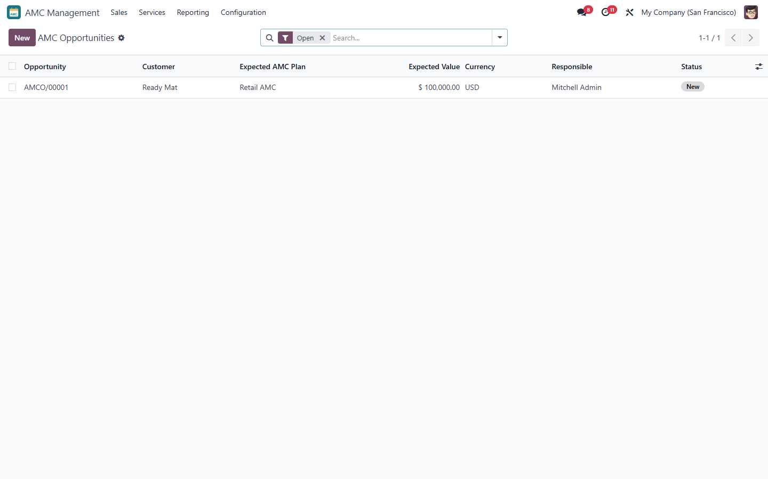
Figure 9 – AMC opportunities
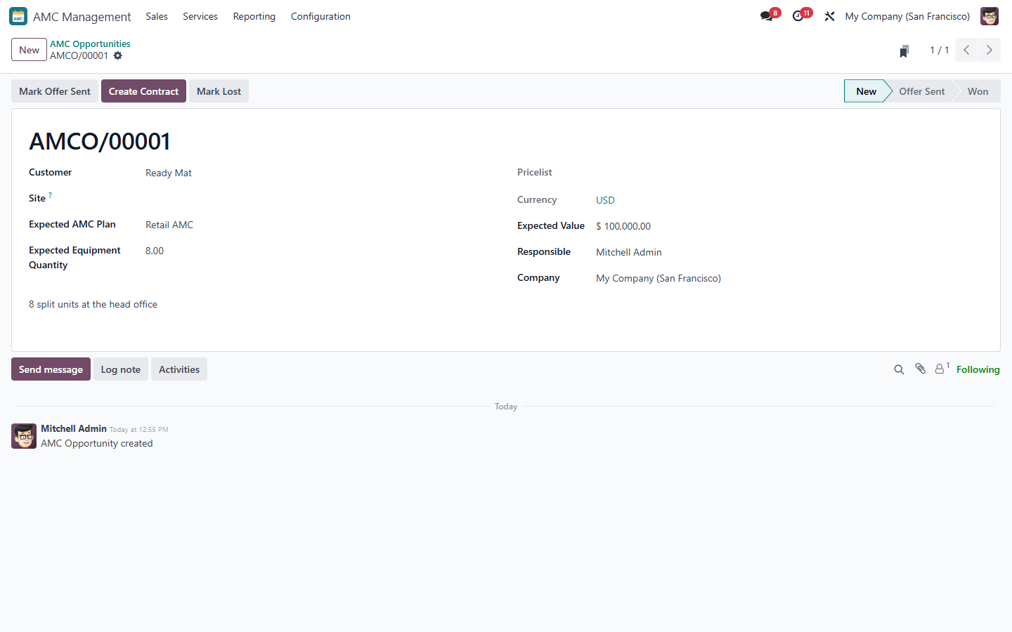
Figure 10 – AMC opportunity – Create Contract when won

3.2 Creating a contract
Sales > Contracts > New: customer, site (service address), AMC plan and the covered equipment (product, serial or warranty unit, whole quantity, site, original equipment value and currency).
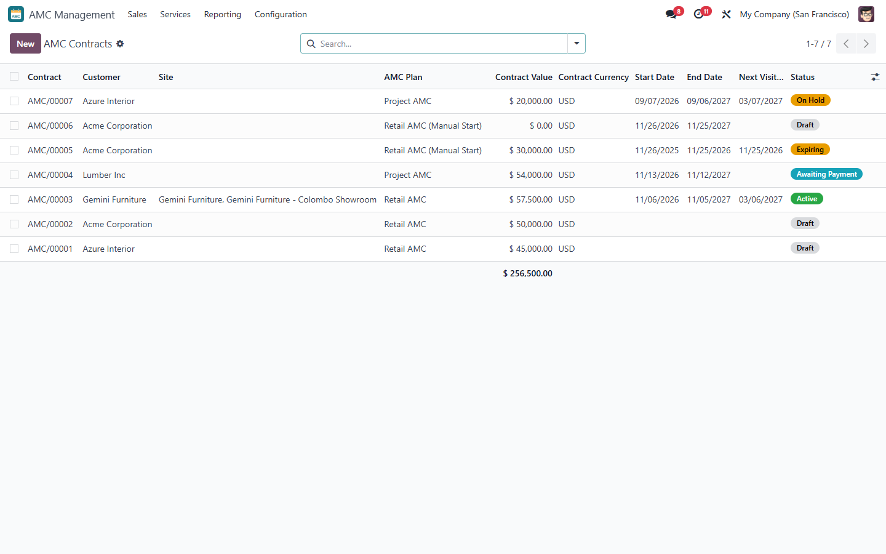
Figure 11 – AMC contracts list with status and next visit
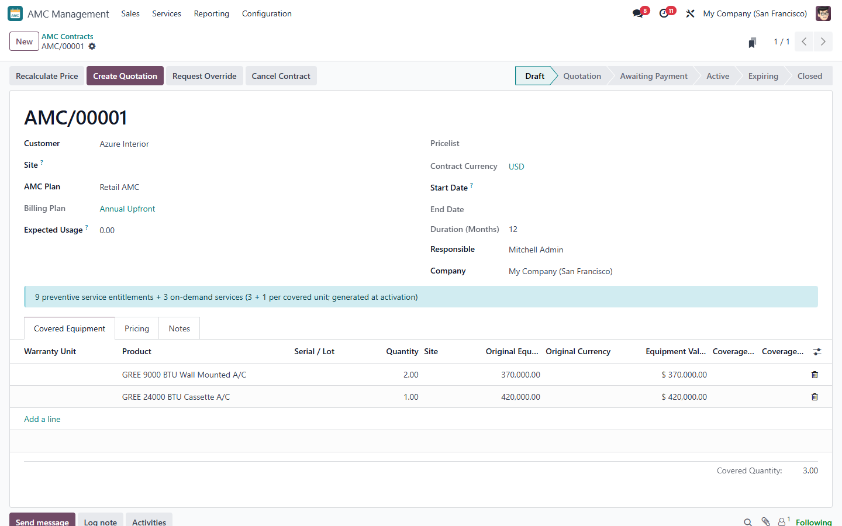
Figure 12 – Draft contract with covered equipment
Note: A serial number or warranty unit can be covered by one open contract only (except the contract and its renewal). The plan must apply to the customer's pricelist and to the products.

3.3 Calculating the price
Click Calculate Price. The formula version in force today is used and converted into the contract currency; the Pricing tab keeps the full snapshot (formula, version, rate, breakdown). Any change of the customer, plan, equipment, start date or expected usage resets the price.
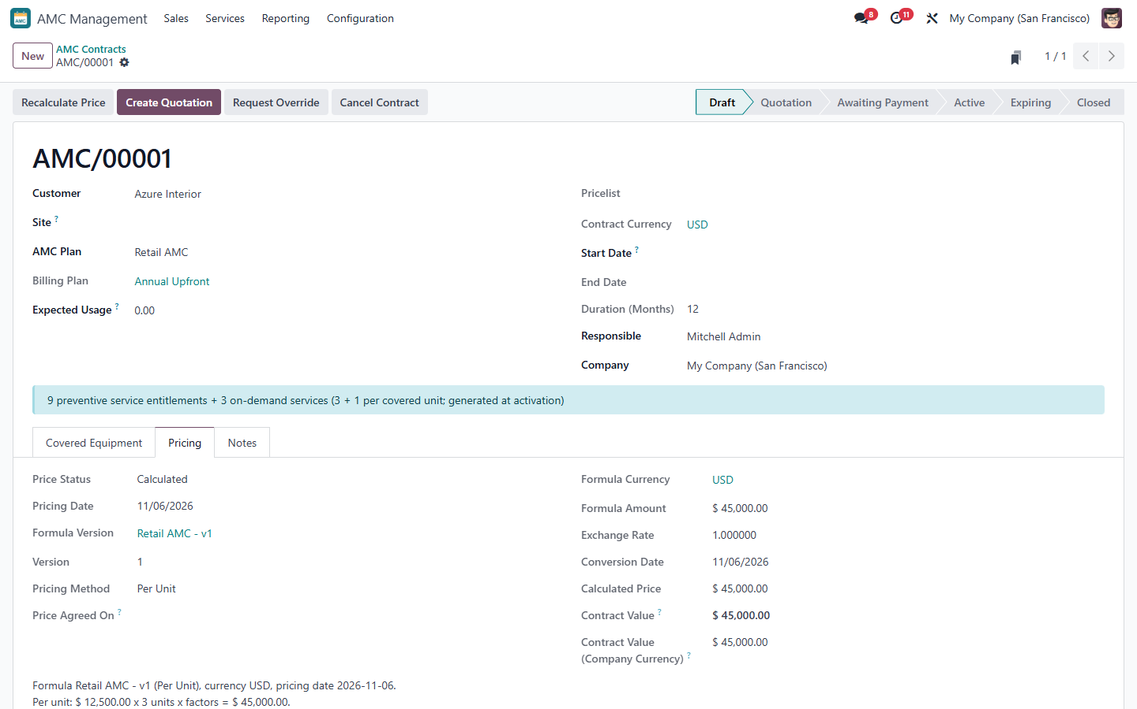
Figure 13 – Pricing tab with the calculation breakdown

3.4 Price override
Request Override (Coordinator, with a reason) asks for another price or pricelist. An AMC Approver who is not the requester approves or rejects it; the approved price is used for the quotation.
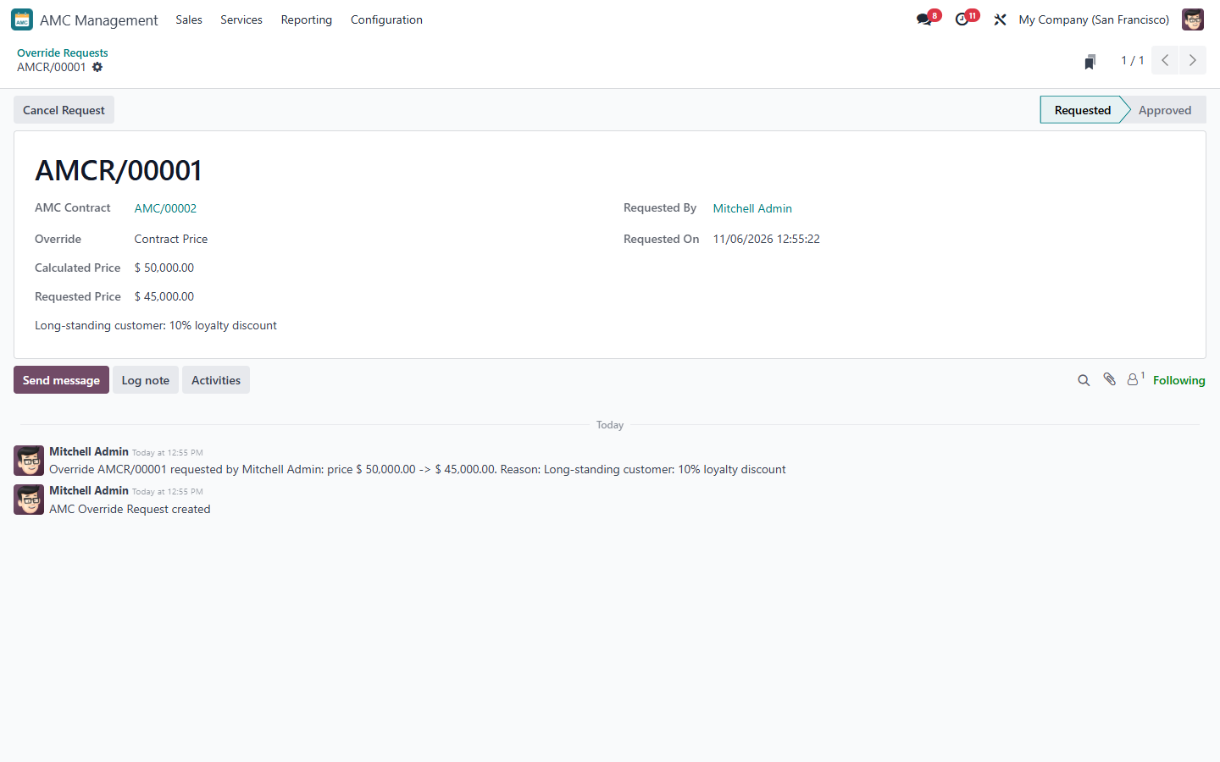
Figure 14 – Override request waiting for approval

3.5 Quotation and activation
- Click Create Quotation. A standard Sales quotation is created; its quantity is the number of billing periods. AMC quotation lines cannot be edited, copied or extended.
- Send and confirm the quotation in Sales. The price is frozen and the billing schedule is created.
- Activation On Sales Order Confirmation: the contract becomes Active at once. On Payment: it becomes Awaiting Payment; create the invoice of the first period, post it and register the payment – the contract is then Active.
- On activation the preventive visits (with due dates) and the included free services of every covered unit are generated.
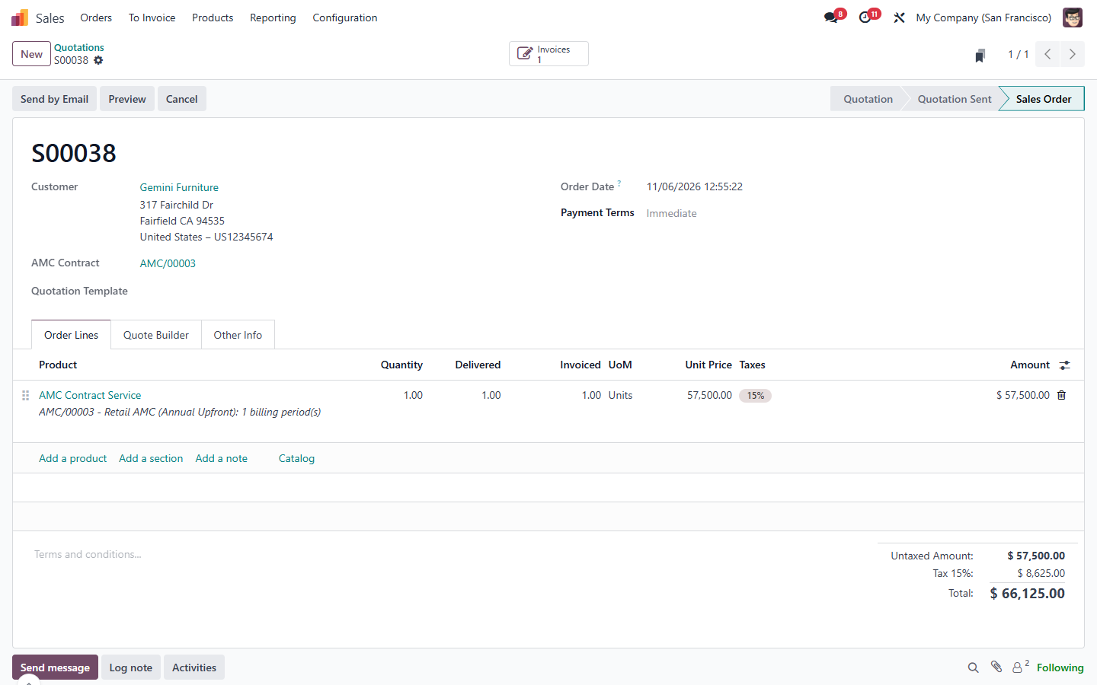
Figure 15 – AMC Sales Order (locked lines = billing periods)
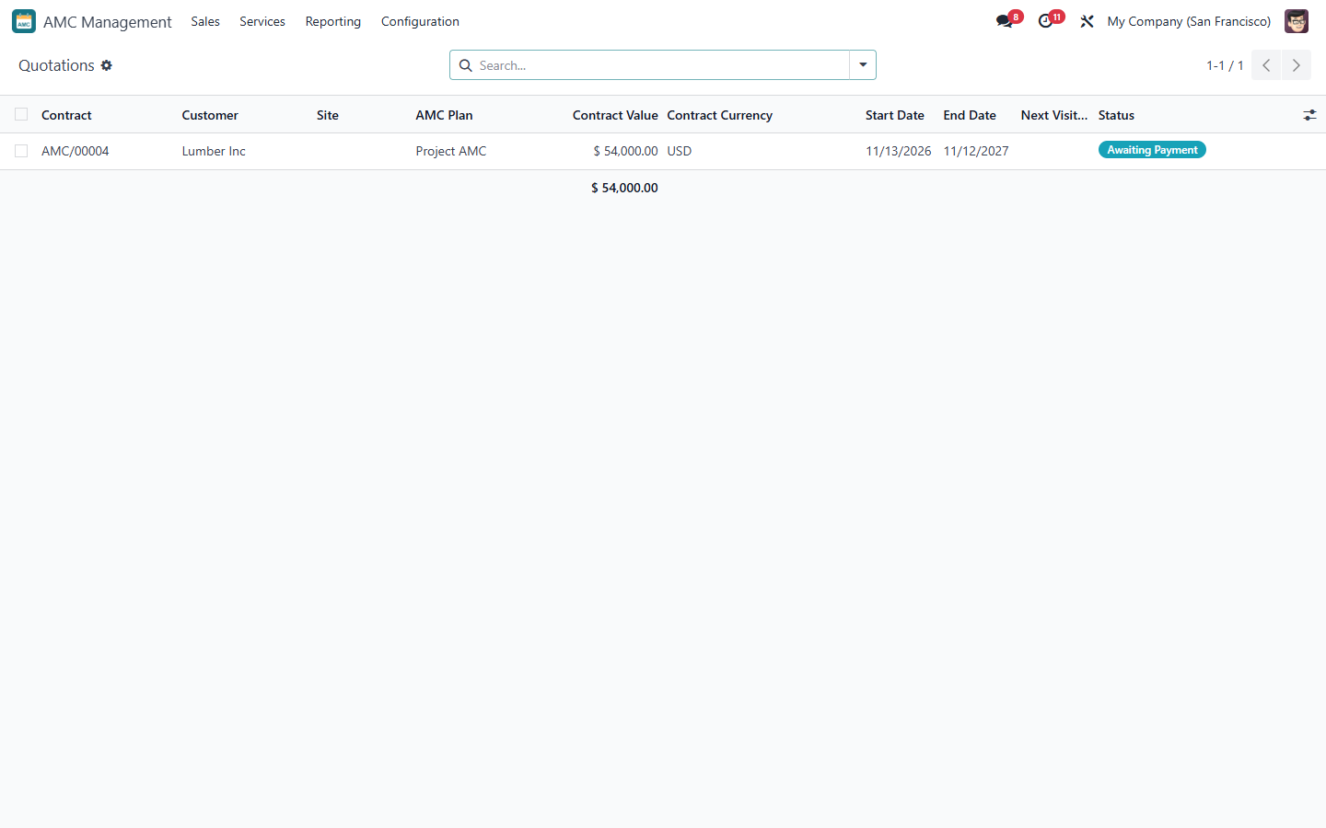
Figure 16 – Contracts in Quotation / Awaiting Payment
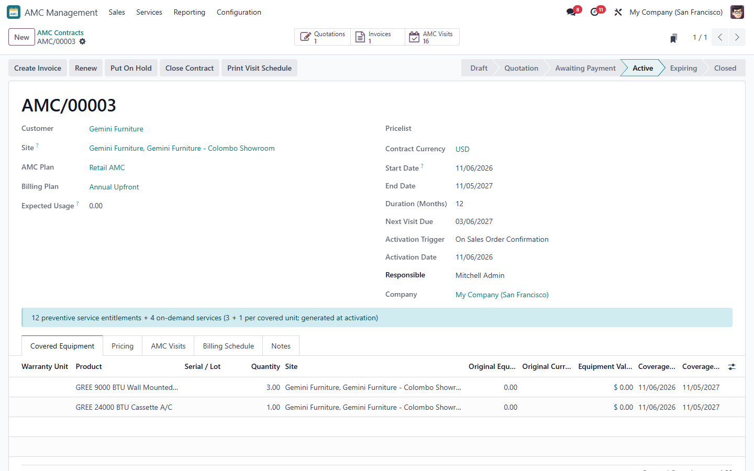
Figure 17 – Active contract with smart buttons Quotations, Invoices, AMC Visits
Note: An expired quotation cannot be confirmed: use Reissue Quotation on the contract (the price is calculated again for today).

4. Billing
The Billing Schedule tab lists one line per billing period with its dates and amount. Periods are released automatically by the daily scheduler: in advance on the period start, in arrears on the period end, per visit when the visit is completed. A released period is one delivered unit on the Sales Order line.
- Click Create Invoice on the contract (or Create Invoice on the Sales Order) to create the draft invoice of the released periods.
- Accounting checks, posts and collects the invoice as usual. Nothing is posted or paid automatically.
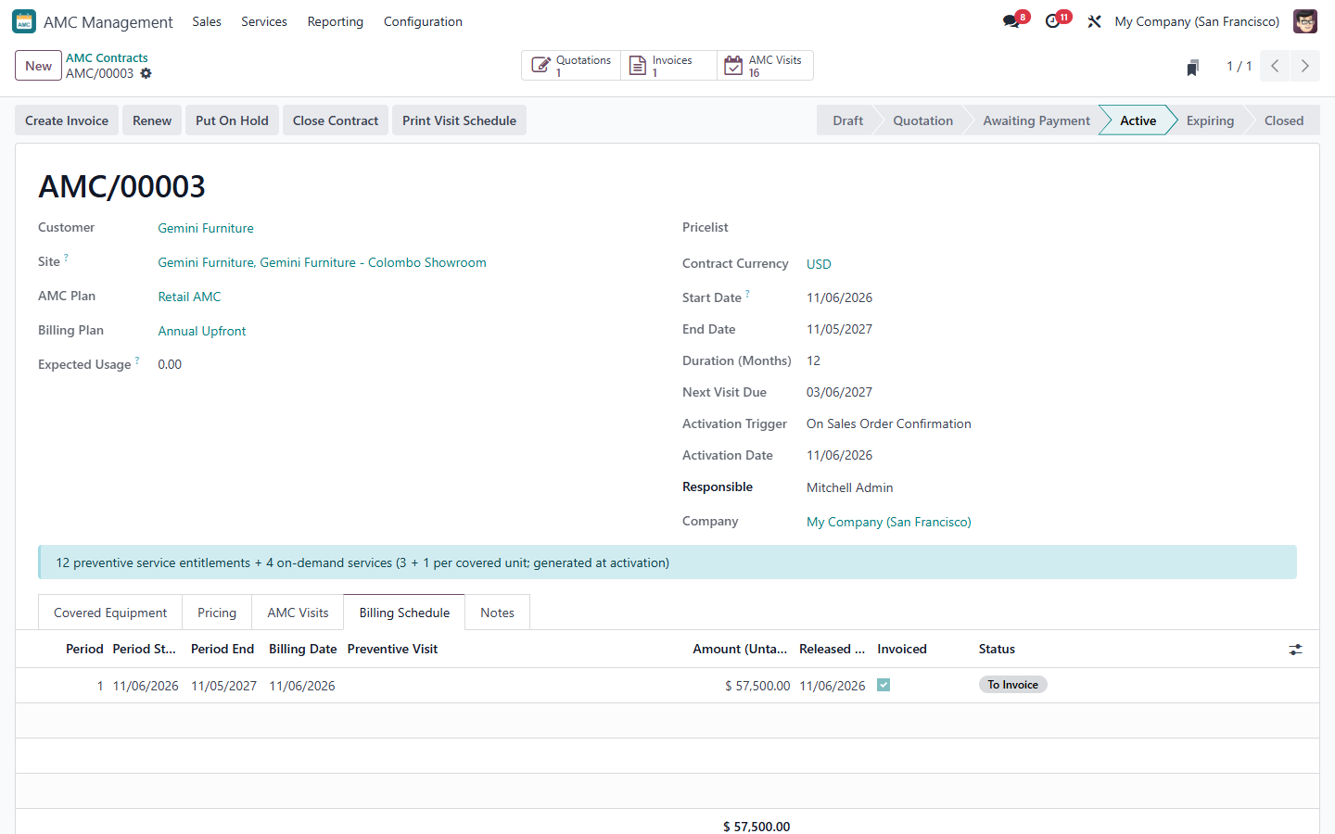
Figure 18 – Billing schedule of a contract
Note: When a contract is closed, periods not yet released are cancelled; invoiced periods are handled in Accounting (credit note if needed).

5. AMC visits and services

5.1 AMC visits
Services > AMC Visits lists every entitlement: preventive visits (with due date, or usage due) and included free services. Use the filters Due, Overdue, Planned, Missed and the views list, kanban and calendar.
Status | Meaning
Pending | Available, not yet requested
Scheduled | Planned, or linked to an AMC service request (warranty case)
In Progress | Its Service Job is confirmed (Field Service visit created)
Completed | Consumed once by a completed visit with customer sign-off
Missed | Not serviced within the grace period (if enabled) – an AMC Manager can Reopen it
Expired | Contract closed or renewed before the visit was used
Cancelled | Cancelled by an AMC Manager with a reason (not consumed)

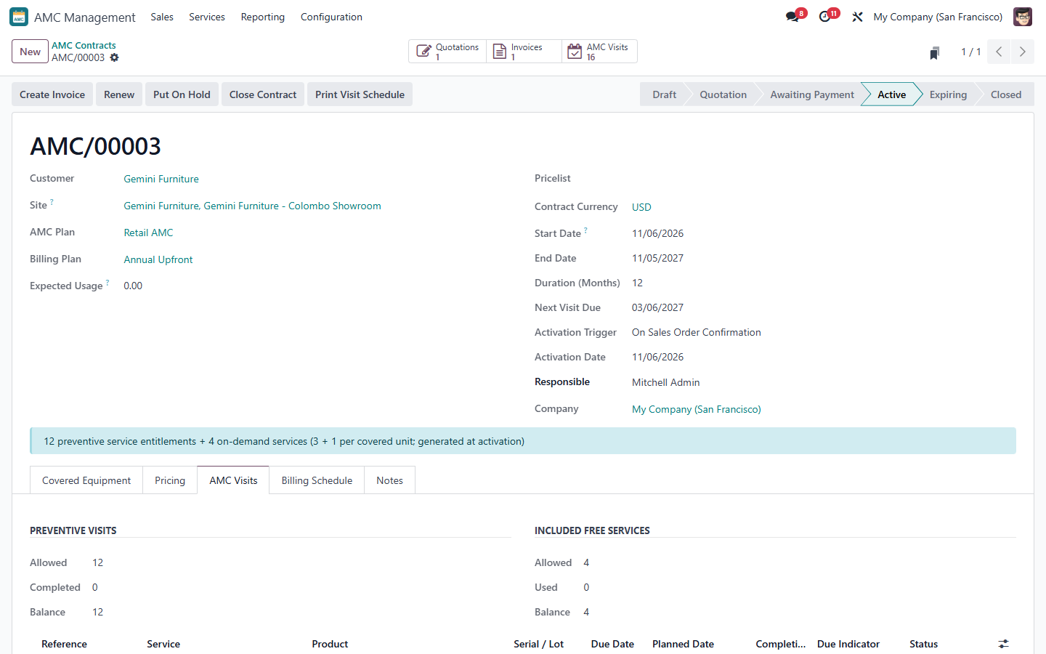
Figure 19 – AMC Visits tab of a contract with allowed / used / balance
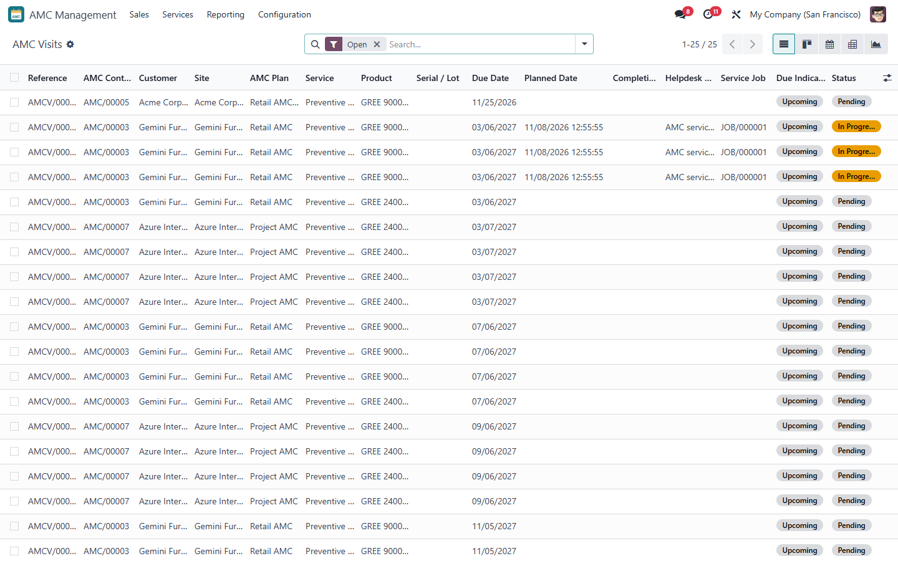
Figure 20 – AMC visits list
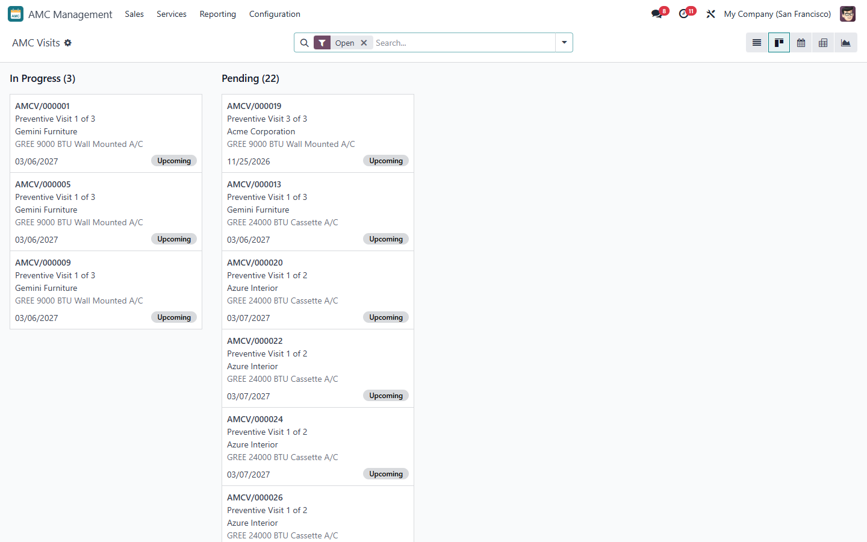
Figure 21 – AMC visits kanban by status
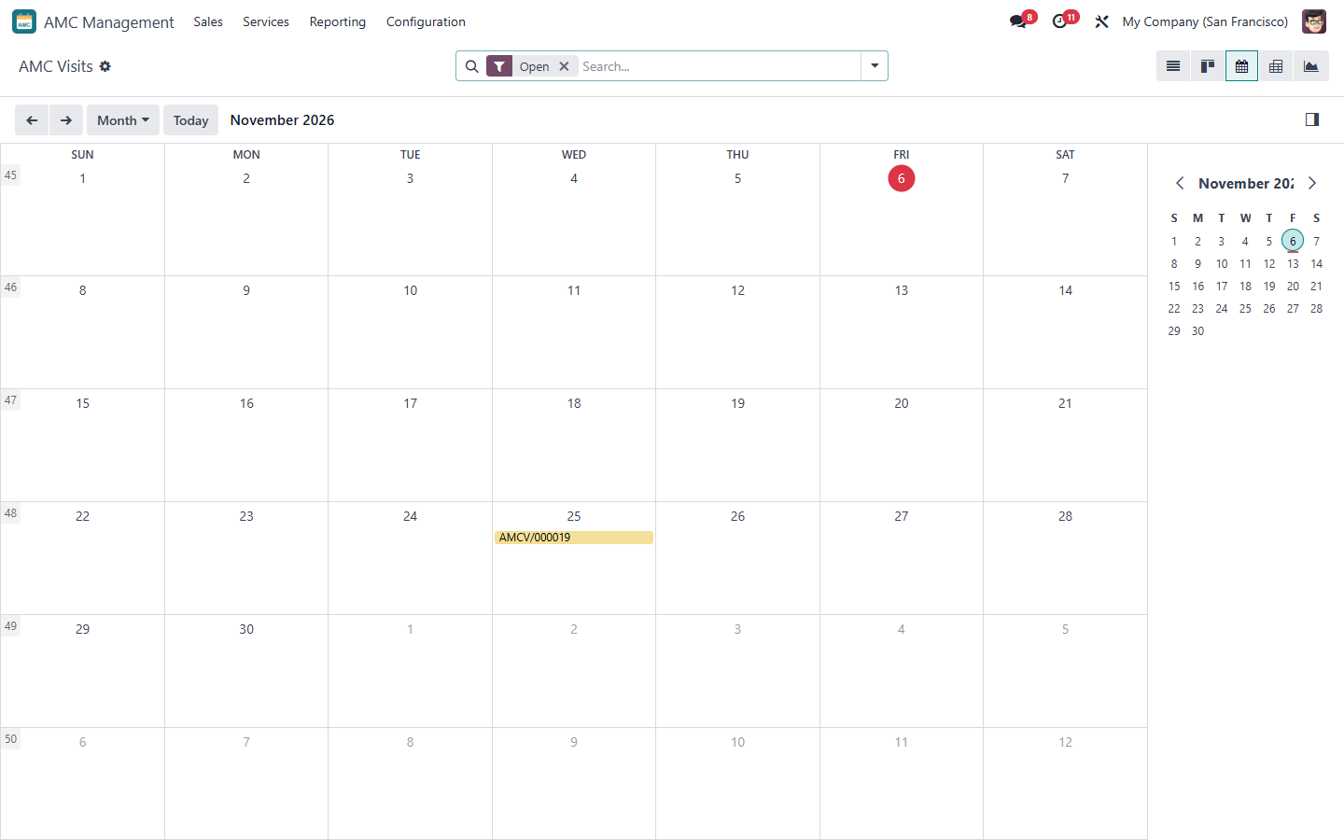
Figure 22 – AMC visits calendar by due date
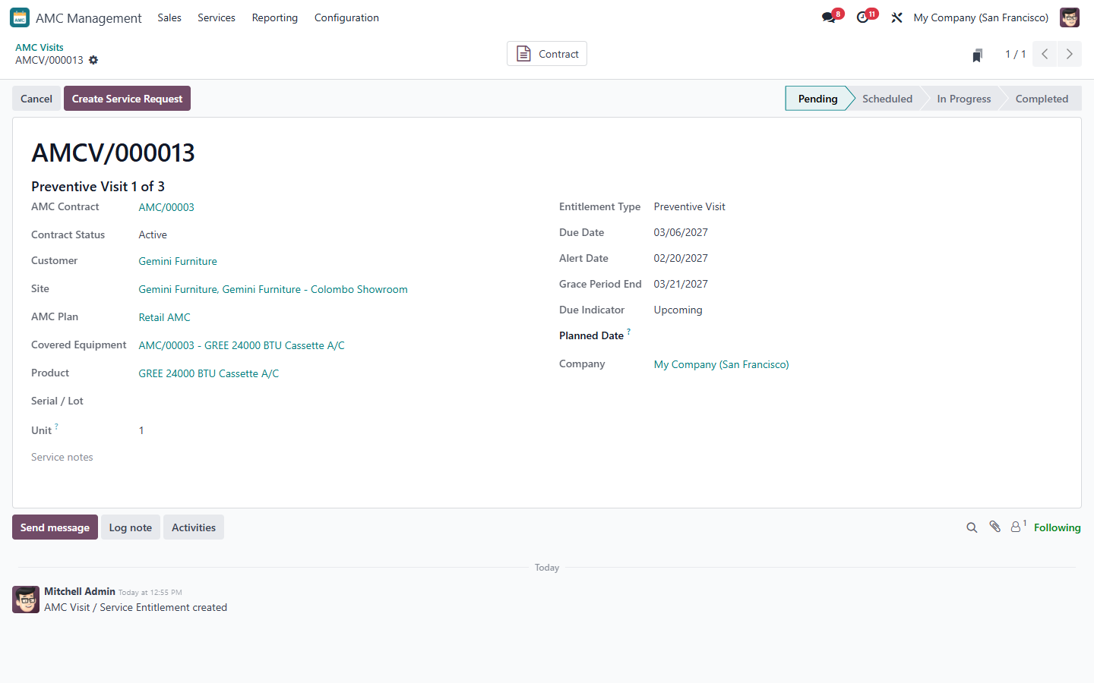
Figure 23 – AMC visit form
Due indicator: Upcoming before the alert date, Due from the alert date, Overdue after the due date. Alert-Driven plans create a to-do for the contract responsible Alert Days before the due date.

5.2 Creating a service request
- Select one or more Pending visits of the same contract and site (list view), or open a visit.
- Click Create Service Request. Choose Create New (Helpdesk team) or Link Existing ticket and describe the request.
- A Helpdesk ticket (tag AMC) and a warranty case of type AMC are created; the visits become Scheduled.
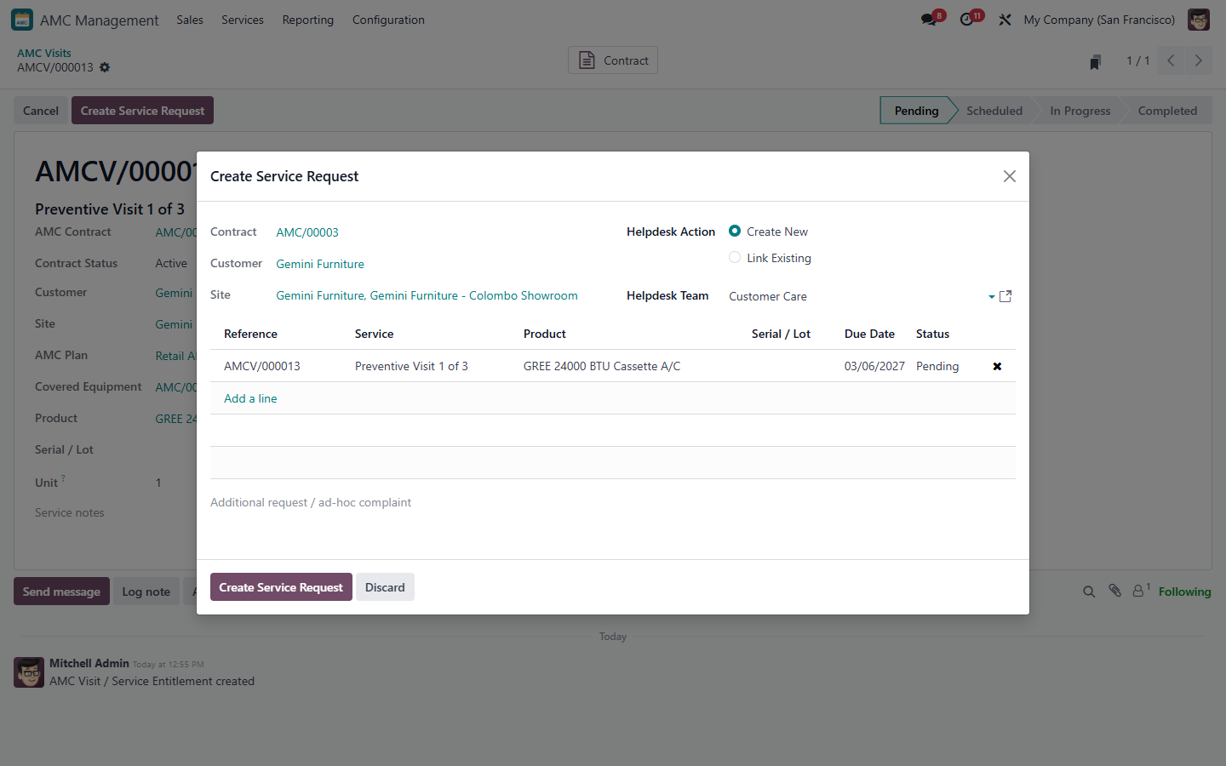
Figure 24 – Create Service Request
Note: Visits of different contracts or sites, visits that are not Pending and visits of contracts that are not Active / Expiring cannot be requested together.

5.3 Helpdesk, Service Job and Field Service
- Helpdesk ticket: the AMC request; a ticket of the customer shows the Pending AMC Services and Add AMC Services to this Ticket.
- Warranty case (AMC): Check Eligibility applies the AMC rules (contract Active or Expiring, request date inside the contract period, visits open), then Approve Case (approver other than the creator / checker).
- Prepare Service Job: set the planned date, the main technician (mandatory) and support technicians, then Confirm – the Field Service visit and one worksheet per AMC visit are created; the visits become In Progress.
- Field Service visit: the technician records the time, fills the worksheet (usage reading for usage-based visits), collects the customer signature and clicks Complete Visit. The AMC visits are completed automatically (consumed once) and the next due visit is shown on the contract.
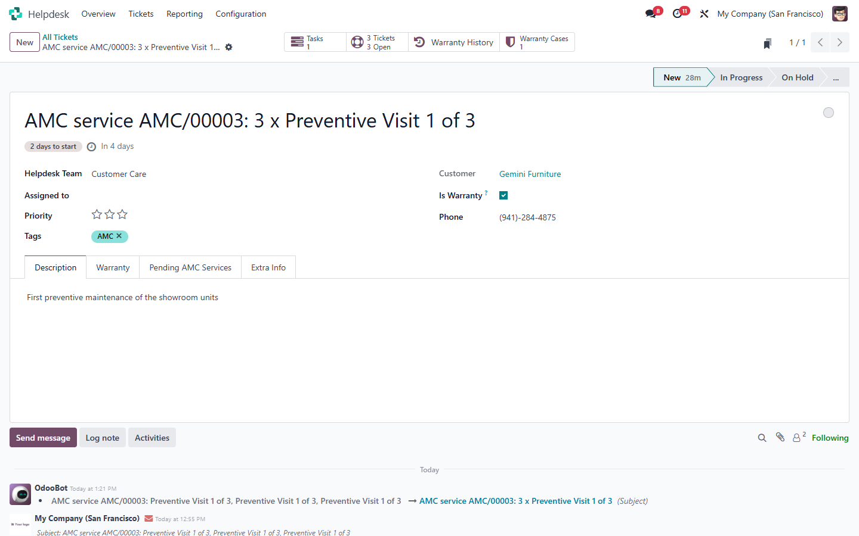
Figure 25 – Helpdesk ticket of an AMC service request
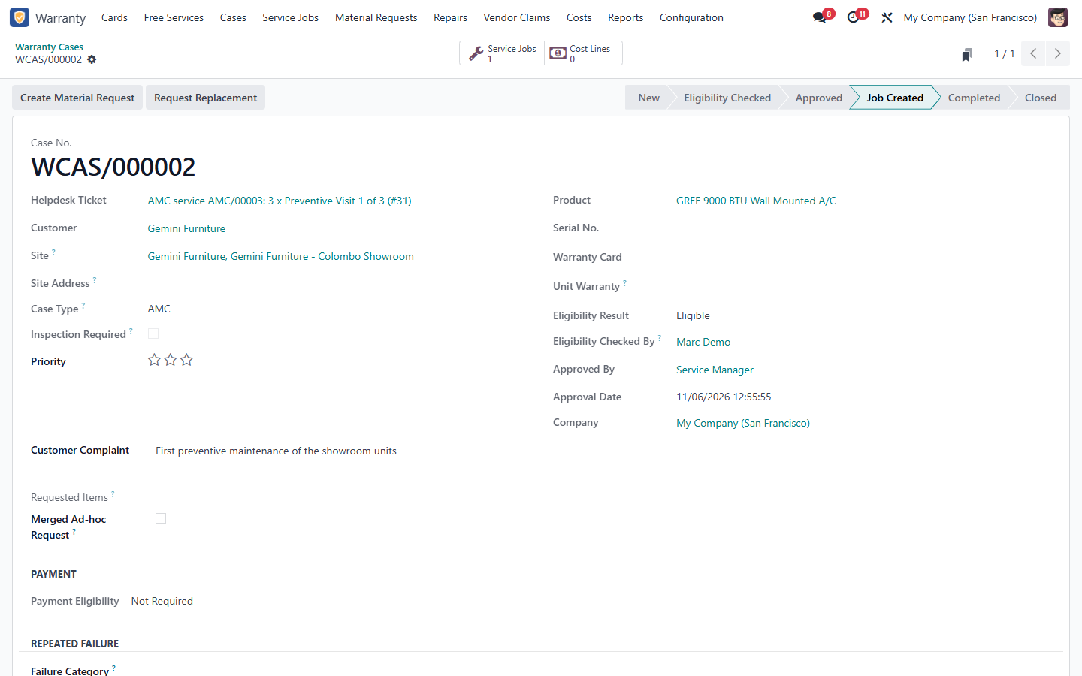
Figure 26 – Warranty case of type AMC
Figure 27 – AMC tab of the case: contract and visits
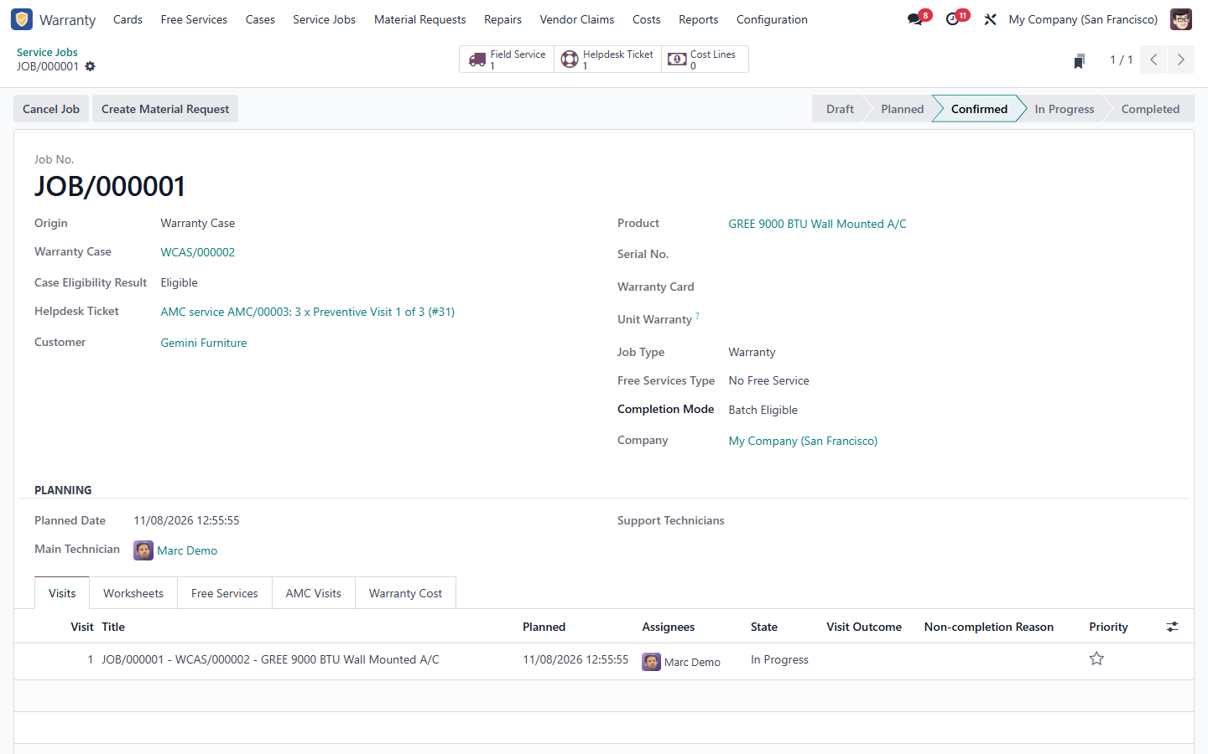
Figure 28 – Service Job of the AMC request
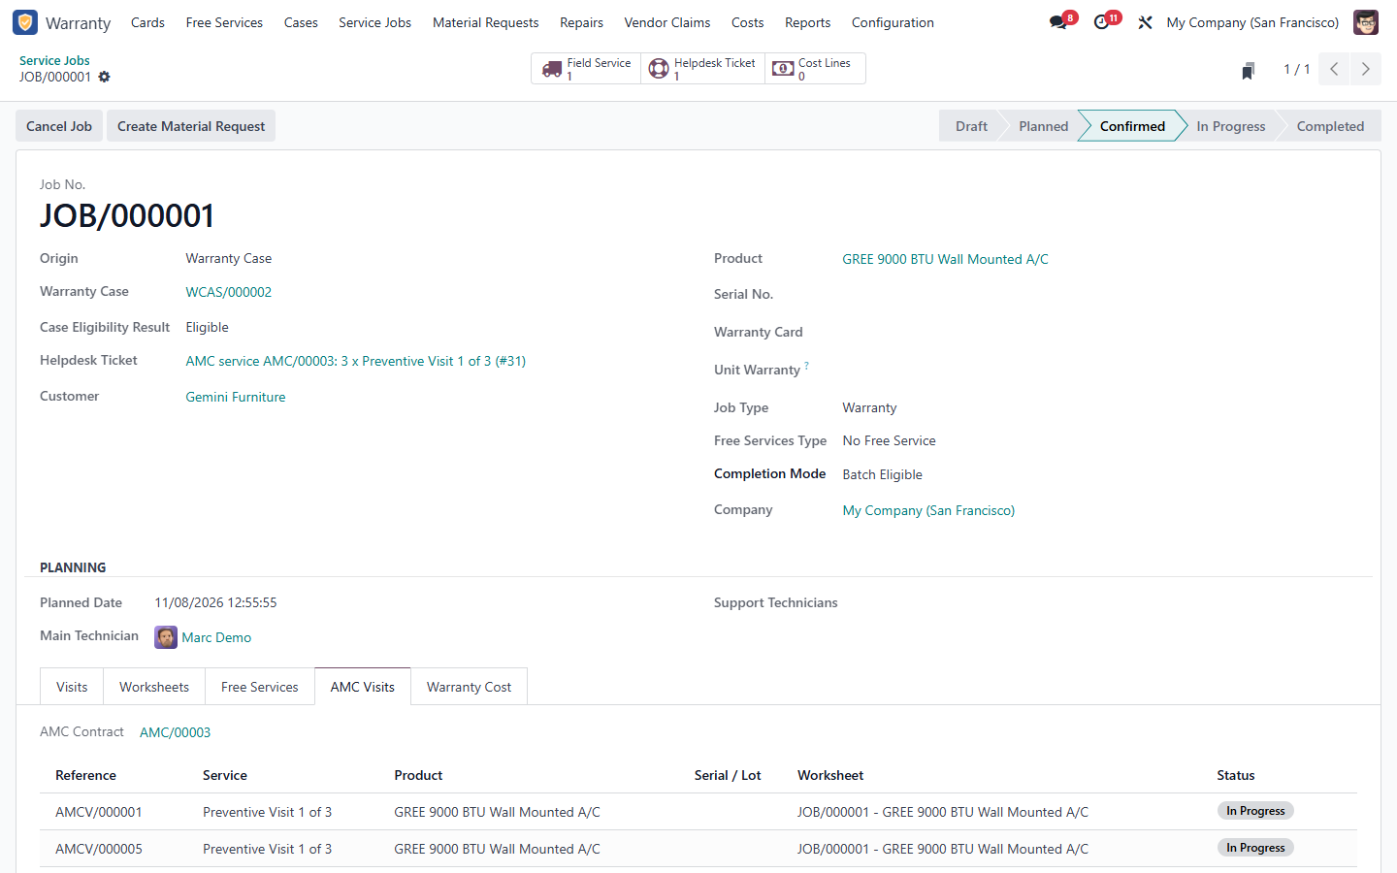
Figure 29 – AMC Visits tab of the Service Job
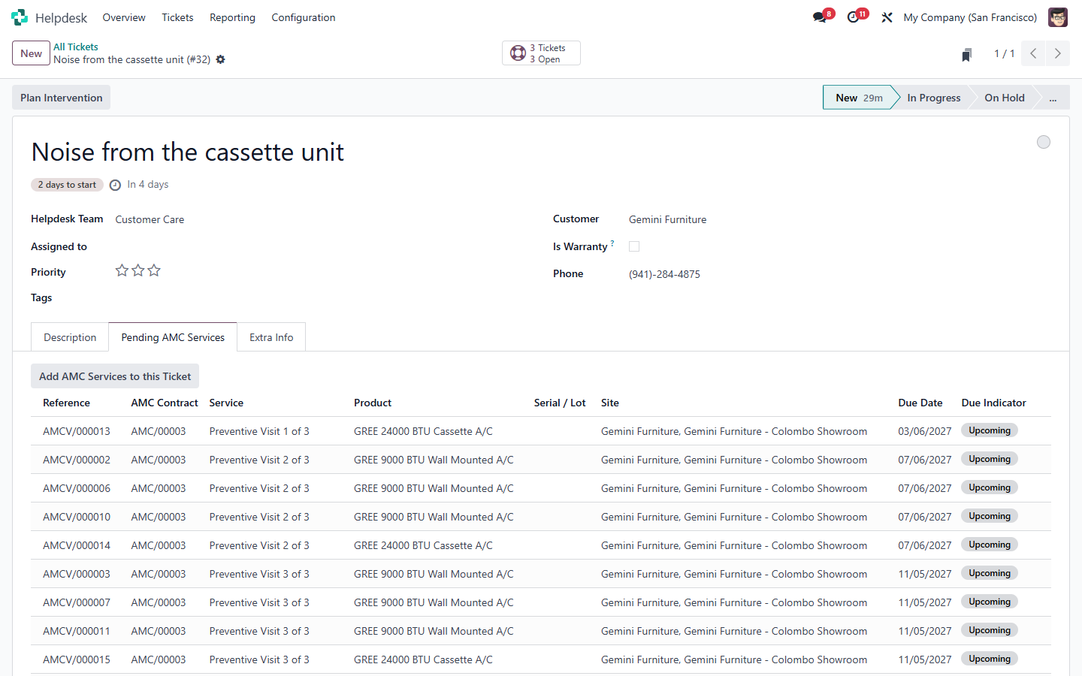
Figure 30 – Pending AMC Services on a Helpdesk ticket
Situation | Effect on the AMC visits
Visit not completed / rescheduled | Job and visits stay open, not consumed; a follow-up visit is planned on the job
Service Job cancelled | Visits back to Scheduled on the (Approved) case, not consumed
Case rejected or closed | Visits back to Pending
No customer sign-off (when required) | Completion refused

Note: With the Service Execution module, AMC visits can only be completed through their Service Job. Without it, a Coordinator sets the Planned Date and uses Complete on the visit.

6. Contract lifecycle
Status | Meaning / how it is reached
Draft | Being prepared; equipment and price can change
Quotation | Quotation created; waiting for confirmation
Awaiting Payment | Order confirmed; waiting for the payment of the first invoice
Active | Coverage running; visits and billing active
On Hold | Put on hold by a Manager (reason): no planning, requests or alerts; dates unchanged
Expiring | Within the renewal notice before the end date
Renewed | Replaced by its activated renewal
Closed | Ended (end date passed or closed by a Manager)
Cancelled | Cancelled before activation

6.1 Hold and resume
Put On Hold (Manager, reason) on an Active or Expiring contract; Resume returns it to Active (or Expiring). The contract period is not extended.
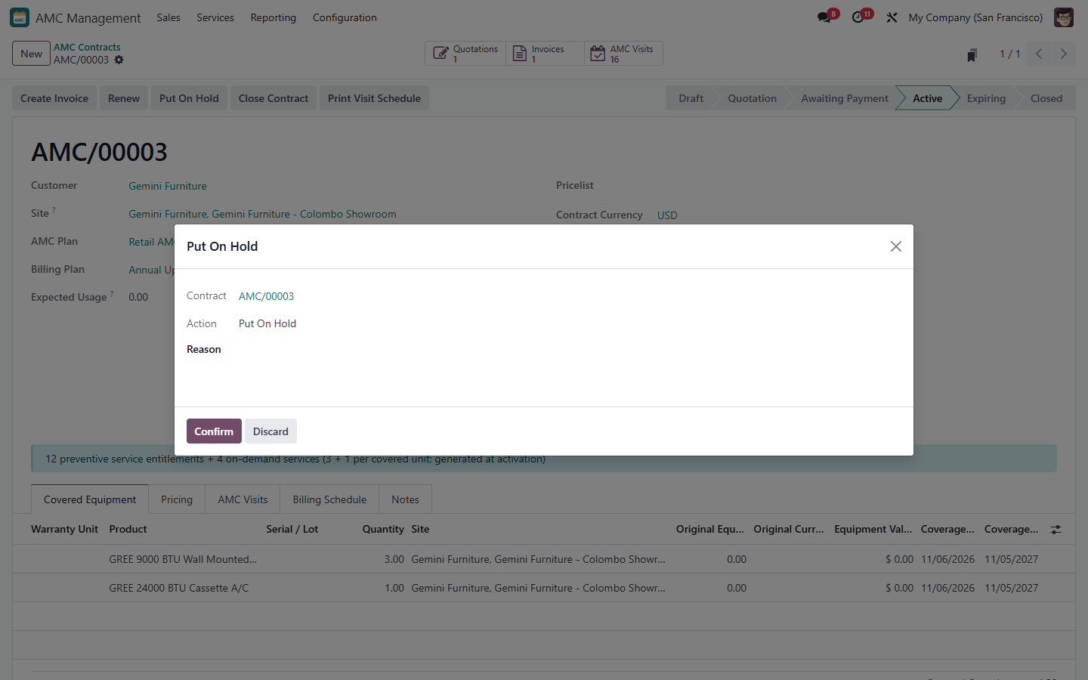
Figure 31 – Put On Hold with a reason
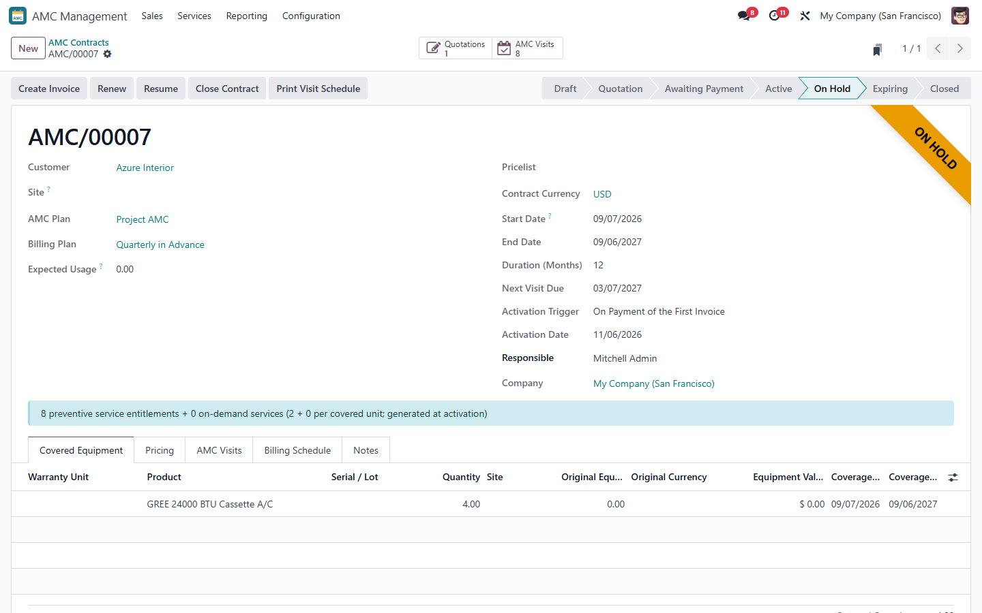
Figure 32 – Contract On Hold

6.2 Expiring and renewal
The daily scheduler sets Expiring when the renewal notice is reached and creates a to-do. With the Auto Offer rule a renewal Draft is prepared automatically; otherwise click Renew. The renewal copies customer, site, plan and equipment, starts the day after the end date and is priced and sold like a new contract. Sales > Renewals lists expiring contracts and renewals.
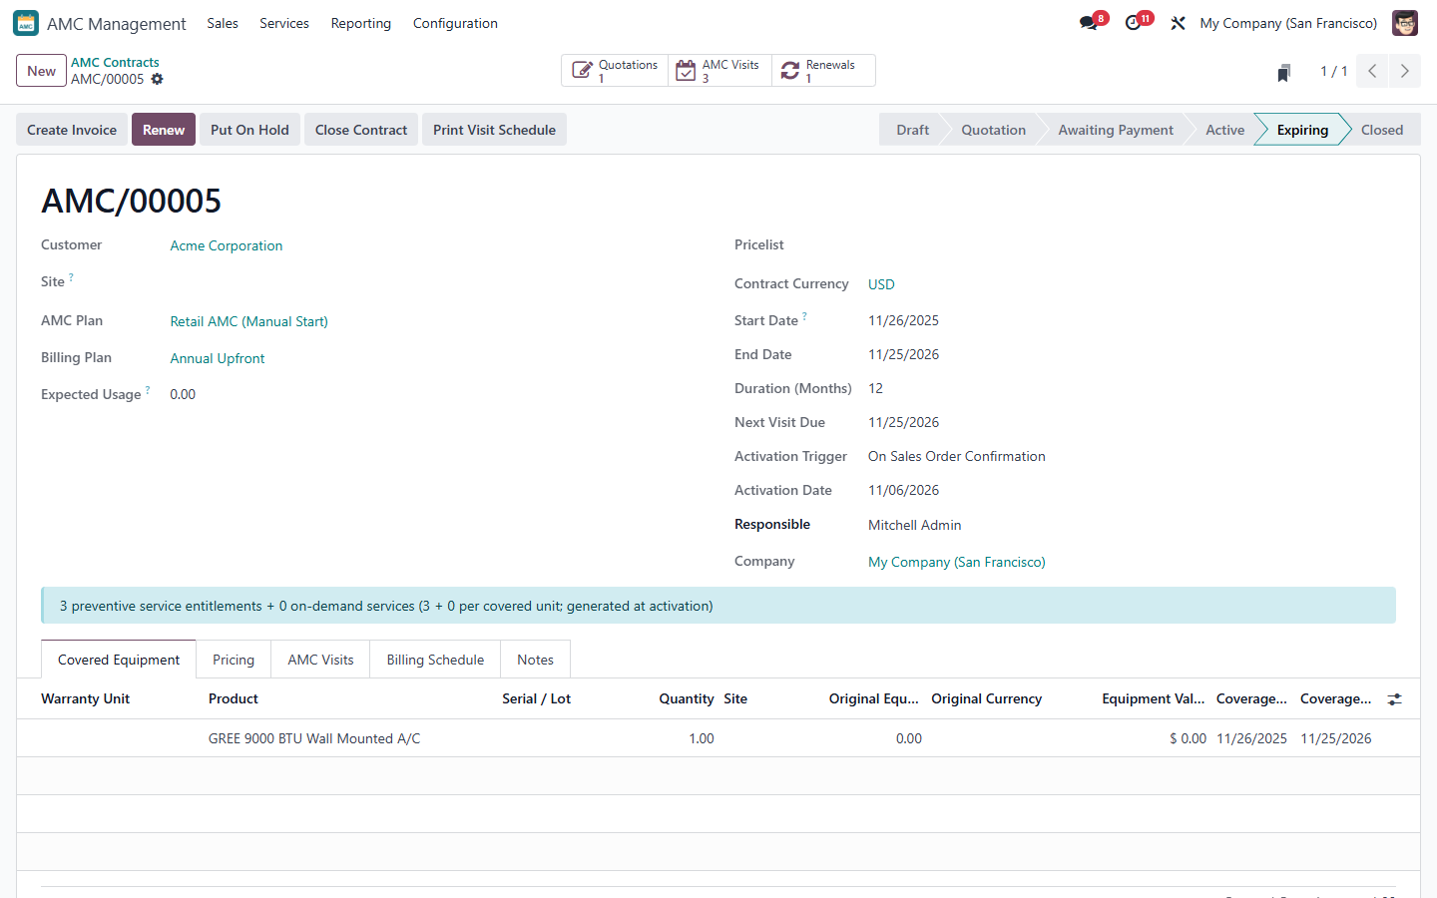
Figure 33 – Expiring contract with its renewal
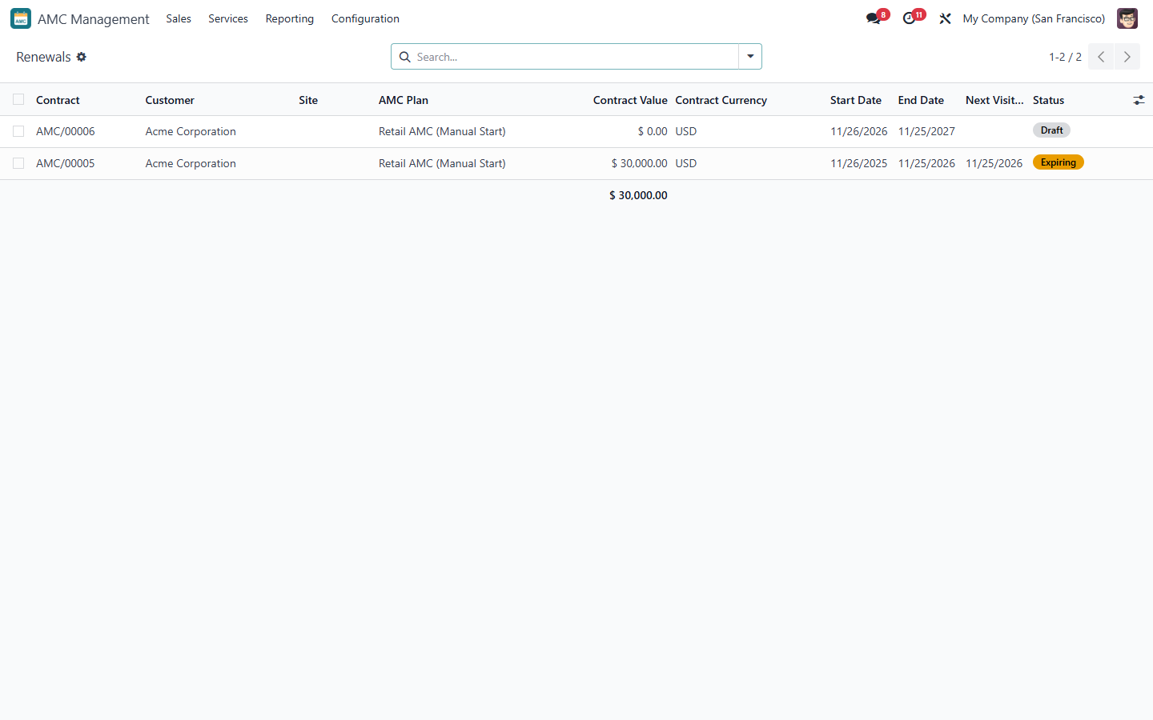
Figure 34 – Renewals

6.3 Closing and cancelling
- After the end date the scheduler closes the contract (or marks it Renewed when its renewal is Active). Open visits expire; billing periods not yet released are cancelled.
- Close Contract (Manager, reason) ends a running contract earlier.
- Cancel Contract (Manager, reason) is only possible before activation; the quotation is cancelled.

7. Warranty integration
- Convert to AMC on a Confirmed or Expired warranty card creates a Draft AMC contract covering the card's units, linked to the card. It starts the day after the warranty end if that date is still ahead.
- With AMC Auto-create Mode, a Draft AMC contract or opportunity is created automatically after warranty confirmation (never active).
- With Offer AMC on Warranty Expiry, a to-do is created when a warranty card expires.
- The AMC smart button on the card and the Warranty Cards smart button on the contract link both records.
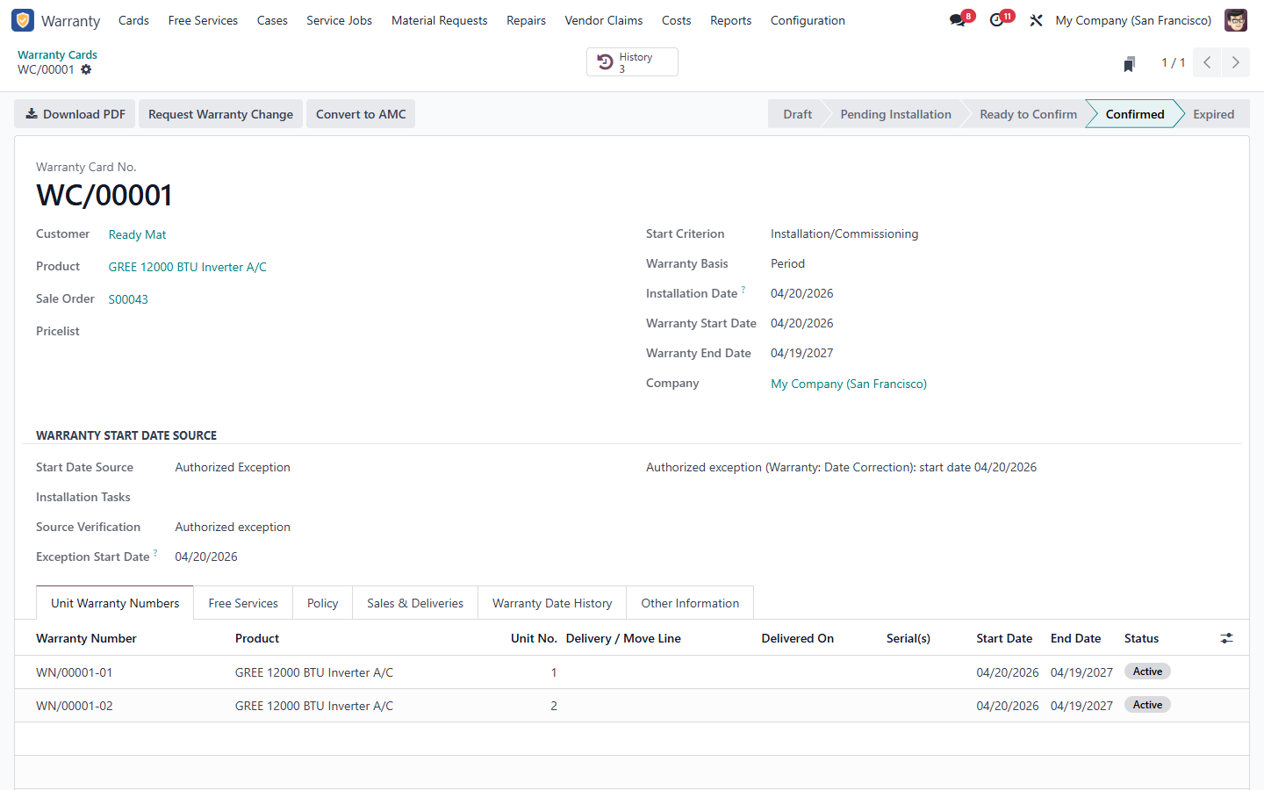
Figure 35 – Warranty card with Convert to AMC

8. Reports
Reporting > AMC Visit Schedule analyses planned, due, overdue, missed and completed visits by AMC plan (type), due month, customer, site and contract status (On Hold, Renewed). Switch between pivot, graph, list, kanban and calendar; export from the list view.
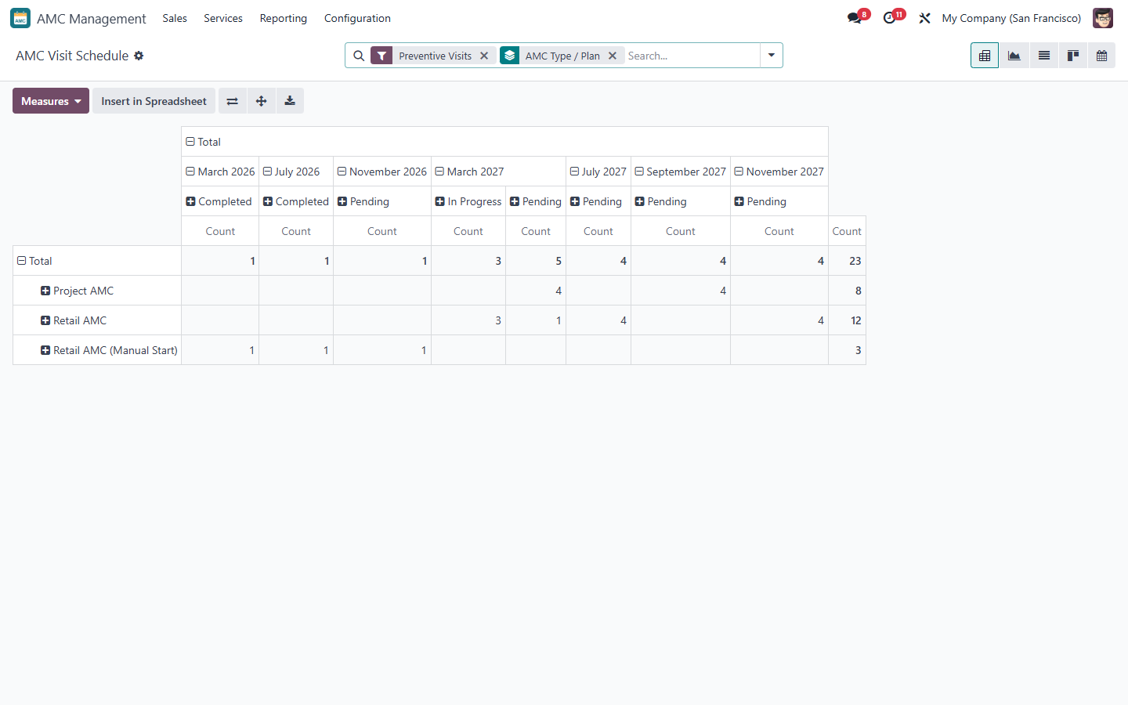
Figure 36 – AMC Visit Schedule – pivot
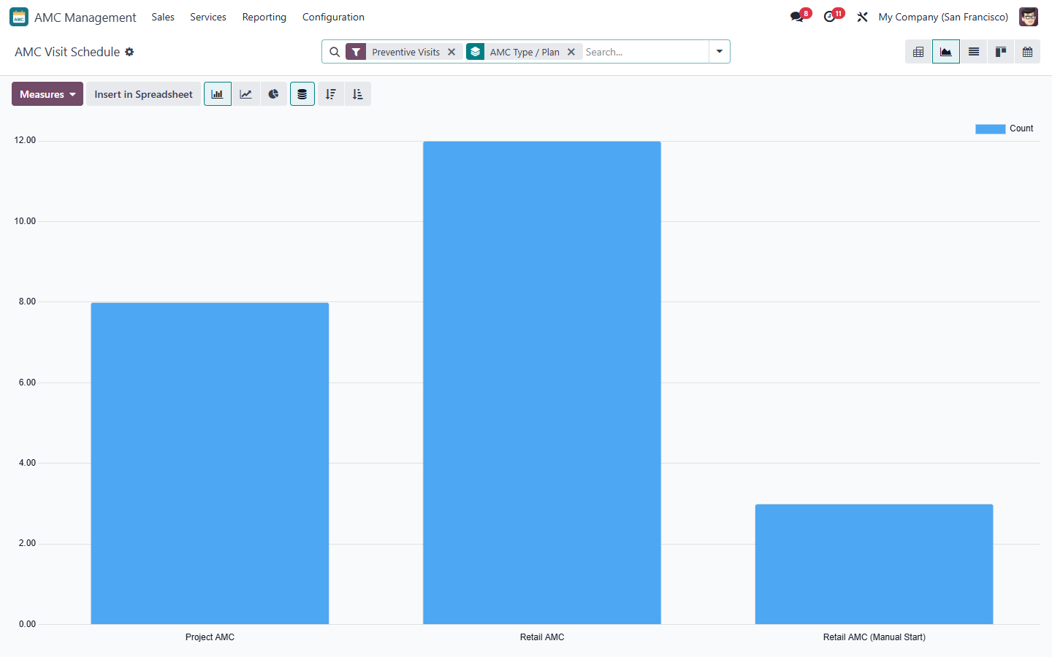
Figure 37 – AMC Visit Schedule – graph
Print Visit Schedule on a contract prints the PDF of its visits.

9. Messages and troubleshooting
Message (shortened) | Cause / what to do
The price cannot be calculated: … | The listed items are missing (plan, equipment, start date for Manual Start plans, plan applicability, serial already covered)
The price was calculated on …: calculate it again | Quotations use today's price – click Recalculate Price
No quotation …: an override request waits for approval | Wait for the AMC Approver decision
… has no released billing period to invoice | No period is due yet; check the Billing Schedule
… cannot be planned: contract … is On Hold | Resume the contract first
The AMC visits cannot be requested together | Select Pending visits of one running contract and one site
AMC visits are completed through their Service Job | Complete the Field Service visit of the job
Customer sign-off is required | Use Sign Report on the Field Service visit
Only Draft, Quotation or Awaiting Payment contracts can be cancelled | Use Close Contract for running contracts
… already has the renewal … | Open the existing renewal (Renewals smart button)

Scheduled action
AMC: Daily Contract and Visit Scheduler (Settings > Technical > Scheduled Actions) runs once a day: billing release, Expiring, end of period, due indicators, alerts and Missed visits. Running it twice changes nothing.

