AMC Management
Technical Architecture of the AMC Process
Item | Details
Platform | Odoo 18.0 (Community + Enterprise: helpdesk, industry_fsm, worksheet)
Modules | amc_management 18.0.1.1.0 · amc_management_warranty 18.0.1.0.0 · amc_management_service 18.0.1.0.0
Repository | warranty_module_18 (custom addons root)
Requirement sources | Warranty Module SRS V1 (81 p.), AMC Consolidated Requirements (AMC-A01 … H06)
Audience | Developers, solution architects, technical consultants, support engineers
Version / date | 1.0 – 06 November 2026

Contents
Contents 2
1. Architecture overview 3
1.1 Architectural principles 3
1.2 Module layers 3
1.3 Component view of the core 4
2. Code organisation 5
3. Data model 6
3.1 Models 6
3.2 Integrity constraints 6
3.3 Entity-relationship diagram 8
4. State machines 9
4.1 Contract lifecycle 9
4.2 Entitlement (visit) lifecycle 10
5. Process flows 11
5.1 Sell, price and activate 11
5.2 AMC visit execution through the warranty service chain 12
6. Core engines 13
6.1 Pricing engine 13
6.2 Entitlement generation 14
6.3 Billing engine 14
6.4 Scheduler 15
7. Integration architecture 16
7.1 Extension points on shared models 16
7.2 AMC eligibility (service bridge) 17
7.3 Warranty integration (warranty bridge) 17
8. Security architecture 18
8.1 Access control 18
8.2 Protected fields (marker pattern) 18
8.3 Privilege elevation (sudo) boundaries 19
9. Transactions, concurrency and reliability 20
10. Configuration parameters 21
11. Deployment and testing 22
11.1 Data migration 22
11.2 Deployment 22
11.3 Test architecture 22
12. Extension guide 23

1. Architecture overview
The AMC (Annual Maintenance Contract) solution is implemented as one standalone core module and two optional bridge modules. The core owns the complete commercial and contractual lifecycle (plans, pricing, contracts, entitlements, billing, renewals). The bridges connect it to the warranty solution without modifying any warranty file: they extend warranty models by inheritance and act only on records linked to an AMC.

1.1 Architectural principles
- Separation (SRS 2.1 / 2.12): AMC stages, formulas, visits and billing never live on the warranty card; the core depends only on mail, product, sale_management and stock.
- Reuse of standard Odoo: quotations / Sales Orders, invoicing on delivered quantities, payments, activities, chatter, Helpdesk, Field Service and worksheets are reused rather than re-implemented.
- Mandatory service chain: AMC visits are executed through Helpdesk Ticket → Warranty Case → Service Job → Field Service Task (bridge amc_management_service).
- Server-side integrity: every state, price, schedule and link field is written only by server actions protected by non-serialisable Python marker objects; the UI, imports and RPC cannot forge them.
- Scoped extension: every override of a shared model calls super() and acts only when an AMC link exists (amc_contract_id, case_type = amc + contract, AMC order lines).
- Idempotent automation: generation, releases and the daily scheduler can run repeatedly without duplicates.

1.2 Module layers
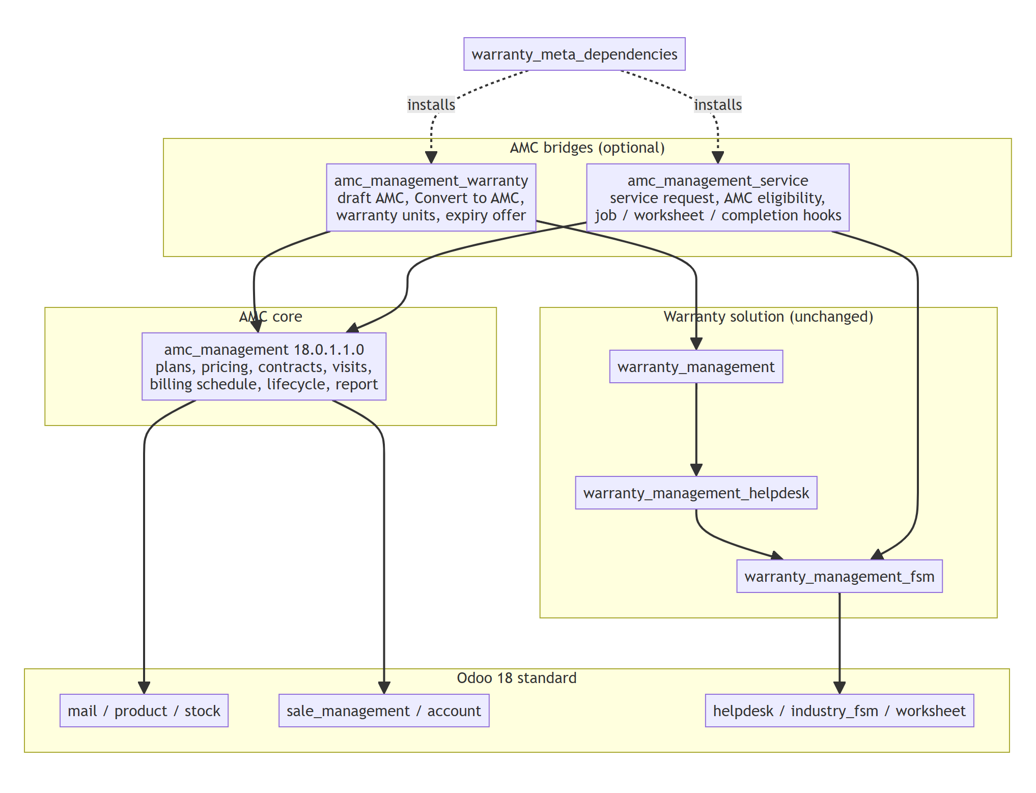
Figure 1 – Module layers and dependencies
Module | Depends on | Responsibility
amc_management | mail, product, sale_management, stock | Plans, billing plans, pricing engine, opportunities, contracts, overrides, quotations, entitlements (visits), billing schedule, lifecycle, scheduler, report
amc_management_warranty | amc_management, warranty_management | Auto-create draft AMC on warranty confirmation, Convert to AMC, warranty units on covered equipment, AMC offer on warranty expiry, smart buttons
amc_management_service | amc_management, warranty_management_fsm | Service requests (ticket + AMC case), AMC eligibility, Service Job / worksheet / completion / cancellation hooks, pending AMC services on tickets, AMC ticket tag
warranty_meta_dependencies | all custom addons | Installs the complete solution in one step

Design note: No warranty module depends on an AMC module, so the AMC modules can be installed, upgraded or removed independently. Neither bridge is auto_install.

1.3 Component view of the core
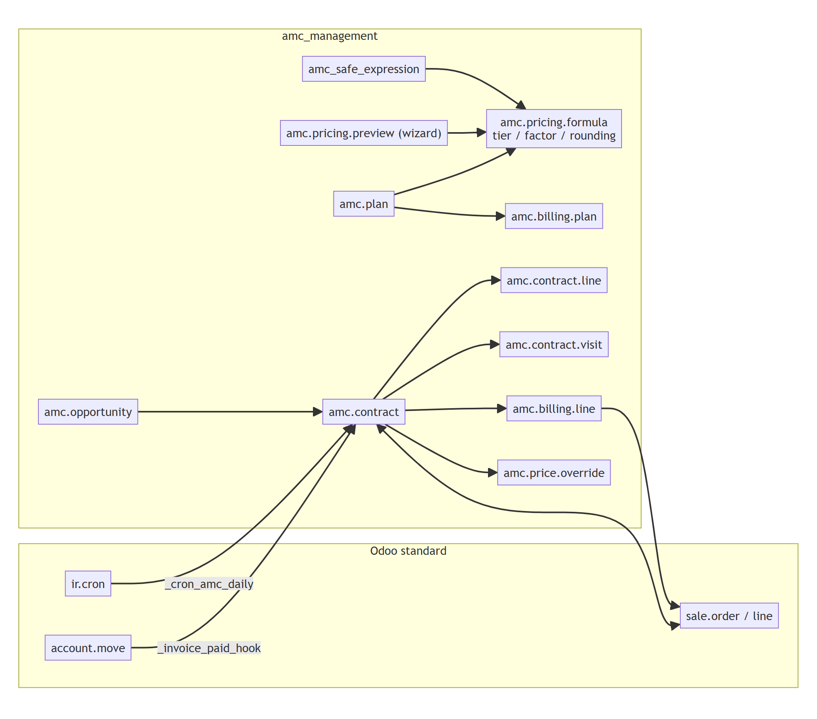
Figure 2 – Core components and their standard Odoo collaborators

2. Code organisation
amc_management/ (one class per file, file = model technical name)
__manifest__.py 18.0.1.3.0, OPL-1, data load order
controllers/amc_management.py Configuration > Documents pages (manual, architecture, video)
models/
amc_plan.py amc.plan (+ constants PRICING_METHODS, ACTIVATION_TRIGGERS ...)
amc_billing_plan.py amc.billing.plan
amc_pricing_formula.py amc.pricing.formula (pricing engine)
amc_pricing_tier.py amc.pricing.tier
amc_pricing_factor.py amc.pricing.factor
amc_pricing_rounding.py amc.pricing.rounding
amc_safe_expression.py AST-based controlled expression evaluator
amc_opportunity.py amc.opportunity
amc_contract.py amc.contract: lifecycle, scheduler
amc_contract_line.py amc.contract.line (covered equipment)
amc_contract_visit.py amc.contract.visit (entitlements)
amc_billing_line.py amc.billing.line (billing schedule)
amc_price_override.py amc.price.override
sale_order.py, sale_order_line.py quotation guards and hooks
account_move.py account.move._invoice_paid_hook
res_company.py, res_config_settings.py AMC settings, AMC Enabled check
ir_ui_menu.py hides the AMC app when AMC Enabled is off
wizard/ <transient>.py + <transient>_views.xml
amc_pricing_preview(_line) price preview
amc_opportunity_lost lost reason
amc_contract_cancel cancellation
amc_contract_reason hold / close reason
amc_contract_visit_action visit completion / cancellation
amc_price_override_reject override rejection
views/ <model>_views.xml (views, actions, model menus),
amc_management_menus.xml (root, sections, documents)
report/ amc_contract_reports.xml, amc_contract_templates.xml
data/ amc_billing_plan, ir_sequence, product_product, ir_cron _data.xml
security/ amc_management_groups.xml, <model>_security.xml, ir.model.access.csv
tests/ test_amc_lifecycle, test_amc_pricing, test_amc_security,
test_amc_documentation
docs/ 00-28, user manual, this document
amc_management_warranty/models/ res_company, res_config_settings, amc_contract,
amc_contract_line, amc_opportunity, warranty_card, warranty_unit
amc_management_service/models/ amc_contract_visit, warranty_case, warranty_service_job,
helpdesk_ticket
amc_management_service/wizard/ amc_service_request (+ _views.xml)

3. Data model
The ERD on the next page shows the AMC models and their links to Sales, the warranty card / unit and the warranty service chain. All transactional AMC models carry company_id (stored) for multi-company record rules.

3.1 Models
Model | Purpose | Key fields
amc.plan | AMC type (e.g. Retail / Project AMC) | service_basis, visit_count, frequency_value/unit, usage_interval/unit, included_free_services, visit_planning_mode, alert_days, grace_days, auto_mark_missed, pricing_method, billing_plan_id, start_rule, duration_value/unit, renewal_rule, renewal_notice_days, activation_trigger, pricelist_ids, product_ids, category_ids
amc.billing.plan | How the value is invoiced | billing_frequency (upfront / monthly / quarterly / half_yearly / annual / per_visit), billing_timing (advance / arrears), interval_months
amc.pricing.formula | Versioned price formula of a plan | version, state (draft / active / archived), method, effective_from/to, currency_id, method parameters, hybrid_expression, min_price, max_price, rounding_step/method, tier_ids, factor_ids, rounding_rule_ids
amc.opportunity | Pre-sales follow-up | state (new / offer_sent / won / lost), plan_id, expected_quantity / value, contract_ids
amc.contract | The AMC contract | state (9 values), partner_id, site_id, plan_id, line_ids, pricelist_id, currency_id, start_date, contract_months (snapshot), end_date, expected_usage, price snapshot fields, sale_order_id, activation_trigger, visit statistics, next_visit_date, billing_line_ids, hold/close/expiring fields, renewal_of_id
amc.contract.line | Covered equipment | product_id, serial_id, quantity (whole units), site_id, original_value / currency, equipment_value, (bridge) warranty_unit_id
amc.contract.visit | One entitlement of one covered unit | visit_type (preventive / free_service), sequence_no/total, unit_no, due_date, usage_due/unit, alert_date, grace_end_date, scheduled_date, state (7 values), due_status, completion evidence; (bridge) warranty_case_id, service_job_id, task_id, worksheet_id
amc.billing.line | One billing period | sequence, sale_line_id, amount, date, period_start/end, visit_id, state (planned / released / cancelled), invoiced (computed)
amc.price.override | Price / pricelist override request | override_type, original / requested values, reason, state, requested_by_id, decided_by_id

3.2 Integrity constraints
- UNIQUE(contract_id, line_id, visit_type, unit_no, sequence_no) on amc.contract.visit – no duplicate entitlement.
- UNIQUE(name, company_id) on amc.plan.
- Covered quantity > 0 and whole; a serial line covers quantity 1; a serial / warranty unit belongs to one open contract only (predecessor and renewal excepted); plan applicability by pricelist, product and category.
- Plan: counts ≥ 0, visits fit into the duration at the frequency, Per Preventive Visit billing requires activation on SO confirmation.
- Formula: non-negative amounts, min ≤ max, effective_to ≥ effective_from, valid Hybrid expression, tiers without gaps / overlaps, unique factor per product / category, unique rounding rule per currency.
- Company consistency: plan / contract, warranty unit / contract, AMC case / contract.

3.3 Entity-relationship diagram
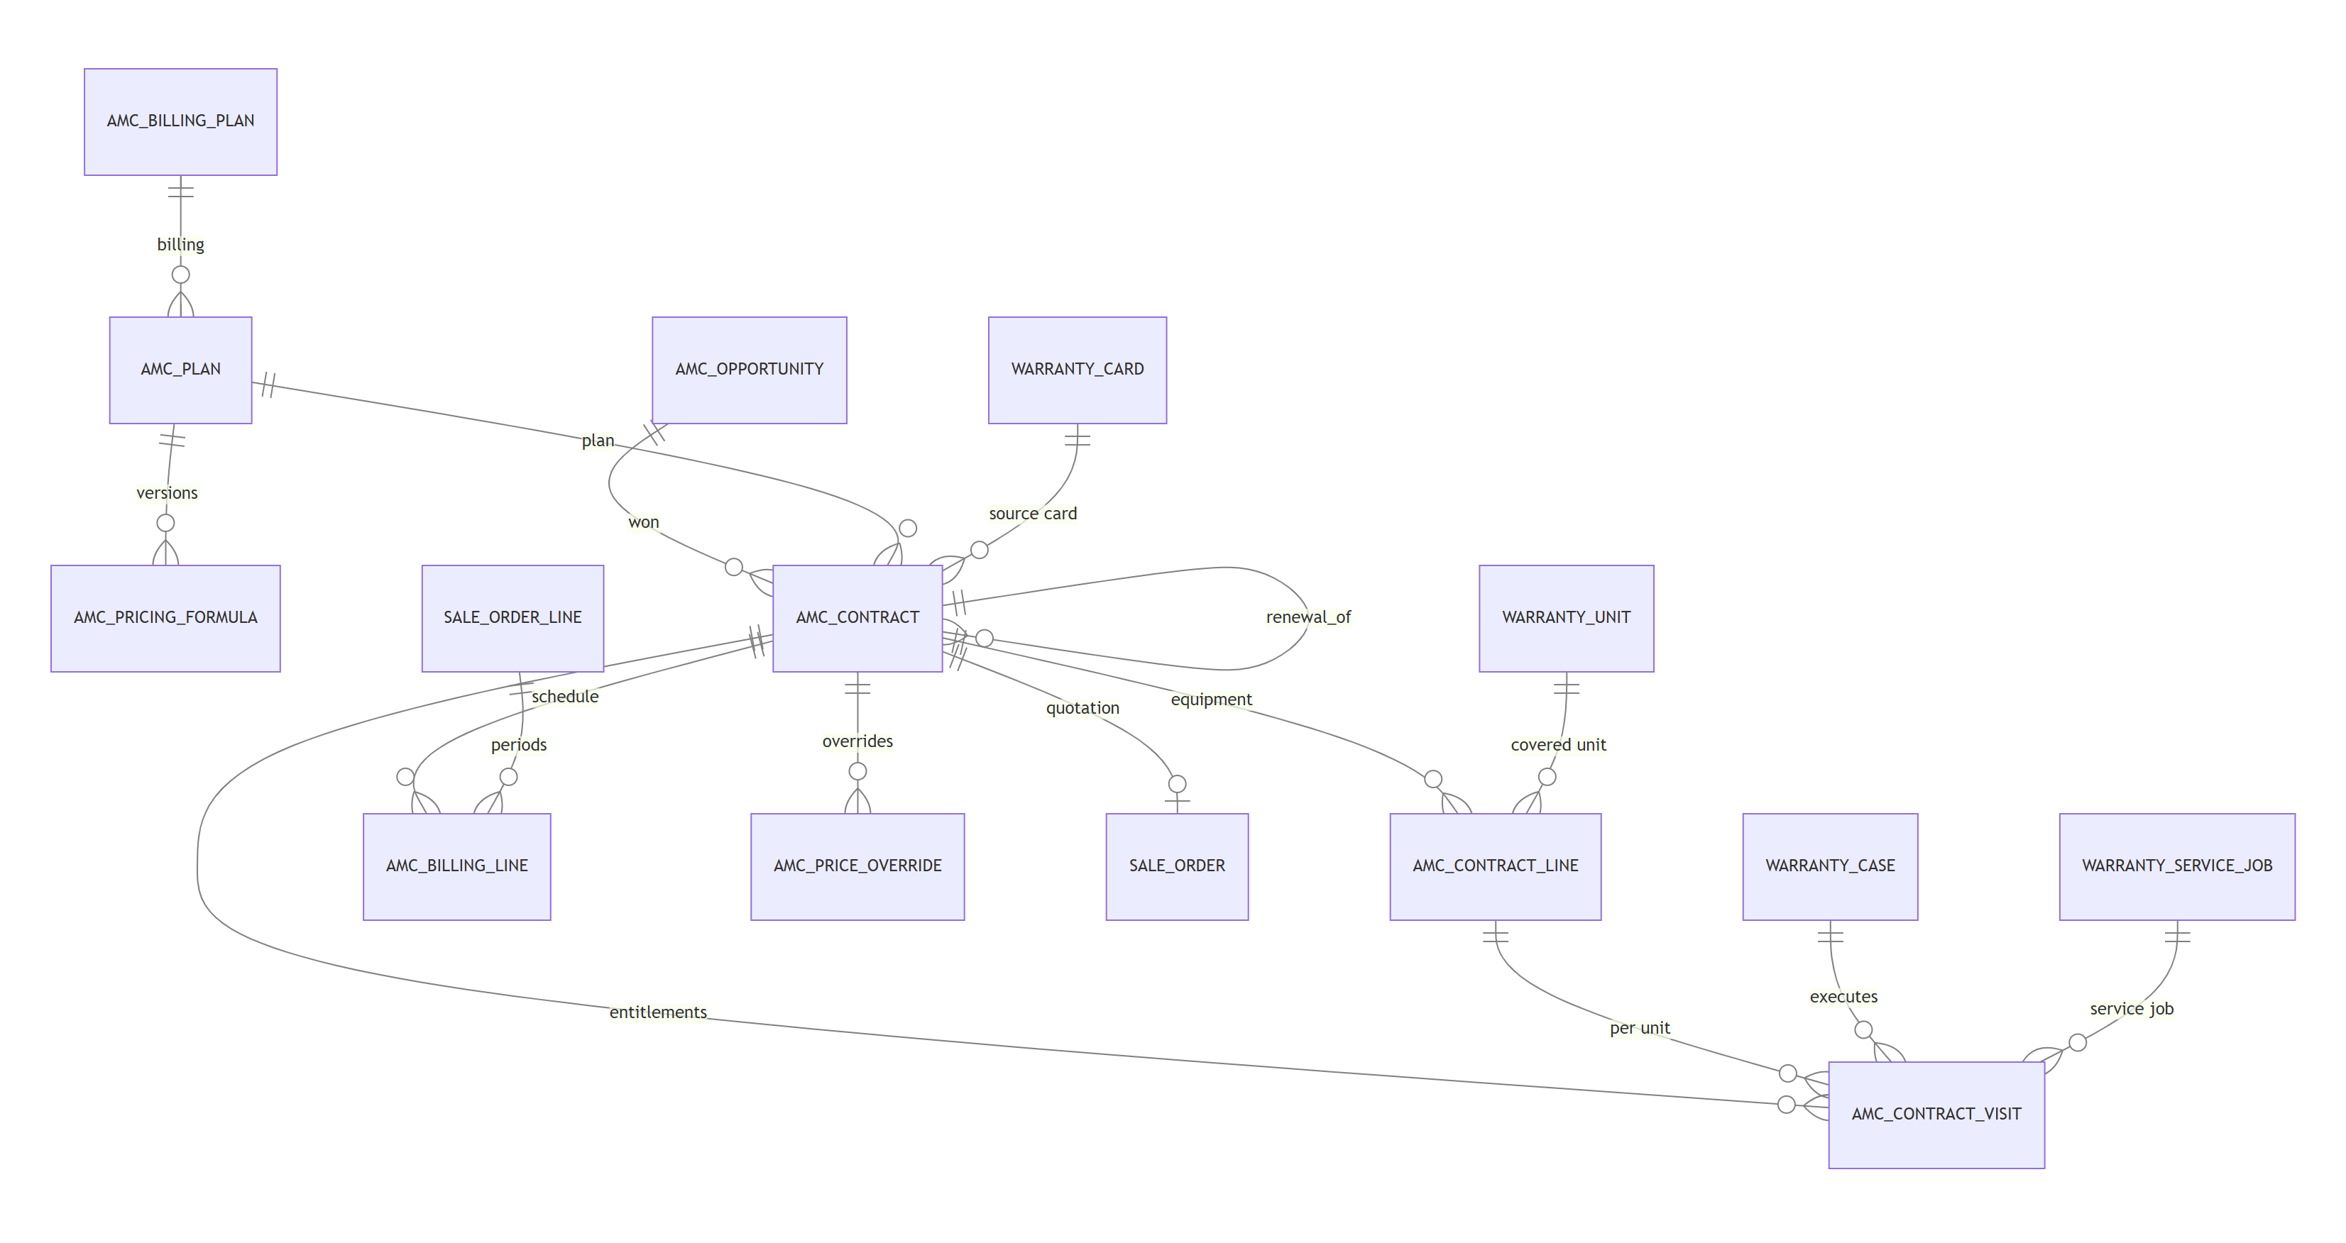
Figure 3 – AMC entity-relationship diagram (core and bridges)

4. State machines

4.1 Contract lifecycle
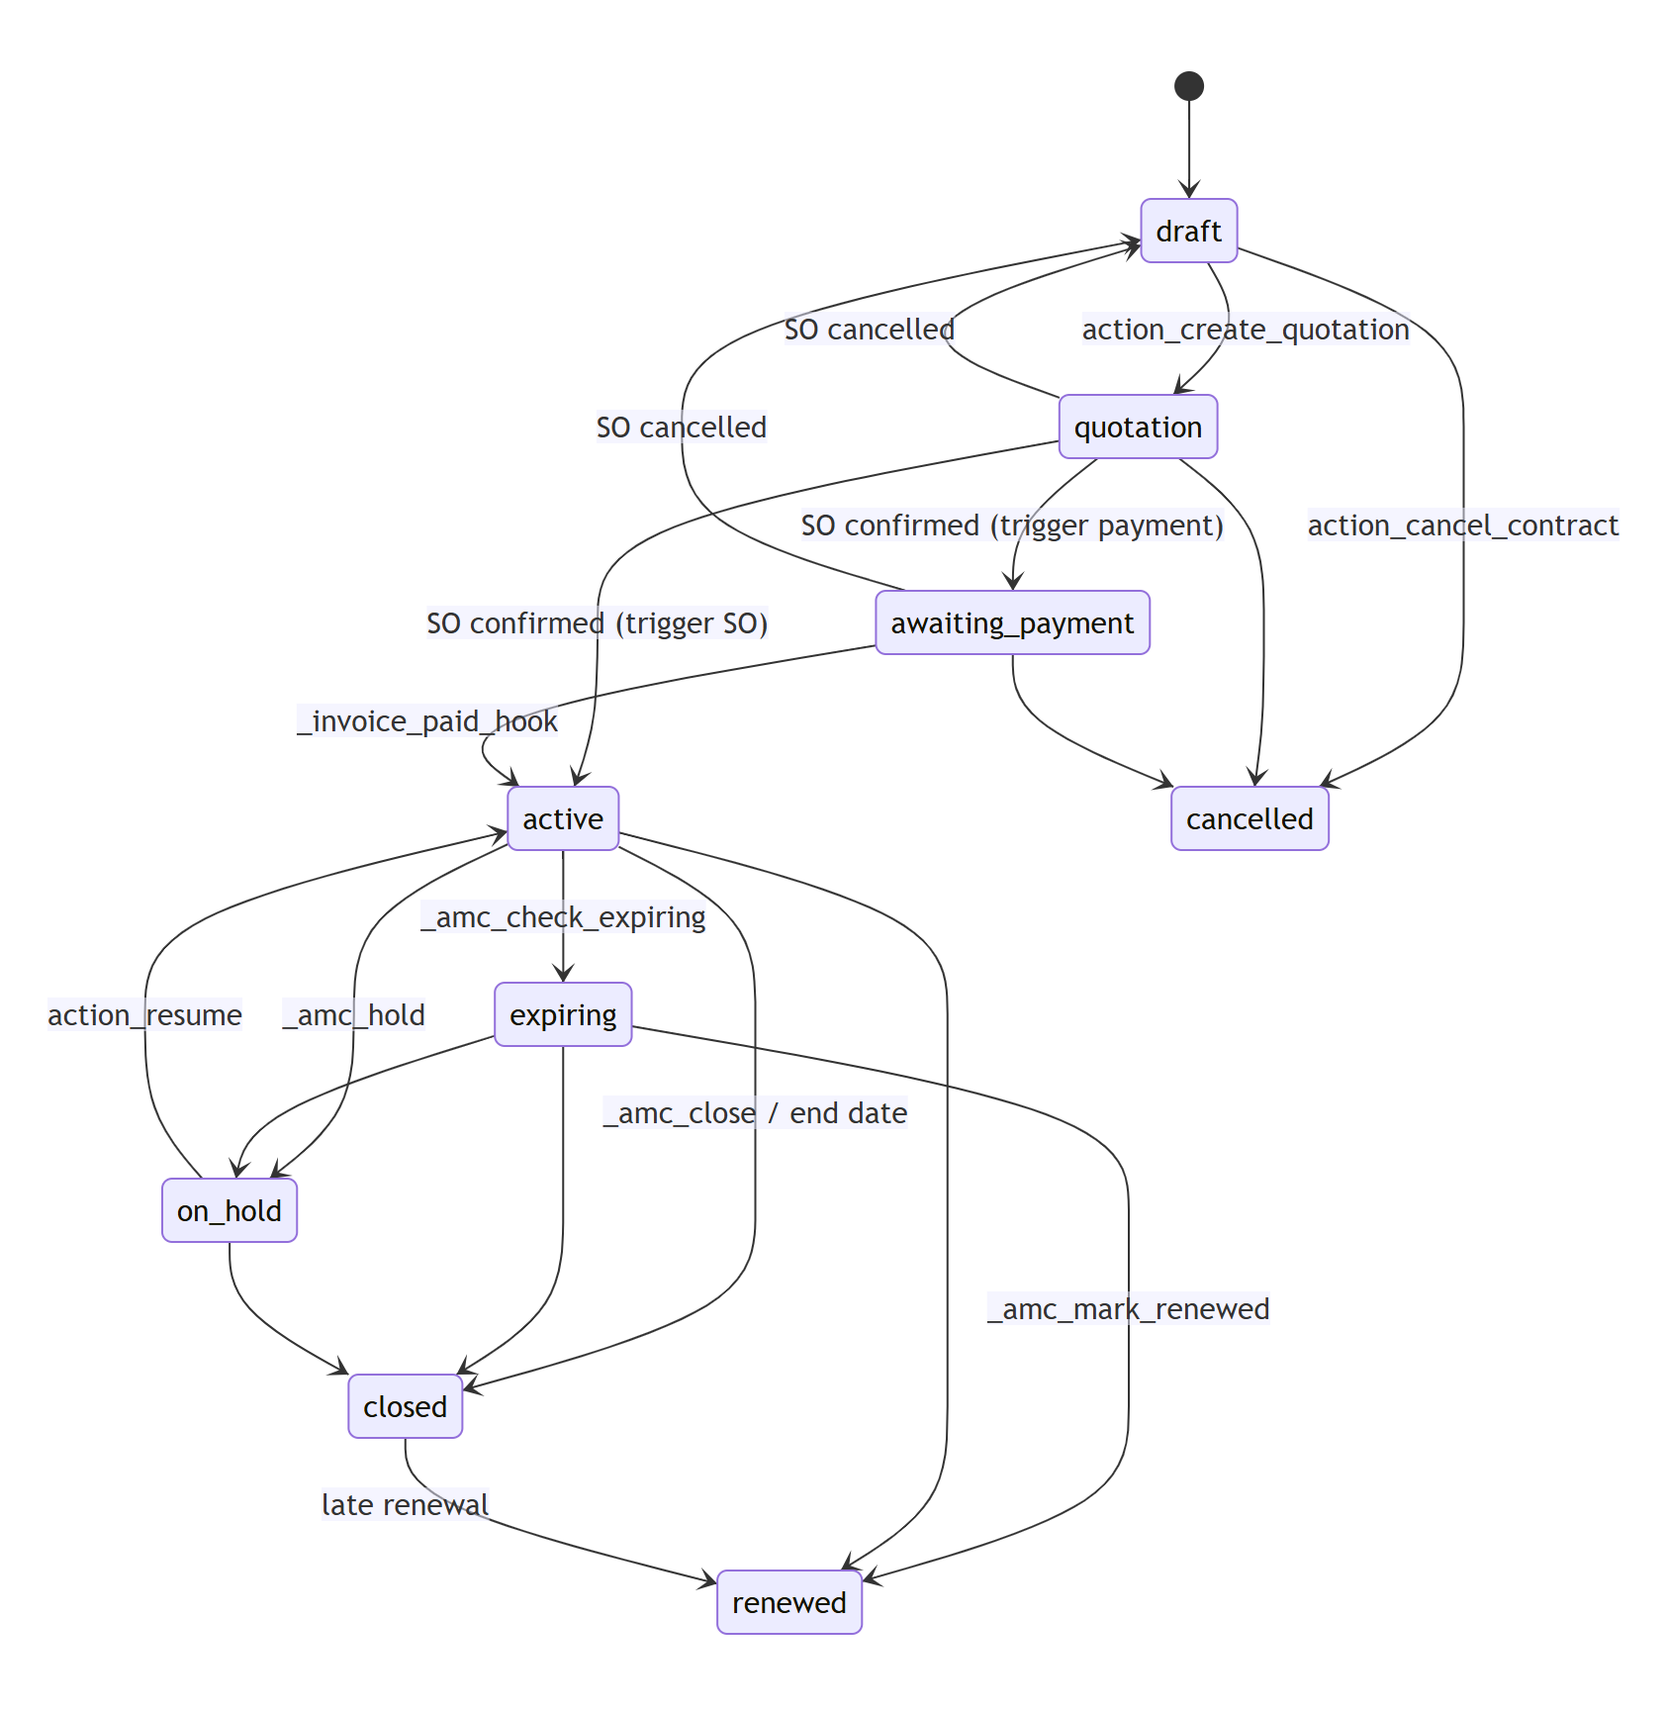
Figure 4 – amc.contract state machine
Transition | Method | Guard | Side effects
draft → quotation | action_create_quotation | Coordinator + Salesman; priced today; billing plan; no open quotation / override request; row lock | sale.order created with locked lines (qty = periods)
quotation → active / awaiting_payment | sale.order.action_confirm → _amc_on_order_confirmed (sudo) | order = contract open quotation | price frozen, billing schedule; activation or period 1 released
awaiting_payment → active | account.move._invoice_paid_hook → _amc_on_invoice_paid | invoice has lines of the AMC order | _amc_activate
* → active (activation) | _amc_activate | state quotation / awaiting_payment; row lock | start date, visits, billing dates, due release, predecessor renewed, expiring check
active / expiring → on_hold | _amc_hold(reason) | Manager, reason | hold fields; planning / requests / alerts blocked
on_hold → active | action_resume | Manager; end not passed | expiring re-check
active → expiring | _amc_check_expiring (cron / activation) | end − notice ≤ today | to-do; Auto Offer → _amc_create_renewal
running → closed | _amc_close(reason, automatic) | Manager or scheduler after end | _amc_end_entitlements (visits expired, planned billing cancelled)
running / closed → renewed | _amc_mark_renewed | renewal activated after end, or running renewal at end | entitlements ended
draft / quotation / awaiting → cancelled | action_cancel_contract(reason) | Manager; no posted invoice | SO cancelled, billing cancelled

4.2 Entitlement (visit) lifecycle
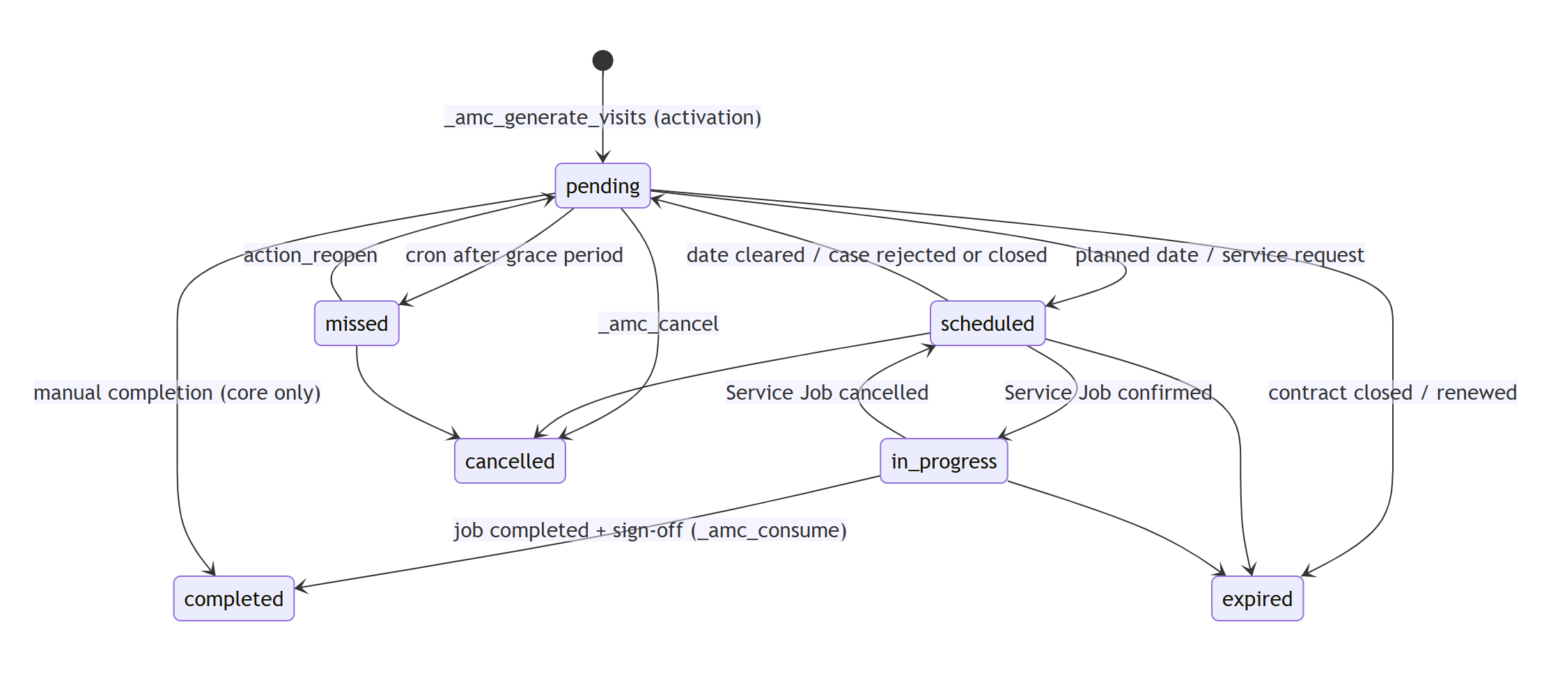
Figure 5 – amc.contract.visit state machine
Design note: Consumption (_amc_consume) is the only path to completed. It validates the open state, a running contract, the coverage period and – for usage-based visits – a positive, non-decreasing usage reading, and is called either by manual completion (core without service bridge) or inside the warranty job completion savepoint (service bridge).

5. Process flows

5.1 Sell, price and activate
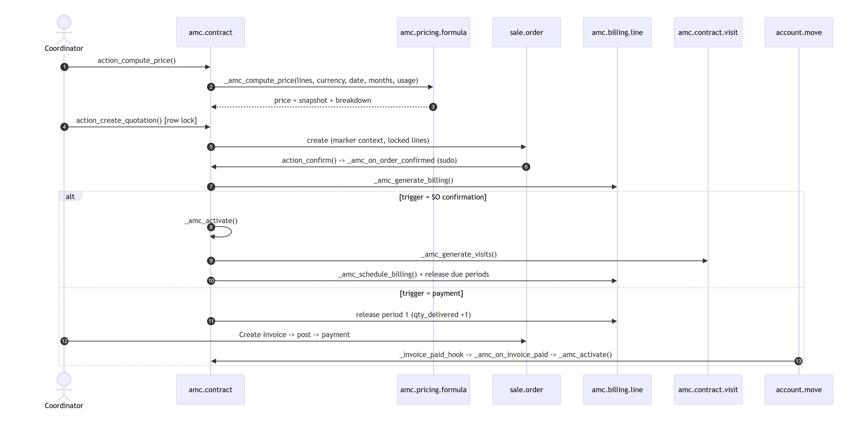
Figure 6 – Sequence – pricing, quotation, confirmation and activation

5.2 AMC visit execution through the warranty service chain
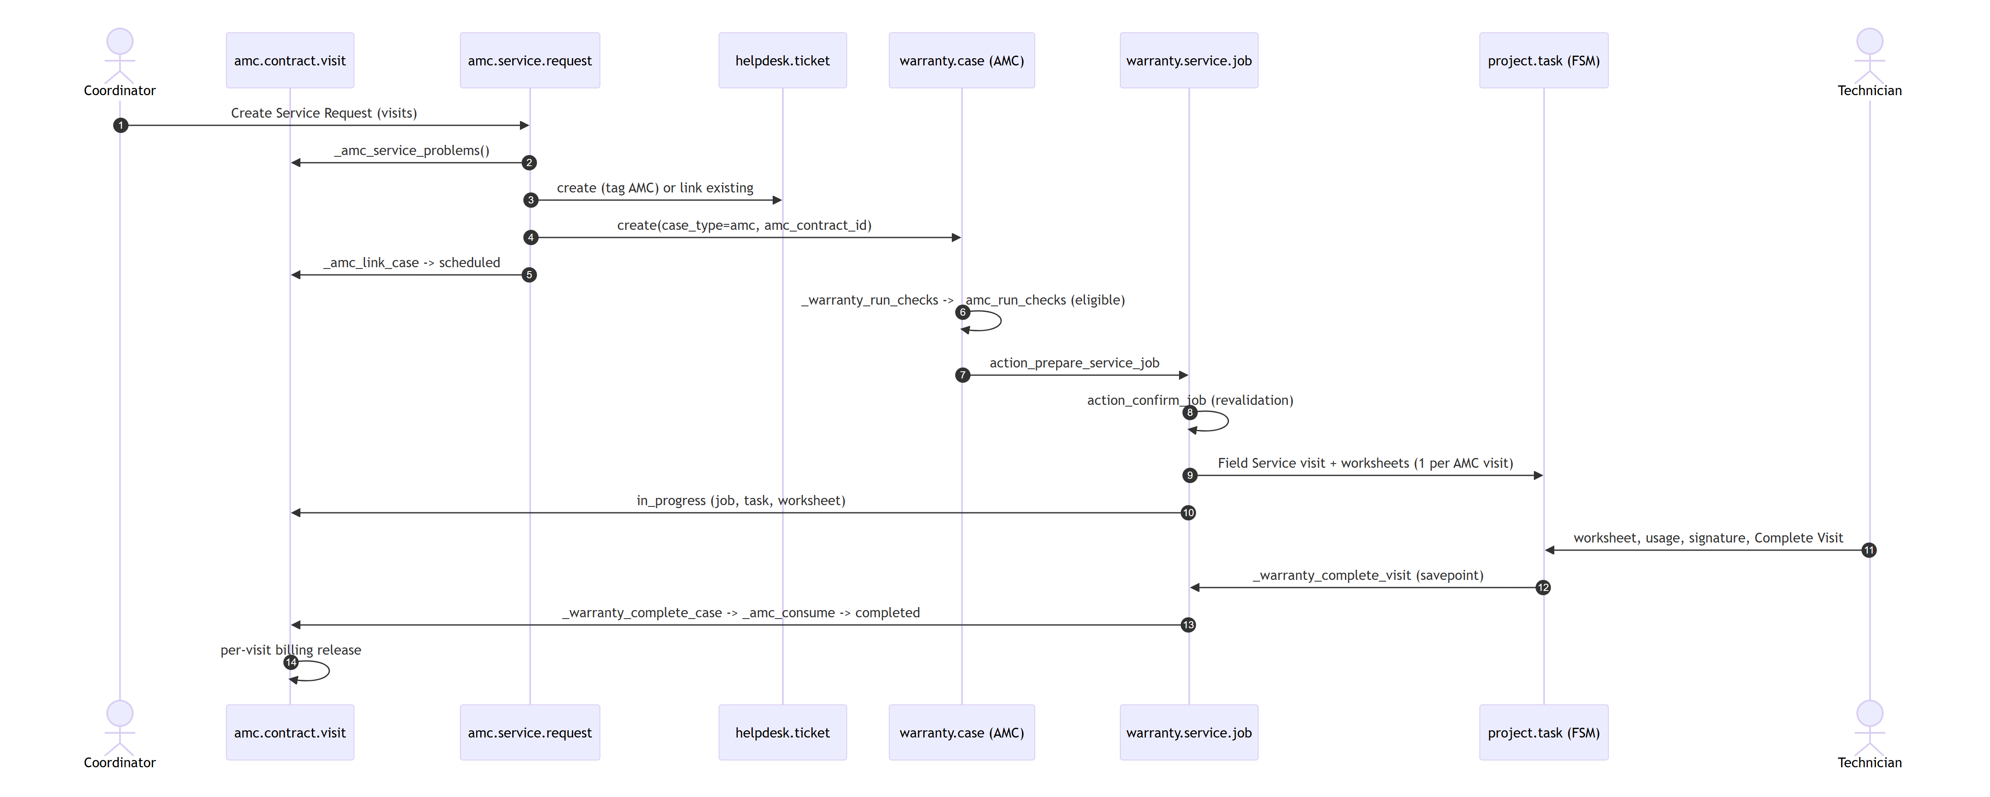
Figure 7 – Sequence – service request to consumption (amc_management_service)

6. Core engines

6.1 Pricing engine
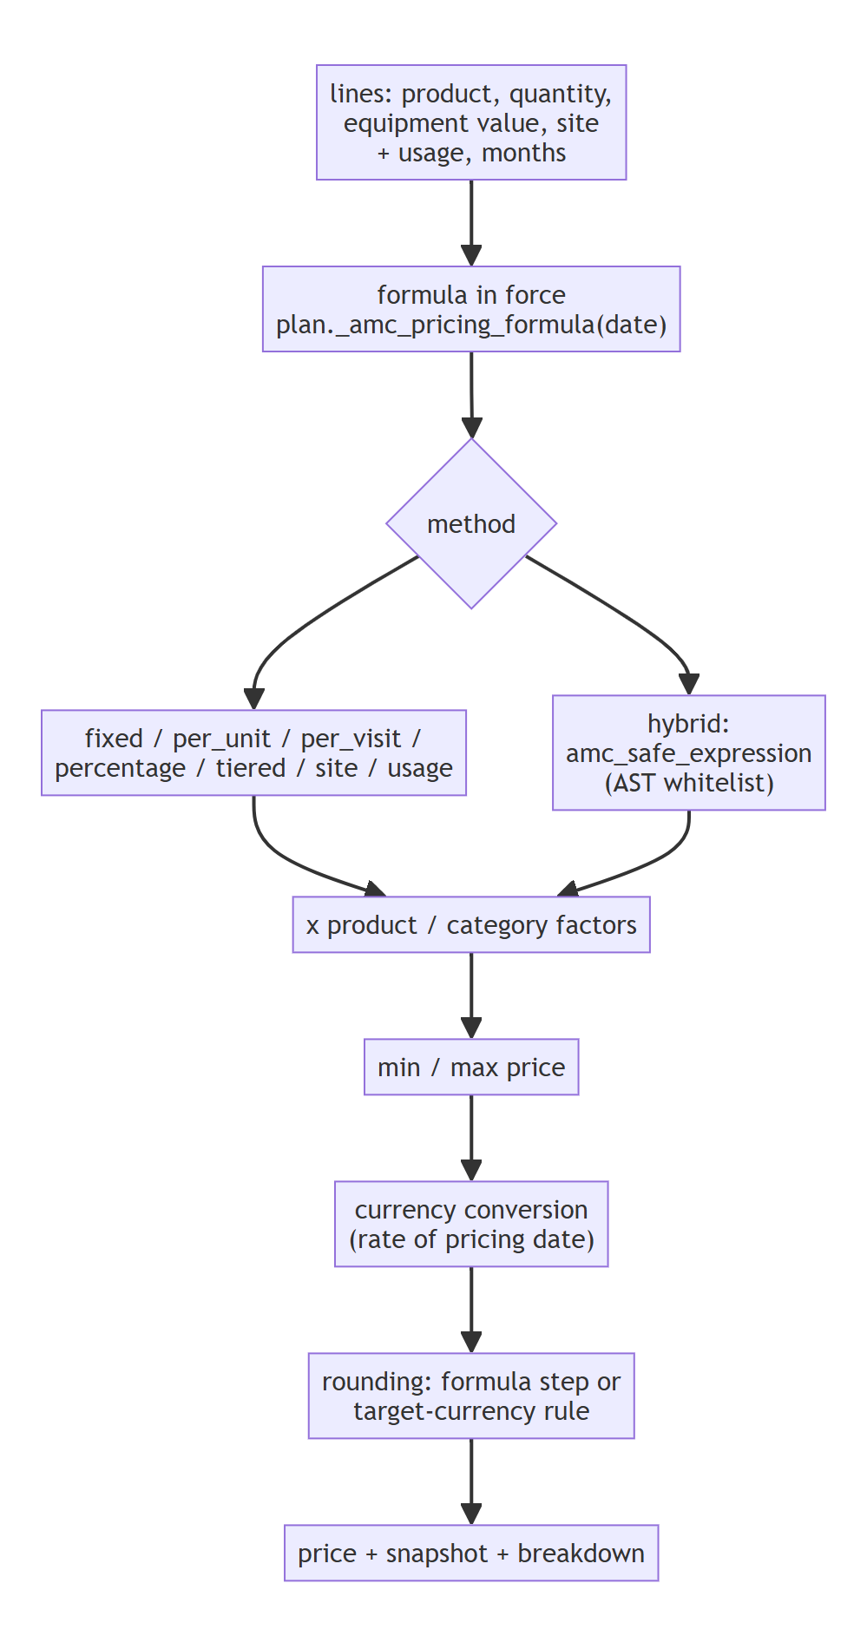
Figure 8 – Pricing pipeline (amc.pricing.formula._amc_compute_price)
Method | Calculation
fixed | fixed_amount
per_unit | Σ unit_rate × quantity × factor(line)
per_visit | visit_rate × visit_count × covered quantity (entitlements, not physical visits)
percentage | Σ equipment_value × percentage / 100 × factor(line)
tiered | rate of the tier containing quantity (or site count) × that basis
site | site_rate × number of distinct sites
usage | usage_base + usage_rate × expected usage
hybrid | controlled expression over equipment_value, quantity, visit_count, contract_months, usage, site_count, factor, min_price, max_price

Snapshot. action_compute_price stores formula, version, method, formula currency and amount, exchange rate, conversion date, calculated price and the textual breakdown on the contract. The quotation is refused if the snapshot is not from today (approved C3); confirmation freezes it (price_approved_date).
Controlled expression (amc_safe_expression). The Hybrid expression is parsed with ast.parse(mode="eval") and checked against a whitelist: numeric constants, approved variable names, + − * /, unary ±, and calls of min, max, round, abs with positional arguments. Attributes, subscripts, comparisons, power, lambdas, strings and any other name are rejected; length is limited to 500 characters; evaluation is a custom tree walk – eval / safe_eval are never used; division by zero raises a business error.

6.2 Entitlement generation
amc.contract._amc_generate_visits() runs once at activation (idempotent: returns existing visits). For every line and every covered unit (quantity rounded to whole units):
- Period plans: Visit Count preventive visits; due date n = start + n × (12 / frequency) months (fractional months as 30-day days), capped at end_date.
- Usage plans: usage_due n = n × usage_interval, no due date.
- Free services: Included Free Services on-demand entitlements without due date.
Monitoring fields are stored computes (alert_date = due − alert days for Alert-Driven plans, grace_end_date = due + grace days); due_status is written by actions and the scheduler only when it changes.

6.3 Billing engine
Step | Method | Detail
Quotation lines | _amc_quotation_lines | quantity = billing periods; unit price = value / periods; final period absorbs the rounding difference
Schedule | _amc_generate_billing | one amc.billing.line per ordered unit, mapped to its sale.order.line (on SO confirmation)
Dates | _amc_schedule_billing(release) | upfront: start; periodic: advance = period start, arrears = period end (capped at end); per visit: linked preventive visit
Release | amc.billing.line._amc_release | planned → released; sale line qty_delivered = released count (contract marker); chatter log
Invoicing | action_create_invoice | sale.order._create_invoices() of the released quantities – draft only
Activation on payment | account.move._invoice_paid_hook | Awaiting Payment contract of the invoiced AMC order → _amc_activate

Design note: Billing reuses the standard "invoice on delivered quantity" mechanism of a manual service product, so taxes, fiscal positions, journals, payment terms and accounting entries remain 100 % standard Odoo.

6.4 Scheduler
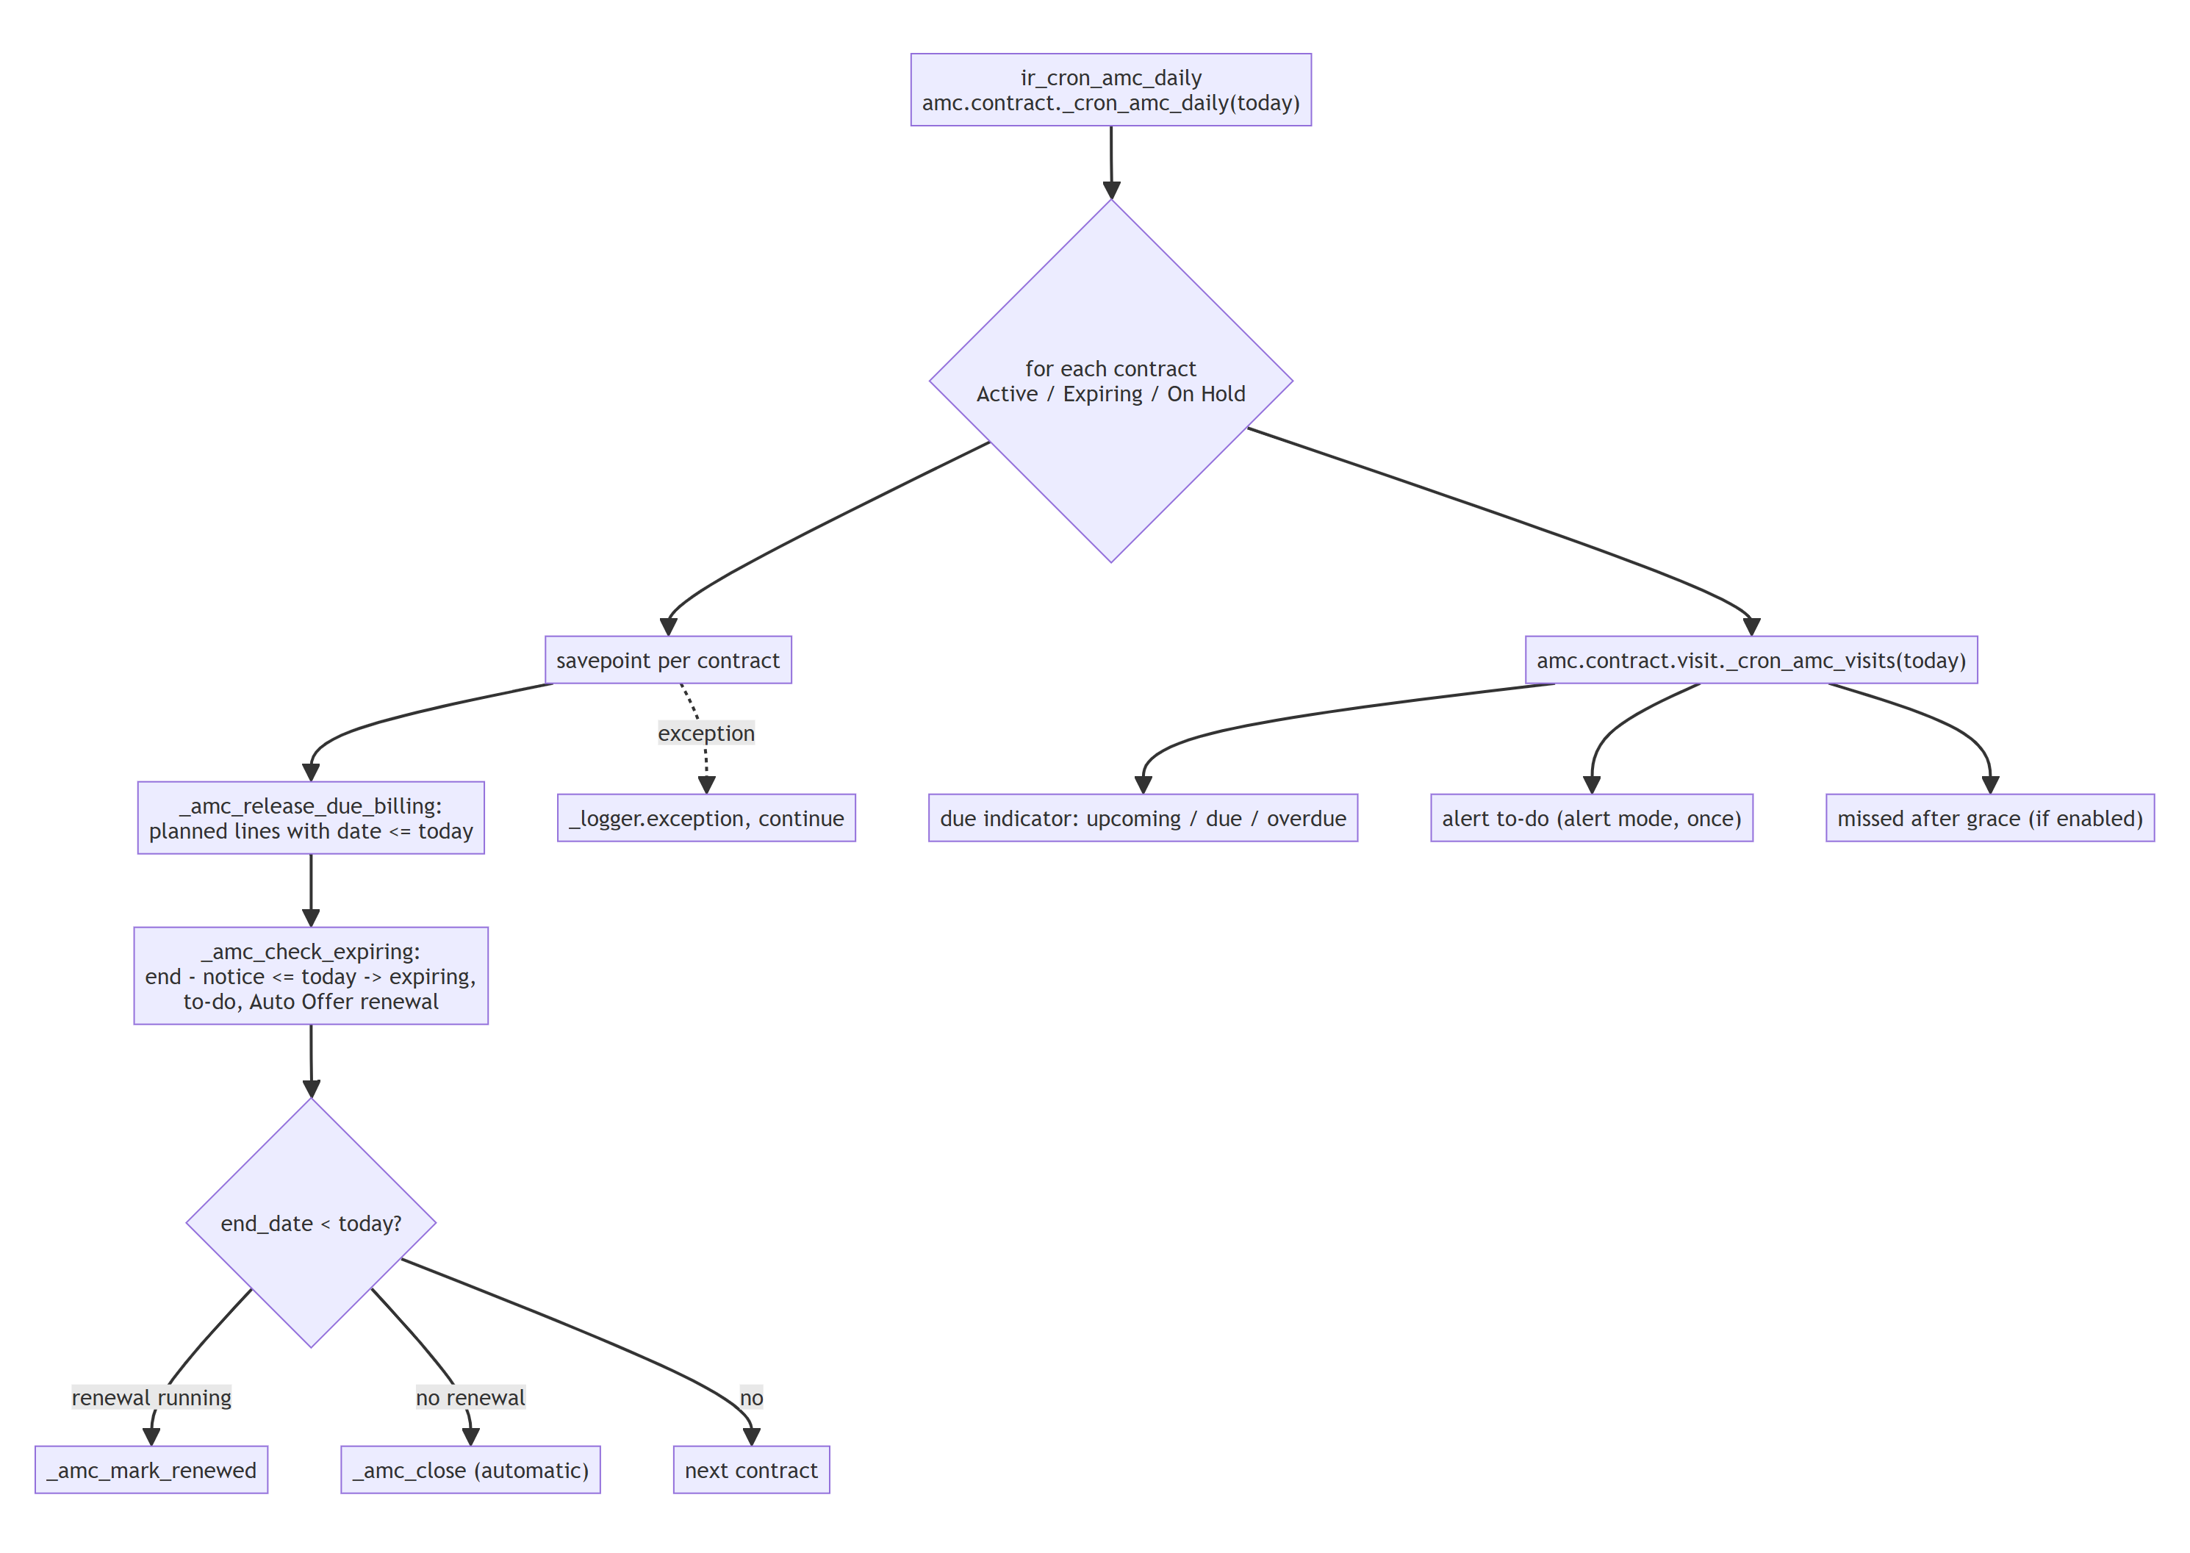
Figure 9 – Daily scheduler (ir_cron_amc_daily)

7. Integration architecture

7.1 Extension points on shared models
Model.method | Module | Behaviour | Scope guard
sale.order.create / write / copy / action_update_prices | core | AMC quotations created only by the contract; customer, pricelist, currency locked; no copy | amc_contract_id set
sale.order.line.create / write / unlink | core | quantities, prices, discount, delivered quantity locked | order has amc_contract_id; contract marker bypass
sale.order.action_confirm | core | expired AMC quotation refused; contract hook (sudo) | AMC orders
sale.order._action_cancel | core | refused for activated contracts; Draft again before activation | AMC orders
account.move._invoice_paid_hook | core | activation on payment | invoice lines of AMC orders
warranty.card.action_confirm_warranty | warranty bridge | draft AMC (savepoint, never raises) | company mode ≠ none
warranty.card._warranty_apply_expiry | warranty bridge | AMC offer activity | setting on, card newly expired, no AMC
warranty.case._warranty_run_checks | service bridge | AMC eligibility | case_type = 'amc' and amc_contract_id
warranty.case.write | service bridge | release visits on rejected / closed | cases with AMC visits
warranty.service.job.action_confirm_job | service bridge | visits In Progress, job / task links | job case has AMC contract
warranty.service.job._warranty_worksheet_lines / _warranty_create_worksheets | service bridge | one worksheet per AMC visit; usage flags | idem
warranty.service.job._warranty_visit_completion_problems | service bridge | AMC consumption checks added | idem
warranty.service.job._warranty_complete_case | service bridge | consumption inside the completion savepoint | idem
warranty.service.job._warranty_cancel | service bridge | visits back to Scheduled | idem
helpdesk.ticket (compute) | service bridge | pending AMC visits of the customer / site / product / serial | read-only

7.2 AMC eligibility (service bridge)
warranty.case._amc_run_checks() replaces the warranty-card checks for AMC cases with a contract and returns the same tuple as the warranty engine (result, steps, payment values, failure values), so Check Eligibility, Approve Case and the confirmation revalidation of the Service Job work unchanged. Checks: contract Active or Expiring; ticket date (service date of the warranty engine) inside the contract period; visits linked, of this contract and still Scheduled / In Progress; overdue receivables shown as information.

7.3 Warranty integration (warranty bridge)
- _amc_auto_create – after a successful confirmation, per company mode: Draft opportunity or Draft contract (units as lines, start = warranty end + 1 if ahead); savepoint + log on failure; never twice per card.
- action_convert_to_amc – Confirmed / Expired cards; opens the open AMC of the card instead of creating a second one.
- amc.contract.line.warranty_unit_id – unit of the customer and company, state Active / Expired / Suspended, one open contract per unit.
- _warranty_apply_expiry – optional to-do for the card's service alert users.

8. Security architecture
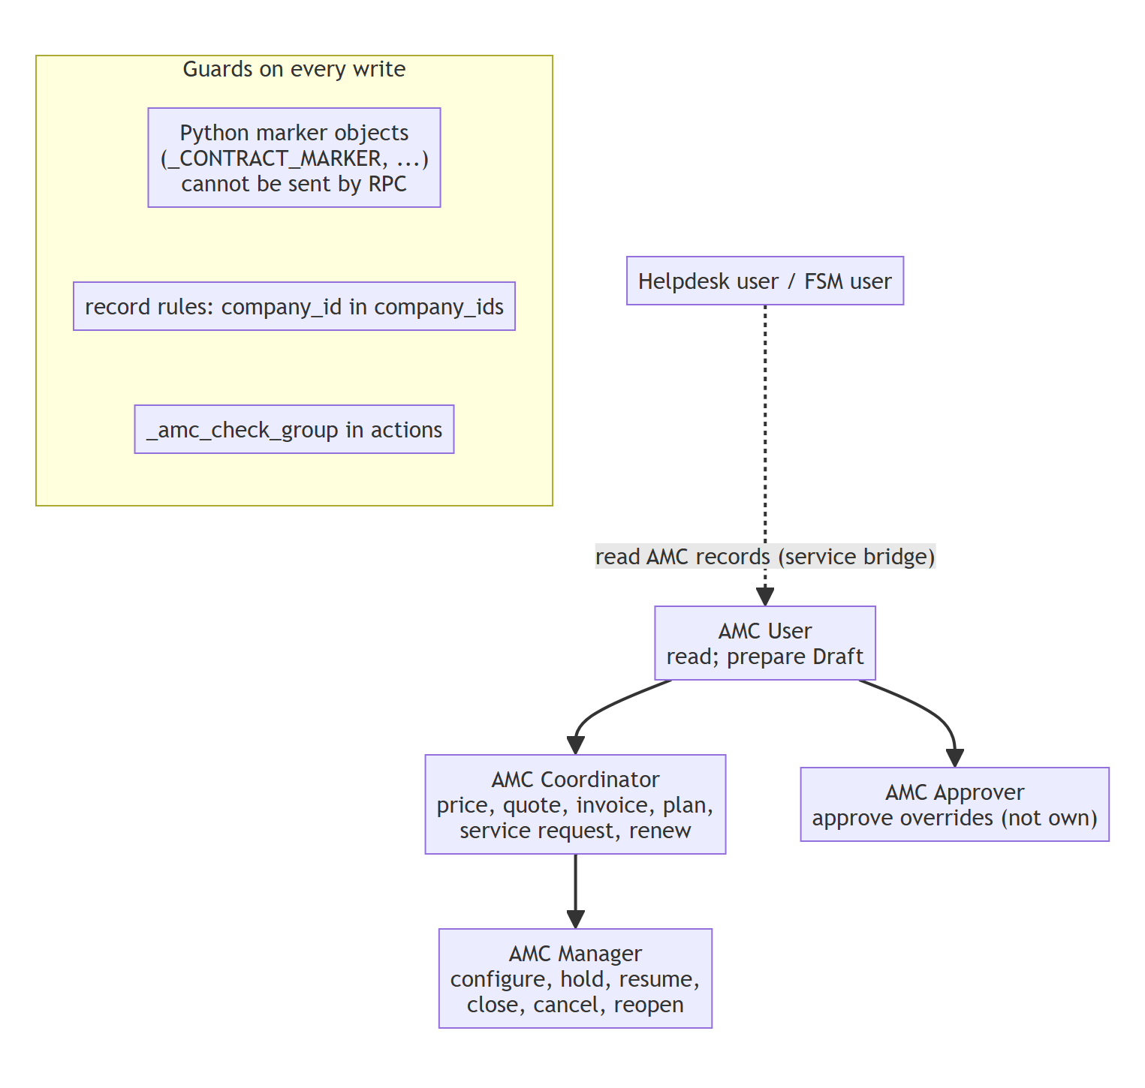
Figure 10 – Roles and write guards

8.1 Access control
Model | User | Coordinator | Manager | Approver | Helpdesk / FSM*
amc.plan, amc.billing.plan, amc.pricing.* | R | R | RWCD | R | R (plan)
amc.opportunity | RWC | RWC | RWCD | RWC | —
amc.contract | RWC | RWC | RWCD | RWC | R
amc.contract.line | RWCD | RWCD | RWCD | RWCD | R
amc.contract.visit | R | RW | RW | R | R
amc.billing.line | R | R | R | R | —
amc.price.override | R | RWC | RWC | RW | —

* granted by amc_management_service. Record rules restrict every transactional model to company_id in company_ids; configuration models allow shared (company-less) records.

8.2 Protected fields (marker pattern)
Each model keeps a module-level object() as marker (_CONTRACT_MARKER, _FORMULA_MARKER, _OVERRIDE_MARKER, _OPPORTUNITY_MARKER). Server code writes protected fields with with_context(amc_contract_marker=_CONTRACT_MARKER); write() / create() refuse protected keys when the context value is not that exact object. A Python object cannot be serialised into a JSON-RPC context, so neither the web client, imports nor external RPC can bypass the guard, and sudo() alone does not pass it either.
PROTECTED_FIELDS = {'state', 'price_state', 'calculated_price', 'sale_order_id', 'contract_months',
'renewal_of_id', 'close_reason', ... }
def write(self, vals):
if self.env.context.get('amc_contract_marker') is not _CONTRACT_MARKER:
if PROTECTED_FIELDS & set(vals): raise UserError(...)
return super().write(vals)

8.3 Privilege elevation (sudo) boundaries
- Only after an explicit group check in the calling action, or for system consequences of an authorised standard event (SO confirmation by a salesman, payment by an accountant, job completion by a technician).
- Internal writes of billing lines and entitlements (users have no write right on billing lines).
- Cross-record chatter logs and activities.

9. Transactions, concurrency and reliability
Concern | Mechanism
Double click / concurrent quotation, activation, renewal | _amc_lock(): parameterised SELECT … FOR UPDATE on the contract row
Atomic consumption with job completion | consumption in _warranty_complete_case, inside the warranty completion savepoint; any AMC error rolls back the whole completion
Warranty confirmation must not fail because of AMC | auto-create inside a savepoint; error logged on the card
Scheduler failures | one savepoint per contract; _logger.exception; next contract continues
Duplicate generation | visits generated only if none exist; billing only if no non-cancelled line exists; unique constraint
Duplicate release / alert / renewal | state filters (planned only), alert_sent flag, one open renewal check

10. Configuration parameters
Level | Parameter | Effect
Company | amc_activation_trigger | sale_confirmation / payment (plan can override)
Company | amc_product_id | AMC service product (service, invoice on delivery, manual delivery)
Company | amc_default_plan_id / _pricelist_id / _billing_plan_id / _start_rule / _renewal_rule / _alert_days | defaults
Company (W) | amc_auto_create_mode, amc_offer_on_warranty_expiry | warranty integration
Company (FSM) | warranty_draft_job_team_id, warranty_signoff_required, warranty_case_approver_ids | reused by AMC service requests
Plan | visit / frequency / usage / free services / planning / grace / missed / renewal / duration / start rule | entitlements and lifecycle
Formula version | method parameters, min / max / rounding, factors, tiers, effective dates | pricing
Product | warranty_worksheet_template_id | worksheet template of AMC visits
Helpdesk | SLA policy on tag "AMC" | AMC response / resolution SLA

11. Deployment and testing

11.1 Data migration
None: the AMC modules are not yet used in production, so they ship without migration scripts. A database with an older AMC version is reinstalled (or upgraded on a copy and checked) rather than migrated.

11.2 Deployment
pg_dump -Fc <db> > before_amc_110.dump (+ filestore)
odoo-bin -c odoo.conf -d <copy> -u amc_management -i amc_management_warranty,amc_management_service --stop-after-init
validate (docs/14 §4), then repeat on the target database with the server stopped

11.3 Test architecture
Suite | Base class | Tests | Focus
amc_management/tests/test_amc_lifecycle.py | AmcCommon (AccountTestInvoicingCommon) | 28 | entitlements, billing, lifecycle, scheduler, report
amc_management/tests/test_amc_pricing.py | AmcCommon | 9 | pricing methods, governance, expression, override
amc_management/tests/test_amc_security.py | AmcCommon | 10 | roles, RPC protection, multi-company, AMC Enabled, non-AMC regression
amc_management_warranty/tests/test_amc_warranty.py | TransactionCase | 10 | auto-create, conversion, units, expiry offer, AMC Enabled
amc_management_service/tests/test_amc_service_chain.py | AmcCommon | 8 | end-to-end Helpdesk → Job → FSM → sign-off → consumption

Result on 2026-11-07: 65 / 65 passed (68 with the 3 documentation tests); 866 warranty regression tests with the AMC modules installed: 860 passed, 6 failures identical on a database without any AMC module (pre-existing).

12. Extension guide
Need | Extend
Allow / forbid manual visit completion | amc.contract.visit._amc_manual_completion_allowed()
Block cancellation of visits in another process | amc.contract.visit._amc_check_not_in_service()
Copy more data to renewals | amc.contract.line._amc_renewal_values(), amc.contract._amc_create_renewal()
Additional activation side effects | amc.contract._amc_activate() (call super first)
Visit generation rules (e.g. offsets) | amc.contract._amc_generate_visits() / amc.plan._amc_visit_interval_months()
New pricing variable | HYBRID_VARIABLES and the values dict in _amc_compute_price
Additional scheduler step | amc.contract._amc_daily(today) (one contract, inside its savepoint)
New protected field | add it to PROTECTED_FIELDS / PROTECTED_VISIT_FIELDS and write it with the marker

Design note: Keep new logic scoped to AMC records, call super() in every override, write protected fields only through the marker helpers (_marked) and add a test with a TC identifier to the relevant suite.

