Knee Abnormality Classification Using Vision Transformers
EEEM068 Applied Machine Learning — University of Surrey
Spring Term 2026

Abstract—Accurate interpretation of knee magnetic resonance imaging (MRI) is central to the diagnosis of common sports injuries such as anterior cruciate ligament (ACL) and meniscal tears, yet specialist radiological expertise is not always immediately available. This work investigates whether a small Vision Transformer (ViT-Small/16) can serve as a useful decision-support tool for three-class classification of knee MRI scans into normal, ACL tear, and meniscal tear categories. Using the publicly available MRNet dataset, we fine-tune a ViT-Small backbone initialised with self-supervised SiT-S ImageNet weights, extracting two informative 2D slices per sagittal volume and applying medically appropriate augmentation. Four training configurations are compared, and the model is evaluated on accuracy, per-class sensitivity, specificity, macro F1-score and macro ROC-AUC. The best configuration attains 70.0% top-1 accuracy, a macro F1 of 0.666, and a macro ROC-AUC of 0.821 on the official MRNet validation split. Attention rollout produces anatomically plausible saliency maps without spatial supervision, supporting interpretability. Testing on six externally sourced internet MRI images reveals a substantial drop in accuracy to 33%, illustrating the dataset-shift problem characteristic of single-site medical AI. We close with a discussion of clinical, ethical and deployment implications.
Index Terms—Vision Transformer, knee MRI, MRNet, ACL tear, meniscal tear, transfer learning, attention rollout, medical imaging.
I. INTRODUCTION
Knee injuries are among the most common musculoskeletal complaints in sports medicine, and tears of the ACL and menisci, in particular, are routinely diagnosed using MRI. Although MRI provides excellent soft-tissue contrast, the interpretation of knee scans is non-trivial: relevant features can be subtle, distributed across multiple slices, and easily confounded by acquisition variability. Specialist radiology reporting is therefore not always available immediately, especially in non-tertiary settings, and triage delays can affect treatment timelines for time-sensitive injuries.
Automated classification systems trained on large MRI archives have the potential to assist clinicians as second readers and triage tools, flagging likely abnormalities for prioritised review. Vision Transformers (ViTs), introduced by Dosovitskiy et al. [1], offer an attractive architectural alternative to convolutional networks for this task. By dividing an image into a sequence of fixed-size patches and processing them through multi-head self-attention, ViTs capture long-range spatial dependencies more naturally than CNNs and produce attention maps that lend themselves to interpretability analyses.
This project applies a ViT-Small backbone to the MRNet dataset [2], framing the task as three-class classification across normal knees, ACL tears, and meniscal tears using sagittal-plane scans. Our contributions are: (i) a sagittal-only ViT-Small classification pipeline with informative-slice sampling; (ii) a controlled comparison of four training configurations including pretrained weight source and loss function; (iii) clinically relevant evaluation using per-class sensitivity, specificity, F1 and ROC-AUC; (iv) attention rollout visualisations for interpretability; and (v) an external-image stress test that quantifies domain shift on publicly sourced internet scans.
II. LITERATURE REVIEW
Vision Transformers and efficient variants. Dosovitskiy et al. [1] demonstrated that a pure transformer applied to image patches achieves competitive performance with CNNs on ImageNet when pretrained on large datasets, fundamentally challenging the long-standing dominance of convolutions for image recognition. Touvron et al. [3] addressed the data-hungry nature of ViTs with DeiT, showing that strong ImageNet performance is reachable without proprietary JFT-300M pretraining through carefully tuned augmentation and knowledge distillation. These two works frame the architectural family used in this project.
Self-supervised pretraining. Ahmed et al. [4] introduced SiT (Self-supervised Image Transformer), combining masked image reconstruction with contrastive and rotation objectives to pretrain ViT backbones without labels. The SiT-S checkpoint provides representations that, in our experiments, transfer more effectively to the small MRNet target distribution than purely supervised pretraining. Self-supervised pretraining is now broadly recognised as advantageous when downstream labels are scarce, which is the standard situation in medical imaging.
Deep learning on knee MRI. Bien et al. [2] released MRNet alongside a CNN-based ensemble that predicts general abnormality, ACL and meniscal tear from multi-plane MRI, reporting AUCs above 0.90 for ACL on the internal validation set and approaching expert performance for general abnormality. Their work established MRNet as the canonical benchmark for knee-MRI classification and motivates the three-class formulation we adopt. Subsequent studies, such as that of Tsai et al. [5], have explored efficient and lightweight CNNs (e.g., EfficientNet variants) on MRNet, reporting strong AUCs but also exposing the limits of single-site evaluation.
Transformers in medical imaging. Chen et al. [6] proposed TransUNet, which combines a transformer encoder with a U-Net decoder for medical image segmentation, demonstrating that transformer-based encoders can outperform CNN-only counterparts when adequately pretrained. While their target task is segmentation, the underlying lesson — that ViT representations transfer competitively to medical domains under appropriate training regimes — directly motivates our choice of backbone.
Transfer learning for medical imaging. Raghu et al. [7] critically examined transfer learning from ImageNet to medical imaging, finding that large ImageNet-pretrained models do not always confer the expected gains over much smaller architectures trained from scratch, but that pretraining still provides faster convergence and modest accuracy improvements on small medical datasets. This justifies our use of pretrained initialisation while warning that pretraining alone is insufficient to close the domain gap, a point reinforced by our external-image evaluation.
Attention-based interpretability. Abnar and Zuidema [8] introduced attention rollout, recursively multiplying attention matrices across layers to estimate how strongly the class token attends to each input patch. Chefer et al. [9] extended this with class-specific relevance propagation that combines gradients with attention. Both approaches produce class-relevant saliency maps from ViTs without architectural modification; we adopt the simpler rollout formulation since it requires no additional gradient computation and remains widely cited as a clinically interpretable baseline.
III. METHODOLOGY
A. Dataset and Three-Class Formulation
The MRNet dataset [2] contains 1,370 knee MRI exams from Stanford University Medical Center, each comprising volumetric acquisitions in axial, coronal and sagittal planes. Three binary labels are provided per exam: general abnormality, ACL tear, and meniscal tear. We use the official 1,130 / 120 train / validation split for the three released label files and re-formulate the labels into a single three-way target with the priority rule: class 1 (ACL) if the ACL label is positive; otherwise class 2 (Meniscus) if the meniscus label is positive; otherwise class 0 (Normal). ACL takes precedence because ACL tears are the more time-critical diagnosis. Only the sagittal plane is used, as it provides the clearest visualisation of both the ACL and meniscal anatomy and is sufficient to demonstrate the methodology within project constraints.
B. Slice Selection and Preprocessing
Each volume is stored as a 3D NumPy array of shape [N, 128, 128]. Rather than treating all N slices uniformly, we extract two informative 2D images per volume: (a) the geometric middle slice (index N/2), and (b) the slice with the highest total pixel-intensity sum, on the assumption that high-signal slices capture more anatomical content than near-empty edge slices. This doubles the effective dataset size, mitigates extreme class imbalance, and avoids the noise of slice-by-slice random sampling while remaining compatible with a 2D classifier. Each selected slice is min-max normalised to [0, 255], replicated across three channels to form an RGB image, resized from 128×128 to 224×224 using bilinear interpolation, and normalised with the standard ImageNet mean and standard deviation. Training augmentation comprises random affine transformations (rotations in ±20°, translations of ±10% along both axes, scaling in [0.85, 1.15]) and random horizontal flips; validation images receive only resizing and normalisation.
C. Model Architecture
We use ViT-Small/16 from the timm library [10], which embeds 16×16 patches (196 patches for a 224×224 input) into a 384-dimensional token sequence prefixed with a learnable class token and processed by 12 transformer encoder blocks with 6 attention heads each. The pretrained 1,000-way classification head is removed and replaced with a single linear layer mapping the class-token embedding to three logits, initialised with truncated-normal weights to match the timm convention. Pretrained weights from SiT-S [4] are loaded into the backbone before fine-tuning; SiT-S shares the ViT-Small architecture exactly, enabling direct weight transfer without any adapter layer.
D. Training Protocol
Optimisation uses AdamW with differential learning rates across parameter groups: a low rate for the pretrained backbone to preserve transferred representations, and a higher rate for the freshly initialised head to allow rapid adaptation. The backbone learning rate is 1×10⁻⁵, the head learning rate is 1×10⁻⁴, and weight decay is 1×10⁻⁴ throughout. A linear warm-up over five epochs ramps the rates from zero, followed by cosine annealing across the remaining epochs. The maximum training length is 50 epochs with batch size 32 on a single NVIDIA T4 GPU; an early-stopping rule terminates training if validation accuracy does not improve for 10 consecutive epochs, and the best-validation checkpoint is retained. To address residual class imbalance after slice expansion, we use cross-entropy loss with weights inversely proportional to class frequency, except in Run 4 below which uses focal loss for comparison.
IV. EXPERIMENTS
A. Hyperparameter Comparison
Four training runs were conducted to isolate the effect of pretrained weight source, learning rate magnitude, and loss function. All other settings were held constant. Results on the MRNet validation set are summarised in Table I.
Run | Init | Loss | Acc | F1 | AUC
1 | timm IN | CE | 62.9 | 0.592 | 0.785
2 | SiT-S | CE | 70.0 | 0.666 | 0.821
3 | SiT-S | CE low-LR | 67.9 | 0.575 | 0.823
4 | SiT-S | Focal γ=2 | 66.3 | 0.585 | 0.820
TABLE I Validation results across four training configurations on MRNet (sagittal plane, three-class). Init: pretrained initialisation source. CE: class-weighted cross-entropy. Acc, F1 and AUC are top-1 accuracy (%), macro F1 and macro ROC-AUC.
Run 2, which uses SiT-S pretrained weights with standard class-weighted cross-entropy, achieves the highest top-1 accuracy and macro F1. The +7.1 percentage-point gain over Run 1 confirms that SiT-S self-supervised pretraining provides a substantially better initialisation than timm's default supervised ImageNet checkpoint for this task — the contrastive and reconstruction objectives appear to capture lower-level texture statistics that transfer well to the relatively small MRNet target. Reducing learning rates (Run 3) yielded marginally higher ROC-AUC but worse accuracy and F1, suggesting that the additional stability did not compensate for slower adaptation given only 50 epochs. Focal loss (Run 4), introduced to focus on hard examples, performed comparably to Run 3 in ROC-AUC but was outperformed on accuracy and F1: with class weights already addressing imbalance, the additional hard-example focusing of focal loss appears to overweight noisy gradients early in training.
Training and validation curves (Fig. 1) show that all four runs converge within the first 10–15 epochs, with Run 2 peaking near epoch six before mild overfitting widens the train/validation gap. The final gap of roughly seven percentage points between training and validation accuracy (~77% vs 70%) is consistent with the size of the dataset and the documented difficulty of MRNet.
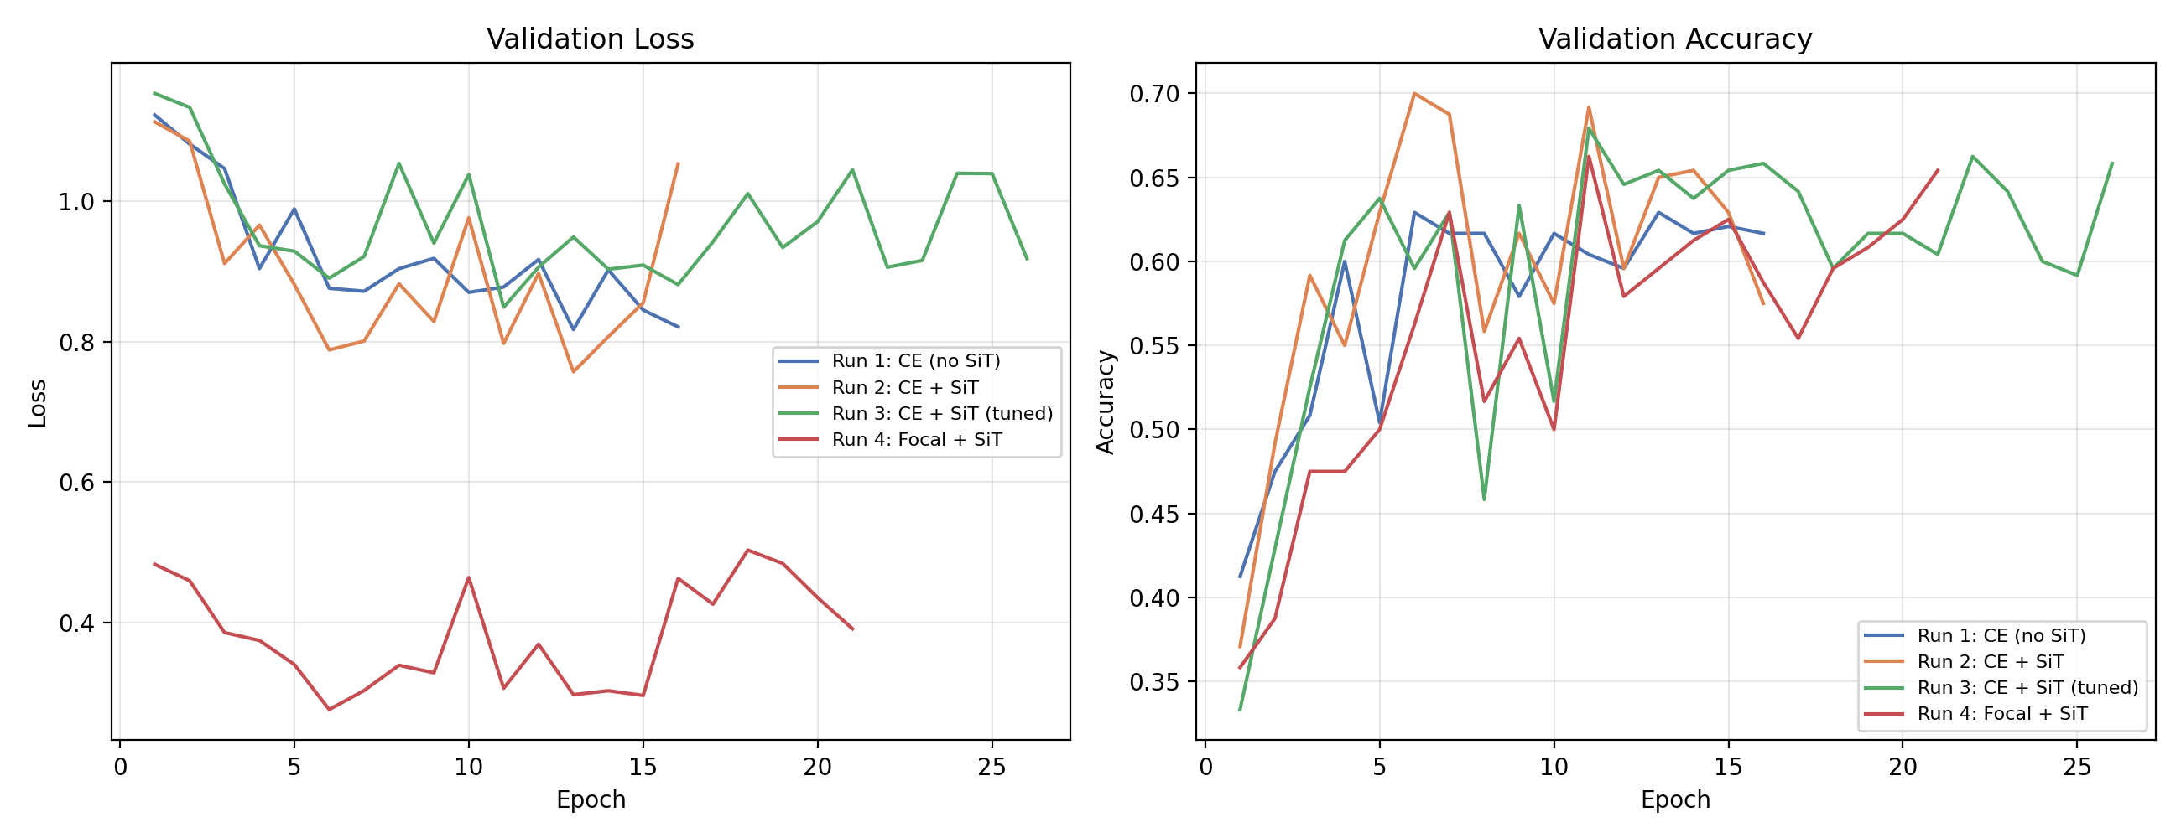
Fig. 1. Validation loss and accuracy across all four training runs.
B. Per-Class Clinical Metrics
Because the three classes carry asymmetric clinical importance, per-class sensitivity (recall) and specificity matter more than aggregate accuracy. Table II reports these metrics for the best model (Run 2). ACL tears are detected with the highest sensitivity (0.843), reflecting the distinctive disruption pattern of the ACL on sagittal views. Meniscal tears are the hardest class (sensitivity 0.548), consistent with their subtler and more variable MRI signatures, while the model is highly specific for the meniscus class (0.914) — when it does predict meniscus, it tends to be correct. Normal cases show moderate sensitivity but high specificity (0.867), meaning the model rarely raises a false alarm on a healthy knee.
Class | Sensitivity | Specificity | ROC-AUC
Normal | 0.600 | 0.867 | 0.825
ACL | 0.843 | 0.735 | 0.819
Meniscus | 0.548 | 0.914 | 0.778
TABLE II Per-class sensitivity, specificity and ROC-AUC for Run 2 on the MRNet validation set.
The confusion matrix (Fig. 2) confirms this asymmetry: the dominant error mode is meniscal tears predicted as normal (18 of 42 meniscus cases), implying that the model under-detects this class — a clinically undesirable failure mode for a triage tool. ROC curves for the three classes (Fig. 3) lie well above chance, with a macro AUC of 0.821, supporting the conclusion that the learned representation separates all three classes meaningfully.
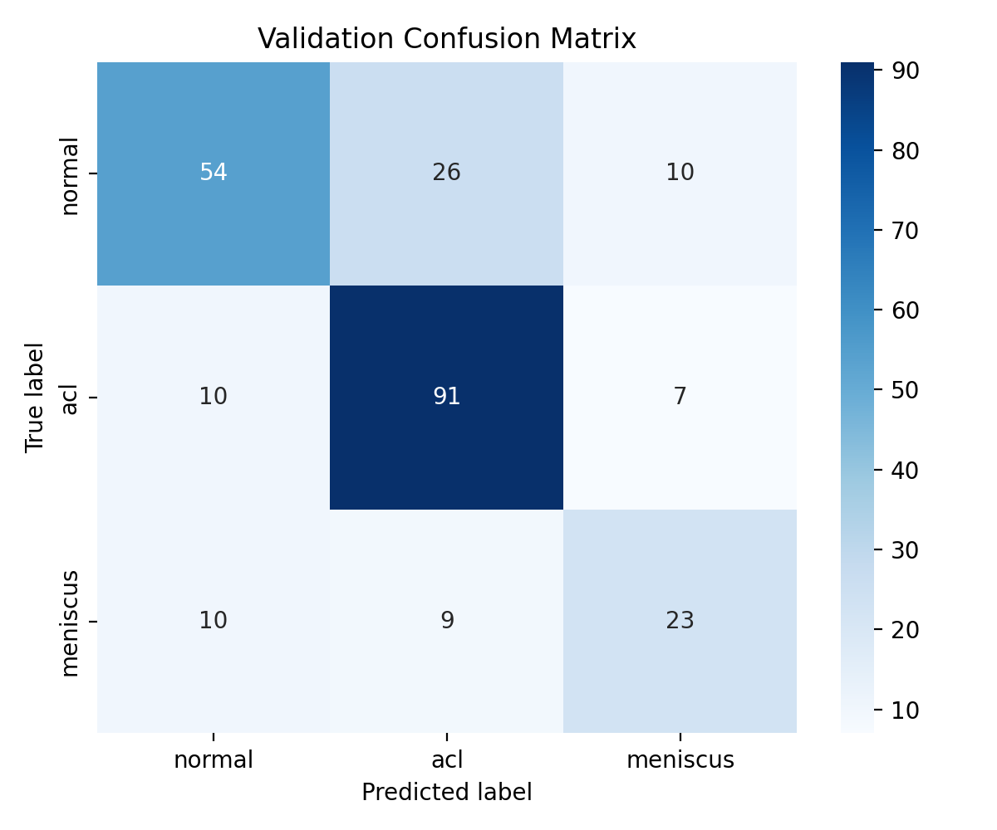
Fig. 2. Confusion matrix for Run 2 on the MRNet validation set (n=240).
C. Attention Rollout Visualisation
To interpret model decisions we apply attention rollout [8] across all 12 transformer blocks, recursively multiplying the attention matrices (with the identity added to model residual connections) and reading off the row corresponding to the class token. The resulting 14×14 saliency map is bilinearly upsampled to 224×224 and overlaid on the input slice. Fig. 4 shows representative attention maps for correctly classified validation examples from each class. For ACL cases, attention concentrates in the central joint region near the ACL insertion site; for meniscus cases, attention shifts to the joint-space periphery where meniscal tissue lies; for normal knees, attention is more diffuse, consistent with the absence of a specific injury target. Crucially, these patterns emerge without any spatial supervision — the model is trained only with image-level class labels — providing weakly supervised localisation that is clinically encouraging from an interpretability perspective.
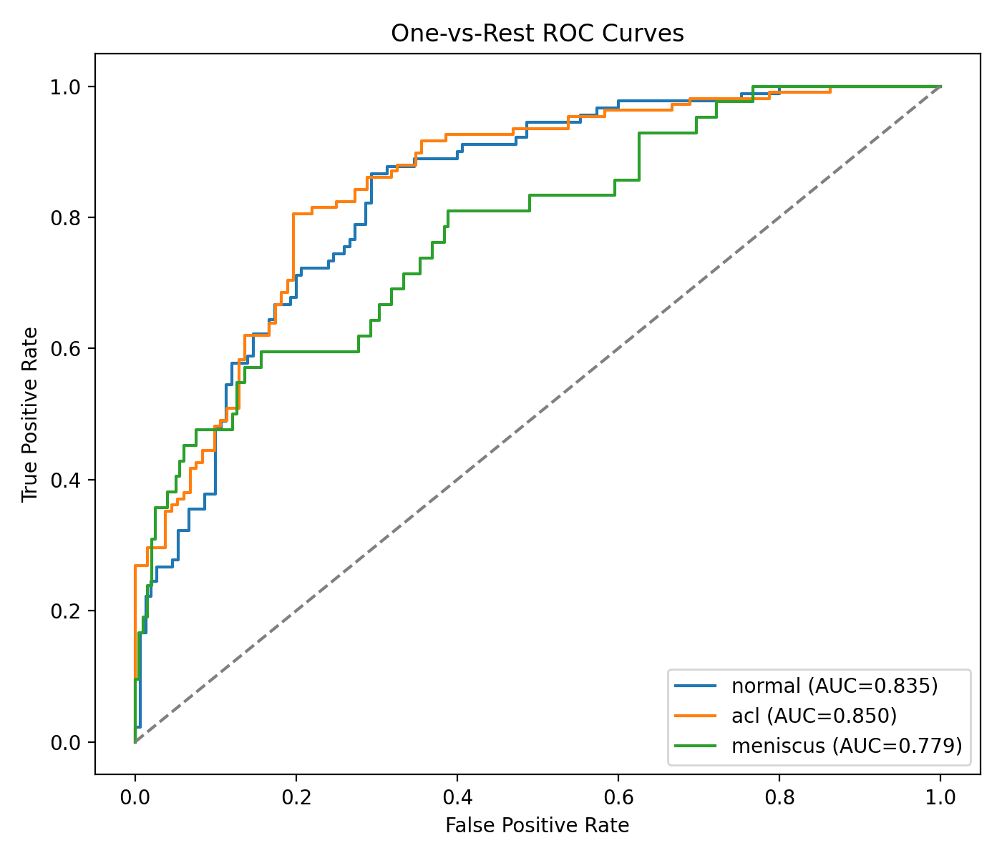
Fig. 3. One-vs-Rest ROC curves for Run 2 (SiT-S). Macro AUC = 0.821.
D. External Image Evaluation
To probe generalisation beyond MRNet's acquisition distribution, we collected six knee MRI sagittal images from public radiology education resources on the internet (two per class). These images were passed through the best Run 2 checkpoint without any retraining or domain adaptation. Table III lists each image's prediction and its softmax confidence.
Image | True | Predicted | Confidence
acl1 | ACL | ACL ✓ | 50.1%
acl2 | ACL | Meniscus ✗ | 48.8%
men1 | Meniscus | Normal ✗ | 62.7%
men2 | Meniscus | Normal ✗ | 68.5%
normal1 | Normal | Normal ✓ | 77.1%
normal2 | Normal | ACL ✗ | 84.1%
TABLE III Run 2 predictions on six externally sourced internet knee-MRI images.
External accuracy is 2/6 (33%), markedly lower than the 70.0% achieved on the in-distribution MRNet validation set. Several factors contribute to this drop. Scanner protocol differences alter signal characteristics: MRNet is acquired at a single site with consistent parameters, whereas internet images vary in field strength, echo time, sequence weighting and slice thickness. Contrast windowing and intensity normalisation conventions differ. Internet images often carry annotations, arrows, borders or non-standard cropping absent from training data. Finally, the average confidence on external images (65.2%) is lower than on MRNet, indicating that the model at least partially expresses its uncertainty rather than failing silently. This pattern is a textbook example of dataset shift in medical AI [7]: single-site training does not guarantee multi-site generalisation, and domain adaptation or multi-centre data is required before any clinical use.
V. CONCLUSION AND FUTURE WORK
We presented a ViT-Small/16 model for three-class knee MRI classification on the MRNet dataset, achieving 70.0% top-1 accuracy and 0.821 macro ROC-AUC with a SiT-S self-supervised pretrained initialisation and class-weighted cross-entropy. The largest single improvement (+7.1 pp accuracy) came from switching from supervised ImageNet pretraining to SiT-S self-supervised pretraining, supporting the broader trend that self-supervised representations transfer well to data-scarce medical domains. Per-class analysis shows ACL tears are the easiest to detect, while meniscal tears remain the hardest class — and importantly the dominant failure mode is to under-call meniscal injury, a finding that any prospective deployment would need to address. Attention rollout produces anatomically plausible saliency maps without spatial supervision, and the external-image stress test reveals a clear dataset-shift penalty.
Ethical considerations. MRNet originates from a single tertiary medical centre, which limits demographic diversity and likely encodes scanner-, protocol- and population-specific biases. Any model trained exclusively on MRNet should be treated as a research artefact and not a diagnostic tool. False negatives — missed injuries — carry significantly more clinical risk than false positives in this setting, particularly for meniscal tears where our sensitivity is lowest. Responsible deployment would require prospective multi-site validation, regulatory approval under the relevant medical-device framework, calibration analysis, and explicit communication of confidence and failure modes to the operating clinician. The system should be positioned as a decision-support tool that augments, rather than replaces, expert radiological judgement.
Future work. Three directions are most promising. First, multi-plane fusion combining sagittal, coronal and axial views should improve sensitivity to meniscal tears, which are visualised best across multiple planes. Second, test-time augmentation and ensembling across slice-selection strategies are low-cost ways to reduce prediction variance on the small validation set. Third, addressing the external generalisation gap will require domain adaptation techniques — including intensity histogram matching, adversarial alignment, or fine-tuning on small amounts of target-site data — together with prospective collection of multi-centre validation cohorts.
Figure references. Fig. 1 — training/validation accuracy and loss curves for Runs 1–4. Fig. 2 — confusion matrix for Run 2. Fig. 3 — per-class ROC curves for Run 2. Fig. 4 — representative attention-rollout overlays for ACL, meniscus, and normal cases. (Insert plots from the experimental notebook here.)
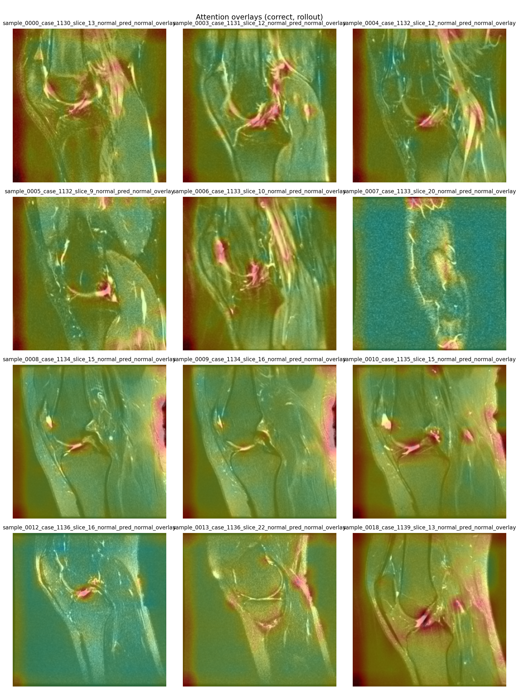
Fig. 4. Attention rollout overlays on MRNet validation samples. Warmer colours indicate higher attention.
REFERENCES
[1] A. Dosovitskiy et al., "An image is worth 16×16 words: Transformers for image recognition at scale," in Proc. Int. Conf. on Learning Representations (ICLR), 2021.
[2] N. Bien et al., "Deep-learning-assisted diagnosis for knee magnetic resonance imaging: development and retrospective validation of MRNet," PLOS Medicine, vol. 15, no. 11, 2018.
[3] H. Touvron et al., "Training data-efficient image transformers & distillation through attention," in Proc. Int. Conf. on Machine Learning (ICML), 2021.
[4] S. Atito, M. Awais, and J. Kittler, "SiT: Self-supervised vision transformer," arXiv:2104.03602, 2021.
[5] C.-H. Tsai, N. Kiryati, E. Konen, I. Eshed, and A. Mayer, "Knee injury detection using MRI with efficiently-layered network (ELNet)," in Proc. Machine Learning for Healthcare (MIDL), 2020.
[6] J. Chen et al., "TransUNet: Transformers make strong encoders for medical image segmentation," arXiv:2102.04306, 2021.
[7] M. Raghu, C. Zhang, J. Kleinberg, and S. Bengio, "Transfusion: Understanding transfer learning for medical imaging," in Proc. Advances in Neural Information Processing Systems (NeurIPS), 2019.
[8] S. Abnar and W. Zuidema, "Quantifying attention flow in transformers," in Proc. Association for Computational Linguistics (ACL), 2020.
[9] H. Chefer, S. Gur, and L. Wolf, "Transformer interpretability beyond attention visualization," in Proc. IEEE/CVF Conf. on Computer Vision and Pattern Recognition (CVPR), 2021.
[10] R. Wightman, "PyTorch image models (timm)," GitHub repository, 2019. [Online]. Available: https://github.com/huggingface/pytorch-image-models

