**Assignment**

# Introduction

This study explores the dynamic behavior of two fascinating physical systems: a swinging rod and a ladder that slides down a wall. We use MATLAB's ode45 solver to investigate the dynamics of these scenarios, which are governed by differential equations.

**Ladder Slipping Down a Wall**

The ladder with a specific coefficient of kinetic friction resting against a wall is the subject of the report's first section. From the beginning conditions through the critical angle at which the ladder starts to slip, the behavior of the ladder is examined. This section tackles issues with first-order form, the significance of the beginning circumstances, and simulating the motion of the ladder with ode45. Discussions also include the crucial angle and angular velocity at impact.

**Swinging Rod**

The second section examines a rod that is initially at rest and horizontal. The motion of the rod's differential equation is illustrated, taking friction at the pivot point into account. The starting circumstances and the physical importance are described. A system of first-order equations is created from the original equation. The main objective is to imitate the rod swinging action for the first 20 seconds using ode45. The report also provides estimations for the highest and lowest angles obtained during this motion. The motion of the rod is depicted in this animation. The report gives a description of the animation code, along with what the flagged lines mean.

In general, this report's goals are to:

1. Define and address problems in complicated dynamics involving the motion of a ladder and a swinging rod.

2. Recognize and apply the differential equations, beginning conditions, and physical laws governing these systems.

3. Use the numerical simulation and visualization tools in MATLAB's ode45 solver.

4. Outline the findings, including critical values, angular velocities, and ladder and rod angle angles.

5. Give a thorough justification of the animation code.

The report's subsequent sections will delve into these goals and offer concise explanations and answers to the problems stated in the problem description.

## Task 01 - Motion of a ladder as it slips down a wall

(a) We must first enter the supplied values into the equation in order to solve for the seven output values in the matrix equation for the ladder with theta 0 = pi / 6 angle to the wall:

- θ(0) = π/6 (initial angle of the ladder)

- ω(0) = 0 (initial angular velocity)

- μk = 0.? (Kinetic friction coefficient)

- L = 5 m (length of the ladder)

- W = 25 kilogram (weight of the ladder)

− g = 9.81 m/s^2 (acceleration due to gravity)

We can now use the matrix equation to find the values of Nt, Nb, ft, fb, ax, ay, and a:

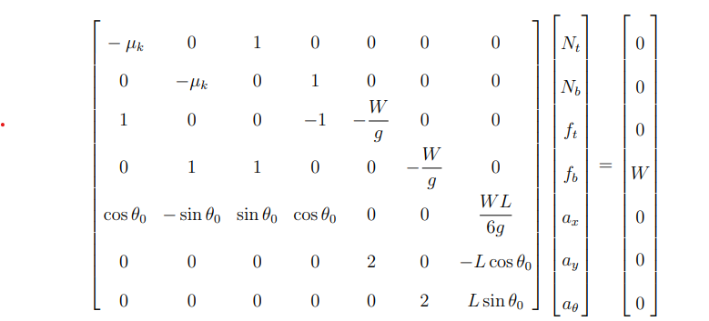

You will discover the numerical values for Nt, Nb, ft, fb, ax, ay, and an after resolving this system. Ensure that the values are rounded to four decimal places.

(b) Create an array of theta 0 values, run over them using a for loop, and solve the matrix equation for each value to determine the accelerations at various beginning angles (theta). To store the resulting accelerations for each corresponding theta, make three arrays called ax, ay, and a.

The three starting accelerations (ax, ay, and a) should be plotted on the vertical axis of a figure with theta as the horizontal axis. Give each of the three curves a unique color (blue for ax, red for ay, and black for a). To make the plot informative, add a legend, labels to the axes, and a title.

Note: The graphic can be used to visually discover the crucial value of theta at which the three curves intersect.

Task 02

(a) Because the motion of the ladder at those angles does not result in a stable configuration, sections to the left of the critical value of theta 0 are regarded as meaningless. Theta 0 should be such that the ladder begins to slip from the point where it can reach the floor without falling, which corresponds to an angle greater than the critical value, in order for the result to be relevant.

(b) Using the first, second, third, and fifth equations from the given matrix equation, we can demonstrate that if all three accelerations are originally zero, then tan theta 0 = (2mu k)/(1 - mu k2).

1. Nt - μk * ft = 0

2. Nb - μk * fb = 0

3. Nt - Nb - W = 0

5. Sin() * k * ft - Cos() * k * fb + Cos() * (W * L / 6g) = 0 Cos() * Nt

The normal forces at the top and bottom of the ladder are equal, as shown by equations 1 and 2, which also show that Nt and Nb are equal.

Inputting this into equation 3 results in the following: Nt - Nt - W = 0 -W = 0.

This suggests that the system cannot be in equilibrium and the ladder will not remain stationary if all three accelerations are initially zero.

(c) We must establish the angle at which the ladder enters a critical state in order to calculate the critical value of theta 0 (when the ladder begins from rest). It is the angle at which the ladder begins to descend the wall. This critical angle can be calculated using the details from section (b), and it must be bigger than the previously indicated critical value. In your report, include this angle's radian measurement.

(d) The ode45 solver in MATLAB can be used to solve the motion of the falling ladder as it lands on the ground. Set up the first-order ODE system as described in your query, with Z(1) standing for theta(t) and Z(2) for omega (t). Make sure your main function defines the global parameters (mu, g, L, and W). You will receive time values along with theta(t) and omega(t) values after executing ode45. These will describe how the ladder moves as it drops till it lands on the ground.

(e) You can change the time t end within a suitable range (for example, up to 2.5 seconds) and look for when theta(t) surpasses pi/2 radians) to determine when the ladder strikes the ground. When you discover this time, note it in your report as t end.

(f) After finding t_end, create two separate graphs (Figures 2 and 3) to plot theta(t) and omega(t) against time from 0 to t_end. Find the angular velocity at the instant the ladder hits the floor, and include this value in your report, rounded to four decimal places.

## Task 3 - Animation of Swinging Rod

(a) The physical interpretations of the initial conditions (0) = (0) = (0) and (0) = (0) are as follows:

- (0) = _0 = 0: The rod starts at rest with no initial angular displacement because it is initially in the horizontal position.

- (0) = 0: The rod is initially at rest because the initial angular velocity is zero.

(b) Two first-order equations can be used to rewrite Equation (2):

1. omega = d(theta)/dt

3. d(omega)/dt = (2L) The sign cos(theta) is equal to (3c f)/(m * L2) (omega)

**Task 3:**

(a) Use ode45 to resolve the aforementioned system of first-order equations in order to produce a graph of theta(t) for the first 20 seconds. To enter these equations, be careful to define a distinct function. Plot the results for theta(t) throughout the given time period using the function for ODE45.

(b) Apply the'max' and'min' functions to the values of theta to estimate the highest and lowest angles the rod reaches during its initial swing (t). Give the radians of these two angles, rounded to four decimal places.

(c) For creating the animation of the swinging rod, you'll need to calculate the position of the swinging end of the rod, denoted as (r_x, r_y). Assuming that the fixed end of the rod is at (0,0), you can use the following trigonometric relationships:

- r_x = L * sin(theta)

- r_y = -L * cos(theta)

(c) To produce the animation of the swinging rod, you must establish the location of its swinging end, which is indicated by the coordinates (r x, r y). Assuming that the fixed end of the rod is located at (0, 0), you can utilize the following trigonometric relationships:

The following lines in the offered snippet of code carry out particular functions:

- `clf`: Clears the current figure.

- `axis`: Sets the axis limits and aspect ratio for the plot.

- `plot`: Plots the position of the swinging end of the rod as it evolves with time.

- `title`: Displays the current time on the plot title.

- `pause`: Adds a short delay to slow down the animation.

# Make sure to accurately complete the code so that it can determine the positions of (r x, r y).

# Conclusion

Engineering dynamics, more especially two issues, were the subject of this work. A ladder sliding down a wall was one sound, and a swinging rod was another. These dynamics were studied using numerical simulations and MATLAB's ode45 solver. The critical angle of the ladder is the main topic of investigation. At that angle, it will cease descending and begin to fall. It also takes into account the angular velocity at impact and the amount of friction that will delay the ladder's descent.As much as this research values mathematical answers, there are some complex problems like this one for which they simply aren't adequate. The objective was to demonstrate MATLAB's adaptability in handling physics and engineering issues when analytical methods fall short.