**EDCHEMY REFERENCE MANUAL**

**HOME PAGE**

**1. Profile**

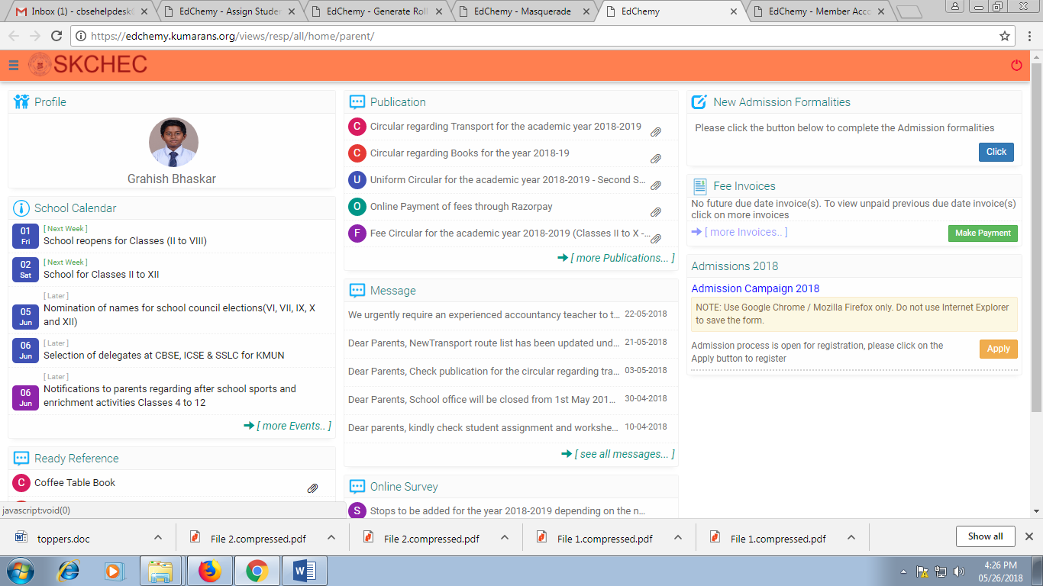Click on the photo to view the child details with section, House, Roll Number, Student Id, Admission Id, Gender, and Date of Birth.

**2. School Calendar**

One can view the academic planner like school events, test and exams, holiday and parental activities updated for the whole academic year. Latest 5 events will be displayed on the home page, click on more events to view the planner month wise.



**3. Ready Reference**

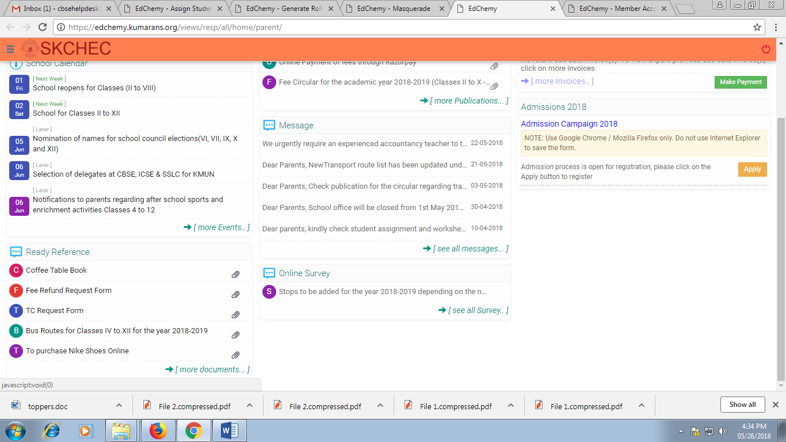Information required for the entire academic year is uploaded under Ready Reference. Eg : Transport Details, Fee Refund Request Form, TC Request Form etc.

**4. Publication**

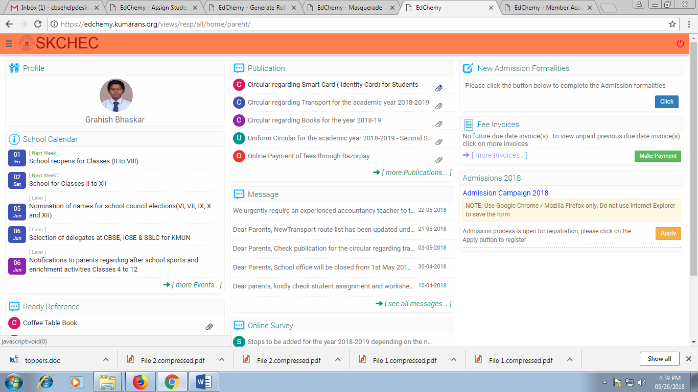All the circulars related to school information will be uploaded under publication. Latest five circulars will be displayed on the home page, click on more publications to view more circulars.

**5. Fee Invoices**

Latest Fee Invoices with due date will be displayed on the home page. To view unpaid previous due date invoices, click on more invoices. Click on the Fee category to search for the invoices to be paid.

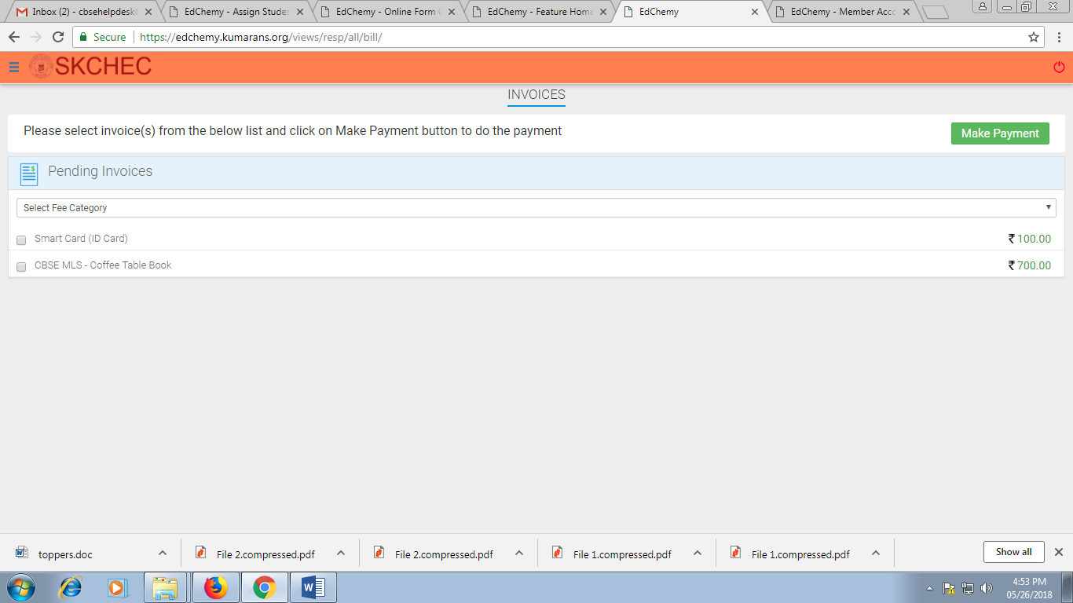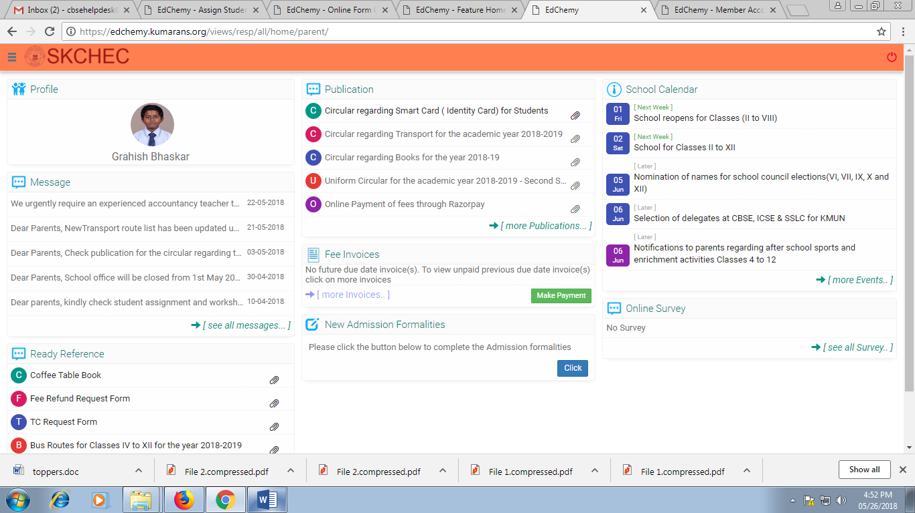

**6. Messages**

A copy of Sent SMS from the school can be viewed under Message.

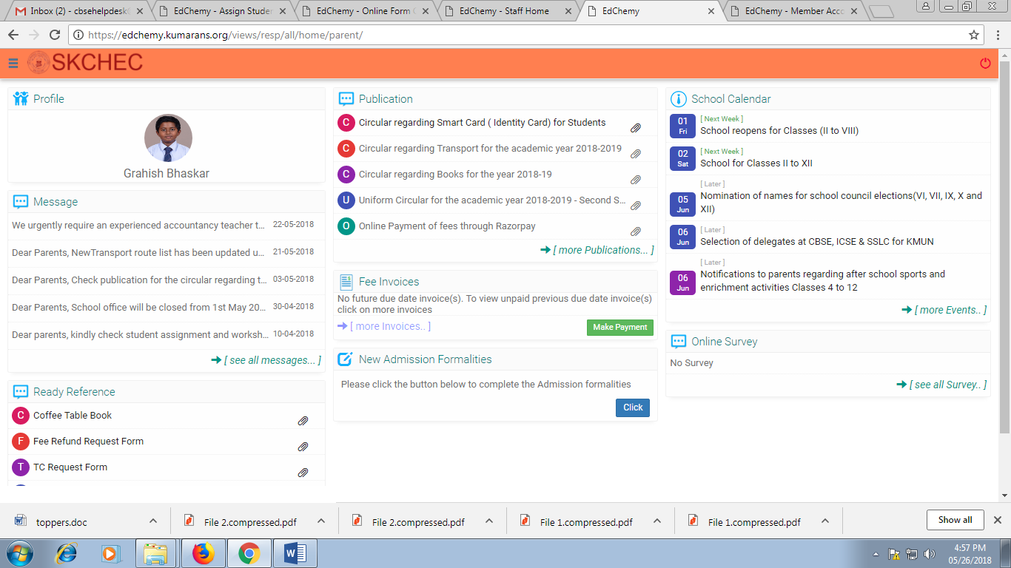

**7. Online Survey**

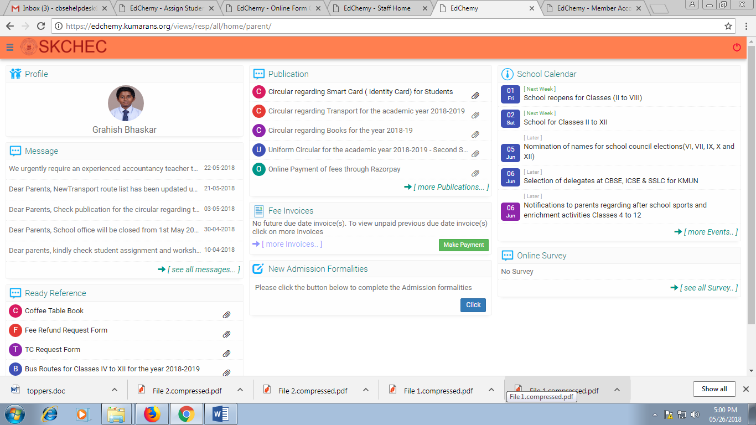Survey – This option will be available when the school requires feedback, make selections, registration forms.

**Tabs on the Left Hand Pane (Click on the icon next to the logo)**

1. **Edit Profile**

Parents can edit or update the information like Mobile Number, Blood Group, Emergency Contact number, Aadhar Card Number.

**2. Transport Details**

Can view the transport details of your child with the route number and stop name along with stop details.

**3. Fee Payment Transactions**

The transaction details for the fee invoices paid can be viewed under Fee payment transactions. All the receipts for the fee paid will be generated in pdf format.

**4. Test Results**

Results of Periodic Tests, Formative Assessments, Enrichment Activities, Term Reports, Test Reports, and Feedback Remarks can be viewed under Test Results.

**5. Student Dossier Reports**

Co curricular Activities and Sports Results conducted within the school will be updated. Parents can also share the activities conducted outside the school, where their children have excelled or won awards, to update in the dossier report. Kindly mail the details to [icsehelpdesk@kumarans.org](mailto:icsehelpdesk@kumarans.org)

**6. Lesson Plan**

Completion of Programme of work - subject wise will be updated. Teachers handling subjects will also be displayed under Lesson Plan.

**7. Discipline Records**

When students behave in an irresponsible manner or flout the school rules, the students will be given a series of reminders to help them reflect on their actions in order to make them behave responsibly. All the details will be updated under Discipline Records.

**8. Student Assignment and Worksheet**

Assignments and practice worksheets subject wise will be uploaded for the students.

**9. Question Bank**

Previous years’ question bank of term papers can be viewed.

**10. Value System and Financial Education – Classes VI to X**

Students of classes 6 to 10 can access the online modules of Value System and Financial Education at home and should be encouraged to go through these modules and take regular assessments.

**11. Detailed Assessment – Classes VIII and IX**

DA is a futuristic assessment tool that formulates customized assessment programs in accordance with the school curriculum and presents immediate detailed feedbacks on individual student performance.

You will automatically be logged into the DA site using your DA Id.

**12. Leave Application**

The digital leave record on Edchemy has to be filled in and the parents can view the days the child has not attended school. We will not accept any hand written application as we are looking only at digital documentation of the same.

**13. Attendance Record**

Parents can find the dates on which the child was absent and the percentage of attendance. If digital leave record is not updated, you can edit the absent dates and give the reason for not attending school.

**14. After School Event Calendar**

After school event dates sport wise will be updated for the whole academic year.

**15. scoolmeal**

Online payment for canteen facilities can be made. Menus can be viewed.

**16. Feedback Form**

Any feedback related to school info can be given. The school will respond to the feedback weekly.

**17. Student Background Info**

Parents need to fill in the required information as this helps the Counsellor know about your child.

**18. Scribbles Uniform**

Parents can place the order and make the online payment for uniforms. Show the receipt and collect the uniform from Mallasandra Campus.

**19. Results and Receipts**

Previous years’ report cards and receipts can be viewed.