HTML 1:

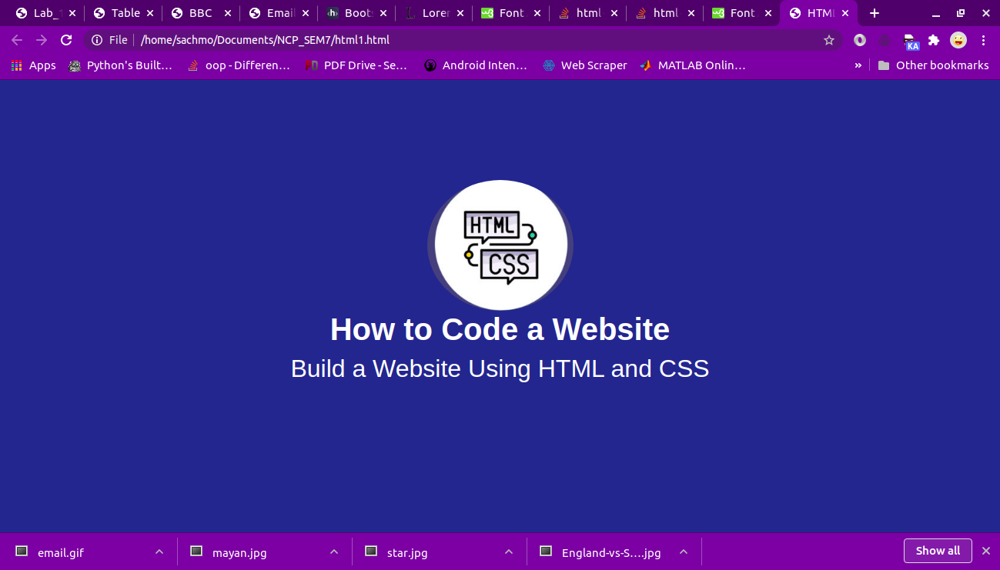

HTMLCODE:

<!DOCTYPE html>

<html>

<head>

<title>HTML & CSS</title>

<link rel="stylesheet" href="https://stackpath.bootstrapcdn.com/bootstrap/4.5.0/css/bootstrap.min.css" integrity="sha384-9aIt2nRpC12Uk9gS9baDl411NQApFmC26EwAOH8WgZl5MYYxFfc+NcPb1dKGj7Sk" crossorigin="anonymous">

<script src="https://stackpath.bootstrapcdn.com/bootstrap/4.5.0/js/bootstrap.min.js" integrity="sha384-OgVRvuATP1z7JjHLkuOU7Xw704+h835Lr+6QL9UvYjZE3Ipu6Tp75j7Bh/kR0JKI" crossorigin="anonymous"></script>

<script src="https://stackpath.bootstrapcdn.com/bootstrap/4.5.0/js/bootstrap.bundle.min.js" integrity="sha384-1CmrxMRARb6aLqgBO7yyAxTOQE2AKb9GfXnEo760AUcUmFx3ibVJJAzGytlQcNXd" crossorigin="anonymous"></script>

</head>

<body style="background-color:#00418c">

<div style="text-align: center; padding-top: 10%;">

<img src = "HTML_CSS.png" style="border-radius: 50%;" />

</div>

<div style="text-align: center;">

<h1 class="font-weight-bold" style="color: white;">How to Code a Website</h1>

<h2 style="color: white;">Build a Website Using HTML and CSS</h2>

</div>

</body>

</html>

HTML 2:

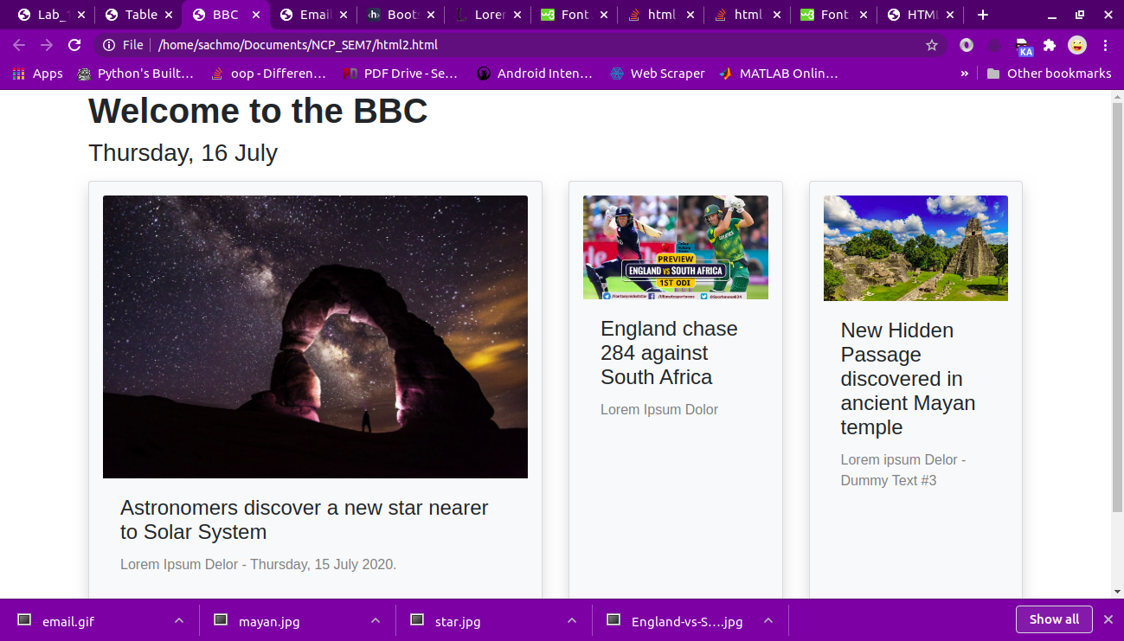

HTML CODE:

<!DOCTYPE html>

<html>

<head>

<title>BBC</title>

<link rel="stylesheet" href="https://stackpath.bootstrapcdn.com/bootstrap/4.5.0/css/bootstrap.min.css" integrity="sha384-9aIt2nRpC12Uk9gS9baDl411NQApFmC26EwAOH8WgZl5MYYxFfc+NcPb1dKGj7Sk" crossorigin="anonymous">

<script src="https://stackpath.bootstrapcdn.com/bootstrap/4.5.0/js/bootstrap.min.js" integrity="sha384-OgVRvuATP1z7JjHLkuOU7Xw704+h835Lr+6QL9UvYjZE3Ipu6Tp75j7Bh/kR0JKI" crossorigin="anonymous"></script>

<script src="https://stackpath.bootstrapcdn.com/bootstrap/4.5.0/js/bootstrap.bundle.min.js" integrity="sha384-1CmrxMRARb6aLqgBO7yyAxTOQE2AKb9GfXnEo760AUcUmFx3ibVJJAzGytlQcNXd" crossorigin="anonymous"></script>

</head>

<body class="container">

<div class="container">

<h1 class="font-weight-bold">Welcome to the BBC</h1>

<h3>Thursday, 16 July</h3>

<table class="table table-borderless">

<tbody>

<div class="row">

<div class="col-6 py-2">

<div class="card shadow p-3 mb-5 bg-light rounded h-100">

<img class="card-img-top" src="star.jpg" alt="Card image cap">

<div class="card-body">

<h4 class="card-title">Astronomers discover a new star nearer to Solar System</h4>

<p class="card-text" style="color: grey;">

Lorem Ipsum Delor - Thursday, 15 July 2020.

</p>

</div>

</div>

</div>

<div class="col-3 py-2">

<div class="card shadow p-3 mb-5 bg-light rounded h-100">

<img class="card-img-top" src="England-vs-South-Africa.jpg" alt="Card image cap">

<div class="card-body">

<h4 class="card-title">England chase 284 against South Africa</h4>

<p class="card-text" style="color: gray;">

Lorem Ipsum Dolor

</p>

</div>

</div>

</div>

<div class="col-3 py-2">

<div class="card shadow p-3 mb-5 bg-light rounded h-100">

<img class="card-img-top" src="mayan.jpg" alt="Card image cap">

<div class="card-body">

<h4 class="card-title">New Hidden Passage discovered in ancient Mayan temple</h4>

<p class="card-text" style="color: gray;">

Lorem ipsum Delor - Dummy Text #3

</p>

</div>

</div>

</div>

</div>

</tbody>

</table>

</div>

</body>

</html>

HTML 3:

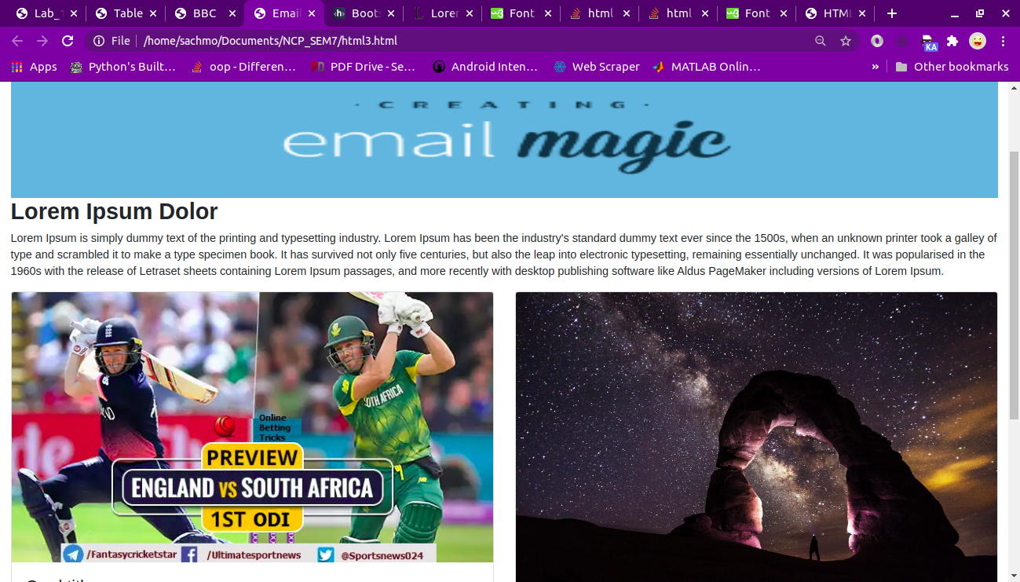

HTML CODE:

<!DOCTYPE html>

<html>

<head>

<title>Email Magic</title>

<link rel="stylesheet" href="https://stackpath.bootstrapcdn.com/bootstrap/4.5.0/css/bootstrap.min.css" integrity="sha384-9aIt2nRpC12Uk9gS9baDl411NQApFmC26EwAOH8WgZl5MYYxFfc+NcPb1dKGj7Sk" crossorigin="anonymous">

<script src="https://stackpath.bootstrapcdn.com/bootstrap/4.5.0/js/bootstrap.min.js" integrity="sha384-OgVRvuATP1z7JjHLkuOU7Xw704+h835Lr+6QL9UvYjZE3Ipu6Tp75j7Bh/kR0JKI" crossorigin="anonymous"></script>

<script src="https://stackpath.bootstrapcdn.com/bootstrap/4.5.0/js/bootstrap.bundle.min.js" integrity="sha384-1CmrxMRARb6aLqgBO7yyAxTOQE2AKb9GfXnEo760AUcUmFx3ibVJJAzGytlQcNXd" crossorigin="anonymous"></script>

<link rel="stylesheet" href="https://stackpath.bootstrapcdn.com/font-awesome/4.7.0/css/font-awesome.min.css" integrity="sha384-wvfXpqpZZVQGK6TAh5PVlGOfQNHSoD2xbE+QkPxCAFlNEevoEH3Sl0sibVcOQVnN" crossorigin="anonymous">

</head>

<body class="container-fluid">

<div class="col-12" style="background-image: url(email_2.png);background-size: 100% 100%; min-height:20rem;" >

</div>

<div>

<h2 class="font-weight-bold"> Lorem Ipsum Dolor</h2>

<p style="justify-content: start;">Lorem Ipsum is simply dummy text of the printing and typesetting industry. Lorem Ipsum has been the industry's standard dummy text ever since the 1500s, when an unknown printer took a galley of type and scrambled it to make a type specimen book. It has survived not only five centuries, but also the leap into electronic typesetting, remaining essentially unchanged. It was popularised in the 1960s with the release of Letraset sheets containing Lorem Ipsum passages, and more recently with desktop publishing software like Aldus PageMaker including versions of Lorem Ipsum.</p>

</div>

<table class="table">

<div class="row">

<div class="col">

<div class="card h-100">

<img class="card-img-top" src="England-vs-South-Africa.jpg" alt="Card image cap">

<div class="card-body">

<h4 class="card-title">Card title</h4>

<p class="card-text">

Contrary to popular belief, Lorem Ipsum is not simply random text. It has roots in a piece of classical Latin literature from 45 BC, making it over 2000 years old. Richard McClintock, a Latin professor at Hampden-Sydney College in Virginia, looked up one of the more obscure Latin words, consectetur, from a Lorem Ipsum passage, and going through the cites of the word in classical literature, discovered the undoubtable source. Lorem Ipsum comes from sections 1.10.32 and 1.10.33 of "de Finibus Bonorum et Malorum" (The Extremes of Good and Evil) by Cicero, written in 45 BC. This book is a treatise on the theory of ethics, very popular during the Renaissance. The first line of Lorem Ipsum, "Lorem ipsum dolor sit amet..", comes from a line in section 1.10.32.

</p>

</div>

</div>

</div>

<div class="col">

<div class="card h-100">

<img class="card-img-top" src="star.jpg" alt="Card image cap">

<div class="card-body">

<h4 class="card-title">Card title</h4>

<p class="card-text">

Contrary to popular belief, Lorem Ipsum is not simply random text. It has roots in a piece of classical Latin literature from 45 BC, making it over 2000 years old. Richard McClintock, a Latin professor at Hampden-Sydney College in Virginia, looked up one of the more obscure Latin words, consectetur, from a Lorem Ipsum passage, and going through the cites of the word in classical literature, discovered the undoubtable source. Lorem Ipsum comes from sections 1.10.32 and 1.10.33 of "de Finibus Bonorum et Malorum" (The Extremes of Good and Evil) by Cicero, written in 45 BC. This book is a treatise on the theory of ethics, very popular during the Renaissance. The first line of Lorem Ipsum, "Lorem ipsum dolor sit amet..", comes from a line in section 1.10.32.

</p>

</div>

</div>

</div>

</div>

</table>

<div class="col-12 d-flex flex-row" style="background-color: darkred;min-height:5%;justify-content: space-between;">

<h2 class="text-weight-bold " style="color:white" >CopyRight by Lorem</h2>

<div class="d-flex" ><i class="fa fa-car " style="font-size:30px;color:black;float:right"></i>

<i class="fa fa-arrows" style="font-size:30px;color:black;float:right"></i></div>

</div>

</body>

</html>

PTO

HTML 4:

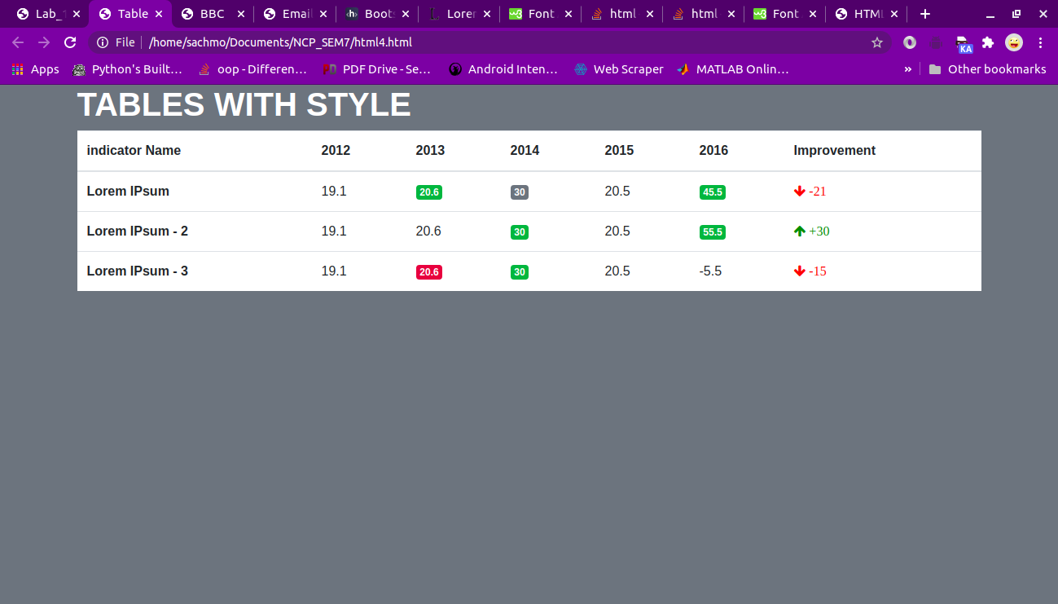

<!DOCTYPE html>

<html>

<head>

<title>Table</title>

<link rel="stylesheet" href="https://stackpath.bootstrapcdn.com/bootstrap/4.5.0/css/bootstrap.min.css" integrity="sha384-9aIt2nRpC12Uk9gS9baDl411NQApFmC26EwAOH8WgZl5MYYxFfc+NcPb1dKGj7Sk" crossorigin="anonymous">

<script src="https://stackpath.bootstrapcdn.com/bootstrap/4.5.0/js/bootstrap.min.js" integrity="sha384-OgVRvuATP1z7JjHLkuOU7Xw704+h835Lr+6QL9UvYjZE3Ipu6Tp75j7Bh/kR0JKI" crossorigin="anonymous"></script>

<script src="https://stackpath.bootstrapcdn.com/bootstrap/4.5.0/js/bootstrap.bundle.min.js" integrity="sha384-1CmrxMRARb6aLqgBO7yyAxTOQE2AKb9GfXnEo760AUcUmFx3ibVJJAzGytlQcNXd" crossorigin="anonymous"></script>

<link rel="stylesheet" href="https://stackpath.bootstrapcdn.com/font-awesome/4.7.0/css/font-awesome.min.css" integrity="sha384-wvfXpqpZZVQGK6TAh5PVlGOfQNHSoD2xbE+QkPxCAFlNEevoEH3Sl0sibVcOQVnN" crossorigin="anonymous">

</head>

<body class="container bg-secondary" >

<div><h1 style="color: white; font-weight: bolder;">TABLES WITH STYLE</h1></div>

<table class="table table-reflow bg-white">

<thead>

<tr>

<th>indicator Name</th>

<th>2012</th>

<th>2013</th>

<th>2014</th>

<th>2015</th>

<th>2016</th>

<th>Improvement</th>

</tr>

</thead>

<tbody>

<tr>

<th scope="row">Lorem IPsum</th>

<td>19.1</td>

<td><span class="badge badge-success">20.6</span></td>

<td><span class="badge badge-secondary">30</span></td>

<td>

20.5

</td>

<td>

<span class="badge badge-success">

45.5

</span>

</td>

<td>

<i class="fa fa-arrow-down" style="color:red;"> -21</i>

</td>

</tr>

<tr>

<th scope="row">Lorem IPsum - 2</th>

<td>19.1</td>

<td><span class="badge badge-danger"></span>20.6</td>

<td><span class="badge badge-success">30</span></td>

<td>

20.5

</td>

<td ><span class="badge badge-success">

55.5</span>

</td>

<td>

<i class="fa fa-arrow-up" style="color:green;"> +30</i>

</td>

</tr>

<tr>

<th scope="row">Lorem IPsum - 3</th>

<td>19.1</td>

<td><span class="badge badge-danger">20.6</span></td>

<td><span class="badge badge-success">30</span></td>

<td>

20.5

</td>

<td>

-5.5

</td>

<td>

<i class="fa fa-arrow-down" style="color:red;"> -15</i>

</td>

</tr>

</tbody>

</table>

</body>

</html>