//Git

//19-october-2021

//Why Git?

*FREE *OPEN SOURCE * Super Fast Scalable *Cheap

//1.Git Version we using

C:\Users\sachin bhat>git --version

git version 2.29.2.windows.2

C:\Users\sachin bhat>code

C:\Users\sachin bhat>git config --global core.editor "code --wait"

C:\Users\sachin bhat>git config --global -e

hint: Waiting for your editor to close the file...

//carrage return set true for win and set input in macc or linux

// \r\n \n

git config --help

//Created Git directory for project

//move terminal to Git directory

//initialize git

git init

Initialized empty Git repository in C:/Users/sachin bhat/Desktop/hashedIn_Learn/Git/.git/

ls -a

./ ../ .git/ Git.txt git-cheat-sheet-education.pdf

start .git //opened .git file

del .git // delete .git directory

git init

//sachin bhat@DESKTOP-TL53QCK MINGW64 ~/Desktop/hashedIn_Learn/Git (master)

$ echo hello > file1.txt

//sachin bhat@DESKTOP-TL53QCK MINGW64 ~/Desktop/hashedIn_Learn/Git (master)

$ echo hello > file2.txt

sachin bhat@DESKTOP-TL53QCK MINGW64 ~/Desktop/hashedIn_Learn/Git (master)

$ git status

On branch master

No commits yet

Untracked files:

(use "git add <file>..." to include in what will be committed)

Git.txt

file1.txt

file2.txt

git-cheat-sheet-education.pdf

nothing added to commit but untracked files present (use "git add" to track)

sachin bhat@DESKTOP-TL53QCK MINGW64 ~/Desktop/hashedIn_Learn/Git (master)

$ git add .

warning: LF will be replaced by CRLF in file1.txt.

The file will have its original line endings in your working directory

warning: LF will be replaced by CRLF in file2.txt.

The file will have its original line endings in your working directory

sachin bhat@DESKTOP-TL53QCK MINGW64 ~/Desktop/hashedIn_Learn/Git (master)

$ echo world >> file1.txt

sachin bhat@DESKTOP-TL53QCK MINGW64 ~/Desktop/hashedIn_Learn/Git (master)

$ git add file1.txt

sachin bhat@DESKTOP-TL53QCK MINGW64 ~/Desktop/hashedIn_Learn/Git (master)

$ git commit

[master (root-commit) 0562aa2] Initial commit.

4 files changed, 51 insertions(+)

create mode 100644 Git.txt

create mode 100644 file1.txt

create mode 100644 file2.txt

create mode 100644 git-cheat-sheet-education.pdf

5 to 10 Commit not more than that.

//without entering staging area

sachin bhat@DESKTOP-TL53QCK MINGW64 ~/Desktop/hashedIn_Learn/Git (master)

$ echo test >> file2.txt

sachin bhat@DESKTOP-TL53QCK MINGW64 ~/Desktop/hashedIn_Learn/Git (master)

$ git commit -am "Without entering staging area"

warning: LF will be replaced by CRLF in file2.txt.

The file will have its original line endings in your working directory

[master 9216c36] Without entering staging area

1 file changed, 1 insertion(+)

sachin bhat@DESKTOP-TL53QCK MINGW64 ~/Desktop/hashedIn_Learn/Git (master)

$ rm file3.txt

sachin bhat@DESKTOP-TL53QCK MINGW64 ~/Desktop/hashedIn_Learn/Git (master)

$ git status

On branch master

Changes not staged for commit:

(use "git add/rm <file>..." to update what will be committed)

(use "git restore <file>..." to discard changes in working directory)

deleted: file3.txt

no changes added to commit (use "git add" and/or "git commit -a")

sachin bhat@DESKTOP-TL53QCK MINGW64 ~/Desktop/hashedIn_Learn/Git (master)

$ git ls-files

Git.txt

file1.txt

file2.txt

file3.txt

git-cheat-sheet-education.pdf

as we can see although file 3 removed it is in directory / staging area

sachin bhat@DESKTOP-TL53QCK MINGW64 ~/Desktop/hashedIn_Learn/Git (master)

$ mv file1.txt main.js

sachin bhat@DESKTOP-TL53QCK MINGW64 ~/Desktop/hashedIn_Learn/Git (master)

$ git status

On branch master

Changes to be committed:

(use "git restore --staged <file>..." to unstage)

deleted: file3.txt

Changes not staged for commit:

(use "git add/rm <file>..." to update what will be committed)

(use "git restore <file>..." to discard changes in working directory)

deleted: file1.txt

Untracked files:

(use "git add <file>..." to include in what will be committed)

main.js

sachin bhat@DESKTOP-TL53QCK MINGW64 ~/Desktop/hashedIn_Learn/Git (master)

$ git add .

bash: $'\302\203git': command not found

sachin bhat@DESKTOP-TL53QCK MINGW64 ~/Desktop/hashedIn_Learn/Git (master)

$ git add .

warning: LF will be replaced by CRLF in main.js.

The file will have its original line endings in your working directory

sachin bhat@DESKTOP-TL53QCK MINGW64 ~/Desktop/hashedIn_Learn/Git (master)

$ git status

On branch master

Changes to be committed:

(use "git restore --staged <file>..." to unstage)

deleted: file3.txt

renamed: file1.txt -> main.js

sachin bhat@DESKTOP-TL53QCK MINGW64 ~/Desktop/hashedIn_Learn/Git (master)

$ git mv main.js first.js

sachin bhat@DESKTOP-TL53QCK MINGW64 ~/Desktop/hashedIn_Learn/Git (master)

$ git status

On branch master

Changes to be committed:

(use "git restore --staged <file>..." to unstage)

deleted: file3.txt

renamed: file1.txt -> first.js

sachin bhat@DESKTOP-TL53QCK MINGW64 ~/Desktop/hashedIn_Learn/Git (master)

$ git commit -m "after move and rename"

[master e6d4aa2] after move and rename

2 files changed, 1 deletion(-)

delete mode 100644 file3.txt

rename file1.txt => first.js (100%)

//GIT IGNORE

sachin bhat@DESKTOP-TL53QCK MINGW64 ~/Desktop/hashedIn_Learn/Git (master)

$ mkdir logs

sachin bhat@DESKTOP-TL53QCK MINGW64 ~/Desktop/hashedIn_Learn/Git (master)

$ echo hello>logs.txt

sachin bhat@DESKTOP-TL53QCK MINGW64 ~/Desktop/hashedIn_Learn/Git (master)

$ echo logs/ >.gitignore

sachin bhat@DESKTOP-TL53QCK MINGW64 ~/Desktop/hashedIn_Learn/Git (master)

$ git status

On branch master

Untracked files:

(use "git add <file>..." to include in what will be committed)

.gitignore

logs.txt

nothing added to commit but untracked files present (use "git add" to track)

sachin bhat@DESKTOP-TL53QCK MINGW64 ~/Desktop/hashedIn_Learn/Git (master)

$ echo logs.txt >.gitignore

sachin bhat@DESKTOP-TL53QCK MINGW64 ~/Desktop/hashedIn_Learn/Git (master)

$ git status

On branch master

Untracked files:

(use "git add <file>..." to include in what will be committed)

.gitignore

nothing added to commit but untracked files present (use "git add" to track)

sachin bhat@DESKTOP-TL53QCK MINGW64 ~/Desktop/hashedIn_Learn/Git (master)

$ git add .

warning: LF will be replaced by CRLF in .gitignore.

The file will have its original line endings in your working directory

sachin bhat@DESKTOP-TL53QCK MINGW64 ~/Desktop/hashedIn_Learn/Git (master)

$ git commit -m "Commit with git ignore"

[master 4821d91] Commit with git ignore

1 file changed, 1 insertion(+)

create mode 100644 .gitignore

//git status -s

sachin bhat@DESKTOP-TL53QCK MINGW64 ~/Desktop/hashedIn_Learn/Git (master)

$ echo hellot > file1.js

sachin bhat@DESKTOP-TL53QCK MINGW64 ~/Desktop/hashedIn_Learn/Git (master)

$ git status -s

?? file1.js

//to view staged

sachin bhat@DESKTOP-TL53QCK MINGW64 ~/Desktop/hashedIn_Learn/Git (master)

$ git diff --staged

sachin bhat@DESKTOP-TL53QCK MINGW64 ~/Desktop/hashedIn_Learn/Git (master)

$ gid add .

bash: gid: command not found

sachin bhat@DESKTOP-TL53QCK MINGW64 ~/Desktop/hashedIn_Learn/Git (master)

$ git add .

warning: LF will be replaced by CRLF in file1.js.

The file will have its original line endings in your working directory

sachin bhat@DESKTOP-TL53QCK MINGW64 ~/Desktop/hashedIn_Learn/Git (master)

$ git diff --staged

**diff --git a/file1.js b/file1.js**

**new file mode 100644**

**index 0000000..4a4bffb**

**--- /dev/null**

**+++ b/file1.js**

@@ -0,0 +1 @@

+hellot

sachin bhat@DESKTOP-TL53QCK MINGW64 ~/Desktop/hashedIn_Learn/Git (master)

$ git diff

sachin bhat@DESKTOP-TL53QCK MINGW64 ~/Desktop/hashedIn_Learn/Git (master)

$ git status -s

A file1.js

//TOOLS

sachin bhat@DESKTOP-TL53QCK MINGW64 ~/Desktop/hashedIn_Learn/Git (master)

$ git config --global diff.tool vscode

sachin bhat@DESKTOP-TL53QCK MINGW64 ~/Desktop/hashedIn_Learn/Git (master)

$ git config --global difftool.vscode.cmd "code --wait --diff $LOCAL $REMOTE"

sachin bhat@DESKTOP-TL53QCK MINGW64 ~/Desktop/hashedIn_Learn/Git (master)

$ git config --global -e

sachin bhat@DESKTOP-TL53QCK MINGW64 ~/Desktop/hashedIn_Learn/Git (master)

$ git add .

sachin bhat@DESKTOP-TL53QCK MINGW64 ~/Desktop/hashedIn_Learn/Git (master)

$ git difftool --staged

Viewing (1/1): 'file1.js'

Launch 'vscode' [Y/n]? Y

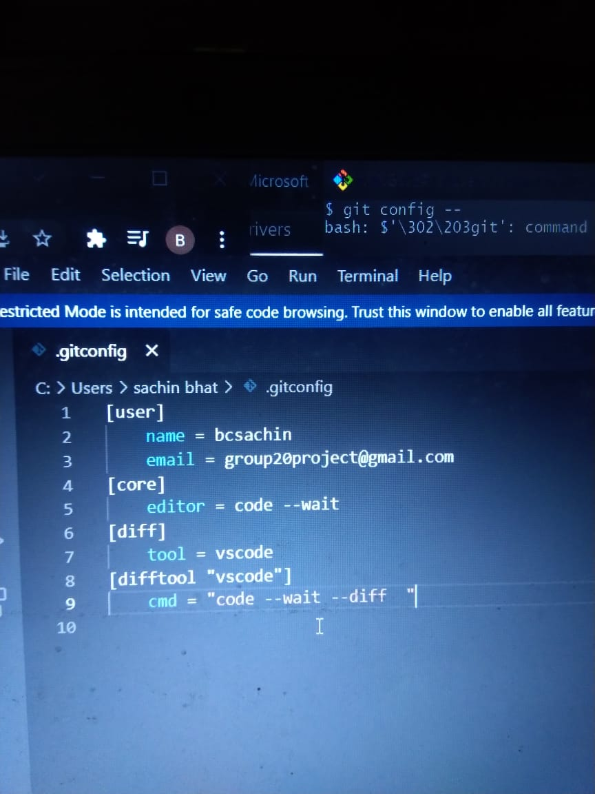

sachin bhat@DESKTOP-TL53QCK MINGW64 ~/Desktop/hashedIn_Learn/Git (master)

$ git log

commit 4821d916c1a7ab56481c77657ef3c3ed0024cf01 (HEAD -> master)

Author: bcsachin <group20project@gmail.com>

Date: Tue Oct 19 21:41:05 2021 +0530

Commit with git ignore

commit e6d4aa2980c5594ec0489f1f07f002ca685e63c9

Author: bcsachin <group20project@gmail.com>

Date: Tue Oct 19 21:31:30 2021 +0530

after move and rename

commit 180c2d860f57d5c0eb24b69a25b4714b3293862e

Author: bcsachin <group20project@gmail.com>

Date: Tue Oct 19 21:21:09 2021 +0530

Third commit.

This is third commit

commit 9216c3668dd950b94aa8c4cc7e37eafe72c89b0d

Author: bcsachin <group20project@gmail.com>

Date: Tue Oct 19 21:18:03 2021 +0530

Without entering staging area

commit 0562aa2d5fa13c3961cab20c3f6fcd98d66946a3

Author: bcsachin <group20project@gmail.com>

Date: Tue Oct 19 21:11:00 2021 +0530

Initial commit.

This is our first Commit.

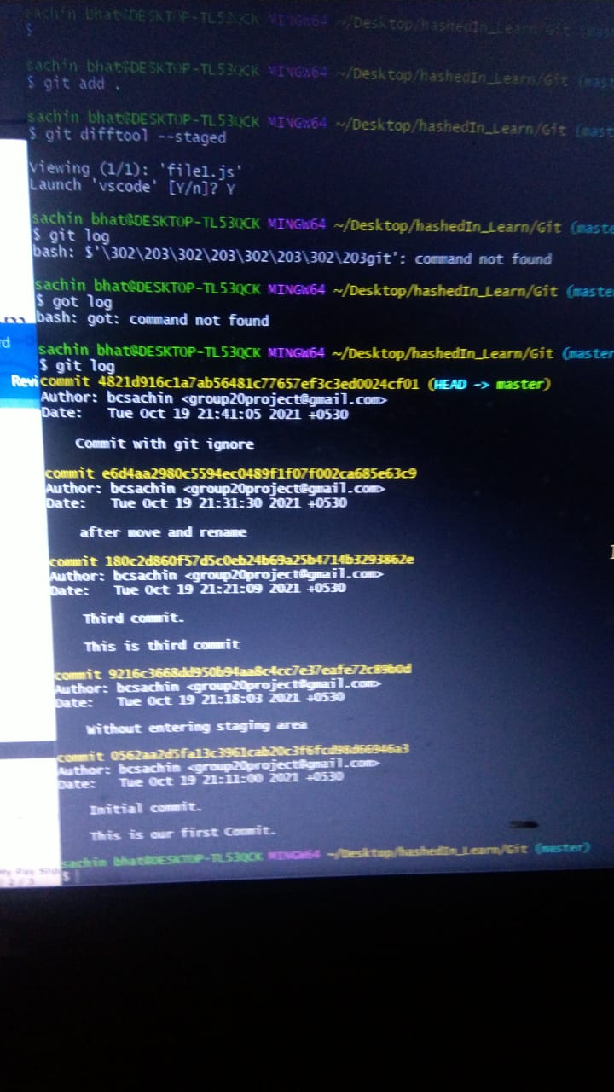

Head reference to current branch

sachin bhat@DESKTOP-TL53QCK MINGW64 ~/Desktop/hashedIn_Learn/Git (master)

$ git log --oneline

4821d91 (HEAD -> master) Commit with git ignore

e6d4aa2 after move and rename

180c2d8 Third commit.

9216c36 Without entering staging area

0562aa2 Initial commit.

//Head~

sachin bhat@DESKTOP-TL53QCK MINGW64 ~/Desktop/hashedIn_Learn/Git (master)

$ git show HEAD~1

commit e6d4aa2980c5594ec0489f1f07f002ca685e63c9

Author: bcsachin <group20project@gmail.com>

Date: Tue Oct 19 21:31:30 2021 +0530

after move and rename

**diff --git a/file3.txt b/file3.txt**

**deleted file mode 100644**

**index ce01362..0000000**

**--- a/file3.txt**

**+++ /dev/null**

@@ -1 +0,0 @@

-hello

**diff --git a/file1.txt b/first.js**

**similarity index 100%**

**rename from file1.txt**

**rename to first.js**

sachin bhat@DESKTOP-TL53QCK MINGW64 ~/Desktop/hashedIn_Learn/Git (master)

$ git ls-tree HEAD~

100644 blob 817f89f0a3ac7e72f24e1abb50a78fd8ce43bfc4 Git.txt

100644 blob b2b9cc97bb0f4415ce6fcb16d7a40ccd60fb4a40 file2.txt

100644 blob 94954abda49de8615a048f8d2e64b5de848e27a1 first.js

100644 blob 36464c78a6fe5b1d5096e90c0034c20217012ef2 git-cheat-sheet-education.pdf

sachin bhat@DESKTOP-TL53QCK MINGW64 ~/Desktop/hashedIn_Learn/Git (master)

$ git status -s

A file1.js

sachin bhat@DESKTOP-TL53QCK MINGW64 ~/Desktop/hashedIn_Learn/Git (master)

$ git restore --staged file1.js

sachin bhat@DESKTOP-TL53QCK MINGW64 ~/Desktop/hashedIn_Learn/Git (master)

$ git status -s

?? file1.js

sachin bhat@DESKTOP-TL53QCK MINGW64 ~/Desktop/hashedIn_Learn/Git (master)

$ git clean -fd

Removing file1.js

Removing logs/

sachin bhat@DESKTOP-TL53QCK MINGW64 ~/Desktop/hashedIn_Learn/Git (master)

$ git status -s

sachin bhat@DESKTOP-TL53QCK MINGW64 ~/Desktop/hashedIn_Learn/Git (master)

$ git restore --source=HEAD~1 file1.js

error: pathspec 'file1.js' did not match any file(s) known to git