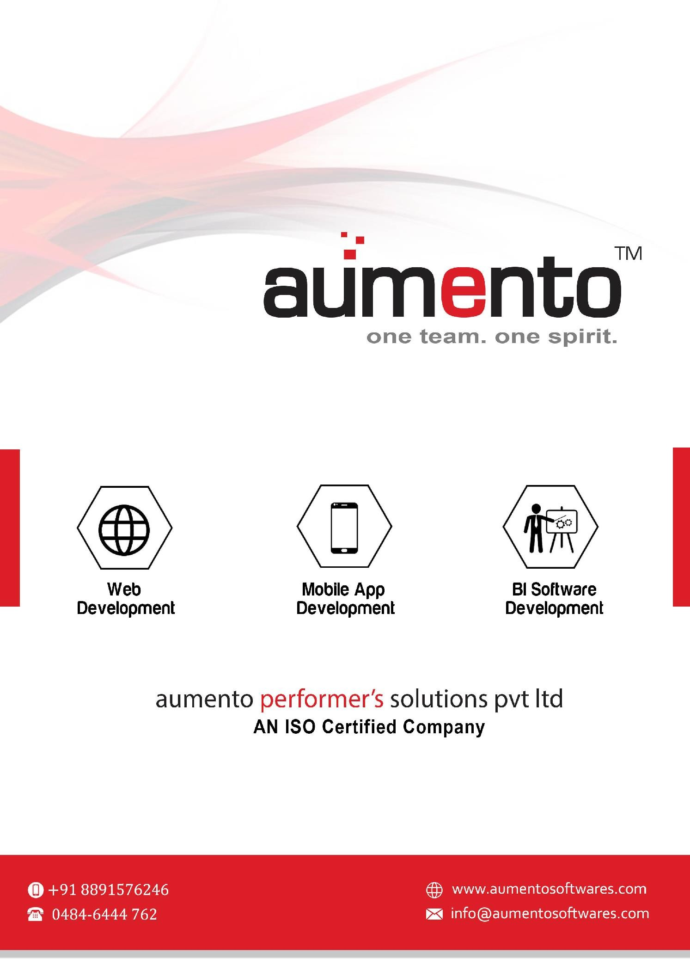

0484 40147672

**Quote**

July 21, 2021

***\* Valid for 10 days from the date issue***

**Subject**: Quote proposed by APS for the Digital Marketing.

Sir,

As per the discussion, the following quote is prepared for the Digital Marketing

# User Benefits

* 8 Poster Creation
* 6 Paid Promotion Support
* Face Book & Instagram Page Management
* Lead Generation Support
* Basic SEO
* Manage Google Analytics

**500 CAD (per-month)**

**Final Cost after Discount**

Above mentioned amount is only service cost and will only be spend up to **100 CAD** for paid promotion. If any other paid services or boost promotion packages required, the client should provide the required amount.