**Initial Page**

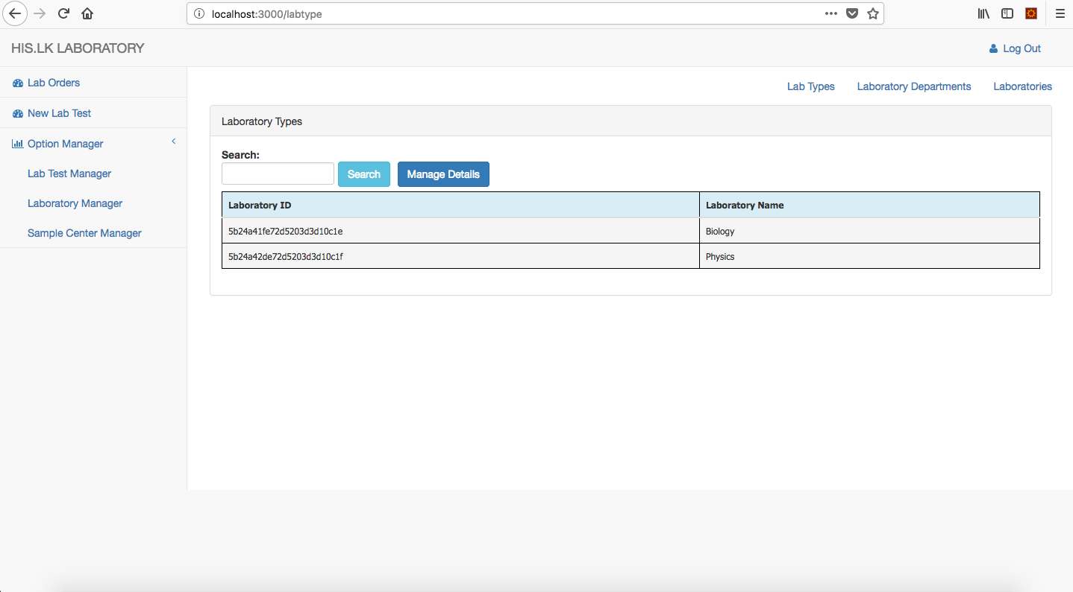

**1**

**2**

**For the Above Window**

**1** – Fill out the search field with a valid ID and click the button. Then you’ll be displayed the result values in the table. If the entered value is not a valid one you’ll be redirected to the same page (Automatically refresh the current page).

**2** – If you want to make any CHANGES in the database kindly click this button. This will direct you to a page where you can add new values, update existing values and delete existing value.

**Manage Details Page**

**3**

**4**

**6**

**5**

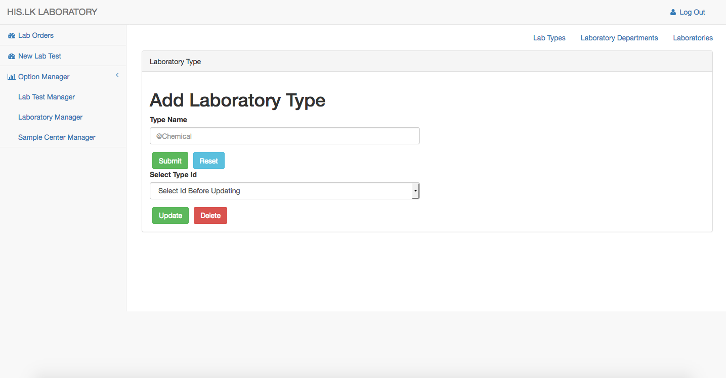

**For the Above Window**

**3** – Add values to the above fields and click this button which adds the inserted value to the database and value will be displayed in the Initial Page’s Table.

**4** – If you have any values in the input field and you want make it empty just click the button.

**5** –Select an available id to which you want to make a change and insert the new value to the input fields above. Then click this button which will update the new value to the relevant id which you have selected.

**6** – If you want to permanently delete a value from database you can Select an id from the drop down list and click this button which will permanently delete the value from the database. (It cannot be restored)

**Note :- Same procedure is followed by all the pages.**