AIR QUALITY MONITORING USING IOT

Team :

|  |  |
| --- | --- |
| S.No | Teammembers |
| 1. | Raja.M |
| 2. | Surya.R |
| 3. | Chandru.s |
| 4. | Ashok.s |
| 5. | Sachin.v |
| 6. | Baloji.p |

INDRODUCTION:

Indoor air quality (IAQ) sensors can sense these pollutants and display real-time data to remind you whether you should ventilate. This indoor air quality monitoring equipment helps improve the air within the building, creating a healthier environment for occupants.

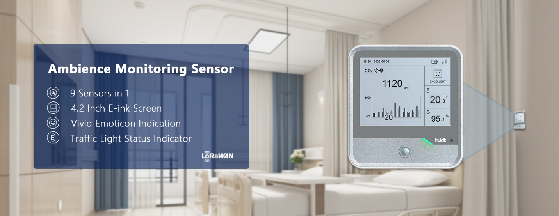

LoRaWAN HKT-IAQ-1000 Indoor Air Quality Sensor

The HKT-IAQ-1000 indoor environment monitoring sensor is independently developed and designed by Hunan HKT Technology Co., Ltd. It is a compact indoor ambience monitoring sensor for measurement of temperature,,humidity, light, CO2 concentration, HCHO/O3 level, TVOC, barometric pressure, PM2.5, PM10 and motion. The data will be shown on the E-ink screen in real-time, which helps to measure the indoor environment and comfort. HKT-IAQ-1000 series is widely used for offices, stores, classrooms, hospitals, etc.

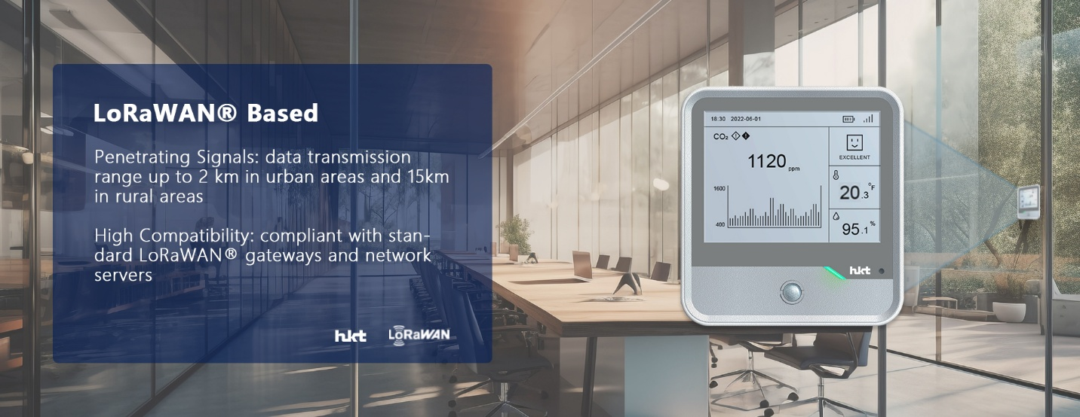

**Features of LoRaWAN Indoor Air Quality Sensor**

* Easy installation:support 3M glue or screw fixing.
* The longest communication distance: Up to 5Km in open environment;
* Super long standby: low power consumption, easy to replace, use 4 AAA alkaline batteries,can be used continuously for more than 1 year;
* Status display: the screen display is delicate, the visual effect is good under the sun,could see every corner, ultra-low power consumption, no refresh and no power consumption;
* Buzzer indication: through the sound of the buzzer to distinguish the state change of the environmental quality scene;
* Various monitoring contents: High-precision sensors are used to integrate formaldehyde, ozone,PM2.5&PM10, temperature and humidity, light, CO2, atmospheric pressure, TVOC, infrared detection and other functions to fully meet the indoor environment monitoring applications;
* Good compatibility:Compatible with standard LoRaWAN® gateways and third-party network server platforms;
* Integrated management: Fast connection with HKT LoRaWAN® gateway and cloud platform without additional configuration;
* Three-dimensional appearance: the shell adopts a three-dimensional structure design, with clean-cut, which brings visual impact experience to users.

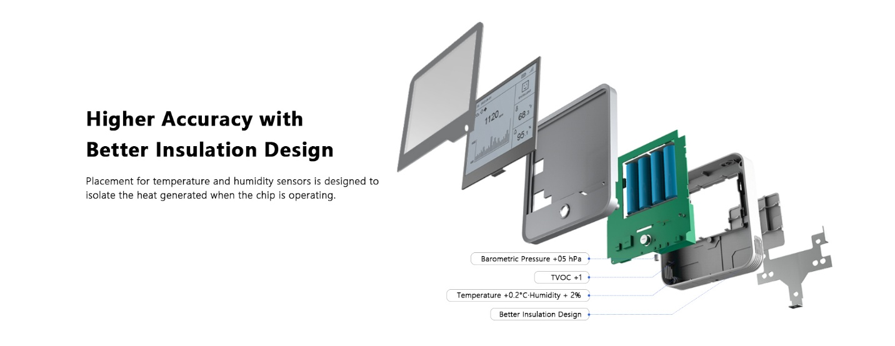**HKT provides customized services:**

* ODM
* Pre-sales & After-sales Services
* Technology Support

**Product Specification**

|  |  |
| --- | --- |
| Parameters | Description |
| Model | IAQ-1000 |
| Communication | Standard LoRaWAN Protocol |
| Frequency | EU868,CN470,IN865,US915,AU915,AS923 |
| Tx Power | 18.5±1dBm(max) |
| Sensitivity | -135±1dBm @SF=12 |
| Activation Method | OTAA/ABP Class A/Class C |
| Display | 4.2-inch Black & White E-Ink Screen |
| Button | 1 × Power Button + 1 × Reset Button(built in) |
| LED & Buzzer | 3×LED lights(green/orange/red) + 1 × Buzzer |
| Configuration | Server or serial port |
| Operating Temperature | -20°C - 60°C (E-Ink Screen: 0°C - 40°C) |
| Relative Humidity | 10% - 90% (non-condensing) |
| Power supply | 4 AAA large-capacity batteries/Type-C power supply（5V/1A) |
| Dimension | 115 × 109 × 23 mm |
| Installation | 3M glue fixed or screw fixed or screw fixed wall mounting |

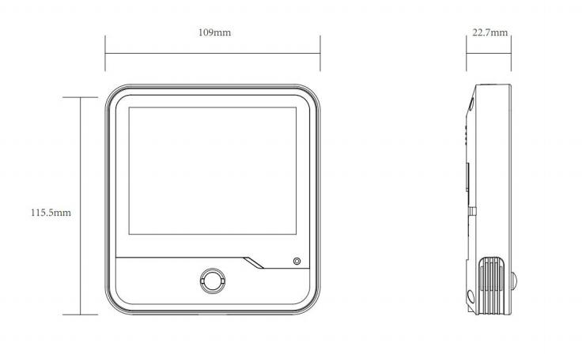LoRaWAN air quality sensor can display the data in real-time. So you can analyze and make a strategic decision to ensure that the best possible environment is provided at all the times for people.

* Home automation: To monitor and control the ambient conditions in a home, such as temperature, humidity, and air quality.
* Commercial buildings: To optimize the ambient conditions in commercial buildings, such as offices, schools, and hospitals.
* Industrial settings: To monitor ambient conditions in industrial settings, such as factories, warehouses, and mines.
* Agricultural environments: To monitor and control the ambient conditions in agricultural settings, such as greenhouses and animal enclosures.
* Transportation: To monitor the ambient conditions in transportation vehicles, such as airplanes, trains, and buses.
* Outdoor environments: To monitor ambient conditions in outdoor environments, such as parks, beaches, and public squares.