Fixation probability in non-equilibrium populations

INTRODUCTION

METHODS

We consider a diploid random mating population of size N. Consider a single locus with two alleles a(wild type) and A (beneficial mutation). The genotypes Aa, aa, AA have finesses as 1+hs, 1 and 1+s respectively. The h is the dominance coefficient and s are the selection coefficient. Here we consider various demographic scenarios such as when population size changes i) logistically, ii) step change, iii) bottleneck, and iv) sinusoidal change in the population size.
The beneficial mutation arises at t=t0 and there are no further mutations. The beneficial mutation either fixes into the entire population or extinct from the population. We carry out the single locus simulation in SLiM where we stop the simulations at t=N0 generations. The various demographic scenarios are described in fig i), ii), iii) and iv). The ${10}^{3}$ fixation events are simulated and fixation probability is obtained.

RESULTS

$$\begin{aligned}\int{}=N_{E} \#\left(1\right)\end{aligned}$$
$$\begin{aligned}F=MA \#\left(1\right)\end{aligned}$$

DISCUSSION

APPENDIX

Results:

We calculate the fixation probability in the non equilibrium population where the population size is not fixed rather changes with the time. Otto+ Whitlock has obtained the expression for the haploids using branching process. We extend the results using recently developed semi deterministic approximation for diploids and for the inbreeding population. We write the forward Fokker-Planck equation for the probability density function defined as probability that the mutant frequency is $x$ at time $t,$ as

$$\begin{aligned}\frac{∂P(x,t)}{∂t}= - \frac{∂}{∂x} \left(s x \left(1-x\right)P\left(x,t\right)\right)+ \frac{∂^{2}}{∂x^{2}} \left(\frac{x \left(1-x\right)P\left(x,t\right)}{4 N(t)}\right) \#\left(1\right)\end{aligned}$$

For simplicity, the above equation with new variable, $τ=s t$ and $l\left(τ\right)=\frac{1}{2 N\left(t\right) s}$, is given as

$$\begin{aligned}\frac{∂P(x,τ)}{∂τ}= - \frac{∂}{∂x} \left( x \left(1-x\right)P\left(x,τ\right)\right)+ l (τ)\frac{∂^{2}}{∂x^{2}} \left(x \left(1-x\right)P\left(x,τ\right)\right) \#\left(2\right)\end{aligned}$$

Now, using semi-deterministic approximation, we write the Fokker-Planck equation in the first stochastic phase $(x→ 0)$

$$\begin{aligned}\frac{∂P(x,τ)}{∂τ}= - \frac{∂}{∂x} \left( x P\left(x,τ\right)\right)+ l (τ)\frac{∂^{2}}{∂x^{2}} \left(x P\left(x,τ\right)\right) \#\left(3\right)\end{aligned}$$

The above $p.d.e$ is converted to $o.d.e$ using laplace transformation by defining $P\left(k,τ\right)=∫P\left(x,τ\right)\exp\left(-k x\right)dx$. The (3) is reduced to

$$\begin{aligned}\frac{∂P(k,τ)}{∂τ}=\left(k-k^{2} l (τ)\right) \frac{∂P(k,τ)}{∂k}\#\left(4\right)\end{aligned}$$

Subject to the initial conditions

$$\begin{aligned}P(p,0)=δ(p-p_{0})\#\left(5\right)\end{aligned}$$

$$\begin{aligned}P(k,0)=exp⁡(-k p_{0})\#\left(6\right)\end{aligned}$$

Now the equation is solved using the method of characteristics (details are in Appendix 1), and the solution is given as

$$\begin{aligned}P\left(k,τ\right)=\exp\left(-\frac{p_{0}}{\frac{1}{k}\exp\left(-τ\right)+ \int_{0}^{τ}{l \left(τ^{'}\right)\exp\left(-τ^{'}\right)dτ^{'}}}\right)\#(7) \end{aligned}$$

The probability that eventualy the mutant extinct, is obtained as $P(k→∞,τ→∞)$,
$$\begin{aligned}E=\exp\left(-\frac{1}{ \int_{0}^{∞}{\frac{N\left(0\right)}{N(t')}\exp\left(-{s t}^{'}\right)dt^{'}}}\right)\#(8) \end{aligned}$$

The fixation probability $(P)$ is obtained as

$$\begin{aligned}1-E=1-exp\left(-\frac{1}{ \int_{0}^{∞}{\frac{N\left(0\right)}{N(t')}\exp\left(-{s t}^{'}\right)dt^{'}}}\right)\#(9) \end{aligned}$$

Case 1: $N\left(t\right)=N_{0}+N_{1}\sin\left(ωt+θ\right), N_{1}≪N_{0}$

$$\begin{aligned}P=1-exp\left(-\frac{1}{\frac{1}{s}-\frac{N_{1} (ω\cos{θ +s\sin{θ}})}{N_{0} (s^{2}+ω^{2})} } \right)\#(10) \end{aligned}$$

Case 2: Logistic growth:
$$\begin{aligned}N\left(t\right)=\frac{K N_{0}}{N_{0}+\exp\left(-r t\right)\left(K-N_{0}\right)} \#(11) \end{aligned}$$

$$\begin{aligned}P=1-\exp\left(-\frac{1}{\frac{N_{0}}{Ks}+\frac{K-N_{0}}{K (r+s)}}\right) \#(12) \end{aligned}$$

Case 3: Exponential growth
$$\begin{aligned}N\left(t\right)=N_{0}\exp{(r (t+t_{0}))} \#(11) \end{aligned}$$

Where $t_{0}$ is the time of arrival of the beneficial mutation. The fixation probability becomes

$$\begin{aligned}P=1-\exp\left(-\left(r+s\right)e^{r t_{0}}\right) \#(12) \end{aligned}$$

Case : Step Change

The time runs backward. Consider a population size change as : $N_{2}$ for $T$ generations, and then $N_{1}$ thereafter.

$$\begin{aligned}N_{eff}=\frac{N_{1}w_{1}+N_{2}w_{2}}{w_{1}+w_{2}}\#(12) \end{aligned}$$

Where $w_{1},$and $w_{2}$ are given as

$$\begin{aligned} w_{1}={\left(1-\frac{1}{2 N_{2}}\right)}^{T}\#(13) \end{aligned}$$

$$\begin{aligned}w_{2}= 1-w_{1}\#(14) \end{aligned}$$

Table:

$3 N_{0}$ for T generations backward and then stays $N_{0}$ where $N_{0}=1000$

$$T$$ | $$Simulations$$ | $$Theory$$
$$0.25 N_{0}$$ | $$1080$$ | $$1081$$
$$0.5 N_{0}$$ | $$1147$$ | $$1160$$
$$N_{0}$$ | $$1297$$ | $$1304$$
$$2 N_{0}$$ | $$1594$$ | $$1566$$
$$3 N_{0}$$ | $$1785$$ | $$1786$$
$$6 N_{0}$$ | $$2250$$ | $$2264$$

Case 4: Bottleneck:

Now the Eyre-Walker use effective population size in the coalescent framework to calculate the fixation probability for various demographics. Here the time runs backward. Consider a case where population size is $N_{0}$ for $T_{1}$ generations and then $N_{1}$ for $T_{2}$ generations and then $N_{0}$ thereafter, now the effective population size is given as

$$\begin{aligned}N_{eff}=\frac{N_{0}w_{0}+N_{1}w_{1}+N_{2}w_{2}}{w_{0}+w_{1}+w_{2}}\#(12) \end{aligned}$$

Where $w_{0}, w_{1}$ and $w_{2}$ are given as

$$\begin{aligned} w_{0}={\left(1-\frac{1}{2 N_{0}}\right)}^{T_{1}}{\left(1-\frac{1}{2 N_{1}}\right)}^{T_{2}}\#(13) \end{aligned}$$

$$\begin{aligned}w_{1}= 1-w_{0}-w_{2}\#(14) \end{aligned}$$

And

$$\begin{aligned}w_{2}=\left(1-{\left(1-\frac{1}{2 N_{0}}\right)}^{T_{1}}\right) \#(15) \end{aligned}$$

Effective population size calculations

So far we have calculated the effective population size for the step changes in the population size. Since we have calculated the fixation probability for the continuous population size, so for the better comparison between the calculation from semi deterministic theory(forward in time) and the coalescent theory, in this section we will calculate the effective population size for the continuously changing population size.

The average population size is calculated as

$$\begin{aligned}N_{eff}=\frac{\sum_{i=1}^{T}{N_{T-i}w_{i}}}{\sum_{i=1}^{T}{w_{i}}}\#(16) \end{aligned}$$

And the $w_{i}$ represent the probability that the two randomly selected individuals coalesce at time $i$ which runs backward in time. The $T$ represents the current time when the data is sampled. The $w_{i}$ are given as :

$$\begin{aligned}w_{i}= \left(\prod_{k=1}^{i-1}{ \left(1-\frac{1}{2 N_{T-k}}\right)}\right) \left(\frac{1}{2 N_{T-i}}\right) \#(17) \end{aligned}$$

The probability that the two individuals coalesce before the $T$ generation will be given as $1-\sum_{i=1}^{T}{w_{i}}$. The weighted average is the calculated from (16). The table 2 shows the $N_{eff}$ calculated from simulations and the using equation (16).

The (17) is then written in the continuous form as

$$\begin{aligned}N_{eff}= \int_{1}^{T}{di N\left(T-i\right) w(i)} \#(18) \end{aligned}$$

$$\begin{aligned}N_{eff}=\frac{1}{2} \int_{i=1}^{T}{di \exp\left(\int_{1}^{i-1}{ \left(1-\frac{1}{2 N(T-k)}\right) dk}\right) }+N_{0}\left(1- \int_{1}^{T}{w\left(i\right)di}\right)\#(19) \end{aligned}$$

The effective population size obtained from the above theoretical formalist has been checked with the forward time simulations conducted in SLiM. We calculate the heterozygosity in this case and then obtain the effective population size using $N_{eff}=\frac{θ}{4 μ}$.

Logistic growth :

$$\begin{aligned}N\left(t\right)=\frac{K N_{0}}{N_{0}+\exp\left(-r t\right)\left(K-N_{0}\right)} \#(11) \end{aligned}$$

$K=5 N_{0}, r=0.005, N_{0}=1000, T=\frac{N_{0}}{()}$

$$T$$ | $$Simulations$$ | $$Theory$$
$$500$$ | $$1124$$ | $$1122$$
$$1000$$ | $$1298$$ | $$1304$$
$$2000$$ | $$1649$$ | $$1655$$
$$3000$$ | $$1978$$ | $$1973$$

FIGURES AND TABLES

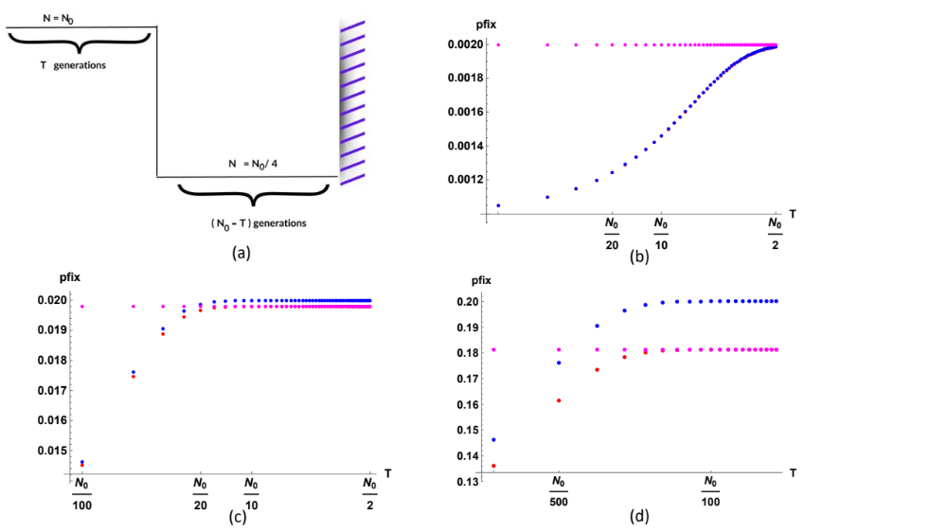

Figure 1: The fixation probability has been obtained for step change in demography. The time, T, represents the time at which the population size changes from N0=10000 to N0/4=2500. The parameters are s=0.001, 0.01, 0.1. The magenta, blue and red points are obtained using Kimura’s equation for fixation probability, Otto’s equation, and (eqn number) respectively.

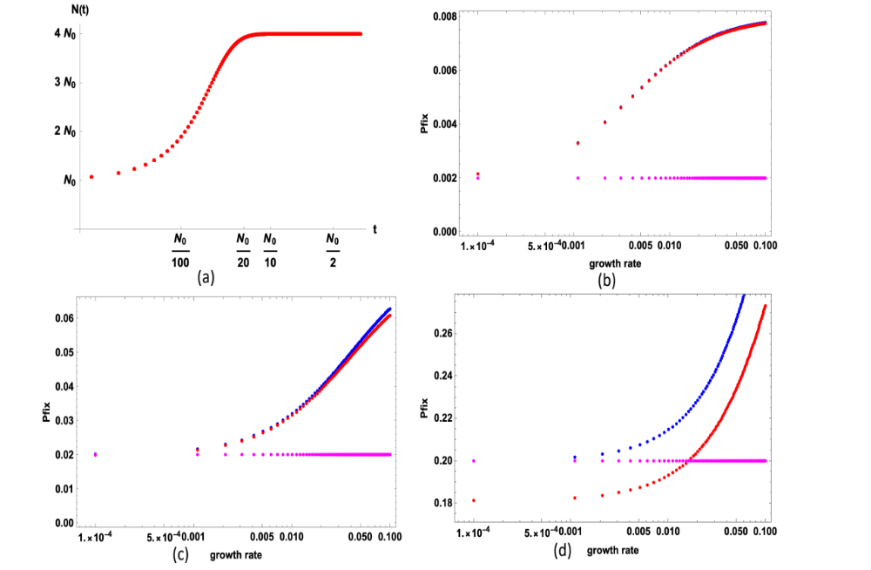

Figure 2: (a) represents the logistic change in demography with carrying capacity K=4 N0. In (b), (c), and (d), the fixation probability has been obtained using Kimura’s equation, Otto’s equation, and (eqn number) for Ns=20, Ns=200, Ns=2000 respectively.

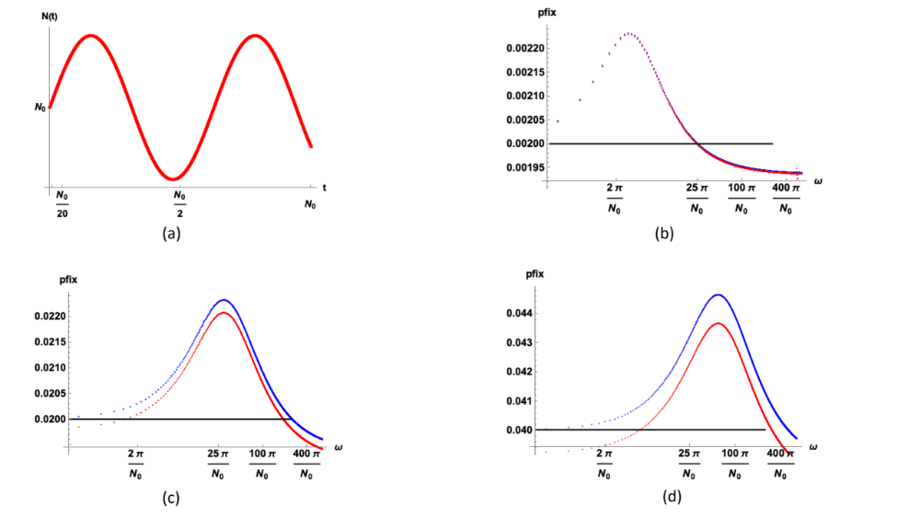

Figure 3: (a) represents the sinusoidal change in demography with carrying omega=N0/400 Pi. In (b), (c), and (d), the fixation probability has been obtained using Kimura’s equation, Otto’s equation, and (eqn number) for Ns=20, Ns=200, Ns=400 respectively.
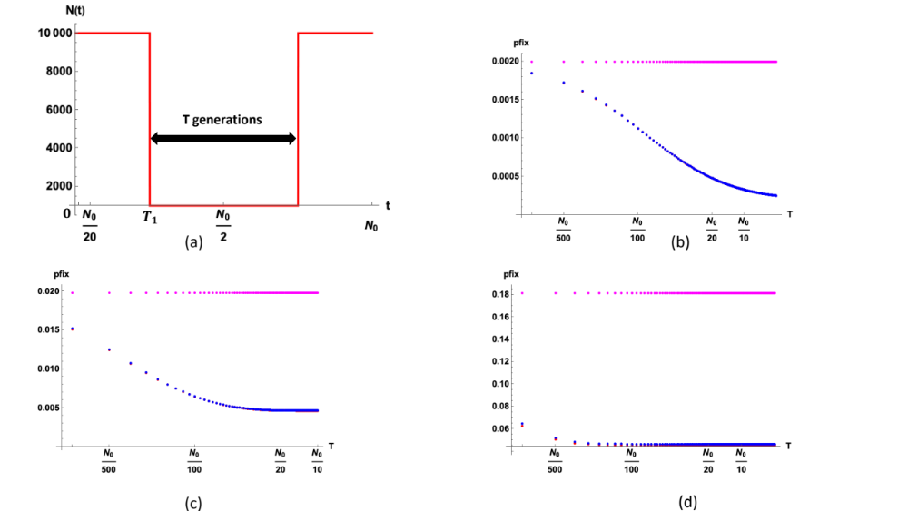

Figure 4: (a) represents the change in demography where $N_{0}=10000, and N_{1}=0.1 N_{0}$. In (b), (c), and (d), the fixation probability has been obtained using Kimura’s equation (Magenta), Otto’s equation (Blue), and (eqn number, Red) for $2N_{0}s=20, T_{1}=\frac{N_{0}}{100}; 2N_{0}s=200, T_{1}=\frac{N_{0}}{100}; 2N_{0}s=2000, T_{1}=\frac{N_{0}}{1000}$ respectively.
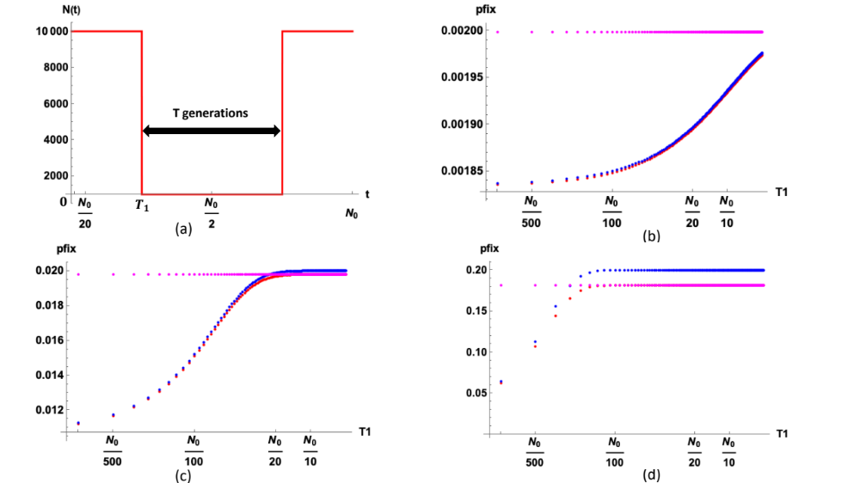

Figure 5: (a) represents the change in demography where $N_{0}=10000, and N_{1}=0.1 N_{0}$. In (b), (c), and (d), the fixation probability has been obtained using Kimura’s equation (Magenta), Otto’s equation (Blue), and (eqn number, Red) for $2N_{0}s=20, T=10; 2N_{0}s=200, T=10; 2N_{0}s=2000, T=10$ respectively, here $T_{1}$ is varied.

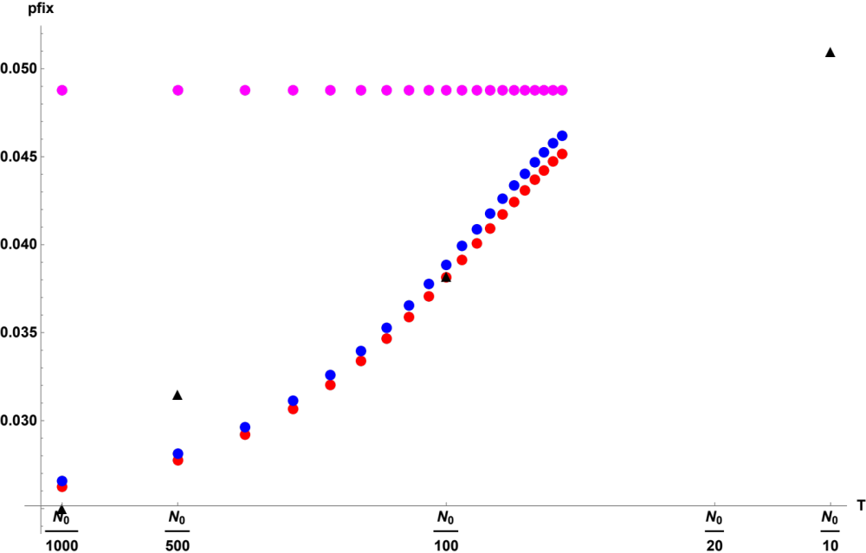

Figure 6: Simulations data has been shown in triangle, s=0.05, h=0.5, N0=5000, N1=2500.

Simulations results for fixation probability:

$N_{0} to N_{1} (\frac{N_{0}}{2}), N_{0} =5000, N_{1}=2500, s=0.05,$

$$T$$ | $$fixations$$ | $$Total_Experiments$$ | $$fixation probability$$
$$\frac{N_{0}}{1000}$$ | $$243$$ | $$9714$$ | $$0.02501$$
$$\frac{N_{0}}{500}$$ | $$231$$ | $$7317$$ | $$0.0315$$
$$\frac{N_{0}}{100}$$ | $$156$$ | $$4089$$ | $$0.0382$$
$$\frac{N_{0}}{10}$$ | $$245$$ | $$4763$$ | $$0.051$$

