## Windows: Lisa/DevTest Local Install

**NOTE**: You must execute the installer as administrator on Windows to ensure that you have the appropriate permissions for all installer actions, such as creating desktop links, registry entries, and installing services.

1.Verify that your local machine can connect to Enterprise Dashboard located on server 10.xx.xxx.xx.

   To verify connection from your local machine place http://10.xx.xxx.xx:xxxx into web browser. You should be able to load the page:

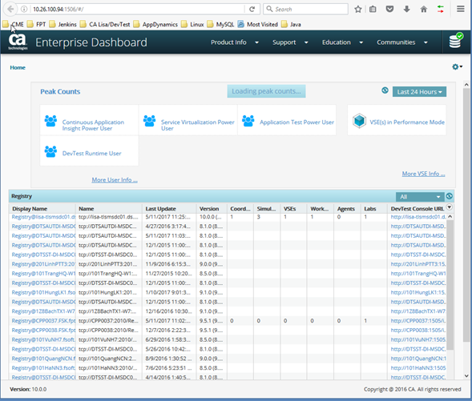

In the case you cannot access the enterprise dashboard server and its port xxxx you need to add firewall exception for it.

2. (Optional) Uninstall previous Lisa/DevTest version (from Control Panel > Program and Features), you might want to backup content of hotDeploy folder (contains additional libraries) and Projects folder (contains Lisa/DevTest projects).

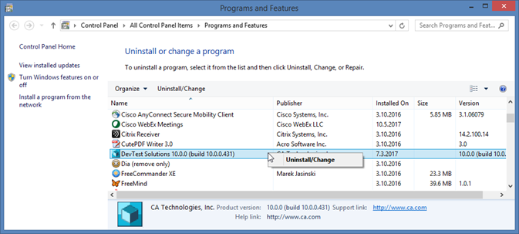

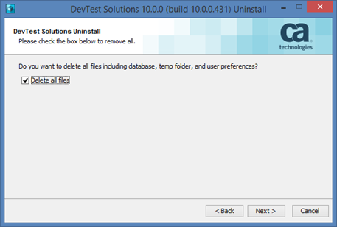

3. Download installation file **LISA_DevTest_10_Win_x64.zip** from http://10.xx.xxx.xxx/installations/LISA/10.0.0/

4. Unzip it and run the file **devtest_win_x64.exe** with **Run as administrator.**

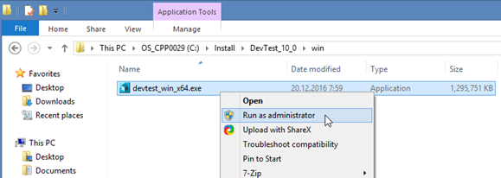

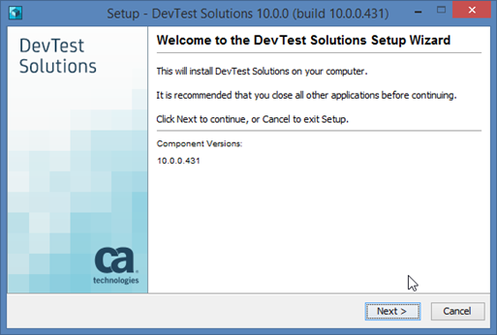

5. Choose **I accept the terms of the License Agreement**and click **Next** button.

6. Destination folder for installation (called **LISA_HOME**) is preferably **C:\DevTest**.

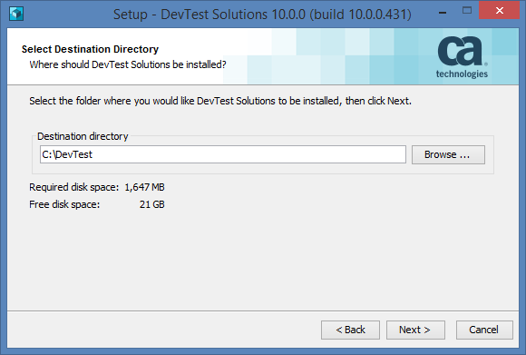

7. Select **Installation Type** as **Local.**

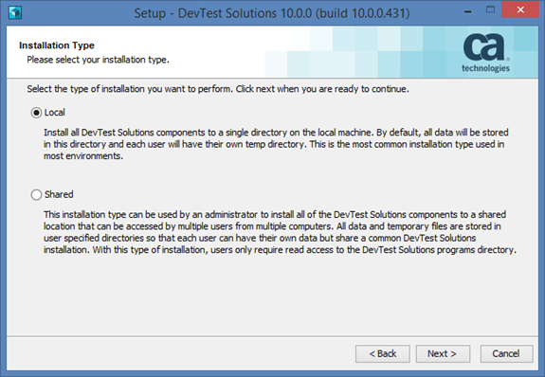

8. For **Select Components**: check both **Workstation** and **Server.**

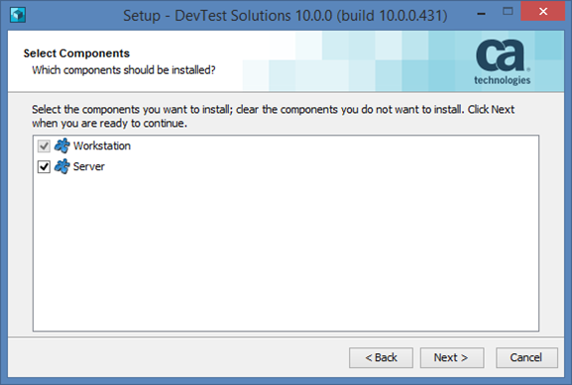

9. Select **Existing Enterprise Dashboard Server** and use **10.26.100.94:1506.**

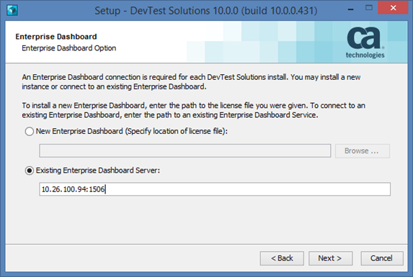

10. For learning purposes you may select **Install demo server** with pointing to location of **DevTestDemoServer.zip** file. If you do not want to use it, select **Do Not install demo server**.

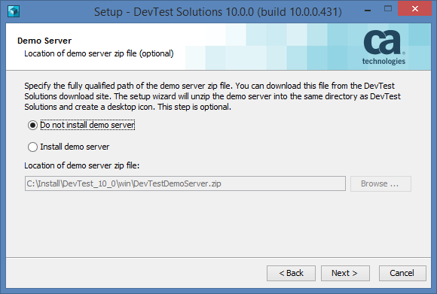

11. Choose **Install Services.**

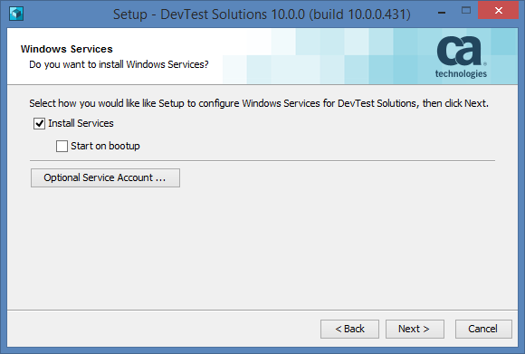

12. Click on **Install**.

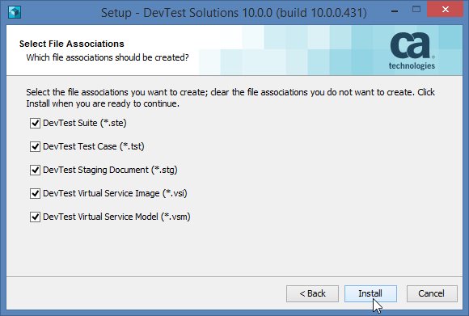

13. Read I**nformation**and click **Next**.

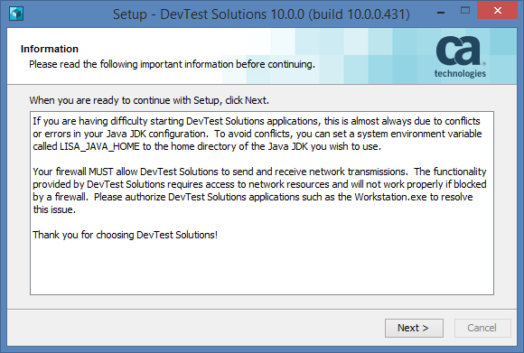

14.**Finish** the installation.

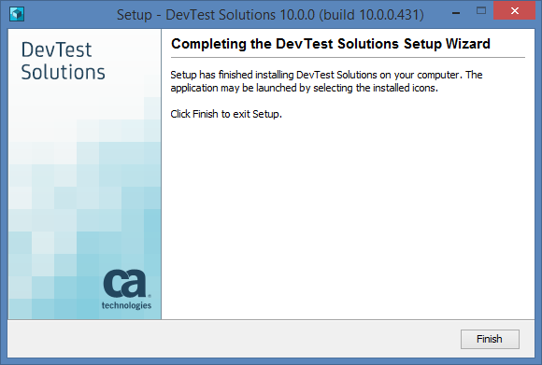

## Starting Registry

Registry is run on local host.

Before you open main Lisa/DevTest desktop application (called Workstation), you need to start Registry service either by:

    1. Go to **LISA_HOME\bin** and run the **Registry.exe**with **Run as administrator.**

    2. Go to **Task Manager** and start **DevTest Registry Service**.

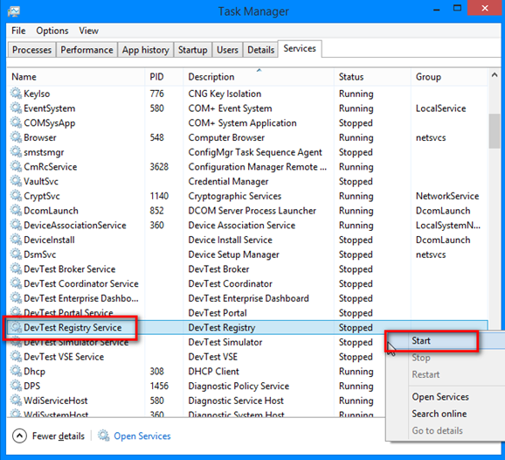

    3. Go to Control Panel > Administrative Tools > **Services**and start **DevTest Registry**service**.**

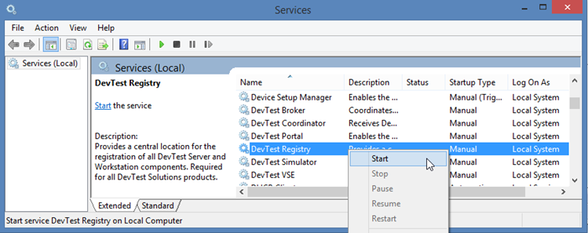

    4. It can take few minutes to start the Registry. You can verify that it is running correctly by navigating to URL address: http://localhost:xxxx which should display:

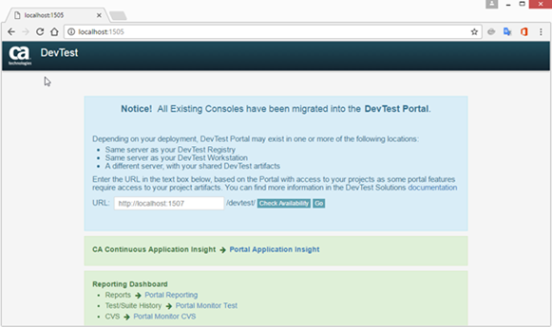

## Starting Workstation

Workstation can be run only when Registry is already running on local host.   DevTest Workstation is started also on your local host. DevTest Workstation is where you create and edit tests and also stage tests.

    1. From the Start menu, expand **DevTest Solutions** and select **Workstation**.

    2. Go to **LISA_HOME\bin** and run the **Workstation.exe** with **Run as administrator.**

    3. You should be presented with the following dialog:

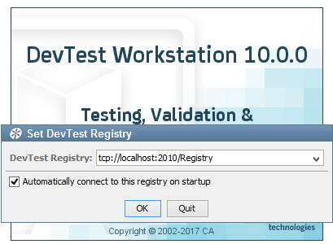

    4. After clicking **OK**, you will be asked to provide credentials, enter username and password and hit **Login** button.

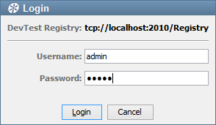

Icon

Username admin is restricted on administering Virtual Services (VSE), so ask (whomever applicable) for permission to administer VSE if needed.

    5. You should see now main Lisa/DevTest **Workstation** application where you can design/execute test cases.

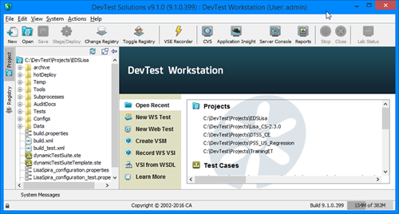

## Lisa/DevTest troubleshooting

* Getting error when running local registry --> this may happen when running DevTest configured with incorrect Enterprise Dashboard.

**Solution:** add the following lines at the end of **local.properties** file (create file **local.properties** in LISA_HOME folder by making a copy from**_local.properties** file, if it does not exist yet)

devtest.enterprisedashboard.host=10.xx.xxx.xx  
devtest.enterprisedashboard.port=xxxx  
devtest.enterprisedashboard.https.enabled=false

* If DevTest **Workstation** displays a **Request Timed Out** error while connecting to the registry, you might have to start the Workstation executable as**Run as Administrator.**
* **Database Error** related to admin rights.  
  Related to permissions on **LISA_HOME** folder and subfolders.  
  **Solution:** Open the Workstation as **Run as administrator**

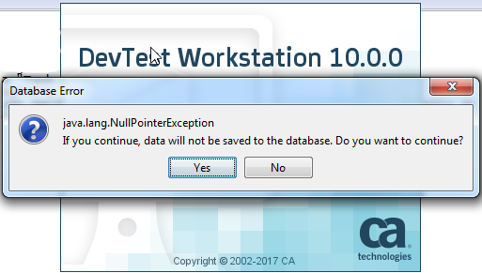

* If you are asked for your local **registry.log** file please follow the below steps:  
  1. Stop any running registry on your local host.  
  2. Go to DevTest **LISA_HOME** folder, usually it should be **c:\DevTest**, and its sub-folder **lisatmp_10.0.0**.  
  3. Rename/backup file **registry.log**.  
  4. Start Registry as service via **Task Manager** or **Local Services.**  
  5. Wait few minutes until the registry is fully started.  
  6. Start **DevTest Workstation** and **Set DevTest Registry** to either **tcp://localhost:xxxx/Registry** or **tcp://127.x.x.x:xxxx/Registry**  
  7. Go back to **lisatmp_10.0.0** folder and send the newly created **registry.log** file to IT services/admin (whomever applicable)

## LISA_SeleniumFramework

To support local execution of automated tests using Web UI, you need to configure **LISA_SeleniumFramework**:

**NOTE**: Please make sure you have Java 7 or higher installed before starting Selenium hub and nodes.

1. Download **LISA_SeleniumFramework.zip** (from the same location as Lisa/DevTest installation) and follow instructions in readme file included in .zip archive to   
   - Unpack content of LISA_SeleniumFramework_hotDeploy.zip to <LISA folder>\hotDeploy and   
   - Unpack content of LISA_SeleniumFramework.zip anywhere on local computer.  
   If you installed Lisa/DevTest into different folder than C:\DevTest, you need to update batch files from LISA_SeleniumFramework.zip (hub.bat, firefox.bat, etc.) with correct path.
2. Start Selenium Hub locally using hub.bat batch file (you should see command prompt window pops up and stays running).
3. Start Selenium Node locally using chrome.bat or firefox.bat batch file (you should see another command prompt window pops up and stays running).
4. Execute Web UI based automated tests
5. You can close Selenium Hub and Selenium Node command prompt windows after you finished working with Web UI tests in Lisa/DevTest.