**REPORT TITLE**

How has the empowered and dynastic Nicaraguan regime affected the health of their citizens and what global development initiatives have been or could be implemented in order to reduce this inequality?

**Student Name: AJ Amos**

**Year 10 Geography Task 1 – Human Wellbeing**

**Teacher Name: Mrs. Esho**

**INTRODUCTION**

Human wellbeing is defined as a concept that uses both subjective and objective factors in order to constitute health and quality of life (Lynda, 2011). It is a broad concept that incorporates many different aspects of our everyday lives, making it difficult to measure. However, the most common form of measurement is the Human Development Index (HDI), which uses three separate dimensions as its basis (United Nations Development Programme, 2000). The one that I will highlight in order to evaluate my chosen country of Nicaragua is health.

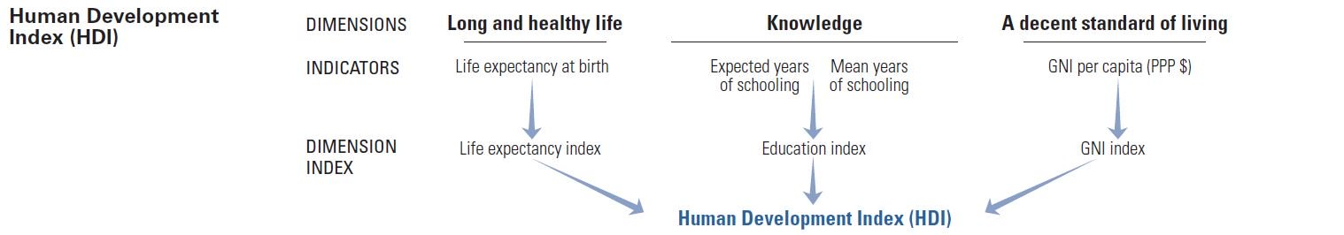

*Figure 1. Human Development Index (HDI). (United Nations Development Programme, 2000).*

According to a study named “Health Systems Profile Nicaragua”, the percentage of Nicaragua’s entire population above the age of 60 is 5.9, whereas Australia’s is more than double that (2017). This extreme low in life expectancy lowers the country’s HDI, and since the “democratic” government is not implementing any strategies to increase the HDI, awareness around this matter needs to be raised, allowing for global development initiatives.

**METHOD**

Name of Source 1:

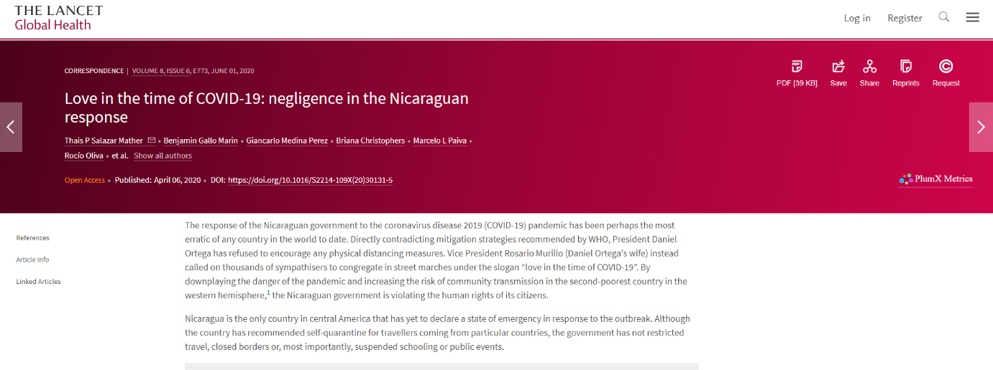

**The Lancet: Global Health**

**Love in the time of COVID-19: negligence in the Nicaraguan response**

Origin:

This article comes from a weekly general medical journal founded in 1823 named “The Lancet”. It was published on 6 April during 2020 by several different authors including:

1. Thais P Salazar Matehr
2. Benjamin Gallo Marin
3. Alejandro Murillo

These authors are in the medical profession and were signed on with The Lancet to write this article.

Purpose:

The purpose of this article was to convey the lack of precautions that the Nicaraguan government as put into place against COVID-19. They wanted to raise awareness in order to invoke global initiatives that improved these citizens’ wellbeing. The perspective appears to be factual and objective with no bias as the authors at the end write, “We declare no competing interests.”

Value:

This source is valuable as it provides insight on how Nicaragua has responded to the pandemic. There are very few sources covering this health topic, therefore the fact that this article is reliable and factual increases the value it has for my project. It provides an original perspective on how the government is affecting the citizens’ health, which is my topic.

Limitations:

One limitation is that it doesn’t show the perspective of the Nicaraguan government. In order to improve its factuality and convey a balanced report, the authors must have obtained the government’s opinion. Furthermore, it doesn’t provide information about global initiatives that have been or could be implemented to improve human wellbeing.

Name of Source 2:

**The 72-Hour Document** 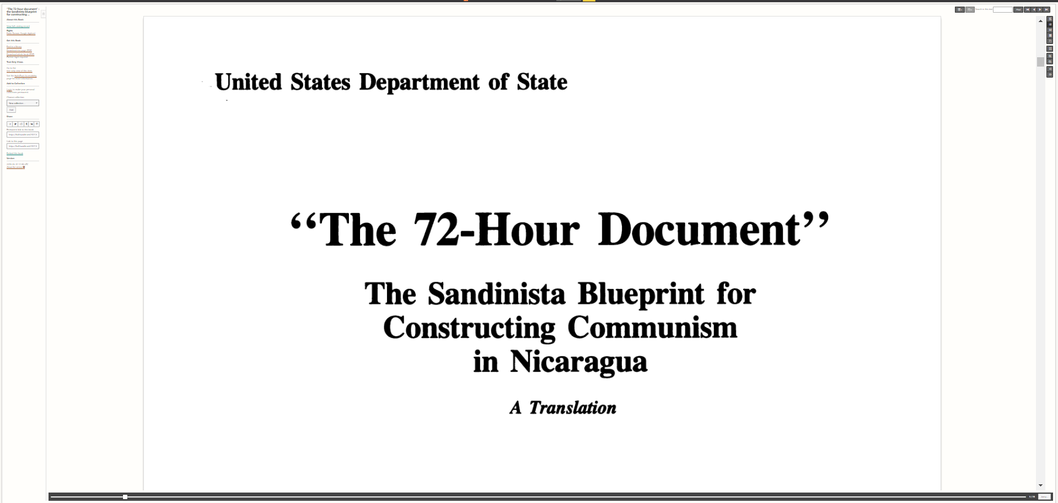

Origin:

This is a primary source written by the Sandinista, a socialist political party, incorporated with secondary source annotation. It was originally published at a library in The University of Texas but was digitized by Google. The Sandinistas wrote this document during secret meetings after the Nicaraguan Revolution; however, it was leaked to the public a couple weeks after it was finished.

Purpose:

The Sandinistas wrote this as a basic blueprint for their rise to power and constructing communism in Nicaragua. They brainstormed strategies, related to both politics and the military, that achieved their goals of a communist government and rebelling against American imperialism. This was then encompassed within the secondary annotation in order to easily spread awareness around the oppressive Nicaraguan government.

Value:

This is very valuable to my project as it provides the government’s point-of-view, allowing me to create a balanced report contrary to the medical report in Source 1. It will reveal what the current regime was built upon and how President Ortego has been able to stay in office for a little over 10 years.

Limitations:

Some of the most revealing sections have been omitted by the Sandinistas when the document was first released. Even though we can’t read all of what they were planning, what we have available is enough to convey their perspective on the future of Nicaragua.

**FINDINGS**

**Human Wellbeing**

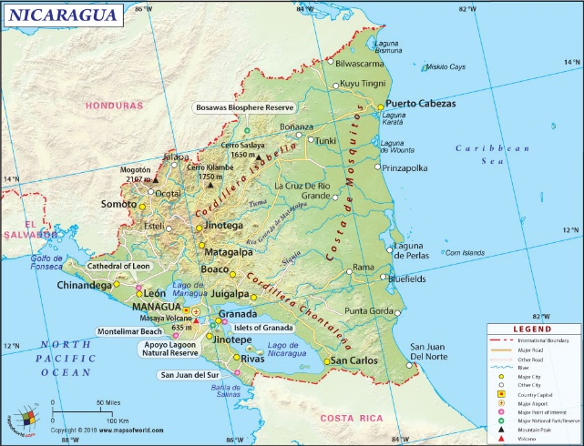Nicaragua is the poorest country in Central America with a history of dictatorship and civil war (Ferrando, 2008). It was first ruled by the authoritarian Garcia family from 1936 to 1979, when it was then taken over by the socialist party Sandinista National Liberation Front. After years of guerrilla warfare with freedom fighters supported by the U.S., the Sandinista-dominated government was defeated and replaced with a presidential election in 1990, which was won by President Daniel Ortega (Parker, Nietschmann, 2019). This election signalled an end to dictatorship and civil conflict. However, the reality is on the contrary.

*Figure 3. Nicaragua (Nicaragua Map, 2020)*

President Daniel Ortega and his wife Rosario Murillo have been in office for over 10 years and citizens that recognise the signs of a dictator from experience have started protesting, only to be met with violent violations of human wellbeing from the regime, evident in the bypass of due process and extrajudicial killings (Stephens, 2019). However, one of the main issue citizens are feeling from this oppressive government is their health, evident the response to the recent pandemic. Directly contradicting strategies implemented by WHO, President Ortega has refused to enforce social distancing and instead congregated street marches with thousands of participants marching under the slogan “love in the time of COVID-19” (Mather, 2020). Furthermore, a lack of lock-down and reducing travel has resulted in 32,500 positive tests for COVID-19, 1016 requiring intensive care. Ortega, who forges the data and officially reports that they only have 4,668 cases (n.a., 2020), has left only 160 ventilators for the aforementioned 1016 (Mather, 2020).

|  |  |  |
| --- | --- | --- |
| Cases or Deaths | Official Report | Reality (from leaked document) |
| Positive Cases | 4,668 | 32,500 |
| Deaths | 141 | 982 |

When you compare this data to other countries such as Australia, who has 4 times the population of Nicaragua and only 26,207 cases, it is evident how the dictator-like government has neglected their citizens, allowing for their health and overall human wellbeing to drastically lower. Investigations around this topic are important as awareness about this inequality needs to be risen so that global initiatives can be implemented.

**Reasons and Impacts**

Mountain range separating East Coast from West Coast

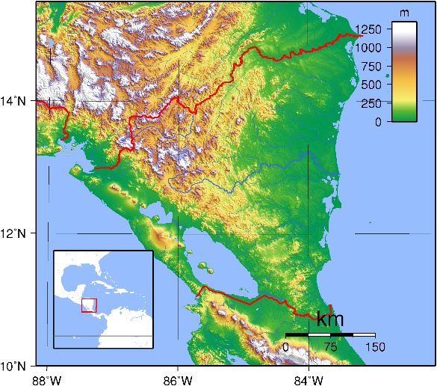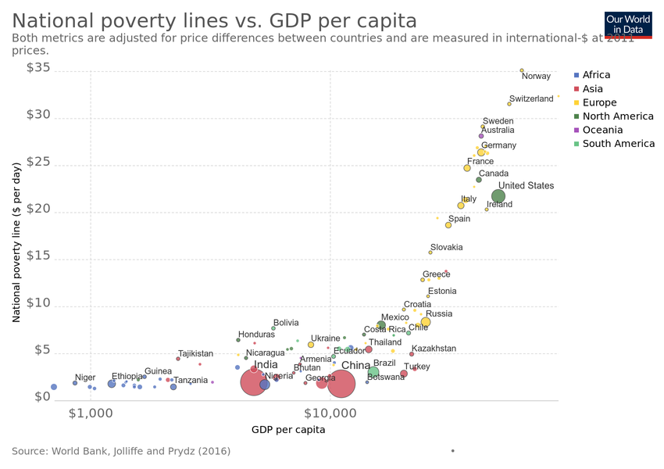Even though the negligent regime refusing to take this pandemic seriously is one of the main reasons for this decrease in human wellbeing, another is more economical. According to the World Bank, extreme poverty in Nicaragua, which is defined as income below $3.2 per day, increased to 13.1% in 2019 from 9.5% in 2017 (2020). Over 240,000 more people were forced into poverty due to the lack of government involvement. However, the majority of the people in poverty are on the eastern coast, away from the urban cities of Managua and Leon (World Bank, 2020). This means that if they received the virus, going to testing facilities, which are on the western coast, would be near impossible since the patients have no money to spare for transportation and a mountain range is separating them as shown in Figure 4. The people on the East Coast have few options for the medical help that they need.

*Figure 5. National Poverty Lines vs. GDP Per Capita (National poverty lines vs. GDP per capita, 2020)*

*Figure 4. Topographic Map of Nicaragua (Sadalmelik, 2007)*

Nicaragua

So why doesn’t the government acknowledge the severity of the coronavirus and follow WHO regulations? According to an article on The Wall Street Journal, doing this would be “fatal for the country’s faltering economy” (Montes, 2020). In 2018, President Ortega’s government used violent measures in order to calm the aforementioned protests, resulting and more than 300 deaths and international sanctions. This caused the already failing economy to shrink by 5.7% as no foreign aid was offered to help them recover from their civil riots (Montes, 2020). Implementing strategies to prevent the spread of the virus would cost money, being the last straw for the fragile economy. This leaves the country in a perpetual cycle of decreasing human wellbeing, specifically in the health aspect, due to a lack of precautions around coronavirus, and yet an inability to solve the issue because of an extremely weak economy.

**Management Strategies and Recommendations**

What global initiatives can be implemented in order to stop this perpetual loop? One solution would be to replace the oppressive, authoritarian government with a more transparent leadership. President Ortega skims off some of the national revenue and invests it into private companies owned by either his friends or family (Parker, Nietschmann, 2019). This highly illegal act further damages the Nicaraguan economy, reducing the opportunity to escape from their cycle. This would allow the government to provide better access to testing facilities for those living on the East Coast as well as incorporate strategies that would help prevent the spread of the virus.

Cuba has already implemented an initiative in order to help Nicaragua. They have decided to dispatch 593 medical workers to 14 different countries, one of them being Nicaragua (Petkova, 2020). This provided medical access to those who would otherwise have no other options, slowing down the death rate and helping those who the government could not. This strategy proved that it was effective in helping improve the health in Nicaragua.

A more long-term solution to this economic problem that affects the health of the country’s citizens is investing in the middle class. Currently, there is an extreme divide between the upper and lower class with a third of Nicaraguans living in poverty (Mather, 2020). Right now, the upper class do not consume enough “to drive a modern economy”, however building a middle class will increase the number of consumers as more people will have a consistent income (Democracy Journal, 2011). This will result in a more stable demand that would not be as easily affected by the virus as it is now. These are a couple examples of global initiatives that have been or could be implemented to stop the negligent and oppressive government and increase the human wellbeing of the Nicaraguan citizens.

**CONCLUSION**

How has the empowered and dynastic Nicaraguan regime affected the health of their citizens and what global development initiatives have been or could be implemented in order to reduce this inequality? They neglected their citizens during the coronavirus due to their own selfish desires for personal gain, causing instability amongst the previously weak economy. Protests trying to gain attention from this government were violently suppressed, resulting in more than 300 deaths. However, wishing for outside support has slowly started to become reality as Cuba sent in medical workers to aid those that didn’t have access to medical facilities. More coverage around this topic is required as more powerful countries, who otherwise wouldn’t know about the oppressive government, can provide financial aid as well as more medical. Accounting for all that I have researched, I believe the future health of the Nicaraguan citizens will improve as awareness about their government is rising.

**REFERENCE LIST**

Correspondent, T. P. L. A. (2019, January 11). Nicaragua closer to new civil war than ever before, judge warns. The Guardian. Retrieved from <https://www.theguardian.com/world/2019/jan/11/nicaragua-rafael-solis-ortega-civil-war-resignation-letter>

Ferrando, J. (2017). HEALTH SYSTEMS PROFILE NICARAGUA MONITORING AND ANALYZING HEALTH SYSTEMS CHANGE (Third Edition). Retrieved from <https://www.paho.org/hq/dmdocuments/2010/Health_System_Profile-Nicaragua_2008.pdf>

Growth and the Middle Class. (2011, March 4). Growth and the Middle Class. Retrieved from Democracy Journal website: <https://democracyjournal.org/magazine/20/growth-and-the-middle-class/>

Lynda. (2009, March 31). Human Well-Being. Retrieved from Wikiprogress website: <http://wikiprogress.org/articles/jobs-and-work/human-well-being/>

Mather, T. P. S., Marin, B. G., Perez, G. M., Christophers, B., Paiva, M. L., Oliva, R., … Tobin-Tyler, E. (2020). Love in the time of COVID-19: negligence in the Nicaraguan response. The Lancet Global Health, 8(6), e773. <https://doi.org/10.1016/S2214-109X(20)30131-5>

Montes, J. (2020). As Coronavirus Spreads in Nicaragua, Official Denials Amplify Risk. Retrieved 6 September 2020, from <https://www.wsj.com/articles/as-coronavirus-spreads-in-nicaragua-official-denials-amplify-risk-11590246000>

National poverty lines vs. GDP per capita. (2020). Retrieved September 6, 2020, from Our World in Data website: <https://ourworldindata.org/grapher/national-poverty-lines-vs-gdp-per-capita>

Nicaragua. (2011). Retrieved September 4, 2020, from LandLinks website: <https://land-links.org/country-profile/nicaragua/>

Nicaragua  Economy: Population, GDP, Inflation, Business, Trade, FDI, Corruption. (2019). Retrieved from Heritage.org website: <https://www.heritage.org/index/country/nicaragua>

Nicaragua Coronavirus: 4,668 Cases and 141 Deaths - Worldometer. (2020, September 6). Retrieved September 6, 2020, from www.worldometers.info website: <https://www.worldometers.info/coronavirus/country/nicaragua/>

Nicaragua Map, Map of Nicaragua. (2020, June 2). Retrieved September 6, 2020, from Maps of World website: <https://www.mapsofworld.com/nicaragua/>

Overview. (2020, June 8). Retrieved September 6, 2020, from World Bank website: <https://www.worldbank.org/en/country/nicaragua/overview>

‌

Parker, F. D., & Nietschmann, B. (2019). Nicaragua | Geography, History, & Facts. In Encyclopædia Britannica. Retrieved from <https://www.britannica.com/place/Nicaragua>

Perez, R. (2015). “The 72-hour document” : The Sandinista blueprint for constructing communism in Nicaragua : a translation. Retrieved from <https://babel.hathitrust.org/cgi/pt?id=txu.059173018442070&view=1up&seq=7> (Original work published 1986)

Petkova, M. (2020, April 2). Cuba has a history of sending medical teams to nations in crisis. Retrieved September 6, 2020, from www.aljazeera.com website: <https://www.aljazeera.com/indepth/features/cuba-history-sending-medical-teams-nations-crisis-200331112744040.html>

Robles, F. (2016, October 16). Nicaragua Dispute Over Indigenous Land Erupts in Wave of Killings. The New York Times. Retrieved from <https://www.nytimes.com/2016/10/17/world/americas/nicaragua-dispute-over-indigenous-land-erupts-in-wave-of-killings.html>

Sadalmelik. (2007, September 16). Topographic map of Nicaragua. Created with GMT from SRTM data. Retrieved September 6, 2020, from Wikimedia Commons website: <https://commons.wikimedia.org/wiki/File:Nicaragua_Topography.png>

‌

Stephens, H. (2019, February). Fears of a Civil War Have Faded, but Nicaragua’s Crisis Is Far From Over. Retrieved from Worldpoliticsreview.com website: <https://www.worldpoliticsreview.com/insights/26683/fears-of-a-civil-war-have-faded-but-nicaragua-s-crisis-is-far-from-over>

United Nations Development Programme. (2000). Human Development Index (HDI) | Human Development Reports. Retrieved from Undp.org website: <http://hdr.undp.org/en/content/human-development-index-hdi>

World Report 2020: Rights Trends in Nicaragua. (2019, December 11). Retrieved September 4, 2020, from Human Rights Watch website: <https://www.hrw.org/world-report/2020/country-chapters/nicaragua>

‌

**APPENDIX A – Action Plan**

|  |  |  |  |
| --- | --- | --- | --- |
| **Tick when completed and write date** | **ACTION**  **What do I need to do?** | **EXPLANATION**  **How will I complete this stage of Action Plan?** | **TIME**  **When do I plan to complete this stage of Action Plan?** |
| 22/08/20 | **SELECT TOPIC**  What is your issue/country? Why did you choose it? | I will complete this first step in my action plan by reading through the assessment notification. After seeing the requirements, I’ll pick a country and research the different problems they are facing. Then, I’ll finish by choosing one that I find suitable, providing me my country and issue. | 22/08/20 |
| 26/08/20 | **READ WIDELY**  What have you learnt about your topic? | I plan to read about my country and issue by via a variety of mediums. I’ll use online articles to read about current news related to my country, such as Britannica, and the geography textbook provided. Furthermore, I will read newspaper articles to understand the current affairs in Nicaragua. This will prepare me to create a well-educated, quality research question that is applicable to my chosen country. | 26/08/20 |
| 29/08/20 | **FORMULATE QUESTION**  What is your research question? How is your research question relevant to the Statement of Inquiry? | I will utilise the research I obtained through the “read widely” action and develop a research question that is clear and focused on how my issue affects the human wellbeing in that country. This issue and country will be decided during my “select topic” action. | 29/08/20 |
| 03/09/20 | **CONDUCT RESEARCH**  What sources of information will you use to answer the question? How will you organise and record your information? | I plan to conduct extensive research on my chosen issue in my designated country so that I’ll be able to write a balanced and thorough report. This will firstly be done through the use of secondary sources. An example of this include newspaper articles such as *“The New York Times”* or *“Washington Post”.* Since I’m going to research how the dictator-like government affects the citizens’ wellbeing, using this secondary source will provide current and relevant information pertaining to this issue’s effect. I’ll also use a section of that Geography textbook (Page 145). This will educate me on the diplomatic relationships between countries, specifically regarding trade, and how more developed countries are favoured over less developed. Understanding how poorer countries trade their resources with richer is applicable as it portrays how Nicaragua’s government is connecting on a global scale.  An example of my primary sources includes a translation of *“The 72-Hour Document”.* This source is the Sandinista’s, who were a socialist political party, blueprint for constructing a communist country after the Nicaraguan Revolution. This, along with the helpful Introduction written by a secondary source summarising the document, will give me information on how the government was first developed, showing me how they have changed over the years. This will help me better understand the goals and perspective of the Nicaraguan government, resulting in a balanced report as both point-of-views (i.e. the citizens’ and the government’s) were researched. | 03/09/20 |
| 10/03/20 | **PRODUCE REPORT**  What will you need to complete and submit? | I will then consolidate the information obtained from my research and fill out the report scaffold above. This will start by analysing two sources, discussing their values and limitations. After writing about my findings and finishing with a conclusion, I will then submit a draft asking for feedback. I’ll finish my report by reading through the feedback and re-editing my work. | 10/03/20 |

**APPENDIX B – Research Question Scaffold**

**The Statement of Inquiry**: Reducing inequality in human wellbeing needs global development initiatives.

My chosen country:

Nicaragua

My chosen issue:

Oppressive government on citizens’ health

Aspects of my topic I am interested in researching. You need to read books and websites about your topic and jot down anything that is of interest to you here:

* What the “president” and First Lady are doing to their citizens?
* How this affects their wellbeing?
* What made the citizens push back against the government now?
* How this affects its international relations?
* How did the government handle, or not handle, the coronavirus?

My draft question:

**ONLY** write this after you have done some wide reading about your topic.

How has the oppressive and dynastic Nicaraguan government, who creates a democratic façade, affected the human wellbeing of its citizens?

Peer Feedback:

I think the grammar is a bit confusing. Maybe you should try to include the SOI in the question more, maybe use the actual phrase “global development initiatives”.

Teacher Feedback:

Focus on one aspect of human wellbeing and inquire about solutions.

My final research question:

How has the empowered and dynastic Nicaraguan regime affected the health of their citizens and what global development initiatives have been or could be implemented in order to reduce this inequality?

Justify how your research question is related to the Statement of Inquiry:

The Statement of Inquiry is “Reducing inequality in human wellbeing needs global development initiatives.” This research question directly correlates to this statement by raising awareness around the dictator-like government leading Nicaraguan citizens. It will show how they have been neglecting the needs of their people, specifically in the lack of protection around the coronavirus, inspiring a global initiative that will be focused on the improvement of these citizens’ wellbeing. This rise in awareness will restore equality between the government and the governed, bringing the country out of an oppressive dynasty and into a democracy where the people are offered a voice.

**APPENDIX C – Note Taking Scaffold**

|  |  |
| --- | --- |
| **Resource Details** | Key points from information in my own words |
| **Author:** Franklin Parker; Bernard Nietschmann  **Title:** Nicaragua  **Source Type:** Secondary  **Published Date:** 1 February, 2019  **Place Published:** Online  **Publisher:** Britannica  **URL:** <https://www.britannica.com/place/Nicaragua/Foreign-intervention> | * Ortega returned to power in the presidential election of 2006, defeating the conservative candidate Eduardo Montealegre * During the late 2000s and early 2010s under the rule of Ortega, the Nicaraguan economy grew and the unemployment rate slid to about 7%, increasing his popularity * However, now the citizens believe Ortega’s rule is increasingly authoritarian, using the lack of transparency and growth in control over a variety of political aspects such as the military, the courts and the National Assembly * He invested money from trading oil with other countries into private companies that were controlled by his friends and family * Citizens started accusing him of mirroring the Somoza, which was a dictator from 1925 to 1980 * Ortega’s wife’s power also grew, allowing to be perceived as a copresident * Citizen’s started to protest in 2018, but Ortega silenced them using a relatively violent response * Now there is war between the citizens and the government * In January 2020, 88,000 Nicaraguans fled the country as a result of this unrest |
| **Author:** Dr. Jaime Ferrando  **Title:** Health Systems Profile Nicaragua  **Source Type:** Secondary  **Published Date:** May, 2009  **Place Published:** Washington, D.C.  **Publisher:** Pan American Health Organization  **URL:** <https://www.paho.org/hq/dmdocuments/2010/Health_System_Profile-Nicaragua_2008.pdf> | * Diseases of the circulatory system, external causes, and tumors account for the three leading causes of death. * Rates of maternal and child mortality due to communicable diseases are still high * Poverty is the main social status for Nicaraguan citizens * Second poorest in Latin America * In 2005, the general poverty rate was 48.3% while 17.2% of the population lived in extreme poverty * General Health Law transferred responsibilty for the citizens’ health to Ministry of Health (MINSA) * MINSA is the main supplier of health supplies * The coverage rates for the country’s health is “MINSA (60%); Nicaraguan Social Security Institute or INSS (7.7% beneficiaries and their family members); Ministry of Government and Military Health networks (8%); and private institutions (4%)” * 46% of the national land is the Atlantic region, with a low population of 10 per square km |
| **Author:** Thais P Salazar Mather; Benjamin Gallo Marin …  **Title:** Love in the time of COVID-19: negligence in the Nicaraguan response  **Source Type:** Secondary  **Published Date:** April 06, 2020  **Place Published:** Online  **Publisher:** The Lancet  **URL:** <https://www.thelancet.com/journals/langlo/article/PIIS2214-109X(20)30131-5/fulltext> | * Nicaraguan response to corona has been the most erratic of any country * They are directly contradicting mitigation strategies recommended by WHO, shown by:   1. Refusing to encourage physical distancing   2. Encouraging citizens to congregate in street marches under the slogan “love in the time of COVID-19”   3. Downplay the danger of the pandemic * Nicaragua is the second-poorest country in the western hemisphere * The government is “violating the human rights of its citizens * Only country in Central America that has not declared a state of emergency in response to the outbreak * The only precautions they have taken is recommending self-quarantine for travellers from certain countries * Government has not restricted travel, closed borders or suspended schools or public events * Nicaragua is lying about their numbers; the official report says 4,500 cases but a leaked document from the Nicaraguan Health Ministry predicted 32,500 * If the government continues to ignore calls for mitigation efforts, the fragile health infrastructure could fall apart * **“It is crucial that WHO, PAHO, and leaders of the global health community take immediate action to help prevent the loss of thousands of lives.”**   Good quote to use. |
| **Author:** Hampton Stephens  **Title:** Fears of a Civil War Have Faded, but Nicaragua’s Crisis Is Far from Over  **Source Type:** Secondary  **Published Date:** 1 February, 2019  **Place Published:** World Politics Review  **Publisher:** World Politics Review  **URL:** <https://www.worldpoliticsreview.com/insights/26683/fears-of-a-civil-war-have-faded-but-nicaragua-s-crisis-is-far-from-over> | * President Daniel Ortega can still be president because of the way the Constitution was written (shown in 72-hour document described below) * In August 2018, protests against Ortega were faced with violent oppression, resulting in 300 deaths and more than 2,000 injuries * Reporters during this time found evidence of systematic repression including violations of the freedom of speech, dismissal of civil servants and torture and extrajudicial killings * U.N. urged Nicaragua to stop and restore equality to the country, but the government subsequently redoubled its efforts. * These violent acts and disregard for human wellbeing decreased the president’s popularity who once enjoyed the highest approval ratings of any president in the Northern Hemisphere * Now the country looks like it’s on the brink of a breakdown * Nicaragua’s economic prosperities has come at the cost of a democracy * Despite contrary evidence, most Nicaraguans believe they live in a free democracy, including 82% of self-identified independent voters * Tens of thousands of Nicaraguans have fled the country because of these violent acts from the government |
| **Author:** Rigoberto Lopez Perez  **Title:** The 72-hour document  **Source Type:** Primary and Secondary  **Published Date:** 5October, 1979  **Released Date:** February 1986  **Place Published:** The University of Texas  **Publisher:** The University of Texas  **URL:** <https://babel.hathitrust.org/cgi/pt?id=txu.059173018442070&view=1up&seq=4> | * After Nicaraguan revolution, the Sandinista national Liberation Front (FSLN) met in secret to lay out these plans for power. Even though it was supposed to be kept amongst themselves, within a few weeks the report became widely known * This document was Sandinistas’ basic blueprint for constructing communism in Nicaragua and spreading subversion amongst the regions * The most sensitive subjects were omitted when the document was leaked, but we can still see a glimpse into the Sandinistas’ true intentions * An example of these intentions is shown during the revolution. The FSLN said they were fighting against the Somoza dictatorship in order to promote pluralism, a mixed economy and a nonaligned foreign policy. However, this document shows they were using the non-Somoza rebellion as a tactical maneuver to help gain power * The FSLN’s real enemy, according to the document, was the imperialist country of America |

**APPENDIX D – Evaluation**

One thing I’m proud of during my research was finding the primary source “The 72-Hour Document”. I wanted use a range of sources, and after searching the Internet for one that was primary, I stumbled upon this. After checking its credibility, which is shown in the fact that it was made by the Sandinista government and was first published at a university, I read through the source and saw what the government planned to do to their people, inspiring me to choose that as my topic.

I also thought my evaluation of the credibility of sources was thorough and creative. I cross-checked my new information to “The 72-Hour Document”, as I had already checked its reliability, making sure they were similar. If the source was unrelated to this primary source, such as Democracy Journal that discussed the importance of the middle class, I then used an online credibility scanner titled “MyBib”. This showed me whether the source I was using was reliable via coloured checkmarks next to the bibliographical citation. This decreased the time I had to spend on manually checking each source’s credibility, allowing for more time on the actual report.

However, one thing I feel I could have improved was the number of diagrams and graphs I used in my findings. I used minimal amounts as it was difficult to find credible ones that related to my topic. Either I would check the website they were from and find that it couldn’t be trusted or the diagram was unrelated to my topic (i.e. a graph showing the economy of Costa Rica over the course of 10 years). If I had had more time to work on this report, I would’ve spent more time trying to find engaging graphs and images that help convey my main points to the audience.

Another improvement I feel I could’ve made was the bias of my report. After reading several articles about the oppressive Nicaraguan government, I started to lean towards the side of the citizens instead of providing factual and objective information. I had originally hoped that having a source from the perspective of this government would help keep me balanced, but that just conveyed to me how they do not care about their people. If I were to do this again, I would try to find more sources that showed the Nicaraguan government’s point-of-view show that the information in my report stays as impartial as possible.