Do the extra Sentinel-2 bands help with an ImageNet-pretrained ViT? A EuroSAT study
The question. Sentinel-2 satellites record 13 spectral bands; ImageNet-pretrained models have only ever seen 3 (red, green, blue). Does an ImageNet-pretrained ViT-S/16 classify EuroSAT land cover better when it gets all 13 bands instead of RGB, with everything else kept the same?
The answer: no. Both inputs reach about 99% test accuracy, and the 13-band model is slightly worse: 98.87% vs 99.13% with the tuned recipe (61 vs 47 wrong tiles out of 5,400; McNemar p = 0.13, not significant). It stayed 0.07–0.48 points behind RGB under all six recipes tried, significantly so for one (p = 0.007). The vegetation classes we expected to gain most lost tiles as a group.

1. Project overview
Project title. Do the extra Sentinel-2 bands help with an ImageNet-pretrained ViT? RGB versus all 13 bands on EuroSAT land-cover classification.
Problem addressed, and why it is interesting.
- Sentinel-2 images all land on Earth every five days, free of charge (Drusch et al., 2012); at that volume, land cover can only be mapped by automatic image classifiers.
- A normal photo has 3 channels (red, green, blue); a Sentinel-2 tile has 13, from visible light to short-wave infrared. Surfaces reflect these wavelengths differently (plants reflect near-infrared strongly, water absorbs it; Tucker, 1979), so the extra bands should make classes easier to tell apart.
- Transfer learning from ImageNet (1.3 million RGB photos) saves data and compute, but the pretrained network has never seen infrared. Whether the extra information outweighs this mismatch decides if it is worth keeping all bands (more data, a modified first layer) or simply using RGB with an off-the-shelf model.
- Earlier evidence is mixed: all bands helped on BigEarthNet (Sumbul et al., 2019), while the EuroSAT paper found RGB the best 3-band combination but never tested all 13 bands on a pretrained transformer (Helber et al., 2019).
Alternative hypothesis (H1), fixed before training: the 13-band model is more accurate than the RGB model, most of all on the four vegetation classes (AnnualCrop, PermanentCrop, Pasture, HerbaceousVegetation), because plants stand out in the infrared.
Null hypothesis (H0): no meaningful difference, or RGB at least as good. The comparisons, their direction and the 5% significance threshold were fixed at the same time, so the results could not be read selectively afterwards.
2. Method
2.1 Overall strategy: one model, one change at a time
- Same everything but the bands. Both final models share architecture, pretrained weights, data split, training code, recipe and seed; only the input differs (3 or 13 bands). A recipe is the set of training settings (optimizer, learning rate, weight decay, batch size, probe epochs, schedule); an arm is one trained model within an experiment.
- Three experiments that build on each other (Table 1): Experiment 1 checks the starting point, Experiment 2 chooses the recipe on RGB, and Experiment 3 answers the question. Two robustness checks repeat the RGB-vs-13-band pair under the five best recipes (Experiment 3b) and with the default recipe plus augmentation (extra pair).
- Validation decides, test scores. Every choice (recipe, augmentation, the epoch kept) is made on the 5,400 validation tiles; each final model is scored once on the 5,400 test tiles, so no choice can flatter the test score (Kapoor & Narayanan, 2023).
- Paired statistical test. Two models are always compared on the same tiles with the exact McNemar test (Section 2.5), at p < 0.05.

Exp. | Arms | Question | How it is decided
E1 | Untrained model, with RGB and with 13 bands | Is the model at chance before training? | Sanity check: test accuracy near 10% (10 classes)
E2 | Baseline: default recipe. Optuna search: 40 trials on RGB. Arm A: best recipe. Arm B: arm A + augmentation | Which recipe should we use, and does augmentation help? | Lowest validation loss over the trials; augmentation kept only if B beats A on the validation split (McNemar p < 0.05)
E3 | 13-band model and RGB model, both with the E2 recipe | Do the extra bands improve classification? (primary test) | McNemar test on the test split, p < 0.05
E3b | The 5 best recipes of the search, each trained on RGB and on 13 bands | Does the answer depend on the recipe, which was tuned on RGB? | Five paired tests; then each input gets its own best recipe, chosen on validation loss
Extra | RGB and 13-band models, default recipe with augmentation | Does the answer hold with the default recipe? | McNemar test on the test split
Table 1. The experiments. All trained runs share the data split, the fixed settings of Section 2.5 and seed 0.

2.2 Models used
- ViT-S/16 (Dosovitskiy et al., 2021): a small vision transformer (21.7 M parameters) with the timm weights vit_small_patch16_224.augreg_in1k, pretrained on ImageNet-1k (Wightman, 2019; Steiner et al., 2022). One architecture keeps the comparison clean, and transformers are now the standard for multispectral remote-sensing models (Cong et al., 2022; Wang et al., 2023).
- Two changes. The ImageNet output layer is replaced by a new 10-class layer (random start, seed 0). For 13 bands, timm widens the first layer by cycling the three pretrained RGB filters over the 13 channels, scaled by 3/13. With TorchGeo's band order (B01, B02, B03, B04, …), only red (B04) lands on its own filter; blue and green land on each other's, and the ten new bands on filters made for colors. So the two models do not start from the same point (Section 4).
- Input size. The 64 × 64 tiles are upsampled (bilinear) to 224 × 224, the resolution the backbone was pretrained at, before being cut into 16 × 16 patches.

2.3 Dataset and short EDA
- EuroSAT (Helber et al., 2019): 27,000 Sentinel-2 tiles from 34 European countries, 64 × 64 pixels at 10 m, 10 classes, all 13 bands as raw reflectance. Loaded with TorchGeo (Stewart et al., 2022) with its published 60/20/20 split of 16,200 / 5,400 / 5,400 tiles (Neumann et al., 2019), so every number can be reproduced tile for tile.
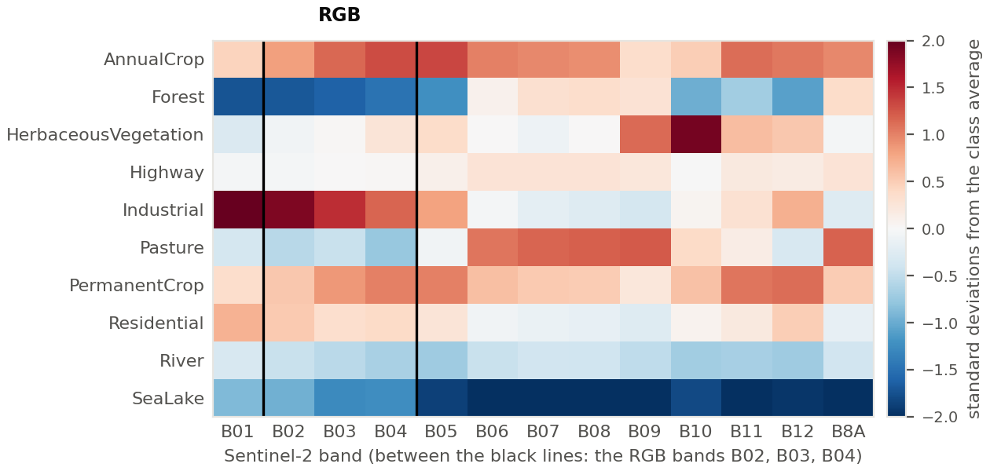
Figure 1. How bright each class is in each band compared with the average class (standardized per band; 3,000 random training tiles; red = brighter, blue = darker). The RGB bands B02–B04 sit between the black lines; everything to their right is invisible to an RGB model. Pasture and SeaLake stand out mainly in the infrared.
- Classes and splits. Mild imbalance (1,195 to 1,863 training tiles per class), the same in every split: no re-weighting, and macro-F1 (all classes weighted equally) is reported next to accuracy. No tile is duplicated within or across splits (hash check), and the splits' band statistics agree within about 1% (4% for the tiny B10), so the test split is a fair, unseen sample.
- Scales. The raw bands differ enormously in size (B10 mean ≈ 12, B8A mean ≈ 2,600), so every band is standardized (Section 2.4).
- The extra bands carry class information that RGB lacks (Figure 1). Pasture is slightly darker than average in RGB but clearly brighter in the red-edge and near-infrared bands; SeaLake is about two standard deviations darker in every infrared band; the vegetation classes all peak in the near-infrared. This is what motivated H1. One caution: B09 and B10 mainly measure water vapor and thin cloud in the air, so part of what they carry is the weather on the acquisition day, not the land.
- Look-alikes. In RGB, the three farmland classes and Pasture all look like green fields, and Highway and River are both a line across the tile. These look-alike pairs are where the trained models make most of their mistakes.

2.4 Data preprocessing
- Bands. RGB arms use B04, B03 and B02 (red, green, blue), the order the pretrained filters expect. 13-band arms use all 13 bands in TorchGeo's order (B01, B02, …, B12, B8A).
- Standardization. Each band is rescaled to mean 0 and standard deviation 1 with statistics from all pixels of the tile's own split (no labels used). Otherwise the near-infrared bands, on average about 200 times larger than B10, would dominate, and a pretrained network expects inputs near zero. Using each split's own statistics changes almost nothing here (the splits agree within about 1%) but is listed as a limitation.
- Augmentation (training tiles only, in the arms that use it): random horizontal and vertical flips, 90° rotations and a random crop keeping 80–100% of the tile. These keep the label valid and act identically on 3 and 13 bands. Whether they help was tested in Experiment 2, not assumed.

2.5 Training setup: split, metrics, hyperparameters
- Split. The published 16,200 / 5,400 / 5,400 train / validation / test tiles, identical for every run. We kept it rather than drawing our own, so the results are reproducible and comparable with other work.
- Two-stage transfer learning. First a few probe epochs, in which the backbone is frozen and only the new output layer learns; then the whole network is fine-tuned. The number of probe epochs is part of the recipe (3 in the default, none in the tuned one). Letting the new layer settle first protects the pretrained features from the large, random early gradients of an untrained head (Kumar et al., 2022).
- Fixed for every run: at most 15 epochs, cross-entropy loss, mixed precision and seed 0. Training stops after 5 epochs without a lower validation loss, and the weights with the lowest validation loss are kept. Losses are averaged per tile (weighted by batch size).
- Metrics. Test accuracy, macro-F1 and correct tiles per class. Two models are compared with the exact McNemar test on the same test tiles (McNemar, 1947): it looks only at the tiles where exactly one model is right and asks whether that split is more lopsided than a coin flip would give. It is the recommended test when each model is trained once (Dietterich, 1998); Section 8.1 of the notebook checks its requirements.
- Engine. A hand-written PyTorch training loop, checked on a small synthetic problem before use: training and evaluation modes, per-batch gradients, mixed-precision scaling and the three loss definitions all pass.

2.6 Hyperparameter tuning (Experiment 2)
- Optuna (Akiba et al., 2019) tried 40 recipes with the TPE sampler (Bergstra et al., 2011; seed 0), which learns from earlier trials where good settings lie. Each trial trained the RGB model without augmentation and was scored by its lowest validation loss, never the test set. Trial 0 was the baseline, so the search could only match or beat it; a median pruner stopped lagging trials from epoch 6 on.
- Search space (Table 2): seven settings. Trial 20 won (AdamW, learning rate 1.18 × 10⁻⁴, weight decay 0.0020, batch size 256, no probe epochs, cosine schedule; validation loss 0.0331 vs 0.0373 for the baseline). It was then trained with and without augmentation to decide, on validation, whether Experiment 3 uses augmentation.

Setting | Searched | Baseline | Best (trial 20)
Optimizer | AdamW (Loshchilov & Hutter, 2019), Adam, SGD | AdamW | AdamW
Learning rate | AdamW and Adam 10⁻⁵ to 10⁻³; SGD 10⁻³ to 10⁻¹ (log scale) | 10⁻⁴ | 1.18 × 10⁻⁴
Weight decay | 10⁻⁴ to 10⁻¹ (log scale) | 0.05 | 0.0020
Batch size | 32, 64, 128, 256 | 64 | 256
Probe epochs | 0, 1, 3, 5 | 3 | 0
Learning-rate schedule | cosine decay (Loshchilov & Hutter, 2017), step, none | cosine | cosine
Momentum (SGD only) | 0.8 to 0.99 | 0.9 | —
Table 2. Search space, baseline recipe and the best recipe found (trial 20). Fixed settings: Section 2.5.
3. Results
Run | Bands | Recipe | Aug. | Best epoch | Val. loss | Val. acc. | Test acc. | Wrong | Macro-F1 | Train Mins.
E2 baseline | RGB | default | no | 8 | 0.0373 | 98.96% | 99.06% | 51 | 0.9904 | 2.9
E2 arm A | RGB | tuned | no | 7 | 0.0331 | 99.09% | 99.13% | 47 | 0.9912 | 2.7
E2 arm B | RGB | tuned | yes | 11 | 0.0357 | 99.07% | 99.09% | 49 | 0.9907 | 3.8
E3 (13 bands) | 13 | tuned | no | 12 | 0.0571 | 98.61% | 98.87% | 61 | 0.9885 | 3.6
Extra RGB | RGB | default | yes | 15 | 0.0361 | 99.02% | 99.11% | 48 | 0.9910 | 3.9
Extra 13 | 13 | default | yes | 13 | 0.0329 | 99.02% | 98.93% | 58 | 0.9889 | 4.3
Table 3. The six main runs (one run each). E3 is the 13-band arm of Experiment 3; its RGB partner is E2 arm A.

Comparison (1 → 2) | Split | Accuracy (1 → 2) | Only 1 / only 2 right | p | Reading
E2 · baseline → tuned (arm A) | test | 99.06 → 99.13% | 18 / 22 | 0.64 | not significant
E2 · arm A → arm B (augmentation; the decision) | val. | 99.09 → 99.07% | 25 / 24 | 1.00 | not significant → no augmentation
E2 · arm A → arm B (for information) | test | 99.13 → 99.09% | 22 / 20 | 0.88 | not significant
E3 · RGB → 13 bands, tuned recipe (primary test) | test | 99.13 → 98.87% | 44 / 30 | 0.13 | not significant; favors RGB
Extra · RGB → 13 bands, default recipe + augmentation | test | 99.11 → 98.93% | 36 / 26 | 0.25 | not significant; favors RGB
Table 4. Paired comparisons (exact McNemar test). “Only 1 / only 2 right”: tiles that only one of the two models got right.
3.1 Experiment 1 · before training
- Before training both models are at chance, as they should be: 14.9% test accuracy with RGB and 10.2% with 13 bands, against 10% for random guessing, with a typical confidence of only about 0.3 (after training: 1.0). The random head of the 13-band model sends 71% of the tiles to River or SeaLake. Any accuracy above this level is therefore learned during training.

3.2 Experiment 2 · the training recipe
- The search took 66 minutes: of 40 trials (the baseline plus 39 new), 13 completed, 25 were pruned and 2 failed (SGD at a learning rate of about 0.09 blew up). The top is flat: ten trials lie between 0.0331 and 0.0373. AdamW with a learning rate near 10⁻⁴ worked almost whatever the other settings; SGD matched it in only 3 of 20 trials and plain Adam's best trial reached only 0.077. Optuna's importance estimate ranks SGD momentum and learning rate highest, but rests on only 13 completed trials, so we treat it as a rough guide.
- Tuned vs baseline (test, for information): 99.13% vs 99.06% (47 vs 51 wrong tiles, p = 0.64). The 40-trial search lowered the validation loss but gained only four test tiles, which is not a measurable improvement. Retraining trial 20 with the same seed (arm A) reproduced its result (validation loss 0.0331, stopped at the same epoch).
- Augmentation decision (validation split): arm A (no augmentation) 99.09% vs arm B (with augmentation) 99.07%, with 25 vs 24 tiles that only one of them gets right (p = 1.0). Augmentation brings no measurable benefit, so Experiment 3 uses arm A, without augmentation, as the RGB reference. On test the picture is the same (99.13% vs 99.09%, p = 0.88).

3.3 Experiment 3 · the research question
- Main test. With the tuned recipe the 13-band model made 61 errors against 47 for RGB (98.87% vs 99.13%, a gap of 0.26 points). On the 74 tiles where the two disagree, RGB is right 44 times and the 13-band model 30 times (p = 0.13). The extra bands therefore did not improve accuracy; the gap favors RGB but is too small to be significant on its own.
- Training curves (Figure 2). The 13-band model is behind RGB on validation at every epoch, ends with a higher validation loss (0.057 vs 0.033) and needs more epochs (best epoch 12 vs 7). Both reach almost zero training loss, so the gap is not under-training: the 13-band model fits the training tiles just as well but generalizes slightly worse.
- Per class. The 13-band model loses tiles on Highway (−6), PermanentCrop (−6), Pasture (−3), River (−3) and Industrial (−2), and gains one or two on the other five classes. The four vegetation classes together lose 7 tiles, the opposite of H1. The new errors are between look-alike classes: PermanentCrop → AnnualCrop, Highway → other classes, River → Highway, Industrial → Residential.
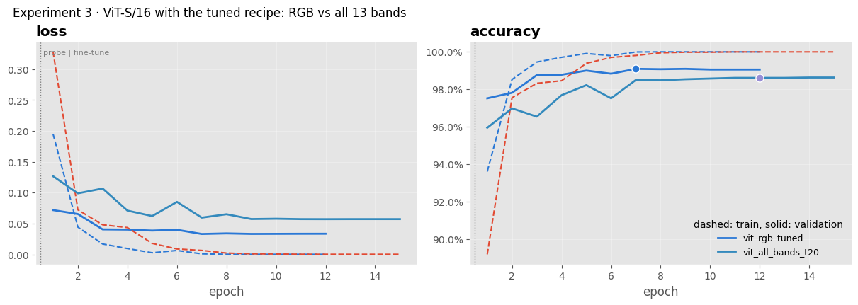
Figure 2. Experiment 3, loss and accuracy per epoch (dashed = training, solid = validation, dot = epoch kept). RGB in dark blue; the 13-band arm is the lighter solid line (validation) and the red dashed line (training). The 13-band validation curve is worse than RGB's from the first epoch on.
3.4 Does the answer depend on the recipe? Experiment 3b and the extra pair
- Five recipes, five tests (Figure 3). Under all five best recipes the 13-band model is behind RGB, by 0.07 to 0.48 points (0 wins out of 5), and has a higher validation loss (0.048–0.057 vs 0.033–0.036). One gap is significant (trial 23, SGD: p = 0.007, which would survive a correction for five tests); the other four are not (p = 0.11–0.75).
- Best recipe for each input. Chosen on validation loss, RGB keeps trial 20 and the 13-band model prefers trial 22 (SGD, validation loss 0.0477). Even then the 13-band model is behind on test: 98.80% vs 99.13% (p = 0.044).
- Default recipe with augmentation (extra pair). RGB 99.11% vs 13 bands 98.93% (48 vs 58 errors, p = 0.25). On validation the two were level (99.02% each) and the 13-band model even had the lowest validation loss of all runs (0.0329), yet it was still behind on test. During the three frozen-backbone epochs it trailed RGB by about 2–4 points and only caught up after full fine-tuning.
- Per class, across the five recipes (Table A1). Highway (−23 tiles) and Pasture (−21) are worse under all five recipes and PermanentCrop loses overall (−15, worse under three); SeaLake is the only class that gains consistently (better under 4 of 5, +5 tiles). All models are confidently wrong (median confidence of a wrong prediction 0.75–0.95), and the best run's most confident mistakes are often ambiguous tiles, such as a road crossing a “River” tile, or a bare field labeled PermanentCrop and predicted as HerbaceousVegetation.
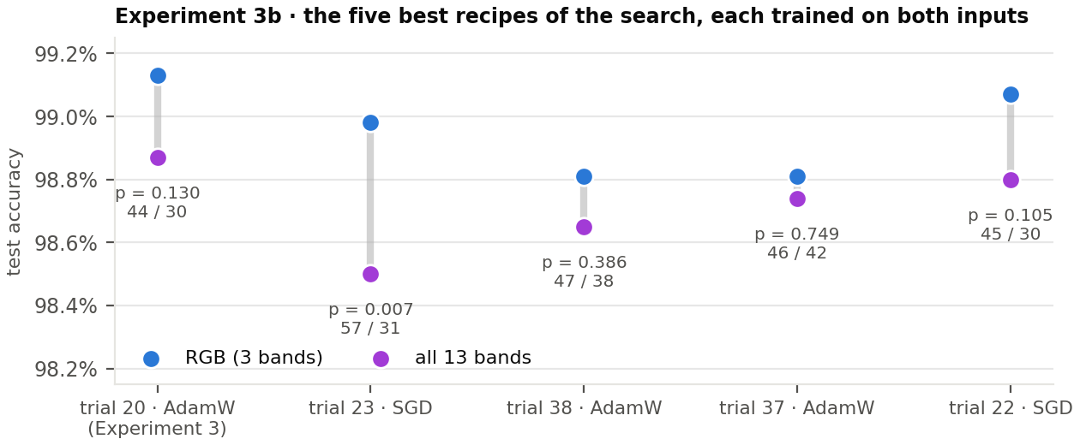
Figure 3. Experiment 3b: test accuracy of the RGB (blue) and 13-band (purple) model under each of the five best recipes, ordered by the recipe's validation loss in the search. Under each pair: the McNemar p-value and the tiles only RGB / only the 13-band model got right. Trial 20 is the Experiment 3 pair.
4. Discussion
What do the results mean? For an ImageNet-pretrained ViT-S/16 fine-tuned on EuroSAT, the ten extra bands do not come for free. The EDA shows that they carry class information (Figure 1), so the information is there, but the model did not turn it into fewer mistakes under any of the six recipes tried. Four explanations fit what we measured:
- A worse starting point that must be re-learned. The 13-band first layer starts from copies of RGB filters: the ten new bands pass through filters made for colors, and with TorchGeo's band order even blue and green start on each other's (Section 2.2). The measurements agree: before training the 13-band model scored 10.2% vs 14.9%; while the backbone was frozen (extra pair) it trailed RGB by about 2–4 points; and under all five tuned recipes it ended with a higher validation loss and a later best epoch. Part of the 15-epoch budget goes into repairing the first layer instead of exploiting the new bands.
- Little room left. RGB already makes only 47–64 mistakes out of 5,400 tiles across the five recipes. Most remaining errors are between look-alike classes, and some tiles genuinely look like the predicted class (Section 3.4). Extra bands cannot fix an ambiguous label; with RGB near the ceiling there is little to gain and some room to lose.
- It is not the recipe. The recipe was tuned on RGB, which could have handicapped the 13-band model. But Experiment 3b shows the same direction under five recipes (three AdamW, two SGD), and the 13-band model loses even with the recipe it prefers (p = 0.044). The recipe changes the size of the gap (0.07 to 0.48 points), not its sign.
- Extra channels without extra detail. Nine of the 13 bands are recorded at 20 m or 60 m and resampled to 10 m, so they add channels but no spatial detail, and B09/B10 mainly describe the atmosphere. This fits the per-class pattern: classes recognized largely by shape and texture (Highway, Industrial, PermanentCrop) lost tiles, while SeaLake, with its very distinct spectrum, was the only class that gained consistently.
What worked. The sanity check showed chance-level performance before training, and retraining trial 20 reproduced its result. Fine-tuning the pretrained model reached 98.5–99.1% test accuracy in all 14 runs, and deciding everything on validation kept the test score honest. Pruning cut a hopeless trial to 1.3–1.8 minutes instead of about 3. Paired tests made small gaps readable: 44 vs 30 disagreements says more than 99.13% vs 98.87% alone.
What did not work. H1 was not supported. The 40-trial search lowered the validation loss from 0.0373 to 0.0331 but improved the test result by only four tiles (p = 0.64); the default recipe was already close to the best. Augmentation brought no measurable gain (p = 1.0). SGD and Adam were unreliable here: two SGD trials blew up, 15 of 20 were pruned, and Adam never came close.
Unexpected outcomes.
- The vegetation classes, which the infrared bands should help most, lost tiles as a group (−37 over the five recipes; only HerbaceousVegetation gained a little), while SeaLake, already one of the easiest classes, gained.
- Validation and test disagreed: in the extra pair the two models were level on validation accuracy and the 13-band model even had the lower validation loss (0.0329 vs 0.0361), yet it was 0.19 points behind on test. At this level, small validation differences do not reliably carry over to new tiles.
- Optuna's importance estimate ranked SGD momentum highest, but it rests on only 13 completed trials (three of them SGD), so it says little about what separates the good recipes.
- The models were often confidently wrong (75–95% confidence), so confidence cannot be used to flag mistakes.
Limitations.
- One seed per run. Fine-tuned ImageNet models can vary by about 0.1–0.5 points between random seeds (Picard, 2021), the same size as our gaps. The main gap of 0.26 points (p = 0.13) should therefore be read as no clear difference; what carries weight is that RGB was as good or better under all six recipes. Picking the best of 40 single-seed trials may also make the tuned recipe look better than it is.
- The comparison depends on how the 13-channel model is adapted. timm's repeat-and-scale method, applied in TorchGeo's band order, is only one possible start, and not a favorable one: the pretrained filters do not even line up with the blue and green bands. The recipe was also tuned on RGB, although Experiment 3b largely rules this out as the cause.
- Data limitations. Each split was standardized with its own statistics (negligible effect; the splits agree within about 1%). The published split is random, so neighboring tiles can fall into both training and test, which may make results look better than they are (Ploton et al., 2020) and weakens the independence assumption of the McNemar test. EuroSAT is also easy (accuracy near 99%), and only one backbone was tested.
With more time, data or resources.
- Train the final pair with 3–5 seeds and test across seeds; run a separate Optuna search for the 13-band input; ablate bands (RGB + near-infrared; all bands without B09/B10) to find which bands help or hurt.
- Test where the extra bands should matter most: few labels (1–10% of the training tiles), a spatially blocked split, and a harder dataset (BigEarthNet).
- Change the starting point: keep the pretrained RGB filters on B04, B03 and B02 and start the ten new channels at zero, or use weights pretrained on Sentinel-2 itself (SSL4EO-S12, SatMAE); add a CNN (ResNet-50) to see whether the result is specific to the ViT.
5. Short conclusion
Under every condition tested, the ImageNet-pretrained ViT-S/16 did not do better with all 13 Sentinel-2 bands than with RGB: 98.87% vs 99.13% with the tuned recipe (p = 0.13), 0.07–0.48 points lower across five recipes (significant once), and 98.93% vs 99.11% with the default recipe and augmentation (p = 0.25). Only SeaLake gained consistently; the four vegetation classes together lost 37 tiles over the five recipes.
Takeaway. On EuroSAT, RGB transfer learning already reaches 99%, and adding the extra bands to an ImageNet-pretrained model did not help: the model first has to rebuild its first layer for the new bands, while RGB already carries most of the useful shape and texture. This held under six recipes, so it is not one tuning choice; with one seed per run, gaps below about 0.3 points should still be read as no clear difference. The extra bands may pay off with Sentinel-2-pretrained weights, fewer labeled tiles or harder datasets, the natural next experiments.

Annex
A. Reproducibility. One Colab notebook (PyTorch, timm, TorchGeo, PyTorch Ignite, Optuna, scikit-learn, scipy) with the EDA, preprocessing, training engine, search and evaluation; every run's history, validation and test predictions and summary are saved under results/, and the Optuna study in a SQLite file, so the analysis re-runs without training. Fixed choices: TorchGeo's EuroSAT split, seed 0 for every run and for the sampler, the settings of Table 2. Decision rules fixed before training: the lowest validation loss among the trials; augmentation only if McNemar p < 0.05 in its favour on the validation split; one primary test (Experiment 3) at p < 0.05. Compute: about 1.9 GPU-hours on one Colab GPU: baseline 3 min, search 66 min, arms A and B 6.5 min, Experiment 3 3.6 min, Experiment 3b 25.5 min, extra pair 8 min. No model weights are shipped.

Class (test tiles) | RGB tuned | 13 tuned | Δ | RGB def.+aug | 13 def.+aug | Δ | Σ Δ over 5 recipes (wins)
AnnualCrop (596) | 593 | 594 | +1 | 592 | 590 | −2 | −6 (2 of 5)
Forest (608) | 605 | 606 | +1 | 608 | 606 | −2 | +1 (2)
HerbaceousVegetation (573) | 562 | 563 | +1 | 560 | 561 | +1 | +5 (3)
Highway (496) | 496 | 490 | −6 | 495 | 491 | −4 | −23 (0)
Industrial (501) | 497 | 495 | −2 | 494 | 492 | −2 | −11 (0)
Pasture (396) | 392 | 389 | −3 | 391 | 390 | −1 | −21 (0)
PermanentCrop (538) | 528 | 522 | −6 | 532 | 530 | −2 | −15 (2)
Residential (554) | 549 | 551 | +2 | 553 | 551 | −2 | −1 (2)
River (529) | 524 | 521 | −3 | 525 | 524 | −1 | −2 (1)
SeaLake (609) | 607 | 608 | +1 | 602 | 607 | +5 | +5 (4)
All (5,400) | 5,353 | 5,339 | −14 | 5,352 | 5,342 | −10
Table A1. Correct test tiles per class: the Experiment 3 pair (tuned recipe), the extra pair (default recipe + augmentation), and the sum of the 13-band-minus-RGB differences over the five recipes of Experiment 3b (with the number of recipes under which the 13-band model was ahead). Vegetation classes in bold.

B. Use of AI
LLMs were used to generate code and to assist with writing the scientific document. The ideas for the experiments, the choice of libraries, the interpretation of the results, what should be tested, the visualizations, and the overall scientific and engineering approach came from us. These ideas were developed through repeated iterations of different experiments.
We mainly used LLMs for code generation and grammar correction. When the LLM generated something that we did not understand, we asked it to explain it and then reviewed the explanation ourselves. We also used LLMs to help identify relevant references, which were then verified, and to check values and results in the final output.

References
Akiba, T., Sano, S., Yanase, T., Ohta, T., & Koyama, M. (2019). Optuna: A next-generation hyperparameter optimization framework. KDD '19, 2623–2631. doi.org/10.1145/3292500.3330701
Bergstra, J., Bardenet, R., Bengio, Y., & Kégl, B. (2011). Algorithms for hyper-parameter optimization. NeurIPS 24, 2546–2554. proceedings.neurips.cc/paper/2011/hash/86e8f7ab32cfd12577bc2619bc635690-Abstract.html
Cong, Y., Khanna, S., Meng, C., Liu, P., Rozi, E., He, Y., Burke, M., Lobell, D. B., & Ermon, S. (2022). SatMAE: Pre-training transformers for temporal and multi-spectral satellite imagery. NeurIPS 35, 197–211. arxiv.org/abs/2207.08051
Dietterich, T. G. (1998). Approximate statistical tests for comparing supervised classification learning algorithms. Neural Computation, 10(7), 1895–1923. doi.org/10.1162/089976698300017197
Dosovitskiy, A., Beyer, L., Kolesnikov, A., Weissenborn, D., Zhai, X., Unterthiner, T., Dehghani, M., Minderer, M., Heigold, G., Gelly, S., Uszkoreit, J., & Houlsby, N. (2021). An image is worth 16x16 words: Transformers for image recognition at scale. ICLR 2021. arxiv.org/abs/2010.11929
Drusch, M., Del Bello, U., Carlier, S., Colin, O., Fernandez, V., Gascon, F., Hoersch, B., Isola, C., Laberinti, P., Martimort, P., Meygret, A., Spoto, F., Sy, O., Marchese, F., & Bargellini, P. (2012). Sentinel-2: ESA's optical high-resolution mission for GMES operational services. Remote Sensing of Environment, 120, 25–36. doi.org/10.1016/j.rse.2011.11.026
Helber, P., Bischke, B., Dengel, A., & Borth, D. (2019). EuroSAT: A novel dataset and deep learning benchmark for land use and land cover classification. IEEE JSTARS, 12(7), 2217–2226. doi.org/10.1109/JSTARS.2019.2918242
Kapoor, S., & Narayanan, A. (2023). Leakage and the reproducibility crisis in machine-learning-based science. Patterns, 4(9), 100804. doi.org/10.1016/j.patter.2023.100804
Kumar, A., Raghunathan, A., Jones, R., Ma, T., & Liang, P. (2022). Fine-tuning can distort pretrained features and underperform out-of-distribution. ICLR 2022. arxiv.org/abs/2202.10054
Loshchilov, I., & Hutter, F. (2017). SGDR: Stochastic gradient descent with warm restarts. ICLR 2017. arxiv.org/abs/1608.03983
Loshchilov, I., & Hutter, F. (2019). Decoupled weight decay regularization. ICLR 2019. arxiv.org/abs/1711.05101
McNemar, Q. (1947). Note on the sampling error of the difference between correlated proportions or percentages. Psychometrika, 12(2), 153–157. doi.org/10.1007/BF02295996
Neumann, M., Pinto, A. S., Zhai, X., & Houlsby, N. (2019). In-domain representation learning for remote sensing. arxiv.org/abs/1911.06721
Picard, D. (2021). Torch.manual_seed(3407) is all you need: On the influence of random seeds in deep learning architectures for computer vision. arxiv.org/abs/2109.08203
Ploton, P., Mortier, F., Réjou-Méchain, M., Barbier, N., Picard, N., Rossi, V., Dormann, C., Cornu, G., Viennois, G., Bayol, N., Lyapustin, A., Gourlet-Fleury, S., & Pélissier, R. (2020). Spatial validation reveals poor predictive performance of large-scale ecological mapping models. Nature Communications, 11, 4540. doi.org/10.1038/s41467-020-18321-y
Steiner, A., Kolesnikov, A., Zhai, X., Wightman, R., Uszkoreit, J., & Beyer, L. (2022). How to train your ViT? Data, augmentation, and regularization in vision transformers. TMLR. arxiv.org/abs/2106.10270
Stewart, A. J., Robinson, C., Corley, I. A., Ortiz, A., Lavista Ferres, J. M., & Banerjee, A. (2022). TorchGeo: Deep learning with geospatial data. SIGSPATIAL '22, Article 19. doi.org/10.1145/3557915.3560953
Sumbul, G., Charfuelan, M., Demir, B., & Markl, V. (2019). BigEarthNet: A large-scale benchmark archive for remote sensing image understanding. IGARSS 2019, 5901–5904. doi.org/10.1109/IGARSS.2019.8900532
Tucker, C. J. (1979). Red and photographic infrared linear combinations for monitoring vegetation. Remote Sensing of Environment, 8(2), 127–150. doi.org/10.1016/0034-4257(79)90013-0
Wang, Y., Braham, N. A. A., Xiong, Z., Liu, C., Albrecht, C. M., & Zhu, X. X. (2023). SSL4EO-S12: A large-scale multimodal, multitemporal dataset for self-supervised learning in Earth observation. IEEE GRSM, 11(3), 98–106. doi.org/10.1109/MGRS.2023.3281651
Wightman, R. (2019). PyTorch Image Models (timm). github.com/huggingface/pytorch-image-models

