Пензенский государственный университет
Кафедра «Вычислительная техника»

ОТЧЕТ
по лабораторной работе №2
по курсу «Основы ОС»
на тему: «Порождение и завершение процессов и нитей»

Выполнили студенты группы 23ВВВ3 бригады 8:
Полиневский В.В.
Кизым И.А.
Проверили:
Федюнин Р.А.
Егоров В. Ю.

2025
Цель работы: Изучение способа организации критических секций с использованием группы Interlocked-функций и структур CRITICAL_SECTION. Изучение способа синхронизации процессов и нитей с использованием событий
(Events).
Задачи: Имеется две нити, выводящих на экран некий текст пословно. Вывод
каждого слова должен производиться после занятия критической
секции. Организацию критических секций производить с
использованием CRITICAL SECTION.

Практическая часть:
Листинг
#include <stdio.h>
#include <Windows.h>
void print_word(char**);
size_t get_words_count(char*);
DWORD WINAPI word_thread(PVOID);
CRITICAL_SECTION _crit_section;
char _output_strign[] = "The AMD641 architecture2 is an extension of the x86 architecture. Any processor implementing the AMD64 architecture specification will also provide compatibility modes for previous descendants of the Intel 8086 architecture, including 32 - bitprocessors such as the Intel 386, Intel Pentium, and AMD K6 - 2 processor. ";
char* _ptr_string = _output_strign;
size_t _size_string;
size_t _current_word = 0;
int main() {
InitializeCriticalSection(&_crit_section);
_size_string = get_words_count(_ptr_string);
printf("COUNT WORDS: %zu \n\n", _size_string);
HANDLE _thread_1 = CreateThread(NULL,
0,
word_thread,
(LPVOID)1,
0,
NULL);
if (_thread_1 == NULL) {
printf("Thread 1 has not been created");
return 0;
}

HANDLE _thread_2 = CreateThread(NULL,
0,
word_thread,
(LPVOID)2,
0,
NULL);;
if (_thread_2 == NULL) {
printf("Thread 2 has not been created");
return 0;
}
WaitForSingleObject(_thread_1, INFINITE);
WaitForSingleObject(_thread_2, INFINITE);
CloseHandle(_thread_1);
CloseHandle(_thread_2);
DeleteCriticalSection(&_crit_section);
_ptr_string = _output_strign;
return 0;
}
size_t get_words_count(char* _ptr) {
size_t _count_words = 0;
while (*_ptr != '\0') {
if (*_ptr == ' ') _count_words++;
_ptr++;
}
_ptr_string = _output_strign;
return _count_words + 1;
}
void print_word(char** ptr_ptr) {
while (**ptr_ptr != '\0' && **ptr_ptr != ' ') {
printf("%c" , **ptr_ptr);
(*ptr_ptr)++;
}
printf("\n");
(*ptr_ptr)++;
}
DWORD WINAPI word_thread(PVOID pv_Param) {
DWORD _current_thread_id = GetCurrentThreadId();
while (_current_word < _size_string) {
EnterCriticalSection(&_crit_section);
printf("Thread %d is worked (ID: %lu)\n", (int)(INT_PTR)pv_Param, _current_thread_id);
print_word(&_ptr_string);
_current_word++;
LeaveCriticalSection(&_crit_section);
Sleep(10);
}
return 0;
}
Отладка
Первая точка остановки: инициализация критической секции, вызов функции CreateThread() для 2 нитей. Вывод количества слов в строке для вывода.
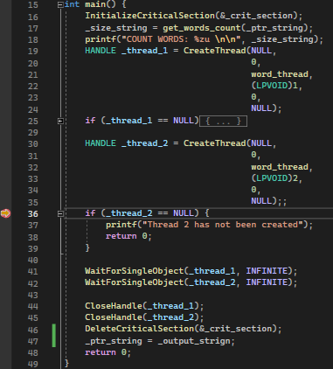
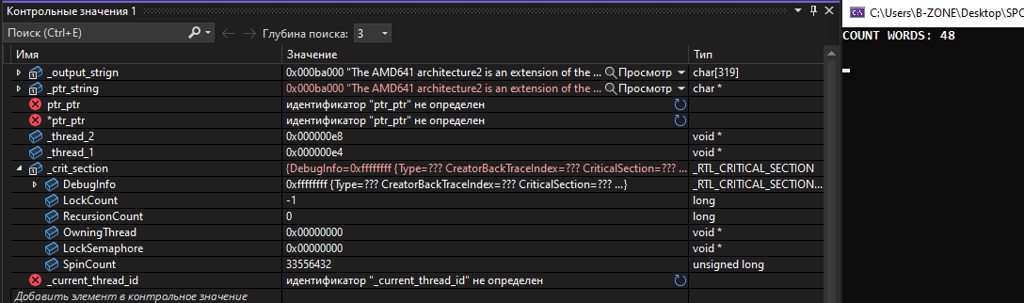
Вторая точка остановки: функция word_thread(). Вывод первого слова в первой нити за счёт функции word_print().
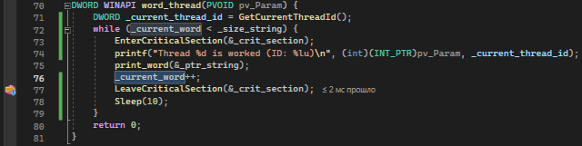
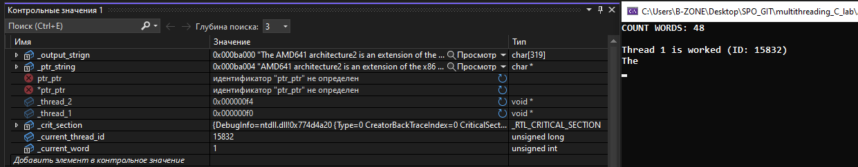
Третья точка остановки: функция word_thread(). Вывод второго слова во второй нити за счёт функции word_print().

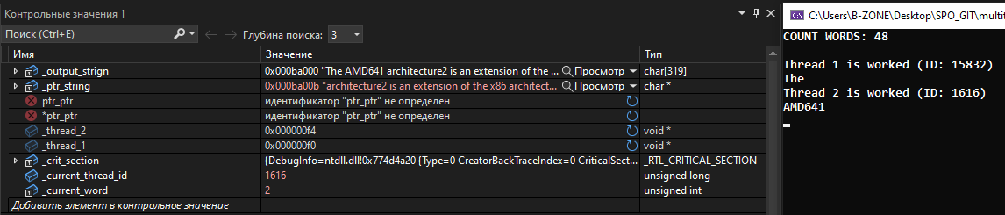
Четвёртая точка остановки: функция word_thread(). Вывод третьего слова во второй нити за счёт функции word_print().

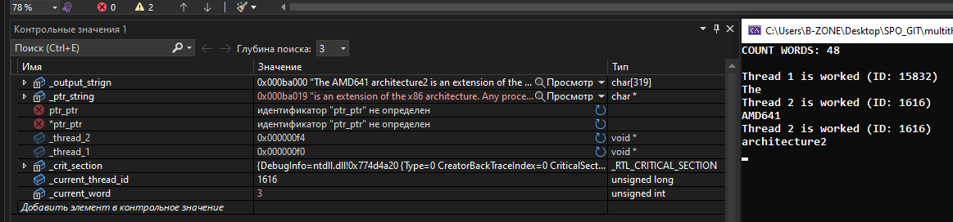
Консольный лог:
COUNT WORDS: 48

Thread 1 is worked (ID: 15832)
The
Thread 2 is worked (ID: 1616)
AMD641
Thread 2 is worked (ID: 1616)
architecture2
Thread 1 is worked (ID: 15832)
is
Thread 1 is worked (ID: 15832)
an
Thread 2 is worked (ID: 1616)
extension
Thread 2 is worked (ID: 1616)
of
Thread 1 is worked (ID: 15832)
the
Thread 2 is worked (ID: 1616)
x86
Thread 1 is worked (ID: 15832)
architecture.
Thread 1 is worked (ID: 15832)
Any
Thread 2 is worked (ID: 1616)
processor
Thread 1 is worked (ID: 15832)
implementing
Thread 2 is worked (ID: 1616)
the
Thread 2 is worked (ID: 1616)
AMD64
Thread 1 is worked (ID: 15832)
architecture
Thread 1 is worked (ID: 15832)
specification
Thread 2 is worked (ID: 1616)
will
Thread 2 is worked (ID: 1616)
also
Thread 1 is worked (ID: 15832)
provide
Thread 2 is worked (ID: 1616)
compatibility
Thread 1 is worked (ID: 15832)
modes
Thread 1 is worked (ID: 15832)
for
Thread 2 is worked (ID: 1616)
previous
Thread 2 is worked (ID: 1616)
descendants
Thread 1 is worked (ID: 15832)
of
Thread 1 is worked (ID: 15832)
the
Thread 2 is worked (ID: 1616)
Intel
Thread 2 is worked (ID: 1616)
8086
Thread 1 is worked (ID: 15832)
architecture,
Thread 2 is worked (ID: 1616)
including
Thread 1 is worked (ID: 15832)
32
Thread 1 is worked (ID: 15832)
-
Thread 2 is worked (ID: 1616)
bitprocessors
Thread 2 is worked (ID: 1616)
such
Thread 1 is worked (ID: 15832)
as
Thread 1 is worked (ID: 15832)
the
Thread 2 is worked (ID: 1616)
Intel
Thread 2 is worked (ID: 1616)
386,
Thread 1 is worked (ID: 15832)
Intel
Thread 2 is worked (ID: 1616)
Pentium,
Thread 1 is worked (ID: 15832)
and
Thread 1 is worked (ID: 15832)
AMD
Thread 2 is worked (ID: 1616)
K6
Thread 2 is worked (ID: 1616)
-
Thread 1 is worked (ID: 15832)
2
Thread 1 is worked (ID: 15832)
processor.
Thread 2 is worked (ID: 1616)
Нажмите любую клавишу, чтобы закрыть это окно:
Выводы: познакомились c организацией критических секций при помощи структры CRITICAL_SECTION, а также работы с ней с использованием функций: InitializeCriticalSection(), DeleteCriticalSection(), EnterCriticalSection(), LeaveCriticalSection().

