Пензенский государственный университет
Кафедра «Вычислительная техника»

ОТЧЕТ
по лабораторной работе №5
по курсу «Основы ОС»
на тему: «Динамически загружаемые библиотеки»

Выполнили студенты группы 23ВВВ3 бригады 8:
Полиневский В.В.
Кизым И.А.
Проверили:
Федюнин Р.А.
Егоров В. Ю.

2025
Цель работы: Изучить связывание процесса с динамически загружаемыми
библиотеками на этапе загрузки и на этапе выполнения.

Задачи: Необходимо разработать программу, состоящую из головной
программы и двух динамически загружаемых библиотек. Одна библиотека
должна загружаться с использованием динамического связывания, а
другая – с использованием функции LoadLibrary. Библиотеки должны
выполнять действия по вариантам заданий из лабораторной работы №4.

Практическая часть:
Листинг client.c
#include <stdio.h>
#include <Windows.h>
#include <string.h>
#include <conio.h>
#include <sysinfoapi.h>
unsigned int tiks_in_second = 10000000;
LPCTSTR SlotName = TEXT("\\\\DESKTOP-UQN8AN0\\mailslot\\network_timesync");
size_t MaxCountMsg = 30;
int main() {
SYSTEMTIME client_st;
HANDLE hMailSlot;
DWORD bytesWritten;
BOOL success;
size_t count_msg = 0;
hMailSlot = CreateFile(SlotName,
GENERIC_WRITE,
FILE_SHARE_READ,
NULL,
OPEN_EXISTING,
FILE_ATTRIBUTE_NORMAL,
NULL);
if (hMailSlot == INVALID_HANDLE_VALUE) {
printf("ERROR: Opening with mailslot %d\n", GetLastError());
return 1;
}
while (count_msg < MaxCountMsg) {
GetSystemTime(&client_st);
success = WriteFile(
hMailSlot,
&client_st,
sizeof(SYSTEMTIME),
&bytesWritten,
NULL);
if (success && bytesWritten == sizeof(SYSTEMTIME)) {
printf("SystemTime is sent\n");
count_msg++;
}
else printf("SystemTime is not sent\n");
Sleep(1000);
}
CloseHandle(hMailSlot);
return 1;
}
Листинг source.c
#include <Windows.h>
#include "static_DDL.h"
#include <stdio.h>
#include <sysinfoapi.h>

typedef HANDLE(WINAPI* P_CreateWaitTimer)();
typedef HANDLE(WINAPI* P_MakeSlot)();
typedef BOOL(WINAPI* P_check_status_MailSlot)(HANDLE);
typedef void (WINAPI* P_printf_info)(ULONGLONG);

P_CreateWaitTimer p_CreateWaitTimer;
P_MakeSlot p_MakeSlot;
P_check_status_MailSlot p_check_status_MailSlot;
P_printf_info p_printf_info;

size_t MaxCountMsg = 30;
LARGE_INTEGER dueTime;
LONGLONG time_timer = -100000000;

int main() {
HMODULE hDll;
HANDLE hMailSlot, hTimer;
SYSTEMTIME server_st, client_st;
ULARGE_INTEGER server_ui, client_ui;
size_t count_msg = 0;

hDll = LoadLibrary(TEXT("dynamicDDL.dll"));
if (!hDll) {
printf("Error loading dll");
return 1;
}

p_CreateWaitTimer = (P_CreateWaitTimer)GetProcAddress(hDll, "?CreateWaitTimer@@YAPEAXXZ");
p_MakeSlot = (P_MakeSlot)GetProcAddress(hDll, "?MakeSlot@@YAPEAXXZ");
p_check_status_MailSlot = (P_check_status_MailSlot)GetProcAddress(hDll, "?check_status_MailSlot@@YAHPEAX@Z");
p_printf_info = (P_printf_info)GetProcAddress(hDll, "?print_info@@YAX_K@Z");

hMailSlot = p_MakeSlot();
if (hMailSlot == NULL) {
printf("Error create MailSlot\n");
return 1;
}
hTimer = p_CreateWaitTimer();
if (hTimer == NULL) {
printf("Error create WaitTimer\n");
return 1;
}
dueTime.QuadPart = time_timer;
if (!SetWaitableTimer(hTimer, &dueTime, 0, NULL, NULL, FALSE)) {
printf("SetWaitableTimer failed: %d\n", GetLastError());
return 1;
}

while (count_msg < MaxCountMsg) {
if (WaitForSingleObject(hTimer, 0) == WAIT_OBJECT_0) {
printf("!!! TIMEOUT: No messages received within 10 seconds !!!\n");
printf("Server stopping. Received: %zu/%zu messages\n", count_msg, MaxCountMsg);
break;
}
if (!p_check_status_MailSlot(hMailSlot)) {
if (!get_client_SystemTime(hMailSlot, &client_st)) {
GetSystemTime(&server_st);
server_ui = convert_ST_in_UI(&server_st);
client_ui = convert_ST_in_UI(&client_st);
p_printf_info(Differt_UI_in_sec(&server_ui, &client_ui));
count_msg++;
SetWaitableTimer(hTimer, &dueTime, 0, NULL, NULL, FALSE);
}
else
return 1;
}
else
Sleep(20);
}

CloseHandle(hTimer);
CloseHandle(hMailSlot);
FreeLibrary(hDll);
return 0;
}
Листинг Dynamic_DLL.cpp:
#include "pch.h"
#include "framework.h"
#include "dynamic_DDL.h"

LPCWSTR SlotName = TEXT("\\\\.\\mailslot\\network_timesync");

DYNAMICDDL_API HANDLE WINAPI MakeSlot() {
HANDLE hMailSlot = CreateMailslot(SlotName, 0, MAILSLOT_WAIT_FOREVER, (LPSECURITY_ATTRIBUTES)NULL);
if (hMailSlot == INVALID_HANDLE_VALUE) {
printf("CreateMailSlot failed with %d\n", GetLastError());
return NULL;
}
return hMailSlot;
}

DYNAMICDDL_API BOOL check_status_MailSlot(HANDLE hMailSlot) {
BOOL return_code;
DWORD next_size, msg_number;
return_code = GetMailslotInfo(hMailSlot, NULL, &next_size, &msg_number, NULL);
if (return_code == FALSE) {
printf("error GETMAILSLOTINFO\n");
return TRUE;
}
if (next_size == MAILSLOT_NO_MESSAGE) {
//printf("No messages \n");
return TRUE;
}
return FALSE;
}

DYNAMICDDL_API inline void print_info(ULONGLONG diff) {
SYSTEMTIME server_LT;
GetLocalTime(&server_LT);
printf("%02d:%02d:%02d --- time difference of two pcs: %llu \n",
server_LT.wHour, server_LT.wMinute, server_LT.wSecond, diff);
}

DYNAMICDDL_API HANDLE CreateWaitTimer() {
HANDLE hTimer;
hTimer = CreateWaitableTimer(NULL, FALSE, NULL);
if (hTimer == INVALID_HANDLE_VALUE) {
printf("Create WaitTimer failed with %d\n", GetLastError());
return NULL;
}
return hTimer;
}
Листинг Static_DLL.cpp:
#include "pch.h"
#include "framework.h"
#include "static_DDL.h"

//unsigned int tiks_in_second = 10000000;
unsigned int tiks_in_msecond = 10000;

STATICDDL_API BOOL get_client_SystemTime(HANDLE hMailSlot, SYSTEMTIME* client_st) {
DWORD bytes_read;
BOOL success;
success = ReadFile(hMailSlot, client_st, sizeof(SYSTEMTIME), &bytes_read, NULL);

if (!success) {
printf("ReadFile failed: %d\n", GetLastError());
return TRUE;
}
if (bytes_read != sizeof(SYSTEMTIME)) {
printf("Invalid data size: received %d bytes, expected %zu\n",
bytes_read, sizeof(SYSTEMTIME));
return TRUE;
}
return FALSE;
}
STATICDDL_API ULARGE_INTEGER convert_ST_in_UI(SYSTEMTIME* ST) {
FILETIME FT;
ULARGE_INTEGER UI;
SystemTimeToFileTime(ST, &FT);
memcpy(&UI, &FT, sizeof(FT));
return UI;
}
STATICDDL_API ULONGLONG Differt_UI_in_sec(ULARGE_INTEGER* server_UI, ULARGE_INTEGER* client_UI) {
ULONGLONG diff;
if (server_UI->QuadPart > client_UI->QuadPart)
diff = server_UI->QuadPart - client_UI->QuadPart;
else
diff = client_UI->QuadPart - server_UI->QuadPart;
return diff / (ULONGLONG)tiks_in_msecond;
}
Отладка
Первая точка остановки: создание почтового ящика и системного таймера, инициализация структур для хранения системного времени.
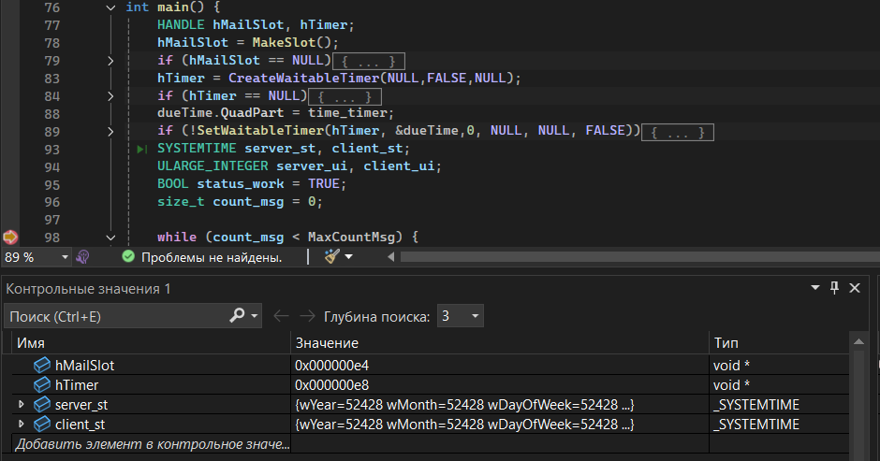
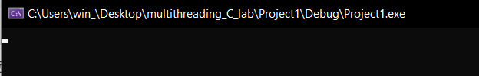
Вторая точка остановки: цикл серверного процесса - вывод разницы во времени на экран
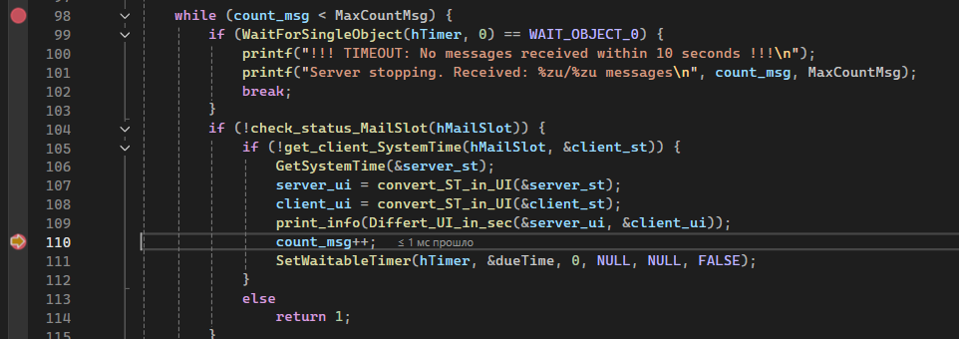
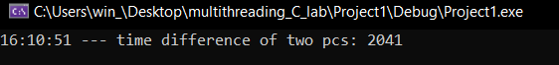
Консольный лог:
16:12:08 --- time difference of two pcs: 8
16:12:09 --- time difference of two pcs: 32
16:12:10 --- time difference of two pcs: 31
16:12:11 --- time difference of two pcs: 32
16:12:12 --- time difference of two pcs: 31
16:12:13 --- time difference of two pcs: 32
16:12:15 --- time difference of two pcs: 32
16:12:16 --- time difference of two pcs: 32
16:12:17 --- time difference of two pcs: 32
16:12:18 --- time difference of two pcs: 32
16:12:19 --- time difference of two pcs: 32
16:12:20 --- time difference of two pcs: 31
16:12:21 --- time difference of two pcs: 31
16:12:22 --- time difference of two pcs: 31
16:12:23 --- time difference of two pcs: 31
16:12:24 --- time difference of two pcs: 32
16:12:25 --- time difference of two pcs: 32
16:12:26 --- time difference of two pcs: 31
16:12:27 --- time difference of two pcs: 31
16:12:28 --- time difference of two pcs: 30
16:12:29 --- time difference of two pcs: 31
16:12:30 --- time difference of two pcs: 31
16:12:31 --- time difference of two pcs: 32
16:12:32 --- time difference of two pcs: 32
16:12:33 --- time difference of two pcs: 31
16:12:34 --- time difference of two pcs: 31
16:12:35 --- time difference of two pcs: 31
16:12:36 --- time difference of two pcs: 31
16:12:37 --- time difference of two pcs: 32
16:12:38 --- time difference of two pcs: 32
C:\Users\win_\Desktop\multithreading_C_lab\Project1\Debug\Project1.exe (процесс 9684) завершил работу с кодом 0 (0x0).
Выводы: познакомились с созданием динамических библиотек с явным связыванием на этапе выполнения и статическим связыванием на этапе компоновки. Разработали проект, содержащий в себе оба типа динамических библиотек с их подключением.

