Coding Challege 4

Sam Donohoo

2025-01-27

Table of Contents

Question 1 1

Question 2 1

Individual Graphs 1

T-Tests 4

Combined Figure 7

Question 6 8

library(knitr)  
library(ggplot2)  
library(markdown)

# Question 1

**Explain a YAML Header:** A header that lists the title, author, date, and output formats for the markdown.

**Explain Literate Programming:** Coding organized into small sections to be more easily read.

# Question 2

#### Take the code you wrote for coding challenge 3, question 5, and incorporate it into your R markdown file.

Data from Noel, Z.A., Roze, L.V., Breunig, M., Trail, F. 2022. Endophytic fungi as promising biocontrol agent to protect wheat from Fusarium graminearum head blight. Plant Disease. <https://doi.org/10.1094/PDIS-06-21-1253-RE>

### Individual Graphs

# Load in Libraries  
library(tidyverse)  
library(ggpubr)  
library(ggrepel)  
  
# Make a color-blind friendly palette  
cbbPalette <- c("#E69F00", "#56B4E9", "#009E73", "#F0E442", "#0072B2", "#D55E00", "#CC79A7", "#000000")  
  
# Load in Data  
myco <- read.csv("MycotoxinData.csv", header = TRUE, na.strings = "na")  
  
# Reorder by Treatment Level  
myco$Treatment <- factor(myco$Treatment, levels = c("NTC", "Fg", "Fg + 37", "Fg + 40", "Fg + 70"))  
  
#### Graph the effects of DON by Treatment  
myco.don.Q1 <- ggplot(myco, aes(x = Treatment, y = DON, color = Cultivar, fill = Cultivar)) +  
 geom_boxplot(outlier.shape = NA, color = "black") +  
 geom_point(aes(fill=Cultivar), pch=21, color = "black",   
 position=position_jitterdodge(dodge.width=0.85), alpha = 0.6) +   
 scale_color_manual(values = cbbPalette) +  
 scale_fill_manual(values = cbbPalette) +   
 ylab("DON (ppm)") +  
 xlab("") +  
 theme_classic() +  
 facet_wrap(~Cultivar)  
  
myco.don.Q1

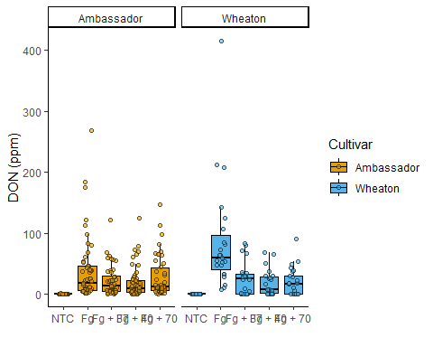

### Graph the effects of X15ADON by Treatment  
myco.don.Q3.1 <- ggplot(myco, aes(x = Treatment, y = X15ADON, color = Cultivar, fill = Cultivar)) +  
 geom_boxplot(outlier.shape = NA, color = "black") +  
 geom_point(aes(fill=Cultivar), pch=21, color = "black",   
 position=position_jitterdodge(dodge.width=0.85), alpha = 0.6) +   
 scale_color_manual(values = cbbPalette) +  
 scale_fill_manual(values = cbbPalette) +   
 ylab("15ADON (ppm)") +  
 xlab("") +  
 theme_classic() +  
 facet_wrap(~Cultivar)  
  
myco.don.Q3.1

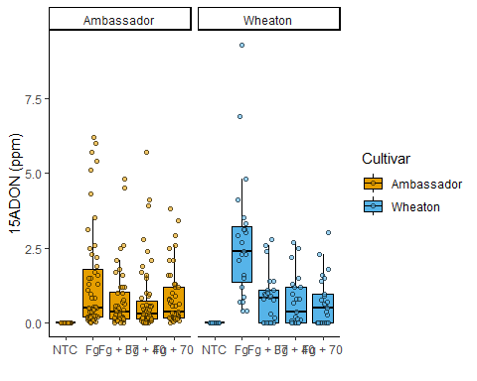

### Graph the effects of MassperSeed_mg by Treatment  
myco.don.Q3.2 <- ggplot(myco, aes(x = Treatment, y = MassperSeed_mg, color = Cultivar, fill = Cultivar)) +  
 geom_boxplot(outlier.shape = NA, color = "black") +  
 geom_point(aes(fill=Cultivar), pch=21, color = "black",   
 position=position_jitterdodge(dodge.width=0.85), alpha = 0.6) +   
 scale_color_manual(values = cbbPalette) +  
 scale_fill_manual(values = cbbPalette) +   
 ylab("Seed Mass (mg)") +  
 xlab("") +  
 theme_classic() +  
 facet_wrap(~Cultivar)  
  
myco.don.Q3.2

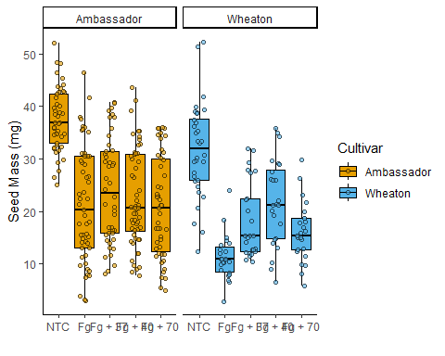

### T-Tests

# Question 1 + Ttest  
myco.don.Q1.Ttest <- myco.don.Q1 +   
 geom_pwc(aes(group = Treatment), method = "t_test", label = "{p.adj.signif}")  
  
myco.don.Q1.Ttest

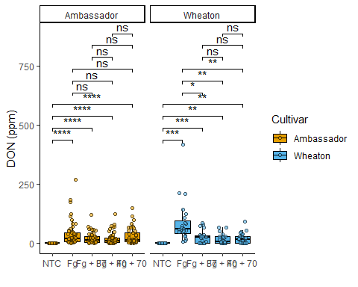

# Question 3 - 15ADON + Ttest  
myco.don.Q3.1.Ttest <- myco.don.Q3.1 +   
 geom_pwc(aes(group = Treatment), method = "t_test", label = "{p.adj.signif}")  
  
myco.don.Q3.1.Ttest

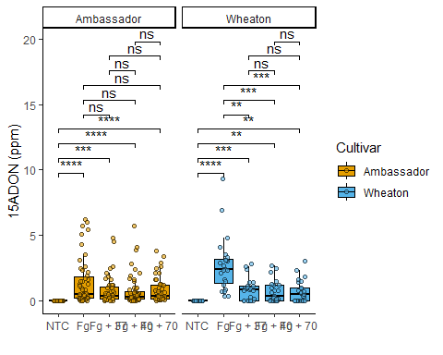

# Question 3 - MassperSeed_mg + Ttest  
  
myco.don.Q3.2.Ttest <- myco.don.Q3.2 +   
 geom_pwc(aes(group = Treatment), method = "t_test", label = "{p.adj.signif}")  
  
myco.don.Q3.2.Ttest

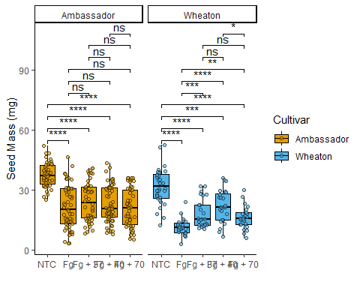

### Combined Figure

myco.don.Ttest <- ggarrange(  
 myco.don.Q1.Ttest, # First plot: Q1 Ttest  
 myco.don.Q3.1.Ttest, # Second plot: Q3.1 Ttest  
 myco.don.Q3.2.Ttest, # Third plot: Q3.2 Ttest  
 labels = "AUTO", # Automatically label the plots (A, B, C, etc.)  
 nrow = 1, # Arrange the plots in 3 rows  
 ncol = 3, # Arrange the plots in 1 column  
 legend = FALSE # Do not include a legend in the combined figure  
)  
  
myco.don.Ttest

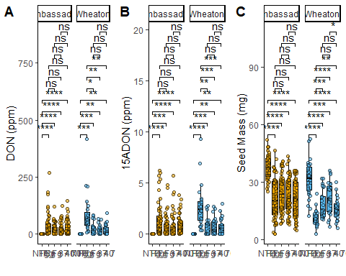

# Question 6

Sam Donohoo GitHub Link: <https://github.com/sad0046/PLPA6820_SP25.git>