## Inhaler Cap Design

* The current design uses Bluetooth 2.1
* New design will use Bluetooth 4.0 module to extend battery life. It is not supported in old phones.  
  The link to Bluetooth 4.0 is : <http://www.bluetooth.com/Pages/Bluetooth-Smart-Devices-List.aspx>

## When device is turned on:

1. Start listening to button presses.

## When discovery mode button is pressed:

1. Enter discovery mode
2. Possibly flash LED?

## When Bluetooth is paired:

1. Disable broadcasting to other devices. (only stay paired to one device)

## When GetData command is received from phone:

1. Send all timestamps in memory to phone over Bluetooth.
2. Send the number of timestamps sent to the phone over Bluetooth
3. Wait for phone to acknowledge that it received the all the timestamps.

## When DeleteData command is received from phone:

1. Delete all timestamps in memory
2. Send acknowledgement to phone over Bluetooth.

## When GetStatus command is received from phone:

1. Read battery voltage level.
2. Convert to a percentage and send to phone.

## When inhaler is used:

1. Get current time
2. Store data in memory

## Battery Life:

Using a CR2032 coin cell battery (non-rechargeable) capacity is 210mAh.

Power mode 1 = 270uA

mode 2 = 1uA

mode 3 = .5uA

Ideally if the device can stay in power mode 1 most of the time it should consume <300uA.

$$\# Days= \frac{8750uA*Day}{300uA}=29 days or ≈1 month$$

Ideally if the device can stay in power mode 2 or 3 most of the time it should consume <10uA.

$$\# Days= \frac{8750uA*Day}{10uA}=875 days ≈ >2 years$$

## Timer:

I am not aware of any way to get the actual time from the Bluetooth module without asking the phone for the time. The issue with this is that asking the phone for the time obviously does not work when the device is not connected to the phone. The way I plan to get around this is have a counter. When the inhaler is used store the use as a 0 in memory. Then every X interval add 1. That way when the phone receives the data it can trace back how long ago the data was used.

$$Use Time=Current time-(Counter*X interval)$$

To keep track of the intervals there are two options.

Option 1 is to attempt to keep track of time using internal oscillator.

Pros

* No extra parts, reduced size.

Cons

* Not as accurate as external oscillator.
* Could prevent the device from entering certain power modes.

Option 2 is to attempt to keep track of time using external oscillator.

Pros

* Better accuracy than internal oscillator.
* More likely to allow lower power modes than internal oscillator.

Cons

* Extra part, increase in size.

## Programming setup:

In order to program the BLE113 chip 7 pins need to be connected to the programmer.

BLE113 - CC Debugger

GND – GND

AVDD – Target Voltage Sense

AVDD – 3.3V

DVDD – Target Voltage Sense

DVDD – 3.3V

P2-2 – Debug Clock

P2_1 – Debug Data

P0_0 – RESETn

Reset – RESETn

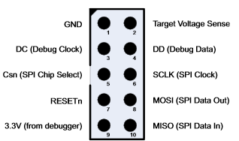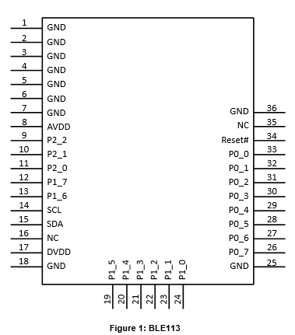

BLE113

CC Debugger