Similar Work here:

* <http://www.ncbi.nlm.nih.gov/pmc/articles/PMC2682572/>
* <https://en.wikipedia.org/wiki/Kalman_filter>

See people and applications could benefit from this work:

* <https://support.strava.com/hc/en-us/community/posts/208836527-Correct-and-Edit-bad-GPS-points-in-an-Activity>
* <http://gis.stackexchange.com/questions/15258/how-to-filter-wrong-gps-readings>
* <http://stackoverflow.com/questions/1134579/smooth-gps-data>
* <http://www.cs.unc.edu/~welch/kalman/Levy1997/index.html>

When we measure GPS readings for locations, most times we get a good reading. However, in some cases, we see a GPS reading that is way off. I notice a location reading in a specific spot when I am in the vicinity, even though I did not visit that location. I am not sure why that happens; is it because some locations have somethings that it is known by GPS reader - is this known in GPS community to ignore those points as invalid?

For example: See the following pictures:

In the last figure, the point in the ocean is a sporadic point.

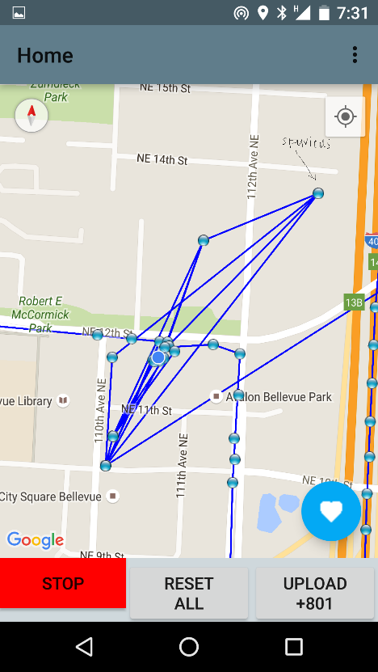 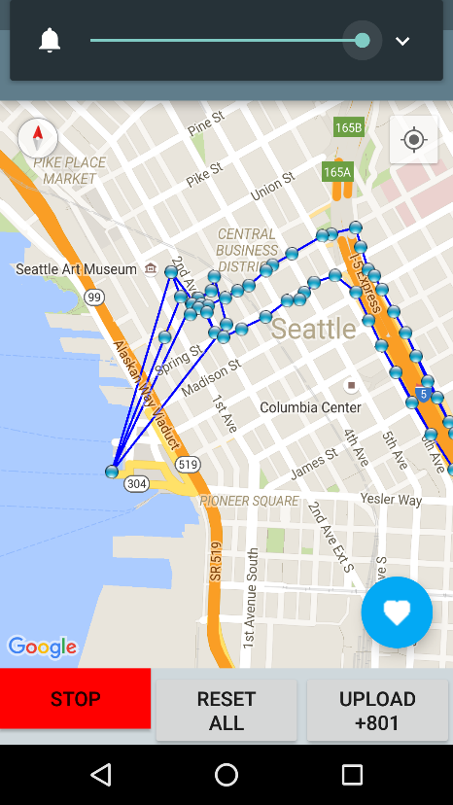

Spurious Points

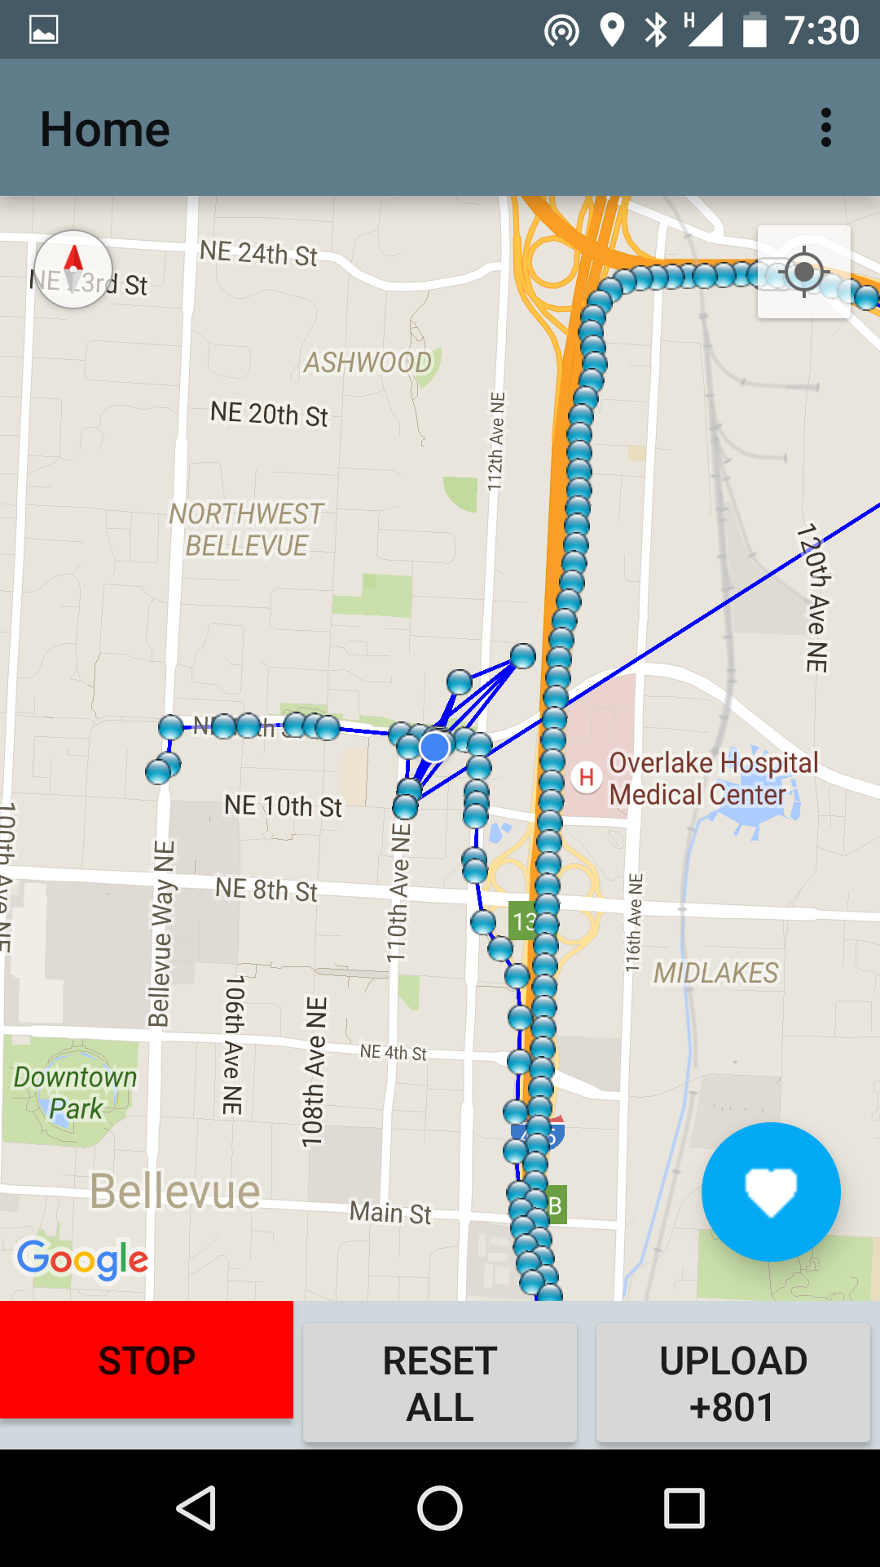

Anyway, sometimes I see readings, when I am not moving, that are invalid. We wanted to know which of these location readings are invalid. We have an accuracy field, but it is not always a good indicator.

Based on some observation, we identified the pattern of locations. It seems our accuracy is varying between 98 - 100% accuracy to detect incorrect GPS readings.

The best machine learning classification we found was "Decision Tree - using GINI to identify the information gain".

I think there are some issues in our data collection for this prediction. Once we fix those, we may reach 100% accuracy. I realize this does not clearly give a picture of False positive or False negative.

We plan to conduct those precise study as next step.

We want to know, through existing research, if there are any works relating to this. Is this publishable?