DecodeLabs — Data Analytics Internship
Project 2: Exploratory Data Analysis (EDA)
E-Commerce Order Dataset — 1,200 Orders (Jan 2023 – Jun 2025)

1. Problem Statement
DecodeLabs' e-commerce order data must be analyzed to understand purchasing patterns, revenue drivers, and operational risks before any dashboard or predictive model is built. This report answers three questions: (1) What do the core statistics tell us about a typical order? (2) Are there trends over time or outliers that need investigation? (3) What actionable insight can be handed to stakeholders?

2. Methodology
The dataset (Cleaned_Dataset_In_Excel.xlsx) contains 1,200 order records across 14 fields, including Quantity, UnitPrice, TotalPrice, ItemsInCart, Product, PaymentMethod, OrderStatus, CouponCode and ReferralSource. The dataset was verified to be free of missing values or malformed entries. Analysis was performed in Python (pandas, matplotlib) covering:
- Descriptive statistics: mean, median, standard deviation, five-number summary
- Outlier detection using the IQR method (1.5×IQR fence)
- Time-series aggregation to identify monthly revenue trends
- Correlation analysis (Pearson coefficient) between numeric fields
- Categorical breakdowns across product, payment method, order status, referral source and coupon usage

3. Key Findings

3.1 Descriptive Statistics
The table below summarizes the core distributions (n = 1,200 orders):
1,200  Total Orders | $1.26M  Total Revenue | $1,053.97  Avg Order Value | $823.62  Median Order Value

Order value (Mean $1,053.97 vs. Median $823.62) is right-skewed — a small number of large bulk orders pull the average well above the typical order. This means the mean overstates what a 'typical' customer spends; the median is the more reliable planning figure. Unit price is close to symmetric (mean $356.41, median $364.21). The average order includes ~3 units (median 3) from a cart containing ~5.5 items (median 5), indicating most shoppers add extra items but only purchase a subset.
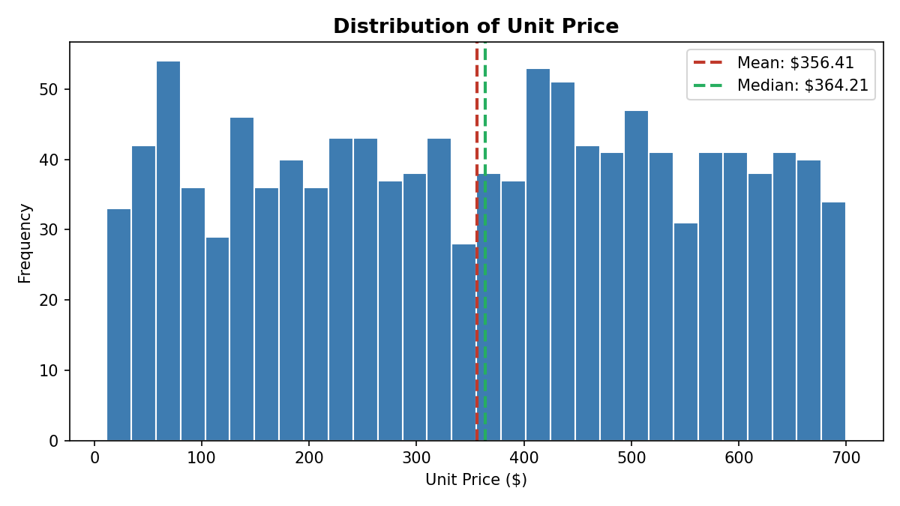
Figure 1 — Distribution of Unit Price. Mean and median are close, indicating a roughly symmetrical spread.

3.2 Outlier Detection
Applying the IQR rule (Q1 − 1.5×IQR to Q3 + 1.5×IQR) to Total Price flags 8 orders (0.7% of the dataset) above $3,330.41 as statistical outliers. Investigation shows these are all legitimate bulk purchases — each has the maximum observed quantity (5 units) combined with a premium unit price (Tablets, Laptops, Monitors, Printers). None show signs of data entry error, so these are signal, not noise: they represent DecodeLabs' highest-value transactions and are candidates for a VIP/bulk-buyer follow-up program rather than data cleaning.
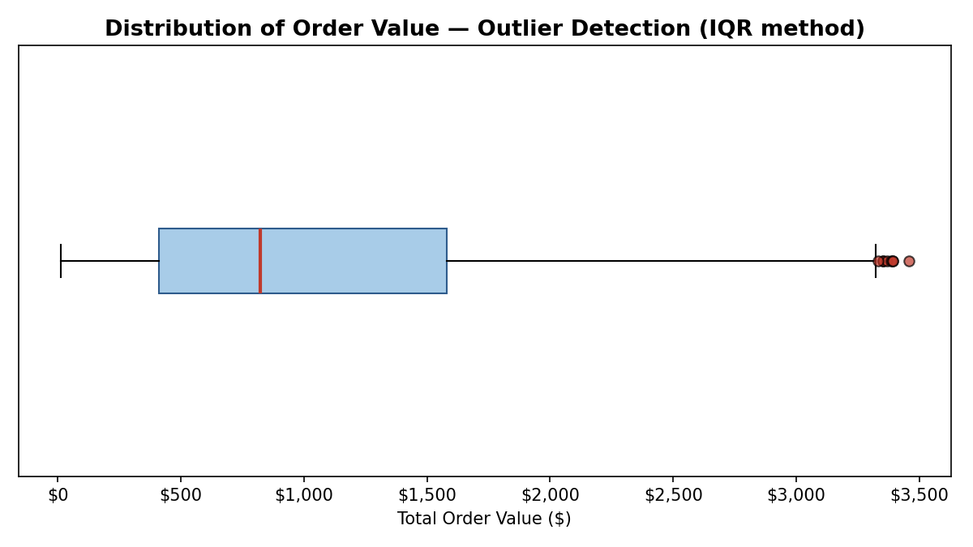
Figure 2 — Boxplot of Total Order Value. Red dots beyond the whiskers are the 8 flagged high-value bulk orders.

3.3 Revenue Trend Over Time
Monthly revenue fluctuates between roughly $27,700 and $68,100 with no strong upward or downward trend across the 30-month window, and no clear seasonal peak (e.g., no consistent holiday spike). This is consistent with month-to-month order counts also varying narrowly (27–53 orders/month), suggesting demand is currently steady rather than growing — a signal that acquisition/marketing efforts have not yet produced compounding growth.
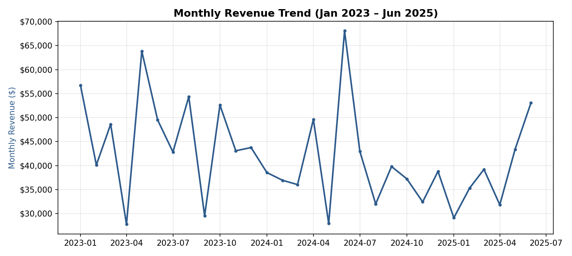
Figure 3 — Monthly Revenue, January 2023 – June 2025.

3.4 Product & Category Performance
Revenue is spread fairly evenly across the seven product categories, with Chairs ($195,620) and Printers ($195,613) narrowly leading and Phones trailing ($151,722). No single product dominates, so revenue risk is not concentrated in one SKU.
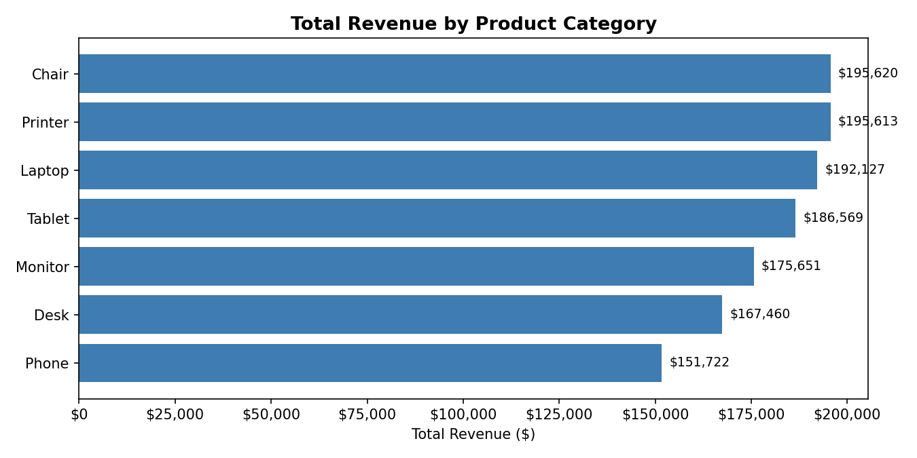
Figure 4 — Total Revenue by Product Category.

3.5 Order Fulfilment Risk
Order status is nearly evenly split across five states, but Cancelled (20.8%) and Returned (20.6%) together account for 41.4% of all orders — meaning more than 2 in 5 orders never convert into completed revenue. This is the single largest risk signal in the dataset and warrants root-cause investigation (payment failures, shipping delays, product mismatch, etc.).
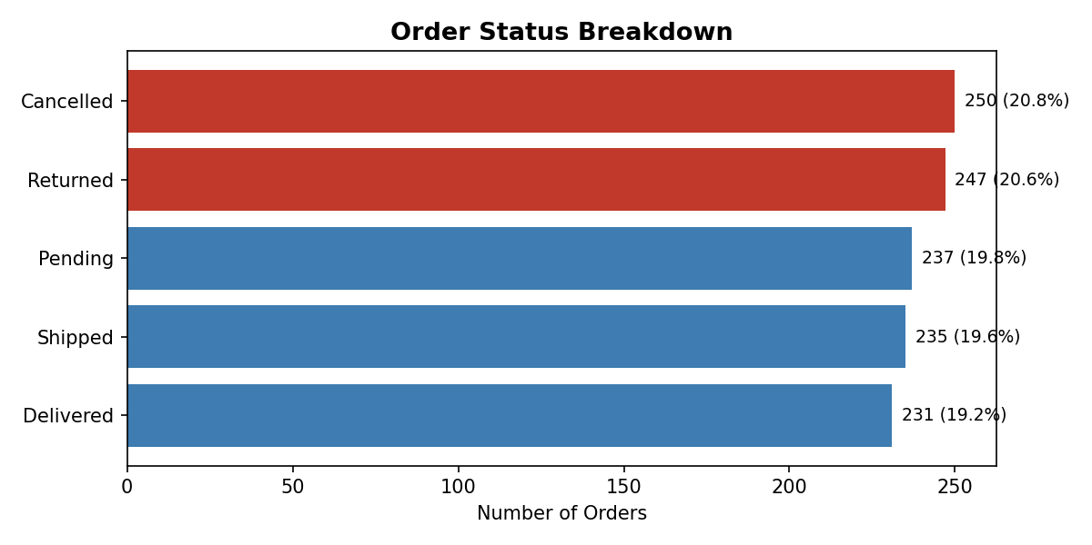
Figure 5 — Order Status Breakdown. Cancelled and Returned orders are highlighted in red.

3.6 Correlation Analysis
Total Price correlates strongly with Unit Price (r = 0.72) and moderately with Quantity (r = 0.62), confirming order value is driven by both how much an item costs and how many units are bought — as expected structurally. Quantity and Items-in-Cart correlate moderately (r = 0.65), while Unit Price is essentially uncorrelated with Quantity (r = 0.01) and Items-in-Cart (r = 0.00). This means customers are not systematically buying more units of cheaper items or vice versa — quantity decisions appear independent of price point.
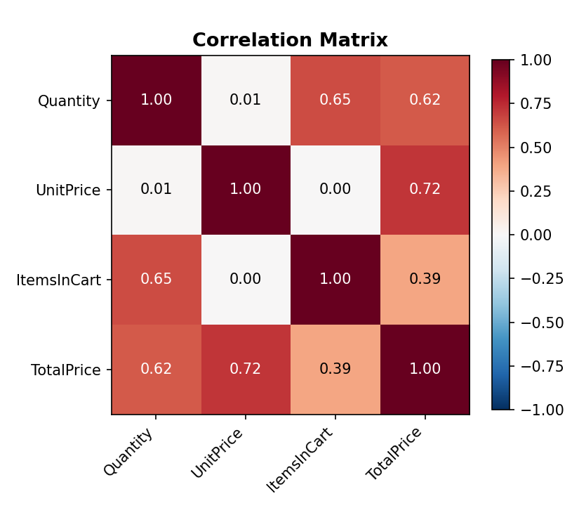
Figure 6 — Pearson Correlation Matrix of Numeric Fields.

4. Synthesizing the Case — "So What?"
What the Data Says | Business Diagnosis / So-What
Mean order value ($1,053.97) sits well above the median ($823.62). | The revenue distribution is right-skewed by bulk buyers. Use the median, not the mean, when setting typical-customer benchmarks or promotional thresholds.
8 orders (0.7%) are statistical outliers, all high-value bulk purchases. | These are DecodeLabs' highest-value customers — worth a dedicated bulk/VIP outreach program rather than exclusion as 'errors.'
Cancelled + Returned orders = 41.4% of all orders. | Roughly 2 in 5 orders fail to convert to retained revenue. This is the top operational priority — a root-cause review of checkout, payment, and fulfilment could recover a meaningful share of the $1.26M gross order value.
Monthly revenue is flat with no clear growth trend or seasonality. | Current marketing/acquisition activity is maintaining, not growing, demand. A seasonal promotional calendar or acquisition push could be tested to create trend lift.
Product revenue is evenly distributed across 7 categories (no dominant SKU). | Inventory and marketing risk is naturally diversified — no single-product dependency to protect against.
Total Price correlates with Unit Price (r=0.72) and Quantity (r=0.62); Unit Price and Quantity are uncorrelated (r=0.01). | Bundle or volume-discount offers can be designed independently of price tier, since customers don't already self-select higher quantities at lower prices.

5. Recommendations
- Report median order value ($823.62), not mean, in leadership dashboards to avoid overstating typical customer spend.
- Launch a root-cause investigation into the 41.4% Cancelled/Returned rate — segment by payment method and referral source to isolate the driver.
- Create a bulk-buyer outreach segment from the 8 identified high-value outlier orders and monitor for repeat-purchase patterns.
- Test a promotional calendar against the flat monthly revenue trend to establish whether seasonality can be created rather than assumed.
- Pilot volume-based bundle pricing, since quantity and unit price currently move independently of each other.

6. Conclusion
This EDA milestone confirms the dataset is clean, well-structured, and ready for deeper modeling. The clearest actionable finding is the 41.4% cancellation/return rate — the single highest-leverage issue for the business. Order value skew and the presence of legitimate bulk-order outliers should inform how targets and VIP programs are set going forward. This report satisfies Project 2's requirements: descriptive statistics, trend and outlier identification, and a synthesized summary of observations translated into business impact.

