AWS NOTES:

EC2 instances Types Reference link

<https://aws.amazon.com/ec2/instance-types/>

Compute Optimized

Memory Optimized:

Storage Optimized:



EC2 Instance types:

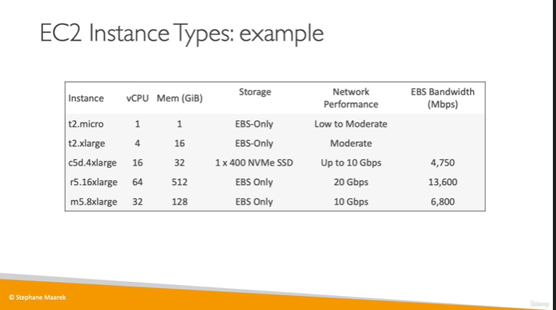

Security Groups:



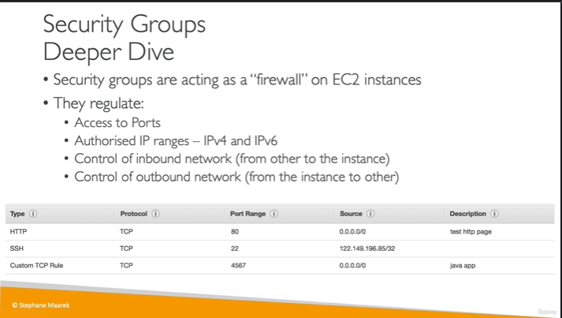



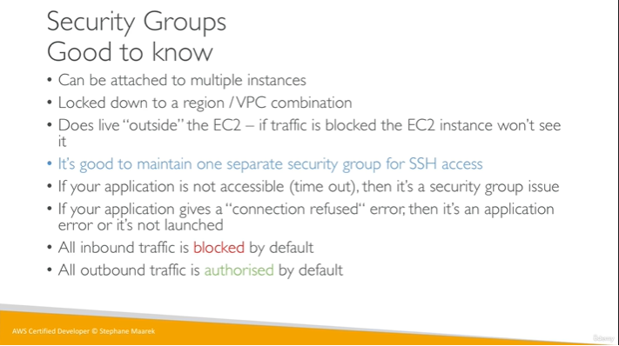

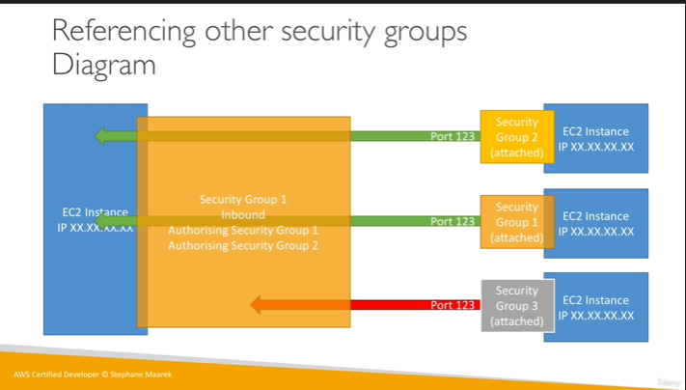

General Ports:

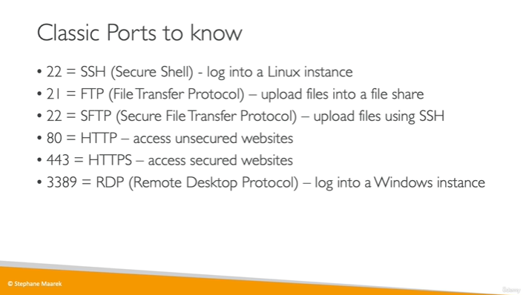

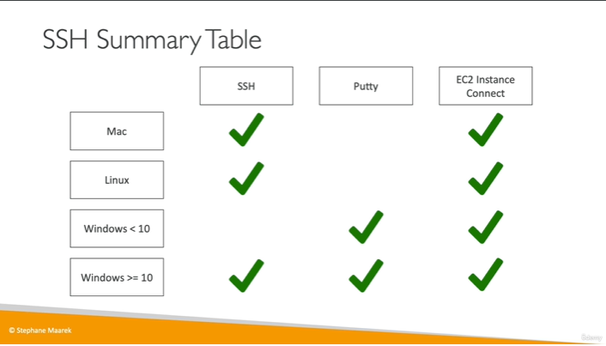

#!/bin/bash

#Use this for your user data(scrpt from top to bottom)

#install httpd (Linux 2 version)

yum update -y

yum install -y httpd

systemctl start httpd

systemctl enable httpd

echo “<h1>Hello World from $(hostname -f)</h1>” > /var/www/html/index.html