**ASSIGNMENT**

1. How internet works?

The internet is a global network of interconnected devices and networks that facilitate the transmission of data worldwide. It operates through a layered system where devices like computers and smartphones connect to local networks, which in turn connect to Internet Service Providers (ISPs).

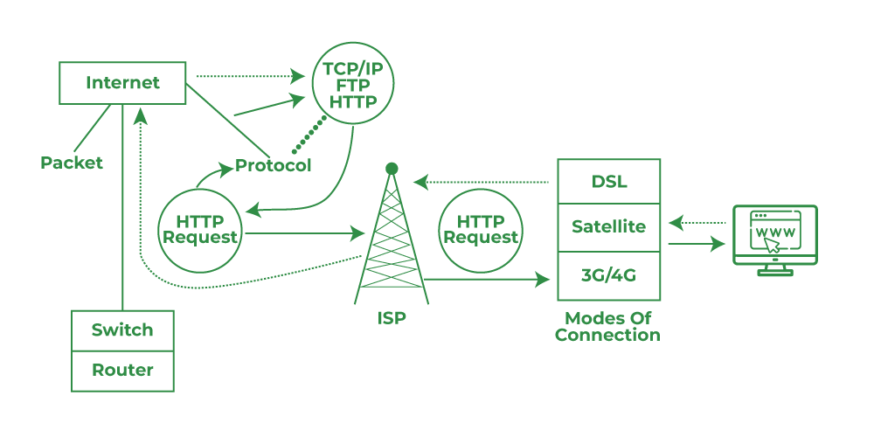

ISPs manage data centers and high-speed connections that form the backbone of the internet. When a user initiates an action, such as requesting a web page, data is broken down into packets that travel through routers across the internet backbone.

1. How browser works?

A web browser is software that allows users to access and navigate the World Wide Web. When a user enters a URL or clicks on a link, the browser initiates a series of processes. First, it sends a request to a Domain Name System (DNS) server to translate the human-readable domain name (like www.example.com) into an IP address that computers understand. Once the IP address is obtained, the browser sends a request to the appropriate web server. The server responds by sending back data, typically in the form of HTML, CSS, and JavaScript files that make up the web page. The browser then interprets and renders this data, displaying it as a visual webpage on the user's device.

1. What is Server?

A server is a specialized computer or software application that provides services or resources to other computers, known as clients, over a network. Servers can serve various purposes depending on the type of service they provide.

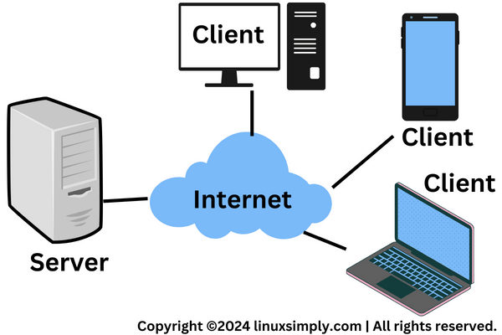

Web servers, for example, store and deliver web pages and content to clients who request them via web browsers. They handle incoming requests, process them, and send back the requested data (like HTML pages, images, videos) through the internet.

1. what are the types of server available?

• **Web Servers**: These servers store and deliver web pages and other web content to clients over the internet. They typically host websites and web applications, responding to HTTP requests from web browsers. Popular web server software includes Apache HTTP Server and Nginx.

• **File Servers**: File servers store and manage files that users can access and share over a network. They provide centralized storage for documents, media files, software updates, and more. Users can access files remotely using protocols like FTP (File Transfer Protocol) or SMB (Server Message Block).

• **Database Servers**: These servers manage databases, storing and retrieving data for client applications. They run database management systems (DBMS) like MySQL, PostgreSQL, Oracle Database, and Microsoft SQL Server. Database servers handle complex queries, transactions, and data integrity to ensure efficient data management.

• **Email Servers**: Email servers manage the storage and delivery of email messages between users within an organization or across the internet. They use protocols like SMTP (Simple Mail Transfer Protocol) for sending emails and IMAP (Internet Message Access Protocol) or POP3 (Post Office Protocol) for retrieving emails from a server to a client device.

• **Application Servers**: Application servers provide a platform for running and managing applications. They handle tasks like transaction processing, middleware integration, and managing communication between clients and backend systems. Examples include Java EE application servers like Apache Tomcat and IBM WebSphere.

• **Proxy Servers**: Proxy servers act as intermediaries between clients and other servers. They provide functionalities like caching frequently requested content, filtering incoming requests (e.g., for improved security or content control), and anonymizing client IP addresses.

• **FTP Servers**: FTP servers specialize in file transfer, allowing users to upload and download files using the File Transfer Protocol (FTP) or its secure variant, FTPS (FTP over SSL/TLS). They are commonly used for sharing large files over networks.

• **DNS Servers**: Domain Name System (DNS) servers translate domain names (like www.example.com) into IP addresses that computers understand. They facilitate the navigation of the internet by mapping human-readable domain names to numerical IP addresses.

• **Print Servers**: Print servers manage printing tasks within a network environment. They receive print jobs from client computers, queue them for printing, and communicate with printers to process and deliver print jobs efficiently.

1. What is SEO? Importance of SEO?

Search Engine Optimization, is the practice of optimizing web pages and content to improve their visibility and ranking in search engine results pages (SERPs). The primary goal of SEO is to attract organic (unpaid) traffic from search engines like Google, Bing, and Yahoo by ensuring that a website appears prominently when users search for relevant keywords or phrases.

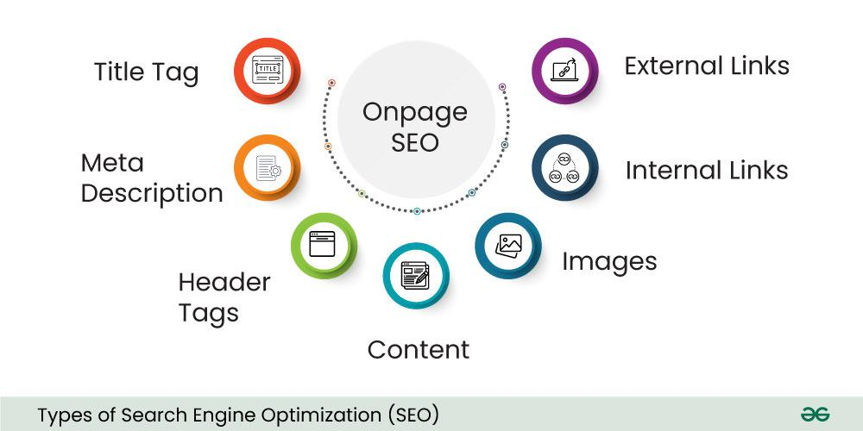

**Importance of SEO:**

1. **Increased Visibility and Traffic**: SEO helps websites rank higher in search engine results, increasing visibility to potential customers who are actively searching for products or services related to what the website offers. Higher visibility leads to more clicks and organic traffic.
2. **Cost-Effective Marketing**: Unlike paid advertising, SEO focuses on organic traffic, which means you don’t pay for clicks from search engines directly. While SEO requires investment in time and resources, the long-term benefits often outweigh the initial costs.
3. **Credibility and Trust**: Websites that rank high in search results are perceived as more credible and trustworthy by users. Good SEO practices, such as providing valuable content and optimizing user experience, help build authority and credibility over time.
4. **Better User Experience**: SEO involves optimizing not just for search engines but also for users. By improving website speed, mobile responsiveness, navigation, and content quality, SEO enhances the overall user experience, leading to higher engagement and conversions.
5. **Long-Term Strategy**: SEO is a long-term strategy that can provide sustainable results over time. While rankings may fluctuate due to algorithm updates or competitive changes, a well-executed SEO strategy can maintain and improve visibility in the long run.
6. **Competitive Advantage**: In competitive industries, effective SEO can differentiate a website from competitors. By outranking competitors in search results, businesses can attract more customers and gain market share.
7. **Measurable Results**: SEO efforts can be measured and analyzed using various tools and metrics, such as keyword rankings, organic traffic, conversion rates, and engagement metrics. This data helps businesses understand the effectiveness of their SEO strategies and make informed decisions for continuous improvement.
8. What is Accessibility?

Accessibility refers to the practice of ensuring that digital content, products, services, and environments are usable by everyone, including people with disabilities. It encompasses designing and developing websites, applications, documents, and other digital technologies in a way that accommodates various disabilities and diverse user needs. Accessibility aims to remove barriers that might prevent individuals with disabilities from accessing information or interacting with digital resources effectively.

1. What is Markup Language?

A markup language is a system for annotating text in a way that conveys structure, formatting, or other semantic information about the text. Markup languages use tags or codes embedded within the text to define how elements should be displayed or processed by software applications. Markup languages play a crucial role in digital communication, enabling the structured representation and interpretation of content across different platforms, applications, and devices. They facilitate clear presentation, efficient data exchange, and consistent formatting in a wide range of contexts, from web development and documentation to data processing and content management.

1. What is HTML?

Hypertext Markup Language, is the standard markup language used to create and structure content on web pages. It defines the structure and layout of web documents by using a system of tags and attributes to describe the appearance and functionality of elements within a webpage. HTML documents are interpreted by web browsers, which render them into the visual and interactive components users see and interact with on websites. HTML continues to evolve with new standards and features to meet the demands of modern web development, ensuring flexibility, accessibility, and compatibility in delivering content on the World Wide Web.

1. What is browser engine?

A browser engine, also known as a layout engine or rendering engine, is a core component of a web browser responsible for rendering web pages. It interprets HTML, CSS, and JavaScript code and displays the content of web pages on the screen according to the instructions provided by these technologies. Browser engines play a crucial role in ensuring that web pages are rendered accurately and consistently across different browsers and devices. They interpret and process web technologies to deliver a seamless browsing experience, handling complex tasks such as layout, styling, scripting, and multimedia integration.

1. What is rendering engine? share the available rendering engine?

A rendering engine, also known as a layout engine, is a core component of a web browser responsible for rendering the visual layout and content of web pages. It interprets HTML, CSS, and JavaScript code and translates them into the visual elements users see on their screens. Rendering engines play a critical role in ensuring that web pages are displayed accurately and consistently across different browsers and devices. They handle the interpretation, layout, styling, and rendering of web content, influencing factors such as performance, compatibility, and user experience.

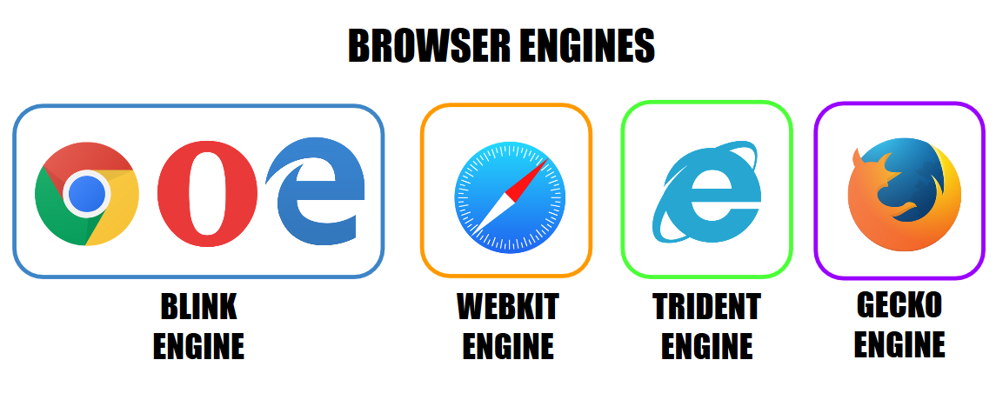

### Available Rendering Engines:

1. **Blink**:
   * Used in Google Chrome, Microsoft Edge (Chromium-based), and other Chromium-based browsers.
   * Developed by the Chromium project, which is maintained primarily by Google.
2. **WebKit**:
   * Used in Apple Safari and some other browsers.
   * Developed by Apple, originally derived from the KDE project's KHTML engine.
3. **Gecko**:
   * Used in Mozilla Firefox and related browsers.
   * Developed by the Mozilla Foundation, known for its open-source nature and robust support for web standards.
4. What is JavaScript Engine? share the available JS engine? Purpose of JS Engine?

A JavaScript engine is a program or interpreter that executes JavaScript code in web browsers and other environments where JavaScript is supported. It converts JavaScript code into machine code that can be executed by the computer's processor. JavaScript engines enable developers to create rich, interactive, and responsive web applications by executing JavaScript code efficiently in web browsers. They play a crucial role in enhancing user experience, enabling dynamic content updates, and supporting modern web development practices.

**Available JavaScript Engines:**

1. **V8**:
   * Developed by Google for the Chrome browser and Node.js runtime environment.
   * Known for its speed and efficiency, uses JIT compilation to optimize JavaScript performance.
2. **SpiderMonkey**:
   * Developed by Mozilla, used in Firefox browser and related projects.
   * One of the earliest JavaScript engines, supports various web standards and features.
3. **JavaScriptCore (Nitro)**:
   * Developed by Apple, used in Safari browser and other Apple products.
   * Designed for efficiency and performance on macOS and iOS platforms.
4. **Chakra (Legacy)** and **ChakraCore**:
   * Developed by Microsoft, originally used in Internet Explorer and Edge browsers.
   * ChakraCore is the open-source version used in legacy Edge and other environments.
5. **Rhino**:
   * Developed by Mozilla, an implementation of JavaScript written in Java.
   * Often used in server-side applications and embedded systems where Java is prevalent.
6. How website works?

A website works through a complex system of interconnected technologies and processes that enable users to access, interact with, and retrieve information from web pages hosted on remote servers. a website functions as a dynamic platform where browsers interact with web servers to retrieve, process, and display content to users. The seamless integration of HTML, CSS, JavaScript, server-side technologies, and network protocols enables the creation of rich, interactive, and responsive web experiences that serve diverse user needs across the internet.

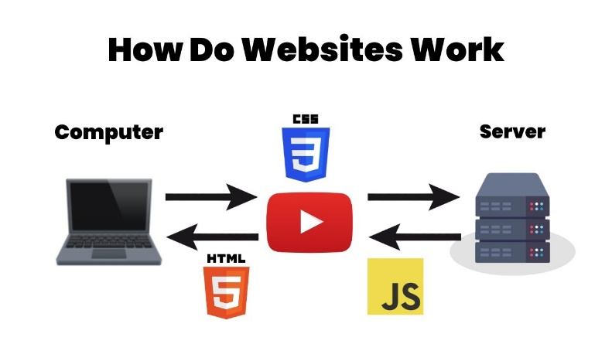

1. What is Data Structure?

A data structure is a way of organizing and storing data in a computer system so that it can be accessed and manipulated efficiently. It defines the relationship between data elements and operations that can be performed on them. Data structures are fundamental concepts in computer science and are used extensively in programming to solve various computational problems. data structures form the foundation of efficient and organized data handling in computer systems.

1. Explain Tree Data Structure?

A tree data structure is a hierarchical, non-linear data structure composed of nodes connected by edges. It is widely used in computer science and programming for organizing and managing data in a hierarchical manner. Trees are characterized by a root node from which all other nodes descend, forming branches that lead to leaf nodes or subtrees. tree data structures provide a flexible and efficient way to organize hierarchical data, enabling a wide range of applications in computer science, programming, and information technology. Understanding tree structures and their variations helps in designing efficient algorithms and solving complex problems in software development and system design.

1. What is user agent? share the list and its purpose?

A user agent is a string of text that identifies the browser and operating system used by a visitor when accessing a website or web application. It is transmitted as part of the HTTP request headers sent from the client (user's device) to the server hosting the website. The user agent string helps websites and web servers identify the capabilities and specifications of the user's browser and device, allowing for customized content delivery and user experience optimization.

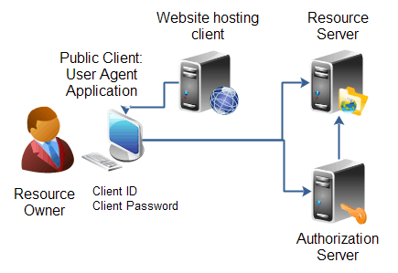

**Purpose of User Agent:**

1. **Browser Detection**: Websites use the user agent string to detect which web browser and version the visitor is using. This information helps in rendering web pages correctly and applying browser-specific optimizations or workarounds if necessary.
2. **Device Detection**: User agent strings often include information about the operating system (OS) and device type (desktop, mobile, tablet). This allows websites to adapt their layout and content for different devices and screen sizes.
3. **Feature Support**: By analyzing the user agent string, websites can determine which HTML, CSS, JavaScript, and other web technologies are supported by the visitor's browser. This helps in delivering appropriate content and features that are compatible with the user's browser capabilities.
4. **Analytics and Statistics**: User agent data is often used for web analytics to track browser usage trends, device preferences, and platform distribution among website visitors. This information informs decisions related to web development, compatibility testing, and user experience improvements.
5. What is Hypertext?

Hypertext refers to text displayed on a computer or other electronic device that contains links to other text, multimedia elements, or resources. It allows users to navigate between pieces of information non-linearly, typically by clicking on hyperlinks that connect related content. Hypertext is foundational to the World Wide Web and enables the creation of interconnected web pages that form a network of information accessible via web browsers.

1. What is HTML Tags?

HTML tags are the fundamental building blocks used to create structured content and elements within a web page. They are the markup language elements that define the structure, appearance, and functionality of the content displayed in web browsers. HTML tags are enclosed within angle brackets < > and typically come in pairs: an opening tag and a closing tag. HTML tags are essential elements of web development that define the structure and presentation of content on the internet. Understanding how to use HTML tags effectively is fundamental for creating and designing functional and user-friendly web pages.

1. What is HTML Attributes?

HTML attributes provide additional information about HTML elements and modify their behavior or appearance. They are key-value pairs added to the opening tag of an HTML element to customize its behavior or provide metadata. Attributes enhance the functionality and styling of HTML elements, making web pages more interactive and accessible. HTML attributes extend the functionality and customization capabilities of HTML elements, enabling developers to create dynamic, accessible, and visually appealing web pages. Understanding how to use attributes effectively is essential for optimizing web content and enhancing user experience across different devices and platforms.

1. What is HTML Elements?

HTML elements are the fundamental building blocks of a web page's structure and content. They are defined using HTML tags and consist of everything from basic text and images to interactive forms and multimedia. HTML elements define the structure and semantic meaning of content on a web page, allowing browsers to interpret and render the content appropriately for users. HTML elements form the structural backbone of web pages, defining how content is organized, displayed, and interacted with by users. Understanding the purpose and usage of HTML elements is essential for creating well-structured and accessible web content that meets web standards and enhances user experience.

1. How do convert elements to tree?

Converting elements into a tree structure is a common task in computer science and programming, especially when dealing with hierarchical data or when representing relationships between entities.

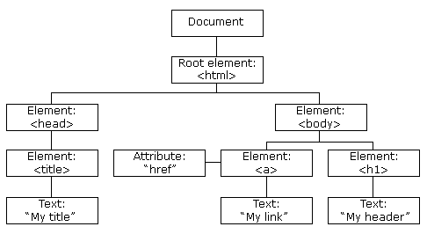

### Steps to Convert Elements to Tree:

1. **Define the Tree Structure**:
   * Determine the structure of your tree, including the types of nodes (elements) and their relationships (parent-child connections).
2. **Identify Root Element(s)**:
   * Decide which element(s) will serve as the root(s) of your tree. In many cases, there might be a single root element that acts as the starting point.
3. **Traverse the Elements**:
   * Traverse through each element that needs to be included in the tree. This may involve iterating through a list of elements or nodes in a specific order (e.g., depth-first or breadth-first).
4. **Create Nodes**:
   * For each element encountered during traversal, create a corresponding node in the tree data structure. Each node should store relevant information from the element, such as its content, attributes, and relationships with other nodes.
5. **Establish Relationships**:
   * Determine parent-child relationships between nodes based on the hierarchy of the elements. Typically, elements nested within others (e.g., child elements within a parent element) will become child nodes of their respective parent nodes in the tree.
6. **Build the Tree**:
   * As you identify parent-child relationships, link nodes together to construct the tree. Ensure that each node correctly references its parent node (if applicable) and its child nodes.
7. **Handle Special Cases**:
   * Consider special cases, such as elements with multiple children, elements without children, or elements with specific attributes that affect their placement in the tree.
8. What is DOCTYPE?

DOCTYPE (Document Type Declaration) is an instruction or directive in HTML that specifies the version of HTML (or XHTML) that the web page is using. It is typically the first line in an HTML document before the <html> tag and informs the web browser about the type and version of markup language used in the document. DOCTYPE is a crucial part of HTML documents that specifies the document type and version, influencing how web browsers interpret and render the content. By including the correct DOCTYPE declaration, developers ensure consistent rendering across different browsers and compliance with web standards.

Top of Form

Bottom of Form

1. What are the ways we can save html file?

### 1. Using a Text Editor:

The simplest and most common method to create and save HTML files is using a text editor. Text editors allow you to manually write, edit, and save HTML code directly:

* **Text Editors**: Tools like Notepad (Windows), TextEdit (Mac), Visual Studio Code, Sublime Text, Atom, and others provide a straightforward interface for writing HTML code.

**Steps**:

* + Open the text editor.
  + Write or paste your HTML code into a new document.
  + Save the file with an .html extension (e.g., index.html).
  + Choose the appropriate encoding (typically UTF-8) when saving.

### 2. Using Integrated Development Environments (IDEs):

Integrated Development Environments (IDEs) provide advanced features for web development, including code editing, debugging, and project management. IDEs often have built-in support for saving HTML files:

* **IDEs**: Software like Visual Studio, JetBrains WebStorm, Eclipse, and others are designed for web development and provide tools for creating and saving HTML files within a project structure.

**Steps**:

* + Open the IDE and create a new HTML file.
  + Write your HTML code in the editor window.
  + Save the file using the IDE’s save functionality, often with options for project organization and file naming conventions.

### 3. Using Web Browser Save Options:

Web browsers allow you to save the rendered content of a web page, which includes HTML, CSS, and images. This method is useful for saving a snapshot of how a web page appears after it has been rendered by the browser:

* **Save Page As**: Most web browsers (e.g., Chrome, Firefox, Edge) offer a "Save Page As" or "Save As" option in the context menu. This saves the entire web page, including HTML, CSS, images, and other resources.

**Steps**:

* + Open the web page in your browser.
  + Right-click on the page and choose "Save Page As" or use the browser menu (typically found under File > Save Page As).
  + Specify the location and filename. The file will be saved with an .html extension.

### 4. Using Command Line Tools:

For advanced users and automation purposes, command-line tools can be used to save HTML files. This approach is useful for batch processing or integrating with scripts:

* **Command Line**: Tools like curl, wget, or scripting languages (e.g., Python with requests library) can be used to fetch and save HTML content programmatically.

**Example (curl)**:

bash

Copy code

curl https://www.example.com -o example.html

### 5. Saving from Online Editors or CMS Platforms:

Online HTML editors and Content Management Systems (CMS) often provide options to save HTML files directly from their interfaces:

* **Online Editors and CMS**: Platforms like CodePen, JSFiddle, WordPress, Drupal, etc., allow users to create, edit, and save HTML files within their respective environments.

**Steps**:

* + Use the editor interface to write or modify HTML code.
  + Save the file through the platform’s save or publish functionality, typically storing it in the platform’s database or file system.

1. What is charset? why we need to use this?

A charset, short for character set, is a term used in computing to describe a specific mapping of characters to their corresponding binary representations (such as Unicode, ASCII, or ISO-8859-1). It defines the set of characters that can be used in a particular system or application, along with their encoding and representation in binary form.

### Why Use Charset?

* **Avoid Character Encoding Issues**: Using the correct charset prevents issues such as garbled text, incorrect character rendering, or unrecognized symbols on web pages.
* **Internationalization**: Enables support for content in multiple languages and scripts, ensuring that users worldwide can view and interact with the content as intended.
* **Web Standards Compliance**: Charset specification is a standard practice recommended by the World Wide Web Consortium (W3C) to ensure interoperability and accessibility of web content across different platforms and devices.

1. What is meta data? what is the purpose of it?

Metadata refers to data that provides information about other data. It describes various aspects of a piece of information, such as its content, format, location, and characteristics. In computing and information science, metadata serves several important purposes:

### Purpose of Metadata:

1. **Descriptive Information**: Metadata provides descriptive details about data, helping users understand its context, relevance, and usage. It includes attributes like title, author, date created, and keywords.
2. **Structural Information**: Metadata outlines the structure and organization of data, indicating relationships between different elements or components. It helps in navigating and accessing complex datasets or documents.
3. **Administrative Information**: Metadata includes administrative details such as ownership, access rights, versioning history, and preservation instructions. It assists in managing and maintaining data throughout its lifecycle.
4. **Technical Information**: Metadata includes technical specifications and requirements necessary for processing, interpreting, and displaying data correctly. This may include file format, encoding, resolution, and software dependencies.
5. **Discovery and Retrieval**: Metadata facilitates the discovery and retrieval of data through search engines, databases, or repositories. It improves information retrieval efficiency by enabling users to locate relevant content based on specific criteria.
6. **Interoperability and Integration**: Metadata enhances interoperability by standardizing data representation and exchange formats. It enables seamless integration of heterogeneous datasets and systems across different platforms.
7. Explain Web Application Architecture?

Web application architecture refers to the structural design and organization of components that constitute a web application. It defines how different modules or components of the application interact with each other and with external systems to deliver the intended functionality to users. web application architecture defines the structure, interactions, and components of a web application, ensuring efficient, scalable, and secure delivery of functionality to users over the internet. Designing a robust architecture involves balancing performance, security, scalability, and maintainability considerations based on the specific requirements and goals of the application.

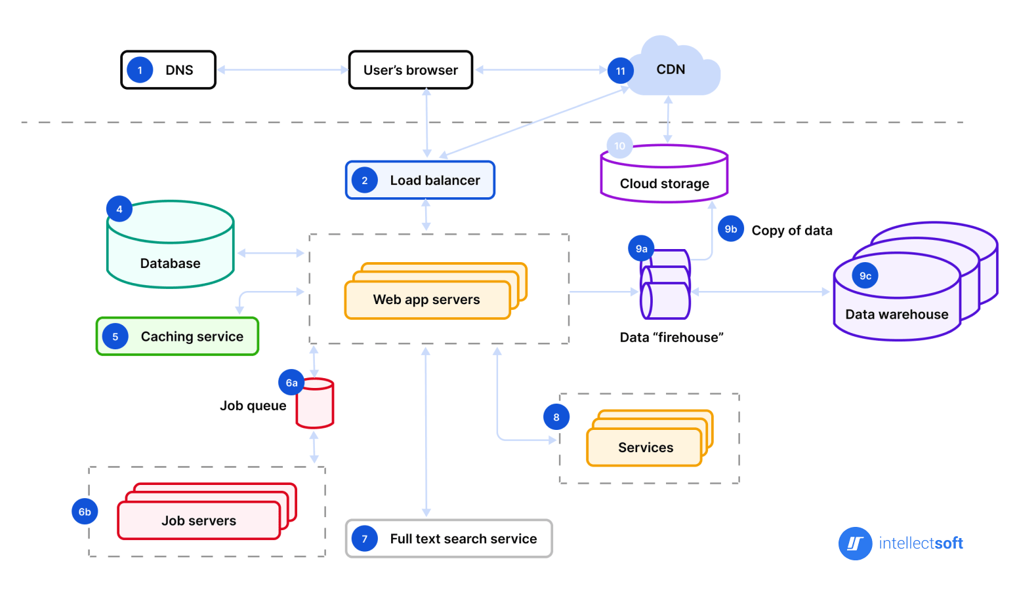

Top of Form

Bottom of Form