**Cryptography And Network Security Lab**

**PRN No: 2019BTECS00038**

**Batch: B2**

**Assignment: 14**

**Title of assignment****: Generation of Digital Certificate**

**Problem statement :** Generation of digital certificate using java key tool and key store utilities or by using open SSL

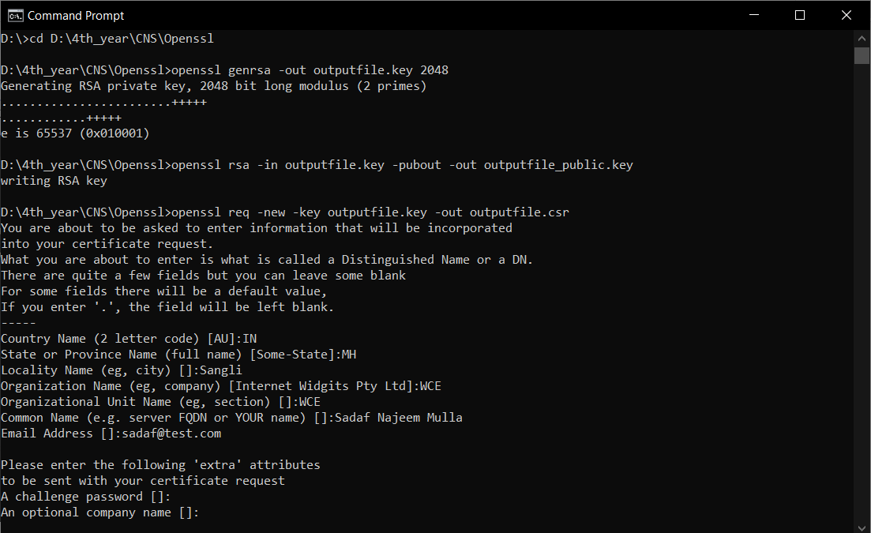

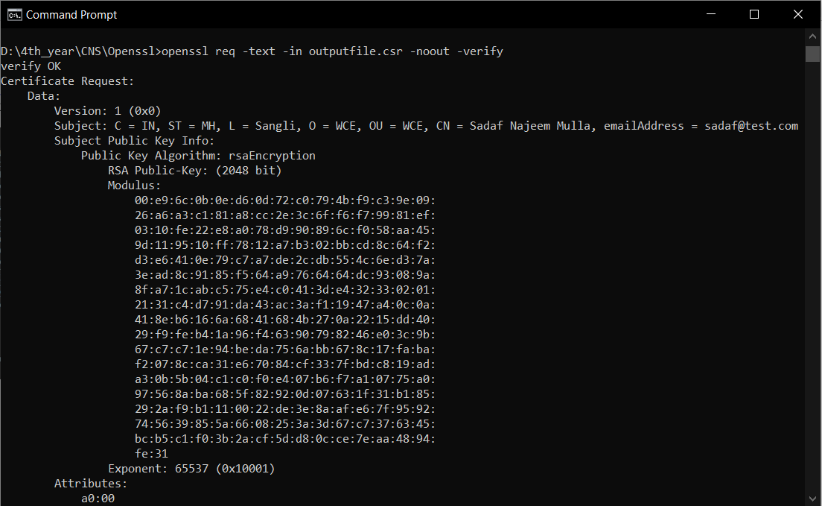

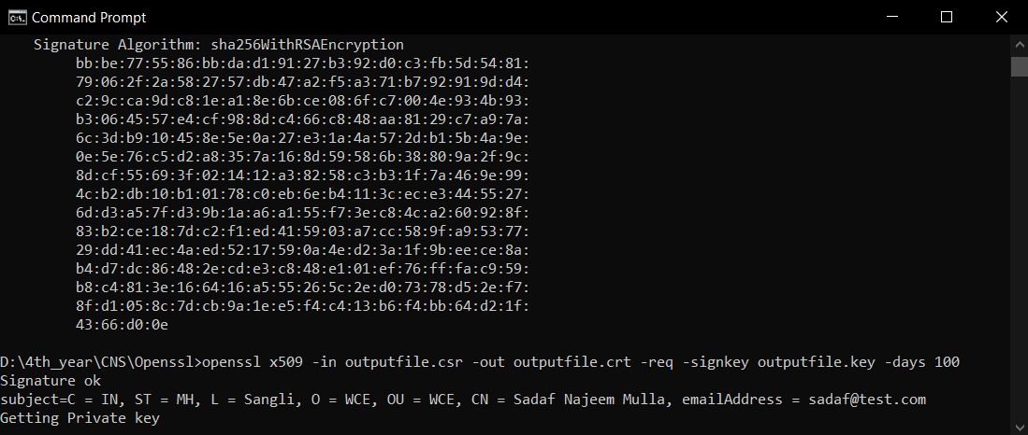

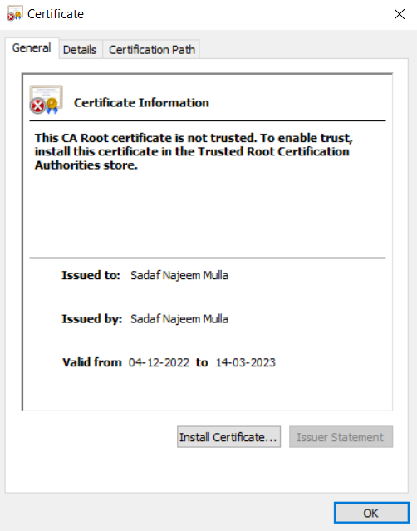

**Applications :**

* Digital certificates are used for to secure email to identify one user to another
* It may also used for electronic document signing.