**Practical No 3**

**To study web browser and its Developer Tools option**

PRN No- 2019BTECS00038

Batch – T6

Cource – Programming Lab 3

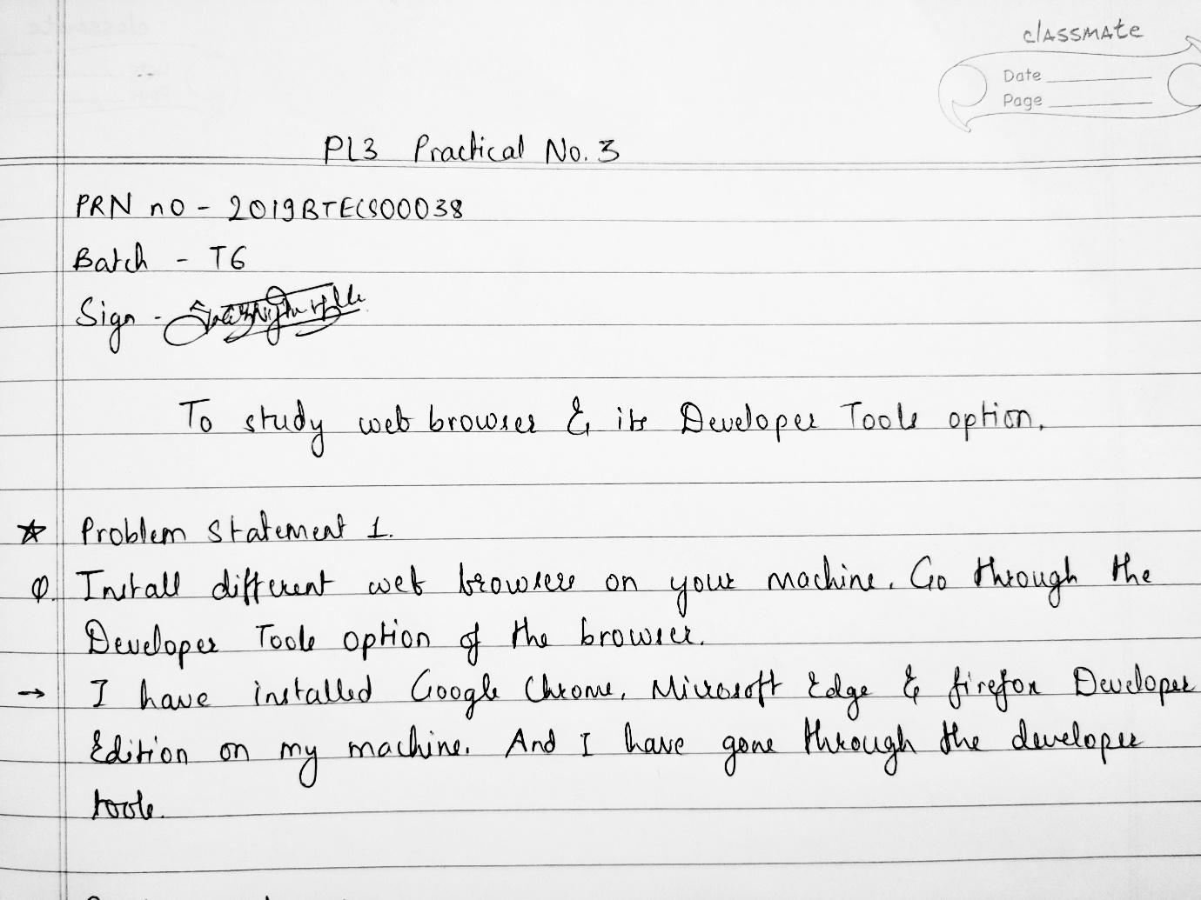

Problem Statement 2

1. Visit https://en.wikipedia.org/wiki/Computer_science on various browsers.

On Microsoft Edge

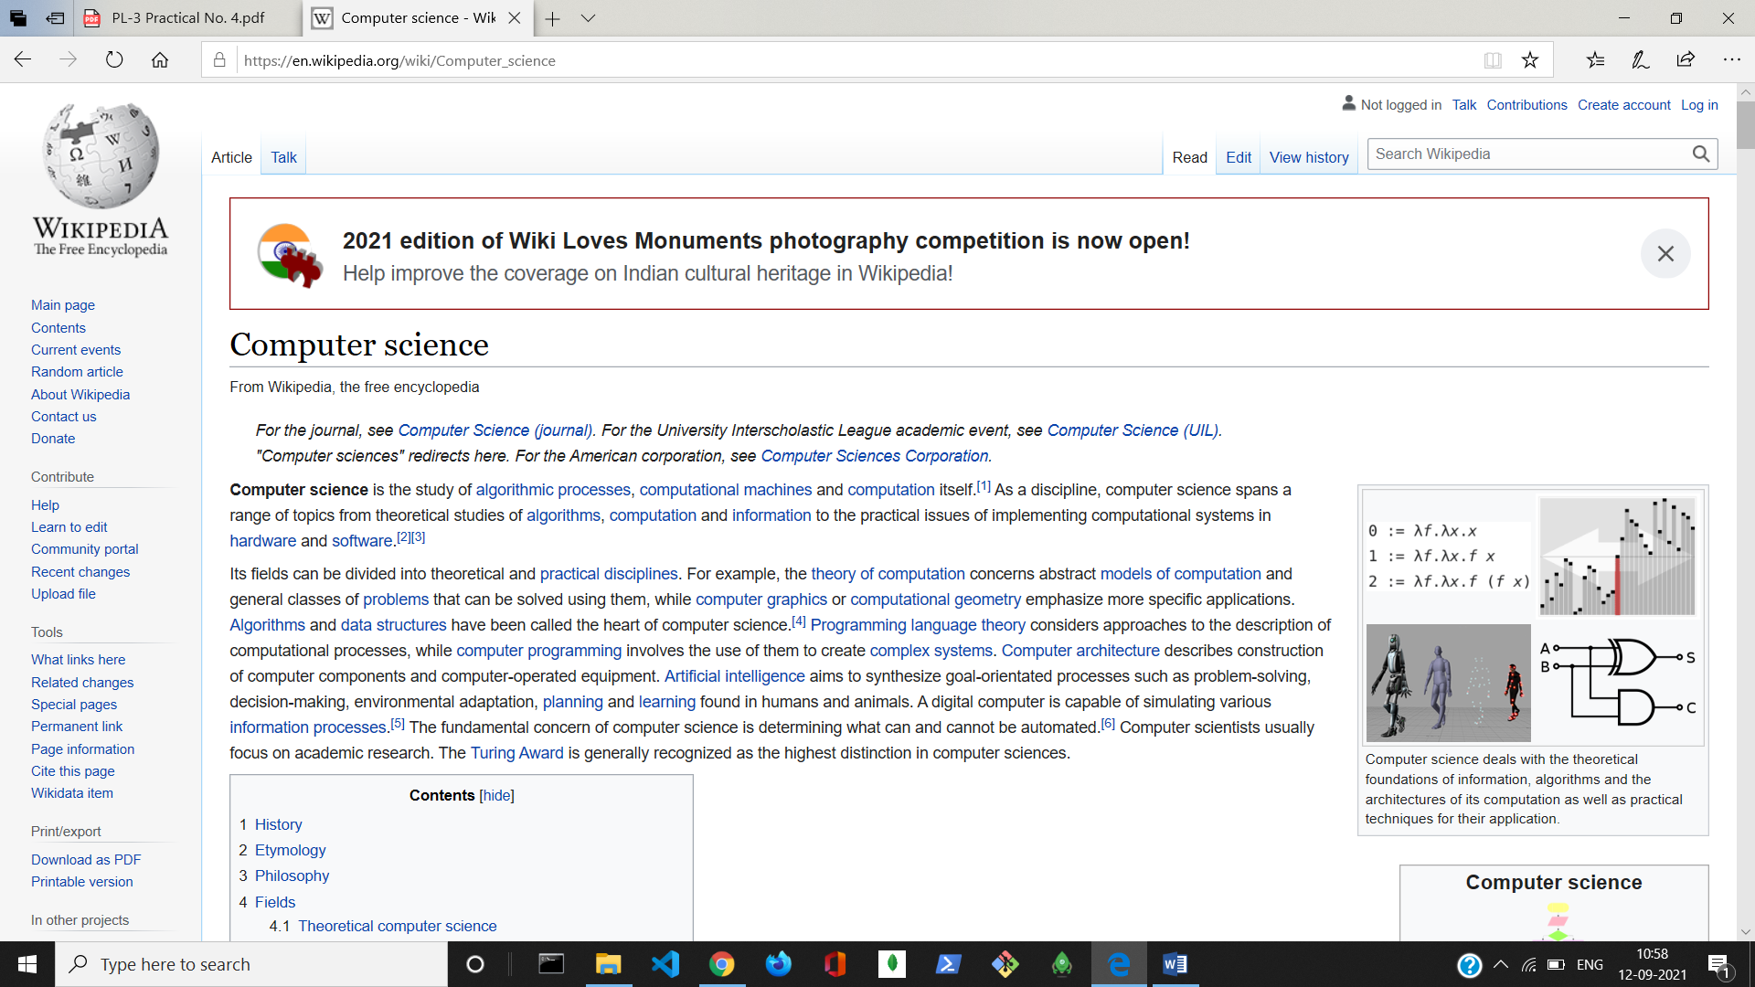

On Google Chrome

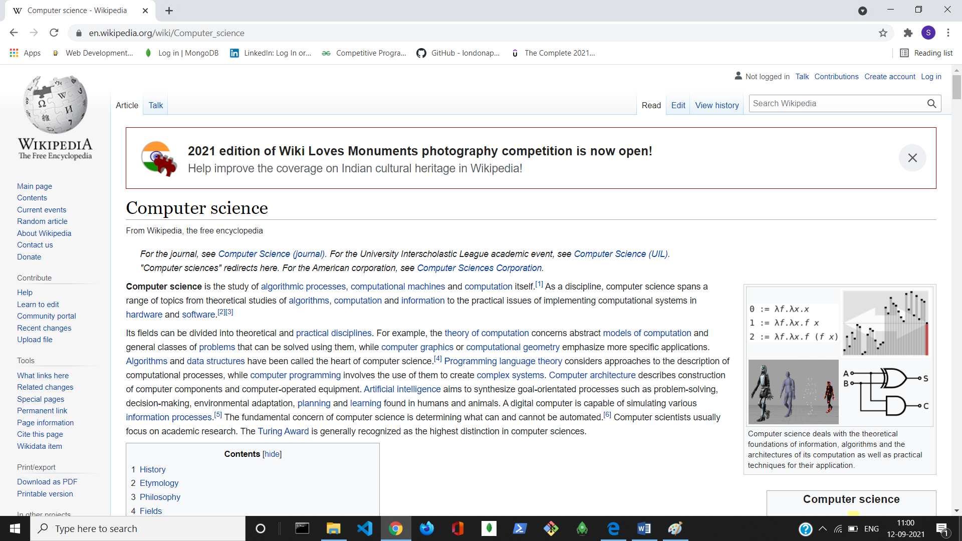

On Firefox

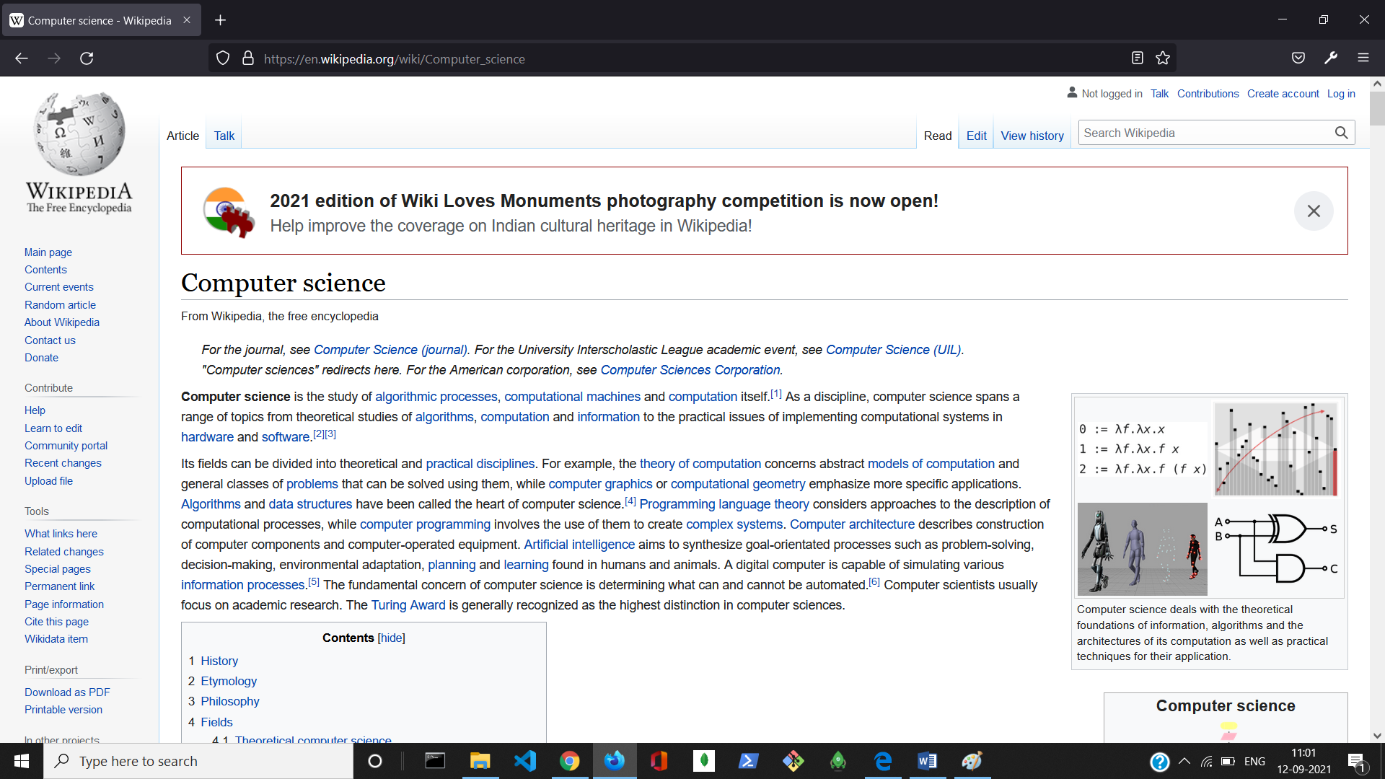

1. Using browser’s Developer Tools option find out how many requests-response cycles are needed to load the page fully on your machine?

Click on more tools.

Go to Developer tools.

Click on Network option.

You will find the requests in the tabular form.

On Microsoft Edge

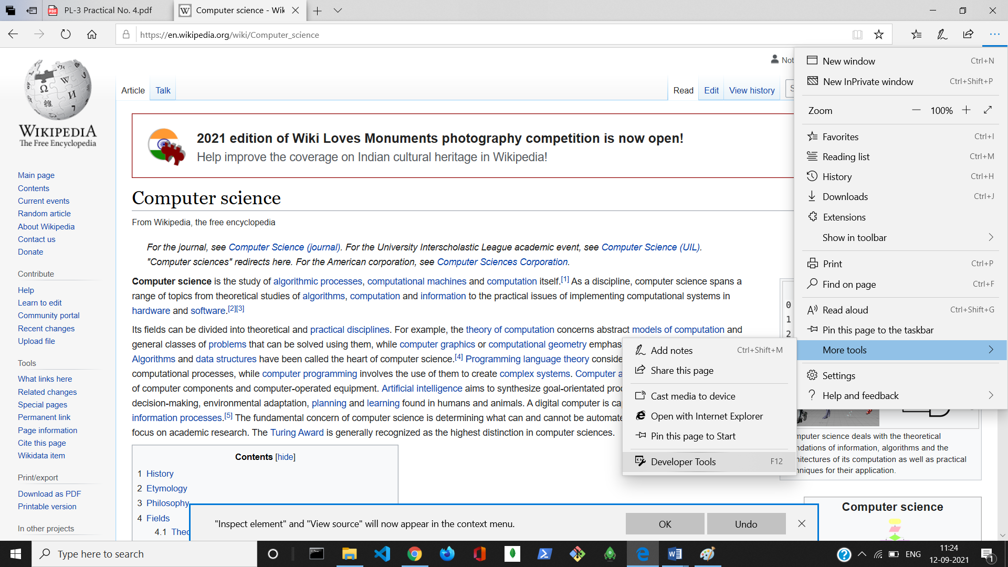

There are 121 request cycles are needed to load the page fully on machine.

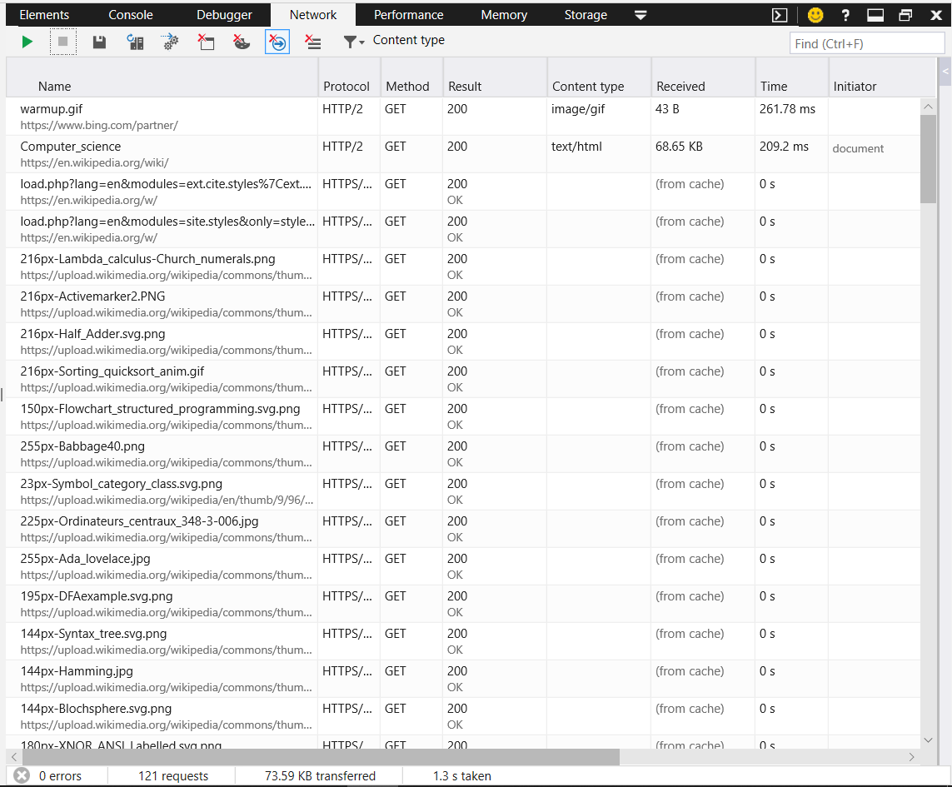

On Google chrome

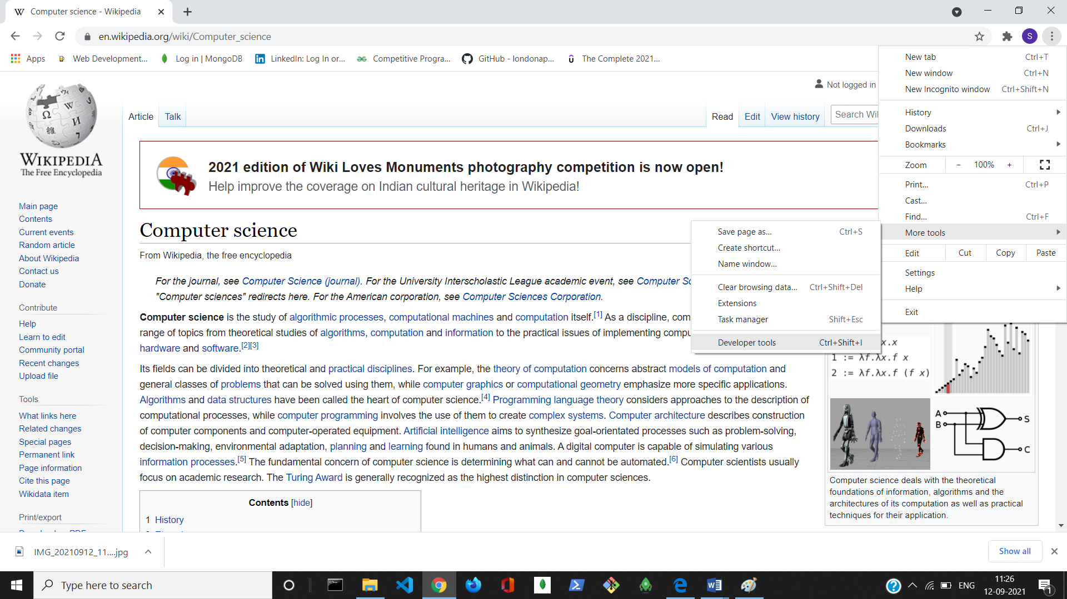

There are 113 request cycles are needed to load the page fully on machine.

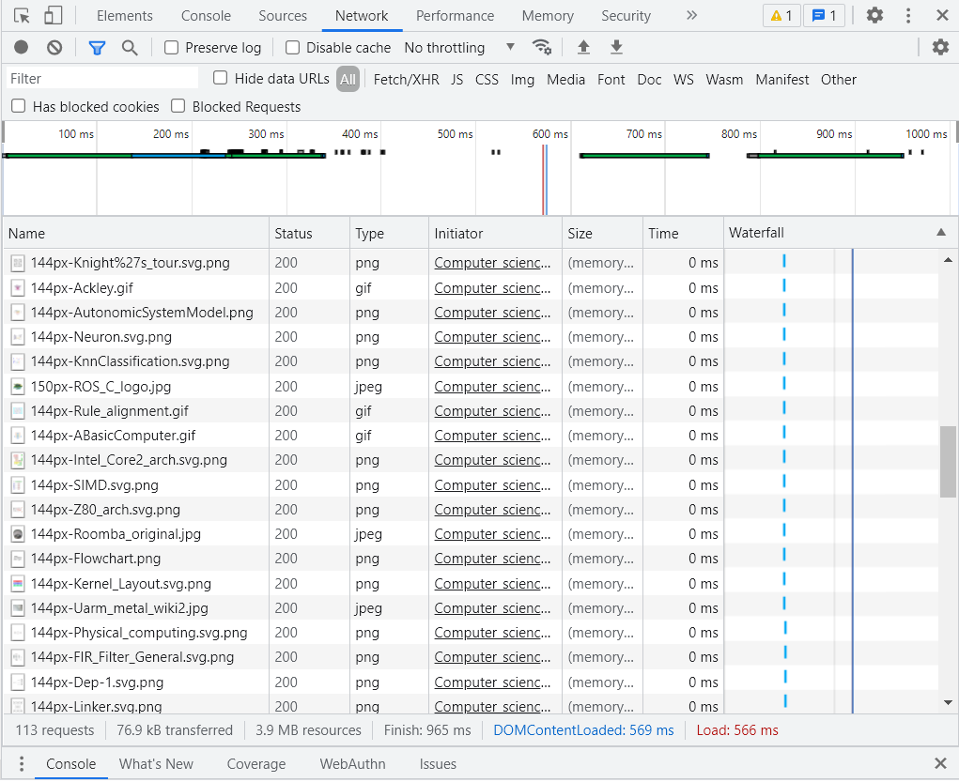

3. Using browser’s Developer Tools option get the header information of the page.

On Microsoft Edge

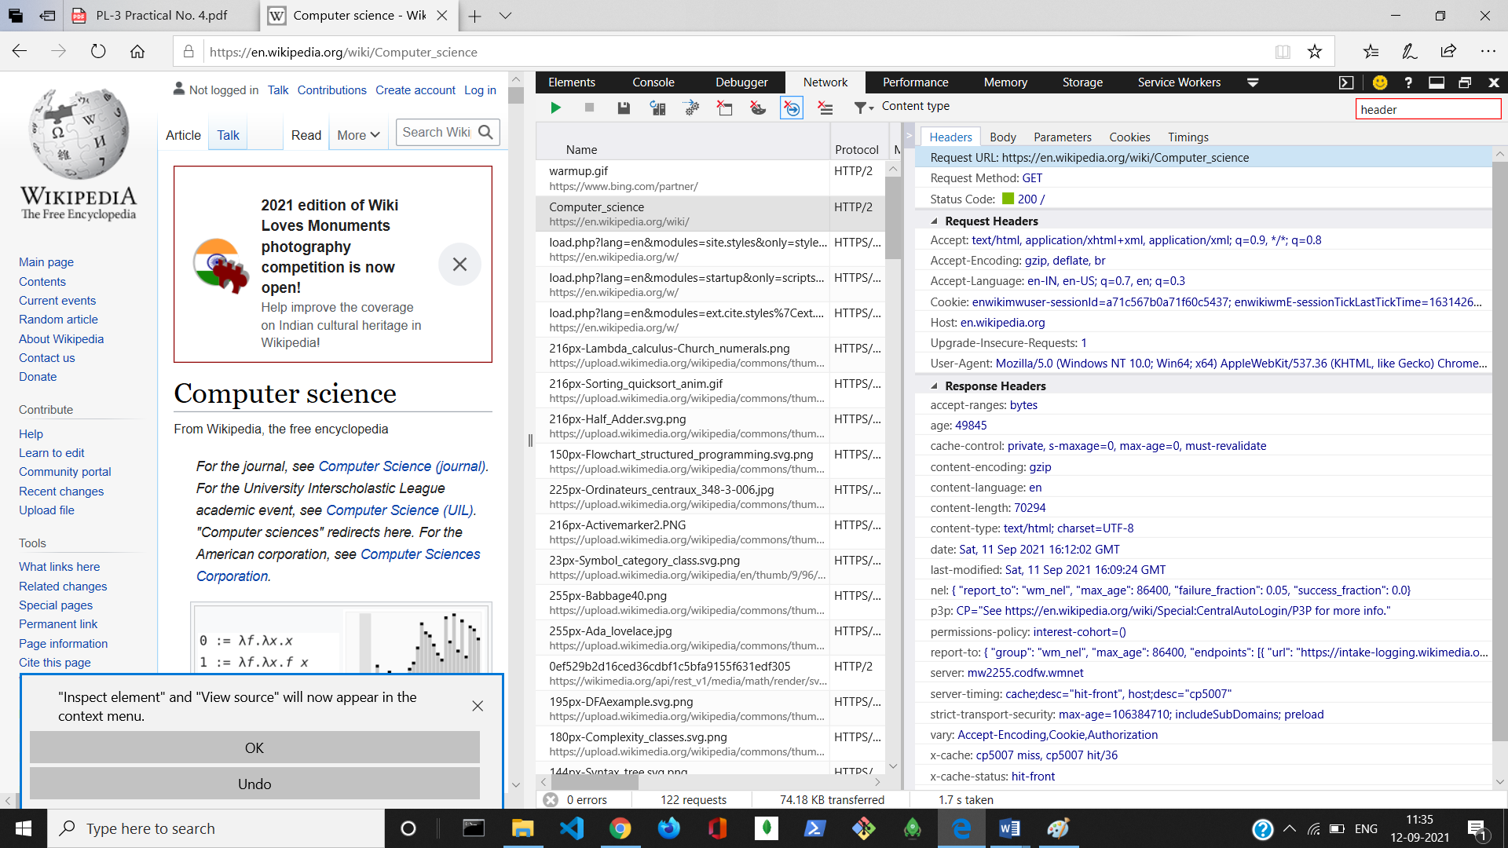

On Google Chrome

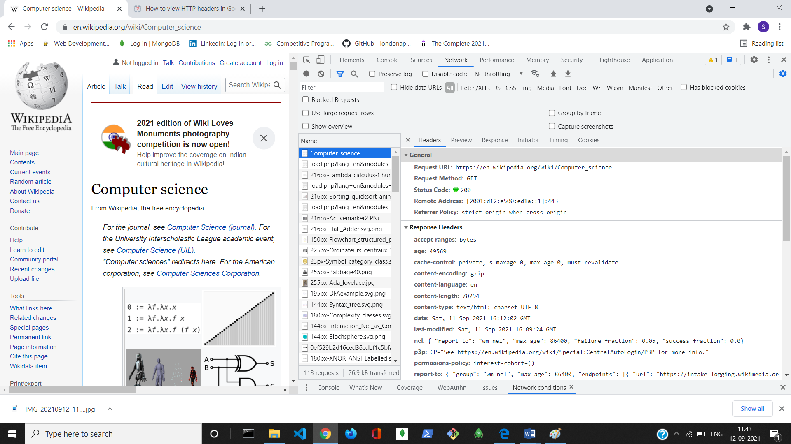

4. Using browser’s Developer Tools option go through the DOM, CSS editor and JavaScript debugger options.

DOM

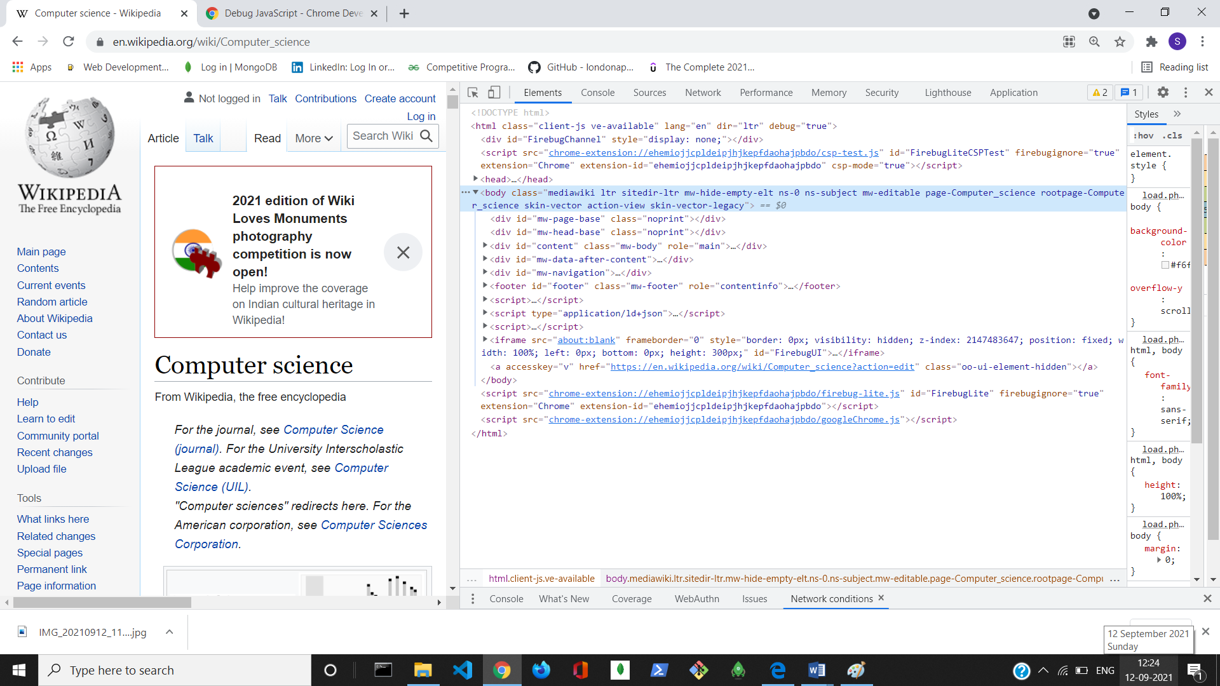

CSS editor

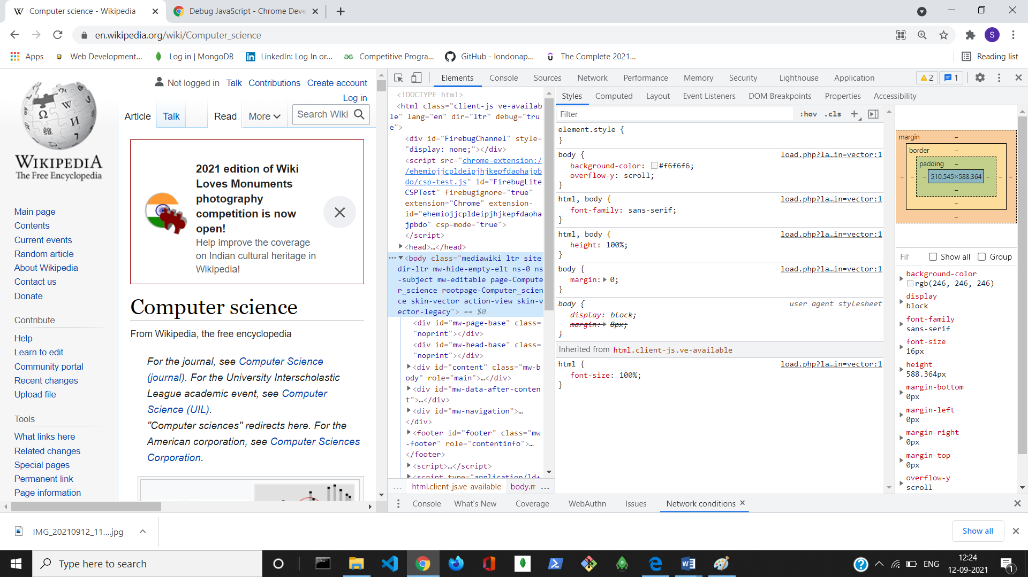

JavaScript debugger

