**Practical 4**

**To install and configure a Web Server.**

PRN no – 2019BTECS00038

Batch – T6

Course – Programming Lab 3

Problem Statement 1:

1.Install a web server on your machine. Run the server locally.

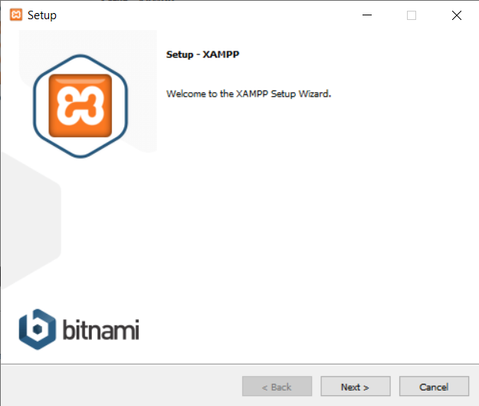

2.Locate and study its configuration file.

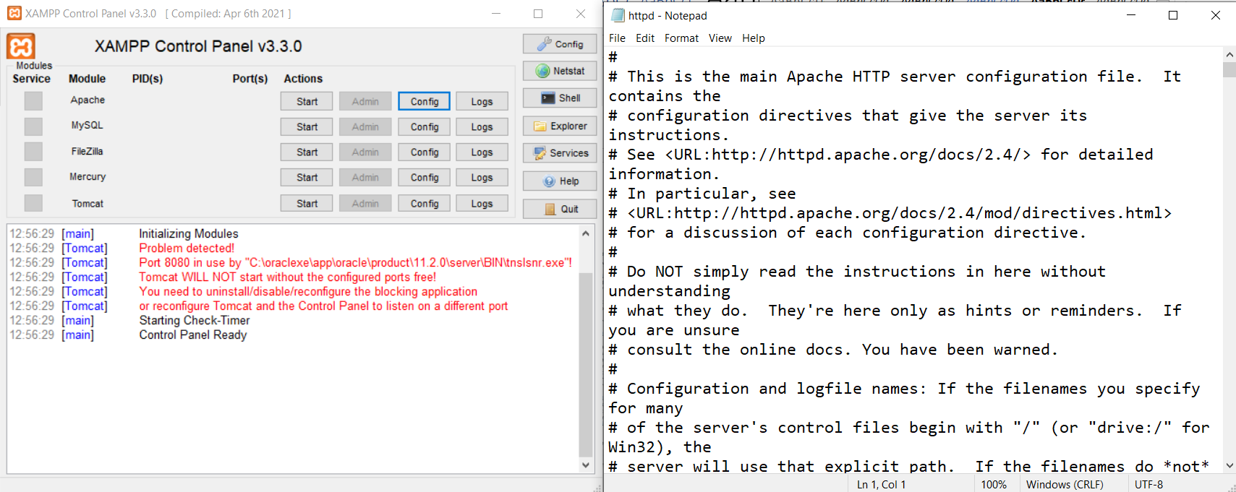

3.Change the port number in the configuration file to any other valid port number. Re-

run the server locally using newly assigned port number.

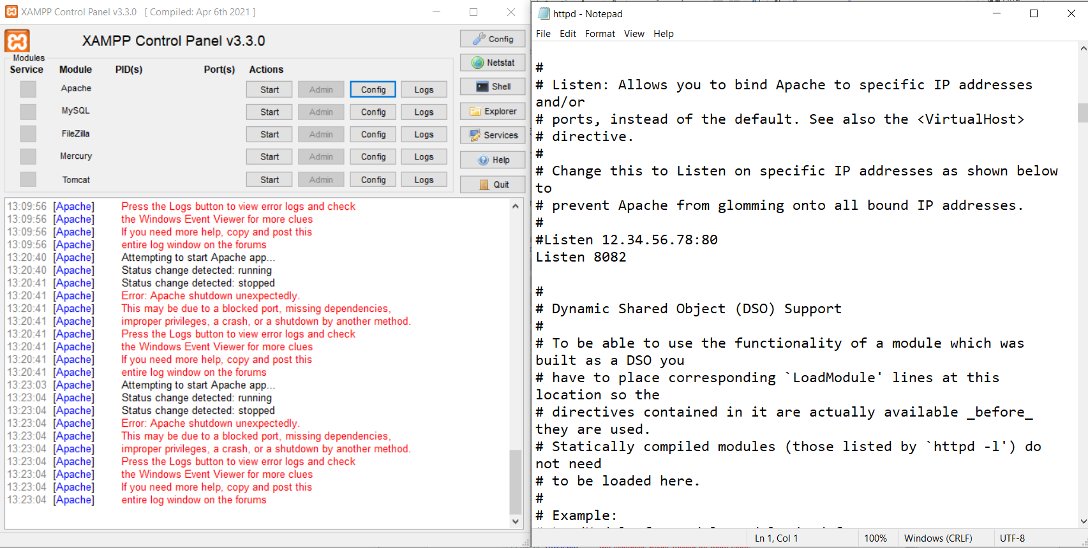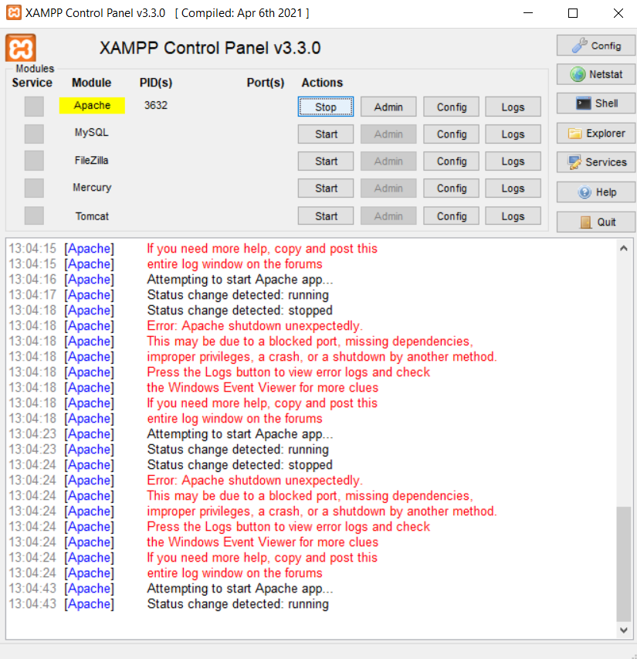

4.Change the default IP address (127.0.0.1 or localhost) and port number of the server

in the configuration file to any other valid IP address and port number. Re-run the

server and access it in a network from another machine.

To access from another machine you need configure file name httpd.xammp.conf where you replace access all denied with access with granted

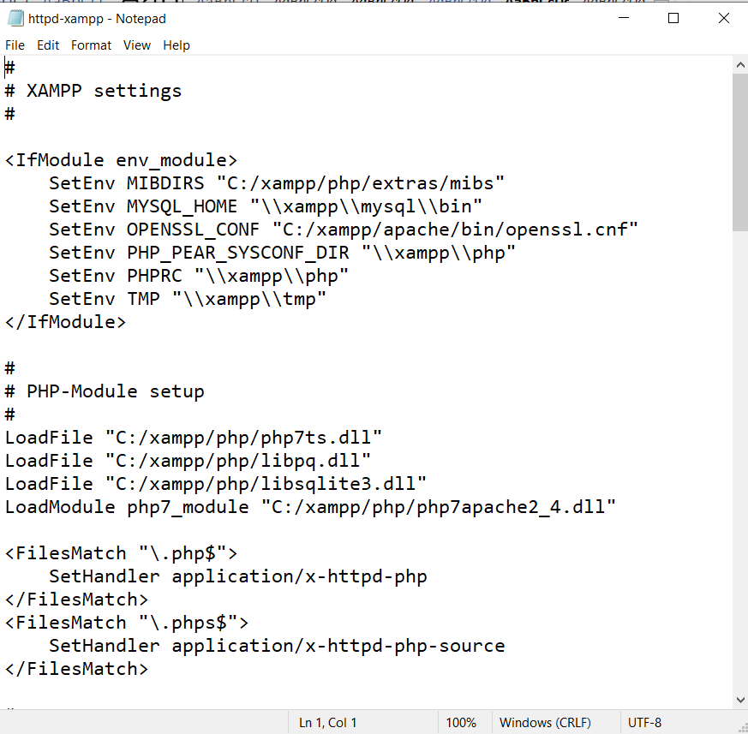

To access localhost from my mobile I use my laptop ip address.

