This script solves the following contents

* first prepare to convert daily dataset into months and annual using sum function
* Draw line and quantile plot
* Draw trend series of annual data set
* Draw mean monthly precipitation using bar plot
* Draw sum of monthly precipitation using box plot
* Trend and significance value of monthly rainfall
* Add libraries function which can be used here

The below is explanatory code calculates annual precipitation amount using line and quantile plots. Blue color shows the annual variation of rainfall at czech republic starts from January 1950 to May 2019, goes to sudden decrease rainfall at 2019.

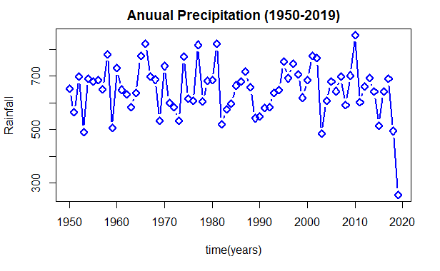

The Q-Q plot, or quantile to quantile plot, is a graph that tests the conformity between the empirical distribution and the given theoretical distribution.

This above quantile figure shows that the the data is normally distributed, more than 50% medians lies on the line, it means that the points in the QQ-normal plot lie on a straight diagonal line and the deviations from the straight line are minimal.

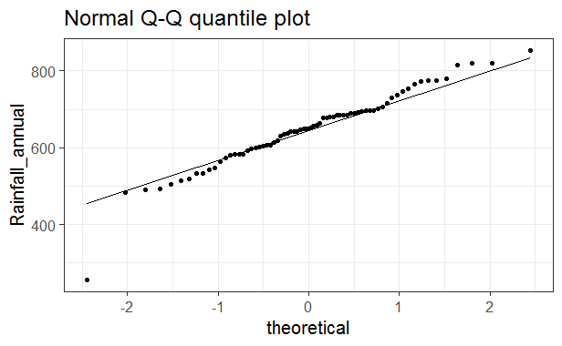

Boxplot consists of a "box" which goes from the first quartile (Q1) to the third quartile (Q3). Within the box, a vertical line is drawn at the Q2, the median of the data set which is mid-point of the data represents the middle 50% of scores for the group “Rainfall”. Two horizontal lines, called whiskers, extend from the front and back of the box.

Size of box become wider at the month of July and August shows higher amount of rainfall while minimum rainfall appear at the month of November .

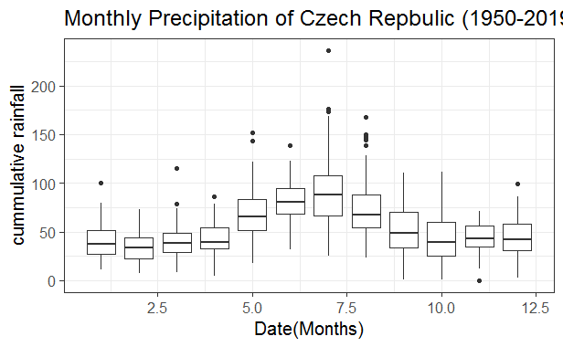

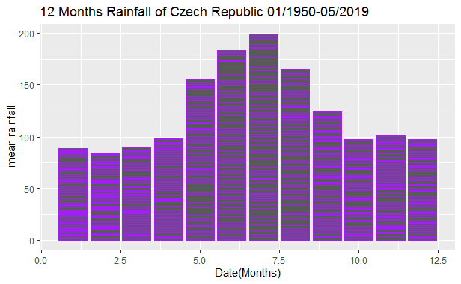

The time series plot produced by R reveals the presence of an downward trend in the annual precipitation levels for the entire Czech Republic over the period of interest.

To better see this trend, let us fit a nonparametric loess curve to the data using the lowess() function in R:

For the annual result, the

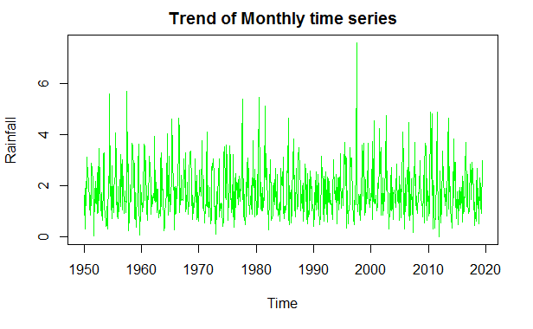

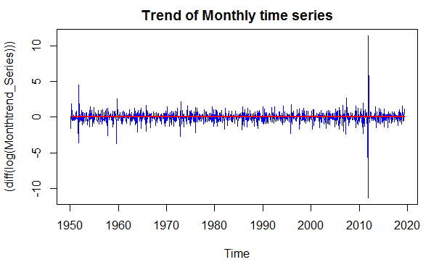

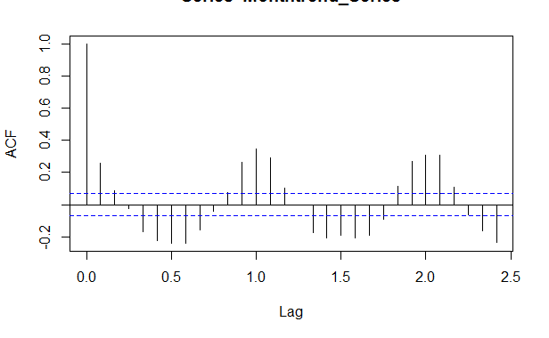

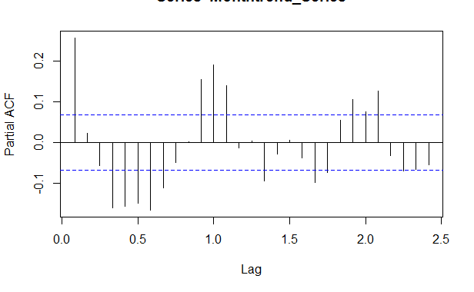

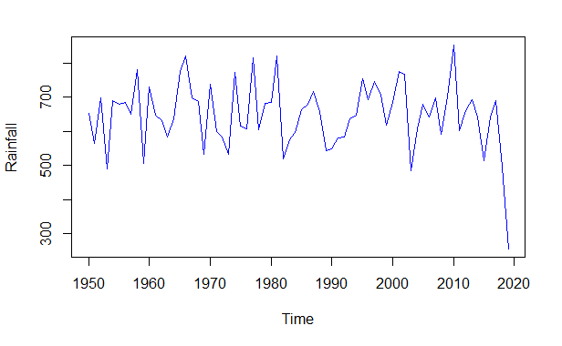

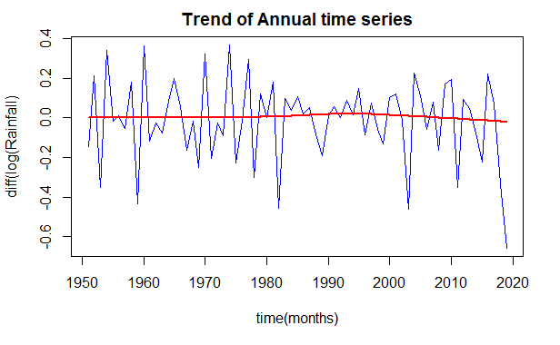

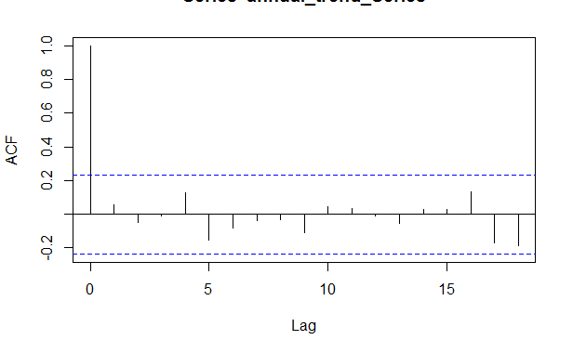

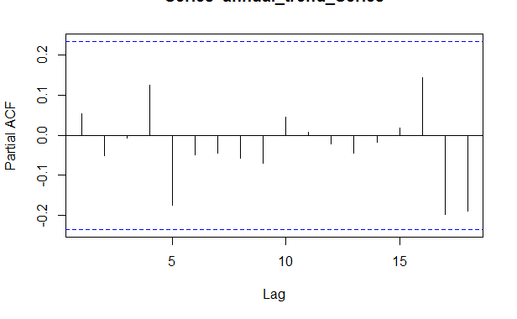

Augmented Dickey-Fuller Test

data: annual_trend_Series

Dickey-Fuller = -3.0346, Lag order = 4, p-value = 0.1545

alternative hypothesis: stationary

p-value greater than printed p-value

KPSS Test for Level Stationarity

data: annual_trend_Series

KPSS Level = 0.13856, Truncation lag parameter = 3, p-value = 0.1

integer(0)

tau = -0.0344, 2-sided pvalue =0.67762

Score = -83 , Var(Score) = 38908.33

denominator = 2415

tau = -0.0344, 2-sided pvalue =0.67762

BLOCK BOOTSTRAP FOR TIME SERIES

Fixed Block Length of 5

Call:

tsboot(tseries = annual_trend_Series, statistic = MKtau, R = 700,

l = 5, sim = "fixed")

Bootstrap Statistics :

original bias std. error

t1* -0.03436853 0.03809614 0.08713045

BOOTSTRAP CONFIDENCE INTERVAL CALCULATIONS

Based on 500 bootstrap replicates

CALL :

boot.ci(boot.out = boot.out, type = "perc")

Intervals :

Level Percentile

95% (-0.1671, 0.1600 )

Calculations and Intervals on Original Scale