**Class Assignment:**

**Question:** Simplify the following Boolean functions, using three-variable maps:

* F(X, Y, Z) = ⅀(1, 2, 3, 5, 6, 7)
* F(A, B, C) = ⅀(0, 2, 4, 6)

**Question:** Simplify the following Boolean functions, using Karnaugh maps:

* F(W, X, Y, Z) = ⅀(2, 3, 12, 13, 14, 15)
* F(A, B, C, D) = ⅀(3, 7, 11, 13, 14, 15)

**Question:** List the truth table of the function:

(a) *F* = *xy* + *xy′* + *y′z* (b) *F* = *bc* + *a′c′*

**Question:** Simplify the following Boolean functions T1 and T2 to a minimum number of literals:

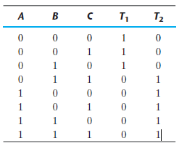

**Question:** Draw logic diagrams to implement the following Boolean expressions:

