**Department of Computer Science, GC University, Faisalabad**

**BS (CS) 2nd Semester Course Code: STA- 321**

**Course Title: Introduction to Statistical theory**

**Submission Deadline: 30 May 2020 Max. Marks: 50**

**Note: There is no extension in last date and there is no resubmission**

***ASSIGNMENT NUMBER 2***

**Feel free to ask questions from 2:15 P.M. to 3:15 P.M. daily via WhatsApp group.**

**Q#1:**

1. Define chi square test of association.
2. For what purpose it is used?
3. Give at least two examples (only example not solution) from your field of study which indicates its application.
4. Provide its computational procedure.

**Q#2: Part (a)**

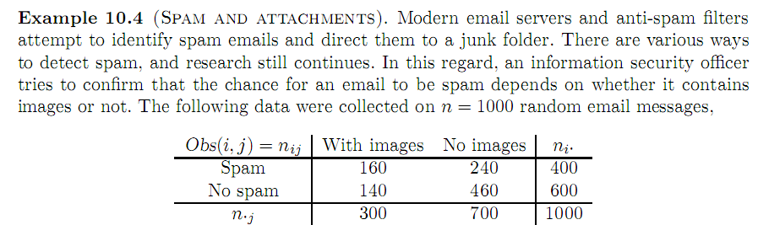

Test whether there is any association between being spam and containing images by using 5% level of significance.

**Part (b):**

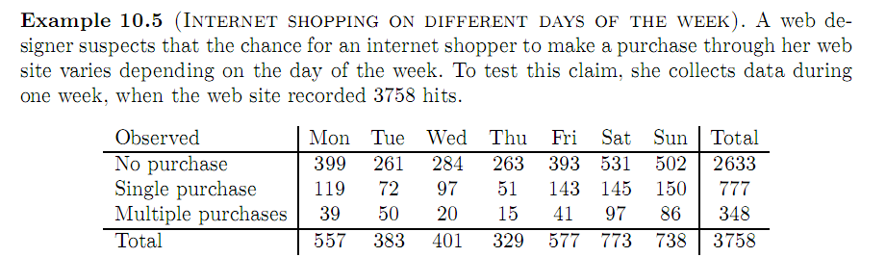

Test whether there is any association between Purchasing and any week day by using 5% level of significance.

**Part (c):**

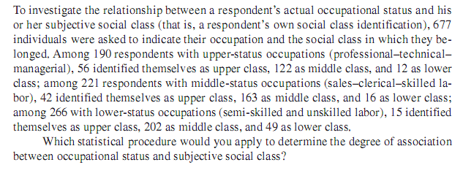

**Q#3**

1. Define One population t- test .
2. For what purpose it is used?
3. Give at least two examples from your field of study which indicates its application.
4. Provide its computational procedure.

**Q#4:**

**Part (a):**

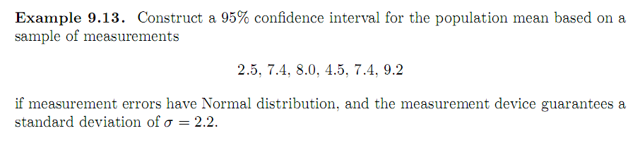

**Part (b):**

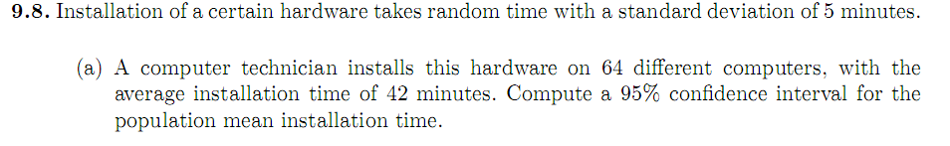

**Part (c):**

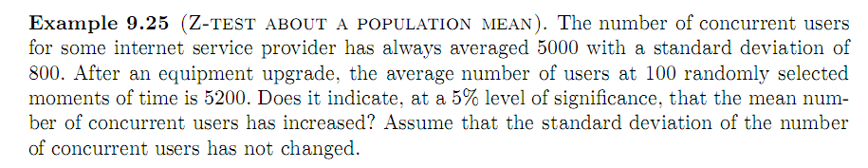

**Part (d):**

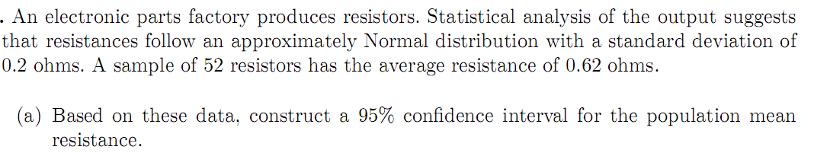

**Normal Distribution:**

**Q#5: Part (a)**

1. Define P-Value or probability value. Also explain its decision rule.
2. Explain its significance in statistics.
3. Define Probability and its application in Sociology.
4. Define normal distribution and its application in Sociology.

**Part (b):**

A new computer virus attacks a folder consisting of 200 files. Each file gets damaged with probability 0.2 independently of other files. What is the probability that fewer than 50 files get damaged?

**Part (c):**

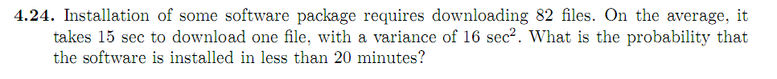

**Part (d):**

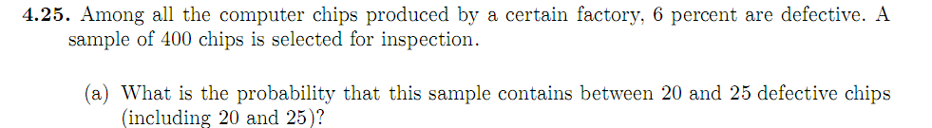

Hint: For all these questions you can take help from the book “Probability and statistics for computer science” which has already been provided to the class OR you can google it.