Word Practical File
For
C Language
(1201)
Performed by Sadafnaaz Sheikh

Write a C program to implement all operators (+,-,*,/,%).
Code:-
#include <stdio.h>
#include<conio.h>
Void main()
{
int a = 9,b = 4, c;
clrscr();
c = a+b;
printf("a+b = %d \n",c);
c = a-b;
printf("a-b = %d \n",c);
c = a*b;
printf("a*b = %d \n",c);
c = a/b;
printf("a/b = %d \n",c);
c = a%b;
printf("Remainder when a divided by b = %d \n",c);

getch();
}

Output:-

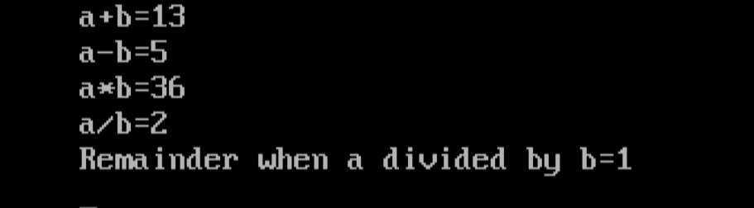

Write a c program to implement relational operator.
Code:-
#include<stdio.h>
#include<conio.h>
Void main()
{
int x = 12, y = 13;

printf("x = %d\n", x);
printf("y = %d\n\n", y);

// Is x is greater than y?
printf("x > y : %d\n", x > y);

// Is x is greater than or equal to y?
printf("x >= y : %d\n", x >= y);

// Is x is smaller than y?
printf("x < y : %d\n", x < y);

// Is x is smaller than or equal to y?
printf("x <= y : %d\n", x <= y);

// Is x is equal to y?
printf("x == y : %d\n", x == y);

// Is x is not equal to y?
printf("x != y : %d\n", x != y);

// Signal to operating system everything works fine
getch();
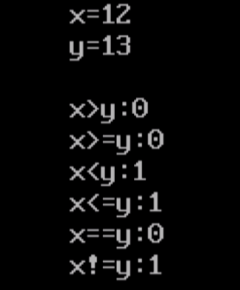
}
Output:-

Write a program to implement logical operator
Code:-
#include <stdio.h>
#include<conio.h>
int main()
{
int x = 5;
int y = 2;
int z = 0;
if (x > y && x > z) {
printf("x is the largest number\n");
}
if (y < x || z < x) {
printf("x is not the smallest number\n");
}
if (!(x == y)) {
printf("x is not equal to y\n");
}
get;
}

Output:-

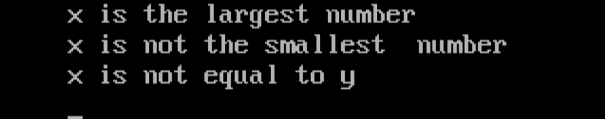

Write a program to find largest among any five numbers with minimum condition.
Code:-
#include<stdio.h>
#include<conio.h>

void main(void)
{
int a,b,c,d,e;
int lar;
clrscr();
printf("Enter any 5 values\n");
scanf("%d%d%d%d%d",&a,&b,&c,&d,&e);
lar=a;

if(b>lar)
lar=b;
if(c>lar)
lar=c;
if(d>lar)
lar=d;
if(e>lar)
lar=e;
printf("Largest element is %d",lar); OUTPUT:-
getch();
}
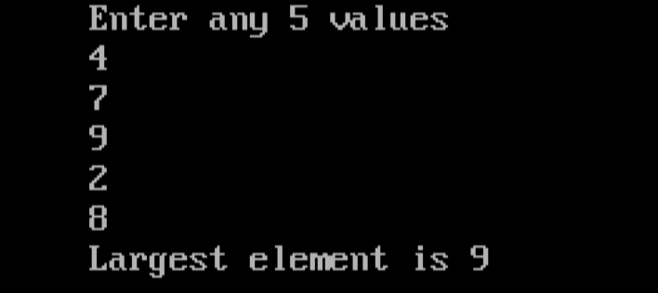
write a program to find given number is even or odd by using goto statement.
Code:-
#include<stdio.h>
#include<conio.h>

void main(void)
{
int num,rem;
clrscr();
printf("Enter a number:-");
scanf("%d",&num);
rem=num%2;

if(rem==0)
printf("Number %d is Even",num);
else
printf("Number %d is Odd",num);
getch();
}

Output:-

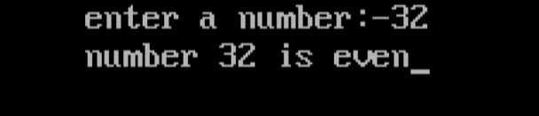

write a program to check the year is leap or not.
Code:-
#include<stdio.h>
#include<conio.h>

void main(void)
{
int year;
clrscr();
printf("\n\t Enter Year :-");
scanf("%d",&year);

if(year%4==0)
printf("%d is a leap year",year);
else
printf("%d is not a leap year",year);
getch();
}

Output:-
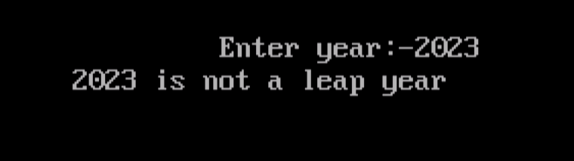

write a program to generate a menu driven program using statement.
Code:-
#include<stdio.h>
#include<conio.h>
#include<stdlib.h>

void main(void)
{
int cho;
do
{
clrscr();
printf("\n\t\t M E N U \n\n");
printf("\t\t (1) add \n");
printf("\t\t (2) edit \n");
printf("\t\t (3) delete \n");
printf("\t\t (4) exit \n");
printf("\t enter choice(1-4):-");
scanf("%d",&cho);
switch(cho)
{
case 1 : printf("\n\n addition routine");
break;
case 2 : printf("\n\n edit routine");
break;
case 3 : printf("\n\n delete routine");
break;
case 4 : exit(0);
}
getch();
}
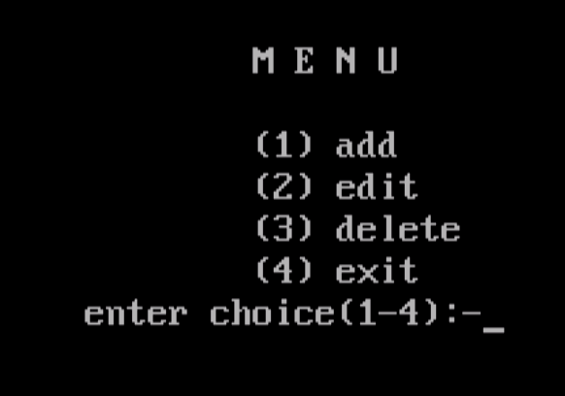
while(cho!=4);
}
Output:-

write a program to print multiplication table.
Code:-
#include<stdio.h>
#include<conio.h>

Void main(void)
{
int n,r,i;
clrscr();
printf("Enter a number:-");
scanf("%d",&n);

for(i=1; i<=10; ++i)
{
r=n*i;
printf("\n%3d*%3d=%5d”,n,i,r);
}
getch();
}

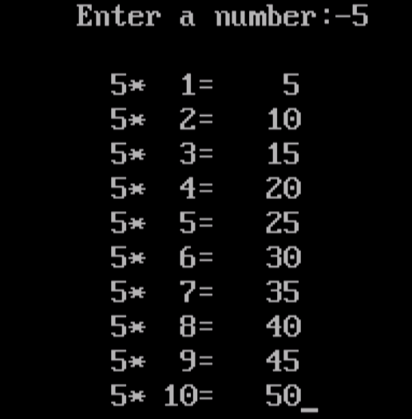
Output:-

write a program to find sum of digit to recerse the given number check weather the number is palindrome or not.

Code:-
#include<stdio.h>
#include<conio.h>

void main()
{
int num,sum=0,orinum,rem,rev=0;
clrscr();
printf("\n Enter the number:- ");
scanf("%d",&num);
orinum=num;

while(num>0)
{
rem=num % 10;
rev=rev*10+rem;
sum=sum+rem;
num=num/10;
}
printf("\n\n Reverse of %d is %d",orium,rev);
printf("\n\n Sum of Digit %d ",sum);

if(orinum==rev)
printf("Number %d is palindrome",orinum);
else
printf("number %d is not palindrome",orinum);
getch();
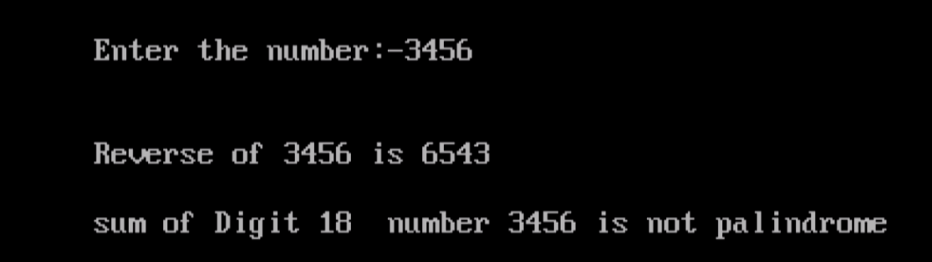
}
Output:-

write a program for list of prime number between 10 – 100 by using break statement.

Code:-
#include<stdio.h>
#include<conio.h>
void main(void)
{
int i,n,r,flag=0;
clrscr();
printf("\n\n\t\t List of Prime Numbers \n");

for(n=10; n<=100; ++n)
{
flag=0;
for(i=2; i<=9; ++i)
{
r=n%i;

if(r==0)
{
flag=1;
break;
}
}
if(flag==0)
{
printf("%d\t",n);
}
}
getch();
} Output:-
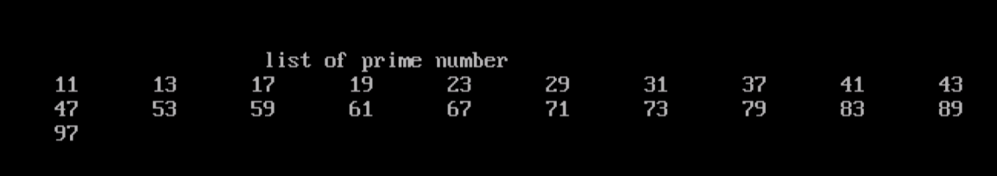

write a program to display the days of week by using switch statement.
CODE:- OUTPUT:-
#include<stdio.h>
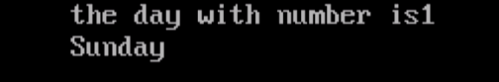
#include<conio.h>
void main()
{
int day=1;
clrscr();
printf("The day with number %d is ",day);
switch(day)
{
case 1:
printf("sunday");
break;
case 2:
printf("monday");
break;
case 3:
printf("tuesday");
break;
case 4:
printf("wednesday");
break;
case 5:
printf("thursday");
break;
case 6:
printf("friday");
break;
case 7:
printf("saturday");
break;
default:
printf("invalid week days");
}
getch();
}

write a program to find transpose of a matrix.
Code:- OUTPUT:-
#include<stdio.h>
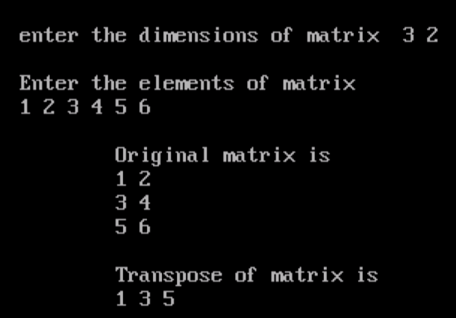
#include<conio.h>

main()
{
int m,n,i,j,a[10][10];
clrscr();
printf("\n Enter the dimensions of matrix ");
scanf("%d %d",&m,&n);
printf("\n Enter the elements of matrix\n ");
for(i=0;i<m;i++)
for(j=0;j<n;j++)
scanf("%d",&a[i][j]);
printf("\n\t Original matrix is \n\t ");
for(i=0;i<m;i++)
{
for(j=0;j<n;j++)
printf("%d ",a[i][j]);
printf("\n\t ");
}
printf("\n\t Transpose of matrix is \n\t ");
for(i=0;i<n;i++)
{
for(j=0;j<m;j++)
printf("%d ",a[j][i]);
printf("\n\t ");
getch();
}
}

Write a program of function length () which count length.
Code:-
#include<stdio.h>
#include<conio.h>

int lenght(char*s)
{
int n=0;
while(*s!='\0')
{
++n;
++s;
}
return(n);
}

void main(void)
{
char *s;
int l;
clrscr();
printf("\nEnter a string:-");
gets(s);
l=lenght(s);
printf("\nLength of string %s is = %d",s,l);
getch();
}

Output:-
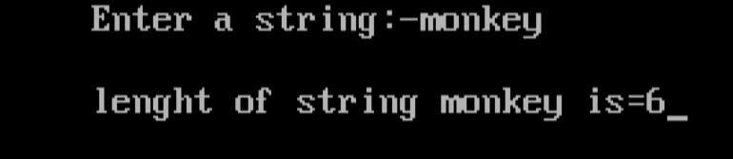

write a program to except the value and display the address of value by using pointer.
Code:
#include <stdio.h>
#include<conio.h>

void main()
{
int var = 789;

// pointer for var
int* ptr2;

// double pointer for ptr2
int** ptr1;

// storing address of var in ptr2
ptr2 = &var;

// Storing address of ptr2 in ptr1
ptr1 = &ptr2;

// Displaying value of var using
// both single and double pointers
printf("Value of var = %d\n", var);
printf("Value of var using single pointer = %d\n", *ptr2);
printf("Value of var using double pointer = %d\n", **ptr1);

getch();
}

Output:-

write a program to display the result of student.
Code:-
#include<stdio.h>
#include<conio.h>
void main()
{
int marks=83;
clrscr();
if(marks>75)
{
printf("first class");
}
else if(marks>65)
{
printf("second class");
}
else if(marks>55)
{
printf("third class");
}
else
{
printf("fouth class"); Output:-
}
getch();
}

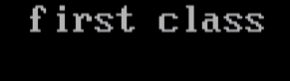

Write a program to create an store information in text file.
Code:-
#include <stdio.h>
#include <stdlib.h>

int main()
{
char str[1000];
FILE *fptr;
char fname[20]="test.txt";

printf("\n\n Create a file (test.txt) and input text :\n");
printf("----------------------------------------------\n");
fptr=fopen(fname,"w");
if(fptr==NULL)
{
printf(" Error in opening file!");
exit(1);
}
printf(" Input a sentence for the file : ");
fgets(str, sizeof str, stdin);
fprintf(fptr,"%s",str);
fclose(fptr);
printf("\n The file %s created successfully...!!\n\n",fname);
return 0;
}
Output:-

